Cloudina aggregates from the uppermost Dengying Formation, Three Gorges area, South China, and stratigraphical implications

Lei Zhang a,b, Shan Chang c, Can Chen a,b, Xia Wang d, Qinglai Feng a,b,*, Michael Steiner e, Ben Yang f, Roger Mason a,g, Zhenbing She a,g, Jiaxin Yan a,g, Jean Vannier h, Marie-Béatrice Forel i, Qian Xiao a, Sébastien Clausen

j a School of Earth Sciences, China University of Geosciences (Wuhan), Wuhan, PR China b State Key Laboratory of Geological Processes and Mineral Resources, China University of Geosciences (Wuhan), Wuhan, Hubei 430074, PR China c College of Urban and Environmental Sciences, Hubei Normal University, Huangshi 435002, PR China d Institute of Sedimentary Geology, Chengdu University of Technology, Chengdu 610059, PR China e Department of Earth Sciences, Freie Universit¨at Berlin, Malteserstrasse 74-100, Haus D, Berlin 12249, Germany f Institute of Geology, Chinese Academy of Geological Sciences, Baiwanzhuang Street 26, Beijing 100037, PR China g State Key Laboratory of Biogeology and Environmental Geology, China University of Geosciences (Wuhan), Wuhan, Hubei 430074, PR China h Universit´e de Lyon, Universit´e Lyon 1, ENS de Lyon, CNRS, UMR 5276 Laboratoire de G´eologie de Lyon: Terre, Plan`_etes, Environnement, Bˆatiment G´eode, 2, rue Rapha¨el Dubois, F-69622 Villeurbanne, France i Centre de Recherche en Pal´eontologie – _Paris, UMR7207, MNHN-CNRS-Sorbonne Universit´e, Muséum national d’Histoire naturelle, 8 rue Buffon (CP38), 75005 Paris, France j Univ. Lille, CNRS, UMR 8198 - Evo-Eco-Paleo, F-59000 Lille, France

Precambrian Research 370 (2022) 106552
https://doi.org/10.1016/j.precamres.2021.106552

ABSTRACT- Numerous issues remain concerning palaeobiology, palaeoecology, and biostratigraphy of Cloudina, an iconic tubular organism of the Ediacaran period. In this study, accumulations of Cloudina are described from the topmost bed of the Dengying Formation in the Baiguotang section of the eastern Three Gorges area, South China. The massive occurrence of Cloudina refutes any possibility of setting the Ediacaran-Cambrian boundary (E-CB) beneath the lithological transition between Dengying and Yanjiahe formations in this area. The age of the Cloudina aggregates is younger than 540.6 Ma based on a concordia 206Pb/238U age of 540.6 ± _3.4 Ma obtained from underlying upper part of the Baimatuo Member (Baiguotang section), which is consistent with the 539 Ma E-CB reported from southern Namibia. Combining fossil evidence provided by Asteridium–Heliosphaeridium–Comasphaeridium acritarchs and Anabarites trisulcatus–Protohertzina anabarica small shelly fossil assemblages and the Basal Cambrian Carbon isotope Excursion (BACE), we tentatively place the E-C boundary within the lower part of the Yanjiahe Formation, close to the BACE excursion located in the lower part of the Yanjiahe Formation in the southern Huangling Anticline.

Keywords: Cloudina Ediacaran Biota Cambrian Zircon age dating Biostratigraphy

1. Introduction

From the end of the Neoproterozoic to the beginning of the Phanerozoic, the atmosphere and ocean water chemistry underwent significant variations (Fike et al., 2006; Li et al., 2010; Maloof et al., 2010a; Grotzinger et al., 2011; Wang et al., 2018). During the late Ediacaran Period, macroscopic metazoans arose rapidly, followed by more complex bilaterian and biomineralized animals by the early Cambrian (Narbonne, 2005; Marshall, 2006, Wang et al., 2018). These evolutionary events left various traces in rocks throughout the Ediacaran-Cambrian (E-C), including abrupt shifting on lithological, geochemical and isotopic records, along with dramatic changes in fossil assemblages (Zhu et al., 2007). However, due the lack of diagnostic fossils and precise age constraints applicable to all paleocontinents, accurate regional and/ or global correlation of the E-C interval has remained a challenge (Knoll et al., 2006; Zhu et al., 2007; Babcock et al. 2014; Ahn and Zhu, 2017). The Three Gorges area, South China, has long been considered as having the best potential for establishing a globally applicable, integrated Ediacaran-Cambrian chronostratigraphy (see debates in von Richthofen, 1882; Lee and Chao, 1924; Chen, 1984; Zhu et al., 20032007). Uncertainties concerning the E-C boundary largely result from
the lack of fossil markers (Chen, 1984; Guo et al., 2014; Chang et al.,
2019). The Global Stratotype Section and Point of the E–C boundary was
established in 1992 at Fortune Head, Southeastern Newfoundland,
Canada, based on the first occurrence of the trace fossil (burrow system)
Treptichnus pedum (Babcock et al., 2014; Zhu et al., 2019). However, the
problem is that Treptichnus occurs almost exclusively in clastic rocks and
is associated with shallow water environments (Babcock et al. 2014; Zhu
et al., 2019). In South China, it is either absent (e.g. in the Three Gorges
area) or occurred above the first occurrence (FO) of the Anabarites
trisulcatus-Protohertzina anabarica Biozone (Small Shelly Fossil (SSF)
Zone I of South China) (e.g. in the eastern Yunnan, Zhu, 1997; Zhu et al.,
2001; Steiner et al., 2007; Chang et al., 2019; Chen and Feng, 2019). In
the eastern Three Gorges area, several Ediacaran and early Cambrian
fossil Lagerst¨atten of great interest for biostratigraphy have been reported
and support the current biostratigraphic subdivisions (Zhu et al.,
2007). For example, the discoveries of the Shibantan biota in the Shibantan
Member of the Dengying Formation clearly indicate a late Ediacaran
age for these deposits (Chen et al., 2013, 2014, 2018, 2019).
Similarly the tubular fossils Sinotubulites and Cloudina found from the
lower part of the Baimatuo Member, Dengying Formation suggest a
terminal Ediacaran age (Chen and Wang, 1977; Chen et al., 1981, 2016;
Liang et al., 2020). The base of the Cambrian in the Three Gorges area is
mainly defined by the first occurrences of SSFs (Guo et al., 2014; Steiner
et al., 2020) or acritarch assemblages (Asteridium-Heliosphaeridium-
Comasphaeridium (AHC)) that have been recognized in the lower-middle
Yanjiahe Formation (Moczydłowska, 1991; Vidal and Moczydłowska-
Vidal, 1997; Moczydłowska et al., 2011). The taphonomic origin of the
large stratigraphic gap observed between the record of those Ediacaran
tubular fossils and the Cambrian AHC and SSF1 in the Three Gorges area
has been questioned.
The worldwide Basal Cambrian Carbon isotope Excursion (BACE, Li
et al., 2009, 2013; Maloof et al., 2010b; Peng et al., 2012; Landing et al.,
2013; Babcock et al., 2014) has also a strong potential for establishing
the E-C boundary. However, chemostratogratigraphic data are unavailable
from the Fortune Head E-CB stereotype, and there is no agreement
whether the onset of the BACE excursion, its nadir, or its demise would
be the best to define this boundary (Peng and Babcock, 2011). As a
consequence, BACE cannot be fully independently used to precisely
identify the E-CB in the Three Gorges area (Chang et al., 2019). Absolute
dating is the best method to establish an accurate chronological
framework but requires adequate material such as tuffaceous ash layers.
Due to the absence of proper ash layers, very limited geochronological work has been done in the Three Gorges area. Absolute ages have been obtained from the Dengying and Yanjiahe formations, such as 543 ± _3.5 Ma for the Baimatuo Member of Dengying Formation (Huang et al., 2020) and 526 ± _6 Ma for the uppermost Yanjiahe Formation (Okada et al., 2014; Lan et al., 2017). New Cloudina aggregates are reported herein from the Baiguotang section, Three Gorges area. These bioaccumulations occur in the uppermost Baimatuo Member, just a few centimeters beneath the boundary between the Yanjiahe and Dengying formations, and few meters above zircon-rich clay layers, in a carbonate dominated succession. As a consequence, this section provides a unique opportunity to better biostratigraphically, chemostratographically (δ13C), and geochronologically (SIMS 206Pb/238U zircon dating) constrain the E-CB interval in the Three Gorges area, adding new important input toward its comprehensive understanding and worldwide correlation.

2. Geological setting

During late Ediacaran to early Cambrian, the Three Gorges area (Hubei Province, China) was situated on the eastern Yangtze Platform of the South China Block, an isolated microcontinent located at mid-northern latitudes (Fig. 1 A; Wang et al., 2012a; Zhu et al., 2003; Li et al., 2008). Ediacaran-Cambrian successions are well exposed in the Three Gorges area. There, the Ediacaran System, composed of the Doushantuo and Dengying formations, is underlain by the Cryogenian tillites of the Nantuo Formation. The Dengying Formation is further divided into the Hamajing, Shibantan, and Baimatuo members (Fig. 2). The Hamajing Member consists of ooidal dolostone with syndepositional karstification features deposited in a high-energy subtidal to peritidal environment. The Shibantan Member is dominated by dark gray, thin-bedded bituminous limestones deposited in a subtidal environment. The Baimatuo Member consists of light gray massive and medium- to thick-bedded dolostones with chert bands and concretions (Fig. 2; Zhu et al., 2003, 2007; Chen et al., 2013, 2014, 2018, 2019). Crossbedding, birds-eye structures, and abundant evidence of dissolution and brecciation indicates a peritidal environment for the Baimatuo Member (Zhu et al., 2007; Duda et al., 2016). The top Baimatuo Member is overlain by the Yanjiahe Formation, which preserved abundant small shelly fossils (Chen, 1984). The thickness and lithology of the Yanjiahe Formation varies in the Three Gorges area. The Yanjiahe Formation represents a sedimentary succession of the uppermost Ediacaran(?)-Terreneuvian
with a significant hiatus at its bottom and top where there is a disconformity with the underlying Dengying Formation and overlying Shuijingtuo Formation (Ishikawa et al., 2008, 2013; Steiner et al., 2020). All materials studied here have been recovered from the Baiguotang section (N 30◦45′10.5′′ _, E 111◦02′01.1′′ _), exposed along a local unpaved road ca. 6 km southeast of Zigui County and 13.5 km southern of Sandouping Town (Fig. 1B), and ca. 2.5 km to the west of the Gunshi’ao section (Fig. 1). The Baiguotang section only exposes the upper Dengying Formation (part of the Shibantan and the Baimatuo Members) and the lowermost Yanjiahe Formation (Fig. 2). The Baimatuo Member of the Dengying Formation studied herein can be subdivided into three intervals (Figs. 2, 3A).
The interval 1 of the Baimatuo Member, ca 1 m thick (partly covered), is characterized by light gray to light-red argillaceous massive dolostones with dissolution cavities (Figs. 3A, 3D-E, 4A). Interval 2 is 3–20 cm thick and composed of veined or lenticular siliceous dolomite formed by bioaccumulations, which are the focus of petrological and paleontological analysis below (Fig. 3A-C). Interval 3 is ca. 10 to 35 cm in thickness and dominated by gray micrite or fine-grained dolomite (Fig. 3A). Twenty-one (n = 21) samples were collected from the Dengying dolomite of the Baiguotang section for carbonate carbon isotope analyses. Three thin, yellowish, tuffaceous clay layers occur ca. 40–45 m above the base of the Baimatuo Member (9–10 m beneath the Dengying- Yanjiahe boundary). Their thickness are 1 cm, 4 cm, and 2 cm, respectively (Figs. 2, 4D-E). Abundant euhedral zircons were recovered from the middle 4 cm-thick layer, which were dated through SIMS 206Pb/238U analyze. Only the lowermost 3 m of the overlying Yanjiahe Formation are exposed, consisting of thin-bedded chert interbedded with thin-bedded silty dolostone and shales (Fig. 4A-C). Thin-bedded chert with crumpled textures can be found in the basal Yanjiahe Formation (Fig. 4A-B). For stratigraphic comparison, the more complete and well-studied Gunshi’ao section is discussed here. The classic Gunshi’ao section (N 30◦45′10.4′′ _, E 111◦02′ _01.0′′ _) is exposed along a local unpaved road ca. 6 km southeast of Zigui county and 13.5 km south of Sandouping town (Fig. 1B), ca. 25 km west of the city of Yichang. The uppermost Baimatuo Member of the Dengying Formation in the Gunshi’ao section is mainly light gray massive dolostone. The disconformable overlying Yanjiahe Formation is 54.4 m thick and is divided into eight beds (Fig. 2; Chang et al., 2019).

3. Materials and methods

3.1. Petrological and palaeontological observations The fossils studied were collected from interval 2 of the Dengying Formation in the Baiguotang section (Fig. 2). Fifty thin-sections and 15 polished slabs were prepared for sedimentological and paleontological analyses. The thin sections were observed and photographed under a Leica DVM6 microscope in the State Key Laboratory of Geological Process and Mineral Resources (GPMR) of China University of Geosciences (Wuhan) (CUG).
3.2. Carbonate carbon and oxygen isotope analyses Twenty-one (n =_ _21) samples were collected from the Dengying dolomite of the Baiguotang section for carbonate carbon isotope analyses. Carbonate carbon and oxygen isotopes (δ13Ccarb and δ18Ocarb) were measured using an online analysis system (Finnigan Gas-bench II +_ _MAT253 gas mass spectrometer) at the State Key Laboratory of Biogeology and Environmental Geology of CUG. 100 to 400 μg of small rock chips were powdered, then transferred to a reaction bottle and sealed by a septum cap and the remaining air removed to eliminate its influence on the isotopic results. Approximately seven drops of 100% phosphoric acid were injected into the reaction bottle and held for approximately one hour at 70 ◦C. The CO2 was purified by a chromatographic column and introduced into a Thermal MAT-253 mass spectrometer for analysis of δ13Ccarb and δ18Ocarb. Chinese carbonate standards GBW04416 and GBW04417 were analyzed for every ten samples for isotopic calibration and checked for memory effects. Analytical precision based on replicate analyses of the two laboratory standards GBW04416 and GBW04417 was better than 0.1‰ _for δ13Ccarb and δ18Ocarb. Isotopic values were presented as per mille relative to the Vienna Pee Dee Belemnite (V-PDB) 5
standard.

3.3. U-Pb zircon chronology analyses The 4 cm thick tuffaceous clay layer within the Dengying Formationat the Baiguotang section was sampled for zircon U-Pb dating. A sample
(labeled BGT-DY-1) of approximately one kilogram was collected and
analyzed. After washing and crushing (using a stamp mill), the residues
were separated by heavy liquid separation with methylene iodide and a
Nd magnetic techniques to concentrate heavy non-magnetic fractions.
Zircon crystals and crystal fragments were hand-picked under an optical
microscope. Subsequently, zircon crystals and Geostandards Pleˇsovice
and Qinghu were mounted in a synthetic epoxy mount (Li et al., 2013b).
The mount was polished to expose the midsections of the crystals for
isotopic analysis. All 300 zircon crystals were recorded in transmitted
and reflected light micrographs and as cathodoluminescence (CL) images
to reveal their internal structure.
Secondary ion mass spectrometry (SIMS) zircon U-Pb analyses were
conducted using a CAMECA IMS1280-HR system at the State Key Laboratory
of Isotope Geochemistry, Guangzhou Institute of Geochemistry,
Chinese Academy of Sciences. The analytical procedure is similar to that
described by Li et al. (2009). The ellipsoidal spot was about 20 μm Å~ 30
μm in size. Each measurement consisted of seven cycles, and the total
analytical time per measurement was about 12 min. Calibration of Pb/U
ratios was relative to the standard zircon Pleˇsovice (337.13 Ma) (Sl´ama
et al., 2008), which was analyzed once for every five unknowns, based
on an observed linear relationship between ln (206Pb/238U) and ln
(238U16O2/238U) (Whitehouse et al., 1997). A long-term uncertainty of
1.5% (1 RSD) for 206Pb/238U measurements of the standard zircons was
extrapolated to the unknowns, allowing for the fact that a measured
206Pb/238U error in a specific session is generally around 1% (1 RSD) or
less. U and Th concentrations of unknowns were also calibrated relative
to the standard zircon Pleˇsovice, with Th and U concentrations of 78 and
755 ppm, respectively (Sl´ama et al., 2008). Measured compositions were
corrected for common Pb using non-radiogenic 204Pb. Common Pb was
extremely low and is probably derived mainly from laboratory
contamination introduced during sample preparation (Ireland and
Williams, 2003). An average of present-day crustal composition (Stacey
and Kramers, 1975) was used for the common Pb. A secondary standard
zircon Qinghu (Li et al., 2013) was analyzed as an unknown to monitor
the reliability of the whole procedure. Thirteen analytical spots conducted
during this study yield a concordia age of 159.0 ± 1.3 Ma,
identical to its recommended value. Uncertainties on single analyses are
reported at the 1σ level; mean ages for pooled U-Pb analyses are quoted
with a 95% confidence interval. The data reduction was carried out
using Geochronology software developed at NORDSIM by Dr. Martin
Whitehouse. The data processing method is equivalent to SQUID. The
plotting program Isoplot 3.75 software (Ludwig, 2012) was used to
calculate ages, uncertainties, weighted means, and generate U-Pb concordia
plots.

4. Results

4.1. Sedimentology of the Cloudina accumulations bearing interval
According to the lithological characters, the uppermost Baimatuo
Member can be further divided into three intervals in the Baiguotang
section. The Cloudina mainly occurred in the interval 2. Reddish or
white, horizontal, or wavy layers of microbial laminae were observed
just beneath the tubular fossil aggregates (Figs. 3A, 5A-B). In the studied
section (Figs. 3A, 3E, 6A-D), the uppermost Dengying Formation is
enriched in brecciated materials. Abundant rounded and brecciated
siliceous fragments found in interval 2 are locally contain the silicified
Cloudina bioaccumulations (Figs. 2, 3A-E, 5A, 6A arrows b and c, 6B-C).
The fossil layer is usually strongly brecciated at its thinnest point
(Fig. 3A). Brecciated structures or conglomerates can also be found from
intervals 2–3. These breccias are composed of intraformational dolomitic or siliceous fragments (2–10 cm, arrows in Figs. 3E, 6A-D). The clasts are poorly sorted and closely packed (Fig. 6A-C). Original fossil structures can only be recognized in the larger fragments of the breccias (e.g., Fig. 6D). In thin sections (Fig. 7A-F), petrographic observations reveal that the fossil tubes, fractures, and voids of breccias are often filled by cryptocrystalline chalcedony, microcrystalline and larger quartz crystals. The surrounding matrix is exclusively replaced by chert (Figs. 8–10). What we see are tube fragments with no clear evidence of attachment structure and tube internal structure. The random-like arrangement of these tubes suggests a parautochthonous deposition, though occasionally,

4.2. Cloudina aggregates The wavy beds containing fossil aggregates are made of largely silicified tubular remains attributed to Cloudina. These tubes have a white color, contrasting with the reddish and gray dolostones matrix. These wavy beds are located about 15–35 cm below the top of Dengying Formation. The thickness of the Cloudina-rich interval varies from less than 1 cm to about 25 cm along the exposed outcrop (Fig. 3A-C). Compared to the background dolostone, the fossil layer is secondarily silicified (Fig. 8A-D). Most tubular fossils are fragmented, ranging from 0.9 to 2.2 mm in length (Fig. 9) and from 0.24 to 1.78 mm in diameter (Figs. 8, 11). The collar structure appears as a series of nested rings in transverse and oblique sections, whereas longitudinal sections display flaring collars extending outward from an inner straight tube wall (Fig. 9B-D). Some tubes have a slightly curved outline (Fig. 9E-F, arrows). Although most of them are parallel to the bedding or slightly oblique (Fig. 8A), some rare specimens seem to be erected. However, it is uncertain whether this configuration represents the original life position of the animal or results from transportation and redeposition (Figs. 9E-F, 10C-F).
precise age determination, U-Pb isotopic ratios obtained by SIMS and calculated ages are shown in Table 3 and Fig. 13. The grains are all euhedral, range from 80 to 240 μm with aspect ratio between 2:1 and 6:1, showing clear oscillatory zoning in cathodoluminescence (CL) images (Fig. 13). A total of 20 zircon grains were analyzed in this study. Analyses no. 13 and 16 are excluded from the age calculation because 206Pb/238U ratios are more than 10% discordant (Table 3). Eighteen spot analyses of zircons are concordant, with 206Pb/238U and 207Pb/235U ages in agreement within analytical error, yielding a concordia age of 540.6 ± 3.4 Ma (2σ, n = 18, MSWD = 3.6; Fig. 13).

5. Discussion

5.1. Biostratigraphy of Cloudina Cloudina is a tubular body fossil with nested flaring collars (“funnel-in-funnel” _units; Conway Morris et al., 1990; Grant, 1990; Chen and Sun, 2001). It was originally described from the Nama Group of Namibia (Germs, 1972; Grant, 1990; Grotzinger and James, 2000; Amthor et al., 2003) and has been reported from every major continent except Antarctica (e.g., McMenamin, 1985; Signor et al., 1987; Conway Morris et al., 1990; Bengtson and Yue, 1992; Vidal et al., 1994; Hagadorn and Waggoner, 2000; Hofmann and Mountjoy, 2001; Hua et al., 2003, 2005, 2007; Sour-Tovar et al., 2007; Kontorovich et al., 2008; Cai et al., 2013, 2014, 2019; Mehra and Maloof, 2018). Although widely distributed, the biological affinity of Cloudina remains controversial (Cortijo et al., 2010, 2015; Vinn and Zato´n, 2012; Yang et al., 2020a). Current reconstructions of tubular hard parts indicate that Cloudina was sessile, epibenthic, and likely a filter feeder (Grant, 1990; Warren et al., 2011; Cai et al., 2011, 2013, 2014; Min et al., 2019), housed in either an aragonitic exoskeleton (Vinn and Zato´n, 2012; Van Iten et al., 2014; Cortijo et al., 2015; Becker-Kerber et al., 2017; Wood, 2011, 2018; Pruss et al., 2018) or in an originally organic (chitinous or collagenous) housing tube (Schiffbauer et al., 2020; Yang et al., 2020a). Its biological assignment to a phylum swings between cnidarians and annelids (Germs, 1972; Glaessner, 1976; Grant, 1990; Hua et al., 2005; Cortijo et al., 2010; Vinn and Zato´n, 2012; Cai et al., 2013, 2014; Schiffbauer et al., 2020; Yang et al., 2020a; Park et al., 2021). Although its exact anatomy remains largely enigmatic, Cloudina is often considered as an important biostratigraphic indicator of the E-C transition owing to its easily recognizable tubular structure, worldwide distribution and temporal range (Grant, 1990; Hua et al., 2005; Cortijo et al., 2015; Warren et al., 2011). Other tubular fossils, such as Sinotubulites and Namacalathus, also have a comparable wide geographic distribution and occur in terminal Ediacaran rocks in South China (Cai et al., 2015), Mexico (McMenamin, 1985), eastern California and Nevada (Signor et al., 1987), and Spain (Cortijo et al., 2015). These skeletal fossils first appear in the upper Ediacaran (ca. 551 Ma). The overwhelming majority of soft-bodied Ediacaran groups (such as rangeomorphs and erniettomorphs) declined in the latest Ediacaran Nama interval and disappeared entirely at the E-CB, potentially representing the first mass extinction of complex multicellular life (Droser et al., 2017; Darroch et al., 2018). Similarly, the Cloudinid assemblages also suffered a significant loss during these assumed extinction events (Grotzinger et al., 1995; Amthor et al., 2003), become extinct by the end of the Ediacaran (Grant, 1990; Zhuravlev et al., 2009, 2012; Cortijo et al., 2010, 2015a; Smith et al., 2017; Chai et al., 2021, but also see Zhu et al., 2017; Cai et al., 2019). Gaucher and Germs (2009) proposed the Cloudina Taxon Range Zone, ranging approximately from >550 to 542 Ma in the Nama Group from Namibia, Ara Group from Oman, Corumb´a Group from Brazil, and Arroyo del Soldado Group from Uruguay. Based on the subsequent discovery of Cloudinid specimens in the earliest Cambrian strata (Yang et al., 2016; Zhu et al., 2017, 2019), the Cloudina-Namacalathus-Sinotubulites Assemblage Zone was proposed (Hofmann and Mountjoy, 2001; Zhuravlev et al., 2012) that immediately precedes the well-established SSF Biozone I (Anabarites trisulcatus–Protohertzina anabarica) (Steiner et al., 2007; Yang et al., 2016). More recently, Yang et al., (2021) introduced a new interval zone, defined by first appearance datum (FAD) of Cloudina hartmannae and that of Protohertzina anabarica. The Cloudina hartmannae Interval Zone is therefore supposed to define the terminal Ediacaran (Warren et al., 2017). This biozone ranges from ca. 550 Ma (Grotzinger et al., 1995) to ca. 541 Ma, or 539 Ma (new data from Namibia, see Linnemann et al., 2019; Yang et al., 2021). In South China, Cloudina has mainly been reported from the Ediacaran Dengying Formation in southern Shaanxi Province, in association with various other tubular fossils such as Shaanxilithes, Conotubus, Gaojiashania, and Sinotubulites (Conway Morris et al., 1990; Hua et al., 2003, 2005; Chen et al., 2008; Cai et al., 2010, 2011, 2013; Zhu et al., 2017). Records of Cloudina in other areas of China, such as the Three Gorges area (Chen et al., 2016; Liang et al., 2020) and the Shennongjia Region (Steiner et al., 2007; Yang et al., 2020b) are relatively rare. We report new Cloudina aggregates from the uppermost Baimatuo Member of the Dengying Formation in the Three Gorges area. Huang et al. (2020) argued that Cloudina (and Sinotubulites) were of limited interest for the biostratigraphy of the uppermost Ediacaran, especially due to the absence of these tubular fossils in the upper Baimatuo Member in the Three Gorges area. Our study shows that this conclusion is no longer valid. Both the occcurrence of Shaanxilithes, Conotubus, Gaojiashania, and Sinotubulites in the lowermost Baimatuo Member, and our discovery confirms that the whole Baimatuo Member in the studied area is latest Ediacaran in age (Fig. 12). Therefore, the Cloudina-bearing interval of the Baimatuo Member would correlate with the Beiwan Member of the Dengying Formation from the Shaanxi Province (Fig. 14). One may argue that since Cloudina also occurs at the bottom of the Cambrian and some Cambrian-type small shell fossils have been reported from the latest Ediacaran (Zhu et al., 2007; Yang et al., 2016; Han et al., 2017; Cai et al., 2019), the occurrence of Cloudina does not necessarily point to an Ediacaran age. Indeed there are 1) rare isolated reports of Anabarites trisulcatus from strata of possible terminal Ediacaran (Zhu et al., 2017; Cai et al., 2019) and 2) very rare cloudinids in lower Cambrian in South China (e.g. Yang et al., 2016, 2020b; Han et al., 2017). However, in these strata, other typical representative of Cambrian small shelly fossils co-occur with Cloudina. Here, the monospecific occurrences of Cloudina indicate that the whole Dengying Formation in the studied section should be attributed to the Ediacaran (see also discussion in Chang et al. (2020) regarding the E-CB in the Gunshi’ao section).

5.2. Chemostratigraphic correlations Before discussing possible chemostratigraphic correlation, the diagenetic effects (post-depositional processes such as burial and meteoric diagenesis) can potentially alter the original carbonate isotopic signal through fluid-rock interactions (e.g., Knauth and Kennedy, 2009). During the diagenetic modification of carbonate, the levels of δ13Ccarb and δ18Ocarb decrease (Kaufman and Knoll, 1995). Moreover, it is generally believed that the correlation between carbon and oxygen isotopes can effectively reflect the impact of diagenesis on carbonate samples: the higher positive correlation, the greater the effects of diagenesis. In our samples, the δ13Ccarb is well correlated with the 18Ocarb results (R2 = 0.61, p < 0.01), but this is possibly caused by the over intensive sampling in the relatively higher rock homogeneity degree of the tested interval rather than a signature of diagenesis (Fig. 12, Table 2). However, the two most negative points obtained from the Cloudina bearing interval indicate that δ13Ccarb results may have been influenced by burial and meteoric diagenesis (Fig. 12, Table 2). It is likely that the lower values of δ18Ocarb (i.e., less than 􀀀 _5‰) also represent some degree of oxygen isotope alteration, especially in the silicified fossil aggregates (Kaufman and Knoll, 1995). These geochemical characteristics are well coupled with silicification and brecciation of both background dolomites and Cloudina aggregates. Multiple analyses of carbon isotope curves have been made in the Three Gorges area (Jiang et al., 2007; 2012; Ishikawa et al., 2008; Wang et al., 2012a; Steiner et al., 2020). These curves generally run from the Baimatuo section of the Dengying Formation to the top of the Yanjiahe Formation or even higher (Ishikawa et al., 2008; Jiang et al., 2012; Wang et al., 2012a; Steiner et al., 2020) and suggest that 1) late Ediacaran positive carbon isotope plateau (EPIP) occurs in the middle to upper part of Baimatuo Member in the studied area (Zhou and Xiao, 2007; Zhu et al., 2019) and 2) the nadir of BACE in the lower Yanjiahe Formation (Ishikawa et al., 2008). Other studies reveal slight divergences concerning the starting point of BACE. Jiang et al. (2007, also see the review in Cui et al., 2019, fig. 15) document the onset of the BACE excursion at the top of the Dengying Formation. However, most studies indicate that BACE might begin at the disconformity boundary or even higher, in the lower part of the Yanjiahe Formation (Ishikawa et al., 2008; Jiang et al., 2012; Wang et al., 2012a; Ahn and Zhu, 2017; Huang et al., 2020; Steiner et al., 2020). It is evident that carbon isotope values of the Cloudina-bearing strata shown in this work oscillate at the zero-cross point. Values that below 0‰ _can be observed in the background
dolomites. In other words, our results imply that the start point of BACE may occur lower in the succession than the cloudinids-bearing interval (Fig. 12, Table 2). Thusly, the opinions to set the E-CB at this interval might therefore be appropriate if the carbonate carbon profile of the background dolomites reflects the pristine or least-altered signatures. A longer range of carbonate carbon isotopic profile crossing the Dengying- Yanjiahe formations would be needed, but is regrettably impossible to obtain because of the limited exposure of the Baiguotang section. Similar carbonate carbon isotopic curves are observed through the uppermost Denying Formation in northeastern Yunnan (Li et al., 2013a) and southern Shaanxi provinces (Cai et al., 2019; Cui et al., 2019). The carbonate carbon isotopic curves documented in the Xiaotan section, Yunnan Province indicate that the negative excursion starts at the top of the Baiyanshao Member, Dengying Formation, which is generally regarded as end Ediacaran in age. Meanwhile, abundant fossils, including Cloudina hartmannae, Ganloudina symmetrica, Rugatotheca typica, and Rugatotheca daibuica, have been recovered from the overlying Daibu Member, indicating that part of the member has already stepped into the Cambrian (Yang et al., 2016). A recent discovery of fossil assemblages dominated by typical Ediacaran taxa (Cai et al., 2019) from the Beiwan Member of the Dengying Formation in southern Shaanxi Province, at the onset of the BACE excursion, also supports the use of the nadir or the demise (as in Cai et al., 2019) of this excursion as a marker of the Ediacaran-Cambrian boundary (Chang et al., 2019, Fig. 14).

5.3. U-Pb zircon geochronology The E–C boundary GSSP in Newfoundland cannot been geochronologically dated. An accurate U–Pb age of 542.0 ± _0.3 Ma (Amthor et al., 2003), which has been further recalibrated to 541.00 ± _0.13 Ma (Bowring et al., 2007), has been proposed for a particular horizon within the Ara Group, Oman, that coincides with the abrupt extinction of Ediacaran fauna (Cloudina and Namacalathus) and a large magnitude, but short-lived, negative δ13Ccarb excursion, thus possibly marking the E–C boundary. This recalibrated value (541.00 ± _0.13 Ma; Bowring et al., 2007) has been widely accepted to date the E-CB boundary (Zhu et al., 2019). Recently, Linnemann et al. (2019) conducted a study in Namibia that places the E-C boundary between 538.58 ± _0.19 Ma and 538.99 ± _0.21 Ma, which is more than 2 Ma younger than previous estimate, but its validity is still debated (Chen and Feng, 2019). The geochronology of the E-CB in shallow water deposits of the South China is uneasy to establish because the widely distributed
depositional hiatus. In slope and basin settings, deposition is more continuous and the E-CB constrained by a series tuffaceous layers make it possible to use absolute geochronology (Chen and Feng, 2019). The U-Pb zircon ages of 522.3 ± _3.7 Ma (Chen et al., 2015), 522.7 ± _4.9 Ma (Wang et al., 2012b), and 532.3 ± _0.7 Ma (Jiang et al., 2009) from the basal Niutitang Formation in the Guizhou Province suggest that the E-C boundary occurs below the basal Niutitang Formation (Chen et al., 2015; Chen and Feng, 2019). A large negative δ13C excursion (N1, BACE) near the base of the Liuchapo chert horizon is dated at 542.1 ± _5.0 Ma in the western Hunan Province, and thus assumed to be at or near the E–C boundary (Chen et al., 2009). Nevertheless, extensive zircon U–Pb dating in a tuffaceous layer from the Zhongyicun Member indicate ca. 540 Ma (Jenkins et al., 2002; Compston et al., 2008; Sawaki et al., 2008; Zhu et al., 2009; Chen et al., 2015). In the present study, a concordia 206Pb/238U age of 540.6 ± _3.4 Ma has been obtained from the upper part of the Baimatuo Member in the Baiguotang section. This tuff layer is considered as airfall volcanic ash deposits, because of (1) the euhedral shape of the grains with the aspect ratio between 2:1 and 6:1, showing clear oscillatory zoning in cathodoluminescence (CL) images (Fig. 13) and (2) the unimodal age distribution of the SIMS U-Pb isotopic data. Combined with the Th/U ratios (0.31–3.18), it appears that all of the selected zircons have an igneous origin (Hoskin and Schaltegger, 2003). Thus, we interpret the zircon U-Pb age to be the depositional age of sample BGT-DY-1. This new obtained age is younger than the recently reported age (ca. 543 Ma) from the Dengying Formation in the neighboring area (Huang et al., 2020) and younger than the previously estimated 541 Ma upper age of the E-CB (Condon et al., 2005). The occurrence of Cloudina above this tuffaceous layer in the uppermost Dengying Formatio implies that the age of the E-CB in the studied area should be no older than 540.6 ± _3.4 Ma. This supports the new estimated E-CB age of ca. 539 Ma proposed by Linnemann et al. (2019).

5.4. A synthesis: constraint on the Ediacaran-Cambrian boundary in the studied area The Lagerst¨atten in the Three Gorges area have been studied before being used in stratigraphy (Guo et al., 2008; Ye et al., 2019; Chen et al., 2019; Fu et al., 2019). This area has also been the subject of intensive geochemical studies that yielded carbon and strontium isotopic curves usable in chemostratigraphy (Steiner et al., 2020). However, the E-C transition in this area has been controversial, even in the well-studied Yanjiahe section where the Yanjiahe Formation has been established. The main reason for stratigraphic uncertainty is the absence of the ichnofossil, Treptichnus pedum, that defines the E-C boundary (Babcock et al., 2014; Zhu et al., 2019). The existence of a major hiatus in the E-CB interval and the diverging opinions to define criteria for international correlations are among the principal sources of controversy (Steiner et al., 2020). The discovery of Cloudina aggregates at the top of Dengying Formation in this paper allows to propose a more precise position of the E-CB in the studied area. Several studies on the E-CB transition interval in the studied area lead to different conclusions. Chen et al. (2016) proposed that the E-C boundary should be placed at the boundary between the Shibantan and Baimatuo members within the Dengying Formation (Region 1, see in Fig. 12), where they recognized a major negative excursion of carbonate carbon isotopes. They interpreted this negative excursion as the BACE excursion, which might have coincided with the mass extinction of the Ediacaran Biota and dramatic changes in the ocean chemistry (Zhu et al., 2007). For the same reason, Gamper et al. (2015) also drew the E-CB near the boundary between the Gaojiashan and Beiwan members in the southern Shaanxi Province. This interval roughly corresponds to the Shibantan-Baimatuo boundary in the Three Gorges (Cui et al., 2016, 2019). However, their proposals have received little support for three reasons: i) These major excursions have not been recorded in other locations in China and are likely to have resulted from diagenetic
12
processes or local variations in the aquafacies. ii) Even if the reported
isotopic signal is original, it might not necessarily represent the BACE
excursion, but instead an unnamed, small-scale carbon isotope excursion
in the late Ediacaran. iii) The discovery of the tubular fossils, such as
Sinotubulites and Cloudina in the Baimatuo Member in the Three Gorges
and the Beiwan Member in southern Shaanxi, further indicates that most
of Baimatuo/Beiwan Member still belongs to the Sinotubulites-Cloudina
Assemblage Zone, which commonly indicates the end of the Ediacaran
(Cai et al., 2019; Liang et al., 2020).
Some researchers have suggested that the E-CB should be set at the
starting point of BACE or at the base of BACE (Zhu et al., 2007). Several
studies have shown that the excursion of carbon isotopes had already
started in the uppermost Dengying Formation (e.g., Jiang et al., 2007,
Cui et al., 2019; this study; but also see Ishikawa et al., 2008; Ahn and
Zhu, 2017; Steiner et al., 2020). According to this, the E-CB in some
sections in the Three Gorges area may be placed just below the top of
Dengying Formation (Region 2 in Fig. 12) although this opinion has not
reached a consensus (Chang et al., 2019). The massive occurrence of
cloudinids in the last 15–35 cm of the Dengying Formation (above the
starting point of the BACE negative excursion in the studied section),
argues against such a placement (Fig. 12). Although this observation
requires further testing in other sections, the range of the δ13Ccarb values
indicates an early negative shift of BACE, which starts in the uppermost
Dengying Formation (i.e. in the terminal Ediacaran).
Because of the disconformity, some researchers have suggested that
the E-CB should be set at the boundary between the Yanjiahe and
Dengying formations (Region 3 in Fig. 12, e.g., Jiang et al., 2012; Cremonese
et al., 2014). Considerable evidence shows that, due to a
regression, a hiatus largely occurs around the E-CB in South China and
worldwide (Steiner et al., 2020). However, the timespan of this most
probably diachronous hiatus is extremely difficult to estimate as the
duration of exposure and erosion varies with the water depth and
palaeogeographic settings (Fig. 14; Chen and Feng, 2019; Steiner et al.,
2020).
If excluding the options mentioned above, the setting the E-CB at the
lower part of the Yanjiahe Formation (Region 4, Fig. 12) appears to be
the best natural choice. This setting is supported by multiple evidences,
such as the FAD of the SSF Zone 1, acritarch assemblages, and isotopic
excursion of BACE. The Gunshi’ao section represents one of the best
stratigraphic sequences across the Ediacaran–Cambrian boundary interval
in the eastern Three Gorges area (Wang et al., 2002; Zhu et al.,
2003; Ishikawa et al., 2008; Wang et al., 2012a). The Asteridium–
Heliosphaeridium–Comasphaeridium (AHC) acritarch assemblage
zone has been widely recognized in South China including within the
lithological sections studied here (Steiner et al., 2007; Dong et al., 2009;
Jiang et al., 2012; Ahn and Zhu, 2017; Chang et al., 2019; Steiner et al.,
2020). In the Gunshi’ao section, the AHC assemblage first occurs at
about 22.2 m above the Dengying-Yanjiahe boundary (Chang et al.,
2019), few meters below the Anabarites trisulcatus–Protohertzina anabarica
zone (SSF Zone 1 of South China), which was reported at about
27.8 m above the boundary (Steiner et al., 2020). This is congruent with
the identification of the BACE peak at ca. 27 m above the boundary of
the Dengying-Yanjiahe formations by Wang et al. (2012a). Moreover,
comparisons between the fossil record of phytoplankton and skeletal
metazoans around this time indicates that acritarchs went through a
major radiation that slightly preceded the radiation of skeletal metazoans
(Moczydłowska, 1991; Dong et al. 2009; Chang et al., 2019). The
same order of appearance between two fossil groups has been precisely
observed in the Three Gorges area, indicating that their absence in the
lowermost Yanjiahe Formation is original and not the result of taphonomic
bias (e.g. lack of fossil preservation).
Newly discovered tuff layers, which are dated herein as ca. 540.6 Ma,
allow to better constrain the onset of the basal Cambrian δ13C excursion
(BACE) which occurs few meters above them in the studied section. This
dating is consistent with re-dated tuffs from southern Namibia (Linnemann
et al., 2019). It is worth noting that a similar absolute age of 540.7
± _3.8 (±6.6) Ma has been reported within the Sifangjing section in northeastern Guizhou province (Chen and Feng, 2019) that would place the negative δ13Ccarb excursion (BACE) slightly older than 540.7 ± _3.8 (± _6.6) Ma. In the Baiguotang section, the corresponding tuffaceous layer is found below the BACE, although the corresponding age determined from these two locations is within the range of experimental errors. Several data sets presented here including the LAD of the Sinotubulites-Cloudina assemblage of the Dengying Formation, FAD of the AHC acritarchs assemblage and SSF Zone 1, carbonate carbon isotopic data, and the SIMS U-Pb age confirms that the Ediacaran-Cambrian boundary should not be placed lower than the Yanjiahe-Dengying boundary. At best, it should occur within the first few meters of the Yanjiahe Formation in the southern Huangling Anticline (Fig. 14; Ishikawa et al., 2008; Chang et al., 2019; Steiner et al., 2020). This result can also be applied to other nearby sections within intra-platform depressions of the Yangtze Platform. As for the regional correlations, more cautions and more reliable combined methodology are required.

6. Conclusions

Massive Cloudina aggregates are reported from the uppermost Dengying Formation in the Baiguotang section of the eastern Three Gorges area, South China. The discovery of Cloudina and newly obtained concordia 206Pb/238U age of 540.6 ± _3.4 Ma in the underlying strata of the Dengying Formation coupled with the previously reported occurrence of the Anabarites trisulcatus–Protohertzina anabarica assemblage, the Asteridium–Heliosphaeridium–Comasphaeridium assemblage, and carbon isotopic data in the Dengying-Yanjiahe formations all suggest that the base of Cambrian should not be set at the base of BACE negative isotope excursion or at the unconformity between the Dengying-Yanjiahe formations, but instead within in the lower part of the Yanjiahe Formation in the Baiguotang and Gunshi’ao sections. Our data shed light on the chronology of important evolutionary events in early animal life such as radiation of the skeletal metazoans that might have been driven by global environmental changes. In addition, as the first appearance data (FADs) of acanthomorphic acritarchs and SSFs are almost contemporaneous, the presence of either fossil group may be used to indicate the lowermost Cambrian in various types of sedimentary environments.

CrediT authorship contribution statement Lei Zhang: Investigation, Data curation, Writing – _original draft. Shan Chang: . Can Chen: . Xia Wang: Investigation, Data curation, Writing – _original draft. Qinglai Feng: Supervision. Michael Steiner: . Ben Yang: . Roger Mason: . Zhenbing She: . Jiaxin Yan: . Jean Vannier: . Marie-B´eatrice Forel: . Qian Xiao: . S´ebastien Clausen: .

Declaration of Competing Interest The authors declare that they have no known competing financial interests or personal relationships that could have appeared to influence the work reported in this paper.

Acknowledgments This research was supported by the NSFC Grants No. 41972024, No. 41430101, No. 41502014, and 41972026 from China. S. Clausen was supported by a grant from the Spanish Ministry of Economics, Finance and Competitiveness CGL2017-87631-P. Mr. Gan Zhengqin and Wei Yuehua are greatly appreciated for their assistants in the experiments and the data processed. Dr. Ding Yi, Dr. Muhui Zhang, Dr. Fayao Chen, Prof. Jianxin Yu and Prof. Xianguo Lang are acknowledged for the constructive discussions and kind supports during preparation of this manuscript. We would like to thank Drs. Yuting Zhong and Ya’nan Yang (GIGCAS) for their assistance in the SIMS U-Pb isotopic analyses. Menghan Zhang is greatly acknowledged for revising the manuscript. Special thanks are due to two anonymous reviewers for their constructive remarks on the manuscript. We thank the editor Dr Zhongwu Lan for editorial input

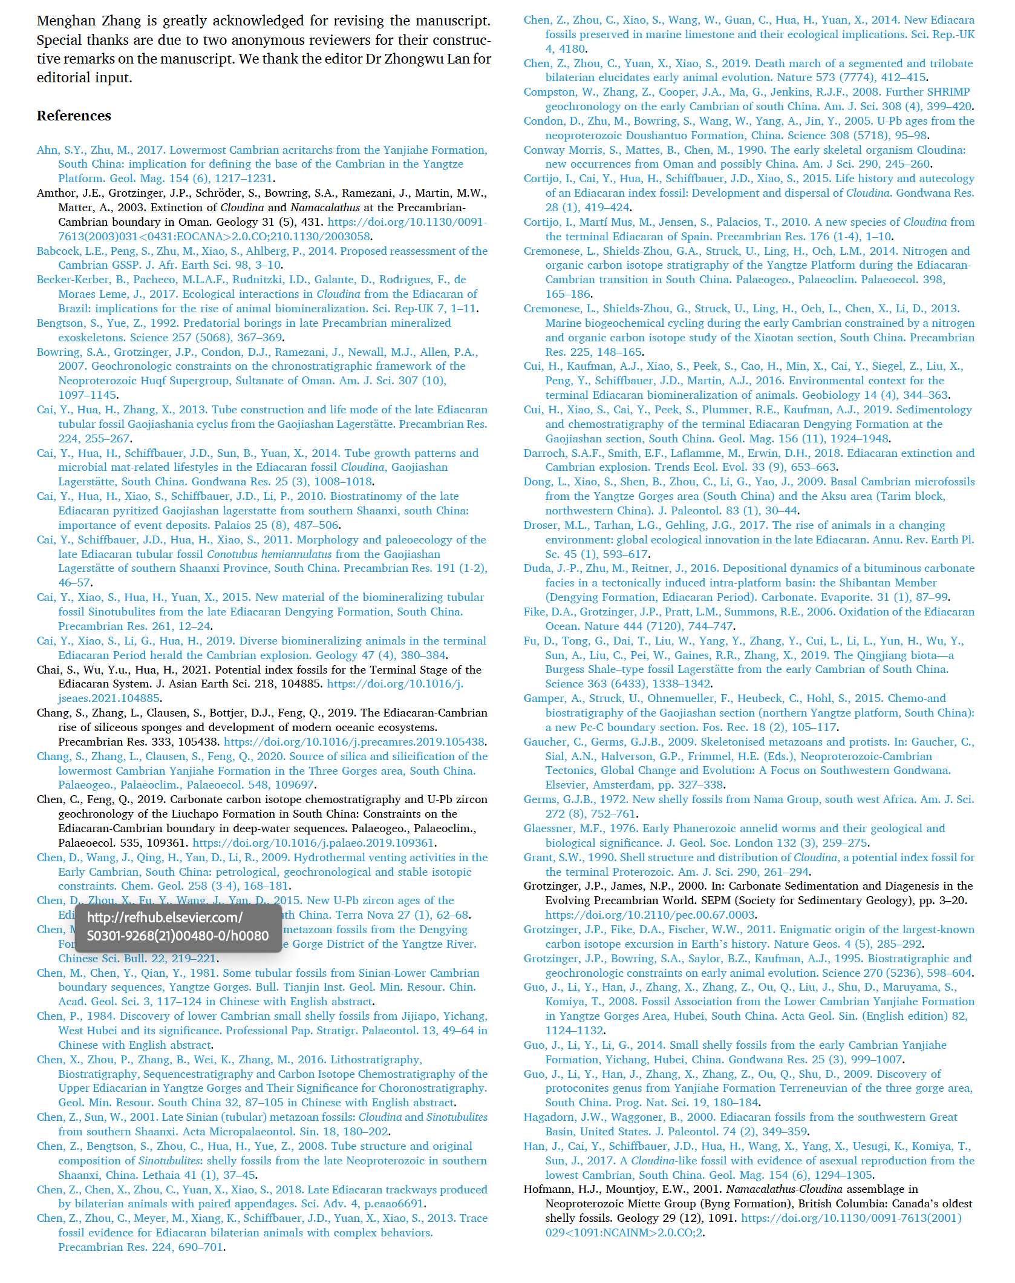t.
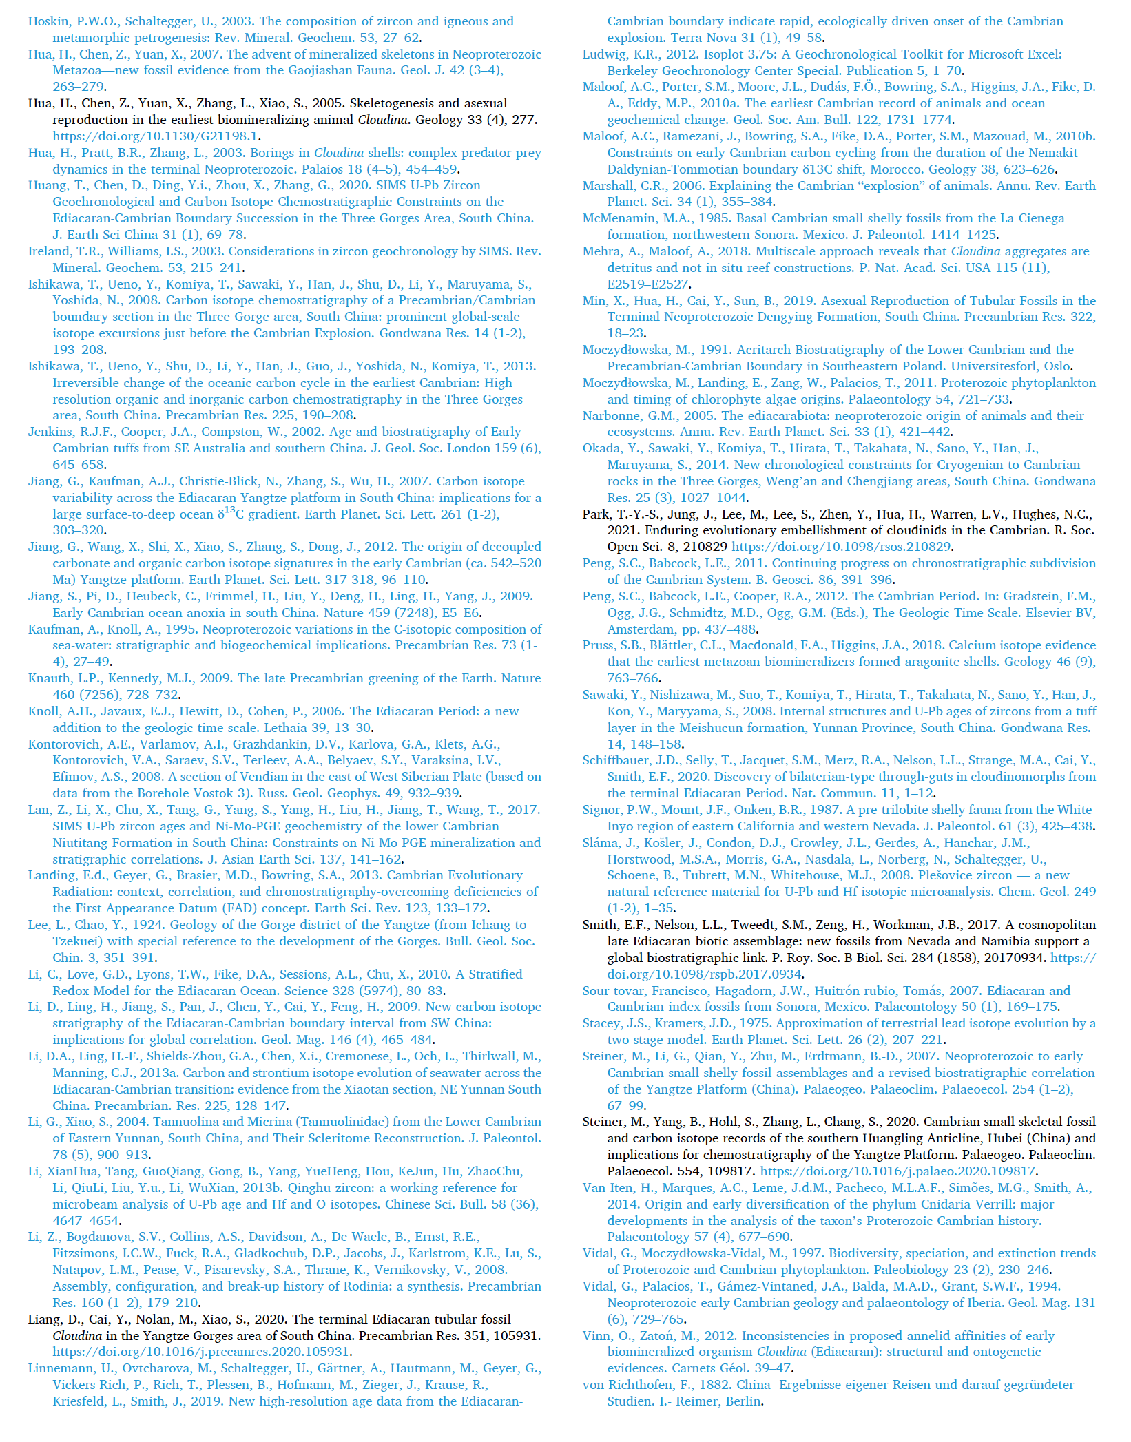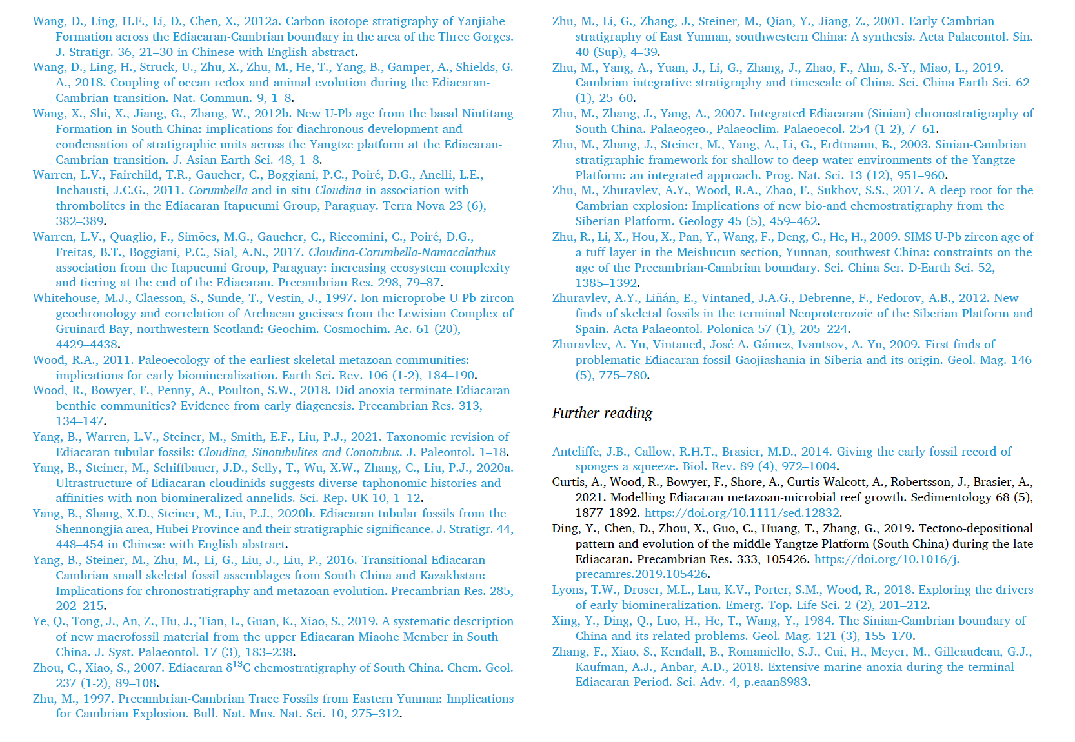

Fig. 1. A. Palaeogeographic reconstruction of South China during the late Neoprotozoic (modified from Zhu et al., 2003), square shows the studied area for which a schematic geological map is provided in (B). Yellow lines represent the boundary of the Yangtze Block. B. Geological map of the Three Gorges area, Hubei Province (after Guo et al., 2009).

Fig. 2. Stratigraphy and fossil distribution in the studied area. SSF1 represent the Anabarites trisulcatus–Protohertzina anabarica Zone (Zone 1). The AHC represents the Asteridium–Heliosphaeridium–Comasphaeridium acritarchs assemblage zone. Red lines in the column represents the clay layer from which abundant zircons has been released and dated.

Fig. 3. Outcrop photos showing the Dengying-Yanjiahe boundary at the Baiguotang section. (A) General view with the Cloudina aggregates in the interval 2. (B) Closeup of the Cloudina aggregates. (C) Aggregation of Cloudina tubes. (D) Rounded siliceous fragments in the silty dolostone in interval 2 (arrows). (E) abundant brecciated mm-thick dolostone layers can be observed in interval 2 (arrows b) beneath the bioaccumulations (arrow a). Scale bars in Fig. 3A-B equal 5 cm.

Fig. 4. Outcrop photos of the rocks of the Yanjiahe Formation and tuffaceous clay layer (BGT-DY-1) in the Baimatuo Member of the Dengying Formation in the Baiguotang section. (A) Thin bedded cherts with convoluted structures in the basal Yanjiahe Formation. (B) Closeup of the convoluted chert beds. (C) Thin bedded cherts interbedded with the silt dolostones in the basal Yanjiahe Formation. (D) Tuffaceous clay layer (BGT-DY-1; red arrow) within the upper part of the Baimatuo Member, Dengying Formation. Marking magnifier for scale about 6.5 cm long. (E). Closeup of (D).

Fig. 5. Outcrop photos of interval 2 at the Baiguotang section. (A-B) The reddish or white color, horizontally or wavy layers of algal-laminated microbialite (arrows) beneath the tubular fossil aggregates. Scale bars in figures equal 5 cm and each color represent 1 cm.

Fig. 6. Polished slabs of dolostone from the intervals 1–3 at the Baiguotang section. (A) Polished sample with dissolution cavities (vugs, arrows a) in the interval 1. Brecciated mm-thick chert layer and rounded siliceous particles (arrow b), and Cloudina tubes (arrow c) can be observed in interval 2. (B) Strongly brecciated silty dolostone with chalcedonization cherts replacive of dolomite or infilling cracks in the interval 3. (C) Abundant rounded siliceous fragments in the laminated silty dolostone in the interval 2. (D) Strongly brecciated silty dolostone and tubular fossil aggregates (arrow) in the interval 2.

Fig. 7. Photomicrographs of thin-sections of the rocks from the Baiguotang section. (A-B) rounded (arrow a) and angled (arrow b) siliceous fragments in the dolostone of the interval 2 in the thin section, showing that they are brecciated silicified dolostone grains. (C-F) Photomicrographs of the thin-section of silicified tubular fossils. (A-F) photomicrographs, plane-polarized light (A, C, E), and crossed polarizers mode (B, D, F).

Fig. 8. Micrographs of polished slabs of Cloudina aggregates from the interval 2 of Baimatuo Member, Dengying Formation in the Baiguotang section. (A) Polished slab of the Cloudina aggregates (arrow a) and underlying layer rich in rounded siliceous fragments (arrow b), showing that the tubular fossils are mainly parallel to the horizontal layers. (B) A Cloudina specimen, showing the flaring collar (“funnel-in-funnel” _structure; arrows) of the tubes. (C-D) Cloudina specimens on the polished slab, showing the chalcedony filling and coating the tubes.

Fig. 9. Photomicrographs of thin-sections of Cloudina aggregates from the interval 2 of the Baimatuo Member, Dengying Formation. (A). longitudinal sections, showing the tubes, the wall, and central cavity of the Cloudina tube. Note that the primary structure of tubes is replaced by silica. Microspar and silica cements can be observed surrounding the tubes and sparry silica filling the tubes (arrow). (B) A Cloudina tube fragment. Note the dark color of the thin walls. (C) Cloudina aggregates, showing that no uniform orientation of the tubes. Note the flaring collar structure (arrows) of the tubes. (D) Funnel-within-funnel structure and collars (arrow) of the tubes. (E-F) Cloudina aggregate showing a curved specimen (arrow). (A-F) photomicrographs, plane-polarized light (C, E), and crossed polarizers mode (A, B, D, F).

Fig. 10. Photomicrographs of thin section of Cloudina aggregates from the interval 2. (A-B) Fragments of the Cloudina tubes. Note tubes that are oriented perpendicular to each other (arrows). (C-F) Parallel tubes clusters of Cloudina. The interparticular porosity between the tubes is secondarily filled by sparry quartz. Note that all the thin sections are parallel to the bedding. (A-F) photomicrographs, plane-polarized light (A, C, E), and crossed polarizers mode (B, D, F).

Fig. 11. Frequency diagram of the diameters measured on the various spherical microfossils (siliceous, organic) observed in polished slab shown in Fig. 8(A).

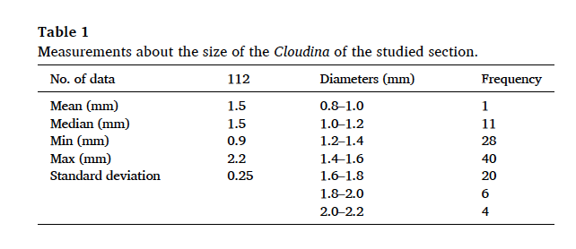

Fig. 12. Carbon isotope data for the Ediacaran-Cambrian Dengying, Yanjiahe, and Shuijingtuo formations measured from Wuhe, Gunshi’ao, and Baiguotang sections in the eastern Three Gorges area. Carbon isotope data obtained in this study are from the Baiguotang section; others are collected from Ishikawa et al. (2008), Wang et al. (2012), Chen et al. (2016) and Ahn and Zhu (2017). The thick black line indicates the position of the studied Cloudina in the Baiguotang section. The SSF1 and SSF3 blue boxes represent the small shelly fossils Anabarites trisulcatus–Protohertzina anabarica Assemblage Zone (Zone 1) and the Aldanella yanjiaheensis Assemblage Zone (Zone 3). The regions 1 to 4 noted in blue represent four options to set the position of the E-CB at the studied area.

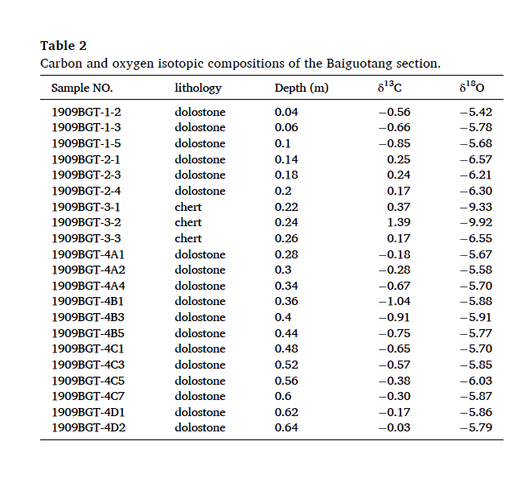

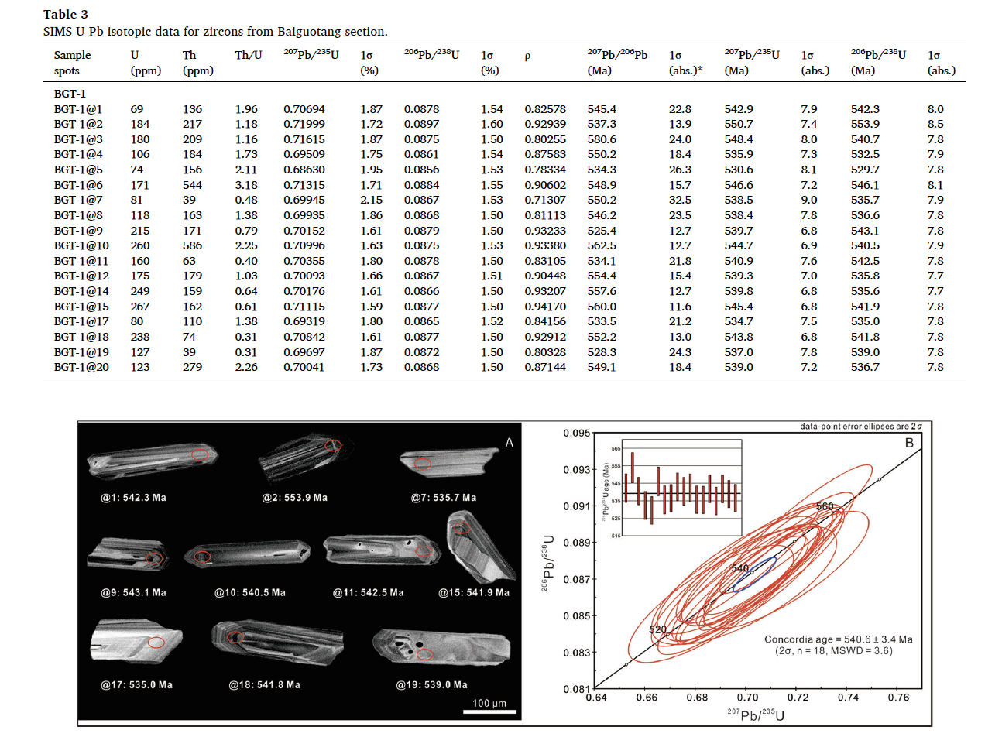
Fig. 13. (A) Cathodoluminescence images of representative zircons obtained from the clay layer in the upper Baimatuo Member of the Dengying Formation. The numbers below each grain are analyzed spot number and the corresponding 206Pb/238U age. The red ellipsoidal spot is about 30 × _20 μm in size. (B) U-Pb concordia diagram for the clay layer (sample No. BGT-DY-1), as analyzed by SIMS. Inset showing the 206Pb/238U ages of individual zircon crystals, which passed the discordance filter.

Fig. 14. Stratigraphic correlation of the Ediacaran-Cambrian boundary successions from shallow- to deep-water settings in South China through the carbon isotope data combined with the zircon U-Pb ages from tuffaceous clay interlayers. The data source: 1-Gunshi’ao area (SSFs biozones from Guo et al., 2014; carbon isotope data from Ishikawa et al., 2008, 2013; age data from Okada et al., 2014); 2-Xiaotan (SSFs biozones from Li and Xiao, 2004; Yang et al., 2016; carbon isotope data from Li et al., 2013 and Cremonese et al., 2013); 3-Lijiatuo (Cai et al., 2019; Cui et al., 2019); 4-Sifangjing (from Chen and Feng, 2019).

