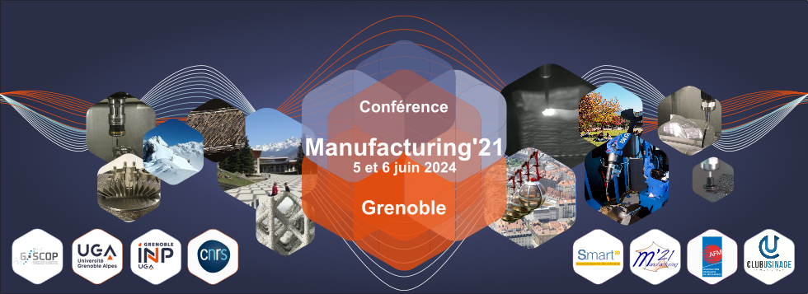

The role of Additive Manufacturing in healthcare: application in blood vessel reconstruction

**Tijana Kavrakova(a), Guillaume Racineux(a), Luciano Vidal(a), Jean-Yves Hascoët(a)**

*(a) Nantes Université, École Centrale Nantes, CNRS, GeM, UMR 6183, [F-44000], France*

*Mail : tijana.kavrakova@ec-nantes.fr* *guillaume.racineux@ec-nantes.fr jean-yves.hascoet@ec-nantes.fr*

**Abstract:** With over 550 million people affected by heart and circulatory conditions, the limitations of current solutions, like stents and bypasses, prompt the exploration of tissue engineering as an alternative. Nowadays, with the advances in bio printing, research is mostly focused on growing vascular networks for 3D-specific organs. There have been attempts on vascularizing different 3D tissues such as muscle, bone, cardiac, skin, liver, etc. However, replicating the intricate anatomy of blood vessels on a small scale with precise dimensional accuracy, while ensuring adequate vascularization, poses a major challenge. This work centers on an innovative approach using an original 3D extrusion-based bioprinting technique. It encompasses rheological studies of natural biopolymers for estimating the material extrusion in additive manufacturing. Initial experiments with gelatin and alginate hydrogel reveal the significant influence of material preparation and storage conditions on scaffold properties. The findings steer the development of a CFD model that just proved the complexity of the material behavior in the process. A three-layered vascular graft, based on data gathered from previous studies, was 3D bioprinted. The result was notably favorable, exhibiting dimensional properties similar to the human aorta. Therefore, this exceptional approach highlights the significance of the polymer phase transition during the extrusion process. The upcoming emphasis will be on developing vascularization by adjusting scaffold porosity through the implementation of diverse toolpath strategies.

**Key words:** Rheology, biomaterials, tissue engineering, additive manufacturing, biofabrication

# Introduction

Nowadays, cardiovascular diseases (CVD) are among the deadliest, contributing to 32% of the global mortality rate (Word Health Organization, 2021). The term itself encompasses a wide range such as such as ischemic heart diseases, ischemic or hemorrhagic strokes, heart valve damage, aneurysm, etc. However, the most dangerous of all are ischemic heart diseases or coronary artery diseases (CAD) and strokes accounting for 85% of the total CVD number. Current solutions such as stents and bypasses, are applied for CAD, while endovascular thrombectomy, medications and injections are treatments for strokes. However, both of them come with some risks. Stents, as medical implants can cause infections and are often rejected by the patient. Bypasses are an autologous grafts, yet when transplanted they require an open heart surgery followed by long recovery that might pose some complications or death in worst case scenarios. Stroke treatments on the other hand, can damage the blood vessel, cause excessive bleeding or infections. Therefore, modern medicine is focusing on developing an alternative that will minimize the abovementioned risks.

One discipline that focuses on reconstruction of artificial vascular grafts is tissue engineering. Tissue engineering is a cross-disciplinary field that uses engineering methods and life sciences to create biological replacements aiming to restore, sustain or enhance tissue functionality(Langer, 1993)*.* While its origins date from the early 80’s of the 19th century, it was not until the development of the first bioprinter that the discipline took a serious turn (Biswas, 2016, Klebe, 1988). Now-a-days, there are four fundamental AM techniques for reconstruction of an artificial blood vessel: extrusion based, inkjet based, laser assisted and stereolithography (SLA). In general, the extrusion based approach is often a first choice due to its ability to work at high speeds at increased workloads. Considering the fact that the material is deposited in the form of cylindrical filament, while the toolpath is numerically determined by a computer, the spatial distribution of cells encapsulated by the hydrogel is superior to than in other techniques (Zhang, 2021, Ozbolat, 2016). Therefore, a remarkable progress has been done in this aspect. For instance Xu et al. have developed an mulit-extrusion system for simultaneously deposing two perimeters at once with with human ubilical vein endothelial cells (HUVECs) for the inner one and human aortic smooth muscle cells (SMC) for the outer one (Xu, 2020). Additonally, Gold et al. have developed a bioink composed of nano-extracellular matrix (nECM) of gelatin methacryloyl (GelMA), poly (ethylene glycol) diacrylate (PEGDA) with the addition 2D nanosilicates for improving printability and structural integrity (Gold, 2021). Moreover, there are certain derivation from the extrusion approach, such as coaxial bioprinting or the Freeform Reversible Embedding of Suspended Hydrogel (FRESH) technique that are focusing on supporting the construct in the process. While some coaxial methods center of withholding the material with physical molds (Hann, 2022), others aim to extrude the bioink and the cross-linker simultaneously[1] (Gao, 2015). FRESH on the other hand, targets material deposition inside a bath of cross-linking solution (Gao,2015) (Skylar-Scott, 2019). The idea of the matrix is to provide support for the extrusion of low viscous bioink.

Inkjet based bio printing is yet another innovative approach. In fact the origins AM in regenerative medicine date from the 1980s when Klebe introduced the term cyto-scribing as he used paper printer for spatial deposition of cells on a substrate (Klebe, 1988). Inkjet based or droplet based bio-printing involves depositing droplets of material onto a substrate, akin to traditional 2D printers used for paper (Murphy,2014). Droplet formation occurs through pulsation that driven by thermal, electromagnetic, or piezoelectric actuators. This approach viscous hydrogels are used for this technique, that can compromise the integrity of the product.

Laser-assisted or laser-guided bio printing operates by manipulating particles through laser-induced forces (Odde, 1999) . Initially designed for creating patterns of metals in the production of mesoscopic components for electronic devices, however, later on it expanded its application in the biomedical sector. The system typically comprises a laser that passes through a ribbon coated with bioink or cells in suspension. When the light beam encounters the cells, it propels them in the direction of the light. Beneath the ribbon lies a substrate designed to receive the cells, usually filled with culture medium or hydrogel (Odde,1999) (Schiele, 2010). The formation of the 3D shape is controlled by the translational motions in the x, y, and z axes of the substrate. Despite its exceptional accuracy, this technology is not frequently the primary choice due to its high cost and relatively low cell viability.

Stereolithography (SLA) stands as another additive approach originating from 3D printing, that operates on the principle of spatial photo-polymerization of resin. SLA systems typically utilize an ultraviolet laser or a direct light projector (DLP) as their light source. Regardless of the specific source used, crucial parameters such as source power, scanning velocity, and exposure time determine the layer thickness (Melchels, 2010). The setup of SLA machines shares similarities with laser-assisted methods, not only in terms of the light source but also in their operational principle. Initially, a focused light beam targets a specific point. This beam reaches a reservoir of resin in which a platform is immersed. As the resin solidifies, it adheres to the platform. Similar as in extrusion-based approach, the 3D geometry is achieved by displacing the platform in the x, y, and z axes. While SLA boasts superior performance in terms of part accuracy and complexity, its limited availability of materials on the market prevents it from being the first choice (Zhang, 2021).

All in all, the application of 3D models had made a significant impact as current research is focusing on growing vascular networks for 3D specific organs. There have been attempts for the reconstruction of vascular scaffolds. However, despite all the progress made on implementing artificial blood vessels in animal models the trials fail when shifted to human. The bounds of this field are limited due to the complex vessel’s anatomy on such a small scale (Jarvis, 2018) (Zhang, 2017) (Cao, 2020). Therefore, the focus of this work is to conduct an extensive research on material phase change under predefined conditions in extrusion based AM to simulate the deposition and simultaneously perform experimental studies to validate data. The ultimate goal is to utilize this data to develop Computational Fluid Dynamics (CFD) models that account for fluctuating conditions. This approach aims to predict the most favorable conditions to achieve optimal dimensional scaffold accuracy.

# Materials and Methods

## Materials

For the purpose of the experiments, Gelatin from bovine skin G9391 and Alginate of medium viscosity A2033 were purchased from Merck group. Gelatin and Alginate are commonly used in extrusion-based bioprinting as the blended hydrogel excels in biocompatibility, biodegradability, cell adhesive properties and it is obtained naturally.

Gelatin is a biomaterial derived from collagen with partial hydrolysis. In comparison with its progenitor collagen I, gelatin solubility is much higher, up to 5-10 times weight of water (Wang, 2017). While in one gelatin chain there are around twenty amino acids connected with covalent bonds, the interactions between them are non-covalent ,van der Waals, hydrogen bonds, and electrostatic and hydrophobic. This non-specific linkage of the molecular chains is weak and breaks effortlessly at slightly elevated temperatures is the reason of the thermos-responsive character of the gelatin. As a result, the material changes from solid (elastic) to liquid (viscous) phase when shifted from cold to hot temperatures respectably. The manner of tuning the properties is one of the reason the material is one of the mostly used hydrogels in bioprinting. Additionally, its excellent biodegradability and biocompatibility make the gelatin the perfect fit in tissue engineering. However, due to the low mechanical properties it is blended with other materials (Ahmady, 2021).

Similarly, alginate is suited for 3D extrusion based bioprinting as it offers a good structural integrity when chemically cross-linked with CaCl2. Alginate is a natural copolymer from the family of polysaccharides that is often used for scaffolds. Even though alginate exhibits superb biocompatibility and biodegradability , it lacks of arginine-glycine-aspartate (RGD) groups that are necessary for cell adhesion (Pawar, 2012) (Bellis, 2011). Therefore, alginate hydrogels are usually reinforced or blended with materials containing RGD adhesive peptide.

### *Hydrogel preparation*

In this study the hydrogel was prepared following two different protocol preparation. Initially, the gelatin and alginate powder were weighted on a balance scale, while ionized water was placed on a magnetic stirrer. The alginate was added progressively, and once fully dissolved, the gelatin was poured in the same manner. The solution underwent stirring for 3 hours at 40°C. Subsequently, it was centrifuged at 2900 rpm at 40°C for 40 minutes and stored at 40°C. These storage conditions were maintained throughout the rheological tests, and post-testing.

In parallel, the second preparation procedure involved stirring the blends of material powder for 3 hours. However, in this case the hydrogel was centrifuged at 23°C with 2900 rpm for 40 minutes to eliminate air bubbles. Additionally, the material was cooled at 4°C temperature for one hour prior to the experiments. In order to be extrudable, samples were kept at 40°C during the experiment. After the tests were performed, the material was stored in the fridge, overnight.

## Method

The idea of this study is based on findings from preliminary experiments that revealed challenges related to the thermoresponsive nature of the hydrogel during manipulation. Considering the necessity for the material to flow when extruded while maintaining the ability to rapidly solidify right after, it is essential to investigate the viscoelastic properties. Taking into account that the phase change can vary not only due to temperature, but as well as concentration, earlier experiments were performed for finding the best concentration ratio. Once tubular constructs at altering concentrations were fabricated via extrusion based approach, 7% Gelatin and 1% Alginate was selected as the final hydrogel composition.

### *Problem modelling*

Initially, this study leaned on earlier comprehensive research on the current state of the art, which demonstrated that the gelatin exhibits shear thinning behavior (Kokol,2021). To model the problem, one has to comprehend the flow during the process. Figure 1, represents the extrusion system made of temperature-controlled extrusion head (1) in which a syringe of length of 91 mm and diameter 15.72 mm was imported. The end of the syringe is attached to a needle (2) or a cone of adjustable diameter, depending on the required printing solution. The flow rate is directly controlled by the pressure applied by the piston (3). Considering that the maximum pressure drop occurs in the needle, a Poiseuille flow in a cylindrical cross section was postulated for calculating the relationship between the pressure applied and the flow rate (Figure 2a).

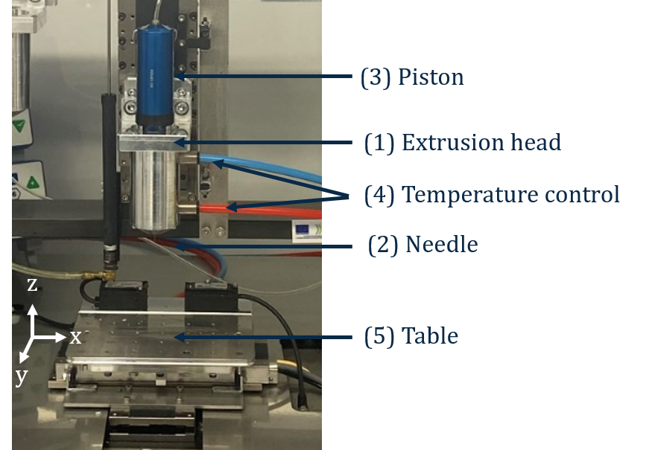

Figure 1. Extrusion-based system

Expressing the model in mathematically meant introducing the following assumptions: (i) the material is homogeneous, non-thixotropic, viscous, incompressible, and stick to the wall; (ii) the flow is laminar; (iii) the gravity forces can be neglected (iii) and the temperature is supposed constant.

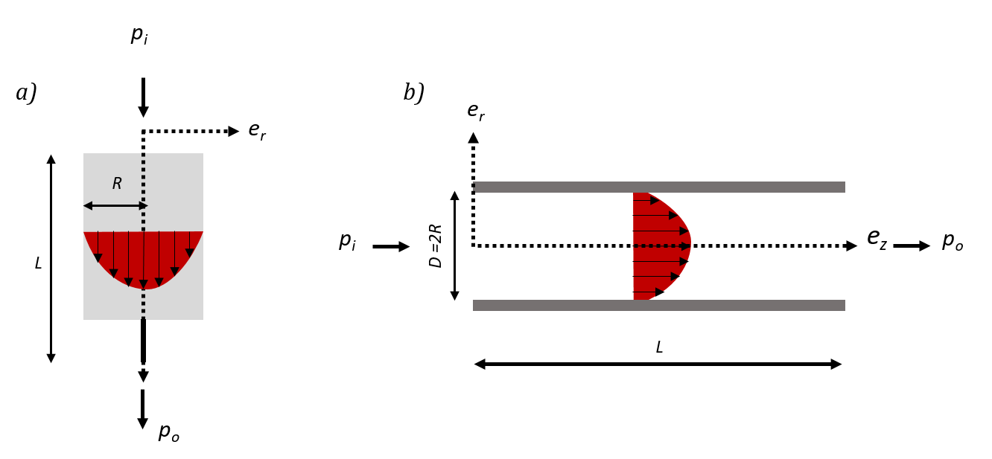

Figure 2. Flow behavior modeling, Poisseuille flow

Additionally, taking into consideration the following governing equations:

While assuming that $Δp=p_{i}-p_{o}$ is the pressure difference between the inlet and outlet of the tube, and that the material exhibits shear thinning ($η=K{\sqrt{\text{2tr}\left[{\overset{̿}{D}}^{2}\right]}}^{m-1}$) then

the flow rate $Q_{t}$ was expressed by the formula:

$Q_{t}= π\frac{m}{3m+1}{[\frac{1}{2K}\frac{∆p}{L}]}^{1/m}({r)}^{(1+3m)/m}$***(1)***

where K is the consistency index, m – the power law constant, L –the total length of the syringe and r – radius of the needle.

The abovementioned calculations prove flow rate can be tuned with the change of the pressure applied and it is directly dependent of the material properties. Thus, in order for one to control the flow rate, one must first prove shear-thinning material behavior.

## Experimental approach

The experimental approach took two phases: rheology and extrusion. The rheological experiments were performed on rotational DHR rheometer with parallel plates. The first phase involved tracing viscosity over time, employing both constant shear rate for both hydrogel preparation procedures. The objectives of these experiments were to demonstrate the significant impact of the protocol and storage conditions on the material properties. Focusing to prove the shear thinning behavior the hydrogel was sheared at 0.1-1000 s-1 shear rates and at 23°C temperature. The results were then express on a graph at logarithmic scale and the power model was fit to the curve. Fitting the Power law meant generating the values of K and m. Once the unknowns were obtained, the flow was calculated using equation 1.

The second set of experiments concentrated on finding an experimental flow rate and making a parallel between the model and the experiments. Here, continuous beads of 40 mm length 0.25 width and 0.25 mm height were deposited under constant parameters – advance velocity (5 mm/s), extrusion pressure (2 bar) and temperature 23°C.

The flow rate was calculated based on the weighted mas and compared with the analytical model.

$Q_{e}= \frac{volume ({mm}^{3})}{time (s)} ={mm}^{3}/s$*(2)*

*Qe –* experimental flow rate

## Analytical approach

The data obtained from rheology was implemented in the flow equation that gave a theoretical value of the volume of material flowing out of the syringe for a given time. Once rheological tests were performed, a Computational Fluid Dynamic analysis was generated using SimScale. Initially, a rough 3D model of the syringe was designed and imported in the program. Additionally, the boundary conditions were applied and the pressure was set to be 2 bars as in the experimental approach. The objective was to simulate the flow under the same conditions to confirm the flow is linear. Once confirmed the study performed iterations at altering conditions.

# Results

Rheological experiments brought two significant discoveries. The first one proved that the storage conditions and the protocol of preparation can significantly impact the viscosity. Figure 4 illustrates that when material was prepared and stored at a constant temperature of 40°C, the viscosity curves measured at different time frame, but same flacon, show non-repeatability. On the contrary, in the case where the material was prepared at 40°C, but centrifuged at 23°C and left for an hour in the fridge, curves showed remarkable repeatability (Figure 3b).

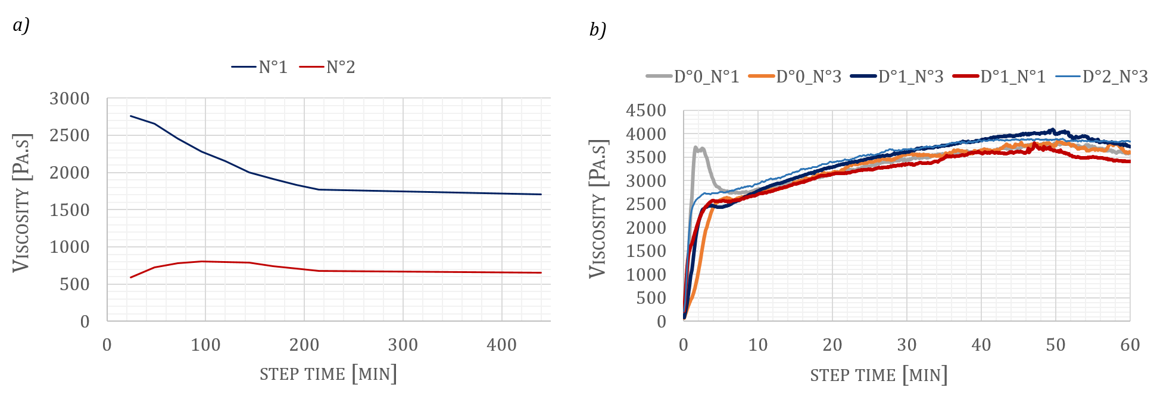

Figure 3. Viscosity over time a) temperature during preparation was maintained around 40°C b) temperature during preparation varied 40°C – 23°C and 4°C

After establishing that the viscosity remains constant throughout time with a particular protocol, the study moved on to validate the material’s shear-thinning character. As mentioned earlier, several hypotheses from previous studies were considered prior to this research. Some employed a Newtonian fluid, while others provided more realistic overview by postulating phase changes due to applied shear. In this case, the rheological experiments referred to the study of Kokol et al. with some modifications (Kokol, 2021). Flow sweep tests were performed for 7% Gelatin and 1% Alginate at gradually changing shear rates, starting from 0.1 s-1 to 1000 s-1 at 23°C with a presoak at the same temperature for 5 min. The results expressed a curve with similar behavior and an order of magnitude close to the one of Gelatin 10% in the referred study. Figure 4a. provides an outline of the cited method, while figure 4b shows the results obtained throughout several rheological tests..

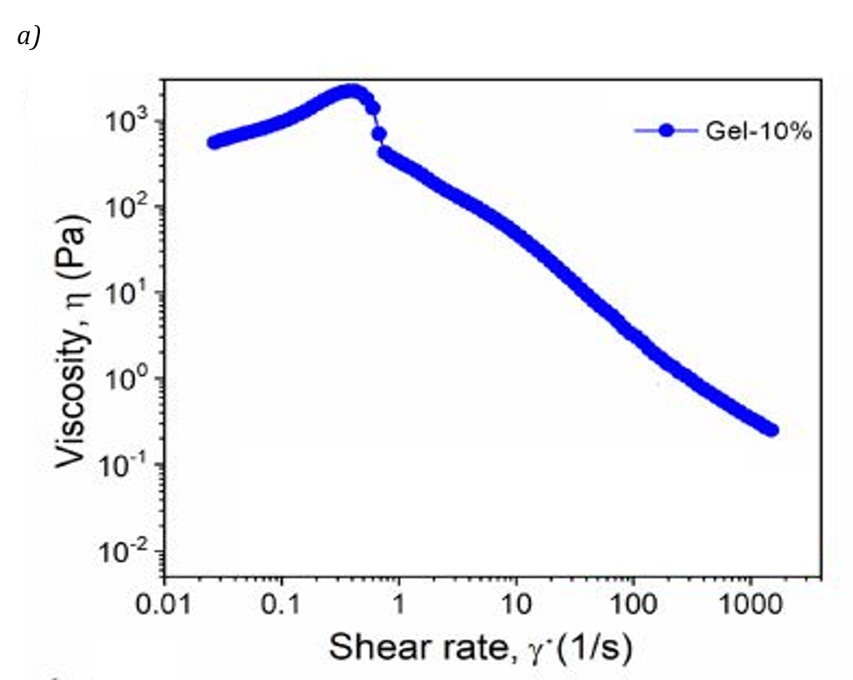

a)

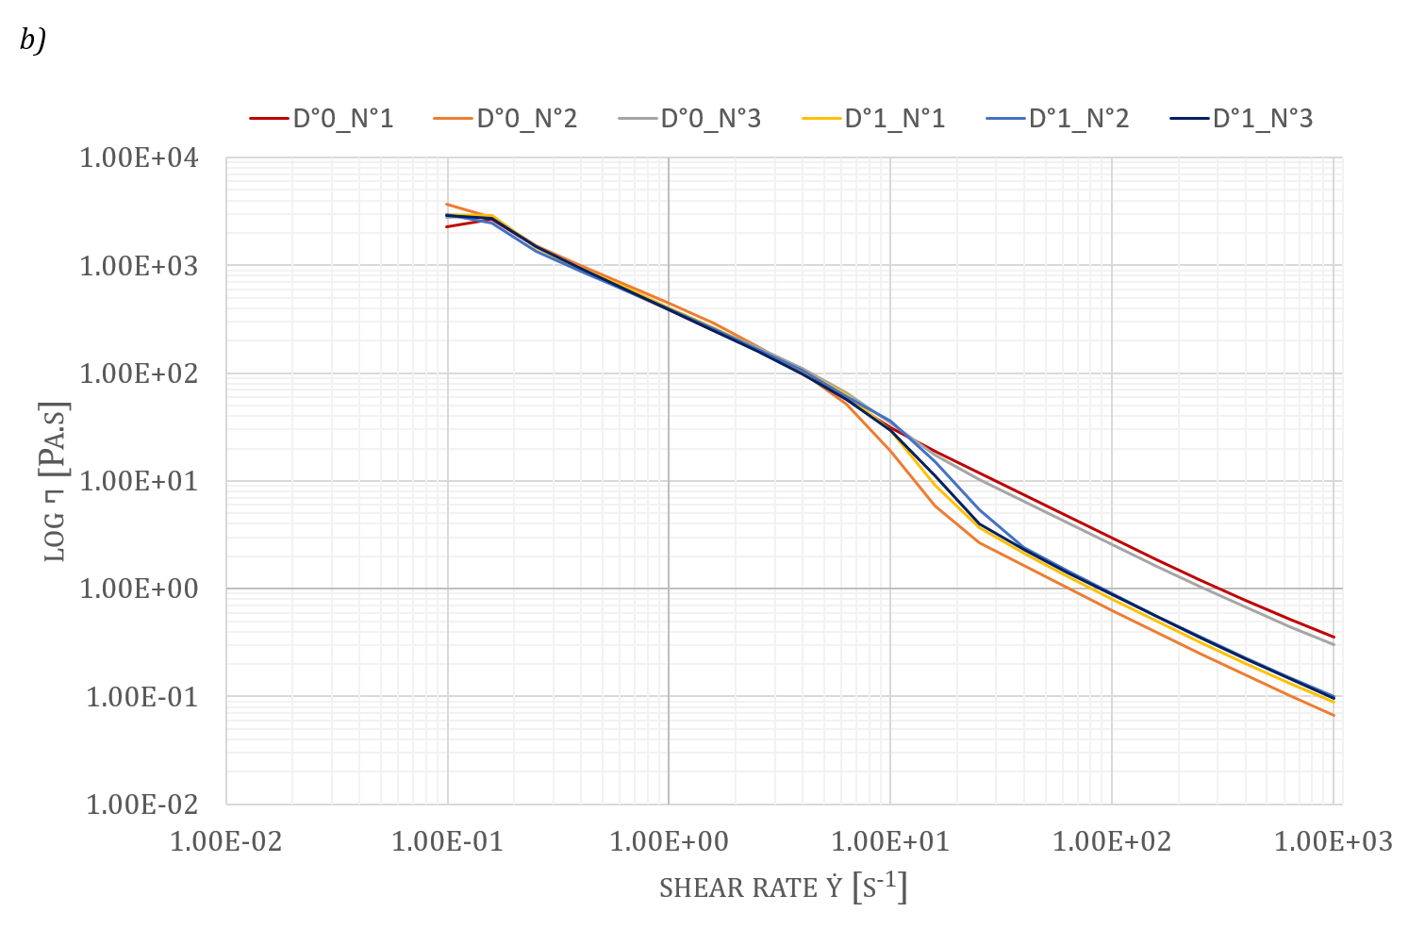

b)

Figure 4 Plots viscosity over shear rate a) referred study by Kokol et al. (Kokol, 2021) b) results from rheological experiments

Subsequently, an average curve out of fifteen tests was computed and plotted on a graph. The Power law model was then fitted to the curve for extrapolating the values for m and K (Figure 5).

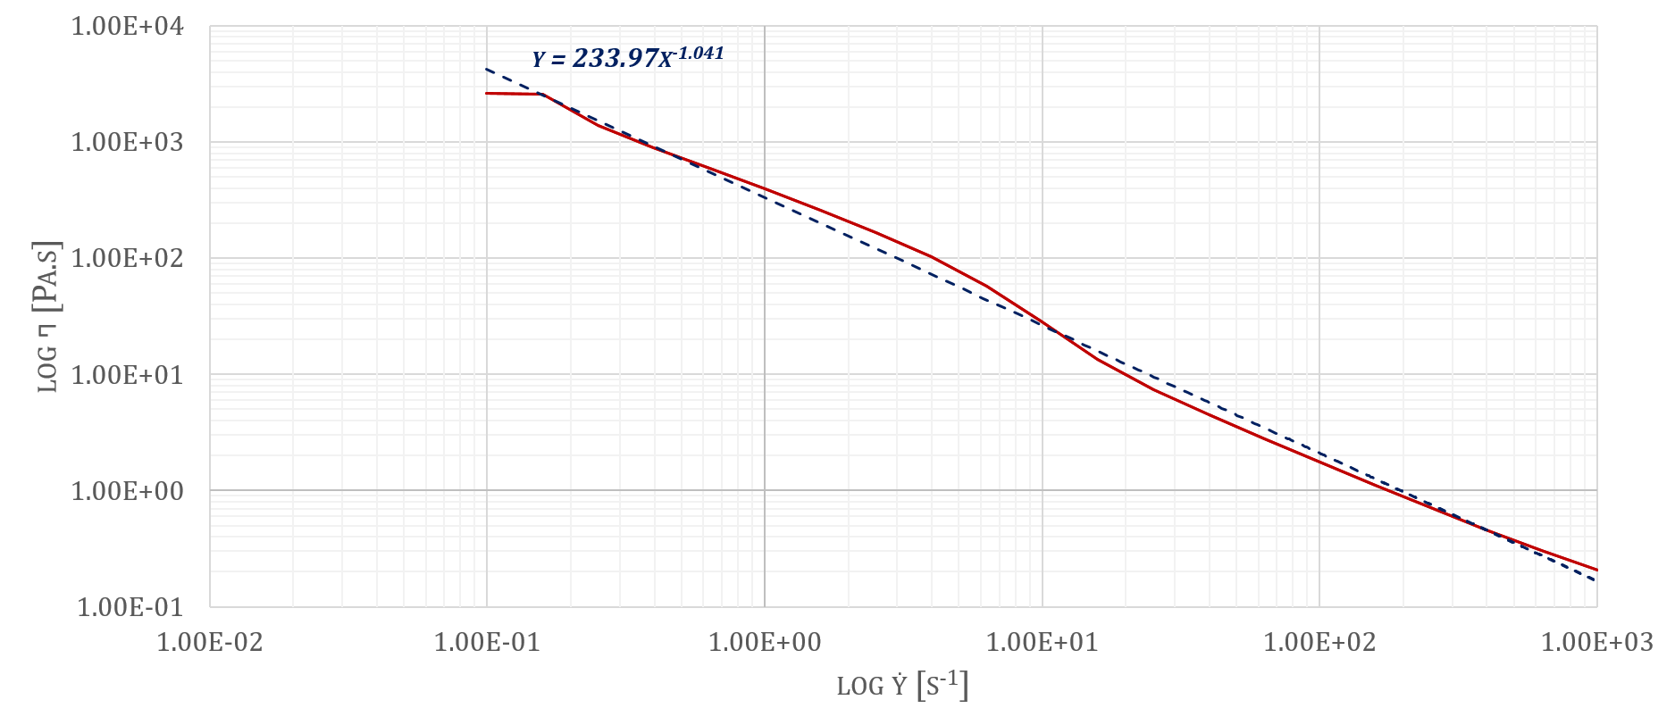

Figure 5. Model fit of the power law

Considering that the shear rate $=K{\dot{γ}}^{m-1}$, the model represented that K = 233.97 and m= - 0.041. While the curve demonstrates a shear thinning properties, the value of m approaches 0,

Simultaneously, the strands were deposited using 3D extrusion-based bioprinter. Figure 6 displays the experimental setup, revealing that the extrusion is non-uniform over the toolpath’s length.

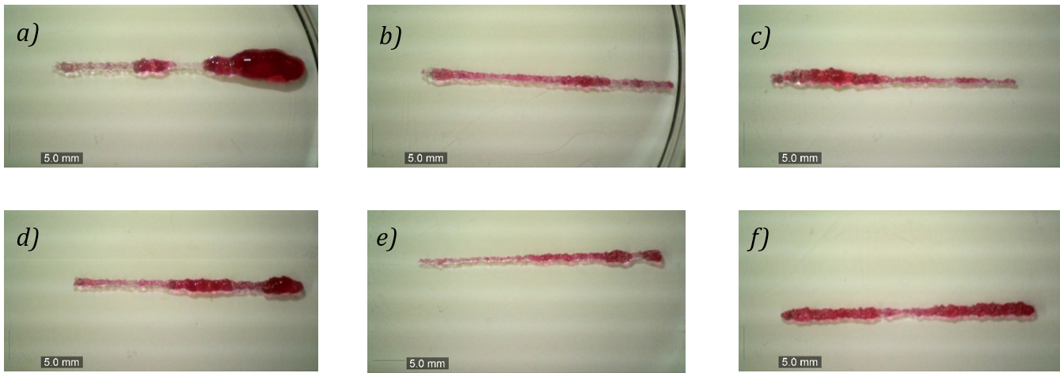

Figure 6. Experimental flow rate at different time

In addition, the theoretical flow rate vas calculated and compared to the experimental one. However, this particular value did not correspond to the one obtained from the rheological experiments.

$$Q_{t}≠Q_{e}$$

# Discussion

First experiments proved that the hydrogel preparation has significant impact on the viscosity. Curves presented in Figure 3a. confirm non-repeatability while Figure 3b. is showing repeatable data. One postulation of this phenomenon can be found in the work of Djabourov et al. that explains the transition from a coil-to helix structure of the molecular chain of the polymer during physical cross-linking. Here it is also stated that the particular configuration is a result of the contact area of the helices and that junctions are formed by hydrogel bonding at low temperatures (Djabourov, 1993). Additionally, Pezron et al. have proven that the process of cross-linking is reversible, with a certain hysteresis (Pezeron, 1990). Therefore, one can postulate that when the gelatin is left at cold temperature for a certain time, the structure stabilizes by creating helices. However, when temperatures are later elevated, while some junctions break, a significant portion of the of them remains undamaged. In the context of this study, the theory implies that when the material is prepared and stored at high temperature, the polymer chains exists in a non-equilibrium state, resulting in non-repeatable curves.

Additionally, second type of rheological experiments consisted validating if the material flows. Figure 4 makes a parallel between data obtained in literature and the results of this study. The evidences in the curve suggest that the plots differ in some regions. For instance the Figure 4a. has a zone of gradual viscosity increase for shear rates within 0.1 s-1 to 1 s-1, whereas Figure 4b. maintains constant values within this range. Additionally, after shear rates superior to 1s-1 are applied, the curve confirms shear thinning behavior for both cases. Evidently, the viscosity values are not identical from one study to another; however, this can be assigned to the concentration of gelatin. Preliminary studies showed that the low concentration of the alginate does not have a significant impact on the mechanical properties. Therefore, initial interpretations of the curves pointed towards the shear-thinning behavior.

However, when the Power law model was fitted on the curve and values for K and m were extracted, the model indicated that the hydrogel behaves like Newtonian fluid, as m ≈ 0. To comprehend the ambiguity of the data, an experimental flow rate was calculated. The empirical results were significant since they introduced two phenomena. The first one was that there was non uniform extrusion over the length. Initial hypothesis was concentrated to the acceleration and deceleration that can cause over extrusion to the bead’s ends as the tool velocity value decreases. However, it is apparent that this error is not repetitive and while some ends are over-extruded, others are experiencing under-extrusion. The second phenomenon proved that the results obtain from sweep tests are not reliable, as the experimental flow rate was significantly different from the theoretical one. In view of the previous conclusion and the fact that the material is viscoelastic, one can be certain that is not a Newtonian fluid.

To confirm the validity of the previous statement, the results of the sweep tests were expressed on a curve tracking stress and rotational velocity. Here, one can claim reliability of the results, as these values are measured by the instrument, rather than computed using series of assumptions. The curves presented in Figure 7 set the groundwork of a new hypothesis that the hydrogel has yielding stress behavior. In other terms, there exists a certain stress threshold below which the material behaves like solid. Here, it is evident that the velocity remains zero until 500 Pa of stress is applied. However, when the stress exceeds this value, the velocity increases significantly even for constant stresses. When stresses exceed this value, the material transitions into a viscous fluid. Considering that, a new velocity profile was introduced in Figure 8 that explains that the material remains undeformed for stresses smaller than this threshold and break if sheared beyond the yield limit. The breakage results in two zones, one sheared and one non-sheared. Drawing a connection between the theory and the experiments, one can assume that the hydrogel experiences fracture when sheared with the rheometer. Therefore, this suggests that as the height of the sheared zone is not known, the model cannot be computed analytically. Hence, the results set the foundation to prove the validity of the yield stress fluid hypothesis. However, one must not only repeat this data, but as well as perform additional experimentation to confirm the previously stated.

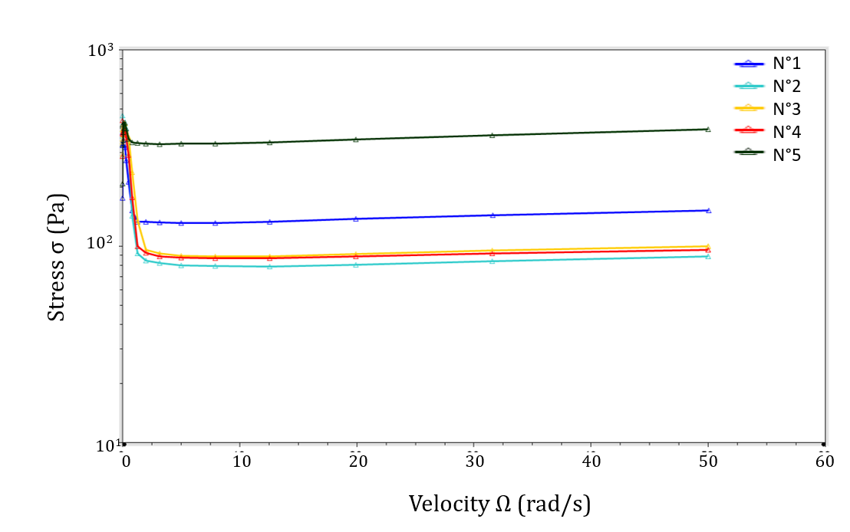

Figure 7. The change of the velocity to the applied stress on 7% Gelatin 1% Alginate

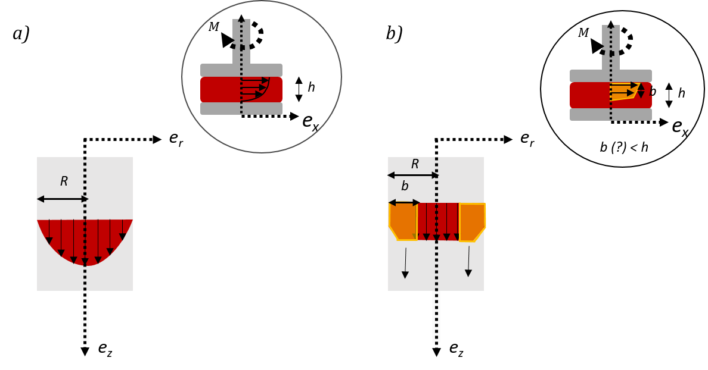

Figure 8. Velocity profile in extrusion based system and replicated to rheometry a) Initial hypothesis b) new theory based on previous data

In the end, despite the fact that the numerical studies did not produce the anticipated outcome, the experimental approach was used for estimating the flow rate and 3D bio printing three-layered vascular construct with wall thickness of human aortaure 9).

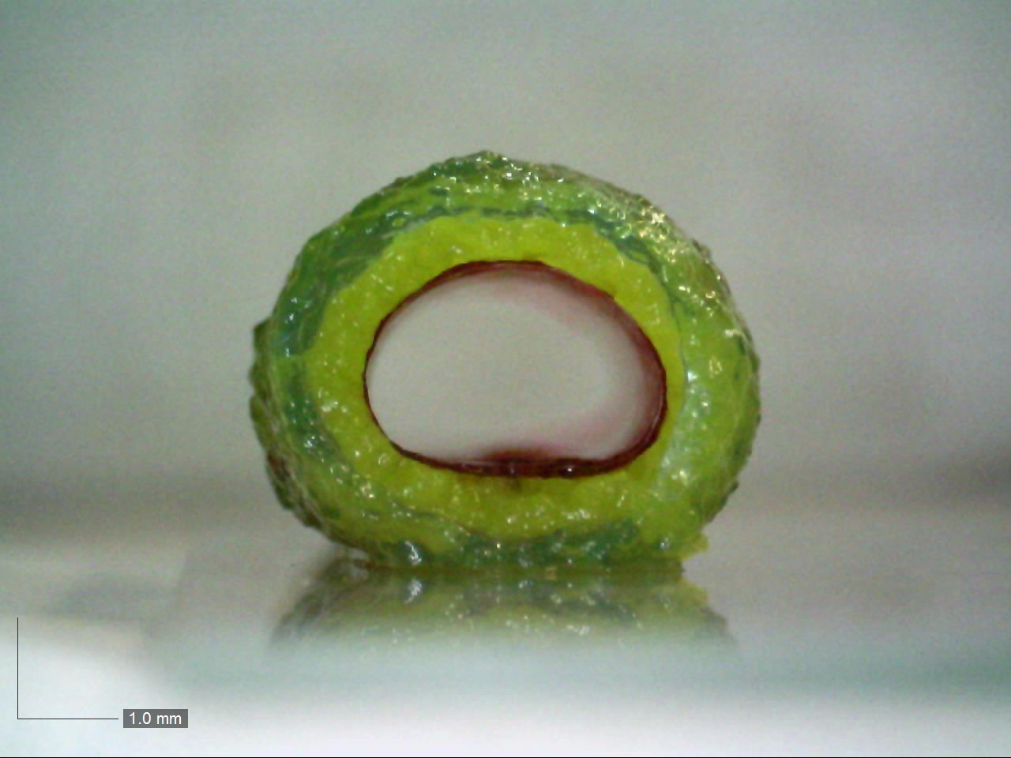

Figure 9. Three layered vascular construct obtained using extrusion based approach on a rotating cylinder

# Conclusions

The study focused on investigating the behavior of 7% Gelatin 1% Alginate to improve dimensional accuracy in 3D extrusion based bio printing. To accomplish that, several hypotheses were postulated. The first one aimed to demonstrate that different preparation methods can significantly impact viscosity. Results showed that when the material is prepared and stored at 40°C, the polymer chain is in a non-equilibrium state, displaying non-repeatable results (Figure 3a). In contrast, when the material is left at low temperatures for 1h during preparation, the molecular chain obtains a more organized structure, demonstrating reproducible curves (Figure 3b). Thus, it was postulated that the similarity in curves is due to the formation of triple helix structure. The second aspect focused on the material’s characterization. While sweep tests portrayed shear thinning behavior, the deduced coefficients provided dissimilar flow rate from the analytical study and experimental one. In light of this, it was postulated that the gelatin-alginate hydrogel exhibits yield stress behavior. To prove that there exists a yielding point, the stress was plotted on a graphs as a function of the velocity. The results showed that there is a stress value below which the velocity remains negligibly small. In contrast, when stress values go above the yielding point, the velocity increases significantly even if stresses is constant. These results are of importance since they might lay the groundwork of a new theory about the behavior of gelatin-alginate. However, at this moment one cannot conclude that the gelatin-alginate is yield stress fluid, rather, one can confirm that its behavior is more complex than the one presented in the literature.

# Perspectives

Future work will focus on providing more data to confirm the yield stress behavior. First, the study will focus on conducting rheological experiments at different temperatures and observing it the yielding point will change. Then, one will perform experiments with an extrusion based system where the flow rate is controlled as a function of the velocity. Similarly, the extrusion rate will be calculated as in equation (6) and results will be compared. Once that is confirmed, the study should continue towards the development of a CFD analysis with the newly obtained data. Upon obtaining favorable results, the study should shift to Additive manufacturing of vascular constructs, observing the dimensional accuracy with variation in parameters. Finally, scaffolds will be fabricated with altering porosity to study cellular interactions and their impact on the development of vascular tissue.

**Références**

1. *World Health Organization (WHO)., 2021 Cardiovascular diseases (CVDs), https://www.who.int*
2. *Robert Langer, Joseph P. Vacanti., 1993, Tissue Engineering, Science*
3. *Saptarshi Biswas, Patrick McNerney., 2016, Sydney Ringer: The pipe water of New River Water Company and the discovery of the elixir of life, American College of Surgeons*
4. *Robert J. Klebe., 1988, Cytoscribing: A Method of Micropositioning Cells and the Construction of Two and Three-Dimensional Synthetic Tissues, Experimental Cell Research*
5. *Yi Zhang, Piyush Kumar, Songwei Lv, Di Xiong, Hongbin Zhao, Zhiqiang Ca, Xiubo Zhao., 2021, Recent advances in 3D bioprinting of vascularized tissues*
6. *Ibrahim T. Ozbolat, Monika Hospodiuk., 2016, Current advances and future perspectives in extrusion-based bioprinting, Biomaterials*
7. *Lei Xu, Mathew Varkey, Adam Jorgensen, Jihui Ju, Qianheng Jin, Ji Hoon Park, Yi Fu, Guangliang Zhang, Dongxu Ke, Weixin Zhao, Ruixing Hou, Anthony Atala., 2020, Bioprinting small diameter blood vessel constructs with an endothelial and smooth muscle cell bilayer in single step, International Society for Biofabrication*
8. *Karli A. Gold, Biswajit Saha, Navaneeth Krishna Rajeeva Pandian, Brandon K. Walther, Jorge A. Palma, Javier Jo, John P. Cooke, Abhishek Jain, Akhilesh K. Gaharwar.,2021, 3D Bioprinted Multicellular Vascular Models, Advanced Healthcare Materials*
9. *Sung Yun Hann, Haitao Cui, Cuibin Chen, Manfred Boehm, Timothy Eastworthy, Lijie Grace Zhang, 2022, 3D printed biomimetic flexible blood vessel with iPS cell-laden hierarchial multilayers, Biomedical Engineering Advances*
10. *Qing Gao, Yong He, Jian-zhong Fu, An Liu, Liang Ma., 2015, Coaxial nozzle-assisted 3D bioprinting with build-in microchannels for nutrients delivery, Biomaterials*
11. *Mark A. Skylar-Scott, Sebastien G. M. Uzel, Lucy L. Nam, John H. Ahrens, Ryan L. Truby,* *Sarita Damaraju, Jennifer A. Lewis., 2021,* *Biomanufacturing of organ-specific tissues with high cellular density and embedded vascular channels, Science Advances*
12. *Sean V Murphy, Anthony Atala., 2014, 3D bioprinting of tissues and organs, Nature Biotechnology*
13. *David J. Odde, Muchael J. Renn., 1999, Laser-guided direct writing for applications in biotechnology, Nanotechnology*
14. *Nathan R. Schiele, David T. Corr,* *Yong Huang,* *Nurazhani Abdul Raof, Yubing Xie, Douglas B Chrisey., 2010, Laser-based direct-write techniques for cell printing, Biofabrication*
15. *Ferry P.W. Melchels, Jan Feijen, Dirk W. Grijpma., 2010, A review on stereolithography and its applications in biometical engineering, Biomaterials*
16. *Selena Jarvis., 2018, Vascular system 1: anatomy and psychology, Nursing Times*

## Zimeng Zhang, Biran Wang, David Hui, Jingjing Qiu, Shiren Wang, 2017, 3D bioprinting of soft materials-based regenerative vascular structure and tissues, Composites Part B: Engineering

1. *Xia Cao, Sushila Maharjan, Ramla Ashfaq, Jane Shin, Yu Shrike Zhang., 2020, Bioprinting of Small-Diametter Blood Vessels, Engineering*
2. *Xiaohong Wang, Qiang Ao, Xiaohong Tian, Jun Fan, Hao Tong, Weijian Hou, Shuling Bai., 2017, Gelatin-based Hydrogels for Organ 3D Bioprinting, Polymers*

## Amina Ahmady, Nor Hayati Abu Samah., 2021, A review: Gelatine as a bioadhesive material for medical and pharmaceutical applications, International Journal of Pharmaceutics

1. *Siddhesh N. Pawar, Kevin J. Edgar.,2012, Alginate derivatization: A review of chemistry, properties and applications, Biomaterials*
2. *Susan L. Bellis, 2011, Advantages of RGD peptides for directing cell association with biomaterials, Biomaterials*

# Vanja Kokol, Yasir Beeran Pottahara, Mohor Mihelcic, Lidija Slemenik Prese, 2021, Rheological properties of gelatin hydrogels affected by flow-and- horizontally-induced cooling rates during 3D cryo-printing, Colloids and Surfaces A physicochemical and Engineering Aspects

1. *Madeleine Djabourov, Jean-Pierre LeChaire, François Gaill., 1993, Structure and Rheology of Gelatin and Collagen Gels, Biorheology*
2. *I. Pazeron, M. Djabourov, 1990, X-ray Diffraction of Gelatin Fibers in the Dry and Swollen States, Journal of Polymer Science*

1.