The Interplay of Spacer Chirality and Parity in Mesogenic Dimers

Antonija Ožegovića, Anamarija Kneževića, Jurica Novakb, Suzana Šegotaa, Patrick Davidsonc, Andreja Lesaca*

a Ruđer Bošković Institute, Bijenička 54, 10000 Zagreb, Croatia

b University of Rijeka, Center for Artificial Intelligence and Cyber Security, Radmile Matejčić 2, 51000 Rijeka, Croatia

c Laboratoire de Physique des Solides, Université Paris-Saclay, CNRS, 91405 Orsay, France

*Corresponding author:

E-mail: Andreja.Lesac@irb.hr

**Abstract**

Introducing chirality into soft materials, including liquid crystals (LCs), profoundly impacts their self-organization and physical properties. In this study, we synthesized a novel series of LC dimers with a chiral center as part of their flexible spacer. The dimers were prepared in racemic and enantiomerically pure forms. Their spacer length and parity were varied to investigate the effect of spacer chirality and parity on mesomorphic behavior and on chiral induction in the nematic phase of achiral mesogens. Our results show that the even-membered chiral dimers only have chiral nematic phases. In contrast, the odd-membered dimers display rich mesomorphism, including the intriguing blue phase (BP) and chiral form of the twist-bend nematic phase (N*TB). The observed significant difference in the 3D surface morphology between the racemic and chiral forms of the N*TB phase suggests that the chiral moiety in the spacer promotes a chiral hierarchy. Furthermore, the chiral dimers show a prominent odd-even effect in the helical twisting power in nematic hosts. These findings highlight the importance of the position of the chiral group within the dimeric molecule and provide new insights into how intrinsic chirality in the spacer affects the overall structural chirality.

**Introduction**

Chirality is an important issue in scientific and technological fields, particularly in soft materials, due to their vast potential for various applications.[1–4] The introduction of chirality into liquid crystals (LC) results in the formation of helical structures such as chiral nematic (N*), also called cholesteric (Ch), and chiral smectics, as well as frustrated phases like twist grain boundary (TGB) and blue phases (BP).[5] Each of these phases has unique properties.[6,7] The helical organization, characterized by the magnitude and sign of the helical pitch P, can be achieved either by incorporating a stereogenic center within the LC molecule itself or by adding chiral mesogenic or non-mesogenic dopants into the LC host. [5,8] The latter method is more common and is often used to obtain the cholesteric phase with its desirable responsive and adaptive properties required for various applications.[3,4,9]

Liquid-crystalline dimers, consisting of two mesogenic units linked *via* a flexible spacer, have attracted considerable attention due to their rich and unusual mesomorphism, which differs from that of the corresponding monomers.[10–12] A wide range of chiral dimers have been studied for technological and fundamental reasons.[13–17] One of the most salient features of this class of materials is that their mesomorphic properties depend on the parity of the flexible spacer, which affects the mutual orientation of the mesogenic units of the dimer.[11,18] Recently, bent-shaped dimers have raised particular interest due to the formation of twist-bend nematic (NTB) [19–26]and twist-bend smectic (SmCTB) phases.[12,27] In both phases, domains of right-handed and left-handed helical organisation spontaneously form, although they consist of achiral molecules in the absence of chiral doping. In this regard, the structure-property relationship has been studied and it is generally accepted that molecular curvature is essential for the formation of the NTB and SmCTB phases,[12,23,28] In addition, according to a classical empirical rule, smectic behaviour requires the terminal chain length to be longer than half the spacer length.[29] Theoretical studies for the NTB phase predict that the double degeneracy of domains of opposite chiralities could be removed by chiral doping.[30,31] Experimentally, only a limited number of systems exhibit the transition from chiral nematic to twist-bend nematic phases. These include both, mixtures of twist-bend nematogens with a chiral dopant[32–34] and particularly rare intrinsically chiral materials.[20,35–37] Limited data show that the experimental evidence for the effect of chirality on the pitch of the NTB phase is not straightforward.

In chiral dimers, the chiral moiety can be incorporated in the terminal chain, [10,13,37,38] mesogenic unit[15,17,35] or within the flexible spacer. [14,39,40] However, dimers with a chiral spacer are relatively uncommon. Chirality in the spacer is usually achieved from the chiral precursors bearing a methyl group at the chiral center.[39,40]. However, the bulky methyl group in the spacer reduces lateral intermolecular interactions and destabilizes liquid-crystalline properties. This is especially pronounced for the bent-shaped dimers, which lack mesogenic properties.[39] The increase of polarizability of the mesogenic units and the terminal chain length increase lateral interactions and mostly result in smectogenic behavior.[14] Compared to dimers with chiral terminal chains that rotate freely, the flexibility of the chiral moiety in the spacer is reduced. Therefore, the different impact of the chiral spacer on chirality transfer is anticipated.

In a previous report, we described the synthesis of a versatile building block, 3-aryl-3-hydroxypropanoic ester subunit. This building block allowed the preparation of LC molecules of various topologies, both in racemic and enantiomerically pure forms.[41] Encouraged by this result, we design a novel series of dimers using 3-phenyl-3-hydroxypropanoic acid that features a chiral center as part of their flexible spacer. The chiral 3-phenyl-3-hydroxypropanoic acid subunit has the hydroxyl group at the chiral center, which is less spacious than the methyl group, while the carboxylic group allows upgrading into dimeric molecules with different spacer lengths (Figure. 1).

Our goal was to study how the interplay between the intrinsic chirality of the spacer and its parity affects the mesomorphic properties. Moreover, the possibility to prepare dimers with different spacer lengths allowed us to modify the average bending angle of the bent-shaped dimers, resulting in materials with the chiral NTB phase. By synthesizing enantiomerically pure and racemic dimers, we were able to compare the mesomorphic behavior of both forms. Although the mesomorphic behavior between the enantiomeric and corresponding racemic forms is not always unequivocal,[42] it is important to have both forms to explore the effect of inherent chirality on the NTB phase. In addition to their mesomorphic behavior, we also investigated the ability of chiral dimers to induce a helical organization in a nematic host. This allowed us to clarify the effect of the chiral spacer parity on the chirality transfer to the host.



**Figure 1.** General structure of target dimers.

**Results and Discussion**

**Synthesis of LC dimers**

The targeted molecules were prepared following the convergent synthetic route described in Scheme 1. The synthesis of the starting compound **1** is described in our previous work.[41] Compounds **3a-f** were obtained via esterification of acid **1** and the corresponding alcohols **2a-f** in a very good yield (58% - 98%). Deprotection of the benzylic protecting group of compounds **3a-f** gave the intermediate diols **4a-f**. Esterification of compounds **4a-f** with 4-butoxybenzoic acid provided molecules **5a-f** in 31% - 96% yields. Targeted LC molecules were obtained by removing the *tert-*buthyldimethylsilyl protection in 36% - 96% yields. All targeted molecules were synthesized in racemic and in enantiomerically pure form.



**Scheme 1.** Synthetic route to target dimers

**Mesomorphic properties of chiral and racemic LC dimers**

The thermal behavior of a series of dimers with 3-phenyl-3-hydroxypropanoic ester subunit (Table 1) shows that all prepared compounds, both in the racemic and corresponding enantiomerically pure forms, are mesomorphic.

**Table 1.** Transition temperatures (°C), enthalpies (kJ mol-1) in italics and the dimensionless value of ∆*S/R* in [ ] for the synthesized compounds **BB-OHm** and **(*S*)*-*BB-OHm**.

|  |  |  |  |  |  |  |  |  |  |  |
| --- | --- | --- | --- | --- | --- | --- | --- | --- | --- | --- |
| m | Racemic dimers **BB-OHm** | | | | | | | | | |
|  |  | SmCA |  | NTB |  | N |  |  |  | I |
| **3** | 93  *31.46*[10.35] | (• | 46)  *5.66*[2.13] |  |  |  |  |  |  | • |
| **5** | 96  *48.10*[15.69] | (• | 42  *3.90*[1.49] |  |  | • | 49)  *0.03*[0.01] |  |  | • |
| **6** | 108  *40.22*[12.69] |  |  |  |  | • | 130  *7.81*[2.33] |  |  | • |
| **7** | 78  *66.91*[22.92] |  |  | (• | 49  *0.21*[0.08] | • | 67)  *0.27*[0.08] |  |  | • |
| **8** | 102  *37.58*[12.04] |  |  |  |  | • | 118  *7.56*[2.32] |  |  | • |
| **9** | 78  *72.07*[24.69] |  |  | (• | 53  *0.10*[0.04] | • | 72)  *0.39*[0.14] |  |  | • |
| Chiral dimers **(*S*)-BB-OHm** | | | | | | | | | | |
|  |  | SmCA* |  | N*TB |  | N* |  | BPIII |  |  |
| **3** | 108  *26.75*[8.43] | (• | 47)  *6.32*[2.37] |  |  |  |  |  |  | • |
| **5** | 109  *52.99*[16.68] | (• | 40  *3.70*[a][1.42] |  |  | • | 41 | • | 49)  *0.07*[0.03] | • |
| **6** | 113  *35.17*[10.96] |  |  |  |  | $$•$$ | 132  *7.37*[2.19] |  |  | • |
| **7** | 96  *58.68*[19.05] |  |  | (• | 48  *0.28*[0.11] | • | 65  *0.17*[0.06] | • | 65.3[b]) | • |
| **8** | 108  43.68[13.80] |  |  |  |  | • | 117  7.29[2.25] |  |  | • |
| **9** | 85  *71.82*[24.15] |  |  | (• | 58  *0.01*[0.01] | • | 66)  *0.04*[0.01] |  |  | • |

SmCA: anticlinic smectic C phase; SmCA*: anticlinic smectic C phase obtained from chiral molecules; N: nematic phase; N*: chiral nematic phase; NTB: twist-bend nematic phase; N*TB: twist-bend nematic phase obtained from chiral molecules; BP: blue phase; I: isotropic liquid; (): monotropic phase; [a]: combined enthalpies; [b]: observed by POM.

Even membered dimers, both racemic and chiral, display straightforward mesomorphic behavior. The nematic phase of **BB-OH6** and **BB-OH8** is characterized by typical schlieren and marbled textures (Figure 2a). Furthermore, chiral analogs **(*S*)-BB-OH6** and **(*S*)-BB-OH8** display only the chiral nematic phase characterized by the *pseudo* focal-conics and oily streaks texture (Figure 2b, c).

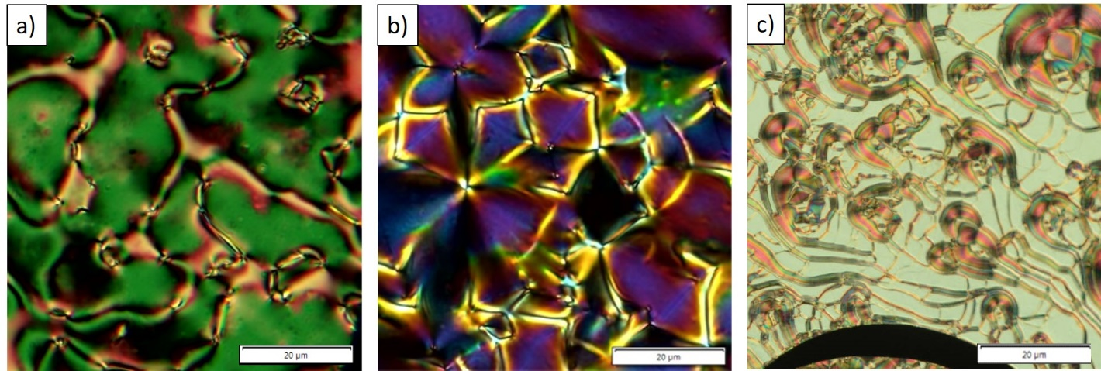

**Figure 2**. Optical textures of even membered dimersobtained on cooling. a) The schlieren texture of the N phase of **BB-OH8** at 116°C. b) The focal-conics texture of the N* of **(*S*)-BB-OH6** at 125°C. b) The oily streaks texture of the N* of **(*S*)-BB-OH8** at 112°C.

The shortest analogues in the set, **BB-OH3** and **(*S*)-BB-OH3**, display only the smectic phase. Upon cooling **BB-OH3** from the isotropic liquid, the focal-conics fan-shaped texture and the schlieren texture with 2- and 4-brush defects appear (Figure 3a, b). This is typical of the SmCA phase, as reported for intercalated smectic phases of mesogenic twins.[11,43] The chiral analogue (***S*)-BB-OH3** displays the corresponding chiral SmCA* phase (Figure 3c).

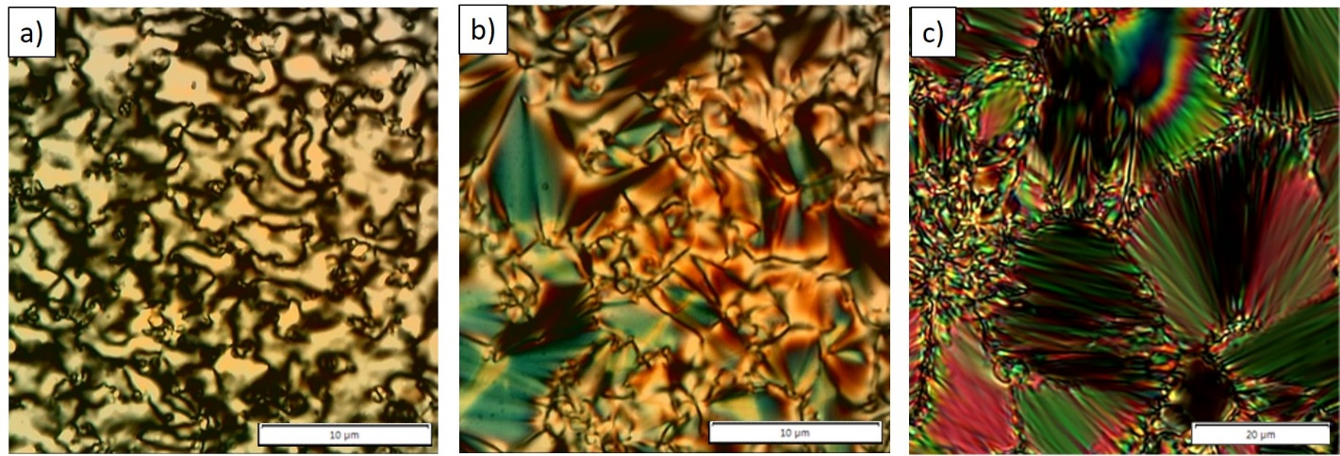

**Figure 3.** Optical textures of **BB-OH3** and **(*S*)-BB-OH3** obtained on cooling. a) The schlieren texture of the SmCA phase at 44°C. b) The focal-conics fan-shaped texture of the SmCA phase at 44°C. c) The focal-conics fan-shaped texture of the SmCA* phase at 45°C.

While even parity dimers and the shortest homolog exhibit expected behavior, other homologs display interesting properties. Upon cooling the racemic **BB-OH5** from the isotropic liquid, the nematic phase with the characteristic marble texture appears, followed by the smectic phase (Figure 4a) with the same textural features as observed for **BB-OH3**. Indeed, the investigation by X-ray scattering of compound **BB-OH5** confirmed the phase identification. However, this study was hampered by the slow recrystallization of the sample, on the time scale of one hour, which prevented the possibility of longer exposure times and thus limited the signal-to-noise ratio. Nevertheless, the scattering pattern of a magnetically aligned sample at 43 °C, shown in Figure 4b, is clearly anisotropic and lacks any sharp scattering features. It is therefore typical of an anisotropic phase with no long-range positional order, i.e. a nematic phase. Moreover, the wide-angle diffuse ring has its maximum intensity in the direction (equator) perpendicular to the field direction (meridian), implying that the mesogenic cores are on average aligned along the field, as expected. In contrast, the scattering pattern of the same sample recorded at 41 °C, shown in Figure 4c, displays along the field direction two very sharp (i.e. resolution limited) reflections, in addition to the wide-angle diffuse ring. These sharp reflections show the existence of a long-range sinusoidal density modulation that is the hallmark of a smectic phase. The smectic period, d = 18.5 Å, is about half the length of the whole molecule, which indicates that the structure of this smectic phased is in fact intercalated, as was previously observed for both symmetric and non-symmetric bent-shaped dimers.[11,44] Furthermore, the unusually wide extension of the wide-angle diffuse ring away from the meridian suggests that the mesogenic cores are slightly tilted with respect to the normal to the layers. All these scattering features are indeed consistent with a SmCA phase.

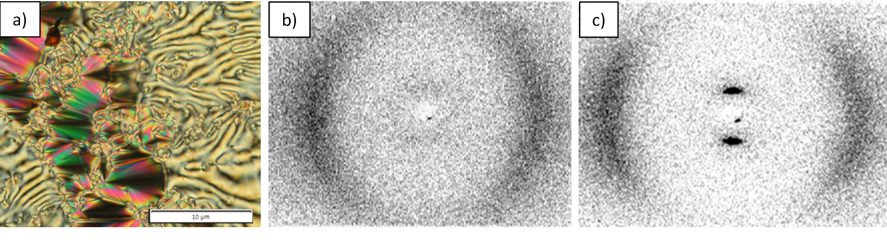**Figure 4**. a) The focal-conics fan-shaped texture of the SmCA phase of **BB-OH5** at 40°C. X-ray scattering patterns of a sample **BB-OH5,** aligned in a 1.7 T magnetic field (applied in the vertical direction), obtained on cooling from the isotropic liquid at b) 43°C in the nematic phase and c) 41°C in the SmCA phase.

The comparison of racemic **BB-OH5** and chiral **(*S*)-BB-OH5** reveals interesting differences. Instead of the expected chiral nematic phase, with chiral **(*S*)-BB-OH5**, the interesting blue phase (BP) appears at the same temperature as the nematic phase in **BB-OH5**,and over the same temperature range. In addition, the transition enthalpies of the racemic and enantiomerically pure compounds are relatively small and have comparable values (see Table 1). On cooling from the isotropic liquid, a mesophase appears at 49°C, showing a bluish, foggy texture without any defects (Figure 5a). This texture is a characteristic of the BPIII phase (also called “blue fog”), an amorphous phase with the same symmetry as the isotropic phase.[8,45] In the case of **(*S*)-BB-OH5**, upon further cooling, a chiral nematic phase appears in a fraction of a degree, followed by the SmCA* phase characterized by focal-conics fan-shaped texture (Figure 5b and S1).

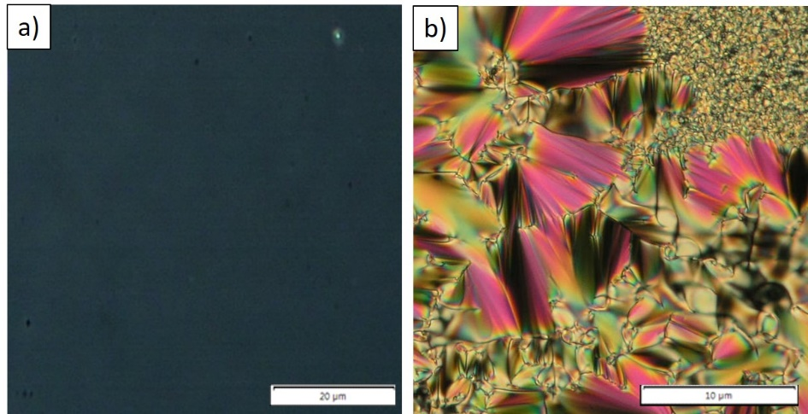

**Figure 5**. Optical textures of **(*S*)-BB-OH5** obtained on cooling. a) Blue, foggy texture of the BPIII phase at 46°C. b) The focal-conics fan-shaped texture of the SmCA* phase at 39°C.

By increasing the spacer length of the odd-membered dimers to seven and nine methylene units, we could tune the effective bending angle and obtain both the nematic and twist-bend nematic phases, in racemic and chiral analogs. The nematic phases of racemic homologs **BB-OH7** and **BB-OH9** were identified by their distinctive optical textures. The uniaxial nematic phase was identified according to its typical schlieren and marbled textures (Figure 6a). On cooling, the transition from N to NTB showed a characteristic blocky texture, from which the rope texture developed (Figure 6b). X-ray scattering studies of **BB-OH7** confirmed that both mesophases lack any long-range positional order, as their scattering patterns show only diffuse scattering, at both small and wide angles, which is typical of nematic phases.[46] However, no significant difference was observed between the scattering patterns of the nematic and twist-bend nematic phases (Figure 6c), which could be due to a small value of the heliconical angle in the latter. Therefore, X-ray scattering only confirmed the nematic character of both phases.

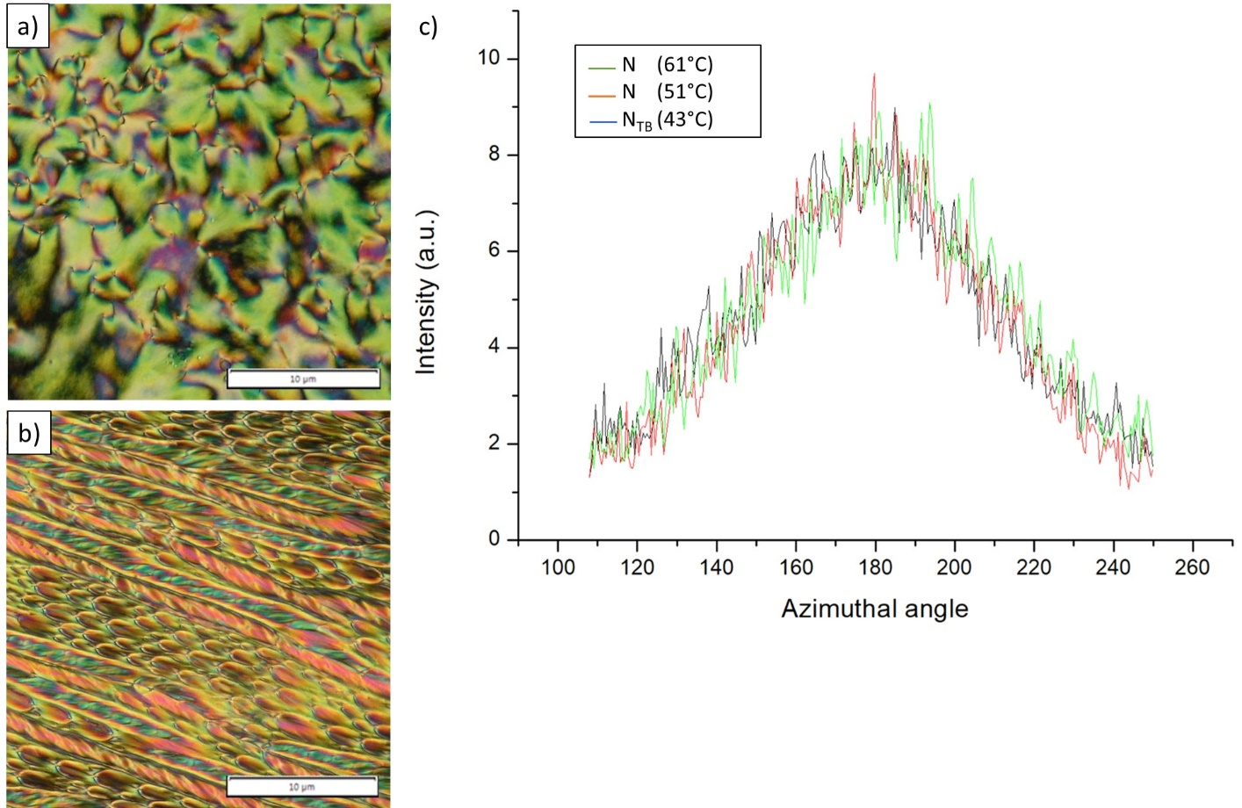

**Figure 6.** a) The schlieren texture of the nematic phase of **BB-OH7** at 61°C. b) The rope texture of the NTB phase of **BB-OH7** at 44°C. c) Comparison of the profiles of scattered intensity versus azimuthal angle of the wide-angle diffuse ring extracted from the X-ray scattering patterns of **BB-OH7** aligned in a 1.7 T magnetic field, obtained upon cooling from the isotropic liquid, in the nematic phase at 61 °C and 51 °C and in the twist-bend nematic phase at 43 °C.

The mesomorphism of the chiral dimer **(*S*)*-*BB-OH7** leads to rather unusual optical textures. Upon cooling from the isotropic liquid, the BPIII phase appears in a tiny temperature range as a bluish texture without any defects. This texture rapidly changes to a bluish texture with small defects, indicating the presence of a chiral nematic phase (Figure 7a). Upon further cooling, another mesophase appears with a texture of small focal conics between untreated glass slides, or with a mosaic-like texture in a 5 µm thick planar cell (Figure 7b, c). By analogy with the mesophase behavior of racemic **BB-OH7**, the low-temperature phase should correspond to the chiral N*TB phase. Due to the fast (i.e. within a few minutes) crystallization of the compound **(*S*)*-*BB-OH7**, it was not possible to perform an X-ray investigation with our setup. The low-temperature mesophase was clearly confirmed as the chiral N*TB phase by miscibility studies with **BB-OH7** (Figure S2). The same texture was observed for the low-temperature phase of **(*S*)*-*BB-OH9,** confirming that both bent-shaped dimers display the N*TB phase. Note that the texture of the N*TB phase that we observed remarkably differs from the previously reported textures of this phase obtained either with lactate-based dimers [37] or by chiral doping.[39]

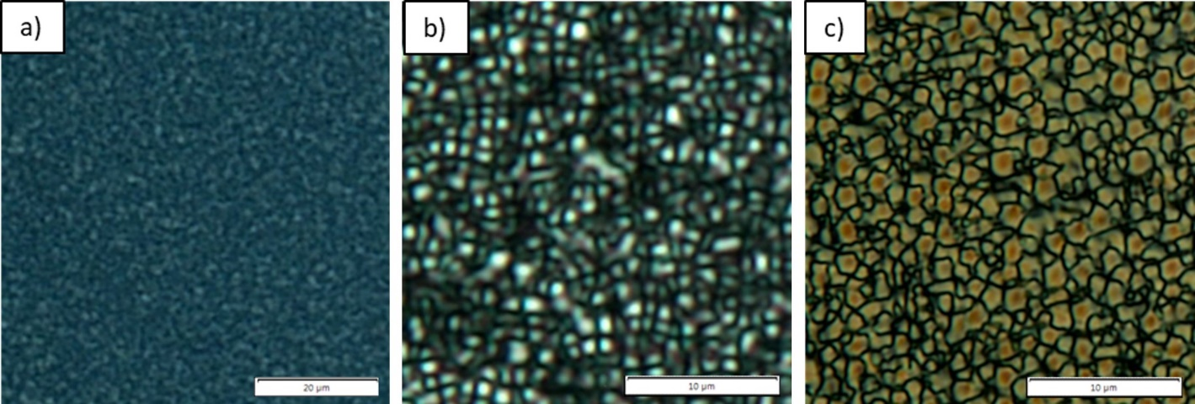

**Figure 7** Optical textures of **(*S*)-BB-OH7** observed on cooling. a) Texture of the N* phase obtained at 65°C. b) The small focal-conics texture of the N*TB phase at 47°C. c) The mosaic-like texture of the N*TB phase in a 5 µm thick planar cell at 45°C.

The results show that we successfully incorporated a chiral group in the spacer of dimers without losing liquid-crystalline properties in the bent-shaped dimers. The mesomorphic properties of the racemic and chiral compounds alternate as the number of methylene units in the spacer changes. The even-membered dimers show only uniaxial or chiral nematic phases, in agreement with their overall linear shape. In contrast, the odd-membered dimers show a polymorphism, ranging from nematic to twist-bend nematic, and smectic phases. The corresponding enantiomerically pure dimers mostly exhibit chiral mesophases equivalent to their racemic counterparts. The shortest homolog exhibits only a smectic phase. Increasing the spacer length promotes nematic behavior resulting in the smectic and nematic phases in the racemic **BB-OH5**, and nematic polymorphism in higher homologs. This evolution of mesophase behaviour with increasing spacer length is already well-established for liquid crystal dimers.[29] In contrast to the racemic homolog, the **(*S*)-BB-OH5** exhibits the BPIII phase at the same temperature as the nematic phase of **BB-OH5** and spans the same temperature interval. However, at the transition to the smectic phase, the N* phase appears in a very narrow temperature range (Figure S1), but at 8 °C lower than the N phase of the racemic analogue. In general, the blue phases (BPI, BPII, and BPIII) are observed in non-symmetric odd but not in even membered chiral dimers, which may be attributed to the smaller twist elastic constant of the odd bent-shaped dimers, which in turn is related to their lower orientational order. [13,15,17] Furthermore, Tanaka et al.[47] showed that a large molecular biaxiality or a small bend elastic constant contributes to the stabilisation of the blue phase. Since the twist and bend elastic constants play an important role in the stability of the blue phase, we can only speculate that their change with temperature destabilises BPIII and leads to the appearance of the N* phase at the transition to the smectic phase. As the spacer length of the chiral odd-membered dimers increases, the temperature range of the BPIII phase decreases, and it eventually disappears while the N* and N*TB phases are promoted. It is known that the effective bending angle increases with the elongation of the odd-numbered spacer.[11] Since the bent shape of the molecules facilitates both BPIII and N*TB phases,[13,23] the results suggest that even slight variations in the effective bending angle could be decisive in determining which of the two phases will appear.

The helical pitch of the chiral nematic phase measured by the Cano-wedge method was found to be 500 nm, 640 nm, and 880 nm for the **(*S*)-BB-OH6**, **(*S*)-BB-OH8**, and **(*S*)-BB-OH9** compounds, respectively. Moreover, the left-handedness of the helix was directly determined by applying Gerber's rule to the wedge cells.[48] However, for the **(*S*)-BB-OH3**, **(*S*)-BB-OH5**, and **(*S*)-BB-OH7** dimers, the helical pitch could not be determined due to either the absence of the N* phase, its narrow temperature range, or poor alignment in the Cano-wedge cell. This prevented us from determining the effect of spacer parity on the helical pitch from the experimental data. However, the observation of the BPIII phase in **(*S*)-BB-OH5** and **(*S*)-BB-OH7** indicates a short pitch of their N* phase and suggests that they have shorter cholesteric pitches compared to **(*S*)-BB-OH6**, **(*S*)-BB-OH8**. Such behavior would be consistent with a lower orientational order of the odd dimers than even.[13]

To gain insight into the periodicity and overall morphology of the racemic and chiral forms of the NTB phase, we performed an atomic force microscopy (AFM) study of the planar-oriented samples of **BB-OH7** and **(*S*)-BB-OH7**. We found that the surface morphology of the two forms of the NTB phase differed significantly (Figure 8). In the racemic NTB phase, at 30 °C, a relatively smooth surface with a fine periodic pattern was observed (Figure 8a). This „fingerprint“ modulation has a period of ≈ 8 nm, as determined by the cross-section analysis. This pitch value corresponds to a few molecular lengths and is quite similar to those previously reported for other twist-bend nematogens.[22,35,37,49] In contrast to the relatively smooth surface of the racemic form, the chiral form of the NTB has a more pronounced relief (Figure 8b). The surface is composed of disk-like units stacked in rows. The disk-like units vary in thickness, ranging from 250 to 600 nm. Higher-resolution imaging revealed a periodicity of ~18 nm within the disk-like units (as shown in Figure 8c), which can be attributed to the helical pitch of the N*TB phase. Thus, a higher stability and pitch value are observed for the chiral form than for the racemic form. This result supports some theoretical models which predict that the pitch of N*TB can be either larger or smaller than that measured for NTB of achiral dimers.[30,31] For comparison, the AFM studies of the dimer with the chiral terminal chain showed a similar fingerprint pattern and ~10 nm pitch in the chiral and racemic form of the NTB phase.[37] Therefore, the 3D morphology of the N*TB phase of **(*S*)-BB-OH7** suggests that the chiral moiety in the spacer has a dual effect. Not only it removes the chiral degeneracy of the NTB phase but also enhances the chiral hierarchy. Further investigations are currently underway in our group to explore this feature and to clarify the influence of the intrinsic molecular chirality on the structural chirality.

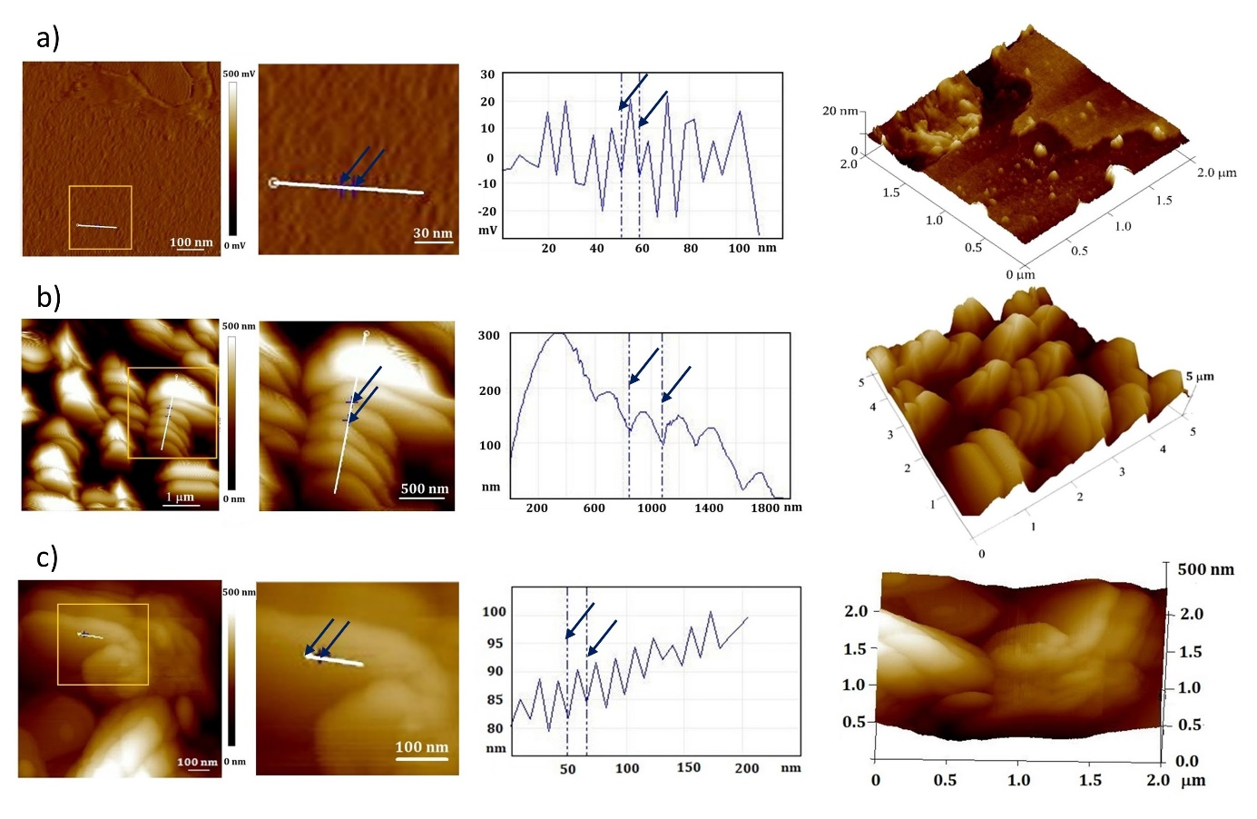

**Figure 8**. AFM2D- topographic image, at 30 °C, of the surface morphology (left); the inset (middle) shows a high-resolution AFM image of the marked region in image left; vertical section profile across the marked line; 3D-topographic image (right) of a) the racemic form of the NTB phase of **BB-OH7**, b) the chiral form of NTB of **(*S*)-BB-OH7** and c) close-up views of the disk-like units of the chiral form.

**Helical twisting power**

The efficiency of a chiral dopant to generate a helical organization is quantified by the ‘‘helical twisting power’’ (HTP), which is defined as β = 1/Pcr, where P (μm) is the pitch of the chiral nematic phase, c is the molar fraction of the dopant, and r is its optical purity. The sign of the HTP can be either positive or negative, indicating the right- or left-handedness of the cholesteric helix, respectively.[8]

To investigate the effect of the spacer length and parity on chiral induction, we determined the HTP in the nematic hosts for all **(*S*)-BB-OHm** dimers. Since the molecular shape controls the short-range dopant-host interactions [50,51], we chose as hosts two nematic solvents that are typical commercial rod-shaped nematogens: 6OCB and 8OPEP, as well as a bent-shaped dimer: BNA-76 [52], which allowed us to study the effect of a host shape (Figure 9a).

The results show that the absolute HTP values are relatively small (<10 μm-1) (Figure 9b), as is generally observed for molecules with a single chiral center.[50] All (*S*)-dimers induce a left-handed helix, except for **(*S*)-BB-OH3**, which induces a right-handed helix in the rod-shaped hosts. Tabular data are provided in the Supporting Information (Table S1).

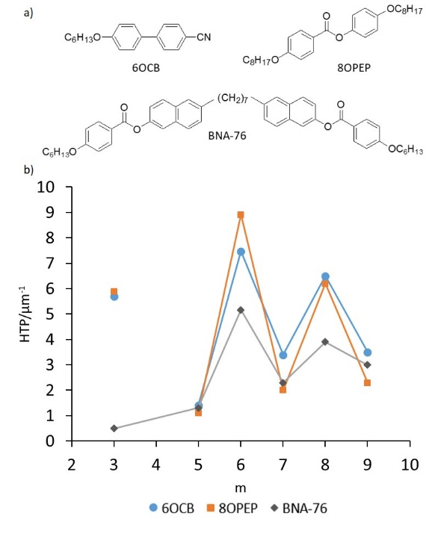

**Figure 9.** (a) Chemical structure of the nematic host compounds, (b) dependence of HTP on the number of methylene units (m) in the flexible spacer of the chiral dimer doped in 6OCB, 8OPEP and BNA-76.

The comparison of the HTP values of the chiral dimers in three different nematic hosts showed an odd-even effect, where the odd-membered dimers had lower HTP than the even-membered dimers. This behavior is quite different from that of dimers with chiral center in the terminal chains, which showed similar HTP values and therefore no odd-even effect.[13] For the same nematic solvent, the HTP is determined by the molecular shape of the chiral dopant and by its orientational order in the nematic host.[53] Thus, the observed behavior in the HTP can be explained by distinct molecular shapes of even- and odd-membered chiral dimers. The smaller HTP observed in the odd-membered dimers can be related to the lower orientational order of the average bent conformations. However, the preferential molecular shape of the dimers with chiral terminal chains also changes with the parity of the spacer and yet does not affect the HTP in common nematic solvent.[13] These controversial results highlight the importance of the position of the chiral moiety. In contrast to the dimers with chiral terminal chains that rotate freely, the flexibility of the chiral spacer is reduced. Kuball and co-workers showed that the contribution of the chiral group to the HTP depends on its orientation with respect to the orientation axis.[54] The orientation of the chiral moiety, positioned in the spacer, is strongly influenced by the average shape of the molecule. Increasing the spacer length enhances the conformational flexibility of the molecule. The flexibility of even-membered dimers appears to weaken the orientational order and reduces the HTP. Conversely, in odd-membered dimers, it slightly increases the HTP and consequently reduces the odd-even effect. Even when the bent-shaped BNA-76 dimer is used as a nematic host, the odd-even effect of the THP remains evident.

The effect of the host shape is most pronounced for **(*S*)-BB-OH3.** In the bent-shaped host, a left-handed helix is induced with a very small HTP. When the host is changed to a rod-like host, the HTP increases significantly, and the handedness changes to a right-handed helix. The opposite handedness was confirmed by contact preparation with a **(*S*)-BB-OH8**-6OCB mixture, as shown in Figure 10. The contact between two chiral nematics of similar pitch but opposite handedness resulted in a racemic form of the nematic texture.

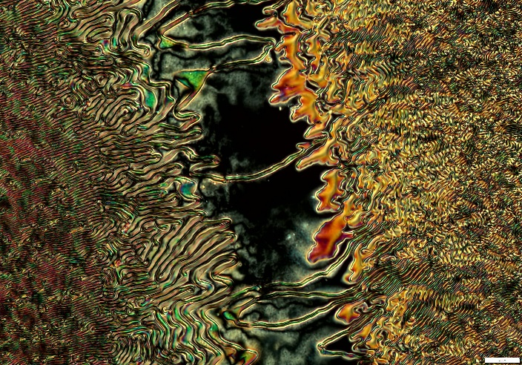

**Figure 10.** Contact preparation between the **(*S*)-BB-OH8**_6OCB and **(*S*)-BB-OH3**_6OCB mixtures of opposite helices at 70°C. The scale bar is 20 μm.

Host-dependent helix inversion was previously observed for flexible dopants and was attributed to their conformational and orientational changes in the LC host.[51,54,55] Thus, the change in handedness that occurs when the host shape changes from bent to rod-like suggests that different conformations or orientation of **(*S*)-BB-OH3** control the chirality transfer. Among the probable conformations, the conformational study (Figure 11) detects a hairpin conformation that closely approximates the rod shape. Due to steric requirements, it is likely that this conformation has a different preferential orientation compared to the bent conformation. Although the hairpin conformation is the most compatible with the rod-shaped host, we cannot exclude the other conformations that may contribute to the higher HTP observed in 6OCB and 8OPEP hosts. However, further investigation of this hypothesis would require extensive experimental and theoretical work, which is beyond the scope of this article.

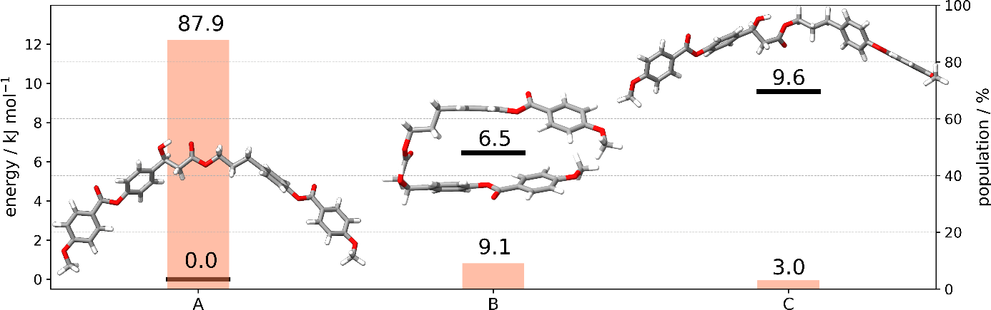

**Figure 11.** Structures, relative energies, and relative populations (at 343 K) of three low energy conformers for the model compound **(*S*)-BB-OH3** obtained at B3LYP/cc-pVDZ level of theory.

**Conclusion**

This article describes the synthesis and mesomorphic behavior of a novel series of dimers with a chiral center in their flexible spacer. The results show that the chiral moiety containing the hydroxyl group at the stereogenic center can be successfully incorporated into the spacer without losing liquid-crystalline properties in the bent-shaped dimers. The dimers, prepared in racemic and enantiomerically pure forms, differ in spacer lengths and parity, which allowed us to study the effect of spacer chirality and parity on mesomorphic behavior and chiral induction in the nematic phase of achiral mesogens. Regardless of whether the dimers are racemic or enantiomerically pure, their mesophase behavior presents an odd-even effect. Thus, the even-membered dimers show only uniaxial or chiral nematic phases, in agreement with their overall linear shape. On the contrary, the odd-membered dimers display rich mesomorphism, including the BPIII and N*TB phases. The study indicates that the effective bending angle impacts not only the stabilization of N*TB but also the temperature range of the BPIII phase. Our investigation of the rarely observed chiral form of the NTB phase revealed that it displays a pronounced surface relief in addition to its unusual optical texture. Indeed, AFM analysis indicates that the chiral moiety in the spacer removes the chiral degeneracy of the racemic NTB phase and promotes a chiral hierarchy. The HTP values of the chiral dimers show a prominent odd-even effect in three different nematic solvents, which has not been observed for the dimers with chiral terminal chains.[13]. This effect highlights the importance of the position of the chiral group within the dimeric molecule.

Our findings shed new light on how intrinsic chirality in the spacer affects the overall structural chirality. They demonstrate the complexity of chirality transfer from molecular to multiple levels of structural chirality. Also, they pave the way for further experimental and theoretical studies of the structure-property relationship of the chiral dimers and their hierarchical self-organization into chiral nanostructures. Understanding the structure-property relationship of chiral soft materials allows tailoring specific chiro-optical properties of innovative soft materials.[56,57] The progression from simple dimeric materials to complex oligomers and polymers could lead to the next generation of advanced devices and digitally enhanced technologies.[3]

**Experimental Section**

Synthesis: The targeted compounds were prepared in racemic and in enantiomerically pure forms. Synthetic procedures and chemical characterization are given in the accompanying Supporting Information.

Characterization of the LC properties: The liquid crystalline behavior of all final materials was examined by a combination of polarized optical microscopy (POM), differential scanning calorimetry (DSC), X-ray diffraction and atomic force microscopy (AFM). The list and description of all instrumentation and characterization methods used in this work is provided in the Supporting Information.

Determination of the helical pitch: The helical pitch of enantiomerically pure compounds and mixtures of the compounds in three nematic hosts, namely hexyloxy cyanobiphenyl (6OCB) and 4-(octyloxy)phenyl-4-(octyloxy)benzoate (8OPEP) and 1,7-bis(6-(4-hexyloxybenzoyloxy)naphthalene-2-yl)heptane (BNA-76) [52], was determined by the Cano-wedge method using commercial EHC cells (KCRS-5, tanθ = 0.0192). The helical twist sense was determined directly from the wedge cells by applying Gerber’s rule.[48]

**Supporting Information**

Supporting Information associated with this article can be found, in the online version, at doi

**Acknowledgments**

The authors thank the Croatian Science Foundation [grant numbers IP-2017-04-7978 and DOK-2020-01] and the French Agence Nationale de la Recherche [grant number ANR-23-CE24-0006-03 "DISPLAY"] for financial support. The authors would like to thank the French Ministry of Foreign Affairs and the Ministry of Science and Education of the Republic of Croatia for providing a COGITO collaborative grant. We are also grateful to Dr. Ivan Dozov (Université Paris-Saclay, France) for very useful discussions. The authors thank the University of Zagreb, University Computing Center—SRCE, for granting access to the Isabella computer cluster.

**Keywords**

Liquid crystalline dimers; Chiral spacer; Chiral NTB phase; Odd-even effect; Chiral hierarchy

**Declaration of Competing Interest**

The authors declare that they have no known competing financial interests or personal relationships that could have appeared to influence the work reported in this paper.

**Data availability**

Data will be made available on request.

References:

[1] L. Wang, A. M. Urbas, Q. Li, *Advanced Materials* **2020**, *32*, 1801335.

[2] K. Ariga, T. Mori, T. Kitao, T. Uemura, *Advanced Materials* **2020**, *32*, 1905657.

[3] H. K. Bisoyi, Q. Li, *Chem. Rev.* **2022**, *122*, 4887–4926.

[4] Y. Yang, L. Wang, H. Yang, Q. Li, *Small Science* **2021**, *1*, 2100007.

[5] I. Dierking, *Symmetry* **2014**, *6*, 444–472.

[6] C. Tschierske, G. Ungar, *ChemPhysChem* **2016**, *17*, 9–26.

[7] J. W. Goodby, *Proc. R. Soc. A.* **2012**, *468*, 1521–1542.

[8] H.-S. Kitzerow, C. Bahr, Eds. , *Chirality in Liquid Crystals*, Springer-Verlag, New York, **2001**.

[9] M. Mrukiewicz, O. S. Iadlovska, G. Babakhanova, S. Siemianowski, S. V. Shiyanovskii, O. D. Lavrentovich, *Liquid Crystals* **2019**, *46*, 1544–1550.

[10] S. K. Pal, S. Kumar, *Liquid Crystal Dimers*, Cambridge University Press, Cambridge, **2017**.

[11] C. T. Imrie, P. A. Henderson, *Chemical Society Reviews* **2007**, *36*, 2096.

[12] C. T. Imrie, R. Walker, J. M. D. Storey, E. Gorecka, D. Pociecha, *Crystals* **2022**, *12*, 1245.

[13] A. E. Blatch, I. D. Fletcher, G. R. Luckhurst, *J. Mater. Chem.* **1997**, *7*, 9–17.

[14] A. Yoshizawa, K. Matsuzawa, I. Nishiyama, *J. Mater. Chem.* **1995**, *5*, 2131.

[15] C. V. Yelamaggad, G. Shanker, U. S. Hiremath, S. Krishna Prasad, *Journal of Materials Chemistry* **2008**, *18*, 2927.

[16] V. Padmini, P. N. Babu, G. G. Nair, D. S. S. Rao, C. V. Yelamaggad, *Chemistry – An Asian Journal* **2016**, *11*, 2897–2910.

[17] B. N. Veerabhadraswamy, S. A. Bhat, U. S. Hiremath, C. V. Yelamaggad, *ChemPhysChem* **2019**, *20*, 2836–2851.

[18] A. Jakli, *Liquid Crystals* **2022**, *49*, 1010–1019.

[19] R. J. Mandle, *Molecules* **2022**, *27*, 2689.

[20] R. Walker, D. Pociecha, M. Salamończyk, J. M. D. Storey, E. Gorecka, C. T. Imrie, *Mater. Adv.* **2020**, *1*, 1622–1630.

[21] M. Salamończyk, N. Vaupotič, D. Pociecha, C. Wang, C. Zhu, E. Gorecka, *Soft Matter* **2017**, *13*, 6694–6699.

[22] V. Borshch, Y.-K. Kim, J. Xiang, M. Gao, A. Jákli, V. P. Panov, J. K. Vij, C. T. Imrie, M. G. Tamba, G. H. Mehl, O. D. Lavrentovich, *Nature Communications* **2013**, *4*, 2635.

[23] R. J. Mandle, C. T. Archbold, J. P. Sarju, J. L. Andrews, J. W. Goodby, *Scientific Reports* **2016**, *6*, 36682.

[24] Y. Cao, J. Feng, A. Nallapaneni, Y. Arakawa, K. Zhao, H. Zhang, G. H. Mehl, C. Zhu, F. Liu, *J. Mater. Chem. C* **2021**, *9*, 10020–10028.

[25] M. Cestari, S. Diez-Berart, D. A. Dunmur, A. Ferrarini, M. R. de La Fuente, D. J. B. Jackson, D. O. Lopez, G. R. Luckhurst, M. A. Perez-Jubindo, R. M. Richardson, others, *Physical Review E* **2011**, *84*, 031704.

[26] D. Chen, J. H. Porada, J. B. Hooper, A. Klittnick, Y. Shen, M. R. Tuchband, E. Korblova, D. Bedrov, D. M. Walba, M. A. Glaser, others, *Proceedings of the National Academy of Sciences* **2013**, *110*, 15931–15936.

[27] E. Cruickshank, K. Anderson, J. M. D. Storey, C. T. Imrie, E. Gorecka, D. Pociecha, A. Makal, M. M. Majewska, *Journal of Molecular Liquids* **2022**, *346*, 118180.

[28] M. Cestari, E. Frezza, A. Ferrarini, G. R. Luckhurst, *Journal of Materials Chemistry* **2011**, *21*, 12303.

[29] R. W. Date, C. T. Imrie, G. R. Luckhurst, J. M. Seddon, *Liquid Crystals* **1992**, *12*, 203–238.

[30] C. Meyer, *Liquid Crystals* **2016**, *43*, 2144–2162.

[31] L. Longa, W. Tomczyk, *Liquid Crystals* **2018**, *45*, 2074–2085.

[32] C. T. Archbold, E. J. Davis, R. J. Mandle, S. J. Cowling, J. W. Goodby, *Soft Matter* **2015**, *11*, 7547–7557.

[33] X. Zhang, Z. Zhou, Y. Shin, S. Halder, L. Hu, D.-K. Yang, *Phys. Rev. E* **2022**, *106*, 014704.

[34] R. J. Mandle, J. W. Goodby, *Soft Matter* **2018**, *14*, 8846–8852.

[35] E. Gorecka, N. Vaupotič, A. Zep, D. Pociecha, J. Yoshioka, J. Yamamoto, H. Takezoe, *Angew. Chem. Int. Ed.* **2015**, *54*, 10155–10159.

[36] R. Walker, D. Pociecha, J. M. D. Storey, E. Gorecka, C. T. Imrie, *Chemistry – A European Journal* **2019**, *25*, 13329–13335.

[37] R. Walker, D. Pociecha, M. Salamonczyk, J. M. D. Storey, E. Gorecka, C. T. Imrie, *ChemPhysChem* **2023**, *24*, e202200807.

[38] S. Sia, I. M. Saez, S. J. Cowling, L. C. Abbott, J. N. Moore, J. W. Goodby, *Liquid Crystals* **2023**, *50*, 1341–1361.

[39] R. J. Mandle, J. W. Goodby, *RSC Advances* **2018**, *8*, 18542–18548.

[40] A. Taugerbeck, C. J. Booth, in *Handbook of Liquid Crystals*, John Wiley & Sons, Ltd, **2014**, pp. 1–63.

[41] I. Dokli, A. Ožegović, A. Šimanović, M. Hromin, A. Knežević, A. Višnjevac, A. Lesac, *J. Org. Chem.* **2022**, *87*, 14045–14057.

[42] H. Ocak, B. Bilgin-Eran, M. Prehm, S. Schymura, J. P. F. Lagerwall, C. Tschierske, *Soft Matter* **2011**, *7*, 8266.

[43] R. J. Mandle, J. W. Goodby, *Chem. Eur. J.* **2016**, *22*, 9366–9374.

[44] C. Meyer, P. Davidson, D. Constantin, V. Sergan, D. Stoenescu, A. Knežević, I. Dokli, A. Lesac, I. Dozov, *Phys. Rev. X* **2021**, *11*, 031012.

[45] S. S. Gandhi, L. Chien, *Advanced Materials* **2017**, *29*, 1704296.

[46] M. Šepelj, A. Lesac, U. Baumeister, S. Diele, H. L. Nguyen, D. W. Bruce, *J. Mater. Chem.* **2007**, *17*, 1154–1165.

[47] M. Tanaka, A. Yoshizawa, *J. Mater. Chem. C* **2013**, *1*, 315–320.

[48] P. R. Gerber, *Zeitschrift für Naturforschung A* **1980**, *35*, 619–622.

[49] A. Knežević, I. Dokli, M. Sapunar, S. Šegota, U. Baumeister, A. Lesac, *Beilstein Journal of Nanotechnology* **2018**, *9*, 1297–1307.

[50] S. Pieraccini, S. Masiero, A. Ferrarini, G. P. Spada, *Chemical Society Reviews* **2011**, *40*, 258–271.

[51] J. Yoshida, S. Tamura, K. Hoshino, H. Yuge, H. Sato, A. Yamazaki, S. Yoneda, G. Watanabe, *J. Phys. Chem. B* **2018**, *122*, 10615–10626.

[52] A. Knežević, M. Sapunar, A. Buljan, I. Dokli, Z. Hameršak, D. Kontrec, A. Lesac, *Soft Matter* **2018**, *14*, 8466–8474.

[53] A. Ferrarini, G. J. Moro, P. L. Nordio, *Molecular Physics* **1996**, *87*, 485–499.

[54] H.-G. Kuball, H. Brüning, T. Müller, O. Türk, A. Schonhöfer, *J. Mater. Chem.* **1995**, *5*, 2167–2174.

[55] N. Katsonis, E. Lacaze, A. Ferrarini, *J. Mater. Chem.* **2012**, *22*, 7088.

[56] J. Xiang, Y. Li, Q. Li, D. A. Paterson, J. M. D. Storey, C. T. Imrie, O. D. Lavrentovich, *Adv. Mater.* **2015**, *27*, 3014–3018.

[57] J. Xiang, A. Varanytsia, F. Minkowski, D. A. Paterson, J. M. D. Storey, C. T. Imrie, O. D. Lavrentovich, P. Palffy-Muhoray, *Proceedings of the National Academy of Sciences* **2016**, *113*, 12925–12928.

**Entry for the Table of Contents**

A key fragment (*S*)-3-phenyl-3-hydroxypropanoic acid enables the synthesis of novel LC dimers with a chiral flexible spacer of different lengths. This work highlights the importance of the position of the chiral group within the dimeric molecule and demonstrates the complexity of chirality transfer from molecular to multiple levels of structural chirality.

