Floristic survey, trace element transfers between soil and vegetation and human health risk at an urban industrial wasteland.

Jordan Collot1, Philippe Binet1, Abdoulaye Mahamat Malabad1, Benjamin Pauget2, Marie-Laure Toussaint1, Michel Chalot1, 3.

1Chrono-Environnement UMR6249, CNRS Université Franche-Comté, F-25000, Besançon, France.

2TESORA, Le Visium, 22 avenue Aristide Briand, 94110 Arcueil, France.

3Université de Lorraine, Faculté des Sciences et Technologies, Nancy, 54000, France.

**Supplementary information**

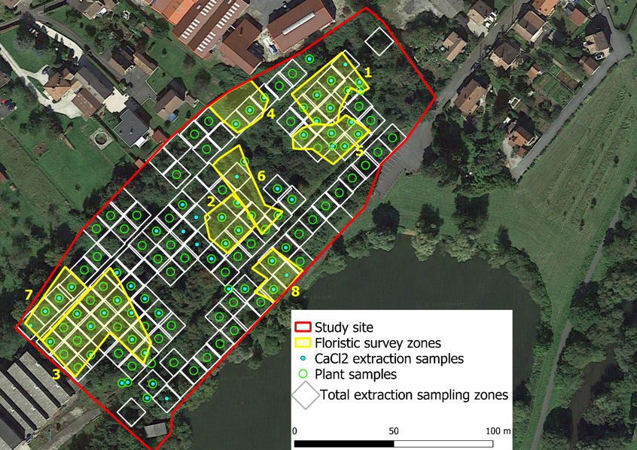

Fig. S1. Location of soil sampling plots for total and CaCl2 extractable fractions and leaf sampling plots and delimitation of homogeneous vegetation zones for the floristic survey (zones 1 to 8) at the industrial wasteland.

Table S1. Toxicological reference values for As, Cd, Cr, Cu, Hg, Ni, Pb and Zn used for HQ and CR calculations for threshold and non-threshold effects, according to MEEM, 2017.

|  |  |  |
| --- | --- | --- |
| **Element** | **Threshold effect TRV** | **Non-threshold effect TRV** |
| As | 0.00045 | 1.5 |
| Cd | 0.00036 | / |
| Cr | 0.0009 | 0.5 |
| Cu | 0.14 | / |
| Hg | 0.00066 | / |
| Ni | 0.0028 | / |
| Pb | 0.0005 | 0.0085 |
| Zn | 0.3 | / |

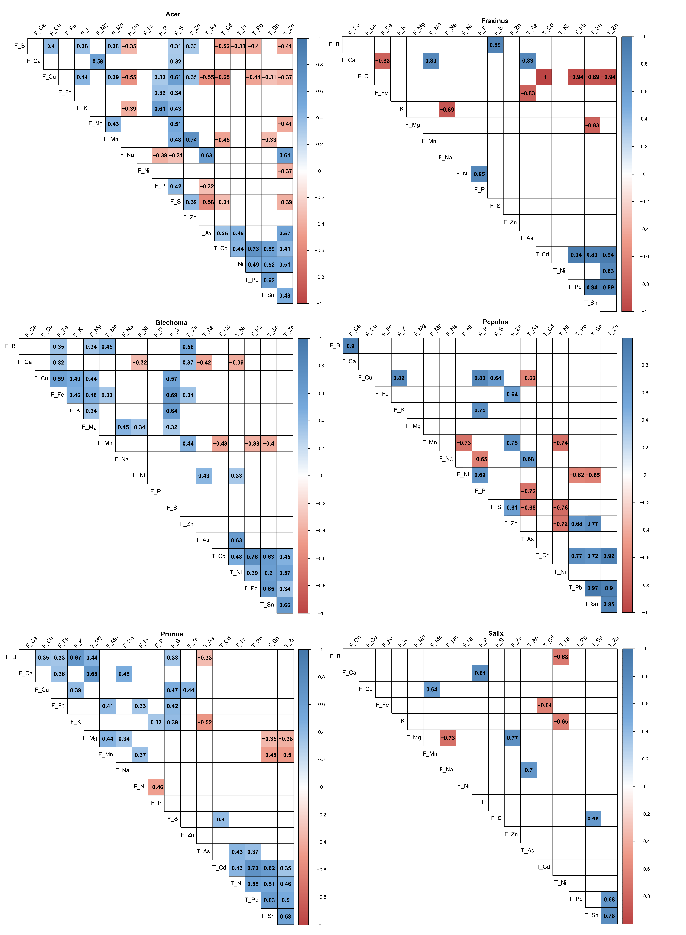

Fig. S2. Correlation matrix of nutrient leaf contents and total TE contents for the genera Acer, Fraxinus, Glechoma, Populus, Prunus and Salix. The Spearman correlation coefficient is shown only for tests with a p value < 0.05. L: Leaf contents; T: Total contents in soil

Table S2. Range of values for HQ and CR and number of soil sampling areas with possible risk (0.2 ≤ HQ ≤ 5, 10-6 ≤ CR ≤ 10-4) and identified risk (HQ > 5, CR > 10-4) for plant and soil scenarios. The scenarios are presented individually and together (sum of HQ and CR values).

|  |  |  |  |  |  |  |  |  |  |  |
| --- | --- | --- | --- | --- | --- | --- | --- | --- | --- | --- |
| Risk type | Element | Plant scenario | | | Soil scenario | | | Plant and soil scenarios | | |
| Range of values | Nb areas with possible risk | Nb areas with identified risk | Range of values | Nb areas with possible risk | Nb areas with identified risk | Range of values | Nb areas with possible risk | Nb areas with identified risk |
| HQ | As | 0 - 0.115 | 0/125 | 0/125 | 0.061 - 0.572 | 86/125 | 0/125 | 0.061 - 0.675 | 87/125 | 0/125 |
| Cd | 0 - 0.613 | 2/125 | 0/125 | 0.002 - 0.334 | 3/125 | 0/125 | 0.002 - 0.618 | 5/125 | 0/125 |
| Cr | 0 - 0.343 | 2/125 | 0/125 | 0.002 - 0.121 | 0/125 | 0/125 | 0.002 - 0.393 | 2/125 | 0/125 |
| Cu | 0 - 0.004 | 0/125 | 0/125 | 0 - 0.032 | 0/125 | 0/125 | 0 - 0.032 | 0/125 | 0/125 |
| Hg | 0 | 0/125 | 0/125 | 0.001 - 0.021 | 0/125 | 0/125 | 0.001 - 0.021 | 0/125 | 0/125 |
| Ni | 0 - 0.057 | 0/125 | 0/125 | 0.014 - 1.445 | 18/125 | 0/125 | 0.016 - 1.453 | 19/125 | 0/125 |
| Pb | 0 - 0.159 | 0/125 | 0/125 | 0.136 - 170.4 | 98/125 | 11/125 | 0.136 - 170.4 | 101/125 | 11/125 |
| Zn | 0 - 0.071 | 0/125 | 0/125 | 0.002 - 0.935 | 6/125 | 0/125 | 0.002 - 1.006 | 6/125 | 0/125 |
| CR | As | 0 - 6.63-6 | 0/125 | 0/125 | 3.52-6 - 3.31-5 | 110/125 | 0/125 | 3.52-6 - 3.91-5 | 110/125 | 0/125 |
| Cr | 0 - 1.32-5 | 1/125 | 0/125 | 8.26-8 - 4.67-6 | 0/125 | 0/125 | 8.26-8 - 1.51-5 | 1/125 | 0/125 |
| Pb | 0 - 5.78-8 | 0/125 | 0/125 | 4.97-8 - 6.21-5 | 6/125 | 0/125 | 4.97-8 - 6.21-5 | 6/125 | 0/125 |