Floristic survey, trace element transfers between soil and vegetation and human health risk at an urban industrial wasteland.

Jordan Collot1, Philippe Binet1, Abdoulaye Mahamat Malabad1, Benjamin Pauget2, Marie-Laure Toussaint1, Michel Chalot1, 3*.

1Chrono-Environnement UMR6249, Université Franche-Comté CNRS, F-25000, Besançon, France.

2TESORA, Le Visium, 22 avenue Aristide Briand, 94110 Arcueil, France.

3Université de Lorraine, Faculté des Sciences et Technologies, Nancy, 54000, France.

⁎ Corresponding author : michel.chalot@univ-fcomte.fr (M. Chalot).

Highlights

* The floristic composition of a wasteland was determined under heterogeneous levels of trace element contamination.
* Trace element contamination reduced biodiversity by selecting tolerant species.
* The dominant species, *Alliaria petiolata*, is a potential Zn bioindicator with the highest leaf Zn, Ni and Cd uptake.
* Pb and As are the elements that presented the greatest risk to human health in the case of accidental soil ingestion.

Abstract:

This study aimed to determine the trace element accumulation in the soil and plants in an industrial wasteland and to estimate the extent of transfer to humans to measure the effects on and risks to vegetation and human health and find bioindicator plants representative of the levels of the main contaminants. In areas with the highest extractable trace element levels, we observed decreases in plant biodiversity explained by the disappearance of several families, favouring the coverage of tolerant species, such as *Urtica dioica* and *Hedera helix*. Trace elements were also found in the leaves of several plants, especially in a dominant species that is poorly studied, *Alliaria petiolata*. Indeed, this species had the highest contents of Zn (1750 mg.kg-1 DW), Ni (13.1 mg.kg-1 DW), and Cd (18 mg.kg-1 DW) found at the site and is a potential Zn bioindicator since its leaf contents were also representative of the Zn extractable contents in soil (R² = 0.94). The hazard quotient and carcinogen risk revealed that most of the site had an identified or possible risk, mainly due to Pb and As. Native species, especially *A. petiolata*, could be used in phytoextraction to manage and limit these human and environmental risks.

Key words:

Industrial wasteland; *Alliaria petiolata*; Trace elements; Contaminated soils; Bioindicator; Human health; Hazard quotient; Carcinogen risk; Phytomanagement.

# Introduction

Due to human activities, large quantities of potentially toxic elements have been released into the environment since the end of the 19th century (Zhang & Wang, 2020). These activities have led to the formation of many marginal sites containing various organic and inorganic compounds in soil (Panagos et al., 2013). The presence of these compounds may impair the ecosystem services provided by the soil of these sites (Morel et al., 2015), such as provisioning services (raw materials, food) or regulating services (water quality, carbon storage, maintaining biodiversity, Jónsson & Davíðsdóttir, 2016). The cost of contamination management leads to a lack of interest in these sites and urban management that favours the artificialization of agricultural land rather than the rehabilitation of these soils (Vidal-Baudet & Rossignol, 2018). Approximately 690 000 industrial sites with past or current polluting activities were identified in the European Union (EU) in 2018 (Paya Perez & Rodriguez Eugenio, 2018), while the Géorisques database (https://www.georisques.gouv.fr/) listed 16 000 sites in France in 2022. Contamination is due to various sources, such as industrial production and commercial services (36%), the oil industry (17%), municipal waste (15%) and industrial waste (9%) (Paya Perez & Rodriguez Eugenio, 2018). The most common contaminants affecting soil are trace elements (TEs) (Panagos et al., 2013). Being nonbiodegradable, TEs tend to accumulate in the environment and could impact the environment and human health (Ali et al., 2013), even at very low concentrations (Arora et al., 2008).

Most TEs are strongly bound to the soil; however, there is always a spreading risk due to the mobile fraction that can be transferred into the ecosystem (Qasim & Motelica-Heino, 2014). Moreover, if some TEs, such as Zn, Cu or Mn, are essential for the health and development of plants and animals (Alloway, 2013), excessive contents may have adverse impacts. Some other TEs without known biological function (e.g., Cd, Pb) present high toxicity for most organisms. The effect of TEs depends on their contents and physico-chemical properties, Zn, Pb, Cd, Cu and Ni being frequently studied elements, as they are considered to have the greatest impact on organisms (Diatta et al., 2003). They can provoke damage to cells (Kabata-Pendias, 2011) and disrupt cellular processes such as photosynthesis among primary producers (Prasad & Strzałka, 1999; Warsi et al., 2023), cause oxidative stress, generate neurotoxic effects, disrupt the function of numerous enzymes, and increase cancer risk (Ali et al., 2013; Turdi & Yang, 2016).

As primary producers, plants are some of the first organisms to suffer from high TE contents in soils. TE transfer from soil to plants constitutes crucial information for understanding the environmental impacts of these pollutants. Ions enter plants through their roots and are then either directly stored or translocated to the shoots through xylem vessels and more specifically deposited in vacuoles (Verbruggen et al., 2009; Rascio & Navari-Izzo, 2011). Sequestration in vacuoles is a way to cope with high metal concentrations and limit their impact on metabolic processes, increasing plant tolerance to TE-contaminated soils (Jabeen et al., 2009). In this way, TEs could be transferred into food chains and will accumulate through networks to become potentially harmful for plant and animal health, including that of humans (Aycicek et al., 2008; Rajaganapathy et al., 2011).

In the context of the rehabilitation of industrial territories, it is necessary to manage marginal sites, often localized around urban areas, to restore their value, in particular through ecosystem services and hence the development of new uses. Proper management of soil pollution requires knowledge of the risks and impacts of contaminants on human health and the environment. For this purpose, plants can be vectors of information about the contamination degree and toxic effects (Diatta et al., 2003). The capacity of a plant to be used as a bioindicator mostly depends on its capacity to take up and accumulate contaminants to a level representative of soil contents (Kabata-Pendias, 2011; Favas et al., 2012). The risk for human health associated with exposure to contaminants can be assessed by measuring the hazard quotient (HQ) and carcinogenic risks (CR) according to scenarios of human ingestion of soil and/or plants from a contaminated site (Antoine et al., 2017; Dehghani et al., 2018). These indexes provide information about the human risk associated with each contaminant present at a site and therefore about the management priorities for the elements present.

In this context, the aims of the present study are as follows: i) Locate and quantify TEs in soil and determine their effect on the floristic diversity of an industrial wasteland. This diversity will be assessed by a floristic survey as well as the measurement of the vegetation cover of species. ii) Determine the accumulation of TEs in plants to estimate the potential of using indigenous plants as bioindicators of contamination as well as measuring the TE effect on nutrient accumulation. For this purpose, the leaf contents of TEs and their relationship with the soil contents will be measured. iii) Calculate the human HQ and CR for individuals exposed to contaminants by soil ingestion and consumption of edible plants. Contaminant levels in soil and plant leaves will be used for the calculation based on the elemental toxicity and exposure scenarios.

We hypothesized that the variable level of TEs on the site induced the presence of different plant communities by reducing biodiversity and selecting tolerant species in heavily contaminated areas. TEs can also have toxic effects on plants and pose a risk for human health in the event of exposure. On the other hand, among the tolerant species at the site, some could be bioindicators with potential to be used in management decisions.

# Materials and methods

2.1 Study site

The study site is a 2 ha industrial wasteland located in the city of Vieux-Charmont (47°31'15.8"N, 6°50'23.8"E) in eastern France. This wasteland is surrounded by dwellings, a pond created in 1957, the river “La savoureuse” and 2 operational factories (Fig. 1). Several activities have taken place in the factories since 1871, such as watchmaking, heat treatment and manufacture of piston pins, cars and precision parts. The site was used as an uncontrolled landfill for industrial and household wastes, found buried and on the surface. The wasteland was closed to the public in 2007 after soil analysis revealed contamination by organic (PAH, PCB) and inorganic (Zn, Pb, Cd, As, Cu, Ni, Cr, Hg) compounds.

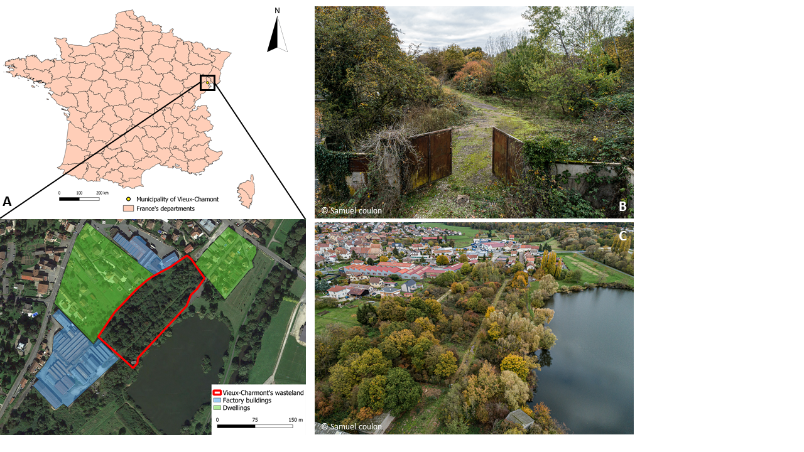

Fig. 1. The industrial wasteland of Vieux-Charmont (Doubs, France). (A) Location of the Vieux-Charmont wasteland (in red) and its environment. (B) Aerial picture of the Vieux-Charmont wasteland entrance. (C) Aerial picture of the Vieux-Charmont wasteland and its environment.

2.2 Floristic survey

From June to July 2020, a floristic survey of the herbaceous layer was carried out in 8 zones; 4 zones had intense woody cover and were named undergrowth zones (UZ, zones 1 to 4), and 4 zones were considered open zones (OZ, zones 5 to 8) with low woody cover, as representative as possible of the diversity of the accessible parts of the site (Fig. S1). Each zone was homogenous in terms of vegetation, cover, stratification and human intervention. Between 10 and 20 quadrats of 0.2 m² were randomly delimited on each zone, and the species present on these surfaces were determined as well as their cover value based on the Braun-Blanquet scale and cover estimation (+, 1, 2, 3, 4, 5 for 0.1, 2.5, 15, 37.5, 62.5, 87.5%, respectively) (Wikum & Shanholtzer, 1978; Anne et al., 2021). Based on these data, four diversity indices were calculated: species richness, Shannon index (eq. 1), Simpson index (eq. 2) and Hill index (eq. 3).

$$\begin{aligned}H’ = - \sum{\left(pi∙log\left(pi\right)\right)}\#\left(eq. 1\right)\end{aligned}$$

$$\begin{aligned}λ = 1 – \left(∑\left({pi}^{2}\right)\right)\#\left(eq. 2\right)\end{aligned}$$

$$\begin{aligned}Hill=1-\left(\frac{λ-1}{\exp\left(H’\right)}\right)\#\left(eq. 3\right)\end{aligned}$$

pi being the cover value of species i divided by the total plant cover value. The Simpson and Hill indices are subtracted from 1; thus, for each of the four indices, an increase in value means higher diversity.

2.3 Soil sampling and analyses

In May 2021, soil was sampled in 125 zones (10 m x 10 m) that cover all accessible parts of the site (Fig. S1). A composite sample was collected in each zone by mixing 4 samples taken from the corners and 1 sample taken in the middle of the zone at a depth of 0-30 cm. The samples were then stored in plastic bags and air dried before analysis. The pH value was determined directly on the soil samples using a field Soil Stick pH meter (Spectrum Technologies, Inc., Aurora, USA) (Tano et al., 2020). The total element content was measured on a 500 mg dry soil sample using inductively coupled plasma atomic emission spectrometry (ICP‒AES, Thermo Fischer Scientific, Inc., Waltham, USA) after acid digestion (DigiPREP system, SCP Sciences, Courtaboeuf, France) using a mixture of 2 ml of 67% nitric acid, 6 ml of 34% hydrochloric acid and 2 ml of 48% hydrofluoric acid (Ciadamidaro et al., 2019).

Soil samples collected for total element fraction measurements were also used to ensure at least 3 measurements of the extractable fraction in each floristic survey zone (the number of samples depended on the surface). These samples are related to one of the 125 zones described in Fig. S1 and are considered representative of the zone. 2.5 g of dried soil was extracted with 25 ml of 0.01 M CaCl2 solution under constant agitation at 100 rpm for 3 h (Houba et al., 1996). Then, the samples were filtered, acidified at 1% (v/v) and quantified by ICP‒AES.

2.4 Plant sampling

Leaf samples were collected from the genera *Acer*, *Ailanthus*, *Alliaria* (on first- or second-year plants), *Betula*, *Fraxinus*, *Glechoma*, *Populus*, *Prunus*, *Quercus*, *Salix* and *Urtica*, which are well represented herbaceous plants, shrubs and trees found throughout the site during two campaigns in summer 2018 and autumn 2021. A maximum of one sample per species was sampled in the 125 zones previously described (Fig. S1). The samples were stored in plastic bags at 4°C until washing with distilled water to remove soil particles. Samples were then dried in an oven at 70°C and crushed for 3 min in a mixer mill (MM 200, Retsch, Éragny, France) at 30 rps before analysis. The plant element concentration was measured in 100 mg samples using ICP‒AES after acid digestion using a mixture of 2 ml of 67% nitric acid and 0.5 ml of 35% oxygen peroxide (Assad et al., 2017).

2.5 Measurement of the human health risk

Based on the contaminant contents in the total soil fraction and in edible plant leaves, the daily intake (DI; eq. 4) of contaminants was calculated according to the French national methodology of management of polluted sites and soils (MEEM, 2017). Two exposure scenarios were considered in the present study: (1) ingestion of 91 mg of soil per day (Stanek et al., 2001) while frequenting the site 148 days a year for 6 years by a 15 kg child and (2) ingestion of 37.5 g of edible plant leaves per day (Barbillon et al., 2019), 26 days a year, corresponding to 7% of the total leaf consumption from the site, for 6 years by a 15 kg child. Two plants with edible leaves are considered, *Alliaria petiolata* and *Urtica dioica*.

$$\begin{aligned}DI \left(mg.{kg}^{-1}.{day}^{-1}\right)=\frac{C x IR x EF x ED}{BW x \left(AT x 365\right)}\#\left(eq. 4\right)\end{aligned}$$

C is the concentration of the material ingested (mg.kg-1 of dry weight for soil and mg.kg-1 of fresh weight for leaves); IR is the intake rate of material (kg.day-1); EF is the exposure frequency (day.year-1); ED is the exposure duration (years); BW is the body weight (kg); AT is the average time (years), equivalent to ED for noncarcinogenic contaminants or a lifetime (70 years) for carcinogenic contaminants (MEEM, 2017).

The hazard quotient (HQ; eq. 5) for threshold effects and the carcinogenic risk (CR; eq. 6) for non-threshold effects were calculated for each contaminant studied when the toxicological reference value (TRV) was available (As, Cd, Cr, Cu, Hg, Ni, Pb and Zn for threshold effects and As, Cr and Pb for non-threshold effects). In accordance with the national methodology (MEEM, 2017), the DI values were compared to TRV, as described in Table S1.

$$\begin{aligned}HQ=\frac{DI}{TRV}\#\left(eq. 5\right)\end{aligned}$$

$$\begin{aligned}CR=DI x TRV\#\left(eq. 6\right)\end{aligned}$$

For HQ and CR, the sum of the values for the soil and plant scenarios in each soil sampling area are considered for interpretation. According to the methodology, there is no risk for HQ values < 0.2 and CR values < 10-6, a possible risk for HQ values between 0.2 and 5 and CR values between 10-6 and 10-4 and an identified risk for HQ values ≥ 5 and CR values ≥ 10-4 (MEEM, 2017).

2.6 Mapping and statistical analysis

Mapping was performed with QGIS (ver. 3.16) using Google background maps. The analyses were performed using R (ver. 4.1.1) with the packages *agricolae* (De Mendiburu, 2021), *corrplot* (Wei & Simko, 2021), *cowplot* (Wilke, 2020), *ggplot2* (Wickam, 2016), *Hmisc* (Harrell, 2022), and *vegan* (Oksanen et al., 2022). For all the tests performed, results were considered statistically significant at a p value < 0.05. The Shannon and Simpson diversity indices were calculated using *vegan*. The normality of the data was first tested using Shapiro‒Wilk and Levene tests. Comparisons of means were made using Kruskal‒Wallis tests for biodiversity indices and extractable TE contents by vegetation zone as well as for foliar TE contents between genera. Spearman’s test was used to assess the correlation between biodiversity indices and TE extractable contents, between pH values and TE extractable percentage and between soil total contents of TEs and nutrient contents in plant leaves. The graphs were made using the *ggplot2* package, and the correlation matrix was made using the *corrplot* package.

# Results

3.1 Soil TE contents

The main contaminants found at the site were Zn, Pb, Cd, Sn, Hg, Ni and As (Fig. 2), which were heterogeneously distributed throughout the investigated area. Indeed, in most of the wasteland, the measured contents varied from 200 to 10 000 mg.kg-1 dry weight (DW) for Zn, 0.2 to 10 mg.kg-1 DW for Cd, 30 to 2 500 mg.kg-1 DW for Pb, 2 to 1 830 mg.kg-1 DW for Sn and 0.12 to 2 mg.kg-1 DW for Hg. However, the contaminant map highlighted a heavily contaminated zone of almost 500 m² in the northeast of the site that contained the highest amounts of Zn (36 000–115 000 mg.kg-1 DW), Pb (13 500–34 600 mg.kg-1 DW), Cd (17–50 mg.kg-1 DW), Sn (3 200–13 600 mg.kg-1 DW), and Hg (1.4–4.5 mg.kg-1 DW). Concerning Ni and As, the contents varied from 16 to 1650 mg.kg-1 DW and 11 to 105 mg.kg-1 DW, respectively. The highest contents for these two elements were localized in the south of the site, close to the factory and the pond. In addition, the site was also contaminated with Cr (26-1475 mg.kg-1 DW), Cu (24–1800 mg.kg-1 DW), Fe (13 000–224 000 mg.kg-1 DW) and Mn (250–2300 mg.kg-1 DW). Cu was localized in the most contaminated area of the site (northeast), and Cr, Fe and Mn were localized in the southern part of the site, similar to Ni and As. The pH values were heterogeneous throughout the site, although they remained close to neutral, with values that varied from 6.4 to 7.3 in the most contaminated zone (Fig. 2). The other part of the site had pH values that varied from 4 to 7.9, and the lowest pH value (4–5.5) was localized along a line from the southwest of the site to the centre.

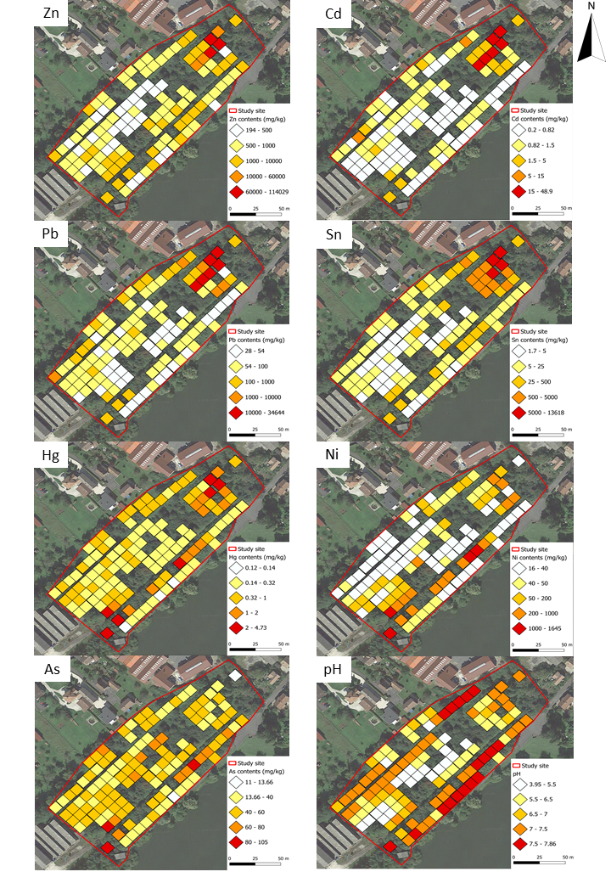

Fig. 2. Maps of total contents of the main contaminants (Zn, Cd, Pb, Sn, Hg, Ni, As) and pH value localized at the soil sampling plots described in Fig. S1 in the industrial wasteland. For TE contents, the first levels of the scale (white square) range from the minimum values found on the site to twice the world soil average values defined by Kabata-Pendias (2011), except for Zn, where the minimum value was too high.

The analysis of the bioavailable fractions further revealed this high heterogeneity for both the UZ (zones 1 to 4) and OZ (zones 5 to 8) (Fig. S1 & 3). Zones 1 and 5 were statistically the most contaminated zones, with Zn extractable contents of 110 and 85 mg.kg-1 DW, respectively, while the other zones had Zn contents of < 4 mg.kg-1 DW (Fig. 3B). Furthermore, the same distribution was observed in zone 1 for Sn, with a mean value of 1.1 mg.kg-1 DW; this value was higher than that in the other zones, with a content of 0.026 in zone 5 and contents below the limits of quantification (< LQ) in the other zones. Zone 5 had the highest contents of Ni, with a value of 0.74 mg.kg-1 DW, which was statistically higher than that in the other zones (except zone 3), where the contents were in the range of 0.02-0.39 mg.kg-1 DW. For other TEs, although zones 1 and 5 had the highest Pb and Cd contents, the differences in content were lower. Indeed, the contents varied from 0.01 to 0.1 mg.kg-1 DW for Cd (< LQ for zones 4 and 8), from 0.01 to 1.8 mg.kg-1 DW for Pb (< LQ for zone 6) and from 0.01 to 0.036 mg.kg-1 DW for As (< LQ for zones 2, 5, 6, 7 and 8) (Fig. 3A).

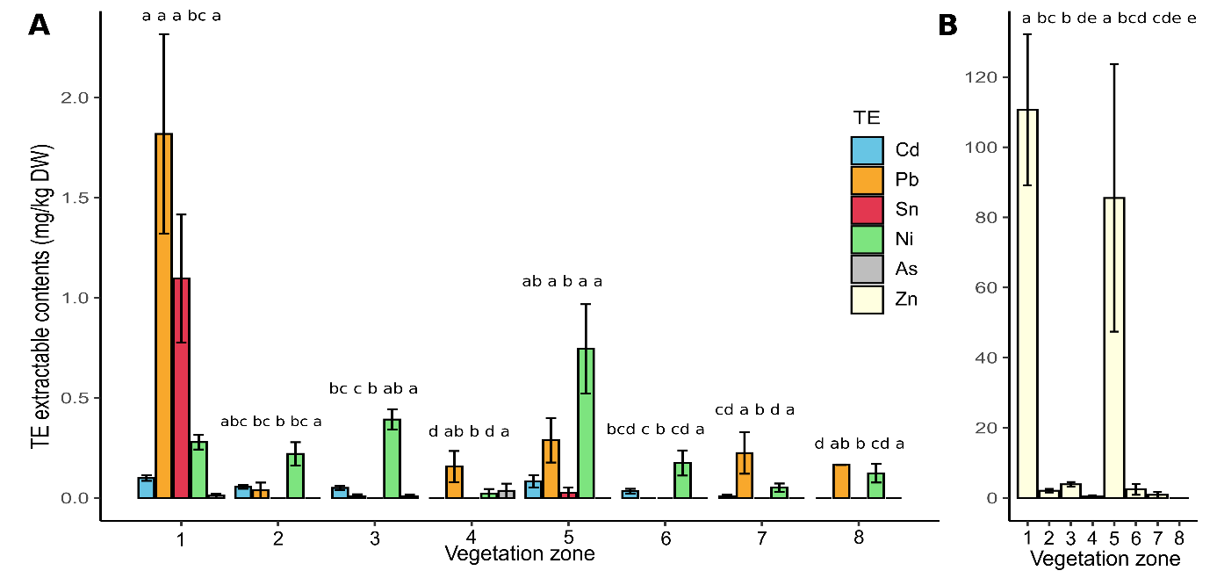

Fig. 3. Mean CaCl2 extractable contents (mg.kg-1 DW) of Cd, Pb, Sn, Ni, As (A) and Zn (B) in the 8 floristic survey zones and standard errors. Letters in common indicate statistically similar groups at p < 0.05 according to Kruskal‒Wallis and post hoc pairwise comparison tests.

3.2 Plant diversity

The floristic survey, conducted over a total area of 4860 m², and the vegetation samples led to the identification of 96 species (including 72 herbaceous species) belonging to 40 families (Tables 1 & 2).

Table 1. Identification and frequency of species from the herbaceous layer on the Vieux-Charmont wasteland. Frequencies were measured based on the number of quadrats in the floristic survey.

|  |  |  |  |  |  |
| --- | --- | --- | --- | --- | --- |
| **Family** | **Species** | **Frequency (%)** | **Family** | **Species** | **Frequency (%)** |
| Aceraceae | *Acer campestre* | 23.6 | Juglandaceae | *Juglans regia* | 0.9 |
| Aceraceae | *Acer pseudoplatanus* | 4.5 | Lamiaceae | *Galeopsis tetrahit* | 21.8 |
| Adoxaceae | *Sambucus nigra* | 15.5 | Lamiaceae | *Glechoma hederacea* | 29.1 |
| Apiaceae | *Aethusa cynapium* | 1.8 | Lamiaceae | *Lamium maculatum* | 10.0 |
| Apiaceae | *Daucus carota* | 8.2 | Lamiaceae | *Stachys sylvatica* | 0.9 |
| Apiaceae | *Heracleum sphondylium* | 1.8 | Malvaceae | *Malva moschata* | 1.8 |
| Apiaceae | *Torilis japonica* | 8.2 | Malvaceae | *Malva alcea* | 0.9 |
| Aquifoliaceae | *Ilex aquifolium* | 1.8 | Oxalidaceae | *Oxalis stricta* | 2.7 |
| Araliaceae | *Hedera helix* | 42.7 | Papaveraceae | *Chelidonium majus* | 0.9 |
| Asteraceae | *Achillea millefolium* | 4.5 | Plantaginaceae | *Linaria vulgaris* | 8.2 |
| Asteraceae | *Artemisia vulgaris* | 3.6 | Plantaginaceae | *Plantago lanceolata* | 0.9 |
| Asteraceae | *Cirsium arvense* | 1.8 | Poaceae | *Agrostis capillaris* | 14.5 |
| Asteraceae | *Cirsium vulgare* | 3.6 | Poaceae | *Arrhenaterum elatius* | 12.7 |
| Asteraceae | *Crepis capillaris* | 6.4 | Poaceae | *Avena fatua* | 2.7 |
| Asteraceae | *Erigeron annuus* | 26.4 | Poaceae | *Brachypodium sylvaticum* | 0.9 |
| Asteraceae | *Erigeron canadensis* | 6.4 | Poaceae | *Dactylis glomerata* | 19.1 |
| Asteraceae | *Jacobea vulgaris* | 2.7 | Poaceae | *Elymus caninus* | 4.5 |
| Asteraceae | *Lactuca serriola* | 3.6 | Poaceae | *Elystrigia repens* | 1.8 |
| Asteraceae | *Lapsana communis* | 5.5 | Poaceae | *Holcus lanatus* | 6.4 |
| Asteraceae | *Picris hieracioides* | 0.9 | Poaceae | *Poa trivialis* | 9.1 |
| Asteraceae | *Tanacetum vulgare* | 8.2 | Poaceae | *Triticum aestivum* | 3.6 |
| Asteraceae | *Tripleurospernum inodorum* | 1.8 | Polygonaceae | *Reynoutria japonica* | 0.9 |
| Berberidaceae | *Berberis aquifolium* | 1.8 | Rosaceae | *Crataegus monogyna* | 20.9 |
| Brassicaceae | *Alliaria petiolata* | 40.9 | Rosaceae | *Crataegus laevigata* | 8.2 |
| Campanulaceae | *Campanula patula* | 6.4 | Rosaceae | *Geum urbanum* | 8.2 |
| Cannabaceae | *Humulus lupulus* | 0.9 | Rosaceae | *Potentilla reptans* | 2.7 |
| Caprifoliaceae | *Dipsacus fullonum* | 0.9 | Rosaceae | *Prunus avium* | 1.8 |
| Caryophyllaceae | *Silene vulgaris* | 0.9 | Rosaceae | *Prunus spinosa* | 4.5 |
| Convolvulaceae | *Convolvulus sepium* | 5.5 | Rosaceae | *Prunus domestica* | 2.7 |
| Cornaceae | *Cornus sanguinea* | 7.3 | Rosaceae | *Rubus fruticosus* | 54.5 |
| Dryopteridaceae | *Dryopteris filix-mas* | 1.8 | Rosaceae | *Rubus caesius* | 5.5 |
| Euphorbiaceae | *Euphorbia dulcis* | 8.2 | Rubiaceae | *Galium aparine* | 23.6 |
| Fabaceae | *Lathyrus pratensis* | 0.9 | Rubiaceae | *Galium mollugo* | 18.2 |
| Fabaceae | *Melilotus albus* | 6.4 | Rubiaceae | *Galium rotundifolium* | 0.9 |
| Fabaceae | *Robinia pseudoacacia* | 2.7 | Rubiaceae | *Galium palustre* | 11.8 |
| Fabaceae | *Trifolium pratense* | 4.5 | Scrophulariaceae | *Verbascum blattaria* | 0.9 |
| Fabaceae | *Vicia cracca* | 2.7 | Simaroubaceae | *Ailanthus altissima* | 6.4 |
| Fabaceae | *Vicia sepium* | 0.9 | Solanaceae | *Solanum nigrum* | 0.9 |
| Fagaceae | *Quercus robur* | 0.9 | Taxaceae | *Taxus baccata* | 1.8 |
| Geraniaceae | *Geranium robertianum* | 4.5 | Urticaceae | *Urtica dioica* | 24.5 |
| Geraniaceae | *Geranium pusillum* | 0.9 | Verbenaceae | *Verbena officinalis* | 2.7 |
| Hypericaceae | *Hypericum humifusum* | 0.9 | Vitaceae | *Parthenocissus quinquefolia* | 3.6 |
| Hypericaceae | *Hypericum perforatum* | 14.5 |  |  |  |

Table 2. Shrubs and tree species identified by leaf sampling on the Vieux-Charmont wasteland. Frequencies were measured based on the 125 zones used for soil and plant samplings.

|  |  |  |
| --- | --- | --- |
| **Family** | **Species** | **Frequency (%)** |
| Betulaceae | *Betula verrucosa* | 0.8 |
| Fagaceae | *Quercus petraea* | 2.4 |
| Malvaceae | *Tilia platyphyllos* | 0.8 |
| Oleaceae | *Fraxinus excelsior* | 4 |
| Rosaceae | *Prunus serotina* | 0.8 |
| Salicaceae | *Populus nigra* | 0.8 |
| Salicaceae | *Populus tremula* | 3.2 |
| Salicaceae | *Salix alba* | 0.8 |
| Salicaceae | *Salix fragilis* | 1.6 |
| Salicaceae | *Salix purpurea* | 4 |
| Salicaceae | *Salix viminalis* | 0.8 |

The main families of surveyed species were Asteraceae, Poaceae and Fabaceae (13, 10 and 5 species, respectively), which represented almost 40% of the herbaceous species, as well as Salicaceae and Rosaceae (6 species each), which represented 50% of shrubs and tree species. However, some families were also well represented due to the frequency of certain member species. Indeed, *Hedera helix* was the only species observed from the Araliaceae family, but its frequency was 42.7%. Similarly, the Brassicaceae family was exclusively represented by *A. petiolata* with a frequency of 40.9%. These two plants, along with the Rosaceae species *Rubus fruticosus* (frequency of 54.5%), were the most frequent herbaceous species on the site. Conversely, 25 species were observed only once and had a frequency of less than 1%, such as the herbaceous species *Dipsacus fullonum* (Caprifoliaceae), *Hypericum humifusum* (Hypericaceae) and *Verbascum blattaria* (Scrophulariaceae)and the tree species *Tilia platyphyllos* (Malvaceae), *Prunus serotina* (Rosaceae) and *Salix alba* (Salicaceae).

The species richness ranged from 3.7 to 5.6 in the UZ (zones 1 to 4) and from 5.4 to 7.4 in the OZ (zones 5 to 8); the Shannon index, from 1.17 to 2.09 in the UZ and from 1.61 to 2.39 in the OZ; the Simpson index, from 0.44 to 0.72 in the UZ and from 0.58 to 0.77 in the OZ; and the hill index, from 0.38 to 0.54 in the UZ and from 0.48 to 0.59 in the OZ (Fig. 4).

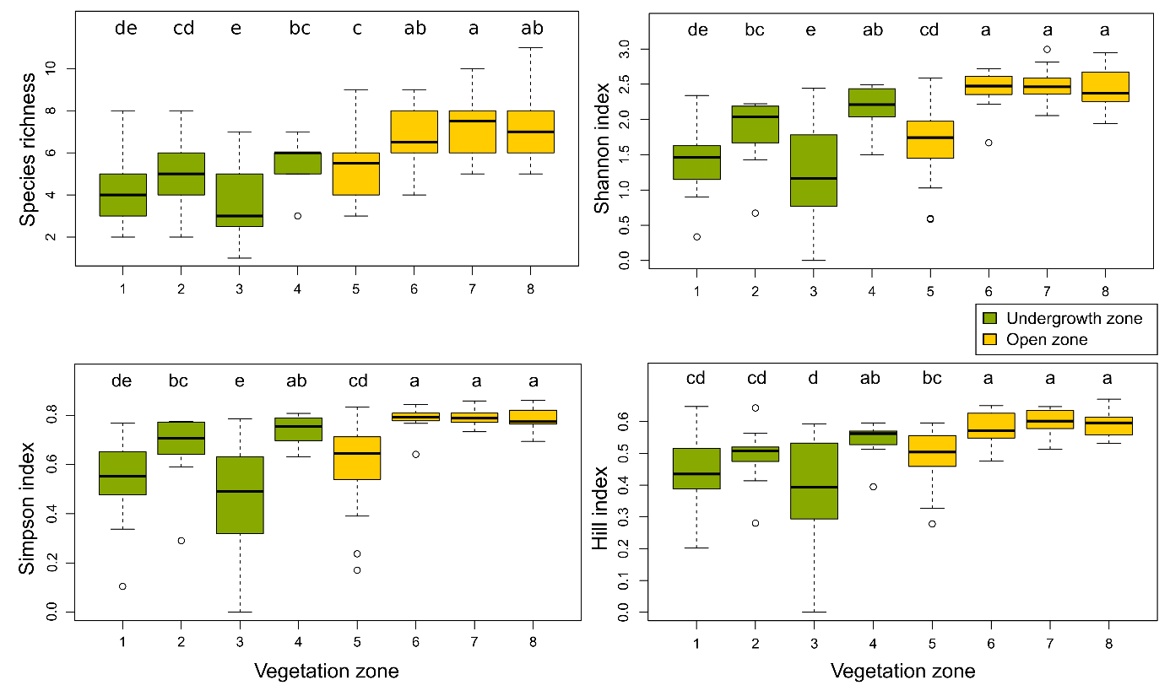

Fig. 4. Boxplots of Shannon, Simpson and Hill indices and species richness in the 0.2 m² quadrats of the 8 survey zones. Letters in common indicate statistically similar groups at p < 0.05 according to Kruskal‒Wallis and post hoc pairwise comparison tests.

Overall, the OZ had statistically higher biodiversity indices than the UZ (p values < 0.01), except for zone 4, which was the least contaminated part of the UZ, and zone 5, which was the most contaminated part of the OZ. We also observed that the biodiversity indices of zone 4 were all statistically higher than those of zones 1 and 3. This was also the case for zone 2 but only for the Shannon and Simpson indices. Concerning the OZ, the most contaminated area (zone 5) had a systematically lower biodiversity for each index than the three other zones. In addition, the TE extractable contents and the biodiversity indices for the UZ had significant anticorrelations with Zn (from -0.28 to -0.45) and Ni (from -0.39 to -0.57). For the OZ, there were not only anticorrelations with Zn (from -0.44 to -0.6) and Ni (from -0.48 to -0.62) but also with Cd (from -0.44 to -0.6), Pb (from -0.36 to -0.61) and Sn (from -0.47 to -0.68).

In addition to these relationships between biodiversity and TE extractable contents, the plant communities also differed from one zone to another (Fig. 5). Indeed, in the UZ, the Adoxaceae, Apiaceae, Asteraceae, Euphorbiaceae and Poaceae families appeared in zones 2, 3 and 4 but not in zone 1, which was the most contaminated. Moreover, the Rosaceae family represented almost 5.4% of the plants in zone 1, unlike the other zones, where it represented between 8.2 and 15.6%.

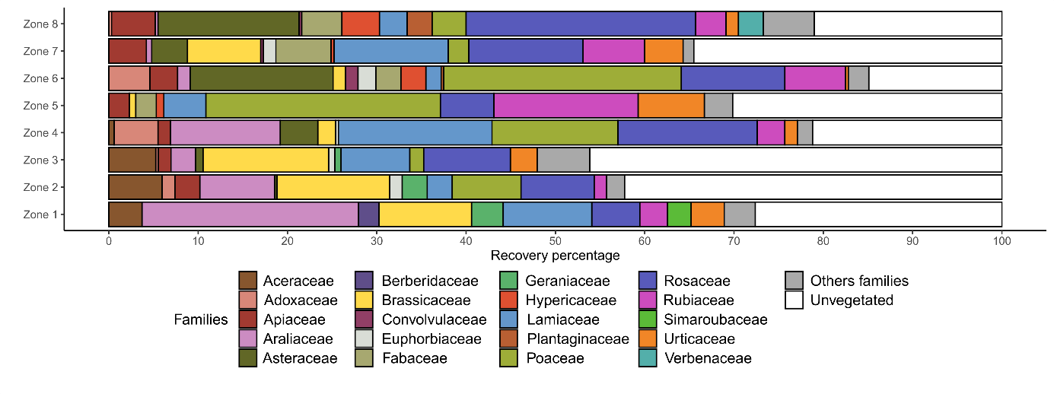

Fig. 5. Plant communities present in the floristic survey zones expressed as a recovery percentage of the 37 families identified and unvegetated parts.

In contrast, Berberidaceae and Simaroubaceae, each represented by only one species at the site, *Ilex aquifolium* and *Ailanthus altissima,* respectively, were found only in zone 1. The Araliaceae family, also represented by only one species, *H. helix*, represented a quarter of the vegetation (24.25%) in zone 1, while it represented 2.75 to 12.3% of the vegetation in other areas. Concerning the OZ, Asteraceae and Convolvulaceae were not found in the most contaminated zone (zone 5) but were present in the other zones. The Rosaceae family was also less represented in the most contaminated area, with a cover percentage of 6%, compared with 11.6 to 25.7% for the other zones. Conversely, Rubiaceae and Urticaceae were more represented in zone 5, accounting for 16.15 and 7.4% of the vegetation, respectively, in comparison to other zones, where the values varied from 3.4 and 6.9 for Rubiaceae and from 0.3 to 4.3 for Urticaceae. Globally, except for the most contaminated zones (zones 1 and 5), the families identified were similar between the UZ (except Geraniaceae in zone 4 and Urticaceae in zone 2) and the OZ (except Adoxaceae and Plantaginaceae in zone 7 and Euphorbiaceae and Verbenaceae in zone 8).

3.3 TE uptake by the vegetation

*A. petiolata* was the plant species with the highest maximal Zn, Ni and Cd contents, with 1750, 13.1 and 18 mg.kg-1 DW, respectively (Fig. 6). The data also highlighted that the second-year *A. petiolata* accumulated significantly more of these TEs than the first-year plants. For Cd, the maximal content value was found in first-year plants. The Zn, Ni and Cd contents in leaves were highly dependent on the plant genus considered. Indeed, *Alliaria* (second-year plants), *Betula*, *Populus*, *Salix*, *Glechoma* and *Urtica* contained an average of 1250, 1210, 390, 174, 111 and 253 mg.kg-1 DW of Zn, respectively. Those values were significantly higher than those for the *Ailanthus*, *Alliaria* (first-year plants), *Fraxinus*, *Prunus* and *Quercus* genera, where the contents were between 13 and 60 mg.kg-1 DW. For Ni, second-year *Alliaria* had a mean content of 10.7 mg.kg-1 DW, which was statistically higher than that of the other plant genera (except *Populus*, *Quercus* and *Urtica*), where the values varied from 0.36 to 2 mg.kg-1 DW. Concerning Cd, *Alliaria* (second-year plants), *Populus* and *Salix* had mean contents of 1.00, 1.46 and 1.13 mg.kg-1 DW, respectively, which were statistically higher than those of other genera (except *Acer*), where the values were between 0.09 and 0.96 mg.kg-1 (< LQ for *Ailanthus* and *Urtica*). The data also showed high Mn contents in the leaves of Quercus and Acer species, with an average of 400 (max = 1 350) and 280 mg.kg-1 (max = 2 400), respectively. In contrast, other genera showed mean Mn contents that varied from 15 to 150 mg.kg-1 with a maximal value of 550 mg.kg-1.

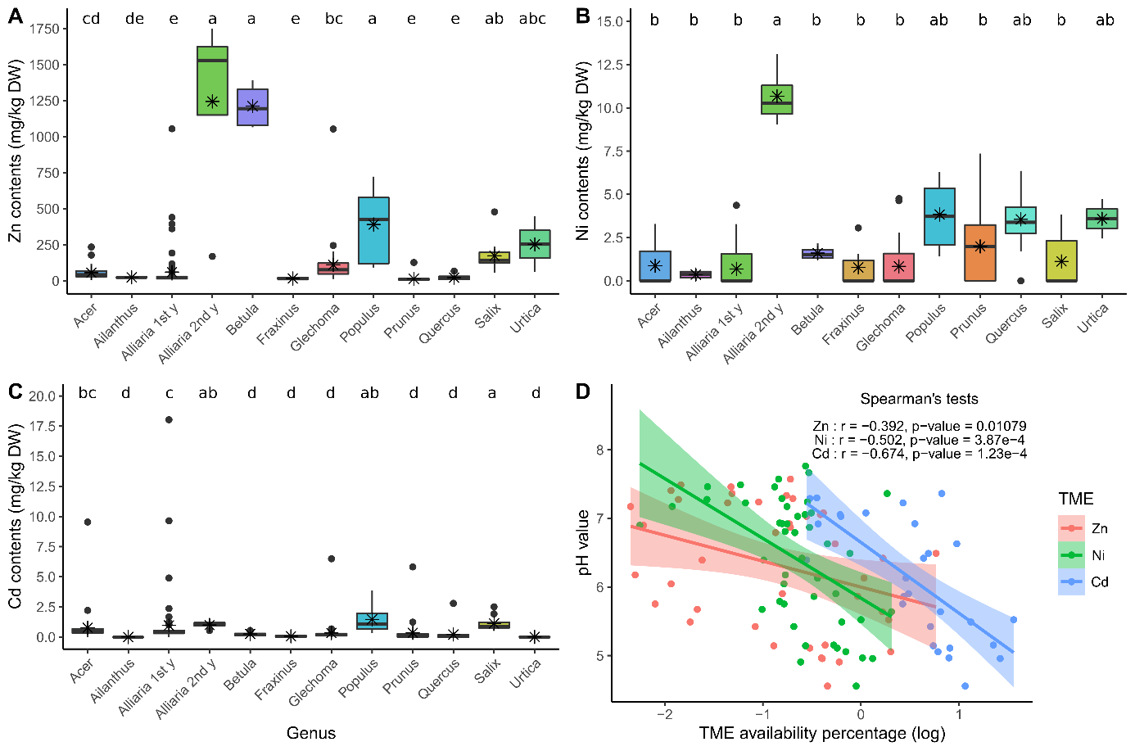

Fig. 6. Leaf contents of Zn (A), Ni (B) and Cd (C) in the main plant genera and TE CaCl2 extractable percentage as a function of pH value (D). The mean value of TE contents in each plant genera is represented by stars in the boxplots. Samples from first-year plants (1st y) and second-year plants (2nd y) are separated for the Alliaria genus. The TE availability is expressed as a logarithm of the percentage of TE availability (extractable contents of TE divided by total contents of TE). The 95% confidence interval is represented in a scatter plot around the equation lines.

The mean Fe and Cu contents in leaves were 82 mg.kg-1 DW (max = 370) and 7 mg.kg-1 DW (max = 42), respectively, for all the genera. Finally, for As, Pb, Cr, Hg and Sn contents in plant leaves, most of the samples had values < LQ. However, the data still showed that Pb reached 10.7 mg.kg-1 DW and As reached 4.2 mg.kg-1 DW for *Alliaria*. We also showed that pH values were anticorrelated with Zn, Ni and Cd availability percentages (Fig. 6), indicating that the extractable contents increased with decreasing pH values. We also highlighted that the anticorrelation was highest for Cd (r = -0.67), followed by Ni (r = -0.5) and finally Zn (r = -0.39). No correlations were found between the pH and the available percentages of As, Pb and Sn.

In addition to the high contaminant contents found in *A. petiolata*, the data showed that Zn leaf contents in first-year plants were representative of soil extractable Zn contents. Indeed, as highlighted in Fig. 7, the scatter plot of these two parameters showed that the leaf contents were strongly related to the extractable contents since the R² value of the relationship was 0.94. Furthermore, there was a positive correlation between these two parameters with an r value of 0.62. This link was observed only for first-year plants.

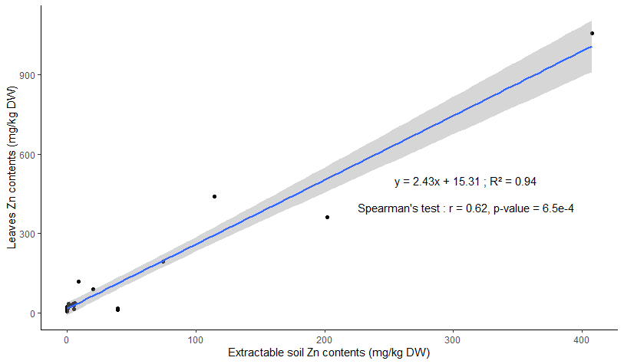

Fig. 7. Scatter plot of the first-year Alliaria petiolata Zn leaf contents depending on Zn CaCl2 extractable contents of soil and Spearman correlation test between these two parameters. The 95% confidence interval is represented around the relationship.

3.4 TE toxicity and risk assessment for plants and humans

The correlations between the nutrient contents in leaves and the TE total contents in soil for the *Alliaria* and *Quercus* genera are compared in Fig. 8. These 2 genera were compared because they had the lowest (*Alliaria*) and the highest (*Quercus*) correlation values of all the genera studied (presented in Fig. S2). Concerning *Alliaria*, few anticorrelations were found between Cd, Pb, Sn and Zn soil contents and Mn leaf contents and between As soil contents and P leaf contents. Correlation coefficients were low, with r values of -0.28 to -0.38 for Mn and -0.26 for P. For other nutrients, there were no highlighted links, but there were positive correlations with Mg (r = 0.27 to 0. 29 for Ni, Pb, Sn and Zn soil contents), S (r = 0.31 to 0.35 for Cd, Pb, Sn and Zn soil contents) and Zn (r = 0.31 to 0.41 for Cd, Ni, Pb, Sn and Zn soil contents). Soil TE contents were more strongly related to nutrient contents for the *Quercus* genus than for *Alliaria*. Indeed, Cu, Fe, K, Mg, Mn, P, S and Zn plant contents were negatively correlated with As, Cd, Ni and Zn soil contents (and with Sn for K, Mn and P). The correlation coefficients were higher for *Quercus* than *Alliaria,* with r values that varied from -0.43 to -0.69 for Fe, K, Mg, P and Zn and from -0.69 to -0.86 for Cu and S.

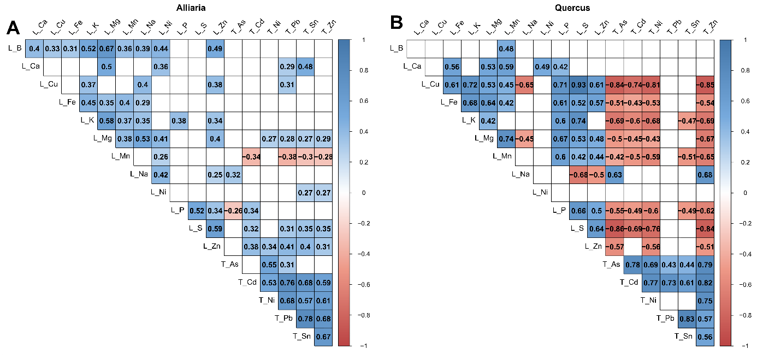

Fig. 8. Correlation matrix of nutrient leaf contents and total TE contents for the Alliaria (A) and Quercus (B) genera. The Spearman correlation coefficient is shown only for tests with a p value < 0.05. L: Leaf contents; T: Total contents in soil.

For other nutrients, the data did not show noteworthy links with soil contents, with only 2 positive correlations between Na leaf contents and As and Zn soil contents (r = 0.63 and 0.68, respectively). In general, the anticorrelations with nutrients were higher for As, Ni and Zn than for Cd and higher for Cd than for Sn.

Based on the TE contents in the plants and soil TE contents, the HQ and CR were calculated, and their values were mapped (Fig. 9). For the soil and leaf ingestion scenarios, most of the sampling areas had a maximal HQ between 0.2 and 5 across the site (117/125 areas) and were considered to have a possible risk for human health. Pb and As were the elements with the highest number of areas with possible risk (101 and 87 areas, respectively), followed by Ni (19 areas), with the areas of risk mainly distributed close to the pond; other elements had lower numbers of areas with possible risk with 6 areas for Zn, 5 areas for Cd and 2 areas for Cr (Fig. 9A). In comparison, only 8 areas had values < 0.2 for all elements and were therefore considered to have no risk (data not shown). In addition, 11 sampling areas had maximal HQ values between 5 and 170 and were therefore considered to have an identified risk (Table S3). One of these areas with high HQ values was localized close to the factory (west), while the others were all in the most contaminated part of the site (north-east). Pb was the only element with HQ > 5 and therefore justifies the risk in these areas. However, in the most contaminated area, a possible risk was also detected for As in 7 areas with HQ values between 0.2 and 5, as well as for Zn (6 areas), Cd (3 areas), Ni (3 areas) and Cr (1 area).

Concerning CR, there was no risk identified in 14 areas (values < 10-6). All the other areas (111 areas) had a possible risk due to values ranging from 10-6 to 10-4 (Fig. 9B). The elevated CR values were often due to As throughout the site, with a maximal value that reached 3.91x10-5, except in the most contaminated area, where Pb (6 areas) and Cr (1 area) also had high CR values that reached 6.21x10-5 and 1.51x10-5, respectively.

A comparison of the two scenarios showed that soil ingestion contributed more than plant consumption to the HQ and CR values (Table S2). Indeed, for the plant consumption scenario, only 4 HQ values exceeded 0.2 for Cd and Cr (max = 0,61 for Cd), and only 1 CR value exceeded 10-6 for Cr (CR = 1.32x10-5). Concerning the soil ingestion scenario, HQ values exceeded 0.2 in 109 areas for Pb (11 areas with HQ > 5), followed by As (86 areas), Ni (18 areas), Zn (6 areas) and Cd (3 areas), and Cr values exceeded 10-6 in 110 areas for As and 6 areas for Pb.

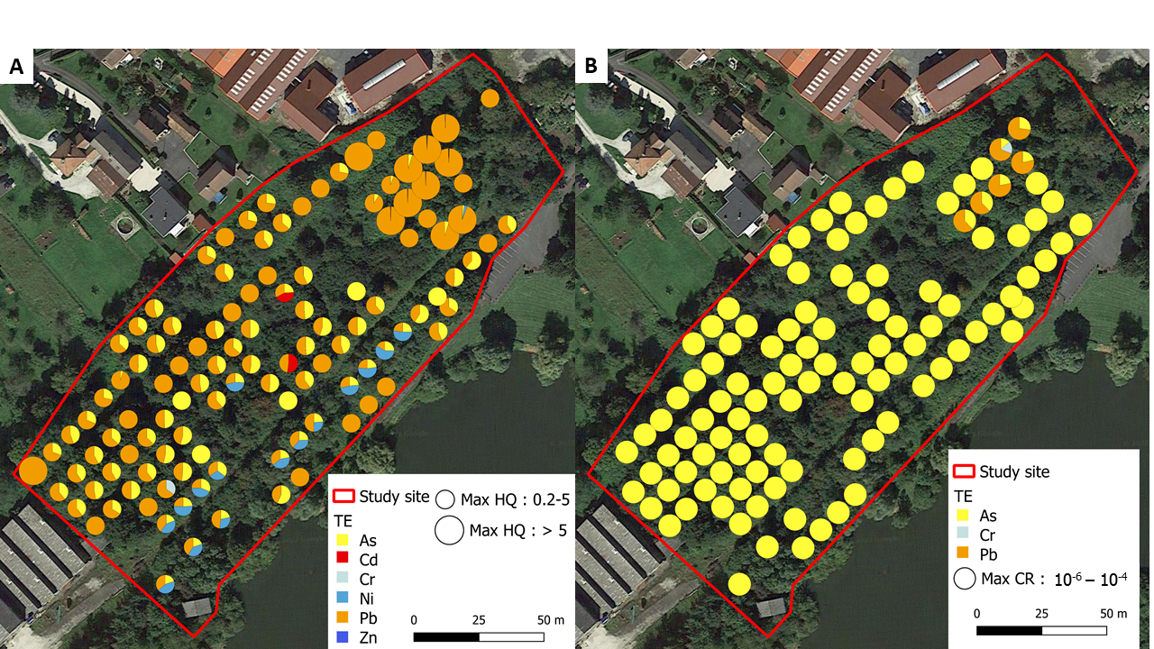

Fig. 9. Location and ranges of HQ (A) and CR (B) values calculated at the study site. For each sampling area, a pie chart compared the HQ or CR values associated with each element. The size of the pie chart represents the HQ or CR value of the element with the highest risk. The values below 0.2 for the HQ and 10-6 for the CR are not shown on the map.

# Discussion

4.1 TE contamination and its impact on floristic diversity and plants

Among the main contaminants described in Fig. 2, all had maximal content values at the site that far exceeded the average TE values in surface soil described by Kabata-Pendias (2011). Indeed, the average values commonly reported were 70, 0.41, 27, 2.5, 0.07, 29 and 6.83 mg.kg-1 for Zn, Cd, Pb, Sn, Hg, Ni and As, respectively. Therefore, this contamination had an effect on the floristic composition of the study site. Indeed, the herbaceous families Asteraceae, Poaceae and Fabaceaeand tree family Salicaceae, which were the dominant plant families at the study site, have also been reported as the main families at a naturally recolonized industrial site contaminated with Mn, Fe, Cu and Zn in France (Zapata-Carbonell et al., 2019). More specifically, 23 species were shared by the two industrial wastelands. These families have also been described as dominant in several other sites contaminated by various TEs, such as As, Pb and Cd in Mexico (Salas-Luévano et al., 2017) and Zn, Cu, Ni and Cr in Cameroon (Anne et al., 2021), although with fewer shared species (2 and 1, respectively). Our results confirm that TE tolerance, regardless of the element considered, is common in species belonging to these families.

However, the composition of the plant communities found on the wasteland differed between the different areas studied. Indeed, two factors structured these communities. The first factor is the type of area, the plant communities are not the same between open and undergrowth areas. This is a logical conclusion since the plants composing the ecosystems have ecological requirements for development, such as light intensity, temperature or humidity (Syed et al., 2018). The second factor is the level of contamination, highlighted in zones 1 and 5, which were the most contaminated UZ and OZ, respectively. The disappearance of species sensitive to TEs along a contamination gradient on a wasteland has already been reported by Dazy et al. (2009). However, our data also showed a decrease in the vegetation cover of some families, even the most represented ones such as Asteraceae, Fabaceaeand Rosaceae. In contrast, coverage for some families, especially Araliaceae, Rubiaceae and Urticaceae, increased with increasing levels of contamination. This is explained by the replacement of species that do not tolerate high levels of TEs by new species and by an increase in the abundance of other species, such as *U. dioica* and *H. helix*, that are more tolerant. Therefore, the contamination level led to a selection of communities based on tolerance to contaminants. As hypothesized, the level of contaminants at the site was a factor that modified the composition of plant communities.

As a consequence, the TE contents in soils explained most of the variation observed for the four biodiversity indices. Indeed, while the lower biodiversity in the UZ than in the OZ was related to the area type, the environmental impacts of contaminants were highlighted by the lower biodiversity indices found in the most contaminated UZ (except zone 3) and OZ areas. These decreases were related to the modifications of the plant communities resulting in the presence of fewer but more abundant species. Indeed, TEs are well known to inhibit plant growth and alter plant communities by selecting tolerant species (Muszynska & Labudda, 2019), thus inducing a reduction in plant biodiversity (Alsherif et al., 2022). More specifically, our data showed that Zn and Ni had the greatest impact on biodiversity for both the UZ and OZ based on the anticorrelations with extractable contents. Cd, Sn and Pb also showed anticorrelation but only for OZ. Zone 3 showed a high percentage of bare soil and therefore low biodiversity indices (with high variability), while contaminant levels were comparable with that in zones 2 and 4. This could be explained by the heterogeneous pH values in this part of the site, varying from 3.95 (minimal pH value on site) to 7, with pH being one of the major soil parameters influencing metal-tolerant plant communities, as shown by Conesa et al. (2007).

In addition to influencing biodiversity, TE contents also modified nutrient uptake, as shown by anticorrelations between TE contents in soil and Cu, Fe, K, Mg, Mn, P, S, Zn contents in the leaves of *Quercus* species (Fig. 8). These differences can be explained by the mechanisms involved in the uptake of nonessential TEs by plants. Indeed, these elements can enter the plant through nonspecific pathways by substituting other divalent cations, such as Ca2+, Cu2+, Mg2+, Fe2+ and Zn2+ (Rascio & Navari-Izzo, 2011; Tibbett et al., 2021), and the effect depends on the element and the plant considered (Boechat et al., 2016). Indeed, for the most accumulative species found at the site, *A. petiolata*, few effects were shown and only for Mn uptake. The tolerance and accumulation capacities are usually explained by the overexpression of genes encoding transmembrane transporters, proteins involved in the responses to oxidative stress and synthesis of metal chelators in accumulator species (Rascio & Navari-Izzo, 2011; Corso & Garcia de la Torre, 2020). The genomic study of *A. petiolata* would allow us to better understand the mechanisms involved in these metal-accumulating species, which should receive attention.

4.2 TE accumulation in plants with a special emphasis on *Alliaria petiolata*

Overall, Zn, Cd and Ni were the most accumulated elements in plant leaves at the site because the CaCl2 extractable fraction of these elements was higher than that for the other elements, e.g., Pb and Sn. The anticorrelations between the availability percentage and the pH value in soil for Zn, Cd and Ni supported this assumption. Indeed, the soil pH value has a strong influence on the availability of these contaminants, and a decrease in the pH value induces an increase in the extractable CaCl2 content, as previously described by other authors (Kashem & Singh, 2001; Spurgeon et al., 2006; Gandois et al., 2010). Therefore, the pH indirectly affected Zn, Cd and Ni plant contents by solubilizing them in soil.

Therefore, of the major contaminants studied at the site, Zn, Cd and Ni were the most heavily accumulated in plants. In particular, the following genera tended to accumulate one or more of these contaminants: *Alliaria* (Zn, Cd, Ni), *Betula* (Zn), *Populus* (Zn, Cd), *Salix* (Zn, Cd) and *Urtica* (Zn). The *Betula*, *Populus* and *Salix* genera are known to contain species with accumulation capacities for Zn and/or Cd (Margui et al., 2007; Migeon et al., 2009; Bissonnette et al., 2010; Mrnka et al., 2012; Dmuchowski et al. 2014), including several species found at the study site (*P. nigra, P. tremula, S. alba, S. fragilis, S. purpurea, S. viminalis*) (Marmiroli et al., 2011). Migeon et al. (2009) found Zn contents varying from 200 to 950 mg.kg-1 DW in the genera *Betula*, *Salix* and *Populus* at a Zn-, Pb- and Cd-contaminated site, which is similar to our data. However, much higher contents can be found in the literature, as for the species *Salix aquatica grandis*, which can reach 2800 mg.kg-1 DW for Zn and 128 mg.kg-1 DW for Cd (Ciadamidaro et al. 2019). These genera are therefore frequently studied in phytoremediation because of their interesting capacities (Mleczek et al., 2010; Lewis et al., 2015; Dadea et al., 2017; Kubatova et al., 2022; Yi et al., 2022; Yin et al., 2022). In contrast, the other genera contained low leaf contents, especially *Ailanthus*, *Fraxinus* and *Prunus*, as found previously (Migeon et al., 2009).

Fe, Cu and Mn were also found to be transferred to the leaves, which seems rational since these are essential elements for plants (Fernando et al., 2016; Lange et al., 2017; Naranjo-Arcos et al., 2017). However, Mn values exceeded the normal leaf content range of 30-300 mg.kg-1 DW described by Kabata-Pendias (2011), especially in samples from the genera *Acer* and *Quercus*. Comparable Mn concentrations have been reported by Stanković et al. (2011), with mean values that ranged between 370 and 550 and 67 and 285 mg.kg-1 DW for *Quercus petraea* and *Acer campestre* species,respectively, species that are also present at our study site. Fernando et al. (2016) found Mn contents that reached 2600 mg.kg-1 DW for *Acer rubrum* (similar to our data) and even higher maximal contents in *Acer saccharum*, with a value of 4300 mg.kg-1 DW. Concerning the *Quercus* genus, Huang et al. (2014) found contents of 800 mg.kg-1 DW, with a maximal value of 2700 mg.kg-1 DW in *Quercus alba* on an Mn mining site, which was almost twice as high as the values found for *Quercus* species at our study site. All of these data highlight that accumulation capacities of Mn, Zn and Cd can vary greatly from one species to another, even within the same genus.

Hg, Sn and Cr were not found in the leaves of any of the tree, shrub or herbaceous species studied. These results are consistent with the contents of these elements found in the soil CaCl2 extractable fraction, which were less than the LQ for most of the samples. Several studies on the chemical distributions of Pb and As have highlighted that the exchangeable fraction of these elements was lower than that of other TEs, such as Cd or Zn (Pichtel et al., 2000; Qasim et motelica-Heino, 2014; Gankhurel et al., 2020). Indeed, depending on the soil, Pb and As could be bound to carbonate, Fe-Mn oxides, organic matter and/or in residual fractions that are harder to extract and therefore less mobile (Angelova et al., 2004; Qasim & Motelica-Heino, 2014) and hence poorly transferred to plant tissues.

The dominant species of the site, *A. petiolata,* which belongs to the Brassicaceae family, showed the highest levels of TEs in its leaves. The Brassicaceae family is known to contain 25% of the metal-hyperaccumulating species described (Gall & Rajakaruna, 2013; Suman et al., 2018), which are more tolerant to metal contamination. *A. petiolata* does not seem to differ from this general feature. To our knowledge, few studies have been conducted on TE contents in this species, with lower values reported than is our study for Zn. Grabner et al. (2011) found maximal contents of 393 mg.kg-1 DW for Zn and 2.1 mg.kg-1 for Cd at contaminated sites. Furthermore, the translocation ratio (ratio between shoot and root contents) was higher than 1 for Zn, Cd and Ni (Grabner et al., 2011; Drozdova et al., 2019), indicating that this species has the capacity to concentrate these three contaminants in its aerial parts. Moreover, the use of *A. petiolata* in phytoextraction strategies has been suggested by Drozdova et al. (2019), and the maximal Zn and Ni values found in the present study were much higher than the previously published data, supporting this potential. In addition, this plant is fast growing and produces a high biomass, which has interesting implications for phytoextraction (Grabner et al., 2011).

*A. petiolata* was also demonstrated to be a relevant Zn bioindicator, being distributed throughout the site. Indeed, Zn accumulation in the leaves of this species was correlated with the CaCl2 extractable fractions. These features are usually described to consider a plant as a metal bioindicator (Kabata-Pendias, 2011).

4.3 Impact of TEs on human health

The HQ and CR calculated for several parts of the site showed that the TE contents could have an impact on human health depending on the soil and plant ingestion scenarios considered. For most of the areas, a possible risk was identified due to Pb and As based on the HQ and CR values. These two elements are known to be particularly toxic to humans either by disturbing metabolism or being carcinogenic (Turdi & Yang, 2016). The element that presented the highest risk at the site for both HQ and CR is Pb, especially in the soil ingestion scenario, due to its high total contents in soil relative to its toxicity. Indeed, even if this element was the second most abundant after Zn, it would remain the greatest threat since its toxicity is a thousand times higher than that of Zn. However, in our study site, the low bioavailability of Pb prevented it from accumulating in plants to levels that are dangerous for humans in the scenarios considered; nevertheless, the maximal contents found reached the tolerable limit for the crops described by Kabata-Pendias (2011), which varies from 0.5 to 10. The low contents available for plants have often been reported in the literature for this element, as previously explained in section 4.2.

Although Pb is the element with the highest risk values at the site, As is the element that most frequently exceeded the boundary between no risk and possible risk. Although this element had no HQ or CR values high enough to identify it as a risk, there is a possible risk in almost all the areas studied. This is explained by the high levels of As throughout the site, with more than 60% of the areas studied having total As contents in soil that exceed 40 mg.kg-1 DW. Indeed, these values are almost 6 times higher than the world soil average of 6.8 mg.kg-1 identified by Kabata-Pendias (2011).

On the other hand, for Cd and Cr, although most of the areas had HQ and CR values < 0.2, the contents in leaves of *A. petiolata* presented a potential risk for humans in the case of consumption for 4 areas at the site. Human exposure to these elements via consumption of metal-accumulating plants in contaminated sites has already been described as potentially toxic (Naz et al., 2020). Concerning Cr, the risk values exceeded 0.2 for only a few parts of the site because most plant sample contents were below the LQ. Nevertheless, even low contents (18 to 25 mg.kg-1 DW) were sufficient to consider a possible risk, indicating that this TE should be taken into consideration even at low levels in plants as should its bioavailability. Cd is considered one of the elements with the most toxic effects on human, animal and plant biological processes (Diatta et al., 2003; Kabata-Pendias, 2011). Antoine et al. (2017) reported that Cd was responsible for higher HQ than As, Al, and Pb in several food crops tested. Our data also showed that this element had the highest risk in the plant exposure scenario. This can be explained by the efficient mechanisms for the uptake and translocation of Cd in plants, although it is not essential, which leads to high concentrations in aerial plant parts (Naz et al., 2020). Consequently, although few areas of the site showed a possible risk for Cd, its bioavailability needs to be monitored, especially under high pH variation, as in our study site. Indeed, pH can greatly increase the Cd contents accumulated in aerial plant parts and thus the risk from consumption.

Overall, the modification of nutrient contents in plants and the measurement of HQ and CR showed that TE contamination had an effect on the environment at the study site. These results highlight the human and environmental risks and the necessity to manage the study site and similar marginal lands to restore interest and uses to these sites.

# Conclusions

The soils of the industrial wasteland located in Vieux-Charmont presented contamination with several TEs, with heterogeneous TE contents and pH values. This has led to the presence of environments with similar abiotic conditions but with modified floristic compositions. Moreover, this study highlighted differences in the accumulation of TEs with the vegetation of the site, depending on the genus considered. One of these species, *A. petiolata*, is also a potential bioindicator of Zn that could provide information about the mobility and spreading risk of this element in ecosystems, especially since the species grows easily in contaminated environments. The accumulation capacities of this species, as well as others on the site, notably those belonging to *Salix*, *Populus* and *Betula*, allow us to consider the possibility of using these indigenous species for managing the site by phytoremediation techniques such as phytoextraction to reduce the quantity of contaminants in the soil. These techniques are low-cost and non-invasive ways to use plants to manage site contamination (Peer et al., 2005). Moreover, it may be possible to use marginal lands for economic purposes and to restore some ecosystem services. The level of contamination in the soil and vegetation as well as the measurement of the associated HQ and CR also make it possible to decide and locate the necessary actions for the future of the site. Indeed, the measurement of human health risks is fundamental because the long-term objective is to open a part of the site as an educational park with communication about the research conducted for the public.

**Funding**

The project ECOPOLIS has received funding from the Agence Nationale de la Recherche (ANR) under ANR-20-CE22-0010 and from the French General Secretariat for Investment, under grant “Territory of Innovation” of the Investment for the Future Program (PIA3) and by the Pays de Montbéliard Agglomération under the Ph-D grant for JC. We thank Pays de Montbéliard Agglomération for allowing access to the Vieux-Charmont site.

# Acknowledgments

We acknowledge Dr. Nadia Morin-Crini, and Caroline Amiot of the PEAT² platform for ICP analyses.

# References

Ali, H., Khan, E., Sajad, M.A., 2013. Phytoremediation of heavy metals—Concepts and applications. Chemosphere 91, 869–881. <https://doi.org/10.1016/j.chemosphere.2013.01.075>

Alloway, B.J., 2013. Chapter 7 Heavy Metals and Metalloids as Micronutrients for Plants and Animals, in: Alloway, B.J. (Ed.), Heavy Metals in Soils, Environmental Pollution. Springer Netherlands, Dordrecht, pp. 195–209. <https://doi.org/10.1007/978-94-007-4470-7_7>

Alsherif, E.A., Al-Shaikh, T.M., AbdElgawad, H., 2022. Heavy Metal Effects on Biodiversity and Stress Responses of Plants Inhabiting Contaminated Soil in Khulais, Saudi Arabia. Biology 11, 21. <https://doi.org/10.3390/biology11020164>

Angelova, V., Ivanov, K., Ivanova, R., 2004. Effect of Chemical Forms of Lead, Cadmium, and Zinc in Polluted Soils on Their Uptake by Tobacco. Journal of Plant Nutrition 27, 757–773. <https://doi.org/10.1081/PLN-120030609>

Anne, A., Ebenezer, S.K., Guy Valerie, D.W., Pierre, N., Cédric, D.C., Annie Stephanie, N., Pierre François, D., Noumsi Ives Magloire (In memorium), K., 2021. Floristic surveys of some lowlands polluted of a tropical urban area: the case of Yaounde, Cameroon. International Journal of Phytoremediation 23, 1191–1202. <https://doi.org/10.1080/15226514.2021.1884183>

Antoine, J.M.R., Fung, L.A.H., Grant, C.N., 2017. Assessment of the potential health risks associated with the aluminium, arsenic, cadmium and lead content in selected fruits and vegetables grown in Jamaica. Toxicology Reports 4, 181–187. <https://doi.org/10.1016/j.toxrep.2017.03.006>

Arora, M., Kiran, B., Rani, S., Rani, A., Kaur, B., Mittal, N., 2008. Heavy metal accumulation in vegetables irrigated with water from different sources. Food Chemistry 111, 811–815. <https://doi.org/10.1016/j.foodchem.2008.04.049>

Assad, M., Tatin-Froux, F., Blaudez, D., Chalot, M., Parelle, J., 2017. Accumulation of trace elements in edible crops and poplar grown on a titanium ore landfill. Environmental Science Pollution Research 24, 5019–5031. <https://doi.org/10.1007/s11356-016-8242-4>

Aycicek, M., Kaplan, O., Yaman, M., 2008. Effect of Cadmium on Germination, Seedling Growth and Metal Contents of Sunflower (Helianthus annus L.). Asian Journal of Chemistry 20, 11.

Barbillon, A., Aubry, C., Manouchehri, N., 2019. Guide R.E.F.U.G.E. Caractérisation de la contamination des sols urbains destinés à la culture maraîchère et évaluation des risques sanitaires. Cas de la région Île-de-France. https://www.inrae.fr/sites/default/files/guide_refuge.pdf

Bissonnette, L., St-Arnaud, M., Labrecque, M., 2010. Phytoextraction of heavy metals by two Salicaceae clones in symbiosis with arbuscular mycorrhizal fungi during the second year of a field trial. Plant Soil 332, 55–67. <https://doi.org/10.1007/s11104-009-0273-x>

Boechat, C.L., Carlos, F.S., Gianello, C., de Oliveira Camargo, F.A., 2016. Heavy Metals and Nutrients Uptake by Medicinal Plants Cultivated on Multi-metal Contaminated Soil Samples from an Abandoned Gold Ore Processing Site. Water, Air & Soil Pollution 227, 11. <https://doi.org/10.1007/s11270-016-3096-4>

Ciadamidaro, L., Parelle, J., Tatin-Froux, F., Moyen, C., Durand, A., Zappelini, C., Morin-Crini, N., Soupe, D., Blaudez, D., Chalot, M., 2019. Early screening of new accumulating versus non-accumulating tree species for the phytomanagement of marginal lands. Ecological Engineering 130, 147–156. <https://doi.org/10.1016/j.ecoleng.2019.02.010>

Conesa, H.M., García, G., Faz, Á., Arnaldos, R., 2007. Dynamics of metal tolerant plant communities’ development in mine tailings from the Cartagena-La Unión Mining District (SE Spain) and their interest for further revegetation purposes. Chemosphere 68, 1180–1185. <https://doi.org/10.1016/j.chemosphere.2007.01.072>

Corso, M., García de la Torre, V.S., 2020. Biomolecular approaches to understanding metal tolerance and hyperaccumulation in plants. Metallomics 12, 840–859. <https://doi.org/10.1039/d0mt00043d>

Dadea, C., Russo, A., Tagliavini, M., Mimmo, T., Zerbe, S., 2017. Tree Species as Tools for Biomonitoring and Phytoremediation in Urban Environments: A Review with Special Regard to Heavy Metals. Arboriculture & Urban Forestry 43, 155–167. <https://doi.org/10.48044/jauf.2017.014>

Dazy, M., Béraud, E., Cotelle, S., Grévilliot, F., Férard, J.-F., Masfaraud, J.-F., 2009. Changes in plant communities along soil pollution gradients: Responses of leaf antioxidant enzyme activities and phytochelatin contents. Chemosphere 77, 376–383. <https://doi.org/10.1016/j.chemosphere.2009.07.021>

De Mendiburu F., 2021. agricolae: Statistical Procedures for Agricultural Research. R package version 1.3-5. <https://CRAN.R-project.org/package=agricolae>

Dehghani, S., Moore, F., Vasiluk, L., Hale, B.A., 2018. The influence of physicochemical parameters on bioaccessibility-adjusted hazard quotients for copper, lead and zinc in different grain size fractions of urban street dusts and soils. Environmental Geochemistry and Health 40, 1155–1174. <https://doi.org/10.1007/s10653-017-9994-6>

Diatta, J.B., Grzebisz, W., Apolinarska, K., 2003. A study of soil pollution by heavy metals in the city of Poznan (Poland) using dandelion (Taraxacum officinale Web) as a bioindicator. Electronic Journal of Polish Agricultural Universities 6, 9.

Dmuchowski, W., Gozdowski, D., Brągoszewska, P., Baczewska, A.H., Suwara, I., 2014. Phytoremediation of zinc contaminated soils using silver birch (Betula pendula Roth). Ecological Engineering 71, 32–35. <https://doi.org/10.1016/j.ecoleng.2014.07.053>

Drozdova, I., Alekseeva-Popova, N., Dorofeyev, V., Bech, J., Belyaeva, A., Roca, N., 2019. A comparative study of the accumulation of trace elements in Brassicaceae plant species with phytoremediation potential. Applied Geochemistry 108, 7. <https://doi.org/10.1016/j.apgeochem.2019.104377>

Favas, P.J.C., Pratas, J., Prasad, M.N.V., 2012. Accumulation of arsenic by aquatic plants in large-scale field conditions: Opportunities for phytoremediation and bioindication. Science of The Total Environment 433, 390–397. <https://doi.org/10.1016/j.scitotenv.2012.06.091>

Fernando, D.R., Marshall, A.T., Lynch, J.P., 2016. Foliar Nutrient Distribution Patterns in Sympatric Maple Species Reflect Contrasting Sensitivity to Excess Manganese. PLOS ONE 11, 17. <https://doi.org/10.1371/journal.pone.0157702>

Gall, J.E., Rajakaruna, N., 2013. Chapter 6 The physiology, functional genomics, and applied ecology of heavy metal-tolerant Brassicaceae, in: Brassicaceae Characterization, Functional Genomics and Health Benefits. Minglin Lang, New York, pp. 121–148.

Gandois, L., Probst, A., Dumat, C., 2010. Modelling trace metal extractability and solubility in French forest soils by using soil properties. European Journal of Soil Science 61, 271–286. <https://doi.org/10.1111/j.1365-2389.2009.01215.x>

Gankhurel, B., Fukushi, K., Akehi, A., Takahashi, Y., Zhao, X., Kawasaki, K., 2020. Comparison of Chemical Speciation of Lead, Arsenic, and Cadmium in Contaminated Soils from a Historical Mining Site: Implications for Different Mobilities of Heavy Metals. ACS Earth and Space Chemistry 4, 1064–1077. <https://doi.org/10.1021/acsearthspacechem.0c00087>

Grabner, B., Ribarič-Lasnik, C., Romih, N., Pfeifhofer, H.W., Batič, F., 2011. Bioaccumulation Capacity for Pb, Cd and Zn from Polluted Soil in Selected Species of the Brassicaceae Family Growing in Different Vegetation Types. Phyton; Annales Rei Botanicae 50, 287–300.

Harrell F.E., 2022. Hmisc: Harrell Miscellaneous. R package version 4.7-1. <https://CRAN.R-project.org/package=Hmisc>

Houba, V.J.G., Lexmond, Th.M., Novozamsky, I., van der Lee, J.J., 1996. State of the art and future developments in soil analysis for bioavailability assessment. Science of The Total Environment 178, 21–28. <https://doi.org/10.1016/0048-9697(95)04793-X>

Huang, J., Nara, K., Zong, K., Wang, J., Xue, S., Peng, K., Shen, Z., Lian, C., 2014. Ectomycorrhizal fungal communities associated with Masson pine (Pinus Massoniana) and white oak (Quercus fabri) in a manganese mining region in Hunan Province, China. Fungal ecology 9, 10. <https://doi.org/10.1016/j.funeco.2014.01.001>

Jabeen, R., Ahmad, A., Iqbal, M., 2009. Phytoremediation of Heavy Metals: Physiological and Molecular Mechanisms. The Botanical Review 75, 339–364. <https://doi.org/10.1007/s12229-009-9036-x>

Jónsson, J.Ö.G., Davíðsdóttir, B., 2016. Classification and valuation of soil ecosystem services. Agricultural Systems 145, 24–38. <https://doi.org/10.1016/j.agsy.2016.02.010>

Kabata-Pendias, A., 2011. Trace elements in soils and plants, 4th edition ed. CRC Press, Boca Raton.

Kashem, M.A., Singh, B.R., 2001. Metal availability in contaminated soils: I. Effects of floodingand organic matter on changes in Eh, pH and solubility of Cd, Ni and Zn. Nutrient Cycling in Agroecosystems 61, 247–255. <https://doi.org/10.1023/A:1013762204510>

Kubátová, P., Žilinčíková, N., Száková, J., Zemanová, V., Tlustoš, P., 2022. Is the harvest of Salix and Populus clones in the growing season truly advantageous for the phytoextraction of metals from a long-term perspective? Science of The Total Environment 838, 9. <https://doi.org/10.1016/j.scitotenv.2022.156630>

Lange, B., Van der Ent, A., Baker, A.J.M., Echevarria, G., Mahy, G., Malaisse, F., Meerts, P., Pourret, O., Verbruggen, N., Faucon, M.-P., 2017. Copper and cobalt accumulation in plants: a critical assessment of the current state of knowledge. New phytologist 213, 537–551. <https://doi.org/10.1111/nph.14175>

Lewis, J., Qvarfort, U., Sjöström, J., 2015. Betula pendula: A Promising Candidate for Phytoremediation of TCE in Northern Climates. International Journal of Phytoremediation 17, 9–15. <https://doi.org/10.1080/15226514.2013.828012>

Marguí, E., Queralt, I., Carvalho, M.L., Hidalgo, M., 2007. Assessment of metal availability to vegetation (Betula pendula) in Pb-Zn ore concentrate residues with different features. Environmental Pollution 145, 179–184. <https://doi.org/10.1016/j.envpol.2006.03.028>

Marmiroli, M., Pietrini, F., Maestri, E., Zacchini, M., Marmiroli, N., Massacci, A., 2011. Growth, physiological and molecular traits in Salicaceae trees investigated for phytoremediation of heavy metals and organics. Tree Physiology 31, 1319–1334. <https://doi.org/10.1093/treephys/tpr090>

MEEM, 2017. Méthodologie nationale de gestion des sites et sols pollués. Direction générale de la prévention des risques. Ministère de l’environnement, de l’énergie et de la mer, Paris, 128. <https://ssp-infoterre-refonte.brgm.fr/fr/methodologie/methodologie-nationale-gestion-ssp>

Migeon, A., Richaud, P., Guinet, F., Chalot, M., Blaudez, D., 2009. Metal Accumulation by Woody Species on Contaminated Sites in the North of France. Water, Air, and Soil Pollution 204, 89–101. <https://doi.org/10.1007/s11270-009-0029-5>

Mleczek, M., Rutkowski, P., Rissmann, I., Kaczmarek, Z., Golinski, P., Szentner, K., Strażyńska, K., Stachowiak, A., 2010. Biomass productivity and phytoremediation potential of Salix alba and Salix viminalis. Biomass and Bioenergy 34, 1410–1418. <https://doi.org/10.1016/j.biombioe.2010.04.012>

Morel, J.L., Chenu, C., Lorenz, K., 2015. Ecosystem services provided by soils of urban, industrial, traffic, mining, and military areas (SUITMAs). Journal of Soils and Sediments 15, 1659–1666. <https://doi.org/10.1007/s11368-014-0926-0>

Mrnka, L., Kuchár, M., Cieslarová, Z., Matějka, P., Száková, J., Tlustoš, P., Vosátka, M., 2012. Effects of Endo- and Ectomycorrhizal Fungi on Physiological Parameters and Heavy Metals Accumulation of Two Species from the Family Salicaceae. Water, Air, & Soil Pollution 223, 399–410. <https://doi.org/10.1007/s11270-011-0868-8>

Muszyńska, E., Labudda, M., 2019. Dual Role of Metallic Trace Elements in Stress Biology—From Negative to Beneficial Impact on Plants. International Journal of Molecular Sciences 20, 27. <https://doi.org/10.3390/ijms20133117>

Naranjo-Arcos, M.A., Maurer, F., Meiser, J., Pateyron, S., Fink-Straube, C., Bauer, P., 2017. Dissection of iron signaling and iron accumulation by overexpression of subgroup Ib bHLH039 protein. Scientific Reports 7, 12. <https://doi.org/10.1038/s41598-017-11171-7>

Naz, A., Chowdhury, A., Chandra, R., Mishra, B.K., 2020. Potential human health hazard due to bioavailable heavy metal exposure via consumption of plants with ethnobotanical usage at the largest chromite mine of India. Environmental Geochemistry and Health 42, 4213–4231. <https://doi.org/10.1007/s10653-020-00603-5>

Oksanen J., Simpson G.L., Blanchet F.G., Kindt R., Legendre P., Minchin P.R., O'Hara R.B., Solymos P., Stevens M.H.H., Szoecs R., Wagner H., Barbour M., Bedward M., Bolker B., Borcard D., Carvalho G., Chirico M., De Caceres M., Durand S., Evangelista H.B.A., FitzJohn R., Friendly M., Furneaux B., Hannigan G., Hill M.O., Lahti L., McGlinn D., Ouellette M.H., Cunha E.T., Smith T., Stier A., Ter Braak C.J.F., Weedon J., 2022. vegan: Community Ecology Package. R package version 2.6-2. <https://CRAN.R-project.org/package=vegan>

Panagos, P., Van Liedekerke, M., Yigini, Y., Montanarella, L., 2013. Contaminated Sites in Europe: Review of the Current Situation Based on Data Collected through a European Network. Journal of Environmental and Public Health 2013, 11. <https://doi.org/10.1155/2013/158764>

Paya Perez, A., Rodriguez Eugenio, N., 2018. Status of local soil contamination in Europe: Revision of the indicator “Progress in the management contaminated sites in Europe.” Publications Office of the European Union, 193. <https://doi.org/10.2760/093804>

Peer, W.A., Baxter, I.R., Richards, E.L., Freeman, J.L., Murphy, A.S., 2005. Phytoremediation and hyperaccumulator plants, in: Molecular Biology of Metal Homeostasis and Detoxification, Topics in Current Genetics. Springer Berlin Heidelberg, Berlin, Heidelberg, pp. 299–340.

Pichtel, J., Kuroiwa, K., Sawyerr, H.T., 2000. Distribution of Pb, Cd and Ba in soils and plants of two contaminated sites. Environmental Pollution 110, 171–178. <https://doi.org/10.1016/s0269-7491(99)00272-9>

Prasad, M.N.V., Strzałka, K., 1999. Chapter 6 Impact of Heavy Metals on Photosynthesis, in: Heavy Metal Stress in Plants. Springer Berlin Heidelberg, Berlin, Heidelberg, pp. 117–138. <https://doi.org/10.1007/978-3-662-07745-0_6>

Qasim, B., Motelica-Heino, M., 2014. Potentially toxic element fractionation in technosoils using two sequential extraction schemes. Environmental Science and Pollution Research 21, 5054–5065. <https://doi.org/10.1007/s11356-013-2457-4>

Rajaganapathy, V., Xavier, F., Sreekumar, D., Mandal, P.K., 2011. Heavy Metal Contamination in Soil, Water and Fodder and their Presence in Livestock and Products : A Review. Journal of Environmental Science and Technology 4, 234–249. <https://doi.org/10.3923/jest.2011.234.249>

Rascio, N., Navari-Izzo, F., 2011. Heavy metal hyperaccumulating plants: How and why do they do it? And what makes them so interesting? Plant Science 180, 169–181. <https://doi.org/10.1016/j.plantsci.2010.08.016>

Salas-Luévano, M.A., Mauricio-Castillo, J.A., González-Rivera, M.L., Vega-Carrillo, H.R., Salas-Muñoz, S., 2017. Accumulation and phytostabilization of As, Pb and Cd in plants growing inside mine tailings reforested in Zacatecas, Mexico. Environmental Earth Sciences 76, 12. <https://doi.org/10.1007/s12665-017-7139-y>

Spurgeon, D.J., Lofts, S., Hankard, P.K., Toal, M., McLellan, D., Fishwick, S., Svendsen, C., 2006. EFFECT OF pH ON METAL SPECIATION AND RESULTING METAL UPTAKE AND TOXICITY FOR EARTHWORMS. Environmental Toxicology and Chemistry 25, 788–796. <https://doi.org/10.1897/05-045R1.1>

Stanek, E.J., Calabrese, E.J., Zorn, M., 2001. Soil Ingestion Distributions for Monte Carlo Risk Assessment in Children. Human and Ecological Risk Assessment 7, 357–368. <https://doi.org/10.1080/20018091094402>

Stanković, D., Krstić, B., Šijačić-Nikolić, M., Knežević, M., 2011. Concentrations of manganese and iron in some woody and herbs plants. Matica Srpska Proceedings for Natural Sciences 121, 39–49. <https://doi.org/10.2298/ZMSPN1121039S>

Suman, J., Uhlik, O., Viktorova, J., Macek, T., 2018. Phytoextraction of Heavy Metals: A Promising Tool for Clean-Up of Polluted Environment? Frontiers in Plant Science 9, 15. <https://doi.org/10.3389/fpls.2018.01476>

Syed, R., Kapoor, D., Bhat, A.A., 2018. HEAVY METAL TOXICITY IN PLANTS: A REVIEW. Plant archives 18, 1229–1238.

Tano, B.F., Brou, C.Y., Dossou-Yovo, E.R., Saito, K., Futakuchi, K., Wopereis, Marco.C.S., Husson, O., 2020. Spatial and Temporal Variability of Soil Redox Potential, pH and Electrical Conductivity across a Toposequence in the Savanna of West Africa. Agronomy 10, 22. <https://doi.org/10.3390/agronomy10111787>

Tibbett, M., Green, I., Rate, A., De Oliveira, V.H., Whitaker, J., 2021. The transfer of trace metals in the soil-plant-arthropod system. Science of The Total Environment 779, 29. <https://doi.org/10.1016/j.scitotenv.2021.146260>

Turdi, M., Yang, L., 2016. Trace Elements Contamination and Human Health Risk Assessment in Drinking Water from the Agricultural and Pastoral Areas of Bay County, Xinjiang, China. International Journal of Environmental Research and Public Health 13, 15. <https://doi.org/10.3390/ijerph13100938>

Verbruggen, N., Hermans, C., Schat, H., 2009. Molecular mechanisms of metal hyperaccumulation in plants. New Phytologist 181, 759–776. <https://doi.org/10.1111/j.1469-8137.2008.02748.x>

Vidal-beaudet, L., Rossignol, J.-P., 2018. Urban Soils: Artificialization and Management, in: Soils as a Key Component of the Critical Zone 5. John Wiley & Sons, Inc., Hoboken, NJ, USA, pp. 189–210. <https://doi.org/10.1002/9781119438298.ch8>

Warsi, M.K., Howladar, S.M., Alsharif, M.A., 2023. Regulon: An overview of plant abiotic stress transcriptional regulatory system and role in transgenic plants. Brazilian Journal of Biology 83, 14. <https://doi.org/10.1590/1519-6984.245379>

Wei T., Simko V., 2021. R package “corrplot”: Visualization of a Correlation Matrix (Version 0.92). <https://CRAN.R-project.org/package=corrplot>

Wickham H., 2016. ggplot2: Elegant Graphics for Data Analysis. Springer-Verlag New York. ISBN 978-3-319-24277-4, <https://ggplot2.tidyverse.org>.

Wikum, D.A., Shanholtzer, G.F., 1978. Application of the Braun-Blanquet cover-abundance scale for vegetation analysis in land development studies. Environmental Management 2, 323–329. <https://doi.org/10.1007/BF01866672>

Wilke C.O., 2020. cowplot: Streamlined Plot Theme and Plot Annotations for “ggplot2”. R package version 1.1.1. <https://CRAN.R-project.org/package=cowplot>

Yi, L., Wu, M., Yu, F., Song, Q., Zhao, Z., Liao, L., Tong, J., 2022. Enhanced cadmium phytoremediation capacity of poplar is associated with increased biomass and Cd accumulation under nitrogen deposition conditions. Ecotoxicology and Environmental Safety 246, 11. <https://doi.org/10.1016/j.ecoenv.2022.114154>

Yin, Z., Yu, J., Han, X., Wang, H., Yang, Q., Pan, H., Lou, Y., Zhuge, Y., 2022. A novel phytoremediation technology for polluted cadmium soil: Salix integra treated with spermidine and activated carbon. Chemosphere 306, 10. <https://doi.org/10.1016/j.chemosphere.2022.135582>

Zapata-Carbonell, J., Bégeot, C., Carry, N., Choulet, F., Delhautal, P., Gillet, F., Girardclos, O., Mouly, A., Chalot, M., 2019. Spontaneous ecological recovery of vegetation in a red gypsum landfill: Betula pendula dominates after 10 years of inactivity. Ecological Engineering 132, 31–40. <https://doi.org/10.1016/j.ecoleng.2019.03.013>

Zhang, Q., Wang, C., 2020. Natural and Human Factors Affect the Distribution of Soil Heavy Metal Pollution: a Review. Water, Air, & Soil Pollution 231, 350. <https://doi.org/10.1007/s11270-020-04728-2>