Table S1 Effects of year (Y), phosphorus (P)-application rate and cropping system (i.e. monoculture and intercropping, Cs) with different crop combinations (Cc) on aboveground biomass, grain yield, shoot P content, agronomic efficiency of applied P (AEP), apparent recovery efficiency of applied P (AREP), and internal utilization efficiency of P (IEP) of intercropping systems and the weighted means of corresponding monoculture systems in 2020 and 2021.

|  |  |  |  |  |  |  |
| --- | --- | --- | --- | --- | --- | --- |
| Factor | Biomass (t ha-1) | Yield  (t ha-1) | Shoot P content (kg ha-1) | AEP (kg kg-1) | AREP (%) | IEP  (kg kg-1) |
| Y | 53.93*** | 0.27ns | 32.88*** | 0.46ns | 0.35ns | 511.04*** |
| P | 633.13*** | 799.06*** | 638.58*** | 397.07*** | 105.02*** | 1258.51*** |
| Cs | 560.84*** | 1051.2*** | 404.02*** | 359.66*** | 389.10*** | 41.71*** |
| Cc | 2.75* | 8.58*** | 12.79*** | 6.61*** | 5.91*** | 68.09*** |
| Y $\text{×}$ P | 23.18*** | 5.29** | 2.06ns | 0.52ns | 0.13ns | 75.04*** |
| Y $\text{×}$ Cs | 5.74* | 30.91*** | 10.00** | 9.19** | 7.68** | 1.1ns |
| P $\text{×}$ Cs | 1.61ns | 4.58* | 26.43*** | 31.83*** | 48.63*** | 59.66*** |
| Y $\text{×}$ Cc | 2.24ns | 0.51ns | 6.08*** | 0.11ns | 5.26** | 4.14** |
| P $\text{×}$ Cc | 5.83*** | 7.81*** | 3.50** | 1.55ns | 2.59ns | 6.21*** |
| $\text{Cs×}$ Cc | 14.58*** | 32.92*** | 10.48*** | 10.26*** | 3.31* | 22.15*** |
| Y $\text{×}\text{P}\text{×}$ Cs | 0.95ns | 1.17ns | 1.09ns | 1.99ns | 0.01ns | 29.54*** |
| $\text{Y}\text{×P×}$ Cc | 1.18ns | 0.97ns | 0.86ns | 0.66ns | 1.16ns | 0.64ns |
| Y $\text{×Cs×}$ Cc | 0.21ns | 0.72ns | 1.91ns | 0.14ns | 2.57ns | 9.98*** |
| P $\text{×Cs×}$ Cc | 6.8*** | 6.99*** | 1.78ns | 1.90ns | 1.10ns | 3.21** |
| $\text{Y}\text{×}$ P $\text{×Cs×}$ Cc | 0.68ns | 0.72ns | 0.42ns | 0.45ns | 0.77ns | 6.54*** |

Note: Shown are the *F* values. Asterisks indicate significance (*, *P*< 0.05; **, *P*< 0.01; ***, *P*< 0.001; ns, not significant).

Table S2 Effects of year (Y), phosphorus (P)-application rate and cropping system (i.e. monoculture and intercropping, Cs) with different species (S) on aboveground biomass, grain yield, shoot P content, agronomic efficiency of applied P (AEP), apparent recovery efficiency of applied P (AREP), and internal utilization efficiency of P (IEP) based on the species in 2020 and 2021.

|  |  |  |  |  |  |  |
| --- | --- | --- | --- | --- | --- | --- |
| Factor | Biomass (t ha-1) | Yield  (t ha-1) | Shoot P content (kg ha-1) | AEP (kg kg-1) | AREP (%) | IEP  (kg kg-1) |
| Y | 3.17ns | 1.61ns | 36.26*** | 1.72ns | 1.24ns | 201.57*** |
| P | 190.59*** | 190.49*** | 360.61*** | 255.76*** | 72.53*** | 315.22*** |
| Cs | 1706.50*** | 2780.93*** | 735.92*** | 781.06*** | 317.49*** | 219.08*** |
| S | 2577.19*** | 4234.06*** | 871.11*** | 773.92*** | 227.77*** | 655.72*** |
| Y $\text{×}$ P | 5.22** | 1.86ns | 0.005ns | 1.08ns | 0.06ns | 10.23*** |
| Y $\text{×}$ Cs | 1.90ns | 3.34ns | 1.40ns | 3.42ns | 0.10ns | 1.93ns |
| P $\text{×}$ Cs | 15.31*** | 11.42*** | 37.11*** | 64.78*** | 24.43*** | 35.55*** |
| Y $\text{×}$ S | 12.25*** | 1.67ns | 3.63** | 2.43* | 2.53* | 9.57*** |
| P $\text{×}$ S | 23.70*** | 30.99*** | 30.94*** | 69.17*** | 11.66*** | 14.86*** |
| $\text{Cs×}$ S | 32.20*** | 59.13*** | 41.88*** | 42.31*** | 32.99*** | 11.84*** |
| Y $\text{×}\text{P}\text{×}$ Cs | 1.88ns | 0.70ns | 0.08ns | 1.06ns | 0.09ns | 0.08ns |
| S | 3.70*** | 0.63ns | 1.25ns | 0.34ns | 0.11ns | 0.66ns |
| Y $\text{×Cs×}$ S | 0.85ns | 3.76** | 1.95ns | 2.39ns | 1.04ns | 0.63ns |
| P $\text{×Cs×}$ S | 0.62ns | 1.22ns | 2.10* | 4.45** | 4.81** | 1.04ns |
| P $\text{×Cs×}$ S | 0.14ns | 0.16ns | 0.44ns | 0.47ns | 0.12ns | 2.09* |

Note: Shown are the *F* values. Asterisks indicate significance (*, *P*< 0.05; **, *P*< 0.01; ***, *P*< 0.001; ns, not significant).

Table S3 Effects of phosphorus (P) and species (S) on rhizosheath acid phosphatase activity of different monoculture species in 2020 and 2021.

|  |  |  |  |  |  |  |  |  |  |  |
| --- | --- | --- | --- | --- | --- | --- | --- | --- | --- | --- |
|  | P-application rate (kg P ha-1) | | M | F | S | C | R | P average | Factor | P value |
| 2020 | 0 | 257 | | 258 | 288 | 268 | 401 | 394 | P | 0.2072 |
|  | 40 | 272 | | 237 | 325 | 289 | 376 | 300 | S | <.0001 |
|  | 80 | 211 | | 261 | 274 | 241 | 379 | 265 | P $\text{×}$ S | 0.9060 |
|  | S average | 247C | | 252C | 296AB | 266C | 372A |  |  |  |
| 2021 | 0 | 170cd | | 362a | 156d | 167cd | 336a | 12.6AB | P | 0.0172 |
|  | 40 | 135d | | 413a | 105d | 312ab | 431a | 12.6A | S | <.0001 |
|  | 80 | 123d | | 300ac | 134d | 186bd | 423a | 12.6B | P $\text{×}$ S | 0.0020 |
|  | S average | 143C | | 358A | 16.1C | 221B | 397A |  |  |  |

Note: Shown are the mean values of the treatments. Different lowercase letters indicate significant differences among all treatments, the middle letters are omitted if there are more than two letters (e.g., the letters ‘ac’ are concisely expressed as ‘abc’); different uppercase letters indicate significant differences among P application rates or species (Tukey HSD). M: maize; F: faba bean; S: soybean; C: chickpea; R: oilseed rape.

Table S4 Effects of phosphorus (P) and species (S) on rhizosheath alkaline phosphatase activity of different monoculture species in 2020 and 2021.

|  |  |  |  |  |  |  |  |  |  |  |
| --- | --- | --- | --- | --- | --- | --- | --- | --- | --- | --- |
|  | P-application rate (kg P ha-1) | | M | F | S | C | R | P average | Factor | P value |
| 2020 | 0 | 170ad | | 183ad | 148bd | 191ad | 265ab | 191B | P | <.0001 |
|  | 40 | 200ad | | 283a | 233ac | 224ac | 198ad | 228A | S | 0.3512 |
|  | 80 | 130cd | | 116cd | 165ad | 103d | 137cd | 130C | P $\text{×}$ S | 0.0135 |
|  | S average | 167 | | 194 | 182 | 173 | 200 |  |  |  |
| 2021 | 0 | 92.7d | | 458.3a | 96.8d | 97.7d | 142.8cd | 178B | P | 0.0035 |
|  | 40 | 29.3d | | 346.3ab | 95.1d | 265.9bc | 357.7ab | 219A | S | <.0001 |
|  | 80 | 48.8d | | 149.6cd | 118.9d | 79.5d | 425.8a | 165B | P $\text{×}$ S | <.0001 |
|  | S average | 56.9C | | 318.1A | 103.6BC | 147.7B | 308.8A |  |  |  |

Note: Shown are the mean values of the treatments. Different lowercase letters indicate significant differences among all treatments, the middle letters are omitted if there are more than two letters (e.g., the letters ‘ac’ are concisely expressed as ‘abc’); different uppercase letters indicate significant differences among P application rates or species (Tukey HSD). M: maize; F: faba bean; S: soybean; C: chickpea; R: oilseed rape.

Table S5 Effects of phosphorus (P) and species (S) on leaf manganese concentrations ([Mn]) of different monoculture species in 2020 and 2021.

|  |  |  |  |  |  |  |  |  |  |  |
| --- | --- | --- | --- | --- | --- | --- | --- | --- | --- | --- |
|  | P-application rate (kg P ha-1) | | M | F | S | C | R | P average | Factor | P value |
| 2020 | 0 | 30.8e | | 52.2de | 120.5ab | 33.5e | 58.6de | 59.1B | P | 0.0034 |
|  | 40 | 38e | | 58.4de | 133.1a | 34.2e | 79.8cd | 68.7A | S | <.0001 |
|  | 80 | 38.5e | | 58.9de | 128.2a | 35.8e | 97.9bc | 71.8A | P $\text{×}$ S | 0.0970 |
|  | S average | 35.7D | | 56.5C | 127.2A | 34.5D | 78.8B |  |  |  |
| 2021 | 0 | 34.3f | | 76.9dde | 145.9a | 45.4f | 95.0bd | 79.5B | P | 0.0048 |
|  | 40 | 41.4f | | 83.8ccd | 162.3a | 38.4f | 115.1b | 88.2AB | S | <.0001 |
|  | 80 | 43.2f | | 83.4ccd | 175.3a | 47.8ef | 112.4bc | 92.4A | P $\text{×}$ S | 0.3122 |
|  | S average | 39.7D | | 81.3C | 161.2A | 43.9D | 107.5B |  |  |  |

Note: Shown are the mean values of the treatments. Different lowercase letters indicate significant differences among all treatments, the middle letters are omitted if there are more than two letters (e.g., the letters ‘ac’ are concisely expressed as ‘abc’); different uppercase letters indicate significant differences among P application rates or species (Tukey HSD). M: maize; F: faba bean; S: soybean; C: chickpea; R: oilseed rape.

Table S6 Effects of phosphorus (P) and species (S) on soil microbial biomass P in bulk soil of different monoculture species in 2020 and 2021.

|  |  |  |  |  |  |  |  |  |  |  |
| --- | --- | --- | --- | --- | --- | --- | --- | --- | --- | --- |
|  | P-application rate (kg P ha-1) | | M | F | S | C | R | P average | Factor | P value |
| 2020 | 0 | 18.02bc | | 17.06bc | 12.05c | 10.45c | 17.81bc | 15.1B | P | <.0001 |
|  | 40 | 15.41bc | | 22.33bc | 19.62bc | 17.09bc | 21.04bc | 19.1B | S | <.0001 |
|  | 80 | 9.56c | | 18.66bc | 28.98bc | 34.61b | 62.05a | 30.8A | P $\text{×}$ S | <.0001 |
|  | S average | 14.3B | | 19.4B | 20.2B | 20.7B | 33.6A |  |  |  |
| 2021 | 0 | 14.4d | | 19.7cd | 17.3cd | 23.7bd | 14.5d | 17.9B | P | 0.0002 |
|  | 40 | 19.5cd | | 27.3bd | 28.9ad | 52.6ab | 13.4d | 28.3A | S | <.0001 |
|  | 80 | 21.7cd | | 25.2bd | 45.9ac | 58.5a | 23.6bd | 35.0A | P $\text{×}$ S | 0.1312 |
|  | S average | 18.5B | | 24.1B | 30.7B | 44.9A | 17.2B |  |  |  |

Note: Shown are the mean values of the treatments. Different lowercase letters indicate significant differences among all treatments, the middle letters are omitted if there are more than two letters (e.g., the letters ‘ac’ are concisely expressed as ‘abc’); different uppercase letters indicate significant differences among different P application rates or different species (Tukey HSD). M: maize; F: faba bean; S: soybean; C: chickpea; R: oilseed rape.

Table S7 Effects of phosphorus (P) and species (S) on rhizosheath pH of different monoculture species in 2020 and 2021.

|  |  |  |  |  |  |  |  |  |  |  |
| --- | --- | --- | --- | --- | --- | --- | --- | --- | --- | --- |
|  | P-application rate (kg P ha-1) | | M | F | S | C | R | P average | Factor | P value |
| 2020 | 0 | 7.747ad | | 7.800a | 7.710bd | 7.780ab | 7.663d | 7.740 | P | 0.1784 |
|  | 40 | 7.750ac | | 7.747ad | 7.717ad | 7.737ad | 7.710bd | 7.732 | S | 0.0001 |
|  | 80 | 7.727ad | | 7.747ad | 7.743ad | 7.697bd | 7.690cd | 7.721 | P $\text{×}$ S | 0.0115 |
|  | S average | 7.741AB | | 7.764A | 7.723BC | 7.738AB | 7.688C |  |  |  |
| 2021 | 0 | 7.705ce | | 7.782a | 7.725bd | 7.767ab | 7.697ce | 7.735A | P | <.0001 |
|  | 40 | 7.662e | | 7.693ce | 7.657e | 7.742ac | 7.790a | 7.709B | S | <.0001 |
|  | 80 | 7.658e | | 7.662e | 7.688de | 7.775ab | 7.775ab | 7.712BB | P $\text{×}$ S | <.0001 |
|  | S average | 7.675C | | 7.712B | 7.690BC | 7.761A | 7.754A |  |  |  |

Note: Shown are the mean values of the treatments. Different lowercase letters indicate significant differences among all treatments, the middle letters are omitted if there are more than two letters (e.g., the letters ‘ac’ are concisely expressed as ‘abc’); different uppercase letters indicate significant differences among different P application rates or different species (Tukey HSD). M: maize; F: faba bean; S: soybean; C: chickpea; R: oilseed rape.

Table S8 Effects of year (Y), phosphorus (P) and cropping system (i.e. monoculture maize and intercropping maize, Cs) on rhizosheath acid phosphatase activity, rhizosheath alkaline phosphatase activity, rhizosheath pH, soil microbial biomass P in bulk soil and leaf manganese concentration of maize in 2020 and 2021.

|  |  |  |  |  |  |
| --- | --- | --- | --- | --- | --- |
| Factor | Acid phosphatase activity (μg PNP g-1soil h-1) | Alkaline phosphatase activity (μg PNP g-1soil h-1) | pH | Microbial biomass phosphorus (mg kg-1) | leaf manganese concentration  (mg kg-1) |
| Y | 259.4*** | 48.7*** | 113*** | 0.3ns | 44.2*** |
| P | 11.8*** | 8.2*** | 0ns | 7.1** | 92.9*** |
| Cs | 0.5ns | 10.9** | 0ns | 1.1ns | 13.2** |
| Y $\text{×}$ P | 1.0ns | 3.7* | 3ns | 2.0ns | 0.1ns |
| Y $\text{×}$ Cs | 0.0ns | 9.2** | 0ns | 2.5ns | 1.0ns |
| Cs | 0.3ns | 0.1ns | 3ns | 1.2ns | 2.6ns |
| Y $\text{×P×}$ Cs | 1.9ns | 1.2ns | 3ns | 1.5ns | 0.0ns |

Note: Shown are the *F* values. Asterisks indicate significance (*, *P*< 0.05; **, *P*< 0.01; ***, *P*< 0.001; ns, not significant).

Fig. S1 Effects of crop combination (Cc) and cropping system (i.e. monoculture and intercropping, Cs) on aboveground biomass and grain yield in 2020 (a,b) and 2021 (e,f). Effects of phosphorus (P)-application rate (factor P) and cropping system (Cs) on aboveground biomass and grain yield in 2020 (c,d) and 2021 (g,h). Aboveground biomass and grain yield of the monocultures were calculated as the weighted means of corresponding monoculture crops based on their land proportions in intercropping. P0: 0 kg P ha-1; P40: 40 kg P ha-1; P80: 80 kg P ha-1. FM: faba bean/maize intercropping system; SM: soybean/maize intercropping system; CM: chickpea/maize intercropping system; RM: oilseed rape/maize intercropping system. Uppercase letters refer to differences among P-application rates. Lowercase letters indicate differences among treatments if the interaction effect is significant. The same letter means there is no significant difference (Tukey HSD). *, P< 0.05; **, P< 0.01; ***, P< 0.001; ns, not significant.

Fig. S2 Land equivalent ratio (LER) based on aboveground biomass of different intercropping combinations under different phosphorus application rates (P) in 2020 (a) and 2021 (c). Land equivalent ratio (LER) based on grain yield of different intercropping combinations under different phosphorus application rates (P) in 2020 (d) and 2021 (d). Asterisks indicate significant differences between LER and 1 using *t*-test (*, *P*< 0.05; **, *P*< 0.01; ***, *P*< 0.001; ns, not significant). P0: 0 kg P ha-1; P40: 40 kg P ha-1; P80: 80 kg P ha-1.

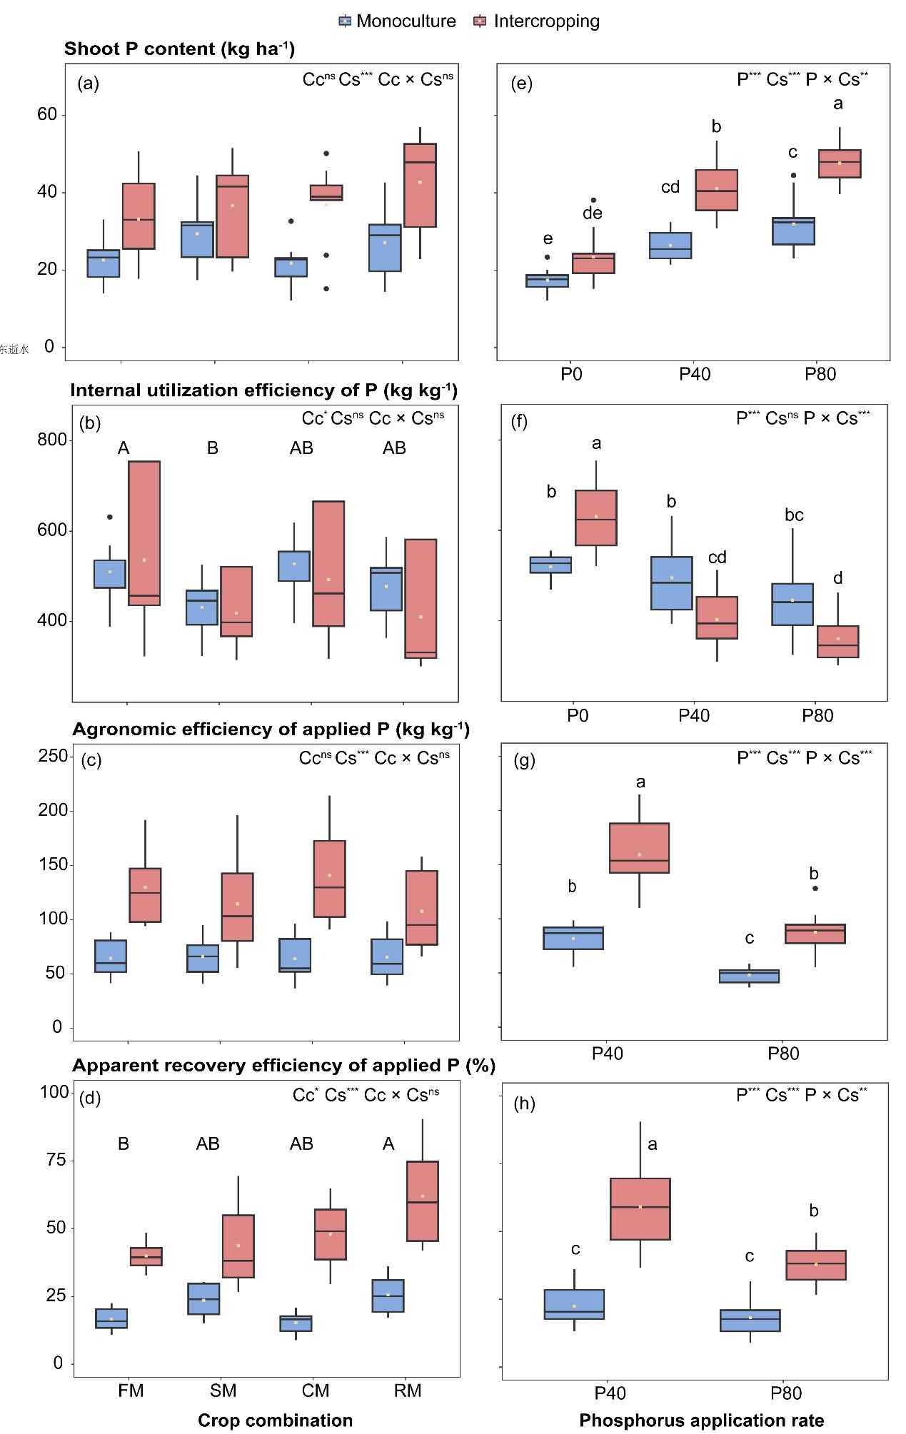 Fig. S3 Effects of crop combination (Cc) and cropping system (i.e. monoculture and intercropping, Cs) on shoot phosphorus (P) content (**a**), internal utilization efficiency of P (**b**), agronomic efficiency of applied P (**c**), and apparent recovery efficiency of applied P (**d**) in 2020. Effects of P-application rate (factor P) and cropping system (Cs) on shoot P content (**e**), internal utilization efficiency of P (**f**), agronomic efficiency of applied P (**g**), and apparent recovery efficiency of applied P (**h**) in 2020. Shoot P content, internal utilization efficiency of P, agronomic efficiency of applied P, and apparent recovery efficiency of applied P of the monocultures were calculated as the weighted means of corresponding monoculture crops based on their land proportions in intercropping. P0: 0 kg P ha-1; P40: 40 kg P ha-1; P80: 80 kg P ha-1. FM: faba bean/maize intercropping system; SM: soybean/maize intercropping system; CM: chickpea/maize intercropping system; RM: oilseed rape/maize intercropping system. Uppercase letters refer to differences among crop combinations. Lowercase letters indicate differences among treatments if the interaction effect was significant. The same letter means there was no significant difference (Tukey HSD). *, *P*< 0.05; **, *P*< 0.01; ***, *P*< 0.001; ns, not significant.

Fig. S4 Effects of crop combination (Cc) and cropping system (i.e. monoculture and intercropping, Cs) on shoot phosphorus (P) content (**a**), internal utilization efficiency of P (**b**), agronomic efficiency of applied P (**c**), and apparent recovery efficiency of applied P (**d**) in 2021. Effects of P-application rate (factor P) and cropping system (Cs) on shoot P content (**e**), internal utilization efficiency of P (**f**), agronomic efficiency of applied P (**g**), and apparent recovery efficiency of applied P (**h**) in 2021. Shoot P content, internal utilization efficiency of P, agronomic efficiency of applied P, and apparent recovery efficiency of applied P of the monocultures were calculated as the weighted means of corresponding monoculture crops based on their land proportions in intercropping. P0: 0 kg P ha-1; P40: 40 kg P ha-1; P80: 80 kg P ha-1. FM: faba bean/maize intercropping system; SM: soybean/maize intercropping system; CM: chickpea/maize intercropping system; RM: oilseed rape/maize intercropping system. Uppercase letters refer to differences among crop combinations. Lowercase letters indicate differences among treatments if the interaction effect was significant. The same letter means there was no significant difference (Tukey HSD). *, *P*< 0.05; **, *P*< 0.01; ***, *P*< 0.001; ns, not significant.

Fig. S5 Effects of year (Y) and cropping system (i.e. monoculture and intercropping, Cs) on aboveground biomass (a) and grain yield (b) based on the species in 2020 and 2021. Effects of species (S) and cropping system (Cs) on aboveground biomass (c) and grain yield (d) based on the species across two years. Effects of phosphorus (P)-application rate and cropping system (Cs) on aboveground biomass (e) and grain yield (f) based on the species across two years. P0: 0 kg P ha-1; P40: 40 kg P ha-1; P80: 80 kg P ha-1. M: maize; F: faba bean; S: soybean; C: chickpea; R: oilseed rape. Uppercase letters refer to differences among P-application rates. Lowercase letters indicate differences among treatments if the interaction effect was significant. The same letter means there was no significant difference (Tukey HSD). *, *P*< 0.05; **, *P*< 0.01; ***, *P*< 0.001; ns, not significant.

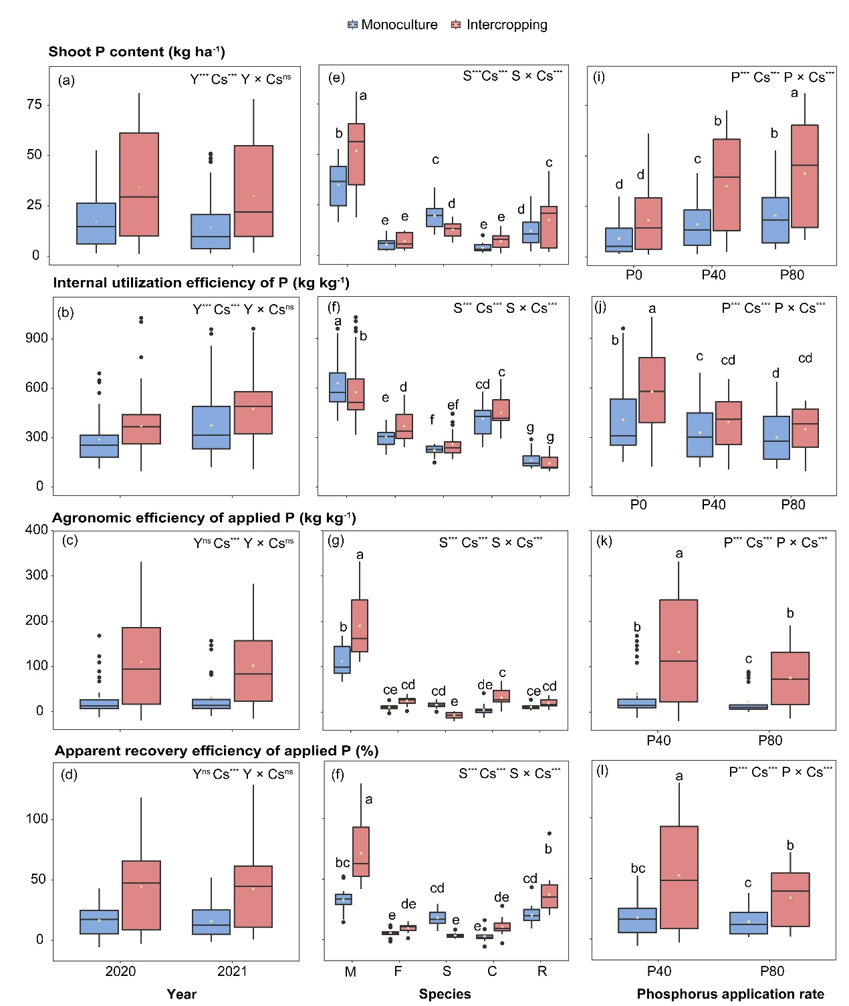

Fig. S6 Effects of year (Y) and cropping system (i.e. monoculture and intercropping, Cs) on shoot phosphorus (P) content (a), internal utilization efficiency of P (b), agronomic efficiency of applied P (c), and apparent recovery efficiency of applied P (d) based on the species in 2020 and 2021. Effects of crop species (S) and cropping system (Cs) on shoot phosphorus (P) content (e), internal utilization efficiency of P (f), agronomic efficiency of applied P (g), and apparent recovery efficiency of applied P (h) based on the species across two years. Effects of P-application rate and cropping system (Cs) on shoot P content (i), internal utilization efficiency of P (g), agronomic efficiency of applied P (k), and apparent recovery efficiency of applied P (l) based on the species across two years. P0: 0 kg P ha-1; P40: 40 kg P ha-1; P80: 80 kg P ha-1. M: maize; F: faba bean; S: soybean; C: chickpea; R: oilseed rape. Lowercase letters indicate differences among treatments if the interaction effect was significant. The same letter means there was no significant difference (Tukey HSD). *, *P*< 0.05; **, *P*< 0.01; ***, *P*< 0.001; ns, not significant.

Fig. S7 Effects of phosphorus (P)-application rate and cropping system (i.e. monoculture and intercropping, Cs) on root surface area (a), specific root length (b), root tissue density (c), root branching intensity (d), average root diameter (e) and proportion of fine roots (f) of faba bean in June 2021. P0: 0 kg P ha-1; P40: 40 kg P ha-1; P80: 80 kg P ha-1. *, *P*< 0.05; **, *P*< 0.01; ***, *P*< 0.001; ns, not significant.

Fig. S8 Effects of phosphorus (P)-application rate and cropping system (i.e. monoculture and intercropping, Cs) on root surface area (a), specific root length (b), root tissue density (c), root branching intensity (d), average root diameter (e) and proportion of fine roots (f) of chickpea in June 2021. P0: 0 kg P ha-1; P40: 40 kg P ha-1; P80: 80 kg P ha-1. Uppercase letters refer to differences among P-application rates. The same letter means there was no significant difference (Tukey HSD). *, *P*< 0.05; **, *P*< 0.01; ***, *P*< 0.001; ns, not significant.

Fig. S9 Effects of phosphorus (P)-application rate and cropping system (i.e. monoculture and intercropping, Cs) on root surface area (a), specific root length (b), root tissue density (c), root branching intensity (d), average root diameter (e) and proportion of fine roots (f) of oilseed rape in June 2021. P0: 0 kg P ha-1; P40: 40 kg P ha-1; P80: 80 kg P ha-1. Uppercase letters refer to differences among P-application rates. The same letter means there was no significant difference (Tukey HSD). *, *P*< 0.05; **, *P*< 0.01; ***, *P*< 0.001; ns, not significant.

Fig. S10 Effects of phosphorus (P)-application rate and cropping system (i.e. monoculture and intercropping, Cs) on root surface area (a), specific root length (b), root tissue density (c), root branching intensity (d), average root diameter (e) and proportion of fine roots (f) of soybean in July 2021. P0: 0 kg P ha-1; P40: 40 kg P ha-1; P80: 80 kg P ha-1. Uppercase letters refer to differences among P-application rates. The same letter means there was no significant difference (Tukey HSD). *, *P*< 0.05; **, *P*< 0.01; ***, *P*< 0.001; ns, not significant.

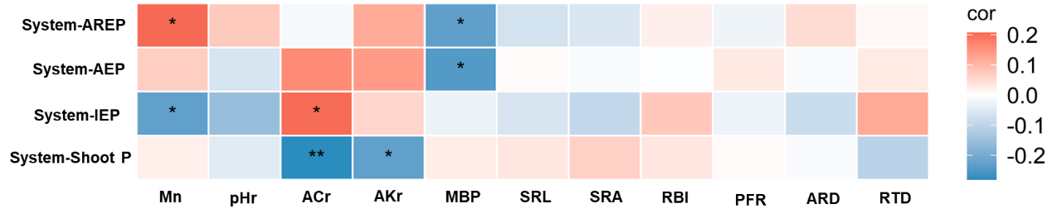

Fig. S11 Correlations between P-related parameters of paired crops and apparent recovery efficiency of applied P (system-AREP), agronomic efficiency of applied P (system-AEP), internal utilization efficiency of P (system-IEP) and shoot phosphorus (P) content (system-shoot P) of intercropping systems and the weighted means of corresponding monoculture systems in 2021. The 11 root variables associated with paired crops, system-shoot P and system-IEP were turned into relative P0 data to maintain consistency with the sample size of system-AREP and system-IEP. The red and blue boxes indicate positive and negative correlations, respectively. Mn: leaf manganese concentration; pHr: rhizosheath pH; ACr: rhizosheath acid phosphatase activity; AKr: rhizosheath alkaline phosphatase activity; MBP: soil microbial biomass P in bulk soil; SRL: specific root length; SRA: root surface area; RBI: root branching intensity; PFR: proportion of fine roots; ARD: average root diameter; RTD: root tissue density. *, *P*< 0.05; **, *P*< 0.01; ***, *P*< 0.001.

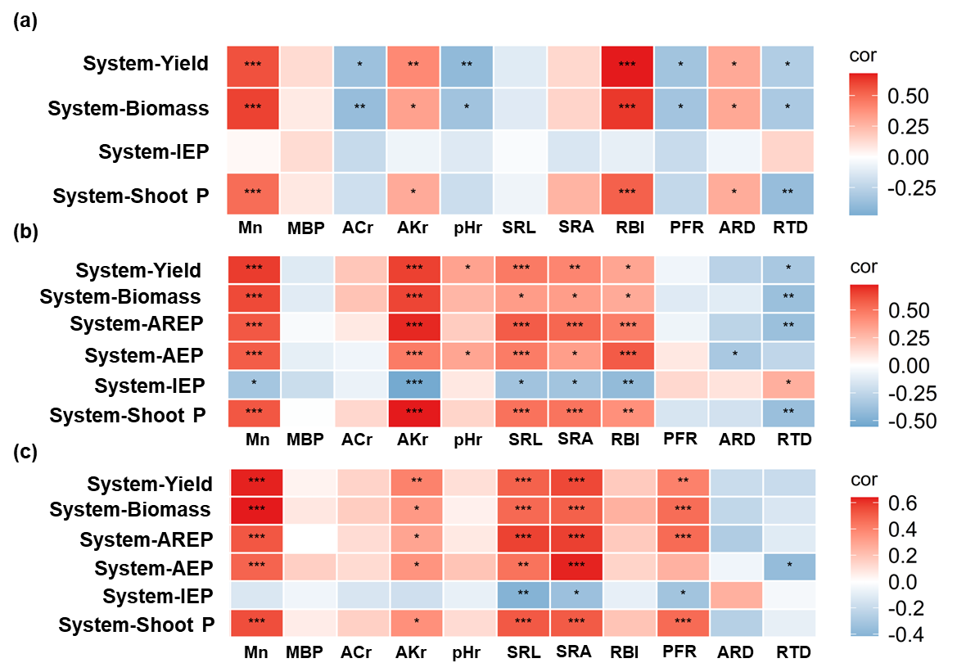

Fig. S12 Correlations between P-related parameters of maize and grain yield, aboveground biomass, internal utilization efficiency of P (system-IEP), and shoot phosphorus (P) content (system-shoot P) of intercropping systems and the weighted means of corresponding monoculture systems under P0 in 2021 (a). Correlations between P-related parameters of maize and grain yield, aboveground biomass, apparent recovery efficiency of applied P (system-AREP), agronomic efficiency of applied P (system-AEP), system-IEP, and system-shoot of intercropping systems and the weighted means of corresponding monoculture systems under P40 (b) and P80 (c) in 2021. The red and blue boxes indicate positive and negative correlations, respectively. Mn: leaf manganese concentration; pHr: rhizosheath pH; ACr: rhizosheath acid phosphatase activity; AKr: rhizosheath alkaline phosphatase activity; MBP: soil microbial biomass P in bulk soil; SRL: specific root length; SRA: root surface area; RBI: root branching intensity; PFR: proportion of fine roots; ARD: average root diameter; RTD: root tissue density. *, *P*< 0.05; **, *P*< 0.01; ***, *P*< 0.001.