KNN lead-free technology on 200 mm Si wafer for piezoelectric actuator applications
Supplementary material
H. Kuentz^{1,2}, C. Dieppedale¹, L. Mollard¹, R. Liechti¹, A. Campo¹, A. Hamelin¹, V. Demange², C. Poulain¹, M. Guilloux-Viry² and G. Le Rhun¹
¹ Univ. Grenoble Alpes, CEA, Leti, F-38000 Grenoble, France
² Univ- Rennes, CNRS, ISCR UMR 6226, F-35000 Rennes, France

Fig. S1 shows an SEM cross-section image of a 1.9 µm thick KNN layer, which appears dense without apparent porosity, with columnar grains. X-ray diffraction (XRD) theta-2 theta (λ = 1.54 Å) and Energy Dispersive X-ray Spectrometry (EDX) measurements were also performed to verify the crystalline structure and the composition of the film. A pure perovskite phase is identified with a preferential orientation (001) as shown on Fig. S2. The composition was determined as (K_{0.34}Na_{0.66})_{1.0}NbO₃. These results are in good agreement with those reported by Shibata et al [1].

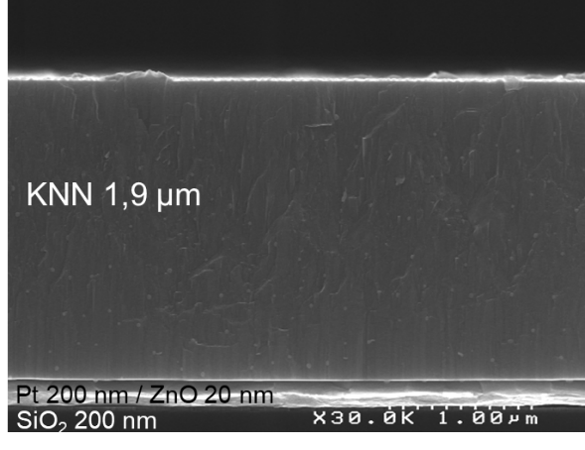
Fig. S1: SEM cross-sectional image of a 1.9 µm thick KNN film deposited on 200 mm in diameter platinized SOI (Silicon On Insulator) wafer.
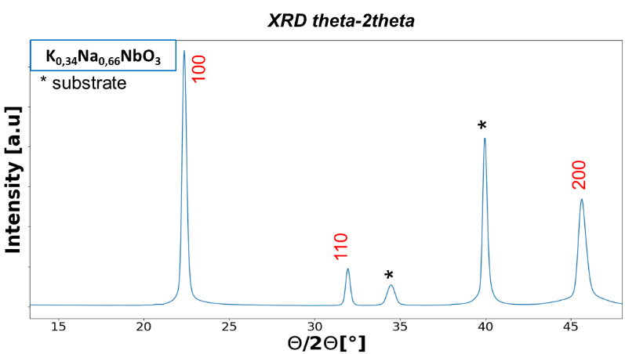
Fig. S2: XRD diffractogram measured on a 1.9 µm thick KNN film deposited on 200 mm in diameter platinized SOI wafer.
Fig. S3 illustrates the main steps of the KNN based MEMS fabrication by taking the example of a ring shaped actuator.
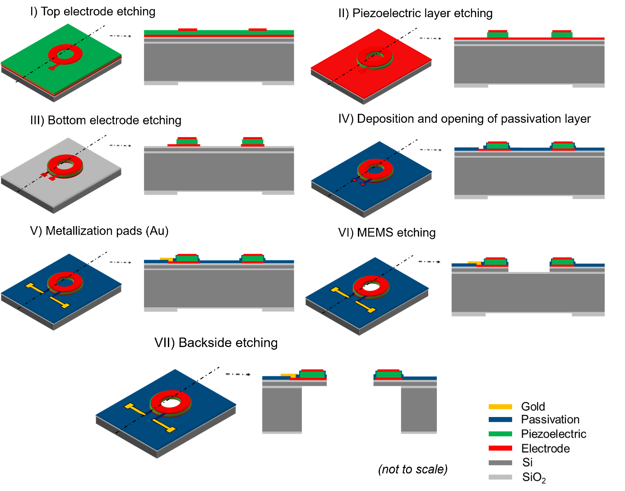
Fig. S3: Schematic view of the KNN based MEMS fabrication process.

[1] K. Shibata, K. Watanabe, T. Kuroda, T. Osada, "KNN lead-free piezoelectric films grown by sputtering" Appl. Phys. Lett. 121, 092901 (2022).

