On the Overall situation of Poly- or perfluoroalkyl substances (PFASs) and Recycling of Fluoropolymers

Bruno AMEDURI
CNRS, Institut Charles Gerhardt
34296 Montpellier, France
bruno.ameduri@enscm.fr

Poly- or perfluoroalkyl substances (PFASs) are divided into two main families, differentiated by their molecular weights (MWs).¹ The first one deals with non-polymers, oligomers or specific polymers bearing fluorinated side moieties. They have undergone major issues of bioaccumulation, persistency, toxicity and mobility, either intrinsically because of their low MW-structure or after some degradation (e.g., hydrolytic hydrolysis of ester functions in poly[(meth)acrylate]s releasing polyfluorinated groups). These specific PFASs are under severe restricted (several of them being banned) and drastic regulations are currently proceeding.
In contrast, fluoropolymers (FPs),² endowed with outstanding properties and involved in High Tech applications are not prone to face such hazardous limitations. They have high molar-masses and are non-mobile, non- bioaccumulative, and non-toxic, hence fulfill the PLC criteria³. Indeed, though the global production of FPs is only ca. 0.1% of plastics, its growth rate is 6-8%.² Much progress has been made in the last decade where several FP manufacturers have modified their production using non-fluorinated polymerization aids (or surfactants). ⁴ In addition, major actors working on the energetic transition are taking FPs more and more into account (fuel cell membranes, binders for Lithium ion batteries, backsheets for PVs, and electroactive FPs as key-examples). Finally various companies have already found solutions to depolymerize, recycle (“close the loop” even on pilot plant) or reuse FPs⁵ that will also be covered in that presentation.⁴

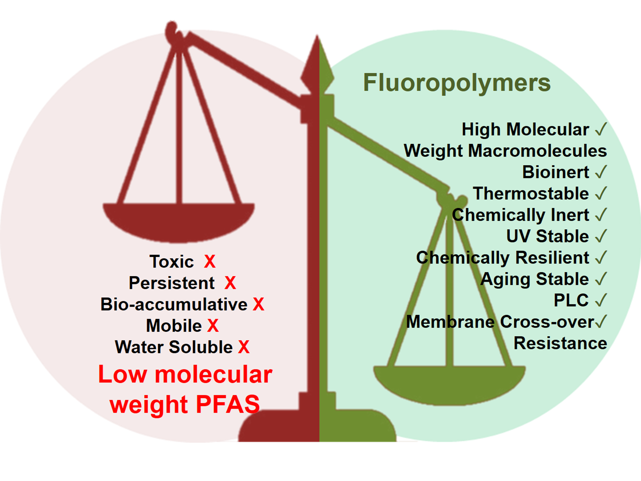
References
¹ B. Améduri Perfluoroalkyl substances: Synthesis, Properties and Regulations, 2022, RSC, Oxford.
² B. Améduri and S. Fomin, Fascinating Fluoropolymers, 2020, Elsevier, Oxford.
³ S.H. Korzeniowski et al. A Critical Review of the Application of Polymer of Low Concern Regulatory Criteria to Fluoropolymers II: Fluoroplastics and Fluoroelastomers. Integ. Envron. Assessm. Manag. 2023, 19, 326-354.
⁴. B. Ameduri, Fluoropolymers: a special class of per- and poly-fluoroalkyl substances (PFASs) essential for our daily life; J. Fluorine Chem., 2023, 267, 110117.
⁵. B. Ameduri and H. Hori; Recycling and End of life assessment of Fluoropolymers: Recent Developments, Challenges and Future Trends Chem. Soc. Rev. 2023, 52, 4208-4247.

