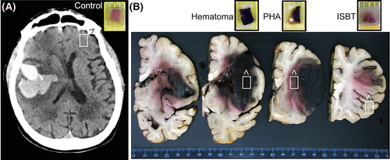
FIGURE 1
Study design. (A) CT scan of a representative patient performed 14 days after symptom onset. Hyperdense lobar intracerebral haemorrhage is shown, surrounded by hypodense peri-haematomal oedema. (B) Formalin-fixed hemispheres of spontaneous intracerebral haemorrhage (sICH) cases were cut into 5-mm-thick blocks taken from 4 specific areas: haematoma, peri-haematomal area (PHA), ipsilateral surrounding brain tissue (ISBT) and contralateral block as reference. Four adjacent 5 μm-thick sections were cut from these blocks and stained with haematoxylin & eosin, Martius Scarlet Blue, and immunolabelled for myeloperoxidase and histone H3 citrulline to detect neutrophil extracellular traps (NETs)

.TABLE 1. Characteristics of the study population
Number | Age | Sex | Past history of Hypertension | Antithrombotic use at the time of ICH onset | ICH location | sICH aetiology¶ | ICH volume (cm³) | Oedema volume (cm³) | Time from ICH to death (days)
1 | 84 | F | no | yes | Lobar | CAA | 113 | 67 | 1
2 | 65 | F | no | yes | Lobar | CAA | 114 | 74 | 2
3 | 84 | F | yes | no | Lobar | CAA | 87 | 105 | 4
4 | 76 | F | no | yes | Lobar | CAA | 82 | 93 | 5
5 | 89 | F | no | no | Lobar | CAA | 93 | 102 | 5
6 | 86 | F | yes | yes | Lobar | CAA | - | - | 6
7 | 89 | F | yes | no | Lobar | CAA | 53 | 69 | 8
8 | 76 | M | yes | no | Deep | HTN-SVD | 46 | 63 | 8
9 | 78 | F | yes | yes | Lobar | CAA | 63 | 74 | 10
10 | 76 | F | no | no | Lobar | CAA | 42 | 47 | 13
11 | 73 | M | yes | no | Lobar | CAA | 163 | 68 | 14
12 | 85 | M | yes | no | Lobar | CAA | 107 | 96 | 17
13 | 78 | M | yes | no | Lobar | CAA | - | - | 27
14 | 71 | F | no | no | Lobar | CAA | 111 | 78 | 30

Note
- CAA: Neuropathologic diagnosis was confirmed by Red Congo staining and Amyloid β40 immunolabelling by one experienced neuropathologist (V.D). The first evidence for NETs infiltration following intracerebral haemorrhage in the human brain.
- Abbreviations: CAA, cerebral amyloid angiopathy; F, female; HTN- SVD, hypertensive small vessel diseaseM, male; PHA, peri-haematomal area; sICH, spontaneous intracerebral haemorrhage.

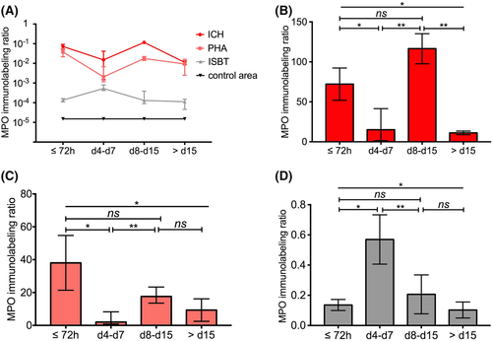
FIGURE 2
Temporal and spatial distribution of neutrophils in the human brain after intracerebral haemorrhage. (A) Immunolabelling ratio ([stacking surface/whole section surface]*10^{^3}) of neutrophil myeloperoxidase (MPO) in the post-mortem brain tissue of 14 patients deceased from spontaneous intracerebral haemorrhage at different time periods after onset (before 72 h, from day 4 to day 7, from day 8 to day 15, above day 15). Curves refer to the ratios calculated in brain areas of interest including the haematoma (ICH), the peri-haematomal area (PHA), the ipsilateral surrounding brain tissue (ISBT), and the contralateral area (control area). Bars and symbols correspond to the median value and the width of the 95% CI. Data were log10-transformed for an easier comparison between ICH, PHA, ISBT and control areas. Raw ratios are presented in histograms for ICH (B), PHA (C) and ISBT (D) areas for statistical analysis. Ratios were significantly different between time points according to Kruskal-Wallis followed by a Tukey post hoc test (**p ≤ 0.01, *p ≤ 0.05; ns: not significant)
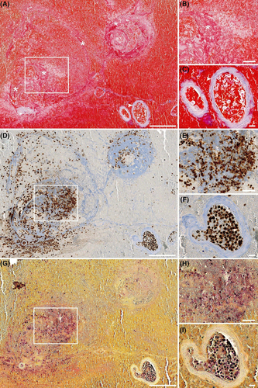
FIGURE 3
Neutrophils and neutrophil extracellular traps are located at dense fibrin fibres within intracerebral haemorrhage. Martius Scarlet Blue (MSB) staining (A, B, C), neutrophil myeloperoxidase (MPO) immunolabelling (D, E, F) and histone H3 citrulline immunolabelling (G, H, I) of adjacent slices of representative haemorrhagic areas observed in a patient who deceased after 13 days post lobar intracerebral haemorrhage (ICH). (A), (D) and (G) correspond to an overview of the examined area. (A) Fibrin fibres (pink to red) are organised into a circular pattern (asterisks), pointing to a bleeding origin at the bottom left vessel, suggestive of significant clot formation. At higher magnification (B), fibrin exhibits a dense fibrillar meshwork (asterisk), and red-stained erythrocytes show typical biconcave morphology and absence of extended haemolysis. Accumulation of non-stained cells in contact with fibrin fibres suggest the presence of leucocyte clusters. In (C), collagen (blue) delineates blood vessel walls (arrowhead) and intravascular erythrocytes and leucocytes. Abundant neutrophils in the extravasated blood are evidenced by MPO (rounded brown stain) close to light-blue fibrillar structures matching with fibrin (D), confirmed at higher magnification (E), as well as in the intravascular compartment (F). Histone H3 citrulline, corresponding to neutrophil extracellular trap (NET) formation, is disclosed both as rounded dark purple dots characteristic of intracellular staining, and as light purple smears, in areas matching with neutrophil clusters in fibrin-rich tissue sites (G), confirmed at higher magnification (H) and inside the vessel lumen (I). Scale bars = 200 µm for A, D and G; 50 µm for B, E and H, and 20 µm for C, F, I
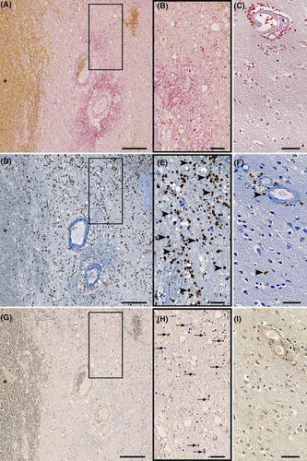
FIGURE 4
Neutrophils and neutrophil extracellular traps infiltrate the surrounding brain tissue after intracerebral haemorrhage. Martius Scarlet Blue (MSB) staining (A, B, C), neutrophil myeloperoxidase (MPO) immunolabelling (D, E, F) and histone H3 citrulline (G, H, I) immunolabelling of adjacent slices of representative peri-haematomal area (PHA) and ipsilateral surrounding brain tissue (ISBT) observed in a patient who deceased 8 days after deep intracerebral haemorrhage (ICH). (A) Blood suffusion (asterisks) at the clot border are observed through yellow-stained erythrocytes. In the PHA, tissue vacuoles and pallor suggest tissue damage and oedema, confirmed at higher magnification (B), and contrary to the ISBT area showing a homogeneous molecular layer between the soma of the more uniformly distributed brain cells (C). Abundant presence of neutrophils is evidenced in the PHA by MPO (rounded brown stain, D), confirmed at higher magnification (E, arrowheads), and contrary to the ISBT area where sparse neutrophils were found, mostly in the perivascular spaces, suggestive of recruitment from the circulation (F, arrowheads). The histone H3 citrulline of neutrophil extracellular traps (NETs) is disclosed mostly as rounded dark purple dots characteristic of intracellular signal in the PHA (G), confirmed at higher magnification (H, arrows), and contrary to the ISBT area where no NETs were found (I). Scale bars = 200 µm for A, D and G; 50 µm for B, C, E, F, H, and I
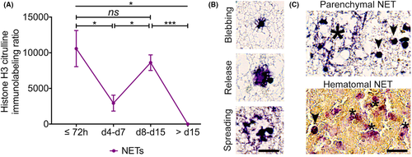
FIGURE 5
Neutrophil extracellular traps are abundant in the human brain after intracerebral haemorrhage. (A) Immunolabelling ratio ([stacking surface/whole section surface]*10^{^3}) of citrullinated histone 3, a hallmark of neutrophil extracellular trap (NET) formation, in the post-mortem brain tissue of 14 patients who died at different time periods after intracerebral haemorrhage (before 72 h, from day 4 to day 7, from day 8 to day 15, above day 15). The curve refers to the ratios calculated in brain areas of interest where NETs were found, including the haematoma and the peri-haematomal area. Bars and symbols correspond to the median value and the width of the 95% CI. Ratios were significantly different between time points according to Kruskal-Wallis followed by a Tukey post hoc test (*** p ≤ 0.001, *p ≤ 0.05; ns: not significant). (B) Representative views of different positive immunolabelling of citrullinated histone 3 (purple), suggestive of different steps of NETosis: membrane blebbing, release of decondensed chromatin to the extracellular space, and spreading of NETs in the surrounding tissue. (C) Representative views of spread NETs in the peri-haematomal area (Parenchymal NETs, large asterisk), or in the haematoma (Haematomal NETs) where multiple smears are observed (small asterisks), next to intracellular NETs (arrowheads). Scale bar = 20 µm for (B) and 50 µm for (C)

