Supplementary Information to

Is heteroatom doping of activated carbons always a good strategy for enhancing CO₂ adsorption?

R. Morales-Ospino^{1,⊥}, R. L. S. Canevesi^{1*,⊥}, S. Schaefer¹, A. Celzard^{1,2}, V. Fierro^{1,*}

¹ Université de Lorraine, Centre National de la Recherche Scientifique (CNRS), Institut Jean Lamour (IJL), F-88000, Épinal, France.
² Institut Universitaire de France (IUF), 75231 Paris, France

*Corresponding authors: rafael_canevesi@hotmail.com, vanessa.fierro@univ-lorraine.fr
⊥ These two authors contributed equally to this work
SI 1. Mathematical modeling of the equilibrium isotherms.

The Sips isotherm is a combination of Langmuir and Freundlich isotherms. Sips introduced a finite adsorption limit to Freundlich equation, and the mathematical form of the model is as follows:
$$q_{eq} \text{= }\frac{{\text{q}}_{\text{max}}{\left(\text{b}\text{P}\right)}^{n}}{\left[\text{1+}{\left(\text{b}\text{P}\right)}^{\text{n}}\right]}$$ | (SI1.1)
where q_{eq} is the equilibrium adsorbed amount (mol kg⁻¹), P (bar) is the equilibrium pressure, q_{max} (mol kg⁻¹) is a constant reflecting the adsorption capacity at saturation, b (1/bar) is the Sips constant or affinity constant, and n (dimensionless) is the heterogeneity factor.
Isotherm parameters were obtained by non-linear fits of the aforementioned equations to the experimental CO₂ equilibrium data using Origin software version 9.0, applying the Levenberg-Marquardt algorithm.
The isosteric heats of adsorption were obtained after fitting with the Sips model and using the Clausius-Clapeyron approach. To calculate equilibrium pressures as a function of the amount adsorbed using the Sips model fit, the pressure P in the Sips model equation is written in the following form:
$$P=\frac{1}{b}.{\left(\frac{q_{eq}}{{\text{q}}_{\text{max}}-q_{eq}}\right)}^{1/n}$$ | (SI1.2)

The isosteric heats of adsorption were then plotted versus fractional coverage. The fractional coverage is represented by the following equation:
$$θ=\frac{q_{eq}N_{A}σ}{{1000S}_{NLDFT}}$$ | (SI1.3)

where N_{A} (6.023×10²³ molecules mol⁻¹) is the Avogadro number, and σ (m²) is the cross-sectional area obtained from the Microactive software (σ = 1.14 × 10⁻¹⁹ m² for CO₂ and σ = 1.62 × 10⁻¹⁹ m² for N₂).
The selectivity of the materials to adsorb CO₂ over N₂ in a post-combustion scenario was estimated considering a binary mixture of CO₂-N₂ with volumetric fractions of $y_{{CO}_{2}}=0.15$ and $y_{N_{2}}=0.85$. The CO₂/N₂ selectivity was estimated with the following equation:
$$Selectivity_{CO_{2}/N_{2}}=\frac{{q^{mix}}_{CO_{2}}}{{q^{mix}}_{ N_{2}}}×\frac{y_{N_{2}}}{y_{{CO}_{2}}}$$ | (SI1.4)

where ${q^{mix}}_{CO_{2}}$ and ${q^{mix}}_{ N_{2}}$ are the adsorbed amount of CO₂ and N₂ respectively in the binary mixture at a given pressure and temperature. The estimation of $q_{CO_{2}}$ and $q_{ N_{2}}$ was performed using the Ideal Adsorbed Solution Theory (IAST) with the Sips model.
The Ideal Adsorption Solution Theory (IAST), which was initially proposed by Myers and Prausnitz in 1965 [1], is a widely employed approach for predicting the equilibrium behavior of multi-component systems using data from single-component equilibria. This theory is founded on the premise that adsorbed molecules exhibit ideal solution behavior, signifying a lack of interactions among them, and it draws an analogy to Raoult's law:
$$Py_{i}=P_{i}^{0}\left(π\right)x_{i}$$ | (SI1.6)

where P is the total pressure, $y_{i}$ is the molar fraction of component i in the gas phase, $P_{i}^{0}$ is the hypothetical pressure of component i that results in the spreading pressure ( π ) of the mixture, $x_{i}$is the molar fraction of the component i in the adsorbed phase. In order to determine the spreading pressure for a pure component, an expression derived from the Gibbs free energy is used as follows:
$$\frac{π_{i}}{RT}=\int_{0}^{P_{i}^{0}}{\frac{q_{i}^{0}}{P}}dP$$ | (SI1.7)

where $q_{i}^{0}$ is the adsorbed amount of component i from single isotherm data and R is the ideal gas constant. Under equilibrium, the surface potential of the mixture is equal to the surface potential of each single component. The spreading pressure must be the same for each component of the mixture (${\text{π}}_{\text{1}} \text{=} {\text{π}}_{\text{2}} \text{=} \text{…=}{ \text{π}}_{\text{n}}$) and $q_{i}^{0}$ can be expressed by an adsorption equilibrium equation (in this case the Sips model). The solution for that equation allows to find a relation between spreading pressure ( π ) and the standard pressure of each component ( $P_{i}^{0}$ ).
The total amount adsorbed in the mixture can be determined by the expression:
$$\frac{\text{1}}{{\text{q}}_{\text{T}}}\text{=}\sum_{\text{i=1}}^{\text{n}}{\frac{{\text{x}}_{\text{i}}}{{\text{q}}_{\text{i}}^{\text{0}}}}$$ | (SI1.8)

where ${\text{q}}_{\text{T}}$ is the total loading of the mixture. To determine the adsorbed amounts of each component in the gas mixture, a system of equations is necessary, which includes the single-component isotherm model as well as Equations (SI1.6), (SI1.7), and (SI1.8). Subsequently, upon reaching equilibrium, the adsorbed concentration can be calculated using the following expression:
$${q^{mix}}_{i}=x_{i}q_{T}$$ | (SI1.9)

References
[1] A.L. Myers, J.M. Prausnitz, Thermodynamics of Mixed-Gas Adsorption., AIChE J. 11 (1965) 121–127. https://doi.org/10.1002/aic.690110125.
SI2. Mathematical model used to simulate the breakthrough curves

The mass balance for each component of the fluid phase is given by Eq. (i):
$\frac{∂C_{i}}{∂t}=-\frac{∂\left(uC_{i}\right)}{∂z}+\frac{∂}{∂z}\left(D_{ax,i}C_{T}\frac{∂Y_{i}}{∂z}\right)-\frac{\left(1-ε_{c}\right)a_{p}k_{f,i}}{ε_{c}\left(\frac{Bi}{5}-1\right)}\left(C_{i}-{Cp}_{i}\right)$ (i)
where C_{i} is the gas phase concentration, D_{ax} is the axial dispersion coefficient, u is the surface velocity, y_{i} is the molar fraction, k_{f,i} is the film mass transfer resistance, Cp_{i} is the averaged concentration in the macropores, C_{t} is the total gas concentration, ε_{c} is the column void fraction, a_{p} is the particle specific area, and B_{i} is the Biot number.
The mass balance in the macropores is described by Eq. (ii):
$\frac{∂{Cp}_{i}}{∂t}=\frac{15D_{p,i}\left(Bi/5\right)}{r_{p}^{2}\left(Bi/5+1\right)}\left(C_{i}-{Cp}_{i}\right)-\frac{ρ_{p}}{ε_{p}}\frac{∂q_{i}}{∂t}$ (ii)
where D_{p,i} is the macropore diffusivity, r_{p} is the particle radius, ε_{p} is the particle void fraction, ρ_{p} is the particle density, and q_{i} is the average adsorbed concentration.
The mass balance in the micropore is given by Eq. (iii):
$\frac{∂q_{i}}{∂t}=D_{μ}\left(q_{eq,i}-q_{i}\right)$ (iii)
where q_{eq,i} is the adsorbed concentration at equilibrium and D_{μ} is the coefficient diffusion in the micropores.
The Ergun equation is used to describe the behavior of the pressure drop along the column, as described by Eq. (iv):
(iv)
where P is the total pressure, μ_{G} is the gas viscosity, ρ_{G} is the gas density and d_{p} is the particle diameter.
The energy balance in the gas phase is given by Eq. (v):
$-ε_{C}C_{T}C_{Vg}\frac{∂T}{∂t}=\frac{∂}{∂z}\left(λ\frac{∂T}{∂z}\right)-C_{T}C_{Pg}\frac{∂\left(uT\right)}{∂z}+ε_{p}R⋅T\frac{∂C_{T}}{∂t}-\left(1-ε_{C}\right)a_{P}h_{f}\left(T-T_{S}\right)-\frac{2h_{w}}{r_{W}}\left(T-T_{W}\right)$ (v)
where T, T_{s} and T_{W} are the temperatures in the gas phase, adsorbent and column wall, respectively, C_{Pg} and C_{Vg} are the gas molar specific heats at constant pressure and volume, respectively, r_{W} is the inner radius of the wall, R is ideal gas constant, λ is the axial heat dispersion coefficient, and h_{W} and h_{f} are the film heat transfer coefficients between the gas phase and wall, and between the gas phase and adsorbent, respectively.
The energy balance in the solid phase is described by Eq. (vi):
$\left[ε_{P}\sum_{i=1}^{nc}{\left({\overline{c}}_{i}C_{V,i}\right)}+ρ_{P}\sum_{i=1}^{nc}{\left(q_{i}C_{V,ads,i}\right)}+ρ_{P}C_{Ps}\right]\frac{∂T_{S}}{∂t}=\left[ε_{P}R⋅T_{S}\sum_{i=1}^{nc}{\left(\frac{∂{\overline{c}}_{i}}{∂t}\right)}+a_{P}h_{f}\left(T-T_{S}\right)\right]+\frac{ρ_{b}}{\left(1-ε\right)}\sum_{i=1}^{nc}{\left(-ΔH_{i}\frac{∂q_{i}}{∂t}\right)}$ (vi)
where C_{V,ads,i} is the molar specific heat at constant volume of the adsorbed phase, C_{Ps} is the mass heat capacity coefficient of the bed and $ρ_{b}$ is the bed density.
The energy balance of the column is given by Eq. (vii):
$ρ_{W}C_{Pw}\frac{∂T_{W}}{∂t}=α_{w}h_{w}\left(T-T_{W}\right)-α_{wL}U\left(T_{W}-T_{∞}\right)$ (vii)
where C_{Pw} is the specific heat of the wall, U is the overall heat transfer coefficient, T∞ is the external temperature, ρ_{w} is the wall density, and α_{w} and α_{wl} are respectively the ratio of the internal surface area to the column wall volume, and the ratio of the logarithmic mean surface area of the column shell to the column wall volume.
The following table defines the most relevant parameters of the aforementioned partial equation system:
Table 1. Mathematical correlations used in the breakthrough modeling.
Parameter | Mathematical correlation
Macropore diffusion coefficient, D_{p} | $$D_{p}=\frac{\frac{1}{τ_{p}}}{\frac{1}{D_{m}}+\frac{1}{D_{k}}}$$
Knudsen diffusivity, D_{k} | $$D_{k}=τ_{p}\frac{d_{p}}{2}\sqrt{\frac{T}{MW}}$$
Molecular diffusivity, D_{m} | $$D_{m,i}=\frac{\left(1-Y_{i}\right)}{\sum_{\begin{aligned}j=1 \\ j≠i\end{aligned}}^{nc}{\frac{Y_{j}}{D_{i,j}}}}$$
Film mass transfer resistance, k_{f} | $$k_{f,i}=\frac{D_{m,i}}{d_{p}}\left(2.0+1.1{Re}^{0.6}∙{Sc}^{\frac{1}{3}}\right)$$
Heat transfer coefficient between the gas phase and wall, h_{w} | $$h_{w}=k_{g}\left(140+0.013396\frac{d_{in}^{2}}{d_{p}k_{g}}\right)Re$$
Heat transfer coefficient between gas phase and adsorbent, hf | $$h_{f}=\frac{k_{g}}{d_{p}}\left(2.0+1.1{Re}^{0.6}∙{Sc}^{\frac{1}{3}}\right)$$
Axial heat dispersion coefficient, λ | $$λ=k_{g}\left(7.0+0.5Pr∙Re\right)$$
Axial dispersion coefficient, D_{ax} | $$D_{ax}=\frac{D_{m}}{ε_{c}}\left(2.0+0.5Re∙Sc\right)$$
Particle area to volume ratio, $a_{p}$ | $$a_{p}=\frac{3}{r_{p}}$$
Particle density, $ρ_{p}$ | $$ρ_{p}=\left(1-ε_{p}\right)ρ_{s}$$
Gas molar specific heat at constant volume, $C_{vads}$ | $$C_{vads}=C_{pgas}-R$$
where R_{e} is the Reynolds number, S_{c} is the Schmidt number, P_{r} is the Prandtl number, k_{g} is the gas thermal conductivity, D_{k} is the Knudsen diffusivity, D_{m} is the molecular diffusivity, $τ_{p}$ is the particle tortuosity, and MW is the molecular weight of the gas.
Some parameters were considered constant with the following values:
Table 2. Values of parameters used in the breakthrough modeling.
Parameter | Value
Tortuosity factor, $τ_{p}$ | 2
Overall heat transfer coefficient, U | - W m⁻² K⁻¹
Ambient temperature, T∞ | 303 K
Column void fraction, ε_{c} | 0.37
Particle porosity, ε_{p} | 0.46
Adsorbent calorific capacity at constant pressure, C_{Ps} | 800 J kg⁻¹ K⁻¹

SI3. (a) Elemental analysis and XPS spectra of the three commercial ACs and their modified counterparts in the (b) O 1s and (c) N 1s regions.
a)
Carbon materials | C  (wt. %) | H  (wt. %) | O  (wt. %) | N  (wt. %) | C  (at. %) | H  (at. %) | O  (at. %) | N  (at. %)
MSP20X | 95.5 | 0.25 | 3.37 | 0.11 | 97.1 | 1.53 | 1.29 | 0.05
MSP20X-O | 86.8 | 1.25 | 12.9 | 0.04 | 87.5 | 7.56 | 4.88 | 0.02
MSP20X-N1 | 86.2 | 1.23 | 8.02 | 6.87 | 86.6 | 7.41 | 3.02 | 2.96
MSP20X-N2 | 85.8 | 1.07 | 6.95 | 10.5 | 86.4 | 6.46 | 2.62 | 4.53
MSP20X-ON2 | 80.4 | 1.45 | 9.50 | 13.2 | 81.8 | 8.85 | 3.62 | 5.75
MSC30 | 95.0 | 0.55 | 3.99 | 0.30 | 95.1 | 3.30 | 1.50 | 0.13
MSC30-O | 87.6 | 1.33 | 13.7 | 0.16 | 86.9 | 7.92 | 5.10 | 0.07
MSC30-N1 | 82.8 | 1.42 | 8.51 | 7.68 | 84.7 | 8.71 | 3.26 | 3.37
MSC30-N2 | 79.0 | 1.63 | 8.09 | 12.0 | 81.5 | 10.1 | 3.13 | 5.30
MSC30-ON2 | 79.9 | 1.36 | 8.98 | 12.9 | 82.4 | 8.42 | 3.47 | 5.70
CW30 | 77.5 | 3.21 | 19.5 | 0.22 | 74.4 | 18.5 | 7.02 | 0.09
CW30-O | 73.9 | 3.33 | 28.0 | 0.22 | 70.7 | 19.1 | 10.1 | 0.09
CW30-N2 | 69.2 | 2.99 | 21.2 | 15.1 | 68.1 | 17.7 | 7.83 | 6.37
CW30-ON2 | 68.0 | 3.17 | 18.0 | 16.5 | 67.4 | 18.9 | 6.69 | 7.01
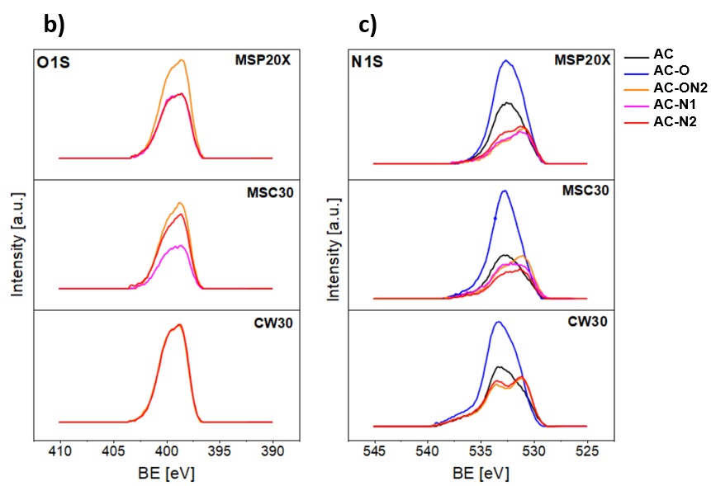
d)
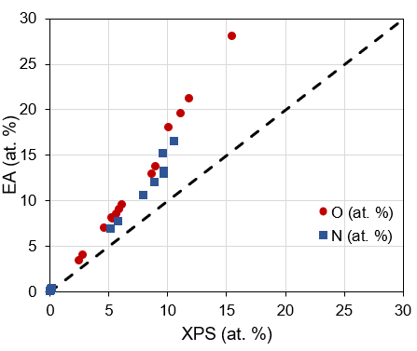
SI 4. Surface composition by XPS.
Carbon materials | Carbon (C) [at. %] |  |  |  |  |  | Oxygen (O) [at. %] |  |  |  |  | Nitrogen (N) [at. %]
 | C I | C II | C III | C IV | C V | total | O I | O II | O III | O IV | total | N6 | N5 | N-Q | N-X | total
MSP20X | 59.7 | 24.7 | 5.9 | 3.4 | 0.9 | 94.7 | 1.5 | 3.6 | 0.1 | 0.0 | 5.2 | 0.0 | 0.0 | 0.0 | 0.0 | 0.0
MSP20X-O | 55.4 | 23.9 | 4.8 | 4.8 | 1.8 | 90.8 | 2.1 | 5.1 | 0.0 | 0.0 | 7.2 | 0.0 | 0.0 | 0.0 | 0.0 | 0.0
MSP 20X-ON2 | 50.0 | 24.4 | 9.7 | 2.5 | 2.1 | 88.7 | 1.6 | 0.8 | 0.2 | 0.0 | 2.5 | 3.3 | 4.6 | 0.8 | 0.0 | 8.7
MSP 20X-N1 | 53.3 | 26.1 | 7.7 | 2.4 | 1.5 | 90.9 | 1.4 | 1.2 | 0.1 | 0.1 | 2.7 | 2.2 | 3.6 | 0.7 | 0.0 | 6.4
MSP 20X-N2 | 52.3 | 26.3 | 8.2 | 2.0 | 1.9 | 90.7 | 1.6 | 1.4 | 0.2 | 0.0 | 3.1 | 2.1 | 3.2 | 0.8 | 0.0 | 6.1
MSC30 | 57.3 | 27.6 | 6.5 | 3.9 | 2.0 | 97.3 | 0.7 | 1.8 | 0.2 | 0.1 | 2.8 | 0.0 | 0.0 | 0.0 | 0.0 | 0.0
MSC30-O | 54.5 | 25.5 | 8.2 | 4.4 | 2.3 | 94.9 | 0.9 | 4.3 | 0.4 | 0.1 | 5.7 | 0.0 | 0.0 | 0.0 | 0.0 | 0.0
MSC30-ON2 | 49.7 | 25.3 | 10.1 | 0.9 | 3.2 | 89.1 | 1.5 | 1.0 | 0.1 | 0.1 | 2.6 | 3.5 | 3.9 | 0.9 | 0.0 | 8.3
MSC30-N1 | 54.1 | 26.2 | 8.6 | 2.1 | 2.1 | 93.1 | 1.0 | 1.3 | 0.1 | 0.1 | 2.5 | 1.5 | 2.3 | 0.5 | 0.0 | 4.4
MSC30-N2 | 50.8 | 24.0 | 10.1 | 1.0 | 2.9 | 88.8 | 1.1 | 1.0 | 0.1 | 0.1 | 2.3 | 3.6 | 4.1 | 1.2 | 0.0 | 8.9
CW30 | 65.8 | 19.4 | 5.9 | 1.1 | 1.5 | 93.8 | 1.7 | 3.8 | 0.1 | 0.5 | 6.1 | 0.0 | 0.0 | 0.0 | 0.0 | 0.0
CW30-O | 63.1 | 16.9 | 6.6 | 1.6 | 0.8 | 89.0 | 2.9 | 7.4 | 0.1 | 0.6 | 11.0 | 0.0 | 0.0 | 0.0 | 0.0 | 0.0
CW30-ON2 | 45.9 | 26.6 | 8.8 | 0.7 | 0.6 | 82.5 | 2.8 | 2.1 | 0.6 | 0.5 | 6.0 | 4.3 | 6.2 | 1.0 | 0.0 | 11.4
CW30-N2 | 47.0 | 25.9 | 8.9 | 0.8 | 0.6 | 83.2 | 2.8 | 2.1 | 0.7 | 0.5 | 6.0 | 4.1 | 6.3 | 0.3 | 0.0 | 10.8

SI 5. N₂ (a, c, e) and H₂ (b, d, f) adsorption-desorption isotherms for: (a) and (b) MSP20X series; (c) and (d) MSC30 series; and (e) and (f) CW30 series. Solid symbols represent the adsorption branch, while empty symbols represent the desorption branch.

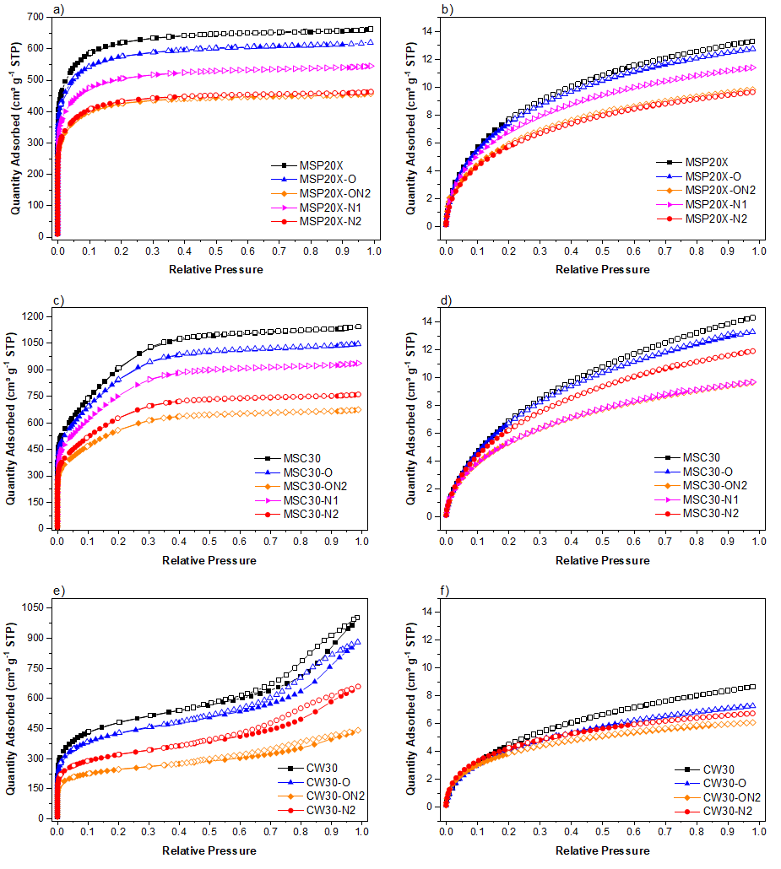

SI 6. Textural properties calculated from N₂ and H₂ adsorption isotherms.

Carbon  material | Textural Properties
 | A_{BET}  [m²/g] | S_{NLDFT}  [m²/g] | V_{µ-DR N2}  [cm³/g] | V_{T}  [cm³/g] | V_{MES}  [cm³/g] | V ult-µicro  [cm³/g] | V sup-µicro  [cm³/g] | V µicro  [cm³/g] | L₀ ult-µicro  [nm] | L₀ sup-µicro  [nm] | L₀ µicro  [nm] | L₀ meso  [nm] | L₀  [nm]
MSP20X | 3200 | 2284 | 0.87 | 0.98 | 0.05 | 0.25 | 0.68 | 0.93 | 0.56 | 1.16 | 1.00 | 3.95 | 1.16
MSP20X-N1 | 2661 | 1948 | 0.69 | 0.82 | 0.06 | 0.24 | 0.52 | 0.76 | 0.56 | 1.18 | 0.98 | 4.50 | 1.22
MSP20X-N2 | 2230 | 1650 | 0.58 | 0.70 | 0.04 | 0.20 | 0.45 | 0.65 | 0.56 | 1.19 | 0.99 | 4.31 | 1.19
MSP20X-O | 2982 | 2170 | 0.78 | 0.92 | 0.06 | 0.28 | 0.58 | 0.86 | 0.57 | 1.17 | 0.98 | 5.02 | 1.22
MSP20X-ON2 | 1981 | 1668 | 0.57 | 0.69 | 0.04 | 0.21 | 0.44 | 0.65 | 0.55 | 1.20 | 0.99 | 4.86 | 1.22
MSC30 | 2344 | 2522 | 1.18 | 1.65 | 0.66 | 0.12 | 0.88 | 1.00 | 0.54 | 1.29 | 1.20 | 2.89 | 1.87
MSCC30-N1 | 1901 | 1918 | 0.90 | 1.31 | 0.50 | 0.07 | 0.74 | 0.80 | 0.64 | 1.28 | 1.23 | 2.90 | 1.87
MSCC30-N2 | 1630 | 2029 | 0.77 | 1.13 | 0.37 | 0.19 | 0.57 | 0.76 | 0.54 | 1.33 | 1.13 | 2.88 | 1.70
MSC30-O | 2178 | 2357 | 1.02 | 1.50 | 0.56 | 0.15 | 0.79 | 0.93 | 0.58 | 1.31 | 1.20 | 2.90 | 1.83
MSC30-ON2 | 1600 | 1722 | 0.67 | 0.98 | 0.30 | 0.16 | 0.51 | 0.67 | 0.56 | 1.32 | 1.14 | 3.10 | 1.75
CW30 | 1736 | 1521 | 0.63 | 1.46 | 0.88 | 0.12 | 0.46 | 0.58 | 0.55 | 1.24 | 1.11 | 9.77 | 6.32
CW30-N2 | 1157 | 1192 | 0.42 | 0.97 | 0.59 | 0.15 | 0.24 | 0.38 | 0.53 | 1.24 | 0.97 | 9.04 | 5.84
CW30-O | 1540 | 1325 | 0.54 | 1.27 | 0.77 | 0.11 | 0.38 | 0.50 | 0.56 | 1.26 | 1.10 | 9.57 | 6.25
CW30-ON2 | 898 | 1032 | 0.32 | 0.67 | 0.34 | 0.16 | 0.17 | 0.33 | 0.54 | 1.26 | 0.92 | 9.17 | 5.10

SI 7. Cumulative pore volumes calculated by the 2D-NLDFT model for: (a) raw, commercial ACs; (b) MSP20X series; (c) MSC30 series; and (d) CW30 series.

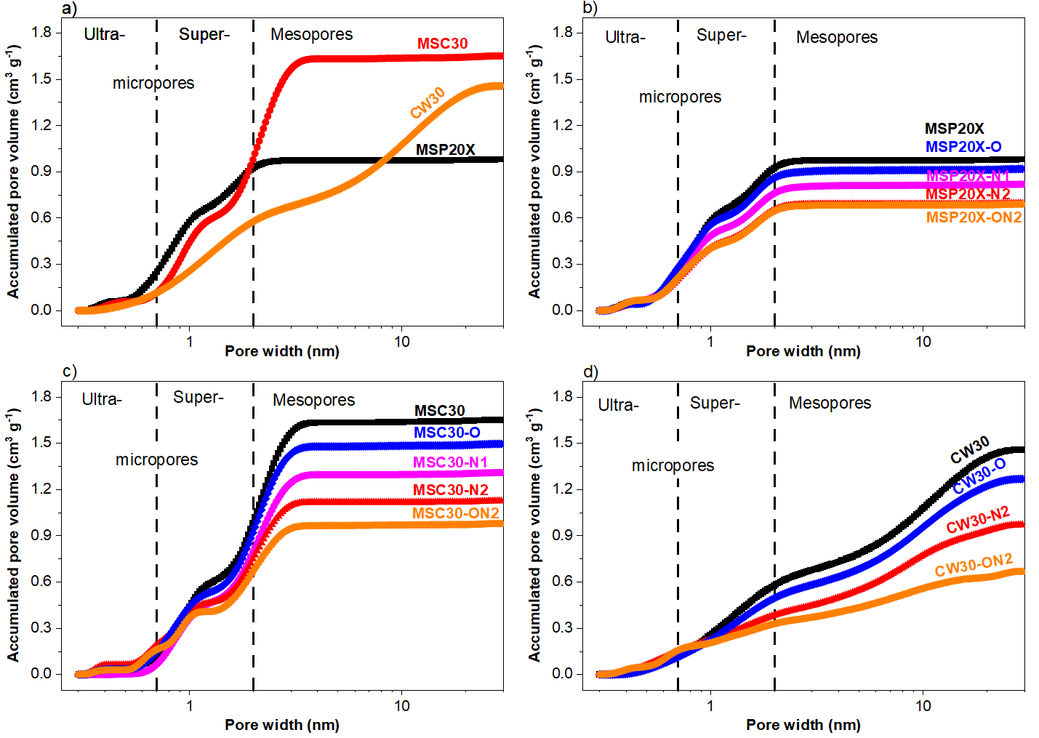

SI 8. CO₂ adsorption isotherms at: (a) 273; (b) 298; and (c) 323 K, and up to 25 bar for the MSP20X series. Solid lines represent the fits of the Sips adsorption model.

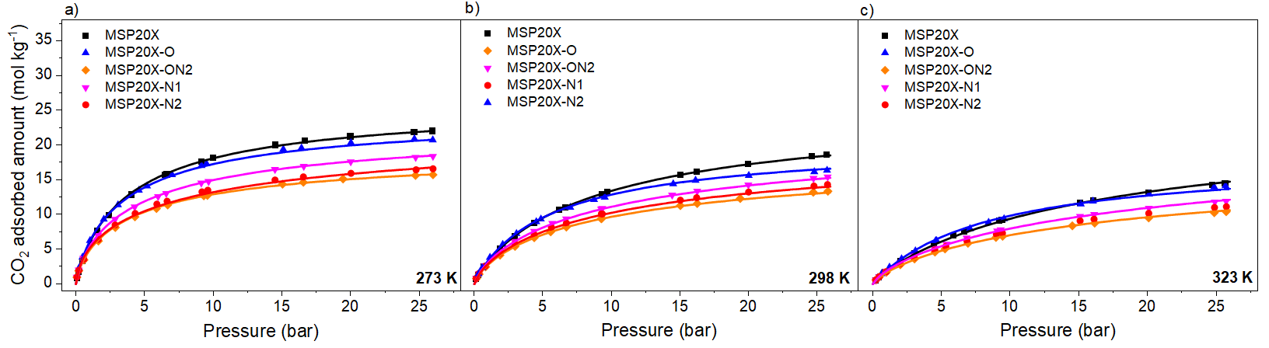

SI 9. CO₂ adsorption isotherms at: (a) 273; (b) 298; and (c) 323 K, and up to 25 bar for the MSC30X series. Solid lines represent the fits of the Sips adsorption model.

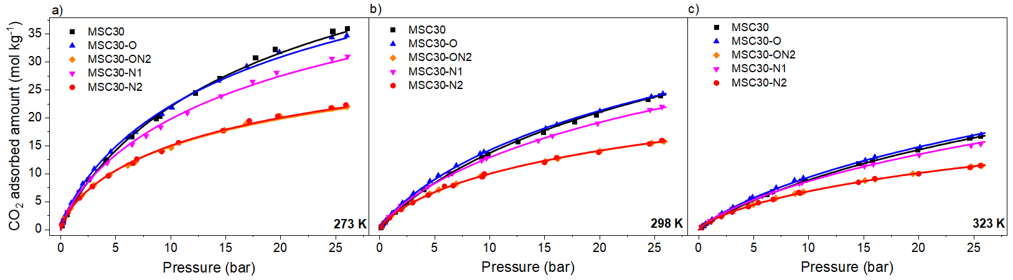

SI 10. CO₂ adsorption isotherms at: (a) 273; (b) 298; and (c) 323 K, and up to 25 bar for the CW30 series. Solid lines represent the fits of the Sips adsorption model.

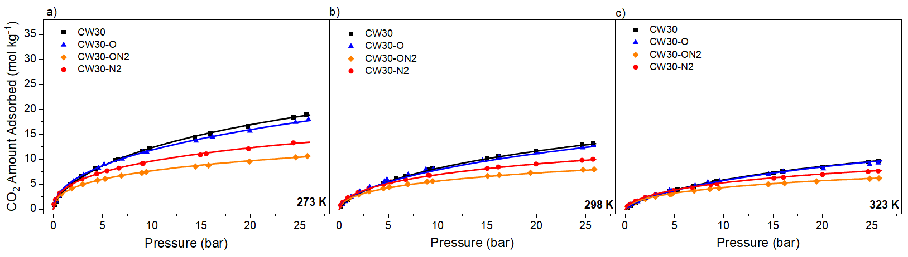

SI 11. Parameters obtained by application of the Sips model to the a) CO₂ adsorption isotherms for all samples and b) N₂ adsorption isotherms for the MSP20X series.
a)
Material | Temperature [K] | q_{max}  [mol/kg] | b  [bar] | n | R²
MSP20X | 273 | 26.1 | 0.242 | 0.88 | 1.00
 | 298 | 24.9 | 0.116 | 0.89 | 1.00
 | 323 | 23.8 | 0.062 | 0.89 | 1.00
MSP20X-O | 273 | 24.1 | 0.266 | 0.85 | 1.00
 | 298 | 21.3 | 0.152 | 0.88 | 1.00
 | 323 | 18.8 | 0.095 | 0.91 | 0.99
MSP20X-ON2 | 273 | 19.1 | 0.214 | 0.75 | 1.00
 | 298 | 18.8 | 0.096 | 0.76 | 1.00
 | 323 | 18.4 | 0.048 | 0.77 | 1.00
MSP20X-N1 | 273 | 23.1 | 0.214 | 0.78 | 1.00
 | 298 | 22.4 | 0.099 | 0.78 | 1.00
 | 323 | 21.7 | 0.051 | 0.79 | 1.00
MSP20X-N2 | 273 | 18.6 | 0.216 | 0.76 | 1.00
 | 298 | 18.4 | 0.097 | 0.77 | 1.00
 | 323 | 18.3 | 0.049 | 0.78 | 1.00
MSC30 | 273 | 78.8 | 0.032 | 0.81 | 1.00
 | 298 | 70.5 | 0.018 | 0.82 | 1.00
 | 323 | 63.1 | 0.011 | 0.83 | 1.00
MSC30-O | 273 | 69.3 | 0.036 | 0.78 | 1.00
 | 298 | 62.4 | 0.021 | 0.79 | 1.00
 | 323 | 56.2 | 0.013 | 0.80 | 1.00
MSC30-ON2 | 273 | 43.2 | 0.037 | 0.70 | 1.00
 | 298 | 38.9 | 0.021 | 0.71 | 1.00
 | 323 | 35.1 | 0.013 | 0.72 | 1.00
MSC30-N1 | 273 | 67.1 | 0.029 | 0.75 | 1.00
 | 298 | 61.3 | 0.017 | 0.76 | 1.00
 | 323 | 56.1 | 0.010 | 0.76 | 1.00
MSC30-N2 | 273 | 44.3 | 0.035 | 0.70 | 1.00
 | 298 | 40.7 | 0.019 | 0.70 | 1.00
 | 323 | 37.4 | 0.011 | 0.71 | 1.00
CW30 | 273 | 35.6 | 0.037 | 0.69 | 1.00
 | 298 | 32.5 | 0.021 | 0.70 | 1.00
 | 323 | 29.7 | 0.013 | 0.71 | 1.00
CW30-O | 273 | 36.7 | 0.027 | 0.62 | 1.00
 | 298 | 33.6 | 0.016 | 0.64 | 0.99
 | 323 | 30.7 | 0.010 | 0.66 | 0.99
CW30-ON2 | 273 | 22.1 | 0.023 | 0.48 | 1.00
 | 298 | 20.8 | 0.013 | 0.51 | 1.00
 | 323 | 19.5 | 0.008 | 0.54 | 1.00
CW30-N2 | 273 | 27.1 | 0.019 | 0.50 | 1.00
 | 298 | 25.2 | 0.011 | 0.52 | 1.00
 | 323 | 23.5 | 0.007 | 0.55 | 1.00

b)
Material | Temperature [K] | q_{max}  [mol/kg] | b  [bar] | n | R²
MSP20X | 273 | 11.1 | 0.068 | 0.93 | 1.00
 | 298 | 11.0 | 0.039 | 0.94 | 1.00
 | 323 | 10.9 | 0.024 | 0.95 | 1.00
MSP20X-O | 273 | 10.9 | 0.062 | 0.93 | 1.00
 | 298 | 10.8 | 0.035 | 0.94 | 1.00
 | 323 | 10.7 | 0.022 | 0.95 | 1.00
MSP20X-ON2 | 273 | 9.49 | 0.061 | 0.91 | 1.00
 | 298 | 9.40 | 0.035 | 0.92 | 1.00
 | 323 | 9.32 | 0.022 | 0.92 | 1.00
MSP20X-N1 | 273 | 7.36 | 0.078 | 0.97 | 1.00
 | 298 | 7.29 | 0.045 | 0.98 | 1.00
 | 323 | 7.23 | 0.028 | 0.99 | 1.00
MSP20X-N2 | 273 | 7.76 | 0.064 | 0.92 | 1.00
 | 298 | 7.68 | 0.037 | 0.93 | 1.00
 | 323 | 7.61 | 0.023 | 0.94 | 1.00

SI 12. Isosteric heat of adsorption calculated using the Clausius-Clapeyron equation on data from fitted isotherms (Sips model) as a function of CO₂ fractional coverage: (a) MSP20X, (b) MSC30, and (c) CW30 series.

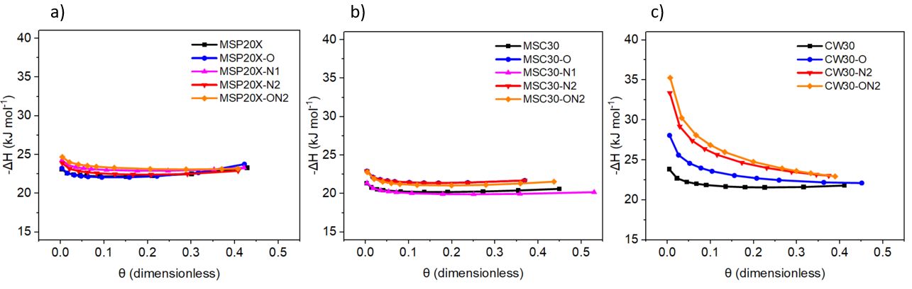
SI 13. Average isosteric heats of adsorption of a) CO₂ (coverage up to 0.5) of commercial and chemically modified ACs and b) N₂ (coverage up to 0.2) of MSP20X series.
a)
Carbon material | -ΔH_{isost}  [kJ/mol]
MSP20X | 22.5
MSP20X-O | 22.6
MSP20X-N1 | 23.3
MSP20X-N2 | 22.8
MSP20X-ON2 | 23.5
MSC30 | 20.5
MSC30-O | 21.8
MSC30-N1 | 20.3
MSC30-N2 | 21.8
MSC30-ON2 | 21.5
CW30 | 20.5
CW30-O | 23.8
CW30-N2 | 26.0
CW30-ON2 | 26.5

b)
Carbon material | -ΔH_{isost}  [kJ/mol]
MSP20X | 15.98
MSP20X-O | 15.98
MSP20X-N1 | 16.02
MSP20X-N2 | 15.87
MSP20X-ON2 | 15.95

SI 14. Pore volume distribution according to Equation (2).
$${\text{C}}_{\text{CO2ads}} \text{=} \text{a} {\text{V}}_{\text{w}\text{<0.7}} \text{+} \text{b}{ \text{V}}_{\text{0.7<}\text{w}\text{<2}} \text{+} \text{c} {\text{V}}_{\text{2<w<}\text{50}} \text{+} \text{d} {\text{C}}_{\text{N}\text{+O}}$$ | (Eq. 2)

Pore volumes
Carbon material | V _{w<0.7} | V_{0.7 <w <2} | V_{2<w<50}
 | [cm³/g] | [cm³/g] | [cm³/g]
MSP20X | 0.246 | 0.676 | 0.055
MSP20X-N1 | 0.241 | 0.519 | 0.057
MSP20X-N2 | 0.201 | 0.452 | 0.041
MSP20X-O | 0.275 | 0.584 | 0.056
MSP20X-ON2 | 0.209 | 0.436 | 0.042
MSC30 | 0.116 | 0.878 | 0.657
MSC30-N1 | 0.067 | 0.737 | 0.505
MSC30-N2 | 0.185 | 0.566 | 0.367
MSC30-O | 0.146 | 0.786 | 0.562
MSC30-ON2 | 0.16 | 0.511 | 0.305
CW30 | 0.116 | 0.463 | 0.878
CW30-N2 | 0.148 | 0.237 | 0.586
CW30-O | 0.113 | 0.384 | 0.772
CW30-ON2 | 0.155 | 0.173 | 0.339

S15. Parameters a, b, c, and d of Equation (2) at different pressures and temperatures.
$${\text{C}}_{\text{CO2ads}} \text{=} \text{a} {\text{V}}_{\text{w}\text{<0.7}} \text{+} \text{b}{ \text{V}}_{\text{0.7<}\text{w}\text{<2}} \text{+} \text{c} {\text{V}}_{\text{2<}\text{w}\text{<}\text{50}} \text{+} \text{d} {\text{C}}_{\text{N}\text{+O}}$$ | (Eq. 2)

273K
Pressure | a | b | c | d
[bar] | [mmol/cm³] | [mmol/cm³] | [mmol/cm³] | [mmol/g at.%]
0.25 | 5.37 | 0.763 | 0.0466 | 0.0566
0.5 | 8.38 | 1.7 | 0.143 | 0.0536
1 | 11.8 | 3.42 | 0.22 | 0.0557
2 | 15.6 | 6.84 | 0.22 | 0.0512
5 | 15.6 | 14.4 | 0.22 | 0.0684
7 | 17.3 | 17.3 | 0.89 | 0.0459
10 | 20.2 | 20.2 | 2.35 | 0
15 | 23.3 | 23.3 | 4.55 | 0
25 | 26.1 | 26.1 | 9.19 | 0
298K
Pressure | a | b | c | d
[bar] | [mmol/cm³] | [mmol/cm³] | [mmol/cm³] | [mmol/g at.%]
0.25 | 2.58 | 0.381 | 2.23E-07 | 0.0356
0.5 | 4.22 | 0.874 | 4.62E-07 | 0.0455
1 | 6.59 | 1.82 | 1.23E-05 | 0.0556
2 | 9.87 | 3.67 | 5.00E-05 | 0.0591
5 | 12.9 | 8.45 | 5.00E-05 | 0.0661
7 | 13 | 11.1 | 6.68E-05 | 0.0745
10 | 14.1 | 14.1 | 6.68E-05 | 0.0715
15 | 17.1 | 17.1 | 1.37 | 0.0295
25 | 21.9 | 21.9 | 1.37 | 0
323K
Pressure | a | b | c | d
[bar] | [mmol/cm³] | [mmol/cm³] | [mmol/cm³] | [mmol/g at.%]
0.25 | 1.4 | 0.203 | 2.23E-07 | 0.0213
0.5 | 2.45 | 0.456 | 4.62E-07 | 0.03
1 | 4.08 | 1.01 | 1.23E-05 | 0.0381
2 | 6.4 | 2.1 | 1.23E-05 | 0.0461
5 | 10.1 | 5.08 | 1.23E-05 | 0.0517
7 | 11.2 | 6.87 | 6.68E-05 | 0.0547
10 | 11.6 | 9.21 | 6.68E-05 | 0.0607
15 | 12.4 | 12.4 | 0.000178 | 0.0654
25 | 15.9 | 15.9 | 1.37 | 0.0177

