**Artificial Water Channels-**

**toward Biomimetic Membranes for Desalination**

MIHAIL BARBOIU

Adaptive Supramolecular Nanosystems Group, Institut Europeen des

Membranes, ENSCM-UMII-UMR CNRS 5635, Place Eugene Bataillon CC047,

34095 Montpellier, France. Email: mihail-dumitru.barboiu@umontpellier.fr

This lecture discusses the incipient development of the first artificial water channels systems. We include only systems that integrate synthetic elements in their water selective translocation unit. Therefore, we exclude peptide channels because their sequences derive from the proteins in natural channels. We review many of the natural systems involved in water and related proton transport processes. We describe how these systems can fit within our primary goal of maintaining natural function within bio-assisted artificial systems. In the last part, we present several inspiring breakthroughs from the last decade in the field of biomimetic artificial water channels. All these examples demonstrate how the novel interactive water-channels can parallel biomolecular systems. At the same time these simpler artificial water channels offer a means of understanding water structures useful to understanding many biological scenarios. Moreover, they can be used for the preparation of highly selective membranes for desalination.

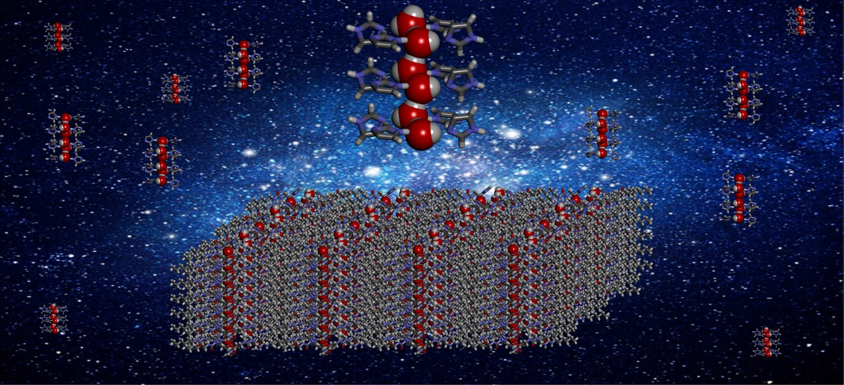

[1] M. Barboiu and A. Gilles, *Acc. Chem. Res.* 2013, **46**, 2814–2823.

[2] M. Barboiu, *Angew. Chem. Int. Ed*. 2012, **51**, 11674-11676.

[3] Y. Le Duc, et al., *Angew. Chem. Int. Ed.* 2011, **50(48)**, 11366-11372.

[4] E. Licsandru, et al., *J. Am. Chem. So*c., 2016, **138**, 5403-5409.

[5] M. Barboiu, ***Chem. Commun*.**, 2016, **52**, 5657- 5665.

[6] I. Kocsis, et al. *Science Adv.* 2018, **4**, eaao5603.

[7] M. Di Vincenzo,A. Tiraferri, V.-E. Musteata, S.Chisca, R.Sougrat, L.-B. Huang, S. P. Nunes, M. Barboiu, *Nature Nanotechnol.* **2021**, 16, 190-196.

[8] M. Di Vincenzo, et al. *Proc. Natl. Acad. Sci. USA,* **2021**, *118(37)*, e2022200118

[9] L.-B. Huang, M. Di Vincenzo, M. Göktuğ Ahunbay, A. van der Lee, D. Cot, S. Cerneaux, G. Maurin, and M. Barboiu, *J. Am. Chem. Soc.* 2021, *143*, 14386-14393.

**D:\Mihai Barboiu\ANTET\MBarboiu.tif**

Biography: Mihail Barboiu graduated from University Politehnica of Bucharest and received his PhD in 1998 from the University of Montpellier. He is CNRS Research Director at the Institut Europeen des Membranes in Montpellier and Fellow of Royal Society of Chemistry. A major focus of his research is Dynamic Constitutional Chemistry toward Dynamic Interactive Systems: adaptive biomimetic membranes, delivery devices etc. Author of more than 340 scientific publications and 450 conferences and lectures, Dr Barboiu has received the EURYI Award in Chemistry in 2004 and the RSC Surfaces and Interfaces Award in 2015 for the development of Artificial Water Channels.