A re-appraisal of the middle-late Miocene fossil decapod
crustaceans of the ‘Faluns’ (Anjou-Touraine, France)

Àlex OSSÓ
Llorenç de Vilallonga, 17B, 1er-1ª, 43007 Tarragona (Catalonia) aosso@comt.cat (corresponding author)
Cyril GAGNAISON
Institut Polytechnique UniLaSalle Beauvais, Département Géosciences, EA 7511 – Equipe B2R (Bassins, Réservoirs, Ressources),19 rue Pierre Waguet – boîte postale 30313, F-60026 Beauvais cedex (France), cyril.gagnaison@unilasalle.fr
Olivier GAIN
F-50130 Cherbourg-Octeville (France), lamarck@wanadoo.fr

ABSTRACT
The access to a new collection of decapod crustaceans collected in the middle-late Miocene ‘Faluns’, and examination of new specimens available, permits to expand the previous compilations of Couffon (1908) and Ossó & Gagnaison (2019), elevating to nineteen the species reported, representatives of seventeen genera and fourteen families. Galatheids such as Galathea weinfurteri Bachmayer, 1950 and parthenopid crabs are reported for the first time in the Atlantic Miocene of France. The expected presence of Xantho moldavicus (Yanakevich, 1977) and Lobocarcinus sismondai (von Meyer, 1843), hitherto known only by chelae, is confirmed herein. The status of Haydnella pulchellus (A. Milne-Edwards, 1864) is discussed. As well, the ventral features of Necronectes michelini (A. Milne-Edwards, 1864) are described for the first time. This decapod assemblage presents clear affinity with coeval decapod faunas from the Mediterranean and Paratethys realm, as evidenced by the presence of identical species such as Liocarcinus kuehni (Bachmayer, 1953) or Pilumnus mediterraneus (Lőrenthey, 1897), which is by far, the most common decapod in the ‘Faluns’ outcrops. Several different chelae and carapace remain are left in open nomenclature.
KEY WORDS
Decapoda, Anomura, Brachyura, Paratethys, Mediterranean, Miocene, Faluns.

TITRE
Réévaluation des crustacés décapodes du Miocène moyen-supérieur des ‘Faluns’ (Anjou-Touraine, France).

RÉSUMÉ
L'accès à une nouvelle collection de crustacés décapodes collectés dans les faluns du Miocène moyen-supérieur associé à l'examen de nouveaux spécimens, permettent d'élargir les synthèses précédentes de Couffon (1908) et Ossó & Gagnaison (2019), augmentant le nombre des espèces (dix-neuf) représentatives de dix-sept genres et de quatorze familles. Des Galathéidés comme Galathea weinfurteri Bachmayer, 1950 et des Parthénopidés sont signalés pour la première fois dans le Miocène de l’Atlantique français. La présence attendue de Xantho moldavicus (Yanakevich, 1977) et de Lobocarcinus sismondai (von Meyer, 1843), jusque-là connus uniquement par des pinces, est confirmée ici. Le statut d’Haydnella pulchellus (A. Milne-Edwards, 1864) est discuté. De plus, les caractéristiques ventrales de Necronectes michelini (A. Milne-Edwards, 1864) sont décrites pour la première fois. Cet assemblage de décapodes présente une affinité évidente avec les faunes contemporaines de la Méditerranée et de la Paratethys, comme en témoigne la présence d'espèces identiques telles que Liocarcinus kuehni (Bachmayer, 1953) ou Pilumnus mediterraneus (Lőrenthey, 1897), qui est de loin, le décapode le plus classique des faluns. Plusieurs pinces et carapaces sont laissées dans une nomenclature ouverte.

MOTS CLÉS
Decapoda, Anomura, Brachyura, Paratéthys, Méditerranée, Miocène, Faluns.

INTRODUCTION
The compilation of decapods of the ‘Faluns’ of Couffon (1908) was expanded by Ossó & Gagnaison (2019), who also updated the systematics of the taxa known at the time. In the latter work, a total of seven genera and eight species of eubrachyuran crabs, undetermined chelae, and one anomuran species, were reported. Access to a new collection of decapod crustaceans collected mainly in the ‘La Blandinerie’ quarry near Breil in the Anjou region (Maine-et-Loire, France), allows us to increase our knowledge of the ‘Faluns’ decapod fauna. This collection, composed of fifty-one remains that, have been identified for the most part, despite the fragmentary and worn condition of many of them. Here we present a selection of them, keeping aside several isolated dactyli, most of them likely belonging to Pilumnus mediterraneus (Lőrenthey, 1897) and Necronectes michelini (A. Milne-Edwards, 1861).
In the present work, some genera of different families of decapods are reported for the first time in the European Atlantic Miocene, for instance galatheids and parthenopids. Likewise, we confirm the expected presence of several taxa previously known from chelae remains only, by the discovery of identifiable carapaces , e.g., Xantho moldavicus (Yanakevich, 1977) and Lobocarcinus sismondai (von Meyer, 1843). The obscure systematic status of the Haydnella pulchellus (A. Milne-Edwards, 1864), whose holotype was lost, is revisited, concluding that one of the specimens attributed by Couffon (1908) to that species, was in fact a sample of Xantho moldavicus, and that the lost holotype could have actually been a sample either of the latter or of Pilumnus mediterraneus. Anew, another specimen of Hebertides jurassica Guinot, De Angeli & Garassino, 2007 is reported, confirming thus its origin in the ‘Faluns’. The enigmatic large cheliped from Doué-la-Fontaine described and depicted by Couffon (1908: t. 2, figs 3-4), was examined at the Muséum national d'Histoire naturelle (Paris, France), and its possible systematic affinity is discussed herein. A large but incomplete sample of Necronectes permits extend the description of this species, known hitherto only by chelipeds, to the ventral features and opens the debate on possible synonyms.
As a result of the present appraisal and of the previous works of Couffon (1908) and Ossó & Gagnaison (2019), a total of seventeen genera, comprising nineteen different species, that tentatively represent fourteen families, are reported from the Miocene of the ‘Faluns’ (Table 1). As pointed out by Ossó & Gagnaison (2019), the similarity between the Miocene ‘Faluns’ fauna and the Mediterranean and Central Paratethys coeval faunas is remarkable, with which—except for a few exceptions—the Miocene ‘Faluns’ fauna shares genera and even species. However, it contrasts the relatively low species richness reported in the ‘Faluns’, when compared to the high species richness reported from the localities with reefal environments (e.g. Müller 1984, 1993; Hyžný 2016) or non-reefal (siliciclastic) environments of the aforementioned areas (e.g. Müller 1993; Artal & Gilles 2007). This could be due to the strong underwater currents of ‘Faluns’ shallow infralittoral environment, precluding the rapid burial of decapod corpses and molts that otherwise disarticulate rapidly, as evidenced by the absence of articulated specimens and the higher percentage of hardest parts such as isolated chelae compared to the number of carapaces.
The specimens described in the present work are housed in the collections at the Muséum d’Histoire naturelle du Havre (Le Havre, France) under acronym MHNH; the Muséum national d'Histoire naturelle (Paris, France) under acronym MNHN; the UniLaSalle Institute (Beauvais, Oise, France) under acronym ULB, and the Musée du Savignéen (Savigné-sur-Lathan, Indre-et-Loire, France), under acronym MS.

Family | Genus/Species | ‘Faluns’ | Mediterranean and Western-Central Paratethys
Galatheidae | Galathea weinfurteri | ● | ●
? Porcellanidae | Undetermined chela | ● | -
Diogenidae | Paguristes gagnaisoni | ● | ○
? Paguridae | Undetermined chelae | ● | -
Calappidae | Calappa praelata | ● | ●
“ | Calappa sp. | ● | ○
Cancridae | Lobocarcinus sismondai | ● | ●
Corystidae | Hebertides jurassica | ● | -
Leucosiidae | ‘Ebalia’ cf. hungarica | ● | ●
Majidae | Maja orbignyana | ● | ●
? Majidae | Undetermined majoid | ● | ○
Parthenopidae | Parthenope cf. szaboi | ● | ●
Pilumnidae | Pilumnus mediterraneus | ● | ●
Carcinidae | Liocarcinus sp. | ● | ○
“ | Liocarcinus kuehni | ● | ●
“ | Undetermined chelae | ● | ○
Portunidae | Necronectes michelini | ● | ○
Xanthidae | Xantho moldavicus | ● | ●
? Xanthidae | Undetermined cheliped | ● | -
Table 1. — Decapods reported in the ‘Faluns’ Miocene outcrops (see Couffon 1908, Ossó & Gagnaison 2019, and this article) and in the circum-Mediterranean and Western-Central Paratethys areas (see Müller 1984, Hyžný 2016). ● species reported; ○ genus reported; - not reported.

LOCATION AND STRATIGRAPHY
The specimens studied herein were recovered from three different localities from the Anjou region (Maine-et-Loire, France): the ‘Blandinerie’ quarry (Breil), the ‘Sonneterie’ quarry (Meigné-le-Vicomte) and the ‘Noyant-la-Plaine’ quarry (Doué-la-Fontaine) (Fig.1).
During the late Burdigalian to the Tortonian, a transgression came from the west to the east until the Blésois region in the Loire Valley, and resulted in the deposition of bioclastic sands locally named ‘Faluns’ (Lecointre 1947) in a tidally-influenced hydrodynamic regime (André & Gagnaison 2012). This sedimentary formation is found in different French regions: Vendée-Bretagne, Poitou, Normandy, Anjou-Touraine and Blésois (Temey 1996). Excavations in these deposits locally reveal a mixture of marine and continental faunas (invertebrates and vertebrates).
The ‘Faluns’ substratum is composed of Mesozoic rocks (Jurassic carbonate platforms, Cenomanian gravelly sands and marls, and finally Turonian chalks, named ‘tuffeau’) (André & Gagnaison 2012) and Paleogene-Early Miocene fluvial to lacustrine deposits (Gagnaison 2017). Quaternary-to-recent soils cover all the Miocene formations.
In the Anjou region, three Miocene marine facies are present: 1) a clinostratified calcarenite with sea urchins of the late Burdigalian-early Langhian; 2) the clayey shelly sands with bryozoans (‘Savignean facies’) which present a diachronism between the Savigné-sur-Lathan/Noyant-sous-le-Lude sedimentary basin (Langhian-Serravallian) and the Doué-la-Fontaine sedimentary basin (Tortonian) (Ginsburg, 1990); and 3) the bioclastic calcarenite with the Tortonian Anadara turonica (‘Lublean facies’) in the Savigné-sur-Lathan/Noyant-sous-le-Lude sedimentary basin (Courville & Bongrain 2003; Gagnaison 2020).
The fossils reported and described herein were recovered from the the base of the clayey shelly (‘Savignean facies’) sands with bryozoans: Langhian for the ‘Blandinerie’ quarry (Breil) and the ‘Sonneterie’ quarry (Meigné-le-Vicomte); and, Tortonian for the ‘Noyant-la-Plaine’ quarry (Doué-la-Fontaine). These facies are composed of clayey, shelly sand with many bryozoan fragments (mainly celleporiforms and reteporiforms) and mollusc shells (Buge 1948; Courville & Bongrain 2003). In these three quarries, the ‘Savignean facies’ begins with many bryozoan bioconstructions in place or slightly broken (Fig. 2). Many fragile invertebrate fossils have been found in these facies such as molluscs with their connecting valves, sea urchins with their spines and sometimes, well-preserved crab remains. This biotope integrates into a warm underwater environment typical of shallow (upper infralittoral) bryozoan colonies (Ossó & Gagnaison 2019). The classic clay shelly sand with bryozoan debris and oblique strata covers this bioconstruction. This unit is interpreted as a warm and shallow infralittoral environment (Gagnaison 2012).

Abbreviations
L = carapace length; W = carapace width; FOW = fronto-orbital width; H = maximum height (for chelae); T = maximum thick (for chelae).

SYSTEMATIC PALAEONTOLOGY

Order DECAPODA Latreille, 1802
Infraorder ANOMURA MacLeay, 1838
Superfamily Galatheoidea Samouelle, 1819
Family Galatheidae Samouelle, 1819
Genus Galathea Fabricius, 1793

Type species: Cancer strigosus Linnaeus, 1761, by subsequent designation of Latreille (1810).

Galathea weinfurteri Bachmayer, 1950
(Fig. 3A, B)

Galathea weinfurteri Bachmayer, 1950: 135-137, pl. 1, figs 2-4. — Bachmayer 1953a: 242-243, pl. 5, figs. 3, 4, 6. — Müller 1974b: 276, pl. 1, fig. 4. — Müller 1984: 60, pl. 21, figs 4, 5, pl. 22, figs 1-5. — Müller 1996: 8. — Radwański et al. 2006, pl. 2, fig. 1. — Gatt & De Angeli 2010, p. 1326, pl. 2, fig. 4. — Ossó & Stalennuy 2011: text-fig. 3.7. — Collins 2014: 33-34, pl. 1, figs 3, 4. — Hyžný et al. 2014: 243-247, text-fig. 2, pl. 1, figs 1-7, pl. 2, figs 1-8. — Hyžný 2016, text-fig. 10.F.

Material examined and measurements (in mm). — One fragmentary carapace preserving only the central portion and part of right lateral, ULB-IV-A (9): L = 4; W = 6.5.

Locality and horizon. — ‘Blandinerie’ quarry, Breil (Maine-et-Loire). ‘Savignean facies’, Langhian (Middle Miocene).

Description
Anterior portion of carapace transversely vaulted, crossed by transverse striae. Cervical and branchiocardiac grooves well marked. Gastric region with sinuous and continuous main striae, raised, axially curved forward. Mesogastric region with secondary transverse striae between the main striae. Protogastric lobes weakly defined, at lower level that the axis. Epigastric striae sinuous, short. Hepatic region subtriangular. Epibranchial regions triangular, with two short striae, defined by cervical groove anteriorly and branchial groove posteriorly. One hepatic spine and two epibranchial spines preserved.

Remarks
Despite of the fragmentary condition of the studied sample, lacking specific characters such as the rostrum, it conserves enough characters to assign it to Galathea weinfurteri. The set of continuous transverse striae and the position of the secondary ones, and the shape of the cervical groove and the branchiocardiac groove, fits with the holotype figured by Bachmayer (1950, pl. 1, figs. 2, 3) and subsequent works (see synonymies list above). Hyzny et al. (2014: 244, pl. 1, figs. 1-5), emended the original diagnosis and also depicted Bachmayer’s images of the holotype. Galathea weinfurteri is by far the most widely distributed galatheid in the Miocene of the Central Paratethys (Hyzny et al. 2014: 254). The described specimen, extends its presence to the Atlantic Coast of Europe.

Family ?Porcellanidae Haworth, 1825
Undetermined chela
(Fig. 3C-F)

Material examined and measurements (in mm). — Fragment of left chela preserving part of palm and pollex, ULB-IV-A (15): L = 8; H = 4; T = 3.

Locality and horizon. — ‘Blandinerie’ quarry, Breil (Maine-et-Loire). ‘Savignean facies’, Langhian (Middle Miocene).

Description
Portion of palm preserved covered by coarse rounded granules, becoming squamous near the pollex; outer and inner margins slightly convex. Pollex slender, strongly curved upwards, slightly curved inwards, covered by squamous rounded granules; occlusal margin with acute cutting edge, not toothed.
Remarks
The slender and curved left pollex does not match with that of the galatheid, usually spinose, neither with that of the porcellanids, such as the typical Miocene species of Petrolisthes, wich have more robust and straighter pollex (cf. Górka 2018: text-fig. 3, 4a-b, 6, 7, 8a-b). Notwithstanding, some extant species of Pisidia Leach, 1920, possesses pollex of left chela somewhat slender and curved. Lacking of complete specimens, we place this chela within Porcellanidae with reservations.

Superfamily Paguroidea Latreille, 1802
Family Diogenidae Ortmann, 1892
Genus Paguristes Dana, 1851

Type species: Paguristes hirtus Dana, 1851, by subsequent designation.

Paguristes gagnaisoni Gagnaison, 2012
(Fig. 3G-K)

Material examined and measurements (in mm). — One complete right chela, ULB-IV-A (19): L = 6; H = 4.5; T = 3. — Two incomplete right chelae ULB-IV-A (19.2): L = 11; H = 6; T = 5.5. ULB-IV-A (17): L = 12.5; H = 7; T = 7.

Locality and horizon. — ‘Blandinerie’ quarry, Breil (Maine-et-Loire). ‘Savignean facies’, Langhian (Middle Miocene).
Description
Palm quasi subtrapezoidal, slightly wider than high, thick, ovoid in section. Upper margin straight, ornated with a row of bluntly rounded granules; lower margin clearly convex, sharp-edged, armed with a row of raised tubercles, varying from blunt to pointed triangular forwardly directed giving a dentate aspect. Outer margin convex, densely covered by blunt granules of different sizes; inner margin strongly convex at the mid, smooth. Pollex inverted triangular in section, somewhat shorter than half the palm, gently curved inwards; outer occlusal margin with large flattened molariform teeth; inner occlusal margin with a row of smaller blunt teeth.

Remarks
Paguristes gagnaisoni was the first paguroid found and described from the ‘Faluns’ (Gagnaison 2012), albeit the presence of hermit crabs was already expected, in view of the findings of gastropod shells covered by bryozoans (Lecointre 1947). It was assigned to the genus Paguristes by its similarity with the right chela of P. santamartaensis Feldmann, Tshudy & Thomson, 1993 (Paguridae Latreille, 1802) from the Upper Cretaceous of the Antarctica. It is assumed that the remains studied belong to the major chela.
The chela ULB-IV-A (17) (Fig. 3J, K), present an apparently different ornamentation in the lower half and distal part of its outer margin, formed by elongated and serrated granules, forming short terraces forward directed of squamous aspect, reminiscent of the ornamentation of some porcellanids chelae. However, this fragment of chela shows the same general features that Paguristes gagnaisoni, therefore it is tentatively left within that species.
Paguristes gagnaisoni presents strong similarities such as similar outline, strongly granulate surface, and dentate lower margin of palm, with ‘Pylopagurus’ leganyii Muller, 1984 (Paguridae), from the Middle Miocene of the Central Paratethys (Hungary), whose fossil decapods population has great affinities with the decapod population of the ‘Faluns’. In absence of remains of dactyli and of the left chelae, the familial and generic assignation of Paguristes gagnaisoni remains uncertain.

Family and genus indeterminate
(Fig. 3L-Q)

Material examined and measurements (in mm). — One right dactylus, ULB-IV-A (49): L = 17; H = 6; T = 5. — One left pollex, ULB-IV-A (44): L = 25; H = 12; T = 7.

Locality and horizon. — ‘Blandinerie’ quarry, Breil (Maine-et-Loire). ‘Savignean facies’, Langhian (Middle Miocene).

Description
Pollex elongate, stout, rounded in section except in the occlusal margin, which is flattened. Cuticle densely covered by rounded granules, larger in outer side. Small portion of palm appears largely concave laterally. Portion of upper margin, broad, flattened. Dactylus curved, proximally ornated with pointed granules, decreasing distally.

Remarks
Since the description of Paguristes gagnaisoni, no other paguroid has been reported from the Miocene sediments of the ‘Faluns’. Therefore, the pollex and dactylus described herein cannot be attributed to any previously described species from the same outcrops. As well, no other paguroid species reported in the Miocene of the Mediterranean or the Central Paratethys, with which the Faluns shares great fauna affinity, shows morphological similarities with that dactyli. Comparison with recent paguroid taxa does not clarify their identity either. The lack of a complete palm prevents us from making a generic and even familiar assignation of these remains.

Infraorder BRACHYURA Latreille, 1802
Section EUBRACHYURA de Saint Laurent, 1980
Subsection HETEROTREMATA Guinot, 1977
Superfamily Cancroidea Latreille, 1802
Family Cancridae Latreille, 1802
Genus Lobocarcinus Reuss, 1867

Type species. — Cancer paulino-würtembergensis von Meyer, 1847, by original designation.

Lobocarcinus sismondai (von Meyer, 1843)
(Fig. 4A-C)

Cancer Sismondae von Meyer, 1843: 590.
Cancer punctulatus – Desmarest 1822: p. 92, pl. 7, figs. 3-4.
Platycarcinus antiquus – Sismonda 1846: 58-60, pl. 3, figs. 1, 2. — Meneghini 1857, p. 528, pl. H, fig. 11.
Platycarcinus sismondai – Vinassa de Regny 1896: 124-127, pl. 2, fig. 1 a, b.
Cancer deshayesii – A. Milne-Edwards 1864: 74-76, pl. 4, figs. 1, 2, pl. 5, fig. 2. — Couffon 1908: 5, pl. 2, fig. 11. — Van Straelen 1927: 87, pl. 3, fig. 2, pl. 4, figs. 1, 2.
Cancer sismondai – A. Milne-Edwards 1864: 76-78, pl. 6, figs. 1, 1a, pl. 7, fig. 1. — Ristori 1886: 95-99, pl. 2, fig. 1. — Varola 1981: 16-26, pl. 3, figs. 5, 6, pl. 4, figs. 1, 2, pl. 5, figs. 1, 2, pl. 6, figs. 2, 4. — Bonfiglio & Donadeo 1982: 270-291, figs. 5-27, pls. 33-44. — Bonfiglio 1982: 5-18, figs. 1-4, pls. 1-7. — Vía et al. 1982. — Moisette & Müller 1990: 739, 740, pl. 1, fig. 1, pl. 2, figs. 1, 2. — Beschin & Santi 1997: 13, fig. 2, pl. 1, figs. 1, 2. — Garassino & Fornaciari 2000: 29, fig. 1.
Lobocarcinus sismondai – Reuss 1858: 41, pl. 9, figs. 1, 2. — Garassino & De Angeli 2004: 42, 43, figs. 9-11. — Ferratges 2017: 58, pl. 16, figs. A-B. — Górka 2018: 523-522, text-fig. 5.1, 5.2.
Lobocarcinus sismondae – Maestre et al. in Bernáldez et al. 2005
Lobocarcinus imperator – Reuss 1858, p. 41, pls. 7, 8, pl. 9, fig. 1. Garassino et al. in Baldanza et al. 2013: 346, fig. 11
Cancer sismondai var. antiatina – Maxia 1946: 134-147, fig. 1, pl. 1, figs. 2-5.

Material examined and measurements (in mm). — One carapace almost complete, cuticle partially preserved, ULB-IV-A (3): L = 42; W = 59.5; FOW = 23.

Locality and horizon. — ‘Noyant-la-Plaine’ quarry, Doué-la-Fontaine (Maine-et-Loire), Tortonian (upper Miocene).

Description
Medium sized carapace, transversely ovate, clearly wider than long, gently convex transversely and longitudinally; regions weakly marked, axial regions more elevated; endocuticle preserved, exocuticle partially preserved; surface smooth. Maximum width about two thirds posteriorly of carapace. Front slightly raised and produced, armed with three sharp triangular teeth, the mesial one smaller, at lower level than the others. Orbits small, rounded, deep. Supraorbital margin raised; inner orbital tooth trifid, produced, adjacent to the frontal teeth; two pointed mesial teeth at higher level than the supraorbital teeth; closed fissures that ending in a small hole, separate these mesial teeth. Infraorbital margin concave, serrated, bearing an inner tooth, dorsally visible, coalescent with basal antennal article, fissure separating them is visible internally; and an outer tooth separated laterally from the outer orbital tooth by a notch. Anterolateral margins widely convex. Right margin preserves six subrectangular lobes bearing three triangular teeth, the medial the larger; closed fissures that ending in a small hole separate the lobes. Left margin with not preserved lobes or teeth. Left posterolateral margin concave, bearing two post epibranchial teeth, subtriangular, serrated, decreasing in size; rest of the margin rimmed by a row of granules. Posterior margin short, broken, rim of granules partially preserved. Gastric process slightly swollen, faintly raised over adjacent regions. Mesogastric anterior lobe slender, at lower level than protogastric lobes; posterior portion of region broader, subtrapezoidal, undifferentiated from meta- and urogastric regions. Protogastric lobes swollen, anterior portion confluent with distal frontal and inner orbital teeth. Cardiac region subhexagonal, swollen. Intestinal region subrectangular, not well defined, narrower than cardiac region. Epi-, meso-, and metabranchial regions, slightly swollen, weakly differentiated. Hepatic regions subtriangular, slightly swollen. Sternopleonal features and appendages not preserved.

Remarks
The specimen of Noyant-la-Plaine, is herein attributed to Lobocarcinus sismondai with confidence. In despite of the partial incompleteness of its margins, it matches perfectly with the descriptions or figures seen in the literature (see synonymies list above). For instance, although the lateral margins are partially incomplete, it is possible to see the ten anterolateral lobes (included the outer orbital tooth), or scars of them, diagnostic character of the species as it is stated, in particular in the description of Milne-Edwards (1864) or in the exhaustive and detailed work of Bonfiglio and Donadeo (1982) (see also: https://science.mnhn.fr/institution/mnhn/collection/f/item/a24543).
Couffon (1908: 5, pl. 1, fig. 11), reported a palm of a left chela from Le Haguineau (Maine-et Loire), and assigned it to Cancer deshayesii (syn. of Lobocarcinus sismondai; cf. https://science.mnhn.fr/institution/mnhn/collection/f/item/b39264?lang=fr_FR). Ossó & Gagnaison (2019: 379, fig. 6G) in face of the absence of known carapaces of that species from the ‘Faluns’ outcrops, and neither in the Miocene of the Atlantic of Europe, left this chela tentatively as Lobocarcinus sp. in view of the similarity with the chelae of L. sismondai.
Lobocarcinus sismondai, is widely spread in deposits from the Miocene to the Pleistocene in the Mediterranean Sea and related basins (cf. Garassino et al. in Baldanza et al. 2013: 346) However, in the Miocene of the Atlantic margin of Europe, Lobocarcinus sismondai it is reported in basis only to isolated dactyli from the Miocene-Lower Pleistocene of the Netherlands (Holthuis 1949). Therefore, thanks to the recovery of the carapace described herein, its presence in the Atlantic margin of Europe from the Miocene times, is completely confirmed.

Superfamily Corystoidea Samouelle, 1819
Family Corystidae Samouelle, 1819
Subfamily Corystinae Samouelle, 1819

Genus Hebertides Guinot, De Angeli & Garassino, 2007b

Type species. — Hebertides jurassica Guinot, De Angeli & Garassino, 2007b by original designation.

Hebertides jurassica Guinot, De Angeli & Garassino, 2007b
(Fig. 4D, E)

Corystid – Guinot et al. 2007a: 53-55, fig. 1.
Hebertides jurassica Guinot, De Angeli & Garassino, 2007b: 241- 260, fig. 1-3. — Van Bakel et al. 2009: 80. — Taylor et al. 2012: 71-83, fig. 1. — Taylor 2012: 9-11, fig. 2. — Jagt et al. 2015: 882. — Emmerson 2017: 323. — Ossó & Gagnaison 2019: 372-373, fig. 3F-J. — Schweitzer & Feldmann 2019: 12, fig. 8.5.
Material examined and measurements (in mm). — Fragment of less than a left half of the carapace. ULB-IV-A (5): L = 19; W = 7.5.
Locality and horizon. — ‘Blandinerie’ quarry, Breil (Maine-et-Loire). ‘Savignean facies’, Langhian (Middle Miocene).

Description
Left half of carapace longitudinally ovate, convex in both sections. Cuticle well preserved. Regions relatively well defined, slightly swollen and separated by weak, smooth grooves; medial regions faintly distinct. Dorsal surface of carapace covered by rounded granules at anterior half, grouped and aligned at posterior half. Orbit broad; inner orbital tooth blunt, as a fold; supraorbital margin sinuous, finely serrated, with two V-shaped fissures; outer orbital tooth triangular, acute, prominent. Supraorbital area slightly depressed, smooth. Anterolateral margin convex, with three granular teeth (excluded the extraorbital one); the third the smallest. Posterolateral margin slightly convex. Protogastric regions slightly swollen, with two tubercles obliquely aligned at each lobe. Hepatic region subtriangular, well delimited by cervical and hepatic groove. Branchial regions slightly swollen. Ventral parts and appendages not present.
Remarks
A complete specimen of Hebertides jurassica was reported by Ossó & Gagnaison (2019), which allowed a complete description of the species, and at the same time to confirm its Neogene age rather than Jurassic—as suspected (Taylor et al. 2012; Taylor 2012)—, and the area of origin of the holotype, which was unknown at that time. The material of H. jurassica here studied confirms the geographical origin and Miocene age of this species.

Superfamily Leucosioidea Samouelle, 1819
Family Leucosiidae Samouelle, 1819
Subfamily Ebaliinae Stimpson, 1871
Genus Ebalia Leach, 1817

Type species. — Ebalia bryerii Leach, 1817

‘Ebalia’ cf. hungarica Müller, 1974a
(Fig. F, G)

Material examined and measurements (in mm). — One small carapace almost complete, with preserved cuticle, ULB-IV-A (7): L = 8.5; W = 7.5

Locality and horizon. — ‘Blandinerie’ quarry, Breil (Maine-et-Loire). ‘Savignean facies’, Langhian (Middle Miocene).

Description
Carapace small, subhexagonal slightly elongate, longer than wide, strongly convex longitudinally and transversely; regions strongly swollen, axially more elevated, well separated by grooves; whole carapace surface uniformly covered by close minute perliform granules. Front broken, but appears to be narrow and produced. Orbits not completely preserved, only the right orbit partially preserved, very close to the front; supraorbital margin raised, with medial tooth, separated from outer orbital corner by a closed fissure; outer orbital corner subtriangular in dorsal view; infraorbital margin visible in dorsal view, bearing a subtriangular distal tooth separated from the corner by a fissure. Anterolateral margin with prominent hepatic lobe. Posterolateral margin convex, rounded in section. A groove notching the margin separates both margins. Posterior margin short, appears to be bilobate, albeit only the right lobe in preserved. Meso-, meta-, and urogastric regions elevated, weakly differentiated. Protogastric lobes inflated, with central tubercle. Cardiac region rounded strongly raised. Intestinal region very short, depressed. Hepatic lobes strongly inflated. Branchial regions swollen, undifferentiated, with one central tubercle.

Remarks
This small carapace fits largely with the diagnosis and figures of ‘Ebalia’ hungarica (see Müller 1974a: 121, 126, pl. 1, figs. 1-5; 1984: 70, pl. 44, fig. 5, pl. 45, figs. 1-5), in particular with the holotype. However, the French form appears to be more rounded and vaulted. A close examination of the type series, and additional material from the ‘Faluns’, would be necessary to stablish the conspecificity of both forms, and also to review the generic attribution of this species. Meanwhile, we place the ‘Faluns’ specimen tentatively as ‘Ebalia’ cf. hungarica.

Superfamily Majoidea Samouelle, 1819
Family Majidae Samouelle, 1819
Subfamily Majinae Samouelle, 1819

Genus Maja Lamarck, 1801

Type species. — Cancer squinado Herbst, 1788, subsequent designation by ICZN (1958).

Maja orbignyana Millet de la Turtaudière, 1865
(Fig. 4H-M)

Maia orbignyana Millet de la Turtaudière, 1865: 577. — Millet 1854: 152 (nomen nudum). — Couffon 1934: 171, fig. 155.
Maja orbignyana – Couffon 1908: 2, 3, pl. 1, figs 1-4. — Glaessner 1929: 247. — Ossó & Gagnaison 2019: 373, figs. 4A-F.
Maïa orbigniana – Couffon 1910: 130, fig. 4.
Maia sp. – Via 1932: 9.
Maia cfr. orbingyana – Vía 1941: 118, 119, pl. 10, fig. 70.
Maja cf. orbigniana – Müller 1993: 13, fig. 6E.

Material examined and measurements (in mm) (Length measurements taken from the basis of the pseudorostral spines). — Two complete carapaces, ULB-IV-A (1): L = 23; W = 17.5. — ULB-IV-A (2): L = 22.5; W = 17.5. — Five fragments of carapaces, ULB-IV-A (23): L = 22.5; W = 22. — ULB-IV-A (24): L = 21; W = 17. — ULB-IV-A (27): L = 22; W = 18. — ULB-IV-A (28): L = 17; W = 18. — ULB-IV-A (29): L = 22; W = 18.5.

Locality and horizon. — ‘Blandinerie’ quarry, Breil (Maine-et-Loire). ‘Savignean facies’, Langhian (Middle Miocene).

Description
Carapace pyriform with spiny outline, longer than wide, strongly vaulted transversely; regions well defined, inflated; surface coarsely tuberculated except in the cervical and gastrohepatic grooves. Front narrow with two long, sharp and conical pseudorostral divergent spines. Orbits shallow, rounded, opened; supraorbital eave broad, strongly vaulted; antorbital spine sharp, laterally directed; intercalated spine subtriangular, short; postorbital spine the longer, sharp, conical, obliquely and slightly upwardly directed; suborbital tooth blunt. Hepatic spine short, laterally directed. Lateral margins with three sharp spines laterally directed. Frontal and epigastric regions defined by two rows of tubercles, separated by a shallow groove, that end at the base of the pseudorostral spines. Gastric process raised over the other regions. Proto-, meso- and metagastric regions strongly swollen, weakly differentiated between them; mesogastric lobe defined by longitudinal rows of coarse rounded tubercles, with medial spine; metagastric lobe with sharp spine; protogastric lobes sloping laterally, with scattered tubercles. Urogastric region transversely narrow, slightly swollen, with prominent tubercles; separated from metagastric lobe by cervical groove. Cardiac region swollen, rhomboidal elongated, prominent sharp central spine. Branchial regions strongly swollen, indistinct, sharp branchial spine upward and laterally directed at posterior part. Intestinal region not preserved. Hepatic region slightly swollen, ornate with rounded granules, the biggest ones at the basis of the hepatic spine. Interantennular spine prominent. Basal antennal article broad with two distal spines.
Remarks
Examination of the new material available: two almost complete small carapaces, and remains of anterior pars of carapace of five larger specimens, allows us to attribute them all with confidence to Maja orbignyana (cf. Couffon 1908: figs 1, 2, 4). Likewise, the new material preserves elements not described previously, e.g., some cephalic appendages and frontal spines, which allows a more detailed description of the species (Fig. 4K, M). A clear distinction between Maja orbignyana and M. biaensis Lőrenthey in Lorenthey & Beurlen, 1929, can be established not only by the strong, rounded and raised tubercles in the protogastric lobes and hepatic regions in the former (see Müller 1993: 13), but also by the more distinct branchial regions in the latter (cf. Müller 1993, pl. 48, figs. 1-6, t. 49, fig. 1). The general shape and the conformation of the regions of Maja orbignyana, strongly recalls those of the extant M. crispata Risso, 1827, which, like the fossil species, inhabits the Mediterranean and the Atlantic coast of Europe (e.g. Ng & Richer de Forges 2015: 126-127, fig. 6A-B).

Family and genus indeterminate
(Fig. 5A)

MATERIAL EXAMINED AND MEASUREMENTS (in mm). — Remains of a central portion of dorsal carapace, ULB-IV-A (26): L = 10; W = 13.

LOCALITY AND HORIZON. — ‘Blandinerie’ quarry, Breil (Maine-et-Loire). ‘Savignean facies’, Langhian (Middle Miocene).

Description
Central portion of dorsal carapace, strongly vaulted, regions defined by inflations with tubercles and coarse granules, well divided by grooves. Mesogastric region with posterior portion subpentagonal bearing a large and prominent granulate tubercle, anterior portion elongate and narrow, bearing a tubercle medially. Protogastric lobe swollen posteriorly, with scattered coarse granules and small tubercles. Urogastric region depressed, defined by two transverse rows of rounded granules, two the anterior one and four the posterior one. Cardiac region large, swollen, with large rounded granules. Epibranchial lobes well differentiated, prominent, with coarse granules and small tubercles, obliquely directed to the anterolateral margin. Cervical and branchiocardiac grooves well marked, smooth, the latter the deeper.
Remarks
It’s difficult to assign this fragmentary remain to a determinate kind of crab. Nonetheless, its regions conformation is reminiscent of majids, in particular the ornamentation and the strong constrictions at the urogastric-cardiac level. The absence of other carapace remains, as well as the lack of similar forms from coeval faunas of the circum-Mediterranean and Central Paratethys areas, prevent us from assigning this remain to any genera or family. Thus, we place it within Majoidea, with reservations.

Superfamily Parthenopoidea MacLeay, 1838
Family Parthenopidae MacLeay, 1838
Subfamily Parthenopinae MacLeay, 1838
Genus Parthenope Weber, 1795

Type species. — Cancer longimanus Linnaeus, 1758

Parthenope cf. szaboi Müller, 1974b
(Fig. 5B-E)

Material examined and measurements (in mm). — Three right propodi, ULB-IV-A (33): L = 14, H = 5.5, T = 3.5; ULB-IV-A (34): L = 15.5, H = 5.5, T = 4. — One left propodus ULB-IV-A (35): L = 13, H = 7.5, T = 6. — Two merus, ULB-IV-A (32): L = 9.5, H = 3, T = 4; ULB-IV-A (36): L = 16, H = 6, T =5.

Locality and Horizon. — ‘Blandinerie’ quarry, Breil (Maine-et-Loire). ‘Savignean facies’, Langhian (Middle Miocene).

Description
Propodus long, subtriangular in cross-section, acute edges; upper margin armed with acute spines irregularly placed; lower margin bearing a continue row of granules or spines; outer margin with a transverse row of continuous acute spines; inner margin coarse granulated, with a medial row of granules; pollex short, obliquely downward directed. Merus elongate, subrhomboidal in section, lateral angles coarsely spiny.

Remarks
The ‘Faluns’ parthenopid chelae are reminiscent of those that Müller attributed to Parthenope szaboi, from several localities of the middle Miocene of Hungary (cf. Müller 1984, pl. 54, fig. 6-9), and in lesser extend of those of Parthenope tetenyensis Müller, 1984, which are shorter than the former species (Müller 1984: 74-75, pl. 66, fig. 3). The ‘Faluns’ chelae have been found isolated, and no carapace attributable to Parthenopidae has been recovered in those outcrops to date, and still, still it's hard to assign an isolated chela to a particular carapace of any species. However, and despite that the poor degree of preservation of the ‘Faluns’ parthenopid chelae, which are strongly reworked, they still preserve some main characters, and can be observed the similarities with the chelae described as Parthenope szaboi, to which, and with reservations, we assign these chelae provisionally.

Superfamily Pilumnoidea Samouelle, 1819
Family Pilumnidae Samouelle, 1819
Subfamily Pilumninae Samouelle, 1819
Pilumnus Leach, 1815

Type species. — Cancer hirtellus Linnaeus, 1761, by monotypy.

Pilumnus mediterraneus (Lőrenthey, 1897)
(Fig. 5F-K)

Pilodius mediterraneus Lőrenthey, 1897: 160, 167, 169; 1898a: 105, 113, 115; 1898b: 126-129, pl. 8, figs 5, 6; 1898c: 99-101, pl. 8, figs 5, 6. — Glaessner 1929: 315.
Pilumnus sp. – Glaessner 1928: 190.
Chlorodopsis mediterraneus – Lőrenthey in Lőrenthey & Beurlen 1929: 34, 225-227, pl. 12, figs 13-17, 19.
Chlorodopsis mediterranea – Bachmayer 1953a: 253, pl. 3, fig. 5. — Bachmayer & Tollmann 1953: 314.
‘Pilodius’ mediterraneus – Müller 1974a: 122, pl. 3, fig. 3.
Pilumnus mediterraneus – Müller 1974b: 280; 1976a: 510; 1976b: 152; 1979: 274, pl. 21, fig. 3; 1984: 93, 94, pl. 87, figs 2-5, pl. 88, figs 1-5. — Radwański et al. 2006: 96, pl. 2, fig. 7. — Ossó & Stalennuy 2011: 37, fig. 9.3. — Górka et al. 2012: 171. — Górka in Wysocka et al. 2016: 379, fig. 14E. — Ossó & Gagnaison 2019: 373, 374, fig. 4G-L.
Pilumnus sp. – Förster 1979: 260-261, pl. 3, fig. 6, pl. 5, fig. 1, 3, text-figs 8, 9.
Pince d’une patte de crabe – Gagnaison et al. 2009: 1, fig. 3.
Pilumnus cfr. P. mediterraneus – De Angeli et al. 2011: 112, fig. 4.

Material examined and measurements (in mm). — Six complete dorsal carapaces with cuticle well preserved, ULB-IV-A (4) L = 8, W = 9, FOW = 7; ULB-IV-A (8): L = 6.5, W = 8, 8, FOW = 6.5; ULB-IV-A (14): L = 11, W = 14.5, FOW = 10.5; ULB-IV-A (18): L = 8.5, W = 11, FOW = 8; ULB-IV-A (37): L = 10, W = 13, FOW = 11; ULB-IV-A (38): L = 7.5, W = 9.5, FOW = 7. —Two right chelae, ULB-IV-A (39): L = 12.5, H = 6; ULB-IV-A (40): L = 11, H = 7. — One left chela, ULB-IV-A (20): L = 25.5, H = 11.5, T = 7.

Locality and horizon. — ‘Blandinerie’ quarry, Breil (Maine-et-Loire). ‘Savignean facies’, Langhian (Middle Miocene).

Description
Carapace relatively small sized, subhexagonal, longitudinally vaulted anteriorly, regions faintly marked; surface smooth, weakly ornate with small acute granules and small clusters of acute granules of squamous aspect, spread mainly by anterior half of carapace; setal pits visible. Maximum width at level of fourth anterolateral tooth, at the anterior half of carapace. Front bilobed, medially notched, each half with inner lobes very wide, and the outer lobes smaller, and separated from the inner orbital angle by notches. Orbits small, subrectangular, complete, forward directed; supraorbital margin finely serrated, with two fissures, one median and a second close to outer orbital tooth. Anterolateral margin with four subtriangular teeth (excluding outer orbital tooth), the first one semifused with the outer orbital one, the second one broad, the third and fourth acute. Posterolateral margin slightly convex, smooth. Posterior margin clearly convex medially, rimmed. Frontal region with a short, longitudinal deep groove, lobes slightly swollen. Gastric process fairly defined. Epigastric lobes faintly swollen, ornate. Protogastric lobes rounded, swollen, faintly ornate. Mesogastric region subpentagonal elongated anteriorly, wider posteriorly. Metagastric region indistinct. Urogastric region slightly depressed and separated from meso- and metagastric lobes by two gastric pits. Cardiac region diamond shaped, weakly swollen. Intestinal region narrow, transversely elongate, faintly swollen laterally. Hepatic region with a short granulate ridge paralleling the anterolateral margin. Epibranchial region with a short, acute, half-moon ridge not reaching the fourth (epibranchial) anterolateral tooth. Meso- and metabranchial regions indistinct, swollen. Gastrohepatic groove well marked; cervical and branchiocardiac grooves slightly marked. Thoracic and abdominal features not preserved. Right chela stout, palm slightly wider than high, outer side smooth, spiny in the upper margin and the distal portion of palm, mainly in smaller individuals; articulation with the dactylus strong; dactyli stout, about one third of chela length; dactylus curved with blunt teeth in occlusal margin; pollex strong, with three to four massive acute teeth in the occlusal margin; setal pits visible in both dactyli. Carpus stout, angle of upper and outer surface with scattered spiny tubercles; upper inner angle with prominent tooth.

Remarks
As pointed out by Ossó & Gagnaison (2019: 380), the decapods population of the ‘Faluns’ appears clearly dominated by Pilumnus mediterraneus, as the new collection of decapods from the ‘Blandinerie’ quarry also evidences. This species, represented usually by undetermined cheliped remains in the ‘Faluns’ outcrops, was confirmed as such by the report of two complete dorsal carapaces (ibid: 373-374, figs. 4G-J). In the same text, the authors suggested that the type of Haydnella pulchellus, figured in A. Milne-Edwards (1863, pl. 9, figs. 2, 2a, as Titanocarcinus pulchellus) was likely a specimen of P. mediterraneus, in basis on the drawings of the holotype, which is lost (see Couffon 1908: 1), and on the description of it (see A. Milne-Edwards 1864: 33, 34). A careful reading of the French text of that description, reveals details such as: ‘La surface est ornée, sur toutes ses parties, de petites granulations, qui sont plus nombreuses près des bords[...] Les régions branchiales sont décomposées en leurs lobes antérieurs, moyens et postérieurs, par des sillons peu profonds’, characters that are more typical, for instance, of Xantho moldavicus, whose presence in the ‘Faluns’ is confirmed herein (see below), rather than of Pilumnus mediterraneus. Thus, it is plausible that the holotype was in fact, a small sample either of Pilumnus mediterraneus or Xantho moldavicus instead of a third species. In any case, the continuity of Haydnella pulchellus as a valid taxon, based on a lost holotype and two schematic drawings, appears problematic now.

Superfamily Portunoidea Rafinesque, 1815
Family Carcinidae Macleay, 1838

Subfamily and genus indeterminate
(Fig. 5L, M)

Material examined and measurements (in mm). — One right chela, ULB-IV-A (52): L = 30; H = 16; T = 11. — One left chela, ULB-IV-A (50): L = 20; H = 10.5; T = 6.5.

Locality and horizon. — ‘Blandinerie’ quarry, Breil (Maine-et-Loire). ‘Savignean facies’, Langhian (Middle Miocene).

Description
Palm stout, subtrapezoidal, longer than high, higher distally; subhexagonal elongate in cross section; surface coarsely granulated; upper margin straight, flattened, with keeled lateral angles, scar of spinule at inner distal corner, over the dactylus insertion; outer margin convex, with two transverse keels, one at halfway up of palm, the second below, near the lower margin and continues along the pollex; inner margin convex medially, with two transverse weak keels; lower margin slightly convex, flattened, rounded lateral angles. Pollex straight, slightly concave proximally, keeled, occlusal margin with serial conical teeth.

Remarks
The two chelae described herein exhibit the typical long and keeled ‘portunid’ shape, but no ‘portunid’ carapace to which they can be related has been found in the ‘Faluns’. Strictly, although both chelae possess very similar construction and ornamentation, we cannot affirm that they are conspecific. Despite this, the absence of spines in their upper margin, mainly at the proximal articulation with carpus, discards their affinities with Portunidae s.s. (Spiridonov et al. 2014: 423). Nevertheless, the general shape of that chelae, shorter as in Portunidae, and the ”lacking spines except for a distal spinule on upper face of manus”’, exactly in the inner distal corner over the dactylus insertion, is characteristic for the Carcinidae, and for at that time considered full family Polybiidae, now subfamily of Carcinidae (Spiridonov et al. 2014: 422).
In view of the aforementioned, we assign both chelae to Carcinidae, which in fact, as seen below, has representatives in the ‘Faluns’ such as Liocarcinus spp., albeit the small size of the specimens available prevent us from relating them at a generic or specific level with confidence.
The two fragments of dactyli attributed by Couffon (1908:2, pl. 1, fig. 5) to Neptunus aff. monspeliensis A. Milne-Edwards, 1861 (sic), could likely belong to the chelae of Carcinidae species such as the described herein.

Subfamily Polybiinae Ortmann, 1893
Genus Liocarcinus Stimpson, 1871

Type species. — Portunus holsatus Fabricius, 1798, by original designation. Liocarcinus sp.

Liocarcinus kuehni (Bachmayer, 1953a)
(Fig. 5N-Q)

Portunites kühni Bachmayer, 1953a: 249-251, pl. 2, fig. 2. — Karasawa 1990: 17.
Liocarcinus kuehni – Müller 1984: 84, pl. 71, figs. 2, 3. — Hyžný et al. 2015: 226.
Material examined and measurements (in mm). — Two dorsal carapaces, ULB-IV-A (10): L = 15, W = 17, F = 7, FOW = 12. — ULB-IV-A (13): L = 6, W = 6.5, F = 3, FOW = 5,5.
Locality and horizon. — ‘Blandinerie’ quarry, Breil (Maine-et-Loire). ‘Savignean facies’, Langhian (Middle Miocene).

Description
Small sized carapace, subhexagonal, slightly wider than long; carapace surface covered by transverse rows of minuscule granules forwardly directed, forming terraces of different sizes. Regions weakly defined. Front gently trilobate, edge finely serrated, medial tooth slightly more advanced than the lateral teeth. Orbits relatively large; supraorbital margin arched, finely serrated, with two closed fissures, first at mid length second near outer orbital tooth; inner orbital tooth blunt; outer orbital tooth broad subtriangular, forwardly directed; infraorbital margin not preserved. Anterolateral margin slightly arcuate, with four subtriangular teeth (excluding the outer orbital tooth), the latest (epibranchial tooth) the sharper. Posterolateral margin slightly concave; anterior half sharp edged, with serrate keel; posterior half blunt edged; reentrant of fifth pereiopod well marked, gently concave. Posterior margin slightly convex, finely rimmed. Frontal region flattened. Gastric process poorly defined. Epigastric lobes slightly marked. Protogastric lobes slightly swollen. Mesogastric region weakly marked, very narrow anteriorly, subrhomboidal posteriorly, slightly elevated above the rest of regions. Metagastric region faintly defined. Urogastric region slightly depressed. Cardiac region broad, swollen anteriorly. Intestinal region depressed. Hepatic region depressed. Epibranchial region sigmoidal, interrupted medially, defined by long terraces, and a sharp ridge distally that ends in the epibranchial tooth. Mesobranchial region slightly swollen internally. Metabranchial region depressed. Cervical groove faintly marked. Branchiocardiac groove weakly marked. Ventral parts and appendages not preserved.
Remarks
The dorsal morphology of the two samples of decapods described herein correspond exactly with the holotype of Liocarcinus kuehni from the upper Miocene of Austria, described and depicted by Bachmayer as Portunites kühni (1953a: 249-251, pl. 2, fig. 2) (see also Müller 1984: 84, pl. 71, figs. 3, 4). The carapace outline, same number and shape of anterolateral teeth, shape of the orbits, similar size, and in particular the squamous carapace surface formed by transverse terraces of different sizes, in despite that the holotype and paratypes does not preserve the front, allows to consider the ‘Faluns’ specimens conspecific of Liocarcinus kuehni with confidence.
Strikingly, the dorsal carapace, the only part preserved of our specimens and of Bachmayer’s types, seems identical to that of the extant Liocarcinus corrugatus (Pennant, 1777). However, they apparently differ in having a much smaller size than the extant species. In this respect, it is interesting to know that molecular analyses by Plagge et al. (2016), concluded that the European and the Asian populations of Liocarcinus corrugatus, only separated morphologically by subtle dorsal and penial differences, are in fact two genetically separated species, as the results of their analyses demonstrated, thus recognizing the Asian population as L. strigilis Stimpson, 1858. In view of that, and given the scarce number of specimens of the fossil form, the two samples here studied, and the three Bachmayer’s samples seen by Müller, is not sufficient to infer that Liocarcinus kuehni is the same species that L. corrugatus. In addition, Plagge et al. (2016: 386) suggested that both extant species are relict of a former range of the eastern Tethys Ocean”, Liocarcinus kuehni would confirm it.
Ossó & Gagnaison (2019: 374-376, fig. 5A-B) reported and described a specimen from the ‘Faluns’ as Liocarcinus sp., and compared it with all the known fossil forms of Liocarcinus. However, it was left in open nomenclature in view of their poor preservation and by to be the only specimen available. Now, compared with the two new specimens of Liocarcinus kuehni, it still appears to be different. Its smooth carapace surface could be due to the reworking, but the specimen of Liocarcinus kuehni ULB-IV-A (13) (Fig. 5P, Q) although it is also strongly worn, it retains still the terraces in the carapace, absent in Liocarcinus sp. In addition, the three characteristic tubercles, longitudinally aligned three tubercles at both sides of carapace that Liocarcinus sp. exhibits, are not present, or at least not interpreted as such, in the specimens of L. kuehni described herein. Consequently, we retain the former in open nomenclature.

Family Portunidae Rafinesque, 1815
Subfamily Necronectinae Glaessner, 1928
Genus Necronectes A. Milne-Edwards, 1881

Type species. — Necronectes vidalianus A. Milne-Edwards, 1881 by original designation.

Necronectes michelini (A. Milne-Edwards, 1861)
(Fig. 6A-C)
Scylla michelini A. Milne-Edwards, 1861: 137, pl.3., figs 3-3A. — Couffon 1908: 3, 4, pl. 1, figs 6-10, pl. 2, figs 1, 2. — Schweitzer et al. 2006: 122; 2010: 110. — Karasawa et al. 2008: 106. — Emmerson 2017: 584.
Cancer macrochelus – Millet 1854: 152 (non Desmarest, 1817).
Scylla cf. michelini – Glaessner 1928: 184, 185.
Scylla? michelini – Glaessner 1929: 374.
Scylla sp. (cf. michelini) – Lőrenthey & Beurlen 1929: 178, pl. 15, figs 5, 6.
Necronectes michelini – Glaessner 1933: 5-6. — De Angeli & Marangon 1992: 178, 179. — Ossó & Gagnaison 2019 : 376-378, fig. 5C-D.
Scylla michelini? – Betancort et al. 2014: 345, pl. 1, figs K1-K2 (non I1-I2)

Material examined and measurements (in mm). — Ventral carapace preserving chelipeds MHNH-2016-79-2003, W (from carpus to carpus) = 150. — Right dactylus, ULB-IV-A (51): L = 41.5, H = 16. — Right dactylus ULB-IV-A (41): L = 20, H = 9.5. — Fragment of right epibranchial portion of dorsal carapace bearing two last anterolateral teeth, ULB-IV-A (42): L = 17.5, W = 9.5.
Locality and horizon. — ‘La Sonneterie’ quarry, Meigné-le-Vicomte (Maine-et-Loire). ‘Savignean facies’, Langhian (Middle Miocene): MHNH-2016-79-2003 and ULB-IV-A (51); and, ‘Blandinerie’ quarry, Breil (Maine-et-Loire). ‘Savignean facies’, Langhian (Middle Miocene): ULB-IV-A and ULB-IV-A (42).
Description (Emended)
Large ventral carapace preserving sternum and chelipeds, surface smooth. Sternum relatively large, flattened, maximum width at level of sternite 6. Sternite 2 subtriangular; sternite 3 inverted subpentagonal; sternite 4 subtrapezoidal; sternite 5, 6 and 7 subrectangular transversely elongate, distal margin rounded; sternite 5 placed in acute angle respect the axis of sternum, sternite 6 almost in right angle, and sternite 6 in slightly obtuse angle. Episternites posteriorly directed. Suture 2/3 complete, horizontal; suture 3/4 inverted V-shaped, weakly distinguishable, only laterally. Sutures 4/5, 5/6, and 6/7 appear complete. Pleon not preserved. Sternopleonal cavity deep, narrow, almost reaching suture 3/4. Pterygostome subtrapezoidal elongate. Ischium of third maxilliped large, with medial longitudinal groove, inner margin strongly convex; exopod subrectangular elongate, narrower than ischium. Chelipeds strong, slightly heterochelous. Merus robust, subtriangular in section, outer margin strongly vaulted, wider at mid length. Carpus strong, embedded in matrix. Right chela strong, dactyli curved distally; palm about 0.70 of length of chela, subtrapezoidal, longer than high, higher distally; upper margin rounded, slightly convex; lower margin rounded, straight; outer margin strongly convex, smooth; dactylus stout, gently curved forward, strong proximal knobstick molariform tooth followed by six serial rounded conical teeth of different sizes, and rounded tip; pollex stout straight with rounded tip, strong flattened proximal molariform tooth, followed by three blunt teeth. Left chela strong, elongate, slightly shorter than right chela, dactyli gently curved distally; palm subrectangular, longer than high, about 0,68 of length of chela, upper and lower margins straight, rounded, outer margin strongly convex; cutting edge of dactyli with serial conical teeth.

Remarks
Erected by A. Milne-Edwards (1861), to place fragmentary large chelipeds found in the ‘Faluns’, Necronectes michelini, was originally placed within the genus Scylla De Haan, 1833 given its similarity to the strong chelipeds of the extant S. serrata (Forskål, 1775), albeit the author already considered the differences between the chelae of both species such as the rounded upper margin of palms, which are flattened and angled in Scylla spp., and the absence in N. michelini of the two typical distinct spines on the distal upper part of the palm, near the insertion of dactylus (see Fig. 6B; Couffon 1908: pl. 1, figs 6-10, t. 2, figs 1, 2; MNHN.F.B25950), which are usually present in Scylla spp. (e.g. Keenan et al. 1998; Trivedi & Vachhrajani 2013; Vincecruz-Abeledo & Lagman 2018). Glaessner (1933: 5), included S. michelini within Necronectes A. Milne-Edwards, 1881, in view of the similarities of the chelae of both taxa. Subsequent authors assigned this species indistinctly to both genera, Scylla and Necronectes, as explained in Ossó & Gagnaison (2019: 376-378, and references therein). Given that the chelipeds of the studied specimen are identical to the type series MNHN.F.B25950 described by A. Milne-Edwards (1861), the conspecificity between them is beyond of doubt.
For the first time, a specimen of Necronectes michelini preserving features other than the chelipeds, is available for study, although important diagnostic features, such as the dorsal carapace are not preserved. Nevertheless, the sternum of the studied specimen fits well with the sternums of other representatives of the genus Necronectes, such as N. proavitus (Rathbun, 1918) and N. schafferi Glaessner, 1928 (e.g. Rathbun 1918: pl. 55; De Angeli & Berti 2017: fig.2, 1b).
The absence of specimens formally available for study with the dorsal carapace preserved, even though some of them are known in private collections (e.g. Gagnaison et al., 2020: fig. 2A), prevents us from going further in our considerations. For instance, to explore the possible conspecific relationship between the circum-Mediterranean and Paratethyan Miocene species of Necronectes, such as N. schafferi and N. batalleri (Vía, 1941), almost identical morphologically, and N. michelini (cf. Vía 1941, figs. 3, 4, pl. 5, figs. 31, 32, pl. 6, figs. 33, 34; De Angeli & Marangon 1992: pl. 1, figs. 1, 2, pl. 2, figs. 1a, 1b; Ferratges 2017: fig. 43, pl. 29, fig. C).

Superfamily Xanthoidea MacLeay, 1838
Family Xanthidae MacLeay, 1838
Subfamily Xanthinae MacLeay, 1838
Genus Xantho Leach, 1814

Type species. — Cancer incisus Leach, 1814 by monotypy.

Xantho cf. moldavicus (Yanakevich, 1977)
(Figs 6D-G)

Titanocarcinus pulchellus Couffon 1908: 4-5, pl. 2, fig. 6, text-fig. unnumbered p. 4.
Titanocarcinus vulgaris Glaessner 1928: 185, pl. 3, figs. 9-11. — Bachmayer1953b: 254, pl. 4, figs. 1-9, pl. 6, figs. 1-2.
Xantho cfr. X. incisus– Müller 1974a: 123, pl. 3, figs. 1-2.
Medaeus moldavicus– Yanakevich 1977: 80, pl. 10, fig. 4.
Xantho cfr. X. incisus– Müller 1979: 274, pl. 20, figs. 1-5.
Xantho cf. X. vulgaris– Förster 1979: 263-264, pl. 5, fig. 4.
Xantho moldavicus– Müller 1984: 92, figs. 5-8, pl. 86, figs. 1-5, pl. 87, fig. 1.
Xantho cf. moldavicus– Friebe 1987: 61, pl. 2, fig. 5.
Xantho moldavicus –Via 1988: 351. — Solé & Via 1989: 35. — Marras & Ventura 1991: 110, pl. 2, fig. 2. — Müller 1996: 11, pl. 2 fig. 6. — Müller 1998: 34. — Radwański et al. 2006: 96, pl. 2, figs. 5, 6. — Gatt & De Angeli 2010: 1339, figs. 8G-K. — De Angeli et al. 2011: 114-115, fig. 6. — Ossó & Stalennuy, 2011: 37, figs 3.11-12, 9.1-2. — Górka et al. 2012: 171, fig. 21D. — Hyžný et al. 2014: 226, pl. 1, fig. 6. — Górka in Wysocka et al. 2016: 379, fig. 14.F-G. — Hyžný 2016, text-fig. 14F, G. — Ferratges 2017, pl. 33, fig. B. — Górka 2018: 528-529, text-fig. 8.3-8.4a-b.

Material examined and measurements (in mm). — One almost complete carapace, ULB-IV-A (6): L = 9.5, W = 14, FOW = 8.5. — Right half of carapace, ULB-IV-A (11): L = 14.5, W= 12.
Locality and horizon. — ‘Blandinerie’ quarry, Breil (Maine-et-Loire). ‘Savignean facies’, Langhian (Middle Miocene).

Description.
Carapace transversely subhexagonal, regions well marked, surface rugose; ratio length/width about 0.67. Front straight, bilobed, medial notch, edges granulated. Orbits complete, small, rounded, forwardly directed; supraorbital margin finely granulated with two fissures, one of them medially placed, the other close to the outer-orbital tooth; inner orbital tooth acute triangular, separated from the frontal lobe by a deep notch, outer orbital tooth blunt triangular; infraorbital margin, visible dorsally, finely granulated ends in a produced tooth. Ratio fronto-orbital margin/width about 0.60. Anterolateral margin bearing four subtriangular teeth with serrated margins, the fourth the smaller. Posterolateral margins straight, rounded in section. Posterior margin incomplete, rim of small granules. Frontal region divided medially by groove. Protogastric region swollen, anterior portion of lobes divided medially, the inner part confluent with epigastric lobes. Mesogastric region slightly swollen, slender anteriorly, broader rhomboidal posteriorly. Metagastric region not differentiated from mesogastric region. Urogastric region very narrow, separated from meso- metagastric by a groove with two gastric pits visible. Cardiac region broadly T-shaped, slightly swollen, laterally confluent with metabranchial lobes. Intestinal region narrow, transversely swollen, medially depressed. Epibranchial region transversely elongate, sigmoidal, bearing three lobes, the inner one smaller, the medial is separated from the distal lobe that ends at the epibranchial tooth, by an oblique groove. Mesobranchial region short, laterally placed, confluent with the distal lobe of epibranchial lobe. Metabranchial region broad, swollen, separated from epi- and mesobranchial regions by transverse grooves. Hepatic region slightly swollen. All regions covered by granules or rows of granules giving a rugose or squamous aspect. Cervical, branchiocardiac and accessory grooves delimiting regions and lobes well marked but shallow, smooth. Sterno-pleonal elements and appendages not preserved.
Remarks
Ossó & Gagnaison (2018: 378, figs 5F-I), reported two left chelae likely referable to Xantho moldavicus, but in the absence of carapace remains, they left them in open nomenclature. Likewise, they suggested that the specimen figured by Couffon (1908, t. 2, fig. 6, text-fig. unnumbered), from Doué-la-Fontaine, could actually be a sample of Xantho moldavicus, which is confirmed without a doubt in view of the new material reported herein, which fits perfectly with the carapaces described and depicted in the literature (e.g. Yanakevich 1969, pl., fig. 6; Müller 1984: pl. 86, figs 1-2, 4, pl. 87, fig. 1; Ossó & Stalennuy 2011: fig. 3, 11-12; Górka 2018: text-fig. 8.3, 4a-b).
Xantho moldavicus is widely present in middle/upper Miocene outcrops of the Central Paratethys and the Mediterranean (e.g. Gorka 2018: 530 and references therein). The occurrence of Xantho moldavicus in the Miocene of the ‘Faluns’, extends the presence of this species to the northeastern Atlantic waters, in a similar palaeogeographic distribution and environments that their extant representatives (e.g. Drach & Forest 1953; Reuschel & Schubart, 2006)

Undetermined cheliped
(Figs. 6H-J)

Cancer sismondae – Couffon 1908: 5, pl. 2, figs. 3-4.
Eriphia? sp. – Glaessner 1933: 6-7, pl. 1, fig. 2.
Undetermined cheliped – Ossó & Gagnaison 2019: 378-379, fig. 6E-F

Material examined and measurements (in mm). — One left cheliped with complete propodus and dactyli, and carpus attached, MNHN.F.B39266: (palm) L = 65.3, H = 31.55, T = 15.80.
Locality and horizon. — Doué-la-Fontaine (Maine-et-Loire), probable Tortonian.

Description
Palm subtrapezoidal, robust, wider than high, higher distally. Outer side convex, surface smooth, five transverse rows of weakly marked spaced spines more pointed proximally. Inner side slightly convex, smooth. Upper margin flattened, with rounded edges, with two rows of spaced spines, irregularly aligned. Lower margin slightly convex, rounded. Dactyli about one third of the length of the chela. Dactylus gently curved with strongly curved spooned tip; upper margin spiny proximally; occlusal margin with four weakly prominent blunt teeth. Pollex robust, with rounded lower margin; occlusal margin, longitudinally depressed with spooned tip, with three blunt teeth in the outer edge. Carpus rounded subtriangular, robust, surface smooth; armed with spaced spines placed irregularly; inner angle with a prominent spine, and a second spine placed below.
Remarks
Couffon (1908) reported this large left cheliped for the first time and attributed it to Lobocarcinus sismondai (as Cancer sismondae). Subsequently, Glaessner (1933) examined the cheliped and an additional right chela and discarded its belonging to the genus Cancer, based on the absence of a cutting-edge in that cheliped, pointing out to a possible relationship with xanthids and particularly with Eriphia, but with a question mark. Ossó & Gagnaison (2019) discussed on this cheliped, discarding any relationship with Cancridae, but avoided any systematic assignation without prior examination of the specimen. Personal examination of this cheliped at MNHN, also did not clarify a proper identification. However, it also cannot be attributed to Eriphia due to the lack of cutting-edge in its dactyli, that Eriphia spp. possess. No remains of carapace has been found in the ‘Faluns’ outcrops, that gives us any clue. Nevertheless, the general construction of the cheliped, the weakly spiny in the upper portion of the palm, and the absence of cutting-edge, and the slightly spooned tips of the dactyli, recall that of some species of xanthids, for instance Etisus. Therefore, this cheliped is left as Xanthidae sensu lato, with reservations.

CONCLUSIONS
This new compilation of all the known decapods collected in the Miocene of the ‘Faluns’ in Anjou-Touraine, yields as a result a total of nineteen different species, possibly representatives of seventeen genera and fourteen families.
The previously pointed out faunal similarity with the Miocene faunas of the Mediterranean and Paratethys, is supported by the results of the present work (Table 1). The relative homogeneity of the Middle Miocene Mediterranean and Paratethys decapod assemblages (Hyzny 2016), is also observed in the ‘Faluns’ decapod assemblage, with the exception of Corystidae. Given that during the Middle Miocene there was no marine communication north of the Atlantic coast of France (Rögl 1998; Popov et al. 2004), the Mediterranean-Paratethyan fauna likely reached the Atlantic coast of France through southern the Iberian Peninsula, probably during the Langhian transgression.
The true diversity and richness of the decapod fauna of the ‘Faluns’ could be blurred by not very favorable conditions of fossilization of decapods, if compared with that of the reefal or siliciclastic deposits of the Mediterranean and Paratethys Miocene.

Acknowledgements We thank Jean-Michel Pacaud (Paris, France) by their assistance during our visit to the MNHN. We are grateful to Pere Abelló, Vassily Spiridonov, Stephen Campbell, Ondřej Radosta, Fernando A. Ferratges by their useful comments. D. Sossong and D. Memeteau for the donation of their collecions, and to Pierre Saulet by help in photographing one specimen. Javier Luque helped us with the English and useful comments. We thank the staff of the Muséum d’Histoire naturelle du Havre (Le Havre, France) for the loan of the specimen MHNH-2016-79-2003.

REFERENCES

André J.-P. & Gagnaison C. 2012. — Some elements of the shelly sands sea. Booklet series of the field trips organized in the frame of the 8th International Conference on Tidal Environments: Tidalites 2012 (31 july-august 2, Caen, Fance): 10-13.
Artal P. & Gilles A. 2007. — New Miocene crabs from Pignan (southeast France), in Garassino A., Feldmann R. M. & Teruzzi G. (eds), 3rd Symposium on Mesozoic and Cenozoic decapod crustaceans. Museo di Storia Naturale du Milano, May 23-25, 2007. Memorie della Società italiana di Scienze Naturali e del Museo cívico di Storia naturale di Milano 35: 37-42.
Bachmayer F. 1950. — Neue Dekapoden aus dem österreichischen Tertiär. Annalen des Naturhistorischen Museums in Wien 57: 133-140.
Bachmayer F. 1953a. — Die Dekapodenfauna des tortonischen Leithakalkes von Deutsch-Altenburg (Niederösterreich). Mitteilungen der Geologischen Gesellschaft in Wien 44: 237-262.
Bachmayer F. 1953b. — Zwei neue Crustaceen-Arten aus dem Helvet-Schlier von Ottnang (Oberösterreich). Annalen Des Naturhistorischen Museums in Wien 59: 137-140. https://www.jstor.org/stable/41769069
Bachmayer F. & Tollmann A. 1953. — Die Crustaceen-Fauna aus dem tortonischen Leithakalk (Steinbrüche der Firma Fenk) bei Groß-Höflein im Burgenland. Skizzen zum Antlitz der Erde (Kober-Festschrift): 308-314.
Baldanza A., Bizzarri R., Famiani F., Garassino A., Hyžný M. & Pasini, G. 2013. — The bathyal decapod crustacean community from the Poggio i Sodi quarries (Siena Basin, Tuscany, Italy). Boletín de la Sociedad Geológica Mexicana 65 (2): 335-353.
Betancort J. F., Lomoschitz A. & Meco J. 2014. — Mio-Pliocene crustaceans from the Canary Islands, Spain. Rivista Italiana di paleontologia e Stratigrafia 120 (3): 337-349.
Beschin C. & Santi L. 1997. — Cancer sismondai Meyer (Crustacea, Decapoda) nelle argille plioceniche di Vignola e Marano sul Panaro (Modena): Studi e Ricerche – Associazione Amici del Museo Civico “G. Zannato”: 11-16.
Bonfiglio L. 1982. — Strutture dell’esoscheletro di Cancer sismondai Meyer osservate al SEM. Bollettino della Società Paleontologica Italiana 21 (1): 5-20.
Bonfiglio L. & Donadeo G. 1982. — Cancer sismondai Meyer nel Pliocene di Torre dell’Orso (Puglia) Atti della Società italiana di Scienze Naturali e del Museo civico di Storia naturale di Milano 123: 255-296.
Buge E. 1948. — Les bryozoaires du Savignéen (Helvétien) de Touraine: essai de paléogéographie du Néogène de l’Ouest de la France. Muséum national d’Histoire naturelle, Paris, 31 p. (Mémoires du Muséum national d’Histoire naturelle – Nouvelle série ; 27 [3]).
Collins J. S. H. 2014. — Middle Miocene “Badenian” (Langhian) decapod crustaceans from the Retznei quarry, Styrian Basin, Austria. Bulletin of the Mizunami Museum 40: 29-50.
Couffon O. 1908. — Sur quelques crustacés des faluns de Touraine et d’Anjou suivi d’un essai de Prodrome des Crustacés podophthalmaires miocènes. La Feuille des jeunes Naturalistes 39: 1-40. https://biodiversitylibrary.org/page/43027551
Couffon O. 1910. — Maïa Orbigniana Millet, in Palaeontologia Universalis. Laval, France, 140 p.
Couffon O. 1934. — Précis de Géologie angevine. Imprimerie Centrale, Angers, 195 p.
Courville P. & Bongrain M. 2003. — Les Pectinidae miocènes des faluns (Ouest de la France). Intérêts biostratigraphiques des associations. Annales de Paléontologie 89: 125-151. https://doi. org/10.1016/S0753-3969(03)00022-3
Dana J. D. 1851. — Paguridae. Conspectus Crustaceorum quae in Orbis Terrarum circumnavigatione, Carolo Wilkes e Classe Reipublicae Foederatae duce, lexit et descripsit. Proceedings of the Academy of Natural Sciences of Philadelphia 5: 267-272.
De Angeli A. & Berti B. 2017. — Necronectes schafferi Glaessner, 1928 (Crustacea, Brachyura, Portunidae) nel Miocene di Tarzo (Treviso, Italia Settentrionale). Studi e Ricerche - Associazione Amici del Museo - Museo Civico “G. Zannato” Montecchio Maggiore (Vicenza) 24 : 36-39
De Angeli A., Garassino A. & Pasini G. 2011. — New report of the coral-associated decapods from the Early Messinian (Late Miocene) of Acquabona, Rosignano Marittimo (Toscana, Italy). Atti della Società italiana di Scienze Naturali e del Museo civico di Storia naturale di Milano 152 (2): 107-122.
De Angeli A. & Marangon S. 1992. — Necronectes schafferi Glaessner, nel Miocene della Sardegna (Italia). Lavori Società Veneziana di Scienze Naturali 17: 175-182.
De Haan W. 1833-1850. — Crustacea, in von Siebold P. F. (ed.), Fauna Japonica sive Descriptio Animalium, quae in Itinere per Japoniam, Jussu et Auspiciis Superiorum, qui summum in India Batava Imperium Tenent, Suscepto, Annis 1823-1830 Collegit,Notis, Observationibus et Adumbrationibus Illustravit. J. Müller et Co., Leyden, i-xvii, i-xxxi, ix-xvi: 1-243. https://doi.org/10.5962/bhl.title.124951
Desmarest A.G. 1822. — Les crustacés proprement dits, in: Brongniart, A., Desmarest, A.G. (eds.), Histoire naturelle des crustacés fossiles sous les rapports zoologiques et géologiques, F.G. Levrault, Libraire, Paris, 67-142 p.
Drach P. &, Forest J. 1953. — Description et répartition des Xantho des mers d‘Europe. Archives de Zoologie Expérimentale et Générale 90 (1):1-35.
Emmerson W. D. 2017. — A Guide to, and Checklist for, the Decapoda of Namibia, South Africa and Mozambique. Volume 2. Cambridge Scholars Publishing, Cambridge, 650 p.
Fabricius J. C. 1793. — Entomologia systematica emendata et aucta. Secundum classes, ordines, genera, species adjectis synonymis, locis, observationibus, descriptionibus, 2. Proft et Storch, Hafniae, Copenhagen, 519 p.
Feldmann R. M., Tshudy D. M. & Thomson M. R. A. 1993. — Late Cretaceous and Paleocene decapods crustaceans from James Ross Basin, Antarctic peninsula. The Paleontological Society, Memoire 28: 1-41.
Ferratges F. A. 2017. — Los crustáceos fósiles de las cuencas Surpirenaicas. Cuadernos de Paleontología Aragonesa 8. Asociación Cultural Bajo Jalón, Zaragoza, 100 p.
Forskål P. 1775. — Descriptiones animalium, avium, amphibiorum, piscium, insectorum, vermium; quae in itinere orientali observavit. Petrus Forskål, Mölleri, Hafniae, Copenhagen, 164 p. https://doi.org/10.5962/bhl.title.2154
Förster R. 1979. — Decapod Crustaceans from the Korytnica basin (Middle Miocene; Holy Cross Mountains, Central Poland). Acta Geologica Polonica 9 (3): 253-268.
Friebe J. G. 1987. — Eine Krebben-Fauna aus dem Leithakalk (Badenien) von Wurzing bei Wildon, Steiermark. Mitteilungen des Naturwissenschaftlichen Vereines für Steiermark 117: 57-65.
Gagnaison C. 2012. — Des bernard-l’hermites dans les faluns miocènes de Channay-sur-Lathan (Indre-et-Loire, France). Cossmanniana 14: 67-72.
Gagnaison C. 2017. — Le site paléontologique du Grand Morier (Pont-Boutard, Indre-et-Loire, France) : contexte géologique et détail biostratigraphique des formations cénozoïques à partir des assemblages de vertébrés fossiles. Geodiversitas 39 (2): 251-271. https://doi.org/10.5252/g2017n2a5
Gagnaison C. 2020. — Le Miocène du Nord-Ouest de la France (vallée de la Loire, Bretagne et Normandie) : révision du contexte taphonomique des fossiles de vertébrés, proposition d’un découpage stratigraphique et clarification des variations paléoenvironnementales. Revue française de paléontologie Fossiles 41: 5-31.
Gagnaison J. C., Gagnaison C. & Hartmann J. P. 2009. — Les fossiles d’invertebrés miocènes de la collection de J.-P. Hartmann conservés dans le Musée du Savignéen. Symbioses 23: 1-6.
Gagnaison C., Ossó À., Hautefort D. & Hautefort P. 2020. — Note sur les carapaces de crustacés décapodes de la collection Hautefort. Revue française de paléontologie Fossiles 42 : 22-23.
Garassino A. & De Angeli A. 2004. — Decapod crustacean fauna from the Pliocene and Pleistocene of Arda, Stirone and Enza Rivers (Piacenza, Parma and Reggio Emilia Provinces, N Italy). Atti della Società italiana di Scienze naturali e del Museo civico di Storia naturale in Milano 145 (1): 29-57
Garassino A. & Fornaciari A. 2000. — Cancer sismondai Meyer, 1843 (Crustacea, Brachyura) in the Pleistocene deposists of Enza River (Parma, Italy). Studi e Ricerche, Associazione Amici del Museo – Museo Civico “G. Zannato”, 1st Workshop on Mesozoic and Tertiary decapod crustaceans: 29-30.
Gatt M. & De Angeli A. 2010. — A new coral-associated decapods assemblage from the Upper Miocene (Messinian) upper Coralline Limestone of Malta (Central Mediterranean). Palaeontology 53 (6): 1315-1348. https://doi.org/10.1111/j.1475-4983.2010.01008.x
Glaessner M. 1928. — Die Dekapodenfauna des Österreichischen Jungtertiárs. Jahrbuch der Geologischen Bundesanstalt 78: 161-219.
Glaessner M. F. 1929. — Crustacea, Decapoda, in Pompeckj F. J . (ed.), Fossilium Catalogus. I: Animalia. Part. 41. W. Junk, Berlin, 464 p.
Glaessner M. F. 1933. — New Tertiary crabs in the collection of the British Museum. Annals and Magazine of Natural History, Series 10, 12 (67):1-28.
Ginsburg L. 1990. — Les quatre faunes de Mammifères miocènes des faluns du synclinal d’Esvres (Val de Loire, France). Comptes Rendus de l’Académie des sciences, Paris, Série II, 310: 89-93.
Górka M. 2018. — Badenian (middle Miocene) decapod crustaceans from western Ukraine, with remarks on eco-taphonomy, palaeoecology and biogeography. Acta Geologica Polonica 68 (4): 511-535. DOI: 10.1515/agp-2018-0031
Górka M., Studencka B., Jasionowski M., Hara U., Wysocka A. & Poberezhskyy A. 2012. — The Medobory Hills (Ukraine): Middle Miocene reef systems in the Paratethys, their biological diversity and lithofacies. Biuletyn Państwowego Instytutu Geologicznego 449: 147-174.
Guinot D. 1977. — Propositions pour une nouvelle classification des Crustacés Décapodes Brachyoures. Comptes Rendus hebdomadaires des Séances de l’Académie des Sciences, série D, Sciences naturelles 285: 1049-1052. https://gallica.bnf.fr/ark:/12148/bpt6k5497404n/f355.item
Guinot D., De Angeli A. & Garassino A. 2007a. — Discovery of the oldest eubrachyuran crab from the Middle Jurassic (Bathonian) of Normandy (France), in 3rd Symposium on Mesozoicand Cenozoic Decapod Crustaceans – Museo di Storia Naturale di Milano, May 23-25, 2007. Memorie della Società italiana di Scienze naturali e del Museo civico di Storia naturale di Milano 35 (2): 53-55.
Guinot D., De Angeli A. & Garassino A. 2007b. — Hebertides jurassica n. gen., n. sp. (Crustacea, Decapoda, Brachyura) from the Middle Jurassic (Bathonian) of Normandy (France). Atti della Società italiana di Scienze naturali e del Museo civico di Storia naturale in Milano 14 (2): 241-260.
Haworth A. H. 1825. — A new binary arrangement of the macrurous Crustacea. Philosophical Magazine and Journal 65: 183-184.
Herbst J. F. W. 1782-1804. — Versuch einer Naturgeschichte der Krabben und Krebse: nebst einer systematischen Beschreibung ihrer verschiedenen Arten. Gottlieb August Lange, Berlin & Stralsund, 515 p. https://doi.org/10.5962/bhl.title.64679
Hyžný M. 2016. — Diversity and distribution patterns of the Oligocene and Miocene decapod crustaceans (Crustacea: Malacostraca) of the Western and Central Paratethys. Geologica Carpathica 67 (5): 471-494. https://doi.org/10.1515/geoca-2016-0030
Hyžný M., Gašparič R., Robins C. M. & Schlögl J. 2014. — Miocene squat lobsters (Decapoda, Anomura, Galatheoidea) of the Central Paratethys – a review, with description of a new species of Munidopsis. Scripta Geologica 147: 241-266.
Hyzny M., Harzhauser M. & Danninger W. 2015. — Decapod Crustacea of the Central Paratethyan Ottnangian Stage (middle Burdigalian): implications for systematics and biogeography. Geologica Carpathica 66 (3): 217-233.
Hyžný M., van Bakel B. W. M. & Guinot D. 2014. —Etisus evamuellerae, a new xanthid crab (Decapoda, Brachyura) from the Middle Miocene of Austria and Hungary. Scripta Geologica 147: 221-231.
Karasawa H. 1990. — Decapod Crustaceans from the Miocene Mizunami Group, Central Japan Part 2 Section Oxyrhyncha, Cancridea and Brachyrhyncha. Bulletin of the Mizunami Fossil Museum 17: 1-33.
Karasawa H., Schweitzer C. E. & Feldmann R. M. 2008. — Revision of the Portunoidea Rafinesque, 1815 (Decapoda: Brachyura) with emphasis on the fossil genera and families. Journal of Crustacean Biology 28 (1): 82-127. https://doi.org/10.1651/07-2882R.1
Keenan C. P., Davie P. J. F. & Mann D. L. 1998. — A revision of the genus Scylla De Haan, 1833 (Crustacea: Decapoda: Brachyura: Portunidae). The Raffles Bulletin of Zoology 46 (1): 217-245.
Lamarck J. B. 1801. — Système des animaux sans vertèbres, ou Tableau général des classes, des ordres et des genres de ces animaux [...] précédé du discours d’ouverture du Cours de Zoologie donné dans le Muséum national d’Histoire naturelle, l’an 8 de la République. Déterville, Paris, 432 p. https://doi.org/10.5962/bhl.title.14255
Latreille P. A. 1802. — Histoire naturelle, générale et particulière des Crustacés et des Insectes. Ouvrage faisant suite aux Oeuvres de Leclerc de Buffon, et Partie du Cours complet d’Histoire naturelle rédigé par C. S. Sonnini, Membre de plusieurs Sociétés savantes. F. Dufart, Paris, vol. 3: 1-468. https://doi.org/10.5962/bhl.title.15764
Latreille P. A. 1810. — Considérations générales sur l’ordre naturel des animaux composant les classes des Crustacés, des Arachnides, et des Insectes ; avec un tableau méthodique de leur genres, disposés en familles. Paris, 444 p. https://doi.org/10.5962/bhl.title.39620
Leach W. E. 1814. — Crustaceology, in Brewster D. (ed.), The Edinburgh Encylopaedia 7: 383-437. https://biodiversitylibrary.org/page/37187640
Leach W. E. 1815. — The Zoological Miscellany; being Descriptions of New, or Interesting Animals, Illustrated with Coloured Figures, Drawn from Nature, in Nodder R. P. et al. (eds). E. Nodder & Son, London, vol. 2: 145-154. https://doi.org/10.5962/bhl.title.41372
Leach W. E. 1817. — Malacostraca Podophthalma Britanniae; or descriptions of the British species of crabs, lobsters, prawns, and of other Malacostraca with pedunculated eyes. James Sowerby, London, XIV 5 p. unpaged.
Leach W. E. 1820. — Galatéadées. Dictionnaire des Sciences Naturelles. F. G. Levrault, Paris 18: 49-56.
Lecointre G. 1947. — Géologie régionale de la France. 4: LaTouraine. Actualités scientifiques et industrielles, Hermann & Cie (Ed.), Paris, 1027, 240 p.
Linnaeus, C. 1758. Systema Naturae per Regna Tria Naturae, Secundum Classes,Ordines, Genera, Species, cum Characteribus, Differentiis, Synonymis, Locis. Edition 10: iii. Holmiae, Stockholm, 824 p.
Linnaeus C. 1761. — Fauna Suecica sistens Animalia Sueciae Regni: Mammalia, Aves, Amphibia, Pisces, Insecta, Vermes. Distributa per classes et ordines, genera et species, cum differentiis specierum, synonymis auctorum, nominibus incolarum, locis natalium, descriptionibus Insectorum. Editio altera, auctior, Stockholmiae, 578 p. https://doi.org/10.5962/bhl.title.46380
Lőrenthey I. 1897. — Adatok Magyarország harmadkorú rák faunájához. Mathematikai és Természettudományi Érttesitő 15: 149-169.
Lőrenthey I. 1898a. — Beitrage zur Decapodenfauna des ungarischen Tertiárs. Mathematische und naturwissenschaftliche Berichte aus Ungarn 14: 92-115. https://biodiversitylibrary.org/page/31025629
Lőrenthey I. 1898b. — Adatok Magyarország harmadkorú rákfaunájához. Mathematikai és Természettudományi Érttesitő 27 (2): 103-271.
Lőrenthey I. 1898c. — Beitrage zur Decapodenfauna des Ungarischen Tertiárs. Természetrajzi füzetek 21: 1-133. https://biodiversitylibrary.org/page/30765126
Lőrenthey E. & Beurlen K. 1929. — Die fossilen Decapoden der Lander der Ungarischen Krone. Geologica Hungarica, Series Palaeontologica 3: 1-420.
Macleay W. S. 1838. — On the Brachyurous Decapod Crustacea Brought from the Cape by Dr. Smith, in Smith A. (ed.), Illustrations of the Annulosa of South Africa; Consisting Chiefly of Figures and Descriptions of the Objects of Natural History Collected During an Expedition into the Interior of South Africa, in the Years 1834, 1835, and 1836; fitted out by “The Cape of Good Hope Association for Exploring Central Africa...”. Vol. 3. Smith, Elder and Company, London: 53-71. https://biodiversitylibrary.org/page/42776618
Maestre V., Rico-García A. Bajo I., Artal P. & Cárdenas Carretero J. 2005. — Presencia de Lobocarcinus sismondae Meyer (Crustacea, Decapoda) en el Neógeno superior de la Cuentca del Guadalquivir (provincias de Sevilla y Cádiz), in Bernáldez Sánchez E., Mayoral Alfaro E. & Guerreiro dos Santos A. (eds), XXI Jornadas de la Sociedad Española de Paleontología, 4-8 Octubre 2005, Sevilla, Libro de Resúmenes: 107-108.
Marras G. & Ventura G. 1991. — Crostacei decapodi del Miocene di Sassari (Sardegna nord-occidentale). Bollettino della Società Sarda di Scienze Naturali, Sassari 28: 105-119.
Maxia, C. 1946, Su alcuni crostacei dei dintorni di Roma. Bollettino del R. Ufficio geologico d'Italia 69 (7): 129-150.
Meneghini G. 1857. — Paléontologie de l’Ile de Sardaigne, in: La Marmora, A Voyage en Sardaigne. Imprimerie Royal, Turin, 584 p.
Meyer H. von 1847. Cancer Paulino-Württembergensis aus einem jungern Kalkstein in Aegypten. Palaeontographica 1: 91-98.
Millet P. A. 1854. — Paléontologie de Maine et Loire. Cosnier et Lachèse, Angers, 187 p. https://doi.org/10.5962/bhl.title.15140
Millet de la Turtaudière P. A. 1865. — Paléontographie ou Description des fossiles nouveaux du terrain tertiaire marin ou terrain miocène supérieur du département de Maine-et-Loire (Supplément). Indicateur de Maine et Loire. Cosnier et Lachèse, Angers, vol. 2, 616 p.
Milne-Edwards A. 1861. — Études zoologiques sur les Crustacés récents de la famille des Portuniens. Archives du Muséum national d’Histoire naturelle 10: 309-421. https://biodiversitylibrary.org/page/11097278
Milne-Edwards A. 1863. — Monographie des Crustacés fossiles de la famille des Cancériens. Annales des Sciences naturelles, Zoologie, 4ème série, 20: 273-324. https://biodiversitylibrary.org/page/29128628
Milne-Edwards A. 1864. — Monographie des Crustacés fossiles de la famille des Cancériens. Annales des Sciences naturelles, Zoologie, 5ème série 1: 31-88, pls 1-10. https://biodiversitylibrary.org/page/29128796
Milne-Edwards A. 1881. — Note sur quelques Crustacés fossiles des environs de Biarritz. Annales des Sciences géologiques 11 (2): 1-8.
Moissette P. & Müller P. 1990. — Crustacés decapodes des facies Marno-Diatomitiques du Messinien d'Iranie (Algerie Occidentale). Geobios 23 (6) : 737-747.
Müller P. 1974a. — Decapoda (Crustacea) fauna a budapesti miocénből 1. (Les faunes de Crustacés Décapodes des calcaires miocènes de Budapest.). Földtani közlöny 104 (1): 119-132.
Müller P. 1974b. — Decapoda (Crustacea) fauna a budapesti miocénből 2. (Faune de Décapodes [Crustacés] du Miocène de Budapest). Földtani közlöny 104 (3): 275-287.
Müller P. 1976a. — Decapoda (Crustacea) fauna a budapesti miocénből 3. (Faune de Décapodes [Crustacés] du Miocène de Budapest). Földtani közlöny 105 (4): 506-512.
Müller P. 1976b. — Decapoda (Crustacea) fauna a budapesti miocénből 4. (Faune de Décapodes [Crustacés] du Miocène de Budapest). Földtani közlöny 106 (2): 149-160.
Müller P. 1979. — Decapoda (Crustacea) fauna a budapesti miocénből 5. (Faune de Décapodes [Crustacés] du Miocène de Budapest). Földtani közlöny 108 (3): 272-312.
Müller P. 1984. — Decapod Crustacea of the Badenian. Geologica Hungarica, Series Palaeontologica 42: 25-317.
Müller P. 1993. — Neogene decapod crustaceans from Catalonia. Scripta Musei Geologici Seminarii Barcinonensis 225: 1-39.
Müller P. 1996. — Middle Miocene Decapod Crustacea from southern Poland. Prace Muzeum Ziemi, Prace paleozoologiczne 43: 3-14.
Müller P. 1998. — Crustacea Decapoda, in Flügel H. W. (ed.), Catalogus Fossilium Austriae. Verlag der Österreichischen Akademie der Wissenschaften: 1-48.
Ng P. K. L. & Richer De Forges B. 2015. — Revision of the spider crab genus Maja Lamarck, 1801 (Crustacea: Brachyura: Majoidea: Majidae), with descriptions of seven new genera and 17 new species from the Atlantic and Indo-West Pacific. Raffles Bulletin of Zoology 63: 110-225.
Ortmann, A. E. 1892. — Die Decapoden-Krebse des Strassburger Museums, mit besonderer Berücksichtigung der von Herrn Dr. Döderlein bei Japan und bei den Liu-Kiu-Inseln gesammelten und zur Zeit im Strassburger Museum aufbewahrten Formen. IV. Die Abtheilungen Galatheidea und Paguridea. Zoologische Jahrbücher. Abteilung für Systematik, Geographie und Biologie der Thiere 6: 241-326.
Ortmann A. E. 1893. — Die Decapoden-Krebse des Strassburger Museums, mit besonderer Berücksichtigung der von Herrn Dr.Döderlein bei Japan und bei den Liu-Kiu-Inseln gesammelten und zur Zeit im Strassburger Museum aufbewahrten Formen. VII. Theil. Abtheilung: Brachyura (Brachyura genuina Boas) II. Unterabtheilung: Cancroidea, 2. Section: Cancrinea, 1. Gruppe:Cyclometopa. Zoologische Jahrbücher. Abteilung für Systematik, Geographie und Biologie der Thiere 7 (3): 411-495. http://www.biodiversitylibrary.org/page/39199489
Ossó À. & Gagnaison C. 2019. — An appraisal of the Middle-Late Miocene fossil decapod crustaceans of the ‘Faluns’(Anjou-Touraine, France). Geodiversitas 41 (9): 367-383. https://doi.org/10.5252/geodiversitas2019v41a9. http://geodiversitas.com/41/9
Ossó A. & Stalennuy O. 2011. — Description of the first fossil species of Bathynectes (Brachyura, Polybiidae) in the Badenian (middle Miocene) of the Medobory Hills (Ukraine, Central Paratethys), with remarks on its habitat ecology. Treballs del Museu de Geologia de Barcelona 18: 37-46. https://doi.org/10.32800/tmgb.2011.18.0037
Pennant T. 1777. — British Zoology. Vol. IV. Crustacea. Mollusca. Testacea: i-viii. White, London: 157 p.
Plagge C., Son N. T., Ng P. K. L., Türkay M., Streit B & Klaus S. 2016. — Liocarcinus corrugatus (Pennant, 1777) (Crustacea: Brachyura: Portunidae): a cosmopolitan brachyuran species?. Raffles Bulletin of Zoology 64: 374-388.
Popov S. V., Rögl F., Rozanov A. Y., Steininger F. F., Shcherba I. G. & Kovác M. 2004. — Lithological paleogeographic maps of Paratethys. 10 Maps Late Eocene to Pliocene. Courier Forschungsinstitut Senckenberg 250: 1-46.
Radwański A., Górka M. & Wysocka A. 2006. — Middle Miocene coralgal facies at Maksymivka near Ternopil (Ukraine): a preliminary account. Acta Geologica Polonica 56: 89-103.
Rafinesque C. S. 1815. — Analyse de la Nature ou Tableau de l’Univers et des Corps organisés. Jean Barravecchia, Palerme, 230 p. https://doi.org/10.5962/bhl.title.106607
Rathbun M. J. 1918. — Decapod crustaceans from Panama, in Vaughan T. W. (ed.), Contributions to the geology and paleontology of the Canal Zone, Panama and geologically related areas in Central America and the West Indies. United States National Museum Bulletin 103: 123-184. http://www.biodiversitylibrary.org/page/32168508
Reuschel S. & Schubart C. D. 2006. — Phylogeny and geographic differentiation of Atlanto-Mediterranean species of the genus Xantho (Crustacea: Brachyura: Xanthidae) based on genetic and morphometric analyses. Marine Biology 148: 853-866.
Reuss A. E. 1858. — Über kurzschwänzige Krebse im Jurakalke Mähren. Sitzungsberichte der Kaiserlichen Akademie der Wissenschaften 31: 5-13.
Reuss A. E. 1867. — Die fossile Fauna der Steinsalzablagerung von Wieliczka in Galizien. Sitzungsberichte der Akademie der Wissenschaften in Wien (Mathematisch-Naturwissenschaftliche Klasse) 40 (1):173-176.
Risso A. 1827. — Histoire naturelle des principales productions de l’Europe Méridionale et particulièrement de celles des environs de Nice et des Alpes Maritimes. Volume 5 [= Animaux Articulés, Annelides, Crustacés, Arachnides, Myriapodes et Insectes]: i–vii. F.-G. Levrault, Paris: 403 p.
Ristori G. 1886. — I crostacei brachiuri e anomuri del Pliocene italiano. Bollettino della Società Geologica Italiana 5: 93-128.
Rögl F. 1998. — Palaeogeographic Considerations for Mediterranean and Paratethys Seaways (Oligocene to Miocene). Annalen des Naturhistorischen Museums in Wien 99 A: 279-310.
Saint Laurent M. de 1980. — Sur la classification et la phylogénie des Crustacés Décapodes Brachyoures. I. Podotremata Guinot, 1977 et Eubrachyura sect. nov. Comptes Rendus hebdomadaires des Séances de l’Académie des Sciences, série D, Sciences naturelles 290: 1265-1268. https://gallica.bnf.fr/ark:/12148/bpt6k57740656/f111.item
Samouelle G. 1819. — The Entomologist’s Useful Compendium; or an Introduction to the Knowledge of British Insects, Comprising the Best Means of Obtaining and Preserving them, and a Description of the Apparatus Generally Used; Together with the Genera of Linné, and the Modern Method of Arranging the Classes Crustacea, Myriapoda, Spiders, Mites and Insects, from their Affinities and Structure, According to the Views of Dr. Leach. T. Boys, London, 496 p. https://doi.org/10.5962/bhl.title.34177
Schweitzer C. E. & Feldmann R. M. 2019. — 2012. Part R, Revised, Volume 1, Chapter 8T7: Systematic descriptions: Superfamily Cancroidea. Treatise Online 51: 1-43.
Schweitzer C. E., Iturralde-Vinent M., Hetler J. H. & Vélez-Juarbe J. 2006. — Oligocene and Miocene decapods (Thalassinidea and Brachyura) from the Caribbean. Annals of Carnegie Museum 75 (2): 111-136. https://doi.org/10.2992/0097-4463(2006)75[111:OAMDTA]2.0.CO;2
Sismonda E. 1846. — Descrizione dei pesci e dei crostacei fossili nel Piemonte. Memorie della Reale Accademia delle Scienze di Torino series 2 (10): 1-89.
Stimpson W. 1871. — Preliminary report on the Crustacea dredged in the Gulf Stream in the Straits of Florida by L.F. de Pourtales, Assist. U.S. Coast Survey. Part I. Brachyura. Bulletin of the Museum of Comparative Zoology at Harvard College 2: 109-160. https://biodiversitylibrary.org/page/6313618
Solé J. & Via L. 1989. — Crustacis Decàpodes fòssils dels Països Catalans (Recopilació i actualització des de 1855 a 1988). Batalleria 2: 23-42.
Taylor P. D. 2012. — Two Tales of ‘Un-Jurassic’ Fossils. Bulletin International Bryozoology Association 8 (2): 9-12.
Taylor P. D., Breton G., Guinot D., De Angeli A. & Garassino A. 2012. — The Cenozoic age of the supposed Jurassic crab Hebertides jurassica Guinot, De Angeli & Garassino, 2007 (Crustacea, Decapoda, Brachyura). Atti della Società italiana di Scienze natural e del Museo civico di Storia naturale in Milano 153 (1): 71-83.
Temey I. 1996. — Le Néogène de Touraine: approche environne¬mentale et paléogéographique des faluns du bassin de Noyant- Savigné (Indre-et-Loire et Maine-et-Loire, France). Mémoire d’Ingénieur géologue, Institut Géologique Albert-de-Lapparent, Cergy-Pontoise 73: 1-292, unpublished.
Trivedi J. N. & Vachhrajani K. D. 2013. — Taxonomic account of genus Scylla (de Haan, 1833) from Gujarat State, India with two new records of species. Arthropods 2 (4): 159-171.
Van Bakel B. W. M., Jag t J. W. M., Artal P. & Fraaije R. H. B. 2009. — Harenacorystes johanjansseni, a new Pliocene crab (Crustacea, Decapoda) from the Netherlands, and notes on Miocene–Pliocene corystoid crabs from the North Sea Basin. Bulletin of the Mizunami Fossil Museum 35: 79-85.
Van Straelen V. 1927. — Contribution à l’étude des Crustacés décapodes fossiles de la Péninsule Ibérique. Eos 3: 79-94.
Varola A. 1981. — Crostacei decapodi neogenici della Penisola Salentina (Italia). Thalassia Salentina: 1-37.
Via L. 1932. — Els crancs fòssils del Terciari de Catalunya. Butlletí de la Institució Catalana d’Història Natural 32 (4): 131-146.
Vía L. 1941. — Los cangrejos fósiles de Cataluña. Boletín del Instituto Geológico y Minero de España 55: 3-73.
Via L. 1988. — Els decàpodes, in Història Natural dels Països Catalans. Fundació Enciclopèdia Catalana, Barcelona, vol. 15 (Registre fossil): 351.
Vía Boada L., Martinell J. & Domènech R. 1982. — Presencia de Cancer sismondai, Meyer 1842 (Crustacea, Decapoda) en el Plioceno español. Boletín de la Real Sociedad Española de Historia natural, Geología 80: 245-254.
Vinassa de Regny P.E. 1896. — Platycarcinus sismondai del Museo Parmense e il Palaeocarpilius macrocheilus del Museo Pisano. Rivista Italiana di Paleontologia 2: 124-129.
Vincecruz-Abeledo C. C. & Lagman M. C. A 2018. — A revised dichotomous key for the mangrove crab genus Scylla De Haan, 1833 (Brachyura, Portunidae). Crustaceana 91 (7): 847-865
Weber F. 1795. — Nomenclator entomologicus secundum Entomologian Systematicam ill. Fabricii adjectis speciebus recens detectis et varietatibus: viii. Chilonii and Hamburgi, 171 p.
Wysocka A., Radwański, A., Górka M., Bąbel M., Radwańska U . & Złotnik M. 2016. — The Middle Miocene of the Fore-Carpathian Basin (Poland, Ukraine and Moldova). Acta Geologica Polonica 66: 377-379. https://doi.org/10.1515/agp-2016-0017
Yanakevich A.N. 1969. — On the character of crabs from bioherm limestones of north-western Moldavia. Paleontologicheskij Sbornik Lvovskogo Geologicheskogo Obshchestva 6: 25-27 [in Russian].
Yanakevich A. N. 1977. — Middle Miocene reefs of Moldavia. Stiinca, Kishinev, 116 p (in Russian).

FIGURES.
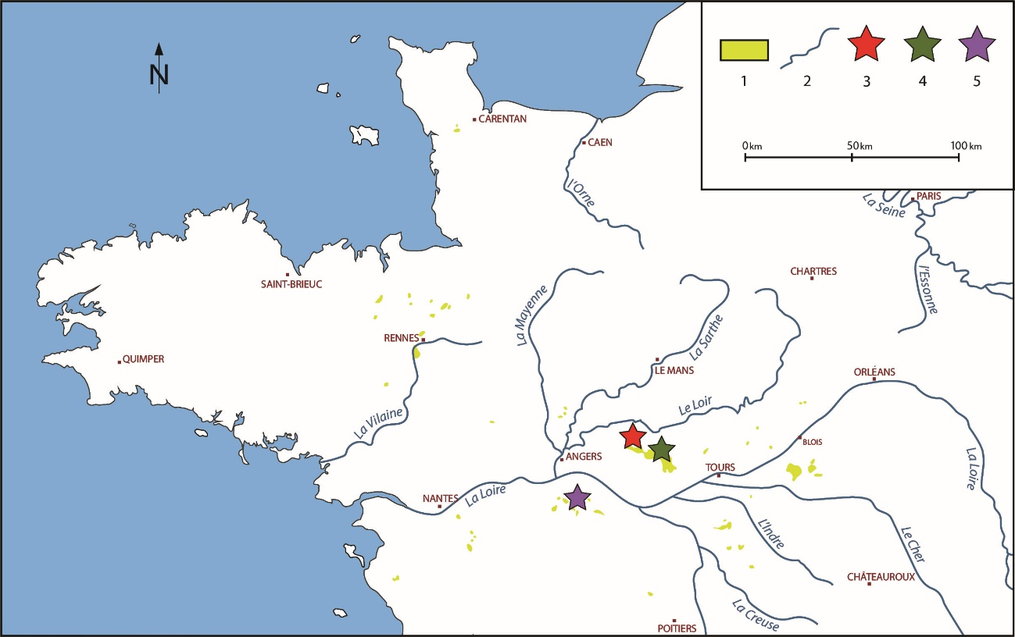
Fig. 1. — Location map of the three quarries. 1: the marine Miocene outcrops, 2: the river network, 3: the ‘Blandinerie’ quarry (Breil), 4: the ‘Sonneterie’ quarry (Meigné-le-Vicomte), 5: the ‘Noyant-la-Plaine’ quarry (Doué-la-Fontaine).

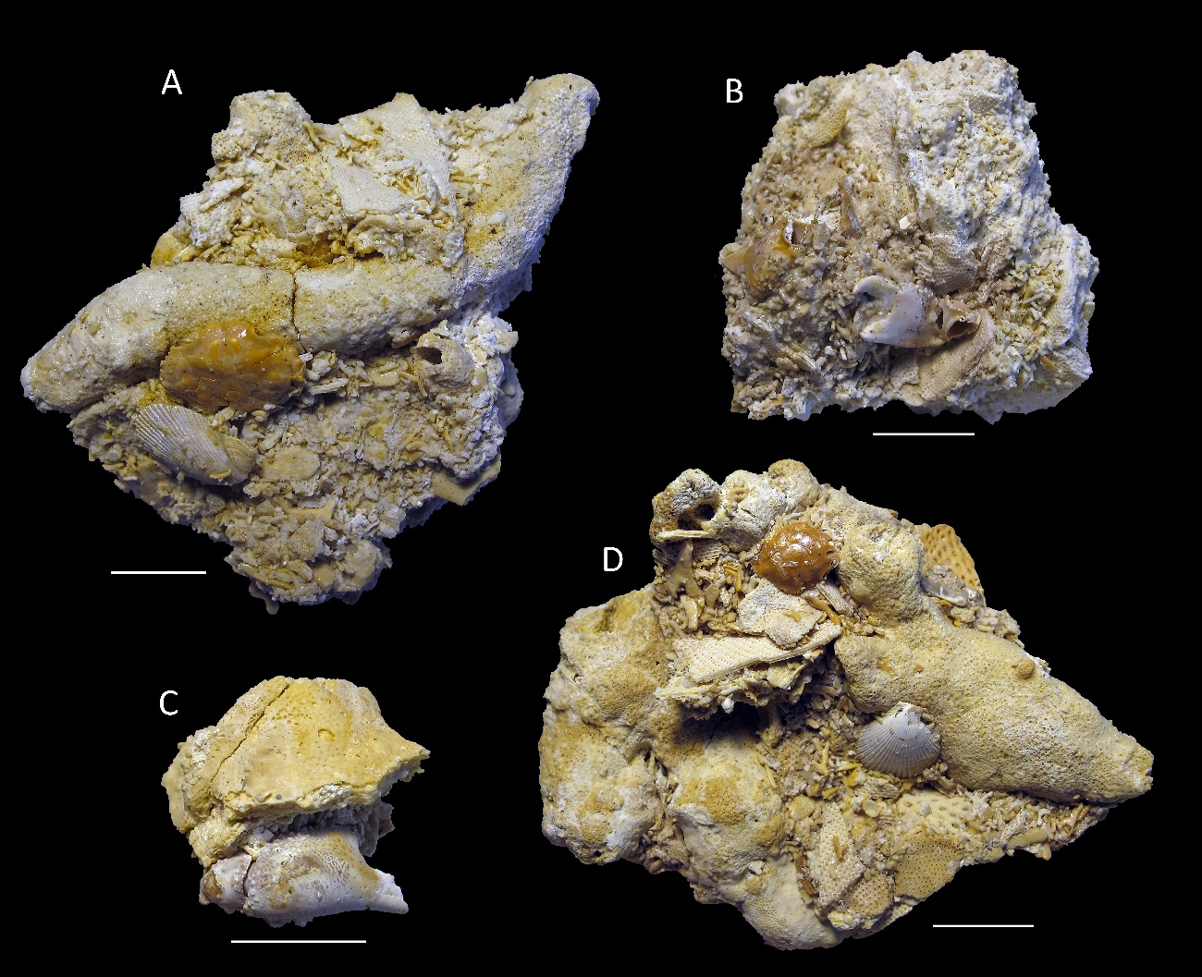
Fig. 2. — Typical aspect of the clayey shelly sands with bryozoans of the ‘Savignean facies’ (Langhian) from the ‘Blandinerie’ quarry Breil (Maine-et-Loire), with embedded remains of Pilumnus mediterraneus (Lőrenthey, 1897). A, ULB-IV-A (37), dorsal carapace; B, ULB-IV-A (39), right chela; C, ULB-IV-A (40), right chela; D, ULB-IV-A (38), dorsal carapace. Scale bars: 10 mm. Photographs by À. Ossó.
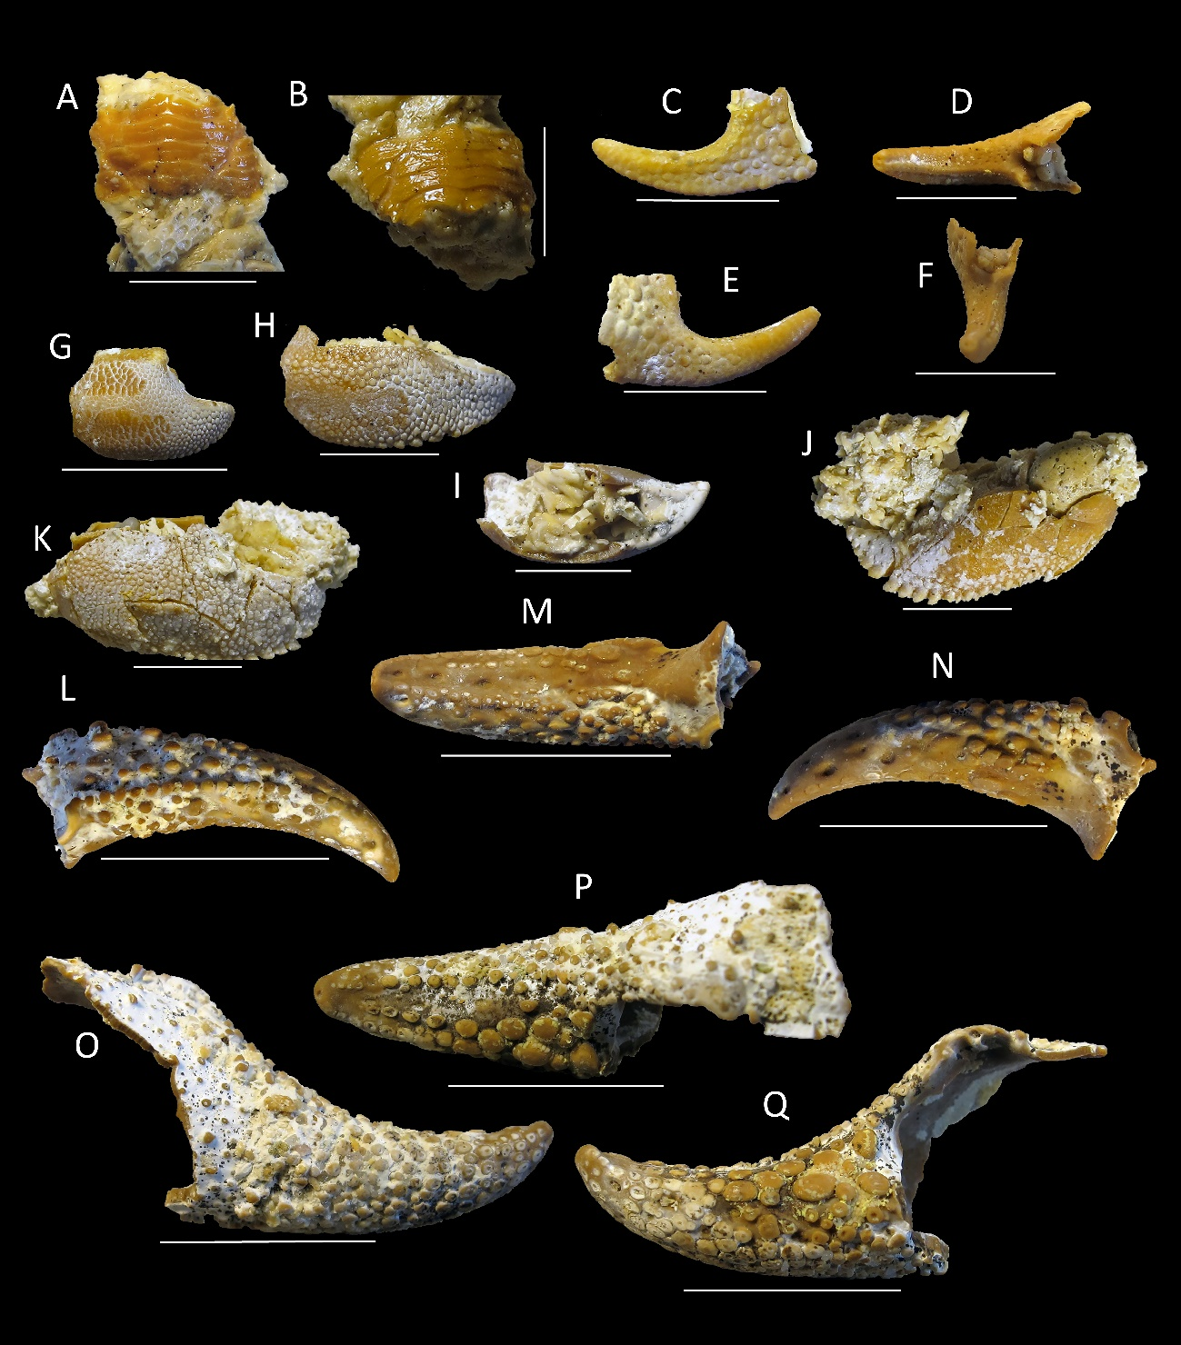
Fig. 3. — Decapods from the ‘Savignean facies‘ (Langhian) of the ‘Blandinerie’ quarry, Breil (Maine-et-Loire). A, B, Galathea weinfurteri Bachmayer, 1950, ULB-IV-A (9): A, dorsal view; B, frontal view; C-F undetermined ?porcellanid; G-K, Paguristes gagnaisoni Gagnaison, 2012: G, ULB-IV-A (19), right chela; H, ULB-IV-A (19.2), right chela outer margin; I, occlusal margin; J, ULB-IV-A (17), right chela inner margin; K, right chela outer margin. L-Q, undetermined paguroid: L, ULB-IV-A (49), right dactylus outer margin; M, occlusal margin; N, inner margin; O, ULB-IV-A (44), left pollex, inner margin; P, occlusal margin; Q, outer margin. Scale bars: A-J, 5 mm; L-Q, 10 mm. Photographs by À. Ossó.

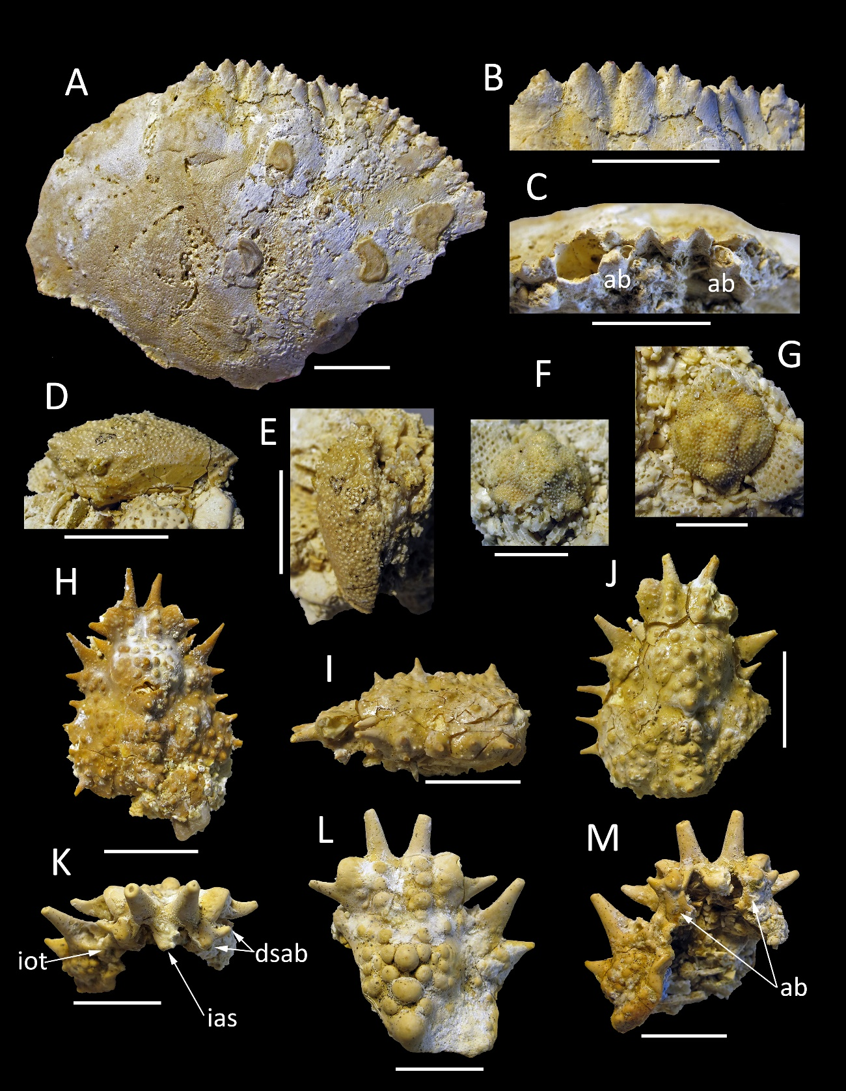

Fig. 4. — Decapod from the Tortonian of the ‘Noyant-la-Plaine’ quarry, Doué-la-Fontaine (Maine-et-Loire). A-C, Lobocarcinus sismondai (von Meyer, 1843), ULB-IV-A (3): A, dorsal view; B, close-up of front in dorsal view; C, close-up of front and orbits in frontal view. Decapods from the ‘Savignean facies‘ (Langhian) of the ‘Blandinerie’ quarry, Breil (Maine-et-Loire). D, E, Hebertides jurassica Guinot, De Angeli & Garassino, 2007b, ULB-IV-A (5): D, left lateral view; E, dorsal view; F, G, ‘Ebalia’ cf. hungarica Müller, 1974a, ULB-IV-A (7): F, frontal view; G, dorsal view; H-M, Maja orbignyana Millet de la Turtaudière, 1865: H, ULB-IV-A (1), dorsal view; I, ULB-IV-A (2), left lateral view; J dorsal view; K, ULB-IV-A (23), frontal view; L, dorsal view; M, ventral view. Abreviations, ab = basal antennal article; dsab = distal spines of basal article; ias = interantennular spine; iot = infraorbital tooth. Scale bars: A-E, H-M 10 mm; F, G, 5 mm. Photographs by À. Ossó.

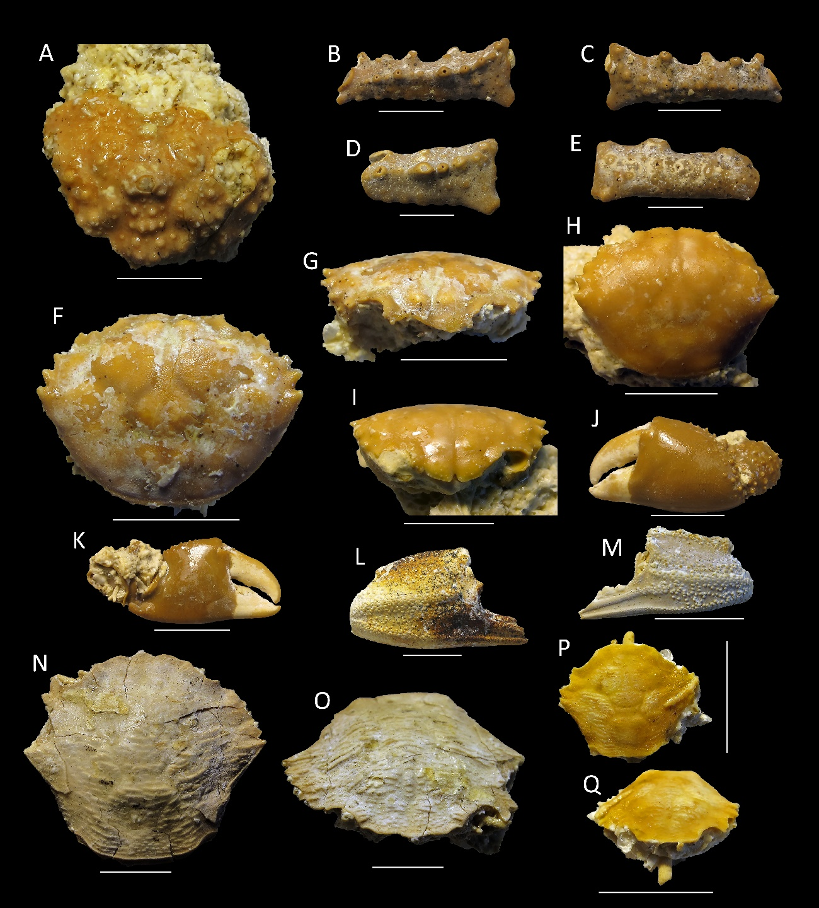
Fig. 5. — Decapods from the ‘Savignean facies‘ (Langhian) of the ‘Blandinerie’ quarry, Breil (Maine-et-Loire). A, indeterminate majoid, ULB-IV-A (26): dorsal view; B-E, Parthenope cf. szaboi Müller, 1974b: B, ULB-IV-A (33), right propodus, outer margin; C, inner margin; D, ULB-IV-A (35), right propodus, outer margin; E, right propodus, inner margin; F-K, Pilumnus mediterraneus (Lőrenthey, 1897): F, ULB-IV-A (14), dorsal view; G, frontal view; H, ULB-IV-A (18), dorsal view; I, frontal view; J, ULB-IV-A (20), left chela, outer margin; K, inner margin; N-Q, Liocarcinus kuehni (Bachmayer, 1953): N, ULB-IV-A (10), dorsal view; O, frontal view; P, ULB-IV-A (13), dorsal view; Q, frontal view. Scale bars: A-E, N-Q 5mm; J-M 10 mm. Photographs by À. Ossó.

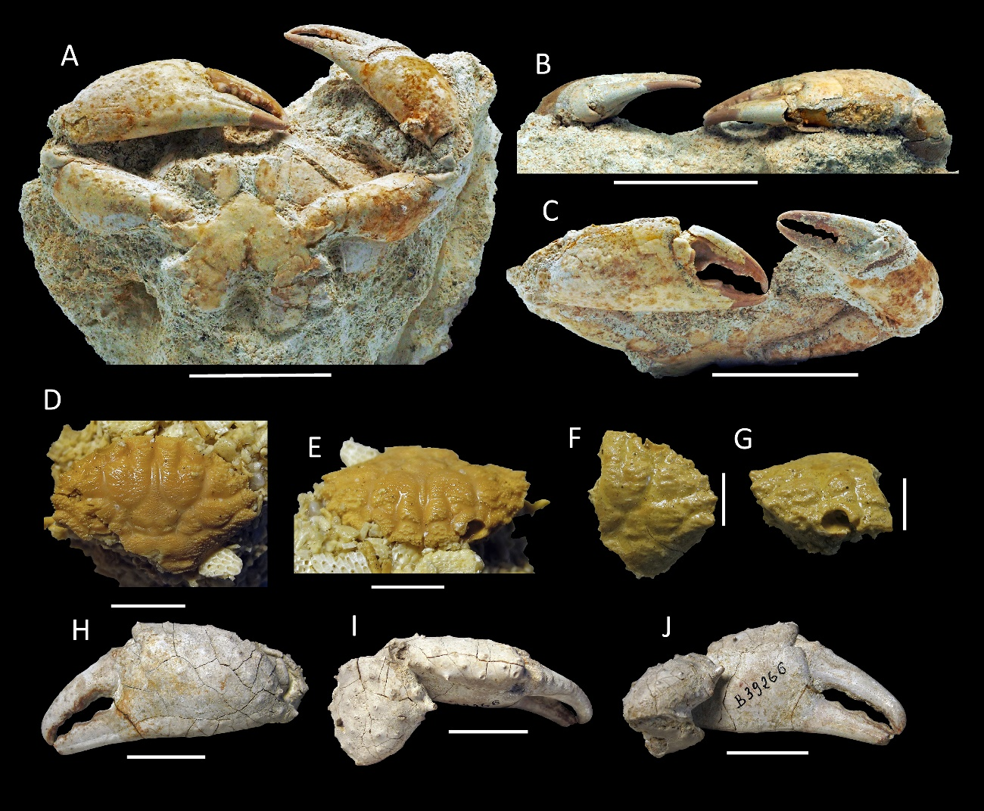

Fig. 6. — Decapod from the ‘Savignean facies’ (Langhian) of ‘La Sonneterie’ quarry, Meigné-le-Vicomte (Maine-et-Loire). A-C, Necronectes michelini (A. milne-Edwardss, 1861), MHNH-2016-79-2003: A, ventral view; B, view of upper margin of chelipeds; C, frontal view of chelipeds. Decapods from the ‘Savignean facies‘ (Langhian-Serravallian) of the ‘Blandinerie’ quarry, Breil (Maine-et-Loire). D-G, Xantho moldavicus (Yanakevich, 1977): D, ULB-IV-A (6), dorsal view; E, frontal view; F, ULB-IV-A (11), dorsal view; G, frontal view. Decapod from the probable Tortonian of Doué-la-Fontaine (Maine-et-Loire). H-I, Undetermined cheliped MNHN.F.B39266: H, outer margin; I, upper margin; J, inner margin. Scale bars: A-C, 50 mm; D-G, 5 mm; H-J 20 mm. Photographs of A-C by P. Saulet; D-J by À. Ossó.

