Laughter Mimicry in Parent-Child and Parent-Adult interaction

Chiara Mazzocconi, ILCB - LPL (UMR 7309), CNRS, Aix-Marseille University, France
Kevin El Haddad, ISIA Lab, University of Mons, Belgium
Benjamin O’Brien, LIA (EA 4128), Avignon Université, France
Kübra Bodur, LPL (UMR 7309), CNRS, Aix-Marseille University, France
Abdellah Fourtassi, LIS, CNRS, Aix-Marseille University, France
Laughter is informative about cognitive and pragmatic appraisals and its use and development begins in the first months of life. Adult studies show that the occurrence of laughter mimicry (i.e. laughter starting after a partner’s laugh within 1 second from its offset – El Haddad et al 2019) is influenced by context and interlocutor (Smoski & Bachorowski, 2003). Babies produce significantly less laughter mimicry in comparison to their caregivers (Nwokah et al., 1994). In comparison to adult-adult interactions, significant differences were also found in caregiver mimicry in response to child laughs over time, where high percentages were reported at initial time points, which subsequently decreased over time (Mazzocconi & Ginzburg, 2022). Less is known about laughter mimicry in middle-childhood. To fill this gap, the current study focuses on the analysis of caregiver-child interactions (6-11y/o) (ChiCo corpus - Bodur et al., 2021). The dataset is composed of video-recorded computer-mediated conversations (mean:17±3min) by 8 Parent-Child (PC) and Parent-Adult (PA - i.e. the parent of each PC dyad interacting with another adult) dyads, all engaged in the same guessing game. Two annotators identified 580 laughs (ELAN 6.4): 337 in PA interactions (per participant: 21±12) and 243 in PC interactions (110 C: 14±14; 133 P: 17±8). Wilcoxon-tests of frequency/minute between PC and PA conversations and between P and C were not significant. Given the variability in laughter production by participants, we measure mimicry in terms of Transitional Probability (TP), i.e. the probability of laughter mimicry given the total laughs produced by the partner. We observe consistently present laughter mimicry in all the PA dyads, however much higher variability in PC interactions (Figure 1). The overall TP means for PA and PC interactions are 0.27±0.17% and 0.14±0.14% (P: 0.13±0.16%; C: 0.16±0.14%) respectively. We observe significantly more laughter mimicry in PA conversations rather than PC (χ2 39.82, df=7, p<.001), and significantly higher TP mimicry (W=103, p=0.03). We report no significant differences between P and C and between P laughter mimicry when interacting with their child or another adult. Despite comparable laughter occurrences between children and adults, laughter mimicry is overall significantly less frequent in PC interactions in comparison to PA interactions (the latter being similar to what was observed in adult face-to-face interactions –Mazzocconi et al., 2020). Coupled with the literature on younger babies, these observations suggest that for the caregiver, laughter responsiveness can dramatically change depending on the communicative development of the child and on the nature of the interaction. Children exhibit more laughter mimicry than babies (Nwokah et al., 1994; Mazzocconi & Ginzburg, 2022) and are more balanced in relation to the interlocutors. Our findings support evidence that laughter and its mimicry are not reflexive behaviours and are objects for learning, modulated by the context and the interlocutor. The results suggest that the use of some multimodal elements of communication continue developing through middle-childhood with other pragmatic skills (Cekaite, 2013). Temporal modulation analysis of laughter acoustic features will offer deeper insights on the differences observed in PA and PC interactions.

Keywords: laughter; mimicry; adult-child ; multimodal communication development.

Figure 1. Transitional Probability of laughter mimicry.
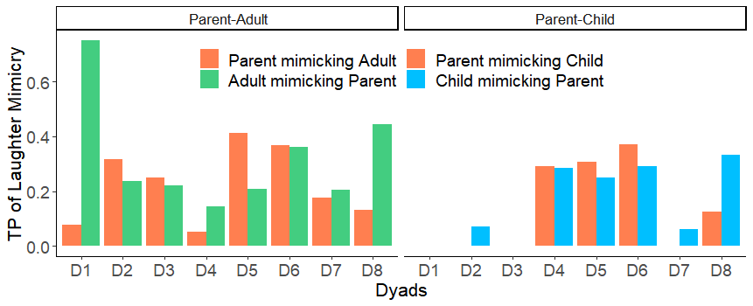
References
Bodur, K., Nikolaus, M., Kassim, F., Prévot, L., & Fourtassi, A. (2021, October). Chico: A multimodal corpus for the study of child conversation. In Companion publication of the 2021 international conference on multimodal interaction (pp. 158-163).
Cekaite, A. (2013). Child pragmatics development. Encyclopaedia of applied linguistics. Blackwell. DOI, 10, 9781405198431.
El Haddad, K., Chakravarthula, S. N., & Kennedy, J. (2019, October). Smile and laugh dynamics in naturalistic dyadic interactions: Intensity levels, sequences and roles. In 2019 International Conference on Multimodal Interaction (pp. 259-263).
Mazzocconi, C., & Ginzburg, J. (2022). A longitudinal characterization of typical laughter development in Mother–child interaction from 12 to 36 months: Formal features and reciprocal responsiveness. Journal of Nonverbal Behavior, 1-36.
Mazzocconi, C., Tian, Y., & Ginzburg, J. (2020). What’s your laughter doing there? a taxonomy of the pragmatic functions of laughter. IEEE Transactions on Affective Computing, 13(3), 1302-1321.
Nwokah, E. E., Hsu, H. C., Dobrowolska, O., & Fogel, A. (1994). The development of laughter in mother-infant communication: Timing parameters and temporal sequences. Infant Behavior and Development, 17(1), 23-35.
Smoski, M., & Bachorowski, J. A. (2003). Antiphonal laughter between friends and strangers. Cognition and Emotion, 17(2), 327-340.

