Supporting Information

Residual Li₂O degrades PVdF during the preparation of NMC811 slurries for Li-ion batteries
Angelica Laurita,^{*a} Liang Zhu,^{b} Pierre-Etienne Cabelguen,^{b} Jérémie Auvergniot,^{b} Dominique Guyomard,ª Philippe Moreau ª and Nicolas Dupré^{*a}
ªUniversité de Nantes, CNRS, Institut des Matériaux Jean Rouxel (IMN), F – 44000, Nantes, France
^{b}Umicore, 31 rue du marais, Brussels BE-1000, Belgium.

* : Corresponding authors

Table S1. Parameters from ⁷Li MAS-NMR signal features for Sample 1, 2 and 3 and corresponding quantification. All the spectra were calibrated with respect to LiCl. Surface diamagnetic lithium amounts evaluated by ⁷Li MAS-NMR given in µmolLi/g_{AM} with an error of ±10%*.

 | δ (ppm) |  | FWHM (ppm) |  | Amount (µmol/g_{AM})
 | Sample 1
 | powder | slurry | powder | slurry | powder | slurry
Li₂O | 4.6 | 4.6 | 13 | 13 | 46 | 59
Li₂SO₄ | -0.6 | -0.6 | 16 | 13 | 10 | 19
LiOH | 2.4 | 2.6 | 3 | 4 | 3 | 2
Li₂CO₃ | 1.0 | 1.0 | 3 | 3 | 0.3 | 1
LiF | --- | 0.2 | --- | 3 | --- | 2
Total Li |  |  |  |  | 115.6 | 162
 | Sample 2
Li₂O | 4.7 | 4.7 | 12 | 12 | 63 | 76
Li₂SO₄ | -0.8 | -0.4 | 14 | 11 | 15 | 18
LiOH | 2.4 | 2.4 | 2 | 2 | 2 | 3
Li₂CO₃ | 1.0 | 1.1 | 2 | 2 | 1 | 2
LiF | --- | 0.2 | --- | 3 | --- | 3
Total Li |  |  |  |  | 160 | 198
 | Sample 3
Li₂O | 4.7 | 4.6 | 14 | 13 | 43 | 46
Li₂SO₄ | -0.6 | -0.9 | 15 | 11 | 6 | 22
LiOH | 2.4 | 2.4 | 2 | 4 | 0.3 | 6
Li₂CO₃ | 1.2 | 1.1 | 1 | 3 | 0.1 | 4
LiF | --- | 0.2 | --- | 5 | --- | 13
Total Li |  |  |  |  | 98.5 | 163

*: The 10% error comes from the reliability factor of the dmfit program used to fit the MAS NMR data. It is an error on the integrated intensity (arbitrary unit) absolute value and depends only on the quality of the NMR spectrum and not directly on the measured amount of lithium nuclei in μmol.g⁻¹

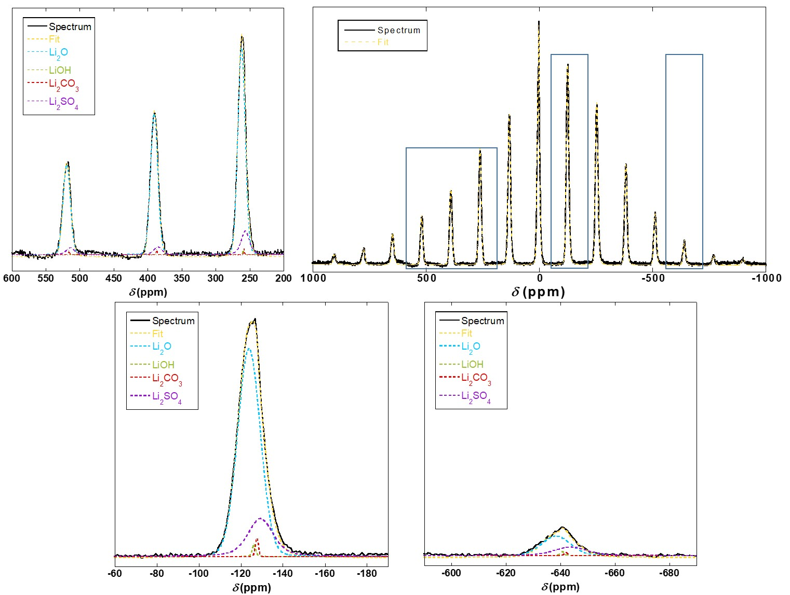
(a)

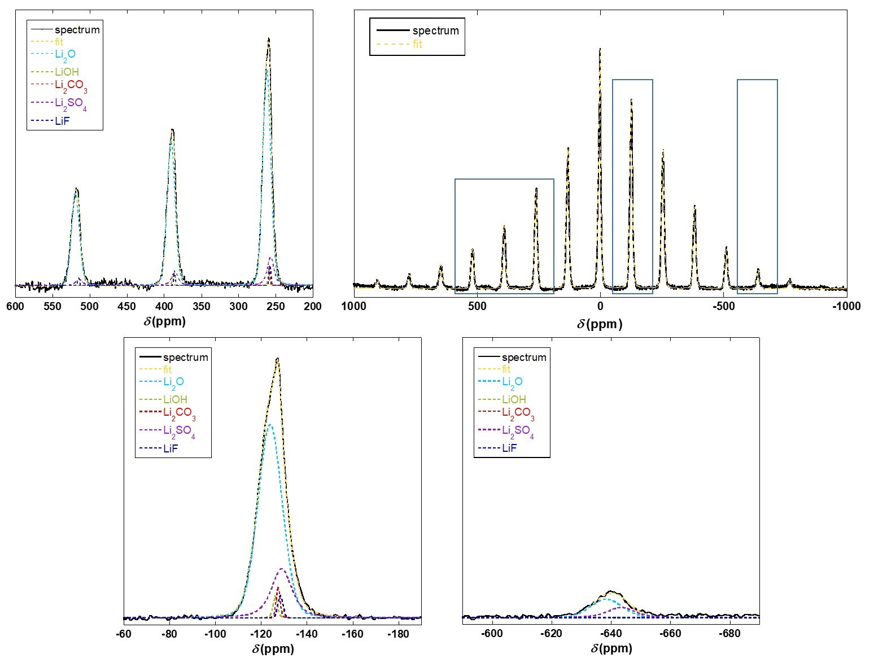
(b)

Figure S1 : Deconvolution of ⁷Li MAS NMR spectra of NMC811 pristine powder (a) and dried slurry (b). Complete spectra are shown with the simulation obtained from the fitting process. Regions in blue rectangles are enlarged as examples.

