**Synthesis and structural and electrochemical characterization of sodium‑based thiophosphates electrolytes for all‑solid‑state batteries**

## S.F. Mayer, J.B. Ducros1, F. Fauth2, L. Lecarme, C. Villevieille

### Univ. Grenoble Alpes, Univ. Savoie Mt Blanc, LEPMI, Grenoble INP, CNRS, F-38000 Grenoble, France, 1Univ. Grenoble Alpes, DEHT, LITEN, CEA, F-38000 Grenoble, France, 2 CELLS ALBA Synchrotron, Barcelona 08290, Spain, **sergio-federico.mayer@grenoble-inp.fr**

Along with the continuous population growth, which according to United Nations is projected to have reached 8 billion in November this year [1], the ever-increasing demand for reliable energy sources becomes the main concern of researchers coming from many different fields of work. To withstand the challenges posed by the current energetic systems, technological developments are pushed towards renewable and decentralized energy sources [2]. To take the most advantage of those, frequently intermittent in nature, reliable energy storage systems are required [3]. Electrochemical energy storage offers several desirable characteristics that include high efficiency, flexibility to meet different grid functions, long cycle life, and little maintenance [4].

All-solid-state batteries (ASSBs) pose advantages regarding the state-of-the-art liquid-based systems as their chemistry can be based on non-flammable materials and they operate at wider temperature ranges while having the potential to enable metallic anode [5]. As lithium is still a critical resource, sodium-based batteries arise among other viable technologies and developing ASSBs using Na as a charge carrier establishes an appealing alternative.

Thiophosphate-based solid electrolytes can reach ionic conductivities beyond 1 mS·cm−1, enabling the viability for commercial applications [6]. However, synthesis, handling and processing of these materials are challenging as plenty of variables affect their electrochemical response.

In this talk we present three different forms of Na solid electrolytes (SEs), a novel amorphous Na3PS4 phase (NPS-amorph), a crystalline one defined in the cubic *I–*43*m* (217) space group (NPS-cryst), and a crystalline Na3SbS4-based SE with W aliovalent partial substitution defined in the same 217 space group (NSWS-cryst). All three samples were obtained by mechanochemical synthesis route. Their structure and morphology, assessed by XRD and SEM EDS, respectively, are discussed and compared. Their intrinsic electrochemical properties, like the ionic conductivity (measured by electrochemical impedance spectroscopy), and their electrochemical stability windows (evaluated by cyclic voltammetry) will be correlated to their structural nature.

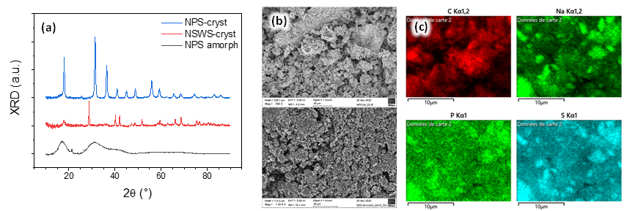

Figure 1: (a) XRD diffractograms (Cu kα) of NPS-cryst, NSWS-cryst, and NPS-amorph samples represented as blue, red, and black solid lines, respectively. (b) SEM images of NPS-cryst (top) and carbon composite based on the same SE (bottom). (c) SEM EDS images of the C composite shown in (b) with C, Na, P and S elemental maps.

**References**

[1] - U. Nations, https://www.un.org/en/desa/8-billion-strong-infinite-possibilities-people-and-planet

[2] - K. Alanne and A. Saari, Renew. Sustain. Energy Rev., **10**, 6, 539 (2006).

[3] - X. Luo, J. Wang, M. Dooner, and J. Clarke, Appl. Energy, **137**, 511 (2015).

[4] - B. Dunn, H. Kamath, and J. M. Tarascon, Science, **334**, 6058, 928 (2011).

[5] - Z. Gao et al., Adv. Mater., **30**, 17, 1 (2018).

[6] - S. Ohno et al., ACS Energy Lett., **5**, 3, 910 (2020).