Pesticide responses of Arctic and temperate microalgae differ in relation to ecophysiological characteristics

Juan Du¹, Disney Izquierdo², Jonathan Naoum², Leanne Ohlund³, Lekha Sleno³, Beatrix E. Beisner⁴, Johann Lavaud^{5,6} and Philippe Juneau^{2*}
¹ Department of Biological Sciences, Université du Québec à Montréal, GRIL-TOXEN, Succ Centre-Ville, Montreal, Quebec, H3C 3P8, Canada² Department of Biological Sciences, Université du Québec à Montréal, GRIL-EcotoQ-TOXEN, Succ Centre-Ville, Montreal, Quebec, H3C 3P8, Canada³ Chemistry Department, Université du Québec à Montréal, EcotoQ-TOXEN, Succ Centre-Ville, Montreal, Quebec, H3C 3P8, Canada
⁴ Department of Biological Sciences, Groupe de recherche interuniversitaire en limnologie (GRIL), Université du Québec à Montréal, Succ Centre-Ville, Montreal, Quebec, H3C 3P8, Canada
⁵ TAKUVIK International Research Laboratory IRL3376, Université Laval (Canada) - CNRS (France), Pavillon Alexandre-Vachon, 1045 av. de la Médecine, local 2064, G1V 0A6 Québec, Canada
⁶ LEMAR-Laboratory of Environmental Marine Sciences, UMR6539, CNRS/Univ Brest/Ifremer/IRD, Institut Universitaire Européen de la Mer, Technopôle Brest-Iroise, rue Dumont d’Urville, 29280 Plouzané, France.
*Corresponding author:
E-mail addresses: juneau.philippe@uqam.ca (P. Juneau)
Full postal address:
Department of Biological Sciences
Université du Québec à Montréal
CP8888, Succ Centre-Ville
Montréal (QC)
H3C 3P8
Canada

Highlights
- Arctic microalgae have distinct ecophysiological characteristics relative to their temperate counterparts.
- Unexpectedly, one Arctic microalgae was more tolerant to pesticides than its temperate counterparts, which disagrees that the greater ecological risk of pollutants in polar ecosystems is always higher than in temperate regions.
- Sensitivity variation to the four pesticides appears to be mainly due to differences in the protective mechanisms between Arctic and temperate microalgae.
Abstract
Polar ecosystems play an important role in global primary production. Microalgae have adaptations that enable them to live under low temperature environments where irradiance and day length change drastically. Their adaptations, leading to different ecophysiological characteristics relative to temperate species, could also alter their sensitivity to pollutants such as pesticides. This study’s objective was to understand how different ecophysiological characteristics influence the response of Arctic phytoplankton to pesticides in relation to the responses of their temperate counterparts. Ecophysiological endpoints were related to growth, cell biovolume, pigment content, photosynthetic activity, photoprotective mechanisms (NPQ, antioxidant enzyme activities), and reactive oxygen species (ROS) content. The Arctic species Micromonas polaris was more resistant to atrazine and simazine than its temperate counterpart Micromonas bravo. However, the other Arctic species Chaetoceros neogracilis was more sensitive to these herbicides than its temperate counterpart Chaetoceros neogracile. With respect to two other pesticide toxicity, both temperate microalgae were more sensitive to trifluralin, while Arctic microalgae were more sensitive to chlorpyrifos (insecticide). All differences could be ascribed to differences in the eco-physiological features of the two microalgal groups, which can be explained by cell size, pigment content, ROS content and protective mechanisms (NPQ and antioxidant enzymes).
Keywords: microalgae, Micromonas, Chaetoceros, ecophysiology, photosynthesis, pesticides, toxicity mechanism

Abbreviations:
T-CN (Temperate Chaetoceros neogracile), T-MB (temperate Micromonas bravo) and A-MP (Arctic Micromonas polaris), Arctic Chaetoceros neogracilis (A-CN), Car, carotenoids; Chl a, chlorophyll a; PSI, photosystem I; PSII, photosystem II; NPQ, non-photochemical quenching; Q_{A}, primary electron acceptor of PSII; Q_{B}, secondary electron acceptor of PSII; RC, reaction center, Ф_{M}, PSII maximum quantum yield; Ф'_{M}, PSII operational quantum yield; NPQmax, Maximum ability for dissipation of excess energy; Ek, Light saturation coefficient; α, Maximum light efficiency use ROS, reactive oxygen species; SOD, superoxide dismutase; CAT, catalase; logK_{ow}, a ratio between the concentration of a chemical in the octanol phase to its concentration in the water phase.
- Introduction
Arctic habitats are subjected to harsh environmental conditions. Nevertheless, they provide a major contribution to global primary production and the Arctic Ocean net primary production has increased recently (Ardyna and Arrigo 2020). More than 75% of the Arctic phytoplankton biomass is composed of diatoms and small flagellate prasinophytes (Micromonas sp.) (Balzano et al. 2012, Lovejoy et al. 2007), and they thus play an essential role in the Arctic food web (Frey et al. 2018). Microalgae in polar regions have adaptations that enable them to grow well in these regions where temperatures are permanently low, but irradiance and day length are extremely variable (Handler 2017). Microalgae are impacted by cold environments in many ways, including lower enzyme activity (Wiebe et al. 1992), altered membrane fluidity (White et al. 2000), nutrient availability, balancing the usage and absorption of energy (Parker and Armbrust 2005), and the capacity to grow (Margesin 2007). There are differences in taxonomy, genetics, and ecology between Arctic microalgae and their temperate counterparts, while photo-physiology is not well documented (Lacour et al. 2017). Although there have been great developments in the taxonomy, genetics, and ecology of polar phytoplankton, their photo-physiological properties are not yet well documented, and the understanding of aquatic contaminant effects on their ecophysiology is lacking (Lyon and Mock 2014).
Application of pesticides leads to a substantial lost from agricultural fields leading to their detection in the aquatic environment, due to leaching, runoff and spray-drift (Larsbo et al. 2016, Zhang et al. 2018). Some authors have reported that Arctic waters are contaminated with pesticides applied in southern regions due to the long-distance aerial and marine transport of chemicals (Cabrerizo et al. 2019, Ma et al. 2018, Muir et al. 2013, Muir and de Wit 2010). Moreover, owing to the accumulation of pesticides in Arctic ice cover and snow over the years, pesticide concentrations in Arctic waters should increase over time, as accumulated ice is melting at an unprecedented rate due to global warming (Pućko et al. 2017). Chlorpyrifos, diazinon, trifluralin, endosulfan and lindane are some of the typical pesticides found in surface and groundwater near agricultural lands across Canada and USA (Vorkamp and Riget 2014), as well as in Arctic waters (Hoferkamp et al. 2010, Vorkamp and Riget 2014, Weber et al. 2010).
Among the main classes of pesticides, herbicides are the most widely used (Balmer et al. 2019). Numerous herbicides have detrimental effects on photosynthesis due to cellular oxidative damage induced by the accumulation of reactive oxygen species (ROS). This accumulation promotes lipid peroxidation, which results in the destruction of membranes, such as the photosynthetic ones (Chalifour et al. 2014, DeLorenzo 2001). Insecticides, although not designed to affect plants, have been demonstrated to have toxic effects on the growth, photosynthesis, biovolume, pigment and lipid contents of phytoplankton (Asselborn et al. 2015, Yadav 2015). It is well known that the sensitivity to pesticides of temperate algal species varies considerably, and several factors may contribute to this species-specificity. For example, damage to photosynthetic apparatus caused by pesticides can be minimized by various photoprotective mechanisms, including antioxidant system designed to eliminate the excess ROS (Medithi et al. 2021) and non-photochemical quenching (NPQ) energy dissipation processes related to the capacity to modulate light absorption and dissipate excess energy as heat (Moustakas et al. 2022). Furthermore, cells can also adjust pesticide uptake by modifying their surface to biovolume ratio (Larras et al. 2013, Tang et al. 1998).
Most of our understanding about the physiological characteristics and pesticide effects on microalgae is from temperate phytoplankton species. Indeed, the physiological features and potential impacts of pesticides on Arctic phytoplankton are very scarce (Kottuparambil et al. 2017), However, some authors have predicted that Arctic ecosystems and their organisms are likely more sensitive to contaminants than those at temperate latitudes (CARC 1990, Kottuparambil et al. 2017). In that case, ecophysiological properties of Arctic microalgae evolved under the extreme conditions found in the Arctic Ocean and this result in adaptations that may permit these algae to cope with pesticide stress. Although there have been many reports on the impacts of pesticides on the physiology and growth of temperate phytoplankton (Singh et al. 2016, Vonk and Kraak 2020), very little is known about their potential impacts on microalgae having extreme low temperatures and rapid environmental change due to global warming such as for Arctic phytoplankton. Moreover, the comparison of the tolerance mechanisms and ecophysiological characteristics between the phytoplankton of Arctic with temperate regions is lacking. This knowledge will permit to gain insights for future development of algal bioassays for Arctic regions since using temperate species could not be appropriate. We thus compared pesticide responses in Arctic microalgae and their temperate counterparts to four pesticides (atrazine, simazine, trifluralin and chlorpyrifos). Arctic microalgae grow under the extreme conditions of the Arctic Ocean, and should have different physiological characteristics from temperate microalgae. Therefore, we examined which ecophysiological adaptation might benefit to Arctic organisms by exploring differences in their sensitivities and response mechanisms.

2. Materials and methods
2.1 Microalgal species and growth conditions
We compared the responses in two temperate species: Chaetoceros neogracile (T-CN; CCMP1425), Micromonas bravo (T-MB; CCMP1646), and two Arctic species strains Micromonas polaris (A-MP; CCMP2099), Chaetoceros neogracilis (A-CN; RCC2279). The first three species were purchased from National Contract Management Association (NCMA), while the latter Arctic strain was obtained from the Roscoff culture collections. All species were cultivated in marine L1 medium (Guillard et al., 1993) with a total volume of 100 mL medium in species-specific 250 mL Erlenmeyer flasks. The cultures were grown at 100 µmol photons m⁻² s⁻¹ under a 14:10 h light: dark illumination cycle with daily gentle shaking. Temperate and Arctic species were grown at 18 °C and 4 °C respectively. Algal cells were periodically transferred (for at least eight generations) into fresh medium to maintain their exponential growth phase. The cell concentrations were measured with a Multisizer 3 Coulter Counter particle analyzer (Beckman Coulter Inc., USA). The growth rate (µ) was determined as follow: µ= (lnN_{n})- (lnN₀)/T, where µ= Average specific growth rate, N_{0,} N_{n} indicate cell density (cells/mL) at the beginning of test and at the end of the treatment (3 days), T expresses the exposure time (3 days).
2.2 Pesticide preparation and treatment
All pesticides (Table 1) used in the present study were obtained from Sigma-Aldrich (PESTANAL®, Canada). Pesticides (stock solutions in acetone) were added to the growth media for the exposure experiments at final acetone concentration never exceeding 0.01%, a concentration of acetone not inducing any measurable effect on the parameters assayed. From the original eight pesticides, the impacts of four of them were further investigated (atrazine, simazine, trifluralin and chlorpyrifos), since the other four pesticides showed no (clopyralid-1000 μg/L, metolachlor-3.5 μM/L and lindane-1000 μg/L) or very little (< 10%) toxicity (endosulfan-1000 μg/L) on the photosynthetic activity at very high concentrations for the studied microalgae (data not shown). Concentrations of atrazine measured in the medium at the beginning of the experiment were 0 μg/L, 6.44 μg/L, 25.93 μg/L, 50.68 μg/L, 99.00 μg/L and 245.14 μg/L. For simazine the measured concentrations were 0 μg/L, 5.55 μg/L, 25.23 μg/L, 50.57 μg/L, 101.61 μg/L and 248.62 μg/L. We indicated these atrazine and simazine concentrations in the figures and tables as 0 μg/L, 5 μg/L, 25 μg/L, 50 μg/L, 100 μg/L and 250 μg/L. Measured trifluralin concentrations tested were 0 μg/L, 198.47 μg/L and 500.93 μg/L and for chlorpyrifos 0 μg/L, 189.13 μg/L and 475.56 μg/L (noted in the figures and tables as 0 μg/L, 200 μg/L and 500 μg/L). No significant differences in the measured concentrations were observed between the two experimental temperatures for the different pesticides. Concentrations of pesticides were evaluated using a QTRAP 5500 mass spectrometer (Sciex, Concord, ON, Canada) according to Chalifour et al. (2016) and Takishita et al. (2021). The four studied pesticides (atrazine, simazine, trifluralin and chlopyrifos) are known to have relatively long half-lives in water, ranging from months to years (Bai et al. 2015, Vonk and Kraak 2020), and therefore are stable and do not degrade during our experiments (Du et al. 2022, in preparation).
Exponentially growing microalgae were transferred into 1L Erlenmeyer flasks at a cell density of 2.5 × 10⁵ (Chaetoceros) and 2.5 × 10⁶ (Micromonas) cells mL⁻¹ respectively, and then exposed to different concentrations of pesticides for 72 h. All treatments were done in triplicate. Cell densities and cell biovolumes were assessed at the beginning and the end of the experiment with a particle counter (Multisizer 3 Coulter Counter, Beckman Coulter Inc., USA).
Table 1. The chemical families and mode of action for pesticides used in this study (adapted from www.irac-online.org).
2.3 Pigment measurements
Algal cultures (25 mL) were harvested, under dim green light, 72 h after the beginning of the treatments by gentle filtration on 0.8µm filter membrane (Polytetrafluoroethylene; Xingya Purifying Materials Factory; Shanghai, China), and placed in 2 mL Eppendorf tubes covered with aluminum foil, then rapidly immersed into liquid nitrogen and kept at -80 °C until analysis. Extractions of the pigments were done by adding 2 mL of acetone 90% overnight at -20 °C prior to analysis. Ultrasonic probe was used to break the cells (3 W/cm² for 20 s; Sonic dismembrator Model 100, Fisher Scientific). The extracts were centrifuged at 4 °C for 10 min (10000×g) and the supernatant was kept for quantification of chlorophyll (Chl a) and carotenoid (Car). Using Cary 300 UV spectrophotometer (Varian, USA) each extract was scanned between 400–750nm. Independent triplicates were sampled for each culture. The contents of Chl a and carotenoids were calculated according to Jeffrey and Humphrey (1975) and Seely et al. (1972) respectively.
2.4 Fluorescence measurements
The photosynthetic light curves were obtained using a PAM fluorometer (Water-PAM, Walz, Germany) according to Du et al. (2019), with saturation pulses (3000 µmol photons m⁻² s⁻¹, 800ms) and 8 levels of actinic light intensities (0, 46, 105, 188, 276, 427, 635, 906, and 1207 µmol photons m⁻² s⁻¹). The samples (3mL) were dark acclimated for 20 minutes before measurements and all samples were measured at their incubation temperature (4 °C and 18 °C). The maximum (Ф_{M}) and operational (Ф'_{M}) PSII quantum yields, and the non-photochemical quenching (NPQ) were determined from this light curve when the actinic light was 0 µmol photons m⁻² s⁻¹ for Ф_{M} and 105 µmol photons m⁻² s⁻¹ for Ф'_{M} and NPQ. Their evaluation was done using the following equations: Ф_{M} = (F_{M–}F₀)/F_{M} (Kitajima and Butler, 1975); Ф'_{M} = (F'_{M}–F_{S})/F'_{M} (Genty et al., 1989); NPQ = (F_{M}–F'_{M})/F'_{M} (Bilger and Björkman, 1990). The maximal electron transport rate (ETR_{MAX}), light saturation coefficient (Ek) and light efficiency use (ɑ) was calculated according to Lacour et al. (2017). The Plant Efficiency Analyzer (PEA, Hansatech, Instruments Ltd, UK) was used to determine the polyphasic rise in fluorescence transients. Transients were induced by a 2s red (maximal emission at 650 nm) light pulse with 3600 µmol photons m⁻² s⁻¹ (Strasser et al., 1995). The O-J-I-P curves of the microalgae were determined and functional parameters evaluating the PSII energy fluxes under environmental stresses were calculated. All parameter definitions are in the Supplementary Material (Table S1).
2.5 Reactive oxygen species (ROS) measurement
Intracellular ROS was evaluated by BD Accuri C6 flow cytometer (Biosciences, San Jose, CA, USA) using the fluorescent dye 2′,7′-dichlorodihydrofluorescein diacetate (H₂DCFDA) (Molecular probes, Eugene, OR, USA) as described in (Stachowski-Haberkorn et al. 2013). Cells were analyzed by forward and side scatters and measured the ﬂuorescence channel FL1 with excitation wavelength of 488 nm and emission wavelength of 530 nm. To eliminate potential signal alterations brought on by pesticide effects on FL1 fluorescence, we presented the results as FL1 ratios (H₂DCFDA-stained samples FL1 value divided by non-contaminated samples FL1 values).
2.6 Antioxidant enzyme activity measurements
After pesticide exposure (72h), microalgal cultures (50 mL) were centrifuged at 15000×g for 25 min at 4 °C, and the pellet was kept into a 2 mL microtube covered with aluminum foil. After adding 1 mL extraction buffer, samples were immediately plunged into liquid nitrogen and kept at -80 °C until analysis. For each extracted sample enzyme activities were determined with Cary 300 UV spectrophotometer (Varian, USA). Cells were broken with the help of liquid nitrogen, grinding one time, and were then centrifuged at 15000×g for 25 min at 4 °C prior to analysis. Each sample was divided into three replicates for analyzing the superoxide dismutase (SOD) and catalase (CAT) according to Vitoria et al. (2001) and Rao et al. (1996) respectively.
2.7 Statistical analyses
JMP software 10.0 (SAS Institute Inc) was used for statistical evaluations. Data were verified for normality (Shapiro–Wilk test) and homogeneity (Bartlett test) and then statistically evaluated using either one or two-way analysis of variance (ANOVA). Interactions between pesticide concentrations and different species were considered in 2-way ANOVA. When there were significant differences in the response variables between treatments, contrast analysis (Tukey’s HSD test) was used. The EC₅₀ (concentration needed to induce 50% of the maximum effect) values for response variables (growth, Ф_{M,} and Ф'_{M} ) were calculated from the nonlinear least-square fits by using the inverse of the regression curve (Juneau et al. 2001).
3. Results
3.1 Effects of pesticides exposure on cell growth and cell biovolume
3.1.1 Effects of atrazine and simazine
The presence of atrazine and simazine for 72h significantly inhibited the growth of all algal species (Tukey’s HSD, P < 0.05), a growth inhibition that was further exacerbated at increased atrazine and simazine concentration (Fig. 1). The growth-EC₅₀ for temperate C. neogracile (T-CN), Arctic C. neogracilis (A-CN), temperate M. bravo (T-MB) and Arctic M. polaris (A-MP) was 143, 86, 52 and 82 μg/L respectively for atrazine, and 166, 171, 69 and 111 μg/L for simazine (Table 2). Cellular biovolume of the T-CN (150 μm³) was intrinsically nearly three times that of A-CN (50 μm³), while the biovolume of temperate M. bravo was almost the same as Arctic M. polaris. The treatment of atrazine and simazine tend to increase the cell biovolumes of all species by 2-12%, although not significantly for all studied species/treatments (Tukey’s HSD, P > 0.05, Fig. S3).
Figure 1. The effects of atrazine and simazine on the growth of four species, including (red color) temperate C. neogracile (T-CN), temperate M. bravo (T-MB), Arctic C. neogracilis (A-CN) and (blue color) Arctic M. polaris (A-MP) after 72 h exposure. Data are expressed as means ± SD (n = 6).
Table 2. The EC₅₀ of atrazine and simazine based on the growth, the maximal PSII quantum yield (Ф_{M}), the operational PSII quantum yield (Ф'_{M}). The same column superscript letters (a-d) showed significant differences among strains for EC₅₀. n.d. = not determined. Data are expressed as means ± SD (n = 6)
3.1.2 Effects of trifluralin and chlorpyrifos
The growth of Arctic microalgae (C. neogracilis, M. polaris) and temperate microalgae (C. neogracile, M. bravo) was drastically inhibited in the presence of chlorpyrifos at 200 µg/L and 500 µg/L, the exception was for M. bravo at 200 µg/L chlorpyrifos (Tukey’s HSD, P < 0.05). Overall, Arctic microalgae showed greater decline in their growths than their temperate counterparts in the presence of chlorpyrifos (Table S2). The chlorpyrifos treatment induced a significant increase (Tukey’s HSD, P < 0.05) in the cell biovolume of all species. Overall, the biovolumes of Arctic microalgae increased by more than 100% compared to the temperate counterparts except for the A-CN at 200 µg/L chlorpyrifos (Table S1).
The growth of all species was significantly decreased by trifluralin (Tukey’s HSD, P < 0.05), but Arctic microalgae had smaller growth reductions than did their temperate counterparts in the presence of trifluralin, which is contrary to what was observed in the presence of chlorpyrifos. Cell biovolume of all species except for M. bravo increased in the presence of trifluralin (Table S1).
3.2 Effects of pesticides on pigment contents
3.2.1 Effects of atrazine and simazine
Pesticides had various impacts on pigment contents of the four studied microalgae after 72 h treatment. The cellular Chl a and Car contents of temperate and Arctic Chaetoceros did not show significant changes with increasing atrazine and simazine concentrations, except for simazine at 250 μg/L (Tukey’s HSD, P > 0.05, Fig. 2), resulting in an unchanged Car/Chl a ratio. For M. bravo, Chl a and Car increased slightly at low atrazine concentrations and then significantly decreased at higher concentrations (>100 μg/L, Tukey’s HSD, P < 0.05, Fig. 2), while atrazine did not affect the pigment composition of M. polaris. Simazine treatments did not induce a significant change in Chl a and Car contents after 72 h of exposure for the temperate and Arctic Micromonas (Tukey’s HSD, P >0.05). Under control conditions, Chl a for the temperate Chaetoceros and Micromonas were respectively almost 2.5 and 2.3 times the concentrations of the Arctic Chaetoceros and Micromonas, and carotenoids 1.5 and 1.2 times higher.
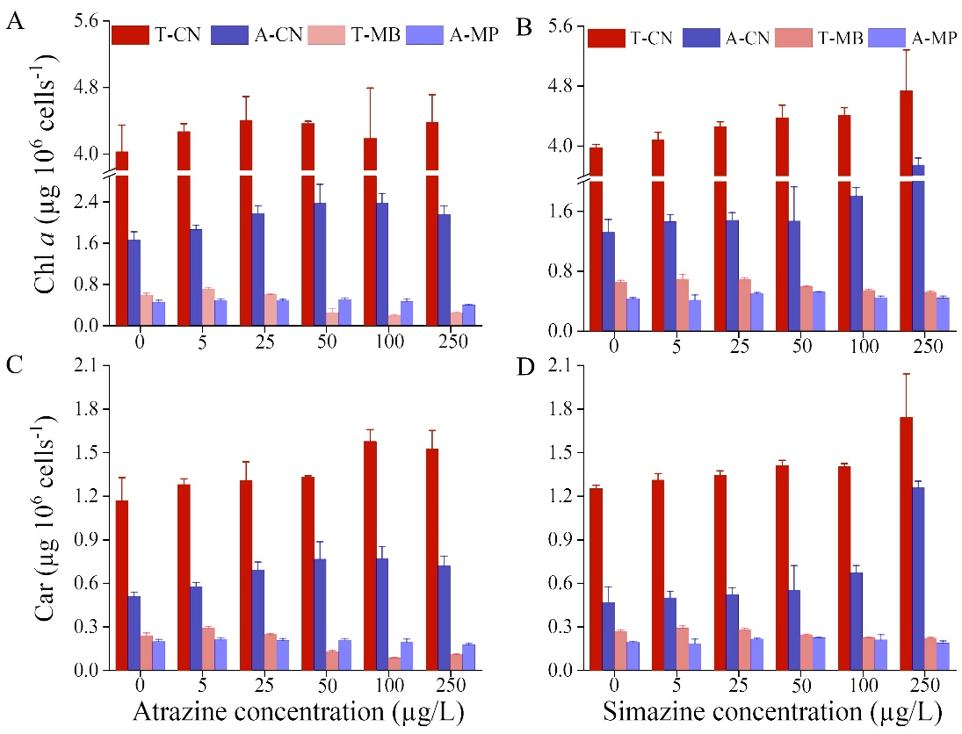
Figure 2. The effects of atrazine (A, C) and simazine (B, D) on the pigment contents of four species, including (red color) temperate C. neogracile (T-CN) and temperate M. bravo (T-MB), (blue color) Arctic C. neogracilis (A-CN) and Arctic M. polaris (A-MP) after 72 h exposure. Data are expressed as means ± SD (n = 6).
3.2.2 Effects of trifluralin and chlorpyrifos
Chl a and Car contents of both temperate microalgae diminished in the presence of chlorpyrifos (Table S1). On the other hand, both Arctic microalgae increased their contents in Chl a and Car except for M. polaris where the Car was unchanged. Car of both diatoms increased and Chl a increased for the lower concentrations of trifluralin, but decreased for the higher concentrations. In contrast, both prasinophytes decreased their Car contents, but Chl a content was not affected.
3.3 Effects of pesticides on PSII activity and the energy fluxes pathways
3.3.1 Effects of atrazine and simazine on PSII activity and the energy fluxes pathways
The maximum PSII quantum yields (Ф_{M}) of the diatoms (T-CN and A-CN) were not affected by atrazine and simazine except at high concentrations (100 and 250 μg/L; Tukey’s HSD, P >0.05) (Fig. 3). On the other hand, Ф_{M} of the two studied prasinophytes (T-MB and A-MP) were reduced (at variable extents) at any tested concentrations except 5 μg/L (Fig. 4). The operational PSII quantum yield (Ф'_{M}) significantly decreased (Tukey’s HSD, P < 0.05) with increasing atrazine and simazine concentrations for all studied species (Fig. 3 and 4). Both Ф_{M} and Ф'_{M} of A-CN decreased more than T-CN. In contrast, Ф_{M} and Ф'_{M} of A-MP decreased less than T-MB. The EC₅₀ of Ф'_{M} and Ф_{M} also confirmed this result, Ф'_{M}-EC₅₀ of T-CN and A-CN are respectively 66.2, 36.7 and 142.2, 62.3 for atrazine and simazine; Ф'_{M}-EC₅₀ of T-MB and A-MP are respectively 30.7, 35.8 and 48.7, 45.8 for atrazine and simazine (Table 2). Therefore, similar trend was observed for Ф_{M}-EC₅₀ and the Ф'_{M}-EC₅₀.
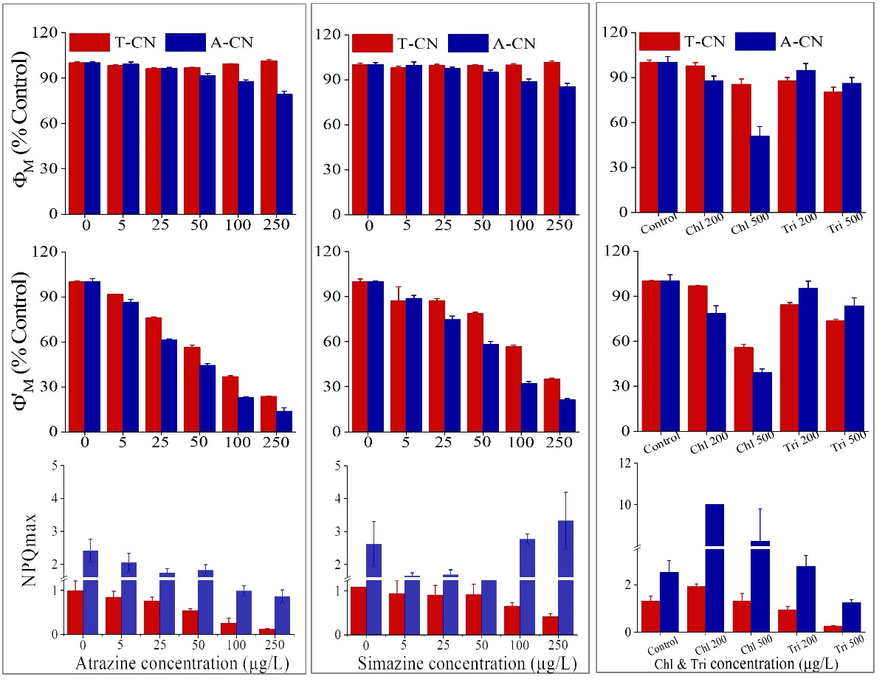
Figure 3. The effects of atrazine, simazine, chlorpyrifos and trifluralin on the maximal PSII quantum yield (Ф_{M}) and the operational PSII quantum yield (Ф'_{M}) of temperate C. neogracile (red color-T-CN) and Arctic C. neogracililis (blue color-A-CN) after 72 h exposure. Chl and Tri represent chlorpyrifos and trifluralin respectively. Data are expressed as means ± SD (n = 6).
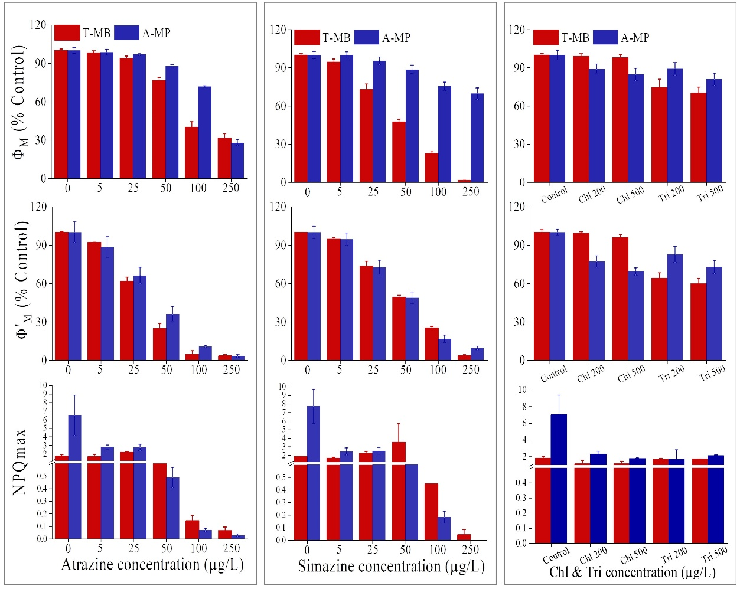
Figure 4. The effects of atrazine, simazine, chlorpyrifos and trifluralin on the maximal PSII quantum yield (Ф_{M}), the operational PSII quantum yield (Ф'_{M}) and non-photochemical quenching (NPQ) of temperate M. bravo (red color-T-MB) and Arctic M. polaris (blue color-A-MP) after 72 h exposure. Chl and Tri represent chlorpyrifos and trifluralin respectively. Data are expressed as means ± SD (n = 6).

Table 3. The effects of atrazine and simazine on ФM, Ф'M, α, ETRmax, and Ek of temperate C. neogracile (T-CN), M. bravo (T-MB) and Arctic C. neogracilis (A-CN), Arctic M. polaris (A-MP) after 72 h exposure. The same column superscript letters (a-d) showed significant differences among strains under different pesticide concentrations. ND = not determined (Showing that calculations are strongly influenced by treatment). Data expressed as means ± SD (n = 6).

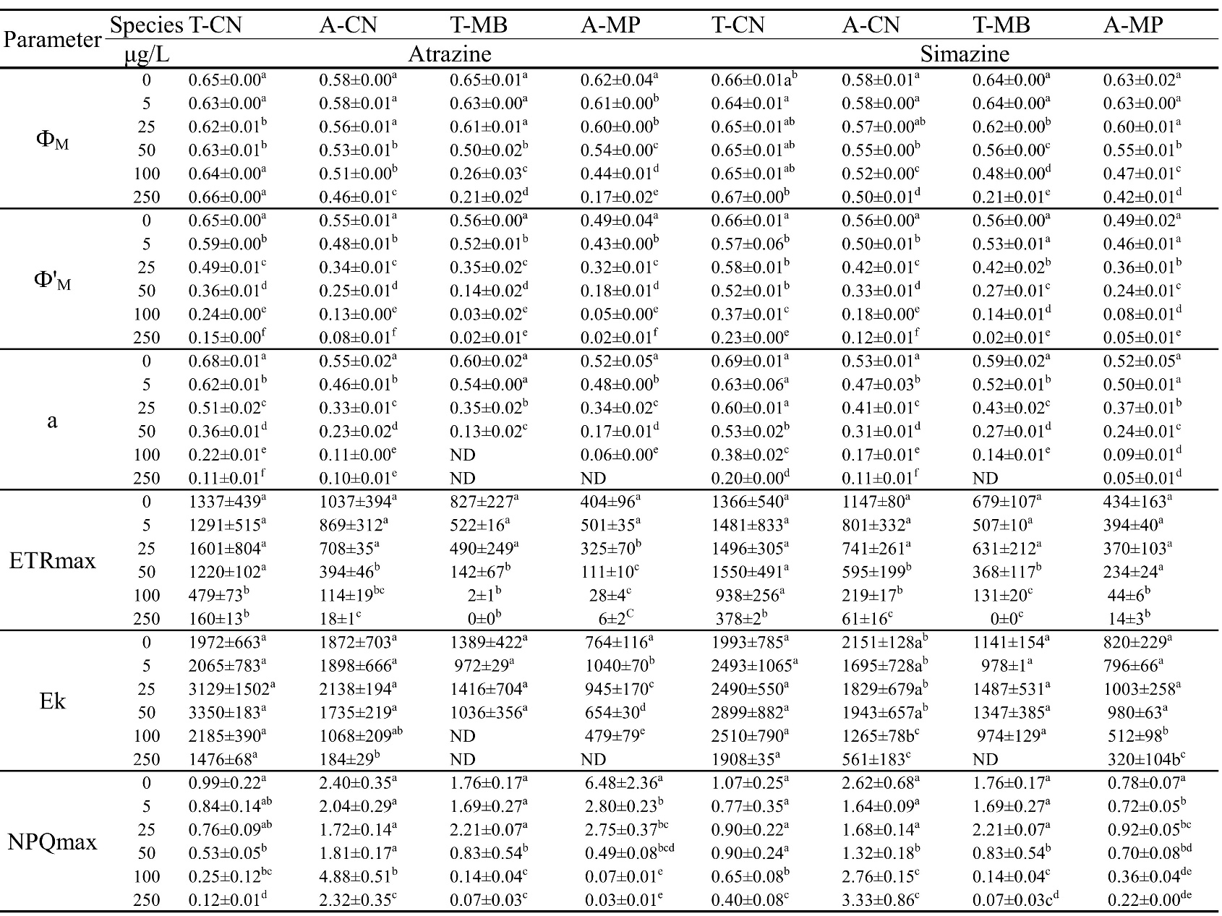
Calculated parameters acquired from the rapid Chl a fluorescence kinetics provide useful indication on how pesticides may affect energy fluxes within PSII (Force et al., 2003). The electron transport rate per active reaction center (ET₀/RC) of all species significantly decreased under the treatment of atrazine and simazine by stopping electron flow between Q_{A} and Q_{B} (Fig. 5 and 6). The energy conservation parameter of PI_{ABS} also declined under these treatment conditions, but to an extent that was species-dependent. We found that PI_{ABS} of the A-CN was more affected than T-CN (Fig. 5A-D); in contrast, the PI_{ABS} of the temperate M. bravo was more affected than in the Arctic M. polaris (Fig. 6A-D). The effective dissipation per reaction center (DI₀/RC) of the four species increased because of the high dissipation of the inactive RCs in the presence of atrazine and simazine. Similarly, the absorption flux per reaction center (ABS/RC), a proxy of the PSII antenna size, was increased by up to 202% in the presence of atrazine or simazine, except for the temperate C. neogracile. The DI₀/RC was increased in agreement with the change in ABS/RC in presence of atrazine and simazine, and the effect of DI₀/RC on Arctic diatom C. neogracilis was stronger (4.5 and 1.6 times) than for the temperate C. neogracile; for the prasinophytes we observed the contrary (the effect on DI₀/RC of the temperate M. bravo was stronger than for M. polaris). The maximal rate at which excitons are caught by the active reaction centers (TR₀/RC) was only altered by simazine for M. bravo.
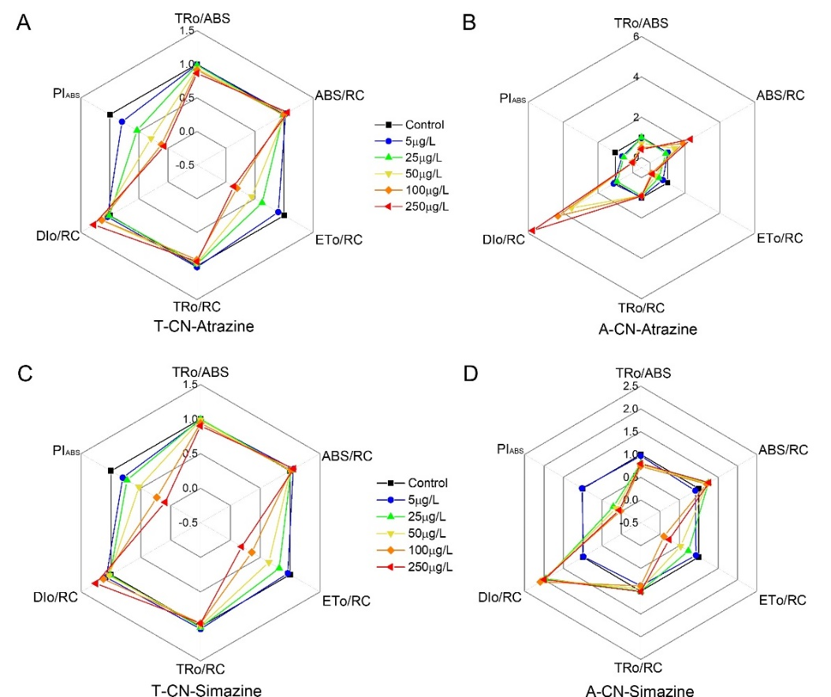
Figure 5. The effects of atrazine and simazine on the chlorophyll fluorescence parameters of temperate C. neogracile (T-CN) and Arctic C. neogracilis (A-CN) after 72 h exposure.
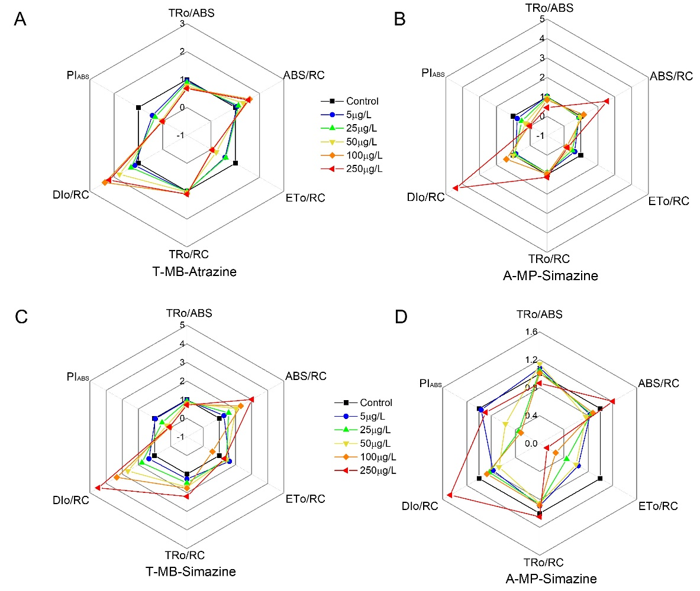
Figure 6. The effects of atrazine and simazine on the chlorophyll fluorescence parameters of temperate M. bravo (T-MB) and Arctic M. polaris (A-MP) after 72 h exposure.
3.3.2 Effects of trifluralin and chlorpyrifos on PSII activity and the energy fluxes pathways
The Ф_{M} and Ф'_{M} of all species declined in the presence of high concentrations (200 and 500 µg/L) of chlorpyrifos and trifluralin (Fig. 3 and 4), but the declines differed between temperate (C. neogracile and M. bravo) and Arctic species (C. neogracilis and M. polaris). Indeed, both Ф_{M} and Ф'_{M} of A-CN decreased more than T-CN when exposed to chlorpyrifos, but this trend was reversed in the presence of trifluralin. For the prasinophytes, we observed similar effect where both Ф_{M} and Ф'_{M} of Arctic M. polaris decreased more in the presence of chlorpyrifos than ones of the temperate M. bravo. This trend was reversed in the presence of trifluralin for Arctic M. polaris which declined less than did the temperate M. bravo. These results indicate greater sensitivity of Arctic species to chlorpyrifos than temperate counterparts, and vice versa with trifluralin. In the presence of chlorpyrifos and trifluralin, ET₀/RC and PI_{ABS} of both Chaetoceros species decreased with increasing pesticide concentration concomitantly with increasing DI₀/RC (Fig. S1). In response to trifluralin, Arctic and temperate Micromonas demonstrated opposite DI₀/RC and ABS/RC trends: these parameters increased for the temperate M. bravo and declined for the Arctic M. polaris (Fig. S1). Similarly, ET₀/RC and DI₀/RC responses in the two Micromonas species showed opposite response to chlorpyrifos.
3.4 Effects of pesticides on reactive oxygen species, antioxidant enzyme activity and protein content
At the lowest concentrations of atrazine and simazine (5 and 25 μg/l), the ROS content of all species was unchanged compared to control conditions (Tukey’s HSD, P>0.05) (Fig. 7). However, the ROS content significantly increased (Tukey’s HSD, P<0.05) at higher concentrations of pesticides (50, 100 and 250 μg/l). Despite similar trends, in the presence of atrazine, simazine and trifluralin, the ROS content of A-CN increased more than for the temperate C. neogracile, while the opposite occurred in the presence of chlorpyrifos. We observed a less marked increase of ROS content in the presence of pesticides for the Arctic M. polaris compared to the temperate M. bravo. Moreover, under control conditions, the ROS content of Arctic microalgae was lower than its temperate counterparts (Table S1). The activity of SOD and CAT of all species strongly increased with atrazine, simazine and trifluralin concentrations (Fig. 8). Concomitantly, the protein concentration per cell significantly decreased in the presence of pesticides, indicating that pesticides induced oxidative stress and a subsequent induction of mechanisms involved in the removal O₂^{.-} and H₂O₂. Surprisingly, for chlorpyrifos, the activity of SOD and CAT, and the total protein content of temperate C. neogracile and M. bravo decreased, suggesting that the antioxidant enzyme system was insufficient to cope with the impact of these pesticides or at least was not the main protective measure.
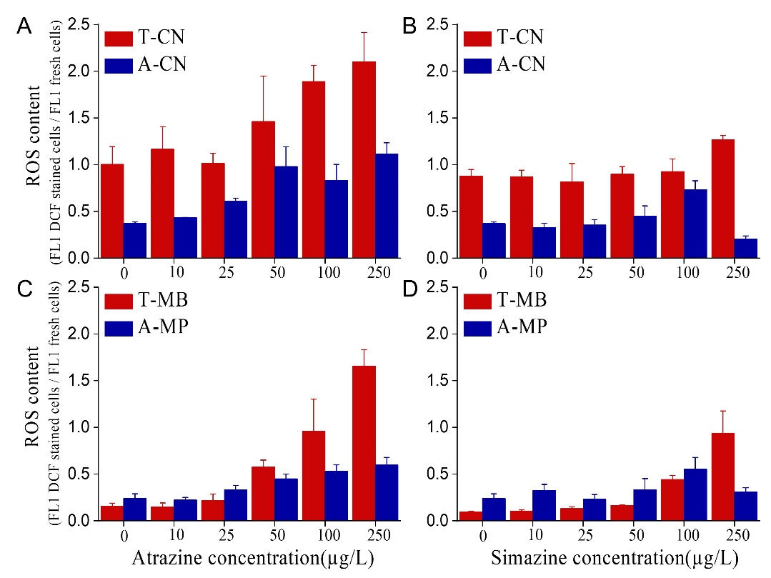
Figure 7. The effects of atrazine (A, C) and simazine (B, D) on the reactive oxygen species (ROS) of four species, including (red color) temperate C. neogracile (T-CN) and temperate M. bravo (T-MB), (blue color) Arctic C. neogracilis (A-CN) and Arctic M. polaris (A-MP) after 72 h exposure. Data are expressed as means ± SD (n = 6).
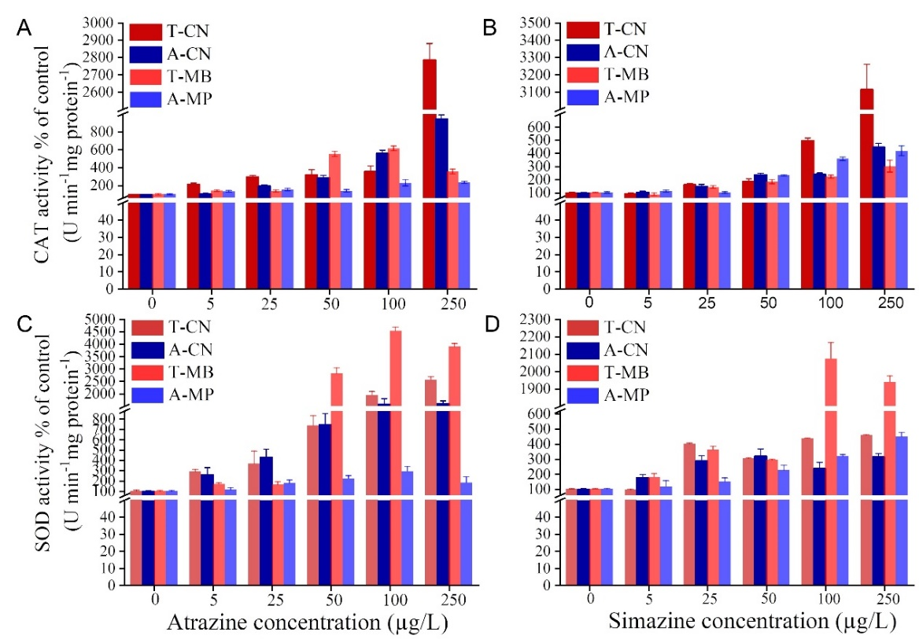
Figure 8. The effects of atrazine (A, C) and simazine (B, D) on the catalase (CAT) and superoxide dismutase (SOD) of four species, including (red color) temperate C. neogracile (T-CN) and temperate M. bravo (T-MB), (blue color) Arctic C. neogracilis (A-CN) and Arctic M. polaris (A-MP) after 72 h exposure. Data are expressed as means ± SD (n = 6).

4. Discussion
4.1 Different physiological characteristics between Arctic microalgae and their temperate counterparts
It is well accepted that at low temperatures Rubisco activity is the limiting step for growth (Young et al. 2015). Similarly, the cell biovolume of microalgae can be affected by growth temperature (Daufresne et al. 2009), and smaller cells have a larger surface/volume ratio compared to bigger cells, which facilitates better utilization of resources such as light and nutrients for growth (Wirth et al. 2019). In our study, the temperate and Arctic prasinophytes have the same cell biovolume (5-8 μm³), since prasinophyte morphological and biochemical characteristics are highly conserved and may not be strongly modified by the long term growth conditions (McKie-Krisberg and Sanders 2014). The growth rate of temperate M. bravo (T-MB) is almost twice that of the Arctic M. polaris (A-MP), which is consistent with previous studies, indicating that growth rates of polar green algae are usually lower than for temperate one (Kottuparambil et al. 2017, Lacour et al. 2017). Thus, not surprisingly, A-MP had lower ETRmax, Ek and α compared to T-MB, indicating that the utilization efficiency of light energy and photosynthetic capacity of A-MP were weaker than those of T-MB (Table 3). This was also supported by the lower maximal and operational PSII quantum yields (Ф_{M} and Ф'_{M}) in A-MP (Table 3). Interestingly, these differences were not found in the comparison between congeneric Arctic (C. neogracilis-A-CN) and temperate (C. neogracile-T-CN) diatoms. Indeed, Arctic and temperate diatoms had similar growth rate, ETRmax, Ek and α (Table 3), indicating that A-CN, while growing at a low temperature, has developed some strategies to improve the ability to harvest light energy and light utilization efficiency to optimize growth. However, these strategies did not prevent lower Ф_{M} and Ф'_{M} in A-CN compared to T-CN (Table 3), which is partly due to the presence of sustained NPQ (Lacour et al. 2018). Furthermore, A-CN with a much lower cell biovolume compared to T-CN can make better use of resources to benefit growth, which may partially explain the same growth rates of A-CN and T-CN.
The growth rates of both diatoms were higher than for Micromonas, as previously shown in other species’ comparisons (the diatom Thalassiosira hyalina with Micromonas pusilla) (Hoppe et al. 2018), probably due to the stronger ability of diatoms to increase the Rubisco gene expression when its activity is reduced at low temperature (Young et al. 2015). However, it is uncertain if prasinophytes also exhibit these acclimation responses (Hoppe et al. 2018). Lacour et al. (2017) observed that for a given Chl a content, polar diatoms grow more slowly than do temperate ones, suggesting that this difference is related to energy allocation. Interestingly, in our study, A-CN and T-CN had the same growth rate, but A-CN had a much lower Chl a content compared to its temperate counterpart. This indicates that different polar diatoms may have developed different adaptation strategies in concordance with their growth environment. Indeed, diatoms have different inherent NPQ abilities in response to their respective habitats (Croteau et al. 2021, Croteau et al. 2022). Lower Chl a content in both Arctic microalgae helps reduce excitation pressure on the photosynthetic reaction center, particularly in situations constraining growth, such as cold environments (Halsey and Jones 2015). Recent studies have demonstrated that for the majority of polar microalgal groups, NPQ is an essential element of the species-specific photoadaptative strategies (Croteau et al. 2021, Galindo et al. 2017). Together with low Chl a, polar microalgae also can induce high NPQ through an efficient de-epoxidation process to jointly protect the photosynthetic apparatus against environmental stress such as sudden increase in light intensity and temperature modifications (Lacour et al. 2020, Ni et al. 2017). In comparison, both Arctic microalgae, having lower ROS content and high CAT and SOD activities, should be more likely to adapt and survive at low Arctic habitat temperatures (Blanc et 2012). In summary, Arctic species appear to have evolved different ecophysiological characteristics than their temperate counterparts: Arctic microalgae have (1) lower Chl a and carotenoid contents, (2) a much higher intrinsic NPQmax, (3) lower ROS content and (4) higher CAT and SOD activities, compared to temperate species.
4.2 Effects of pesticides on Arctic microalgae and their temperate counterparts
4.2.1 Effects of pesticides on diatoms (A-CN and T-CN)
PSII inhibiting herbicides (such as atrazine and simazine) that can bind to the Q_{B} site on the D1 protein of PSII, inhibit the PSII-PSI electron transport resulting in high excitation pressure on PSII and ROS generation (Bai et al. 2015). If the photoprotective processes, NPQ and ROS scavenging system, are ineffective, reduced energy production and cellular damages occur, and ultimately algal growth might be reduced. Our study demonstrated that atrazine and simazine significantly inhibited the growth of both diatoms, as seen previously for Navicula pelliculosa (Chalifour and Juneau 2011). Our observations were linked to the significant reduction in Ф'_{M} and the electron transport rate per active RC (ET₀/RC). Concomitantly, dissipation of excess light energy (DI₀/RC) increased but was not sufficient to protect the PSII since Ф_{M}, a proxy of the PSII RC integrity, was affected, as previously shown when Phaeodactylum tricornutum was treated with PSII inhibiting herbicides (Debenest et al. 2010). This result is also supported by the significant decrease in PI_{ABS}, a sensitive indicator of plant health (Bayat et al. 2018) (Fig. 5A-D). The other unchanged PSII energy fluxes (ABS/RC and TR₀/RC) at low pesticide concentrations, together with the minor variations in the carotenoid contents, indicate that the protection of the photosynthetic electron transport chain from the ROS produced in the presence of atrazine and simazine, are likely due to other protective strategies (like antioxidant enzymatic systems). One could expect that, as the first line of defense against the excess of light energy under stressful conditions, NPQ would be activated (Kress and Jahns 2017, Müller et al. 2001). However, NPQmax decreased with increasing atrazine and simazine concentrations (Fig. 3). As shown in previous studies, the decline of NPQ in the presence of pesticides is attributed to the low buildup of the proton gradient across the thylakoid membranes, since electron transport is decreased (Chalifour and Juneau 2011, Gomes and Juneau 2017). Therefore, we supposed that the inhibition of the ΔpH-dependant non-photochemical energy dissipation mechanism leads to a reduced ability to decrease excitation pressure at PSII RC, resulting in higher ROS production. Although SOD and CAT activities were significantly increased with increasing atrazine and simazine concentrations, it was not sufficient to cope entirely with the ROS production induced by increasing atrazine and simazine concentrations (Fig. 7).
Overall, as shown by the investigation of the physiological parameters in the presence of atrazine and simazine and the determined EC₅₀ (Table 2), A-CN was more sensitive than the T-CN to atrazine and simazine. We suspect that the more pronounced PSII RC inactivation of A-CN results from its smaller cell biovolume, thus increasing overall contact with the pesticide molecules and resulting in an enhanced absorption of the contaminants (Weiner et al. 2004). However, the antioxidant enzyme system (SOD and CAT) induced in A-CN was insufficient to cope with the ROS production in the presence of atrazine and simazine. Furthermore, as previously showed in psychrophilic diatoms, PSII repair rates are slower than the ones found in temperate diatoms (Petrou et al. 2010), since lower temperatures decreased enzyme activity and metabolism (Morgan-Kiss et al. 2006). On the contrary, compared to the Arctic diatom, the temperate diatom potentially showed lower absorption of atrazine and simazine, the capacity for an efficient antioxidant enzyme system and probably higher rate of PSII repair cycle, which ultimately lead to its lower sensitivity to these herbicides.
For trifluralin, interestingly, we observed that A-CN was more tolerant than T-CN according to the growth, and photosynthetic activity (Ф_{M} and Ф'_{M}; Fig. 3). According to our data (Table S1, Fig. S1), the greater decrease of PI_{ABS} and ABS/RC for T-CN compared to A-CN, indicated that PSII RC was more damaged in T-CN. However, the Arctic diatom has more effective antioxidant capacity (SOD and CAT activities) than its temperate counterpart under the same concentration of trifluralin, indicating that its tolerance to trifluralin seems to mainly depend on the high efficiency of the antioxidant system. Although insecticides are not intended to affect plants and algae, chlorpyrifos has been shown to induce some deleterious impacts at the cellular and population levels (Asselborn et al. 2015), leading to the impairment of cell morphology and growth (Asselborn et al. 2006, Garrido et al. 2019), and the decrease in diversity of diatoms (Stratton, 1987). Similar effects were seen in our study, where chlorpyrifos not only affected the growth, and photosynthesis of both diatoms (Fig. 3; A-CN was more affected than T-CN), but also caused oxidative stress. The observed difference in the sensitivity to chlorpyrifos of diatoms was mainly reflected at the electron transport level, where chlorpyrifos induced the accumulation of Q_{A}⁻ and prevented electron transfer downstream of Q_{A} (revealed by the more pronounced increase in O-J and J-I phases for the Arctic diatom, Fig. S2), also evidence in the significant decrease of Ф’_{M}, ETo/RC and PI_{ABS} for A-CN (Fig. S1). In comparison, this impact on electron transport was accompanied by a weaker ability to dissipate excess energy (Dio/RC) in the Arctic diatom, resulting in its greater sensitivity to chlorpyrifos. In addition, some authors have suggested that insecticides disturb the cell cycle of Selenastrum capricornutum since they observed the inhibition of cell-separation, resulting in the intracellular accumulation of macromolecules, which are responsible for increasing the biovolume in A-CN (Fernandez et al. 2021, Rioboo et al. 2002).
4.2.2 Effects of pesticides on prasinophytes (A-MP and T-MB)
Prasinophytes responded to atrazine and simazine similarly to diatoms when growth, pigment composition and photosynthetic efficiency were evaluated. In contrast to diatoms, A-MP was more tolerant than T-MB to atrazine and simazine (Table 2 and Fig. 6). The more pronounced damage to the PSII RC (Ф_{M}), drastic inhibition of photosynthetic electron transport (Ф'_{M} and ETo/RC) and decreased light conversion efficiency (PI_{ABS}) at the PSII RC level in T-MB eventually induced higher production of ROS, which further damaged these photosynthetic components. We propose several reasons why A-MP was more tolerant to atrazine and simazine. First, A-MP has lower Chl a content than T-MB in the absence of pesticides, indicating that A-MP may have lower PSII content and therefore fewer available molecular targets for atrazine and simazine (DeLorenzox et al. 2004). Previous studies have demonstrated that Arctic Micromonas have lower active PSII levels than their temperate counterparts (Ni et al. 2017). Concomitantly, the lower Chl a content in A-MP helps to reduce excitation pressure on the PSII RC caused by atrazine and simazine. Second, the temperate species produced more ROS in the presence of atrazine and simazine compared to the Arctic one, but the induction of CAT and SOD were insufficient to prevent oxidative damage. In comparison, the Arctic species produced lower levels of ROS and have relatively lower CAT and SOD activities compared to the temperate species, which implies that these enzymes can successfully scavenge ROS. ROS has to reach a threshold level to increase the activity of the antioxidant enzyme system (Anu et al. 2016), which may indicate why the temperate species were more affected by the ROS production than the Arctic species in the presence of atrazine and simazine. Finally, A-MP had higher intrinsic NPQ to which was only slightly decreased by atrazine and simazine compared to T-MB (Fig. 4), which would protect PSII (Bai et al. 2015). In summary, T-MB showed higher sensitivity to atrazine and simazine than A-MP, due to the non-effectiveness of its NPQ and antioxidant enzymes to cope with excess light energy and oxidative stress, resulting in photosynthetic damage. In comparison, A-MP seems to mainly rely on NPQ rather than antioxidant enzymes under atrazine and simazine stress.
We observed that growth, photosynthetic efficiency, and electron transfer of the T-MB were more sensitive to the herbicide trifluralin than for the A-MP. Furthermore, significantly increased DIo/RC, ABS/RC and decreased ETo/RC of T-MB in the presence of trifluralin showed that the excess excitation energy caused by a certain number of inactivated RCs, was mostly dissipated. We propose that the different sensitivities of the prasinophytes to trifluralin are mainly determined by the antioxidant enzyme system, since the Arctic species induced five times higher SOD and CAT activities, even if it produced less ROS than its temperate counterpart (Table S1). The insecticide chlorpyrifos, in a way similar to what was observed for diatoms, inhibited the growth of Micromonas (A-MP was more affected than T-MB) and doubled the cell biovolume of A-MP (Table S1), for the same reasons that we proposed for diatoms. For T-MB, chlorpyrifos did not affect the photosynthetic efficiency. Furthermore, the increased PI_{ABS} and ET₀/RC, and unchanged kinetics of Q_{A}-Q_{B} reduction compared to the control (Fig. S1), indicate that PSII RCs and the whole photosynthetic electron transfer chain were protected under exposure to chlorpyrifos. By comparison, photosynthesis of A-MP was strongly affected by this insecticide, as indicated by the strong reduction of the active PSII RC population and suppression of electron transfer between Q_{A} and Q_{B} (Fig. S2).
4.2.3 Comparative effect of pesticides on Arctic microalgae and their temperate counterparts
In our study, based on the EC₅₀ values for Ф'_{M} and growth, the species sensitivity sequence was T-MB>A-MP>A-CN>T-CN in the presence of atrazine and simazine. For trifluralin, based on the impact on Ф_{M} and Ф'_{M} (since no EC₅₀ value cannot be obtained even at very high concentrations) the species sensitivity sequence was T-MB>A-MP>T-CN>A-CN and A-CN>T-CN>A-MP>T-MB for chlorpyrifos (Fig. 3 and 4). We found that diatoms Chaetoceros were more tolerant to atrazine, simazine and trifluralin than the prasinophytes Micromonas for both temperate and Arctic strains. Diatoms are known to be dominant in most aquatic environments (Serôdio and Lavaud 2020), likely owing to their specific ecophysiological characteristics, like their high PSII/PSI ratio (Strzepek and Harrison 2004), their high non-photochemical energy dissipation potential (Lavaud and Lepetit 2013), and the presence of fucoxanthin that can prevent photooxidation (Tuchman et al. 2006). Furthermore, diatoms can more efficiently control the ATP/NADPH ratio during photosynthesis compared to other photosynthetic organisms, permitting them to optimize their carbon fixation and growth (Bailleul et al. 2015). Indeed, we found that Ф'_{M}, pigment, ETRmax, Ek and α in both diatoms were higher than in prasinophytes, suggesting that diatoms have higher intrinsic photosynthetic capacity and light utilization efficiency. Therefore, if we consider only the impact of pesticides, we propose that Chaetoceros would have a greater chance of survival and would become the dominant species in temperate and Arctic ecosystems contaminated with atrazine, simazine and trifluralin in relation to Micromonas. On the other hand, according to the EC₅₀ of Ф'_{M} and growth (Table 2), atrazine induced significantly more damage than simazine to all tested algae even though both molecules have the same mode of action on the Q_{B} site of D1 protein of PSII. Previous studies have shown that irgarol with high octanol/water partition coefficient (logK_{ow}) is more toxic than diuron for marine microalgae as PSII inhibitor, and the higher logK_{ow} of irgarol promotes its affinity for the Q_{B} binding site, leading to its relative higher toxicity (Coquille et al. 2018, Dupraz et al. 2016, Kottuparambil et al. 2017). Therefore, we can assume that the higher toxicity of atrazine compared to simazine (logK_{ow}=2.3) could be due to its higher logK_{ow} (2.7) (Ronka 2016) and therefore to its higher affinity for the Q_{B} binding site. Similarly, in the presence of atrazine, CAT and SOD activities were higher and the total protein content decreased more than in the presence of simazine, resulting in a decrease in the available protein for photoprotection processes, such as NPQ and the PSII repair cycle (Bai et al. 2015).

ACKNOWLEDGEMENTS
This work was supported by a DFO grant (MECTS-#3789712) obtained by Philippe Juneau, Johann Lavaud and Beatrix Beisner and the Natural Science and Engineering Research Council of Canada (NSERC) (RGPIN-2017-06210) awarded to Philippe Juneau. The authors thanks also the GRIL (Groupe de recherche interuniversitaire en limnologie) for funding to PJ and BEB that supported Juan Du’s PhD.

References
Anu, P.R., Bijoy Nandan, S., Jayachandran, P.R. and Don Xavier, N.D. (2016) Toxicity effects of copper on the marine diatom, Chaetoceros calcitrans. Regional Studies in Marine Science 8, 498-504.
Ardyna, M. and Arrigo, K., R. (2020) Phytoplankton dynamics in a changing Arctic Ocean. Nature Climate Change 10(10), 892-903.
Asselborn, V., Fernandez, C., Zalocar, Y. and Parodi, E.R. (2015) Effects of chlorpyrifos on the growth and ultrastructure of green algae, Ankistrodesmus gracilis. Ecotoxicology and Environmental Safety 120, 334-341.
Asselborn, V.M., Zalocar, Y. and Parody, E. (2006) Efectos del insecticida organofosforado clorpirifos sobre el crecimiento y morfología de Selenastrum capricornutum Printz (Chlorophyta).
Bai, X., Sun, C., Xie, J., Song, H., Zhu, Q., Su, Y., Qian, H. and Fu, Z. (2015) Effects of atrazine on photosynthesis and defense response and the underlying mechanisms in Phaeodactylum tricornutum. Environmental Science and Pollution Research 22(17), 499-507.
Bailleul, B., Berne, N., Murik, O., Petroutsos, D., Prihoda, J., Tanaka, A., Villanova, V., Bligny, R., Flori, S., Falconet, D., Krieger-Liszkay, A., Santabarbara, S., Rappaport, F., Joliot, P., Tirichine, L., Falkowski, P.G., Cardol, P., Bowler, C. and Finazzi, G. (2015) Energetic coupling between plastids and mitochondria drives CO₂ assimilation in diatoms. Nature 524(7565), 366-369.
Balmer, J.E., Morris, A.D., Hung, H., Jantunen, L., Vorkamp, K., Rigét, F., Evans, M., Houde, M. and Muir, D.C.G. (2019) Levels and trends of current-use pesticides (CUPs) in the arctic: An updated review, 2010–2018. Emerging Contaminants 5, 70-88.
Balzano, S., Marie, D., Gourvil, P. and Vaulot, D. (2012) Composition of the summer photosynthetic pico and nanoplankton communities in the Beaufort Sea assessed by T-RFLP and sequences of the 18S rRNA gene from flow cytometry sorted samples. ISME Journal 6(8), 1480-1498.
Bayat, L., Arab, M., Aliniaeifard, S., Seif, M., Lastochkina, O. and Li, T. (2018) Effects of growth under different light spectra on the subsequent high light tolerance in rose plants. AoB Plants 10(5), ply052.
Cabrerizo, A., Muir, D.C.G., Teixeira, C., Lamoureux, S.F. and Lafreniere, M.J. (2019) Snow Deposition and Melting as Drivers of Polychlorinated Biphenyls and Organochlorine Pesticides in Arctic Rivers, Lakes, and Ocean. Environmental Science Technology 53(24), 14377-14386.
CARC (1990) Canadian Arctic Resources Committee, Northern perspectives 18.
Chalifour, A., Arts, M.T., Kainz, M.J. and Juneau, P. (2014) Combined effect of temperature and bleaching herbicides on photosynthesis, pigment and fatty acid composition of Chlamydomonas reinhardtii. European Journal of Phycology 49(4), 508-515.
Chalifour, A. and Juneau, P. (2011) Temperature-dependent sensitivity of growth and photosynthesis of Scenedesmus obliquus, Navicula pelliculosa and two strains of Microcystis aeruginosa to the herbicide atrazine. Aquatic Toxicology 103(1-2), 9-17.
Chalifour, A., LeBlanc, A., Sleno, L. and Juneau, P. (2016) Sensitivity of Scenedesmus obliquus and Microcystis aeruginosa to atrazine: effects of acclimation and mixed cultures, and their removal ability. Ecotoxicology 25(10), 1822-1831.
Coquille, N., Menard, D., Rouxel, J., Dupraz, V., Eon, M., Pardon, P., Budzinski, H., Morin, S., Parlanti, E. and Stachowski-Haberkorn, S. (2018) The influence of natural dissolved organic matter on herbicide toxicity to marine microalgae is species-dependent. Aquatic Toxicology 198, 103-117.
Croteau, D., Guérin, S., Bruyant, F., Ferland, J., Campbell, D.A., Babin, M. and Lavaud, J. (2021) Contrasting nonphotochemical quenching patterns under high light and darkness aligns with light niche occupancy in Arctic diatoms. Limnology and Oceanography 66(S1).
Croteau, D., Lacour, T., Schiffrine, N., Morin, P.I., Forget, M.H., Bruyant, F., Ferland, J., Lafond, A., Campbell, D.A., Tremblay, J.É., Babin, M. and Lavaud, J. (2022) Shifts in growth light optima among diatom species support their succession during the spring bloom in the Arctic. Journal of Ecology.
Daufresne, M., Lengfellnera, K. and Sommer, U. (2009) Global warming benefits the small in aquatic ecosystems. Proceedings of the National Academy of Sciences 106(31), 12788-12793.
Debenest, T., Silvestre, J., Coste, M. and Pinelli, E. (2010) Effects of pesticides on freshwater diatoms. Reviews of Environmental Contamination and Toxicology 203, 87-103.
DeLorenzo, M.E. (2001) toxicity of pesticides to aquatic microorganisms: a review. Environmental Toxicology and Chemistry 20 (1), 84-98.
DeLorenzox, M.E., Leatherbury, M., Weiner, J.A., Lewitus, A.J. and Fulton, M.H. (2004) Physiological factors contributing to the species-specific sensitivity of four estuarine microalgal species exposed to the herbicide atrazine. Aquatic Ecosystem Health Management 7(1), 137-146.
Dupraz, V., Coquille, N., Menard, D., Sussarellu, R., Haugarreau, L. and Stachowski-Haberkorn, S. (2016) Microalgal sensitivity varies between a diuron-resistant strain and two wild strains when exposed to diuron and irgarol, alone and in mixtures. Chemosphere 151, 241-252.
Fernandez, C., Asselborn, V. and Parodi, E.R. (2021) Toxic effects of chlorpyrifos, cypermethrin and glyphosate on the non-target organism Selenastrum capricornutum (Chlorophyta). Anais da Academia Brasileira de Ciencias 93(4).
Frey, K., Fansh, L. and Ghhihu, H. (2018) Arctic Ocean Primary Productivity: The Response of Marine Algae to Climate Warming and Sea Ice Decline. Arctic Report Card.
Galindo, V., Gosselin, M., Lavaud, J., Mundy, C.J., Else, B., Ehn, J. and Rysgaard, S. (2017) Pigment composition and photoprotection of Arctic sea ice algae during spring. Marine Ecology Progress Series 585, 49-69.
Garrido, S., Linares, M., Campillo, J.A. and Albentosa, M. (2019) Effect of microplastics on the toxicity of chlorpyrifos to the microalgae Isochrysis galbana, clone t-ISO. Ecotoxicology and Environmental Safety 173, 103-109.
Gomes, M.P. and Juneau, P. (2017) Temperature and Light Modulation of Herbicide Toxicity on Algal and Cyanobacterial Physiology. Frontiers in Environmental Science 5.
Halsey, K.H. and Jones, B.M. (2015) Phytoplankton strategies for photosynthetic energy allocation. Annual Review of Marine Science 7, 265-297.
Handler, E. (2017) Responses to Light Intensity and Regimes by an Arctic strain of the picophytoplankton Micromonas CCMP2099.
Hoferkamp, L., Hermanson, M.H. and Muir, D.C. (2010) Current use pesticides in Arctic media; 2000-2007. Science of the Total Environment 408(15), 2985-2994.
Hoppe, C.J.M., Flintrop, C.M. and Rost, B. (2018) The Arctic picoeukaryote Micromonas pusilla benefits synergistically from warming and ocean acidification. Biogeosciences 15(14), 4353-4365.
Juneau, P., David, D. and Saburo, M. (2001) Evaluation of different algal species sensitivity to mercury and metolachlor by PAM-fluorometry. Chemosphere 45(4-5), 589-598.
Kottuparambil, S., Brown, M.T., Park, J., Choi, S., Lee, H., Choi, H.G., Depuydt, S. and Han, T. (2017) Comparative assessment of single and joint effects of diuron and Irgarol 1051 on Arctic and temperate microalgae using chlorophyll a fluorescence imaging. Ecological Indicators 76, 304-316.
Kress, E. and Jahns, P. (2017) The Dynamics of Energy Dissipation and Xanthophyll Conversion in Arabidopsis Indicate an Indirect Photoprotective Role of Zeaxanthin in Slowly Inducible and Relaxing Components of Non-photochemical Quenching of Excitation Energy. Frontiers in Plant Science 8, 2094.
Lacour, T., Babin, M. and Lavaud, J. (2020) Diversity in xanthophyll cycle pigments content and related nonphotochemical quenching (NPQ) among microalgae: implications for growth strategy and ecology. Journal of Phycology 56(2), 245-263.
Lacour, T., Larivière, J. and Babin, M. (2017) Growth, Chl a content, photosynthesis, and elemental composition in polar and temperate microalgae. Limnology and Oceanography 62(1), 43-58.
Lacour, T., Larivière, J., Ferland, J., Bruyant, F., Lavaud, J. and Babin, M. (2018) The Role of Sustained Photoprotective Non-photochemical Quenching in Low Temperature and High Light Acclimation in the Bloom-Forming Arctic Diatom Thalassiosira gravida. Frontiers in Marine Science 5.
Larras, F., Lambert, A.S., Pesce, S., Rimet, F., Bouchez, A. and Montuelle, B. (2013) The effect of temperature and a herbicide mixture on freshwater periphytic algae. Ecotoxicology and Environmental Safety 98, 162-170.
Larsbo, M., Sandin, M., Jarvis, N., Etana, A. and Kreuger, J. (2016) Surface Runoff of Pesticides from a Clay Loam Field in Sweden. J Environ Qual 45(4), 1367-1374.
Lavaud, J. and Lepetit, B. (2013) An explanation for the inter-species variability of the photoprotective non-photochemical chlorophyll fluorescence quenching in diatoms. Biochimica Biophysica Acta 1827(3), 294-302.
Lovejoy, C., Vincent, W.F., Bonilla, S., Roy, S., Martineau, M.J., Terrado, R., Potvin, M., Massana, R. and Pedrós-Alió, C. (2007) Distribution, Phylogeny, and Growth of Cold-Adapted Picoprasinophytes in Arctic Seas. Journal of Phycology 43(1), 78-89.
Lyon, B.R. and Mock, T. (2014) Polar Microalgae: New Approaches towards Understanding Adaptations to an Extreme and Changing Environment. Biology (Basel) 3(1), 56-80.
Ma, Y., Adelman, D.A., Bauerfeind, E., Cabrerizo, A., McDonough, C.A., Muir, D., Soltwedel, T., Sun, C., Wagner, C.C., Sunderland, E.M. and Lohmann, R. (2018) Concentrations and Water Mass Transport of Legacy POPs in the Arctic Ocean. Geophysical Research Letters 45(23).
Margesin, R. (2007) Alpine microorganisms: useful tools for low-temperature bioremediation Journal of Microbiology 45(4), 281-285.
McKie-Krisberg, Z.M. and Sanders, R.W. (2014) Phagotrophy by the picoeukaryotic green alga Micromonas: implications for Arctic Oceans. ISME Journal 8(10), 1953-1961.
Medithi, S., Jonnalagadda, P.R. and Jee, B. (2021) Predominant role of antioxidants in ameliorating the oxidative stress induced by pesticides. Archives of Environmental & Occupational Health 76(2), 61-74.
Morgan-Kiss, R.M., Priscu, J.C., Pocock, T., Gudynaite-Savitch, L. and Huner, N.P. (2006) Adaptation and acclimation of photosynthetic microorganisms to permanently cold environments. Microbiology and Molecular Biology Reviews 70(1), 222-252.
Moustakas, M., Moustaka, J. and Sperdouli, I. (2022) Hormesis in photosystem II: a mechanistic understanding. Current Opinion in Toxicology.
Muir, D., Kurt-Karakus, P. and Stow, J. (2013) Canadian Arctic Contaminants Assessment Report On Persistent Organic Pollutants. NCP (Northern Contaminants Program).
Muir, D.C. and de Wit, C.A. (2010) Trends of legacy and new persistent organic pollutants in the circumpolar arctic: overview, conclusions, and recommendations. Science of the Total Environment 408(15), 3044-3051.
Müller, P., Li, X.P. and Niyogi, K.K. (2001) Non-photochemical quenching. A response to excess light energy Plant physiology 125(4), 1558-1566.
Ni, G., Zimbalatti, G., Murphy, C.D., Barnett, A.B., Arsenault, C.M., Li, G., Cockshutt, A.M. and Campbell, D.A. (2017) Arctic Micromonas uses protein pools and non-photochemical quenching to cope with temperature restrictions on Photosystem II protein turnover. Photosynthesis Research 131(2), 203-220.
Parker, M.S. and Armbrust, E.V. (2005) Synergistic Effects of Light, Temperature, and Nitrogen Source on Transcription of Genes for Carbon and Nitrogen Metabolism in the Centric Diatom Thalassiosira Pseudonana (Bacillariophyceae)1. Journal of Phycology 41(6), 1142-1153.
Petrou, K., Hill, R., Brown, C.M., Campbell, D.A., Doblin, M.A. and Ralph, P.J. (2010) Rapid photoprotection in sea‐ice diatoms from the East Antarctic pack ice. Limnology and Oceanography 55(3), 1400-1407.
Pućko, M., Stern, G.A., Burt, A.E., Jantunen, L.M., Bidleman, T.F., Macdonald, R.W., Barber, D.G., Geilfus, N.X. and Rysgaard, S. (2017) Current use pesticide and legacy organochlorine pesticide dynamics at the ocean-sea ice-atmosphere interface in resolute passage, Canadian Arctic, during winter-summer transition. Science of the Total Environment 580, 1460-1469.
Rioboo, C., González, O., Herrero, C. and Cid, A. (2002) Physiological response of freshwater microalga (Chlorella vulgaris) to triazine and phenylurea herbicides. Aquatic Toxicology 59(3-4), 225-235.
Ronka, S. (2016) Removal of triazine-based herbicides on specific polymeric sorbent: batch studies. Pure and Applied Chemistry 88(12), 1167-1177.
Serôdio, J. and Lavaud, J. (2020) Diatoms and their ecological importance. Life Below Water, 1-9.
Singh, Z., Jasminder, K. and Ravneet, K. (2016) Toxic Effects of Organochlorine Pesticides: A Review. American Journal of BioScience 4(3).
Stachowski-Haberkorn, S., Jerome, M., Rouxel, J., Khelifi, C., Rince, M. and Burgeot, T. (2013) Multigenerational exposure of the microalga Tetraselmis suecica to diuron leads to spontaneous long-term strain adaptation. Aquatic Toxicology 140-141, 380-388.
Strzepek, R.F. and Harrison, P.J. (2004) Photosynthetic architecture differs in coastal and oceanic diatoms. Nature 431(7009), 684-689.
Takishita, Y., Souleimanov, A., Bourguet, C., Ohlund, L.B., Arnold, A., A., Sleno, L. and Smith, D.L. (2021) Pseudomonas entomophila 23S Produces a Novel Antagonistic Compound against Clavibacter michiganensis subsp. michiganensis, a Pathogen of Tomato Bacterial Canker. Applied Microbiology 1(1), 60-73.
Tang, J., Hoagland, K.D. and Siegfried, B.D. (1998) Uptake and bioconcentration of atrazine by selected freshwater algae. Environmental Toxicology and Chemistry 17(6), 1085-1090.
Tuchman, N.C., Schollett, M.A., Rier, S.T. and Geddes, P. (2006) Differential Heterotrophic Utilization of Organic Compounds by Diatoms and Bacteria under Light and Dark Conditions. Hydrobiologia 561(1), 167-177.
Vonk, J.A. and Kraak, M.H.S. (2020) Herbicide Exposure and Toxicity to Aquatic Primary Producers. Reviews of Environmental Contamination and Toxicology 250, 119-171.
Vorkamp, K. and Riget, F.F. (2014) A review of new and current-use contaminants in the Arctic environment: evidence of long-range transport and indications of bioaccumulation. Chemosphere 111, 379-395.
Weber, J., Halsall, C.J., Muir, D., Teixeira, C., Small, J., Solomon, K., Hermanson, M., Hung, H. and Bidleman, T. (2010) Endosulfan, a global pesticide: a review of its fate in the environment and occurrence in the Arctic. Science of the Total Environment 408(15), 2966-2984.
Weiner, J.A., DeLorenzo, M.E. and Fulton, M.H. (2004) Relationship between uptake capacity and differential toxicity of the herbicide atrazine in selected microalgal species. Aquatic Toxicology 68(2), 121-128.
White, P.L., Wynn-Williams, D.D. and Russell, N.J. (2000) Diversity of thermal responses of lipid composition in the membranes of the dominant culturable members of an Antarctic fellfield soil bacterial community Antarctic Science 12(3), 386-393.
Wiebe, W.J., Sheldon, J.W.M. and Pomeroy, L.R. (1992) Bacterial growth in the cold: evidence for an enhanced substrate requirement Applied and Environmental Microbiology 58(1), 359-364.
Wirth, C., Limberger, R. and Weisse, T. (2019) Temperature x light interaction and tolerance of high water temperature in the planktonic freshwater flagellates Cryptomonas (Cryptophyceae) and Dinobryon (Chrysophyceae). Journal of Phycology 55(2), 404-414.
Yadav, N.R. (2015) Toxic effect of chlorpyrifos and dimethoate on protein and chlorophyll-a content of spirulina platensis. International journal of engineering science & advanced research 1, 24-26.
Young, J.N., Goldman, J.A., Kranz, S.A., Tortell, P.D. and Morel, F.M. (2015) Slow carboxylation of Rubisco constrains the rate of carbon fixation during Antarctic phytoplankton blooms. New Phytologist 205(1), 172-181.
Zhang, X., Luo, Y. and Goh, K.S. (2018) Modeling spray drift and runoff-related inputs of pesticides to receiving water. Environmental Pollution 234, 48-58.

Supplementary Material
Figure S1. The effects of chlorpyrifos and trifluralin on energy fluxes within PSII of four species, including temperate C. neogracile (T-CN), Arctic C. neogracile (A-CN) for A and B, temperate M. bravo (T-MB) and Arctic M. polaris (A-MP) for C and D after 72 h exposure. Data expressed as means ± SD (n = 6).
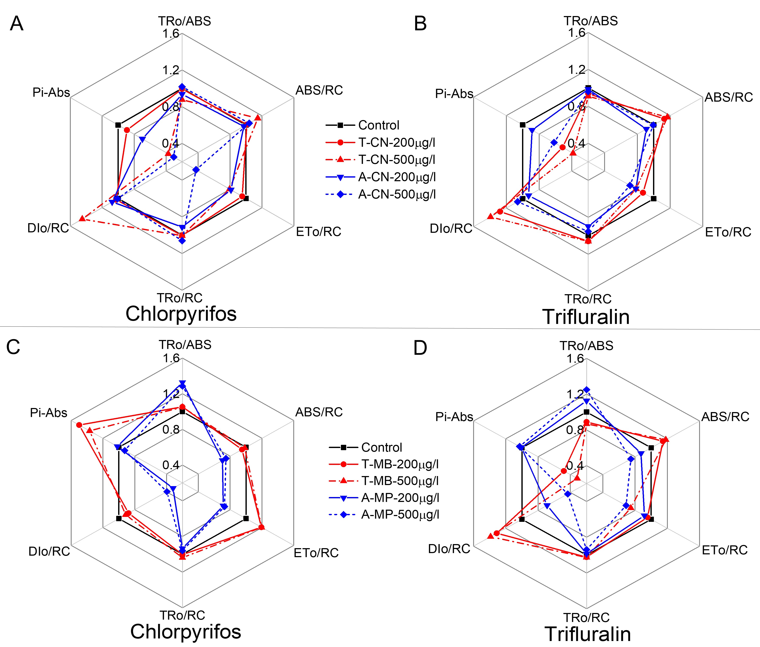
Figure S2. Fast fluorescence kinetics of T-CN (A), A-CN (B), T-MB (C) and A-MP (D), exposed to chlorpyrifos and trifluralin for 72h.
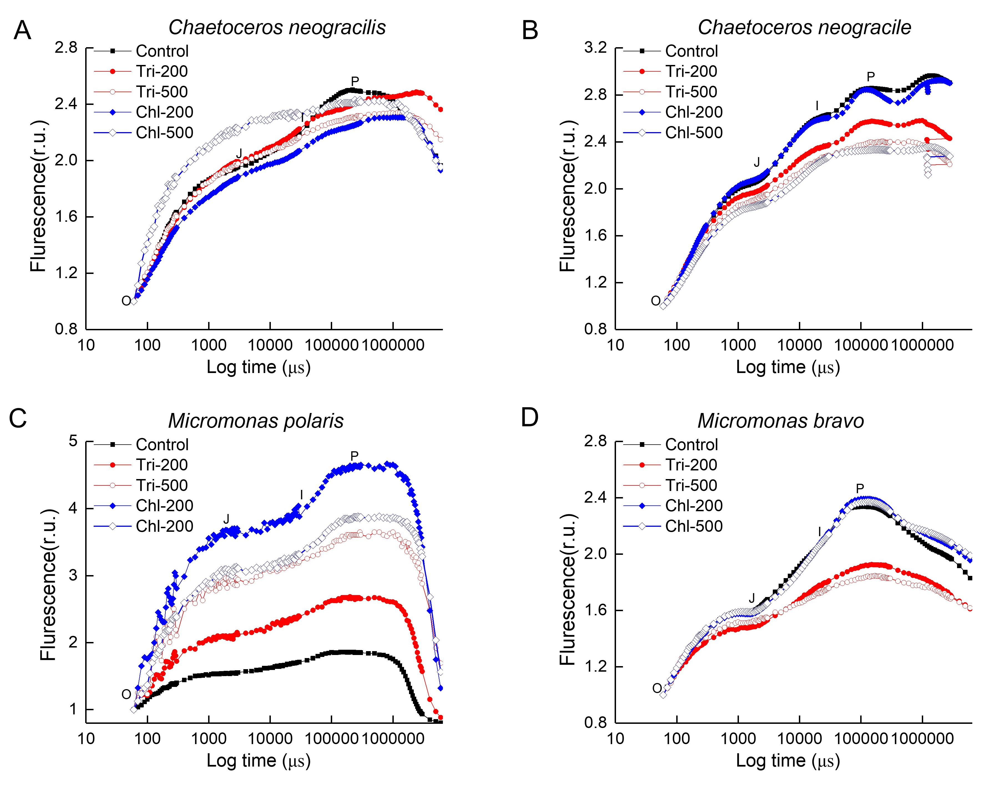
Figure S3. The effects of atrazine and simazine after 72 h exposure on the cell biovolume. Data are means ± SD. for 72h.
Table S1. Definitions for the fluorescence parameters used in this study.
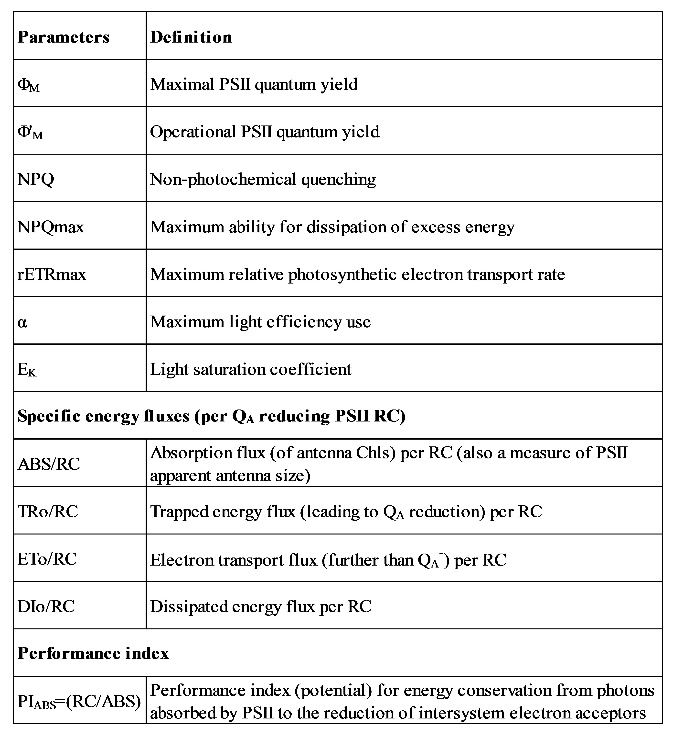

Table S2. The effects of trifluralin and chlorpyrifos after 72 h exposure on the growth rate, cell volume, Ф_{M}, Ф'_{M}, ROS content, and Chl a pigment. The percentages of the control value are shown by the numbers in parentheses. Data are means ± SD.

