New Insights into Fe-N-C Oxygen Reduction Reaction Catalysts Structure from Experimental and Computational X-ray Absorption and Emission Spectroscopies
Viktoriia A. Savelevaª, Marius Reteganª, Kavita Kumar^{b}, Frédéric Maillard^{b}, Pieter Glatzelª
a. ESRF – The European Synchrotron, 71 Avenue des Martyrs, 38000 Grenoble, France
b. Univ. Grenoble Alpes, CNRS, Grenoble INP, LEPMI, 38000 Grenoble, France
viktoriia.saveleva@esrf.fr

Fe-N-C electrocatalysts are promising materials for promoting oxygen reduction reaction (ORR) both in acid and alkaline media.¹ The structure of the active sites (FeN_{x}C_{y}) has been widely studied using various experimental and theoretical methods. The formers were applied for both ex situ and in situ / operando conditions, contributing to the general understanding of these complex moieties.^{1,2} Nevertheless, the exact geometry of the active sites and the iron electronic structure during ORR remain uncertain in the literature. We have recently applied in situ Fe Kβ X-ray emission spectroscopy (XES) to follow the changes in the Fe spin state under ORR conditions.³ In the present work, we further explored the capabilities of this technique by analyzing the valence-to-core (VtC) region of the Fe Kβ XES, which probes directly the filled valence orbitals. As these are dominantly ligand in nature, it allows distinguishing between N and O ligands, unlike the traditional extended X-ray absorption fine structure analysis. High-energy resolution fluorescence-detected X-ray absorption near-edge structure (Fe K edge), Fe Kβ and VtC XES spectra were collected at ID26 beamline of the ESRF synchrotron (Grenoble, France) on pristine and aged (after accelerated stress tests) Fe-N-C-based electrodes (VtC spectra are shown in Figure 1a). The VtC XES features were analyzed using density functional theory with the ORCA quantum chemistry software package.⁴ Several FeN_{x}C_{y} models were selected for the optimization and spectra calculations containing FeN₄ and FeN₃, bulk- and edge-located FeN_{x} sites (Figure 1a, insets) where the oxidation and the spin states of the Fe atom were varied in order to reproduce the VtC features observed experimentally. Additionally, we demonstrate the influence of different oxygen ligands on the VtC spectra features position (see examples in Figure 1b) that can be further used for in situ studies of the ORR mechanism on the Fe-N-C catalysts.

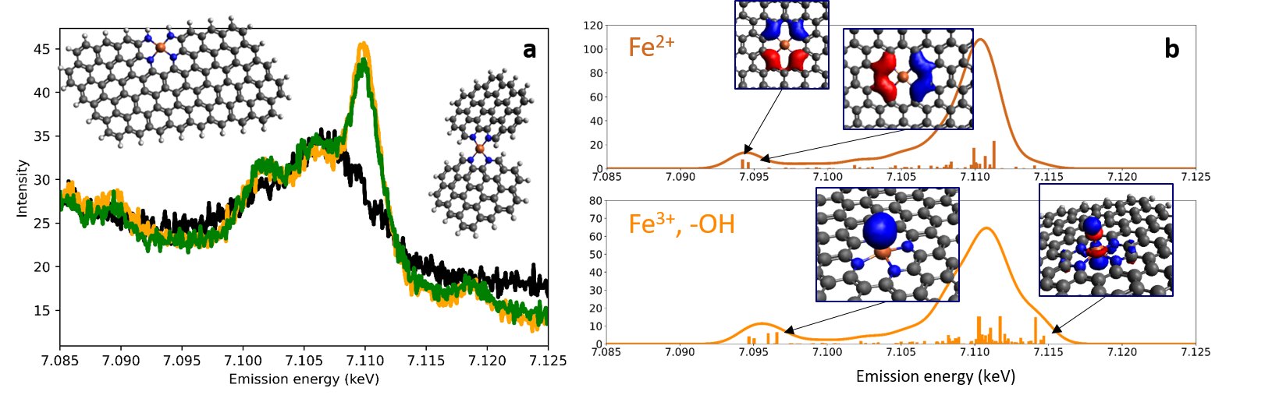
Figure 1. Panel a. Experimental VtC Fe Kβ XES spectra for pristine (black) and aged (green and orange) Fe-N-C electrodes. The insets show some of the models used in this work. Panel b. Calculated VtC XES spectra for the model with (bottom) and without (top) OH groups; the characteristic molecular orbitals representing key spectral features are shown in the corresponding panels.

Acknowledgement
The authors are grateful to Frédéric Jaouen (ICGM, France) for providing the Fe-N-C catalysts used in this study.

References
1 T. Asset and P. Atanassov, Joule, 2020, 4, 33–44.
2 J. Li and F. Jaouen, Curr. Opin. Electrochem., 2018, 9, 198–206.
3 V. A. Saveleva, K. Ebner, L. Ni, G. Smolentsev, D. Klose, A. Zitolo, E. Marelli, J. Li, M. Medarde, O. V. Safonova, M. Nachtegaal, F. Jaouen, U. I. Kramm, T. J. Schmidt and J. Herranz, Angew. Chemie - Int. Ed., 2021, 60, 11707–11712.
4 F. Neese, Wiley Interdiscip. Rev. Comput. Mol. Sci., 2018, 8, 4–9.

