THz Spectroscopic Characterization of Oil Shales,

Moses Eshovo Ojo*, Fréderic Fauquet*, Damien Bigourd*, Patrick Mounaix*

*Laboratoire IMS UMR CNRS 5218, Université de Bordeaux, France

***Abstract-*Grey to dark-grey samples reported to be oil shales have been analyzed under the THz reflection and transmission spectroscopy. In order to examine the organic and mineral stratification of the oil shales, samples at varying height above the ground level were excavated from stream banks and hilly terrains. The constituent of these aquatic and terrestrial-based oil shales were further correlated to investigate any correspondence or dissimilarities in their composition by examining the refractive index, absorption and optical path length maps of the samples.**

# INTRODUCTION

il shale is a combustible source rock, composed of minerals and an organic matter referred to as kerogen. Oil shale is capable of generating oil and other petroleum products when subjected to pyrolysis. Shale oil and oil shale-gas which are among the pyrolytic products of oil shale are chemically identical to the products of fossil fuel, and thus serve as a substitute for conventional crude oil and natural gas respectively**1**. They hold important application in the context of a decline in the crude oil reserves and spike in the oil prices. Oil shale in widespread deposits has been reported in several countries. The oil shale samples in this work were sourced from Lokpanta, Nigeria.

O

Among its huge uses, THz-based spectroscopy has strong applicability in the development of the oil industry due to its non-destructive testing and strong interaction with organic matter. Conventional oil source rocks and petroleum products have well been investigated via the THz spectroscopy. In recent years, the investigation of oil shale via THz spectroscopy is gaining popularity. The kerogen constituent of the oil shale which is a delicate and complex heterogeneous organic substance making up a small percentage by mass of the total weight of the oil shale determines the quality and quantity of the oil yield. The vast majority THz spectroscopy experiments involve probing this organic content.

In a typical oil shale THz transmission spectroscopy at room temperature, THz pulses are mainly absorbed by the kerogen content, due to the fact, that the large macromolecules with aromatic compounds typically have vibration modes in the THz region around 0.5–4 THz. When the THz spectroscopy is performed with a pyrolyzed oil shale sample, there are generally two major phases in the optical response of the kerogen to the THz pulses. The first phase occurring at lower temperature, involves the evaporation of moisture from the oil shale thereby resulting to an increase in the strength of the transmitted THz signal. The second phase is typically characterized by a decrease in the strength of the THz pulse, due to absorption of the pulses at high temperature. At such high temperature, the kerogen macromolecules decompose into lighter molecules mostly with short chains alkanes, while the minerals are decomposed into metals and metallic oxide. At this stage, the absorption of THz pulse is reversed, and mainly dominated by the metallic components. The responses of oil shales have been interpreted in terms of absorption, refractive index plots and contrast image maps. These above parameters have been shown to be related to the oil yield potentiality of the oil shale**2**.

A plot of refractive index 𝑛, normally indicates a narrow decrease with frequency. In general, oil shales with lower 𝑛, exhibits a negative correlation with oil yields, i.e. high-oil yielding oil shales have lower 𝑛 and vice versa. This is particularly valid for samples excavated along the bedding plane. While the absorption coefficient α, of independently analyzed oil shales have revealed that, higher 𝛼 corresponds to higher oil yield, and vice versa. Also, THz subsurface imaging of oil shales has been achieved via the reflection mode of the THz-based spectroscopy technique**3, 4** (refer to Fig. 1.0. In order to realize a robust information, we shall analyze the THz pulse 2 in our work). The amplitude of reflected THz pulse from different regions of the oil shale was employed to reconstruct the non-uniform distribution of organics on the oil shale surface. Three regions corresponding to high kerogen, low kerogen and mineral regions were observed based on the intensity distribution. Results from optical micrographs and micro-Raman spectra showed good agreement with the THz contrast image. In our work, we aim to study the organic distribution of some reported oil shales in relation to elevation and environment type. The height of the undermined bank of streams measured about *11-16* *m*, while the lowland hills measured *5 - 9* *m.*

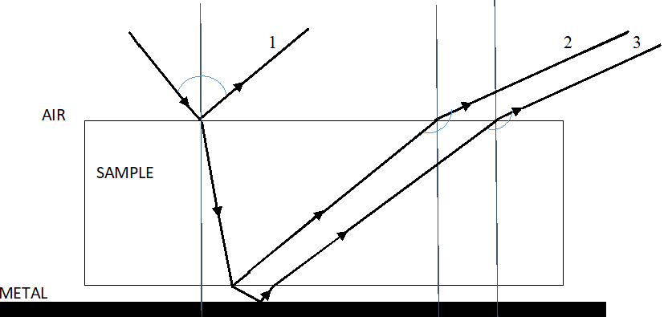

Fig. 1.0. THz spectroscopy reflection geometry (the incoming THz pulse is firstly reflected at the air-sample interface, giving rise to pulse 1 which was utilized by [4] to construct the subsurface image of oil shales. Pulse 2 which corresponds to the refracted pulse at the sample-air was used in our work. While pulse 3 is the reflected pulse from the metallic surface due to void space in-between the sample and metal surface

# RESULTS

The absorption map of four selected oil shale samples are shown for the purpose of a qualitative observation of the trend in kerogen abundance between the aquatic and terrestrially sourced oil shales. The THz pulse are absorbed strongly in the dark red regions, and mostly reflected at the bluish region.

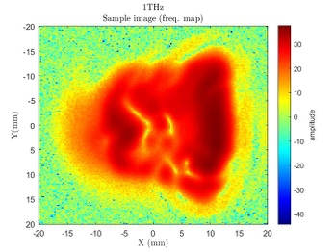

Fig. 2.0. Stream bank oil shale located between 0-2m above the stream.

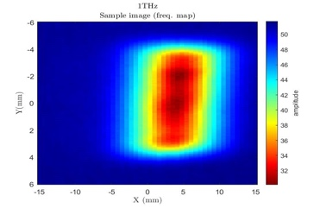

Fig. 2.1. Stream bank oil shale located at 5m above the stream.

The comparison between Fig. 2.0 and Fig. 3.0 indicates that oil shales at the base of the stream are richer in kerogen compared to shales farther from the stream beds. The kerogen pattern of distribution follows a reverse trend among terrestrially sourced oil shale, as we observed from Fig. 3.0 and Fig. 4.0 that oil shale richer in kerogen are located at higher elevation from the foot of the hill. The light bluish region are probably occupied by minerals.

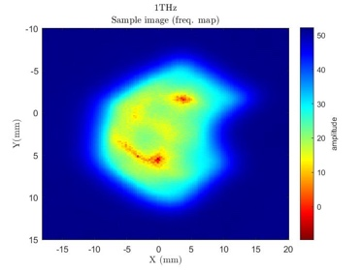

Fig. 3.0. Hilly terrain oil shale located 2m above the foot of the hill.





Fig. 4.1terahertz spectrum extracted

For example, Fig 4.1 shows the room-temperature terahertz spectrum with a baseline correction applied. It was recorded with a TeraView Lx time-domain spectrometer using the sample presented figure 2.0 The three different locations were chosen and the index refractions are found without significant dispersion. The thickness is about 1.85mm.

# Summary

We used a combination of numerical simulations to find parameters that best describe reflections and transmission from a given location in different samples. The reflected terahertz time domain waveform is simulated using Fresnel's equations. Absorption and optical index images will be presented and analyzed to put in evidence the presence and the concentration of organic material within the samples.

# REFERENCES

1. K. Alstadt, D. Katti, K. Katti. An in situ FTIR step-scan photoacoustic investigation of kerogen and minerals in oil shale. *Spectrochimica Acta Part A* 89, 105– 113, 2012.

2. Y. Li, X. Miao, H.Zhan, W. Wang, R. Bao, W. Leng, K. Zhao. Evaluating oil potential in shale formations using Terahertz time domain spectroscopy. *Journal of Energy Resources Technology*, 140(3), 034501, 2018.

3. H. Zhan, M. Chen, Y. Zhang, R. Chen, K. Zhao, W. Yue. Utilization of oil shale as an electromagnetic wave absorbing material in the terahertz range*. IEEE Access*, 8, 46795-46801, 2020.

4. X. Miao, M. Chen, Y. Li, H. Zhan, K. Zhao, W. Yue. Simultaneous determination of organic distribution and content in oil shale by terahertz imaging. Energy and Fuels 34(2), 1664-1668, 2020.