Reliability of FeRAM test vehicles under simultaneous
electrical and irradiative stresses

G. Andreoli¹, L. Courtade¹, Ch. Muller¹, L. Goux², Ch. Turquat¹,
Ph. Ferrandis¹ and D.J. Wouters²

¹ L2MP, Laboratory of Materials and Microelectronics of Provence, UMR CNRS 6137
University of South Toulon Var, BP 20132, F-83957 La Garde Cedex, France
² IMEC, Interuniversity MicroElectronic Center, Kapeldreef 75, B-3001 Leuven, Belgium
e-mail: christophe.muller@l2mp.fr

Space applications require memory technologies combining non-volatility, low power consumption, high operational speed and high read/write cycling endurance. Before using these technologies in a hostile environment, their radiation hardness under severe conditions should be carefully analyzed. If FeRAM memories are envisaged for space applications, it is obviously necessary to characterize and understand their electrical behavior under high energy penetrating radiations (such as x-rays or γ-rays).
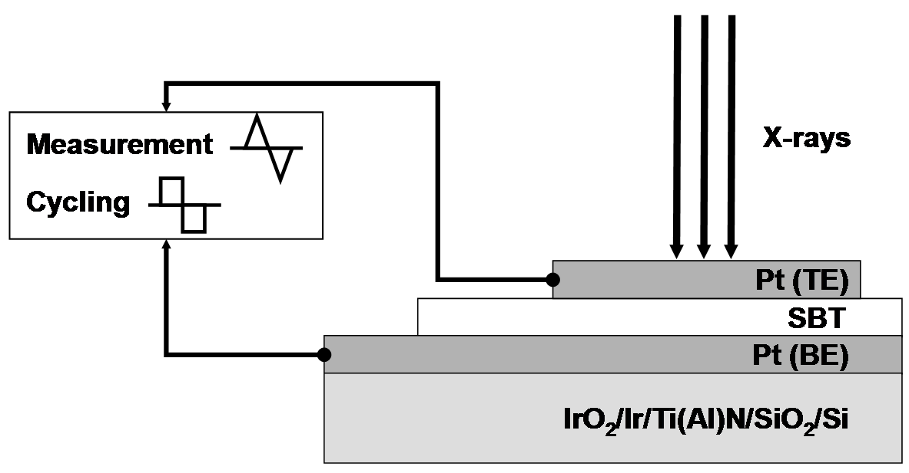
The basic read/write mechanisms in FeRAM memories are directly related to a nucleation/growth process of ferroelectric domains within the capacitor used as storage element. These mechanisms are conditioned by the domain wall mobility which may be strongly perturbed by irradiations. It is commonly admitted that irradiation by x-rays or γ-rays enhances the role of defects in altering the electrical properties. In ferroelectric materials, irradiation produces electron-hole pairs which undergo the influence of the internal field in the different domains. Even in the absence of applied external field, a strong local field exists that ensures a violent separation of photo-generated charge carriers. These charges are subsequently trapped at lattice point defects, stoichiometric defects, impurities or at the grain boundaries.¹ Furthermore, the free electronic charges may also be attracted to domain wall regions where there is a discontinuity in polarization. If the charges become trapped at these positions, the movement of the walls is restricted.
Considering the strong interactions between domain configuration, trapping of photo-generated charges and external electrical field, a sample environment was specially designed to measure in situ the ferroelectric properties of FeRAM test vehicles. The kinetic of degradation of switchable polarization under x-rays has been analyzed in correlation with the electrical stresses (bias voltage, unipolar or bipolar pulses) applied during irradiation. This original approach enables to apprehend the impact of x-rays on various FeRAM test vehicles integrating either standard planar or 3-dimensional ferroelectric capacitors.²

¹ N. Menou, A-M. Castagnos, Ch. Muller, D. Goguenheim, L. Goux, D.J. Wouters, J-L. Hodeau, and R. Barrett, J. Appl. Phys. 97(4), 044106 (2005).
² L. Goux, G. Russo, N. Menou, J.G. Lisoni, M. Schwitters, V. Paraschiv, D. Maes, C. Artoni, G. Corallo, L. Haspeslagh, D.J. Wouters, R. Zambrano, and Ch. Muller, IEEE Transactions on Electron Devices 52(4), 447 (2005).

