Reply on “Mercury Isotope Fractionation by Internal Demethylation and Biomineralization Reactions in Seabirds: Implications for Environmental Mercury Science”: Principles and limitations of source tracing and process tracing with stable isotope signatures

Alain Manceau,^{1,*} Romain Brossier,¹ Sarah E. Janssen,² and Brett A. Poulin^{3,*}

¹Université Grenoble Alpes, ISTerre, CNRS, 38000 Grenoble, France
²U.S. Geological Survey, Upper Midwest Water Science Center, Middleton, WI 53562, USA
³Department of Environmental Toxicology, University of California Davis, Davis, CA 95616,
USA

* Corresponding authors. alain.manceau@univ-grenoble-alpes.fr; bapoulin@ucdavis.edu

In Manceau et al. (2021),¹ we measured the mass-dependent fractionation (MDF) of mercury (Hg) stable isotopes, noted as δ²⁰²Hg, in 22 biological tissues from eight giant petrels (Macronectes spp.) previously characterized for Hg speciation using state-of-the-art X-ray absorption spectroscopy and transmission electron microscopy.² The tissues contained three dominant Hg species (Sp_{i}), a methylmercury cysteinate (MeHgCys) complex, a Hg-tetraselenolate (Hg(Sec)₄) complex, and mercury selenide (HgSe) grains, and their fractions (f(MeHgCys), f(Hg(Sec)₄), and f(HgSe)) in each tissue were known. The δ²⁰²Hg value of each tissue (δ²⁰²Hg_{t}) is a weighted sum of the δ²⁰²Hg of each Hg species expressed as follows:

(1)
in which δ²⁰²Sp_{i} are species- and tissue-specific δ²⁰²Hg values.
If each Hg species occurs in every tissue with a tissue-specific δ²⁰²Sp_{i,t} value, the system of 22 linear equations has 66 unknowns. Such a linear system is underdetermined and has infinitely many solutions. However, using an inversion algorithm, we found that the degree of freedom of the petrel system could be reduced from 44 (some of the tissues had only one or two species) to 3 with identical species-specific δ²⁰²Sp_{i} signatures between different tissues of the same bird and across the eight individuals. The δ²⁰²Hg_{t} values of the 22 tissues were described as a weighted sum of three species-specific δ²⁰²Sp_{i} values:
(2)
using δ²⁰²MeHgCys = 2.69 ± 0.04‰, δ²⁰²Hg(Sec)₄ = −1.37 ± 0.06‰, and δ²⁰²HgSe = 0.18 ± 0.02‰. Further, δ²⁰²Hg of MeHg (δ²⁰²MeHg) values were measured directly on a subset of 9 tissues using an established distillation and anion-exchange chromatography method.³ The majority of the MeHg-specific isotope measurements were in agreement with the calculated values (within the analytical uncertainty of 0.16‰). However, one feather had δ²⁰²MeHg = 3.05‰ which was attributed to differences in dietary sources or feeding ranges that were integrated over time in the bird.¹ Also, one muscle had a δ²⁰²MeHg = 0.90‰ that was anomalous and is discussed in detail below. While there may be limitations to MeHg-specific isotope measurements, all data were presented and discussed in Manceau et al. (2021)¹ for transparency. Wiederhold and Jiskra⁴ comment on the validity of the data analysis approach and contend that the anomalous δ²⁰²MeHg outlier values can be explained using a closed-system Rayleigh fractionation model. We challenge these critiques below and detail a conceptual diagram that is appropriate for isotope analyses and interpretations for organisms with continuous dietary inputs, internal transformations of Hg, and depuration.
First, Wiederhold and Jiskra⁴ comment that the petrel linear isotope system is mathematically underdetermined. Actually, the regression analysis was statistically robust and the 22 δ²⁰²Hg_{t} values were recalculated within experimental uncertainty from the reduced linear system (Eq. 2). The observed linearity in the isotope system in the petrels is consistent with observed two-component isotope systems that documented MeHg demethylation to inorganic Hg in waterbirds⁵ and the brain of whales.⁶ Further, similar isotopic results were obtained in a companion article on long-finned pilot whales.⁷ In this companion study, the δ²⁰²Hg_{t} values of 89 tissues (excluding blood) from 28 individuals reported in the independent studies of Bolea-Fernandez et al. (2019)⁸ and Li et al. (2020)⁶ were analyzed by mathematical inversion. It was also found that three δ²⁰²Sp_{i} values were sufficient to describe the species-averaged δ²⁰²Hg_{t} values between tissues of the same individual and across individuals sampled at different geographical locations and times. The highly consistent observations between the giant petrels and long-finned pilot whales indicate that the isotopic fractionation due to in vivo demethylation and biomineralization reactions occurs in diverse vertebrates, isotopic signatures of the chemical Hg species are homogenized within individuals, and localized isotope effects due to these reactions in tissues are not apparent.
Second, Wiederhold and Jiskra⁴ point out the discrepancy between the calculated (2.69 ± 0.04‰) and two measured δ²⁰²MeHg values (3.05‰, 0.90‰). This was the first study to compare mathematical estimates of Hg isotope end-members based on Hg speciation from X-ray absorption spectroscopy with direct measurements of MeHg-specific isotope values. Given the complexities of each technique, perfect agreement between measured and calculated values was not expected. Giant petrels are wild animals that live across expansive ranges and have diverse prey items, and yet the measured δ²⁰²MeHg isotope values were overall well constrained.¹ We agree with Wiederhold and Jiskra⁴ that the measured δ²⁰²MeHg value of 0.90‰ is puzzling, but it is anomalous compared to the other measurements. Determining if this data point is truly an analytical anomaly is difficult, but the feather tissue from the same petrel containing 100% MeHgCys had a δ²⁰²MeHg value consistent with the mathematical estimate. Importantly, the muscle tissue with the anomalous δ²⁰²MeHg value of 0.90‰ had 40±8% Hg(Sec)₄ and 60±8% HgSe, and the MeHgCys species was below the spectroscopic detection limit (<3%). Therefore, this tissue did not contribute to the calculation of δ²⁰²MeHgCys, as was detailed in the study.
Third, Wiederhold and Jiskra⁴ propose that a Rayleigh fractionation model can explain the anomalous δ²⁰²MeHg values quantified in the petrel tissues. Unfortunately, there are oversights with the proposed use of a Rayleigh fractionation model by Wiederhold and Jiskra⁴ and they egregiously misrepresented the data in Manceau et al. (2021).¹ The Rayleigh fractionation model assumes a closed system, where a finite reservoir of reactant (in this case MeHg) becomes enriched in heavier isotopes as lighter isotopes are demethylated to the product pool. In the birds, however, a constant influx of dietary MeHg replenishes the reactant pool, MeHg undergoes stepwise demethylation and biomineralization reactions, HgSe is accumulated,² both MeHg and Hg(Sec)₄ are excreted in waste, and MeHg is depurated in feathers. Figure 1 presents a schematic representation of the birds, modified from Hayes (2002),⁹ which serves as a model to guide isotope interpretations and applies to other vertebrates (e.g., marine mammals). The continuous input of MeHg and loss terms of MeHg and Hg(Sec)₄ in the birds, as well as internal exchange between tissues via the circulatory system, likely explain the consistency in species-specific measurements of the MeHg isotope pool across different petrels; these processes are not accounted for in the Rayleigh fractionation model. If the finding of a steady-state isotopic fractionation of MeHgCys → Hg(Sec)₄ demethylation and Hg(Sec)₄ → HgSe biomineralization reactions in birds¹ and whales⁷ is novel, its hypothesis is not. Bolea-Fernandez et al. (2019)⁸ observed that δ²⁰²Hg was uniform in the blood of 7 juvenile and 7 adult whales due to the homogenization of the isotopic composition of MeHg throughout the body. This interpretation is reinforced by a previous study showing a rapid shift in Hg isotope values of fish tissues to values of dietary MeHg replenishment.¹⁰
We assess the validity of a Rayleigh fractionation model in Figure 2a, which presents the measured δ²⁰²MeHg values versus the fraction of MeHg in tissues (f_{MeHg}) of the petrels from Manceau et al. (2021)¹ against the theoretical Rayleigh fractionation model from Wiederhold and Jiskra.⁴ The measured δ²⁰²MeHg values are relatively invariant across a wide range of f_{MeHg} (aside from the outlier of 0.90‰), and δ²⁰²MeHg values at low f_{MeHg} never exceeded δ²⁰²MeHg at high f_{MeHg} (counter to the Rayleigh fractionation model). These observations in petrels are consistent with the measurement of δ²⁰²MeHg values of other bird⁵ and seal tissues¹¹ with varying degrees of demethylation (i.e., f_{MeHg}), as shown in Figure 2b. The observed invariance in measured δ²⁰²MeHg data across multiple organisms and studies is inconsistent with the use of a Rayleigh fractionation model in this system, seen by comparing the Wiederhold and Jiskra model (red line and data)⁴ to the measurement of the petrels (Figure 2a).
Given the lack of transparency in the analysis provided by Wiederhold and Jiskra,⁴ we can only surmise the source of the data points they present in their Figure 1b that reside precisely on the theoretical Rayleigh fractionation line. As such, Wiederhold and Jiskra⁴ first used the anomalous δ²⁰²MeHg value of 0.90‰ as the starting pool (red diamond in Figure 2a) and assigned a f_{MeHg} = 1.0 despite the measured value of f_{MeHg} ≤ 0.03. Next, from the “starting pool,” the theoretical Rayleigh fractionation was modeled (shown as a solid line in Figure 2a), and the other data points presented were assigned fictious f_{MeHg} values (red circles in Figure 2a). Simply, the measured paired δ²⁰²MeHg and f_{MeHg} values from Manceau et al. (2021)¹ are not presented in Figure 1b of Wiederhold and Jiskra.⁴ Further, the range of δ²⁰²MeHg values presented by Wiederhold and Jiskra⁴ were as high as ~4.0‰, exceeding those reported in Manceau et al. (2021),¹ and the source of the isotope enrichment factor used in their model simulation is incorrectly cited. While it is important to consider the potential of Rayleigh fractionation in environmental matrices, this model does not explain the outliers in the dataset and the consistency of δ²⁰²MeHg across multiple tissues. In summary, the premise that bulk δ²⁰²Hg signatures of giant petrel tissues can be described as weighted sums of three species-specific δ²⁰²MeHgCys, δ²⁰²Hg(Sec)₄, and δ²⁰²HgSe values is fully validated using the direct measurements of δ²⁰²MeHg.¹
The holistic approach suggested by Wiederhold and Jiskra⁴ holds merit as it highlights current gaps in the literature associated with Hg stable isotope applications in birds and mammals. Specifically, further examination is warranted on the dietary variability of the MeHg pool in wildlife,¹² and the isotopic modeling of open systems (e.g., Figure 1) where multiple products are produced via steady-state reactions (e.g., demethylation and biomineralization) and select products are depurated (e.g., MeHg, Hg(Sec)₄) and others accumulated (e.g., HgSe). These gaps, however, do not directly address any of the points made in an attempt to dismiss the findings of our study. The mechanistic examination of internal demethylation and biomineralization pathways could be overlooked by simplifying these findings to a mass balance within the organism, emphasizing the need for continued isotope research that applies complementary analytical methods (X-ray absorption spectroscopy, species-specific mercury stable isotope, and protein-level screening)¹³ to advance mechanistic understanding and modeling. Furthermore, while the multi-dimensional nature of Hg isotopes (MDF and mass independent fractionation) is an important consideration in source tracking and assessing Hg isotope fractionation in vivo, as noted by Wiederhold and Jiskra,⁴ there was no evidence that individual petrels had dissimilar exposures to Hg processing effects (e.g., photochemical demethylation noted by Δ¹⁹⁹Hg) or differing atmospheric sources (noted by Δ²⁰⁰Hg).¹⁴ Although much remains to be known on the internal cycling of Hg within mammals and birds, the petrels presented a unique opportunity to examine an organism where internal demethylation and biomineralization reactions are responsible for as much as a 3.5‰ difference in tissue δ²⁰²Hg values. This work opens the door for new methods and techniques to examine internal processing of Hg in biota.

References
(1) Manceau, A.; Brossier, R.; Janssen, S. E.; Rosera, T. J.; Krabbenhoft, D. P.; Cherel, Y.; Bustamante, P.; Poulin, B. A. Mercury Isotope Fractionation by Internal Demethylation and Biomineralization Reactions in Seabirds: Implications for Environmental Mercury Science. Environ. Sci. Technol. 2021, 55, 13942–13952.
(2) Manceau, A.; Gaillot, A. C.; Glatzel, P.; Cherel, Y.; Bustamante, P. In Vivo Formation of HgSe Nanoparticles and Hg-Tetraselenolate Complex from Methylmercury in Seabird – Implications for the Hg-Se Antagonism. Environ. Sci. Technol. 2021, 55, 1515–1526.
(3) Rosera, T. J.; Janssen, S. E.; Tate, M. T.; Lepak, R. F.; Ogorek, J. M.; DeWild, J. F.; Babiarz, C. L.; Krabbenhoft, D. P.; Hurley, J. P. Isolation of Methylmercury Using Distillation and Anion-Exchange Chromatography for Isotopic Analyses in Natural Matrices. Anal. Bioanal. Chem. 2020, 412, 681–690.
(4) Wiederhold, J.; Martin, J. Comment on “Mercury Isotope Fractionation by Internal Demethylation and Biomineralization Reactions in Seabirds: Implications for Environmental Mercury Science”: Principles and Limitations of Source Tracing and Process Tracing with Stable Isotope Signatures. Environ. Sci. Technol. 2022, accepted.
(5) Poulin, B. A.; Janssen, S. E.; Rosera, T. J.; Krabbenhoft, D. P.; Eagles-Smith, C. A.; Ackerman, J. T.; Stewart, A. R.; Kim, E.; Baumann, Z.; Kim, J. H.; Manceau, A. Isotope Fractionation from in Vivo Methylmercury Detoxification in Waterbirds. ACS Earth Space Chem. 2021, 5, 990–997.
(6) Li, M. L.; Juang, C. A.; Ewald, J. D.; Yin, R. S.; Mikkelsen, B.; Krabbenhoft, D. P.; Balcom, P. H.; Dassuncao, C.; Sunderland, E. M. Selenium and Stable Mercury Isotopes Provide New Insights into Mercury Toxicokinetics in Pilot Whales. Sci. Tot. Environ. 2020, 710, n° 136325.
(7) Manceau, A.; Brossier, R.; Poulin, B. A. Chemical Forms of Mercury in Pilot Whales Determined from Species-Averaged Mercury Isotope Signatures. ACS Earth Space Chem. 2021, 5, 1591–1599.
(8) Bolea-Fernandez, E.; Rua-Ibarz, A.; Krupp, E. M.; Feldmann, J.; Kvanhaecke, F. High-Precision Isotopic Analysis Sheds New Light on Mercury Metabolism in Long-Finned Pilot Whales (Globicephala Melas). Sci. Rep. 2019, 9, n° 7262.
(9) Hayes, J. Practice and Principles of Isotopic Measurements in Organic Geochemistry (Revision 2); Woods Hole Oceanographic Institution, Woods Hole, Mass., 2002; pp 1–25.
(10) Kwon, S. Y.; Blum, J. D.; Chirby, M. A.; Chesney, E. J. Application of Mercury Isotopes for Tracing Trophic Transfer and Internal Distribution of Mercury in Marine Fish Feeding Experiments. Environ. Toxicol. Chem. 2013, 32, 2322–2330.
(11) Perrot, V.; Masbou, J.; Pastukhov, M. V.; Epov, V. N.; Point, D.; Berail, S.; Becker, P. R.; Sonke, J. E.; Amouroux, D. Natural Hg Isotopic Composition of Different Hg Compounds in Mammal Tissues as a Proxy for in Vivo Breakdown of Toxic Methylmercury. Metallomics 2016, 8, 170–178.
(12) Le Croizier, G.; Sonke, J. E.; Lorrain, A.; Renedo, M.; Hoyos-Padilla, M.; Santana-Morales, O.; Meyer, L.; Huveneers, C.; Butcher, P.; Amezcua-Martinez, F.; Point, D. Foraging Plasticity Diversifies Mercury Exposure Sources and Bioaccumulation Patterns in the World’s Largest Predatory Fish. J. Hazard. Mater. 2022, 425, n° 127956.
(13) Manceau, A.; Bourdineaud, J. P.; Oliveira, R. B.; Sarrazin, S. L. F.; Krabbenhoft, D. P.; Eagles-Smith, C. A.; Ackerman, J. T.; Stewart, A. R.; Ward-Deitrich, C.; Busto, M. E. D.; Goenaga-Infante, H.; Wack, A.; Retegan, M.; Detlefs, B.; Glatzel, P.; Bustamante, P.; Nagy, K. L.; Poulin, B. A. Demethylation of Methylmercury in Bird, Fish, and Earthworm. Environ. Sci. Technol. 2021, 55, 1527–1534.
(14) Tsui, M. T. K.; Blum, J. D.; Kwon, S. Y. Review of Stable Mercury Isotopes in Ecology and Biogeochemistry. Sci. Tot. Environ. 2020, 716, n° 135386.

Disclaimer: Any use of trade, firm, or product names is for descriptive purposes only and does not imply endorsement by the U.S. Government.

Figure caption

Figure 1. Schematic representation of an open isotope system with a continuous input of MeHg (“reactant”) to the bird, the bird being a “reaction chamber” where isotopic fractionation occurs due to stepwise demethylation and biomineralization reactions. HgSe accumulates in the bird (“accumulated product”), and MeHg and Hg(Sec)₄ are excreted in waste and/or depurated (product streams). Modified from Hayes (2002).⁹

Figure 2. (a) Direct comparison of the measured δ²⁰²MeHg versus the fraction of MeHg (f_{MeHg}) from Manceau et al. (2021)¹ for giant petrel tissues and the theoretical Rayleigh fractionation model presented by Wiederhold and Jiskra⁴ (red line and data points, extracted using OriginLab (Version 2121b, OriginLab Corporation, Northampton, MA, USA). The source of the x and y data points from Wiederhold and Jiskra⁴ is unknown. (b) Comparison of the measured δ²⁰²MeHg versus f_{MeHg} for Clark’s grebe (Aechmophorus clarkia) and Forster’s tern (Sterna forsteri) tissues from Poulin et al. (2021)⁵ and seal tissues from Perrot et al. (2016).¹¹ Measured data in plots a and b demonstrate that δ²⁰²MeHg is largely invariant across a wide range of f_{MeHg} and is inconsistent with a Rayleigh fractionation model. For tissues from Manceau et al. (2021),¹ f_{MeHg} = 0.03 was used for samples at the spectroscopic detection limit for MeHgCys.

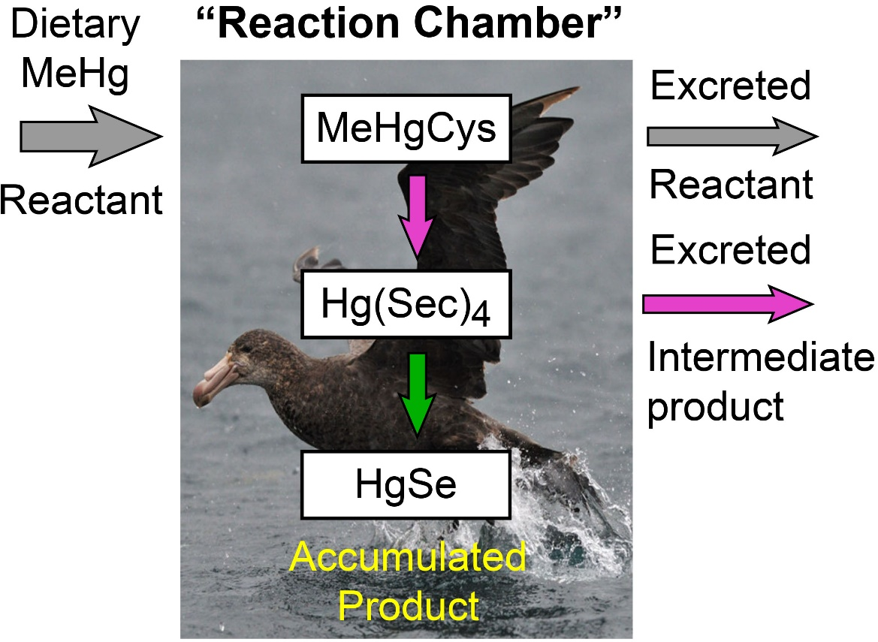

Figure 1

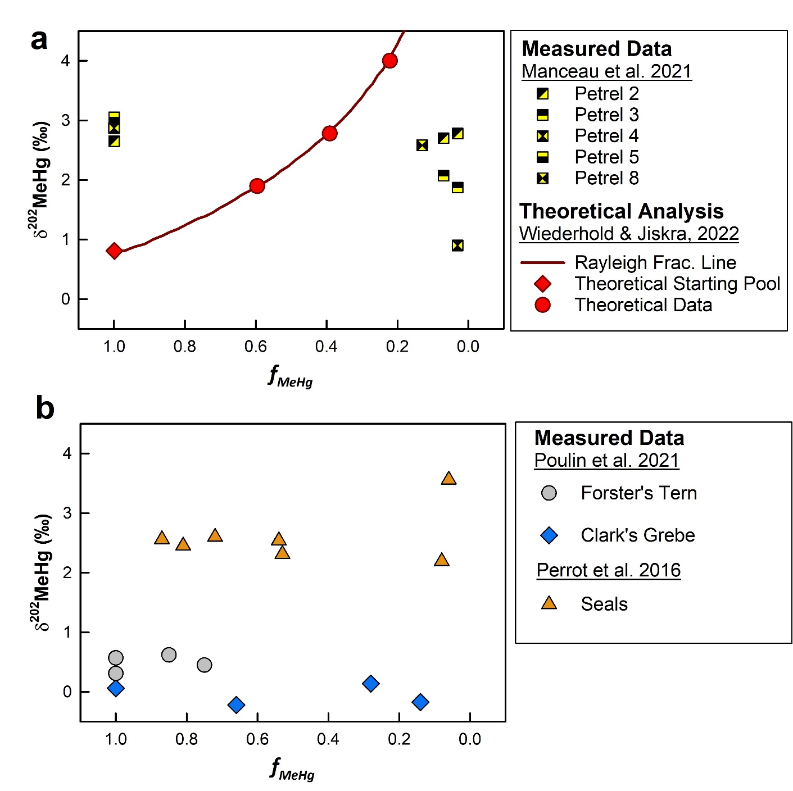
Figure 2

