Supporting Information

Sr- and Fe-substituted LaMnO₃ Perovskite: Fundamental Insight and Possible Use in Asymmetric Hybrid Supercapacitor
P. Muhammed Shafi,ª Debananda Mohapatra,ª V. Pradeep Reddy,^{b} Ganesh Dhakal,ª Deivasigamani Ranjith Kumar,ª Dirk Tuma,^{c} Thierry Brousse,^{d,e,*} Jae-Jin Shim^{a,*}

ª School of Chemical Engineering, Yeungnam University, Gyeongsan, Gyeongbuk 38541, Republic of Korea
^{b} Department of Physics, Vel Tech Rangarajan Dr. Sagunthala R&D Institute of Science and Technology, Chennai 600062, India
^{c} BAM Federal Institute for Materials Research and Testing, 12200 Berlin, Germany
^{d} Université de Nantes, CNRS, Institut des Matériaux Jean Rouxel, IMN, F-44000 Nantes, France
^{e} Réseau sur le Stockage Electrochimique de l’Energie (RS2E), CNRS FR 3459, 33 rue Saint Leu, 80039 Amiens Cedex, France

S1. Chemical composition and oxidation-state measurements
S1.1 XPS analysis
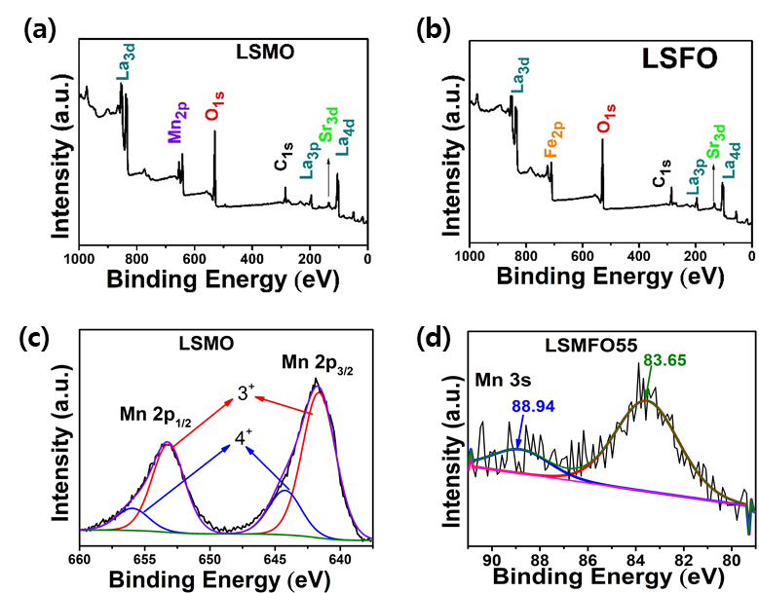
Figure S1. XPS survey spectrum of (a) LSMO and (b) LSFO; (c) XPS Mn 2p_{3/2} spectrum of LSMO and (d) multiplet splitting of Mn 3s corresponding to LSMFO55 sample.

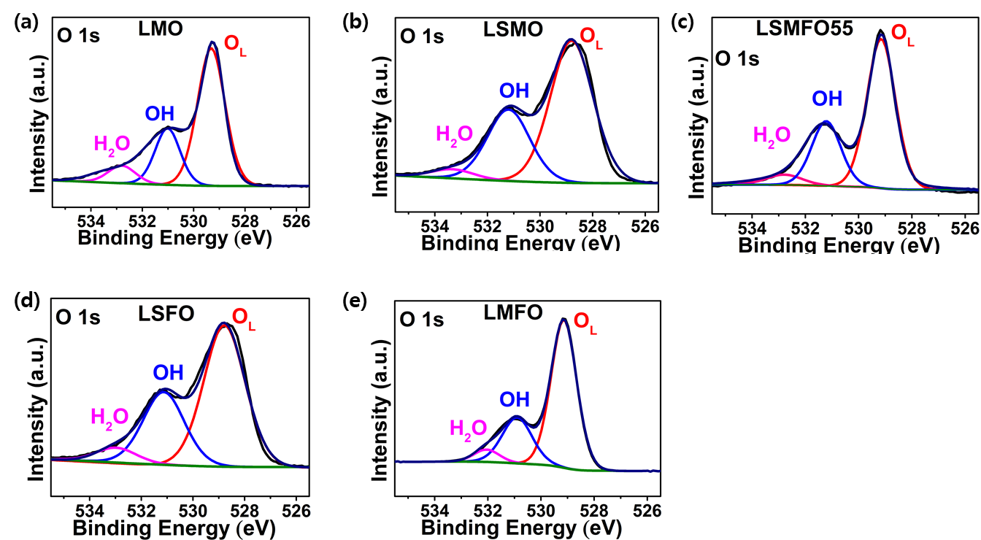
Figure S2. O 1s spectrum corresponding to LMO, LSMO, LSMFO55, LSFO, and LMFO.

S1.2 ICP elemental composition measurements

Table S1. Elemental composition of the prepared samples determined by ICP
Sample | Atomic%
 | La | Sr | Mn | Fe
LSMO | 34.24 | 16.43 | 49.32 | 0
LSMF91 | 35.02 | 15.12 | 43.01 | 6.84
LSMF73 | 36.93 | 14.14 | 31.57 | 17.34
LSMF55 | 34.11 | 14.40 | 26.48 | 24.99
LSMF37 | 33.06 | 13.03 | 15.14 | 38.75
LSMF19 | 32.76 | 13.85 | 5.49 | 47.89
LSFO | 35.52 | 14.20 | 0 | 50.27
LMF55 | 48.07 | 0 | 25.92 | 26.00

S2. Fabrication and pretreatment of working electrodes
The working electrodes were prepared by coating active materials on the compressed Ni foam after removing the NiOs on the surface to avoid the capacity contribution. The detailed pretreatment process is explained below.
- Strips (1 cm x 2 cm) of Ni foam was cleaned well by chemical etching with 3 M HCl with sonication for 1 h and washed several times with ethanol and double distilled water to remove the oxides/hydroxides present at the surface. Subsequently, the Ni foam was kept inside the vacuum oven at room temperature until it was completely dry.
- These cleaned strips (1.65 mm thickness) was compressed to a very thin foil (85 μm thickness) before coating with the active material.
- The slurry of active materials, carbon black, and PVDF which was prepared in Experimental 2.3 was coated the pretreated Ni-foam by doctor blade method to make a uniform coating. The coating was thick enough to cover the active area (a total area of 1 cm²) so that the bare Ni foil was not exposed to the electrolyte. The mass loading of the active material was 2 to 2.5 mg cm⁻².
- The bare Ni-foam, compressed Ni-foam, and active material-coated compressed Ni-foam electrodes were characterized electrochemically to ensure that the capacitive contribution from the bare Ni-foil had been successfully eliminated. Figure S3 shows the comparative performances of the bare Ni foam, bare compressed Ni-foam and sample-loaded compressed Ni-foam electrode. The CV diagram and GCD plot show that the contribution from compressed Ni-foam was negligible (< 7%).

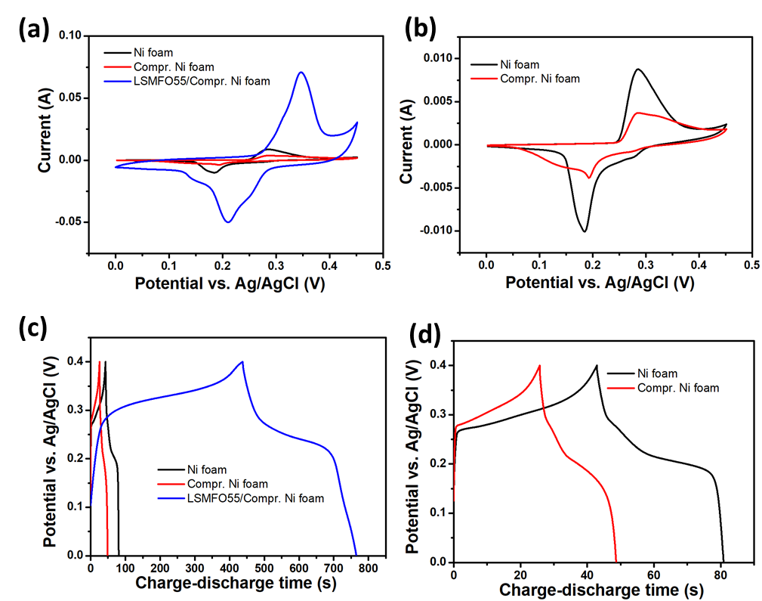
Figure S3. Comparative electrochemical performance of bare Ni foam electrode, bare compressed Ni-foam electrode, and LSMFO55 coated compressed Ni-foam: (a) and (b) represent the CV diagrams recorded at 10 mV S⁻¹, whereas (c) and (d) represent the GCDs recorded at 2 mA.

S3. Calculation of theoretical capacity

Theoretical capacities (in C/g) of all electrode materials were calculated using the following formula:

$Q_{th}= \frac{96,485 × n}{MW}$ (S1)

where 96,485 is the Faraday constant, n is the number of electrons participating in the redox reaction for one perovskite molecule, and MW is the molar mass of the electrode material.

S4. DC ionic conductivity and electrical conductivity

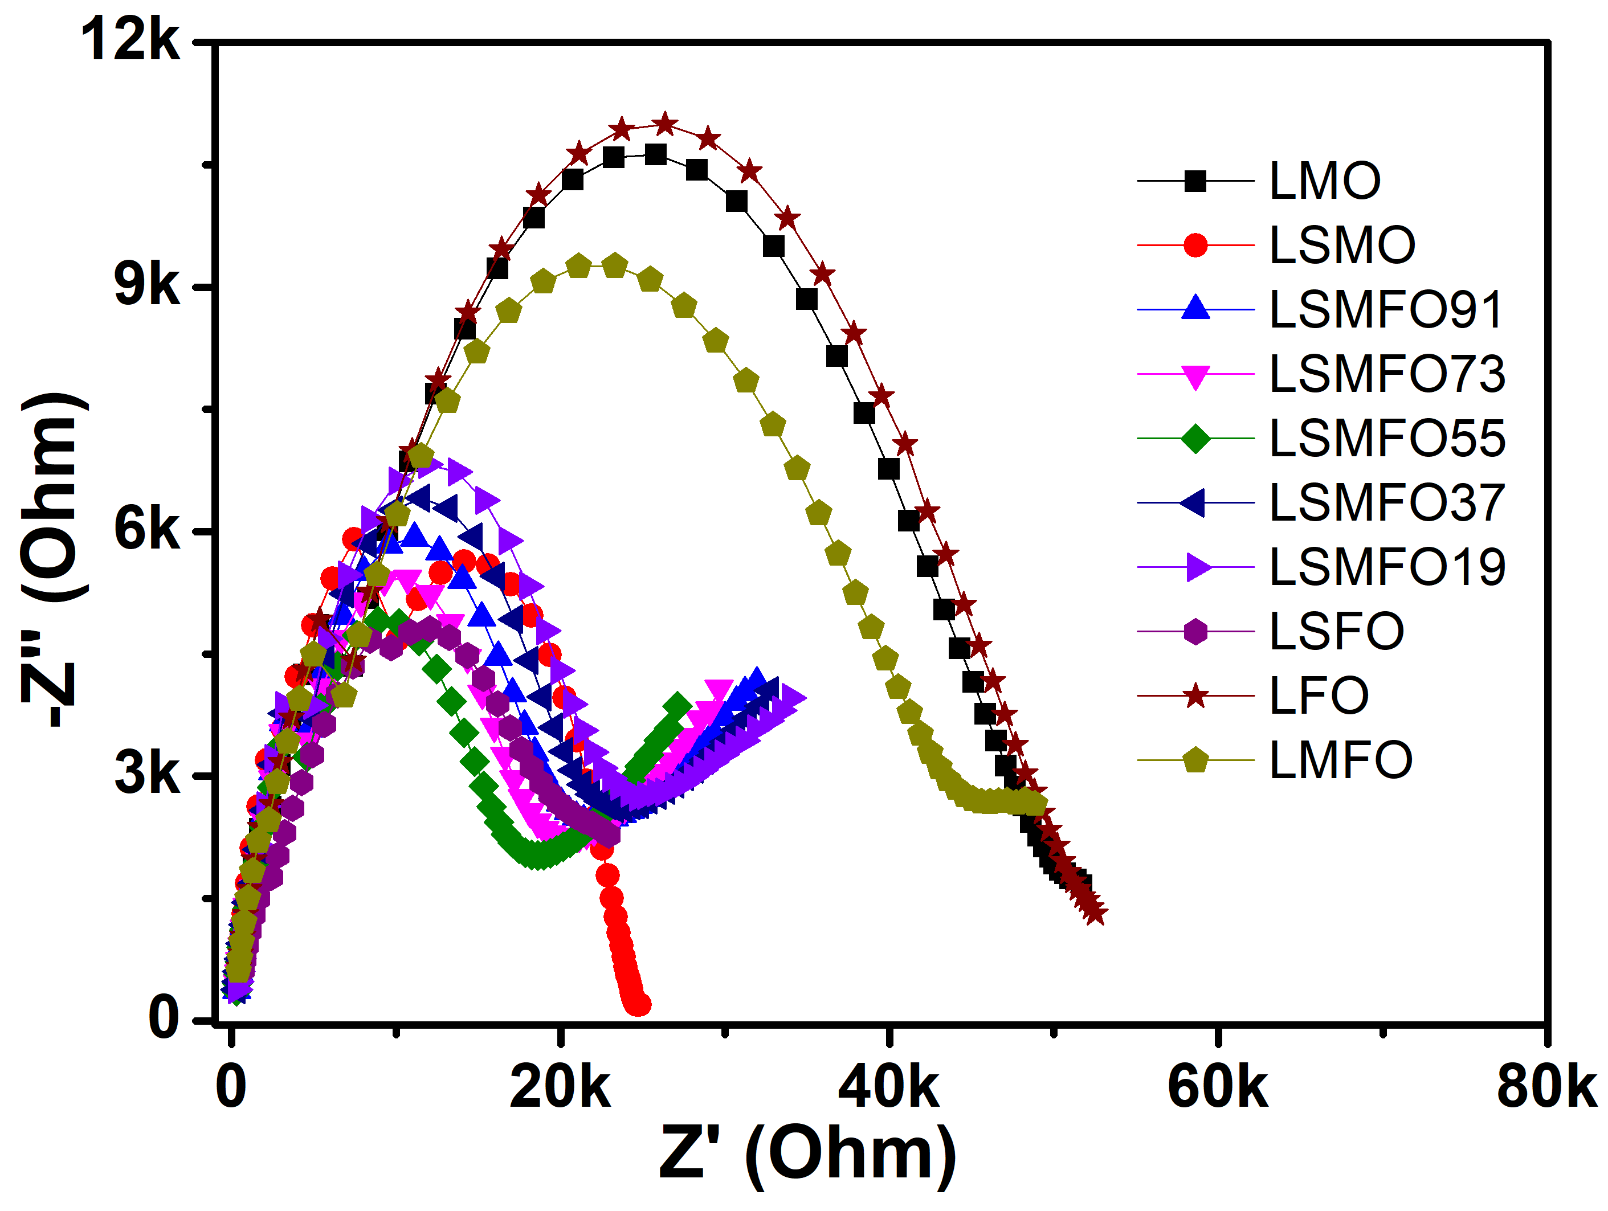

Figure S4. Nyquist plots for the perovskite electrode materials used in this study.

Table S2. Electrical conductivity and DC ionic conductivity for the electrode materials
Sample | Electrical conductivity by a 4-point probe meter  (S cm⁻¹) | DC ionic conductivity obtained from EIS (10 mm pellets)
 |  | Thickness (mm) | R  (kΩ) | σ_{DC}  (10⁻⁴ S cm⁻¹)
LMO | 3.45 | 0.46 | 50.3 | 1.16
LSMO | 5.34 | 0.41 | 24.4 | 2.14
LSMFO91 | 6.45 | 0.425 | 20.9 | 2.59
LSMFO73 | 6.57 | 0.43 | 19.5 | 2.81
LSMFO55 | 8.92 | 0.415 | 17 | 3.11
LSMFO37 | 6.72 | 0.51 | 23.4 | 2.78
LSMFO19 | 6.06 | 0.475 | 24.1 | 2.51
LSFO | 5.81 | 0.395 | 20.2 | 2.49
LFO | 5.25 | 0.41 | 52.5 | 0.995
LMFO | 4.56 | 0.41 | 44.6 | 1.17

S5. Surface Area and Porosity

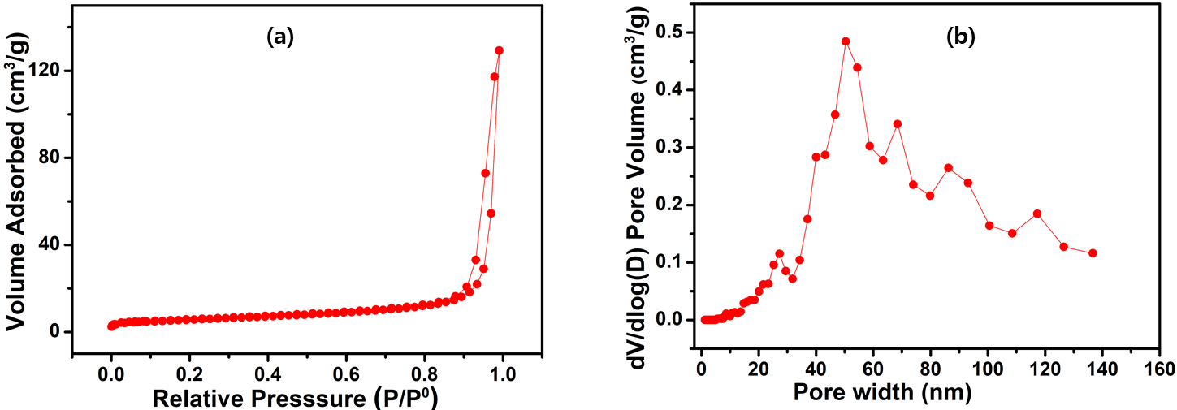

Figure S5: (a) N₂ adsorption/desorption isotherm and (b) pore distribution curve for the LSMFO55 sample.

S6. Electrochemical performances in three-electrode cell and two-electrode device configurations
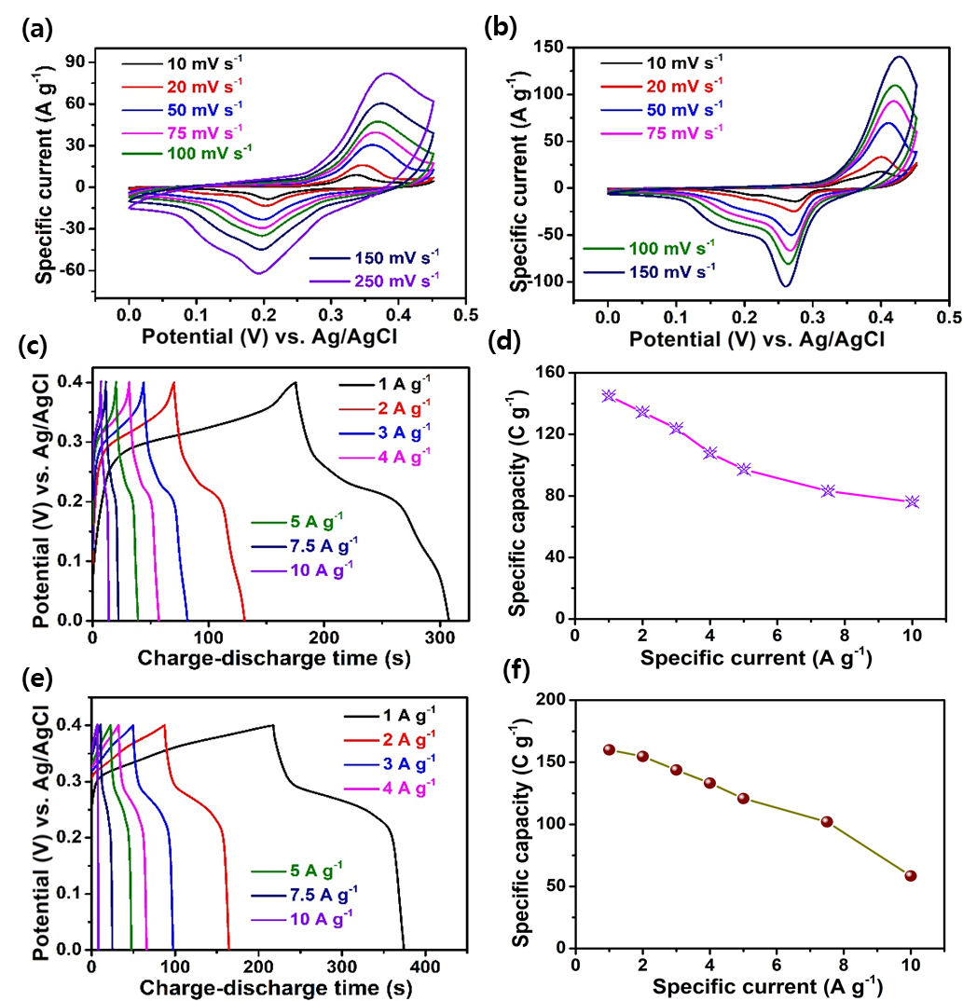

Figure S6: CV curves at different scan rates of (a) LSMO, (b) LSFO, (c) charge–discharge curves recorded at different current densities for LSMO, (d) capacity retention plot recorded at higher current densities corresponding to LSMO electrode, (e) charge–discharge curve of the LSFO electrode at various current densities, (f) capacity-retention plot recorded at higher current densities, which corresponds to the LSFO electrode.

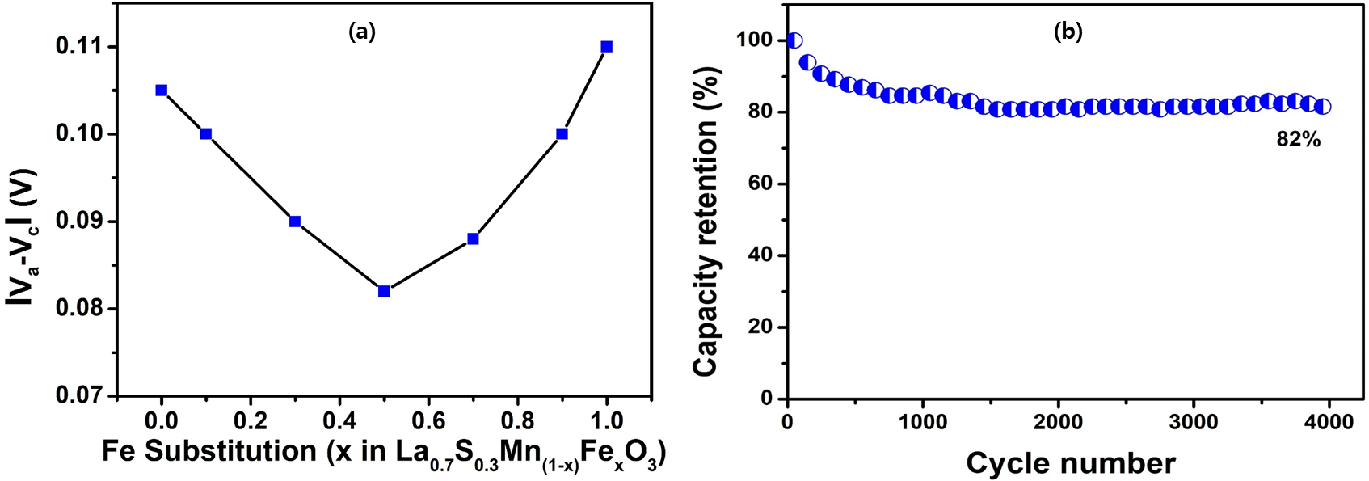

Figure S7. (a) polarization versus Fe content and (b) cycling stability of the LSMFO55 electrode at a specific current of 5 A g⁻¹ in a 3M KOH electrolyte using Ag/AgCl as the reference electrode and Pt as the counter electrode

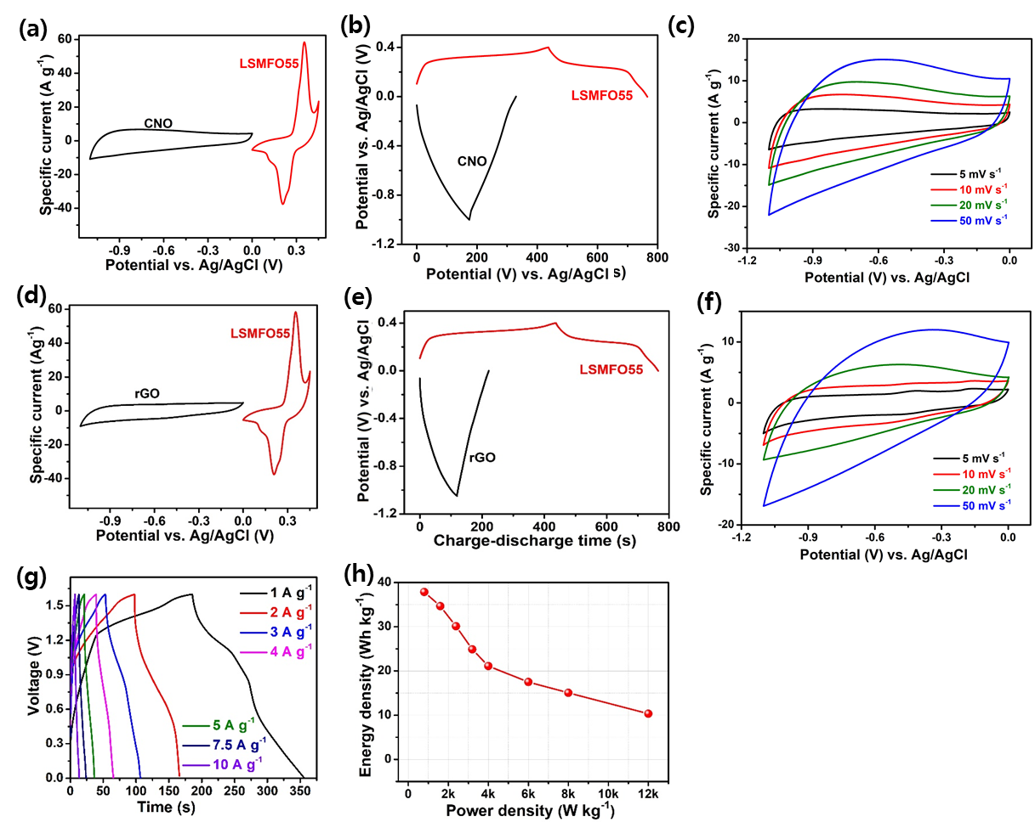

Figure S8. (a and b) CV at a scan rate of 10 mV/s and the charge-discharge curve of the LSMFO55 and CNO electrodes, respectively, in a three-electrode system, (c) CV of CNO at different scan rates in a three-electrode system, (d and e) CV at a scan rate of 10 mV/s and charge-discharge curve of the LSMFO55 and CNO electrodes, respectively, in a three-electrode system, (f) CV of rGO at different scan rates in a three-electrode system, (g) charge-discharge curve of LSMFO55//rGO AHS at different current densities, and (h) Ragone plot of the LSMFO55//rGO AHS device.
S7. Potential-dependent oxidation-state profile
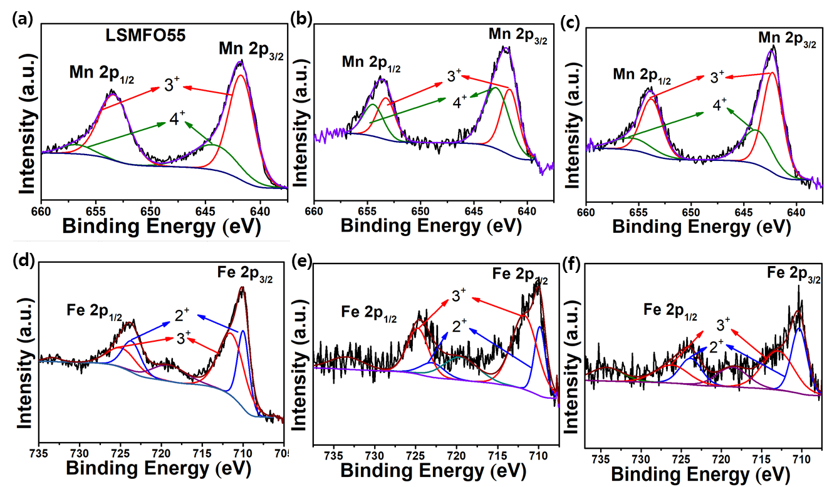

Figure S9: XPS spectrum of LSMFO55; Mn during the charge/discharge process to check the oxidation-state profiles; (a) normal state, (b) charged state, (c) discharged state, and (d) oxidation-state profile for Mn. Fe during the charge/discharge process to check oxidation-state profiles; (e) normal state, (f) charged state, (g) discharged state, and (h) oxidation-state profile for Fe.

S8. Cycling stability of the AHS device

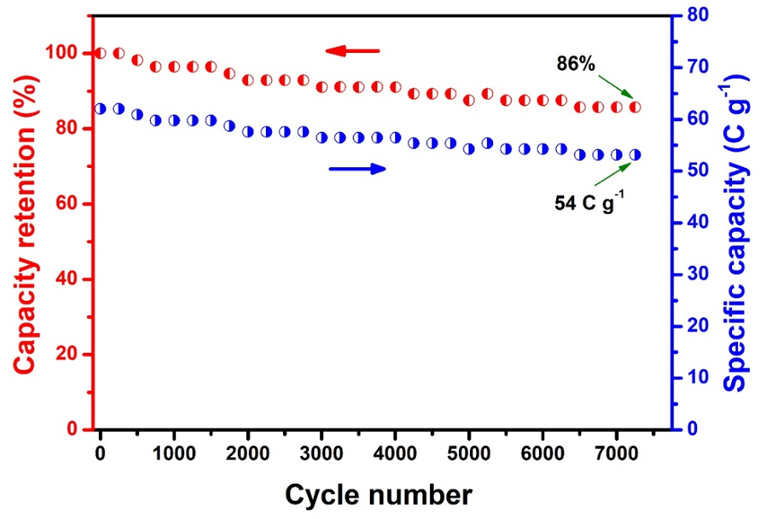

Figure S10. Cycling stability of LSMFO55//CNO AHS for 7500 continuous charge–discharge cycles.

REFERENCES
S1. J.T. Mefford, W.G. Hardin, S. Dai, K.P. Johnston, K.J. Stevenson, Nat. Mater. 2014, 13, 726.
S2. P.M. Shafi, N. Joseph, A. Thirumurugan, A.C. Bose, Chem. Eng. J. 2018, 338, 147

