Supplementary information

Pore-scale mechanisms for spectral induced polarization of calcite precipitation inferred from geo-electrical millifluidics
Satoshi Izumoto^{1,2*}, Johan Alexander Huisman¹, Egon Zimmermann³, Joris Heyman², Francesco Gomez², Herve Tabuteau⁴, Romain Laniel⁴, Harry Vereecken¹, Yves Méheust², and Tanguy Le Borgne²

¹ Agrosphere (IBG-3), Institute of Bio- and Geosciences, Forschungszentrum Jülich, 52425, Jülich, Germany
² Univ. Rennes, CNRS, Géosciences Rennes, UMR 6118, Rennes, 35042, France
³ Electronic Systems (ZEA-2), Central Institute for Engineering, Electronics and Analytics, Forschungszentrum Jülich, Jülich, 52425, Germany
⁴ Institute de Physique de Rennes, Université de Rennes 1, CNRS, Rennes, 35042, France
List of contents
The supporting information contains additional explanation for the experimental setup and results as listed below:
1. Supplementary materials and methods
1.1 Design of the sample holder (Figure S1)
1.2 2D porous media (Figure S2)
1.3 Calibration between the image grey level and the height of the precipitation (Figure S3)
1.4 Effect of heterogeneous solute concentration on SIP response
2. Supplementary results for image analysis and SIP response
2.1 Composite images of the precipitate wall (Figure S4, S5)
2.2 Microscopic image of the calcite precipitates (Figure S6)
2.3 Additional information on model for calcite wall development (Figure S7, S8)
2.4 Effect of capacitive coupling (Figure S9)
2.5 Real part of the electrical conductivity (Figure S10)
2.6 SIP response in duplicated experiment and check of streaming potential (Figure S11, S12)
2.7 SIP response of calcite precipitation in homogeneous solution (Figure S13, S14, S15)
3. Microscopic and macroscopic controls on SIP response
3.1 Electrical circuit model
3.2 Parameterization of three scenarios for electrical field simulations (Figure S16, S17, S18, S19)
3.3 Visualization of electrical potential field (Figure S20)
3.4 Heterogeneous chargeability in flow direction (Figure S21)
3.5 Understanding reproducibility of SIP response by mechanism (Figure S22)
3.6 Interpretation of the SIP response in homogeneous solution (Figure S23)
- Supplementary materials and methods
1.1 Design of the sample holder
The sample holder consists of three plates fixed together with screws (Figure S1). The bottom plate (height: 10 mm) is a flat plate. The middle plate (height: 11 mm) has a large rectangular cuboid cavity in the middle (length: 300 mm, width: 50 mm). This cavity is designed to hold one of the 2D porous media discussed in the next section. The top plate (height: 12 mm) covers the cavity holding the 2D porous media. In the top plate, one hole with a diameter of 1 mm is positioned above the 2D porous media. A needle (diameter: 0.8 mm) is fixed in this hole with UV adhesive (Norland Optical Adhesive 68, Cranbury, NJ, USA) to inject fluid directly into the 2D porous media. The middle plate also has two triangular carved-out areas (each side: 50 mm, depth: 1 mm) on both sides of the large rectangular cavity. An injection and outlet port are located near the end of this triangular area to ensure homogeneous fluid flow to the extent possible.
To ensure an electrical connection between the cavity and the four potential electrodes through water-filled channels, the middle plate has four carved-out channels (length: 12.5 mm, width: 2.5 mm, height: 1 mm) (Figure 1). The water-filled channels ensure that the electrodes are in direct contact with the solution. To avoid electrode polarization during the SIP measurements, the potential electrodes are retracted by 11 mm (twice the inner diameter of the inner small hole) following recommendations of Zimmermann et al.¹ and Huisman et al.². The separation between the potential electrodes and the current electrodes was set large enough to avoid capacitive coupling of the potential electrodes and effects of potentially heterogeneous contact impedances of the current electrodes¹. We do not expect nonlinear effect by applying 5V because the system only uses basic oscillations to calculate the complex conductivity (i.e., only uses the discrete “measurement frequencies”), and the calculated current density (3.9 A m⁻² at the end of the experiment calculated by the measurement of entire measurement zone) is close to the tested cases of the measurement system in the previous study (0.01 – 2 A m⁻²)¹. Due to the different sizes of the cavity in the middle plate and the 2D porous medium, an additional PDMS plate (length: 95 mm, width: 50 mm, height: 10.6 mm) was placed in the part of the rectangular cavity positioned upstream of the 2D porous medium (Supplementary Figure S1). This additional plate ensured a homogeneous flow field and a consistent positioning of the porous medium, decreased the volume of the cavity and made it easier to replace the solution in the porous medium when needed. The downstream cavity (11 mm height, 5.5 cm length) was not filled and served as space to collect mobile calcite precipitates that would otherwise clog the fluid outlet port.
Visual observations during the experiments indeed showed accumulation of calcite in this downstream cavity. The maximum height of the accumulation was well below 1/4 of the cavity’s height. Therefore, the expected distortion of the equipotential lines due to this accumulation is expected to be small.
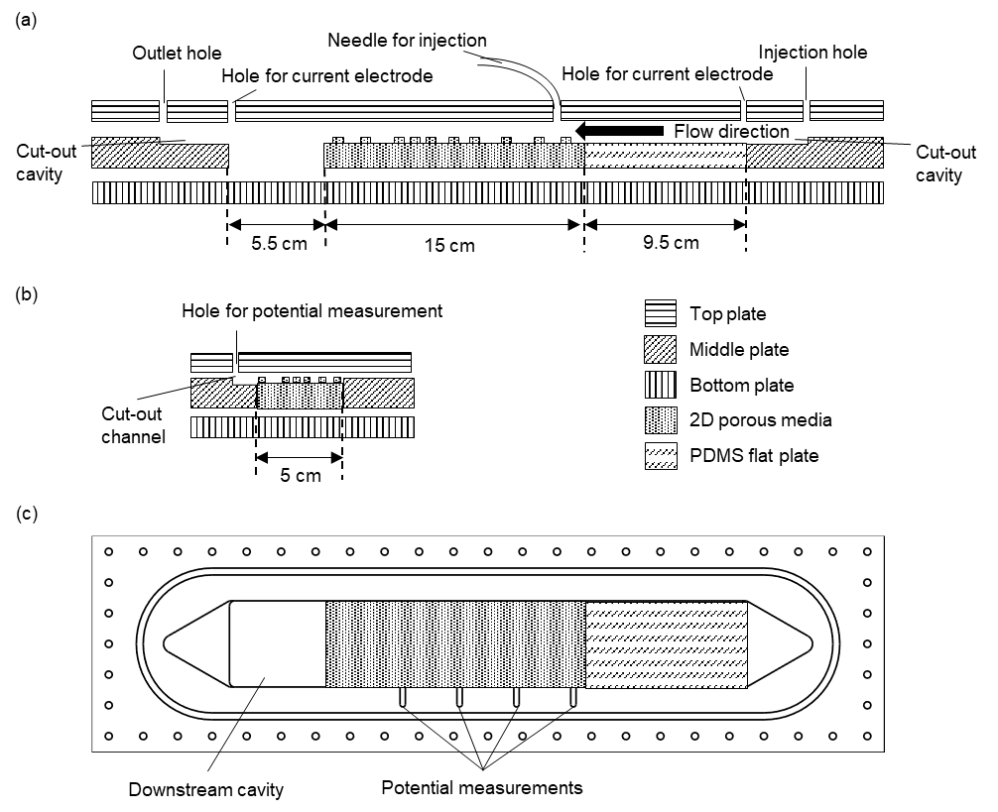
Figure S1. Cross-section of the sample holder in a vertical plane (a) containing the flow direction and (b) perpendicular to that direction. The dimensions of the top plate, middle plate, bottom plate, PDMS flat plate and 2D porous media are given, and key features of the sample holder are also indicated. Please note that the vertical dimension is not to scale, and the flow is from right to left. (c) Top view of the sample holder including 2D porous media and the PDMS flat plate.

1.2 2D porous media
The porous medium was fabricated by casting Polydimethylsiloxane (PDMS) (SYLGARD 184 Silicone Elastomer Kit, Dow, Midland, MI, USA) in a mold. The height of the pillars was carefully selected based on the following considerations. First, the electrical impedance of the 2D porous medium should not be too high to avoid SIP measurement errors. For this reason, the height of the 2D porous medium could not be too small. In addition, it was important to ensure a close to 2D flow through the cell, i.e., a flow that is invariant along the vertical direction except in the vicinity of the top and bottom plates, to avoid three-dimensional transport processes that could not be captured by 2D imaging. This required a large aspect ratio of pillars, i.e. a height larger than the pore size, to ensure that the velocity field was mostly controlled by the horizontal confinement imposed by the grains rather than by the vertical confinement imposed by the top and bottom boundaries. This also ensures that dominant Taylor dispersion occurs in the horizontal direction rather than in a vertical direction. Finally, unmolding the medium without breaking some of the pillars is more difficult when the pillar height is larger. Based on the compromise between these constraints, a pillar height of 1 mm was selected. To obtain such large aspect ratio pillars, the mold for the porous media was not obtained through photo-lithography as is common in standard soft lithography. Instead, the mold was made by a 1 mm-thick (height of the pillars) PMMA plate, in which cylindrical holes corresponding to the pillars were created using a laser cutting machine and reproducing the design desired for the porous medium’s solid cylindrical grains. The mold consisted of a rectangle cuboid chamber in which the PMMA plate is inserted. The PDMS liquid was first mixed with curing agent, poured into the mold, outgassed under vacuum for a few hours, and cured at 60 to 70°C overnight. After the PDMS was solidified, the PDMS was taken out of the mold.
The obtained 2D porous media were composed of a base plate (length: 150 mm, width: 50 mm, height: 10.6 mm) and grains/pillars (height: 1 mm). The grain size distribution, pore size distribution, and the pore throat length distribution of the 2D porous medium are shown in Figure S2. For the design of the porous media geometry, the larger grains were first placed randomly while considering a minimum separation (i.e. pore throat size). Then smaller grains were placed in the remaining void space until we obtained the desired porosity. It should be noted that the total height of the porous media (11.6 mm) is slightly larger than the height of the cavity in the sample holder (11.0 mm). This naturally causes some compression of the porous media during assembly, in particular for the pillars (5% of the total height). This ensured that there is no gap between the top of the pillars and the bottom of the top plate of the sample holder without any notable increase in the pillars’ diameters.
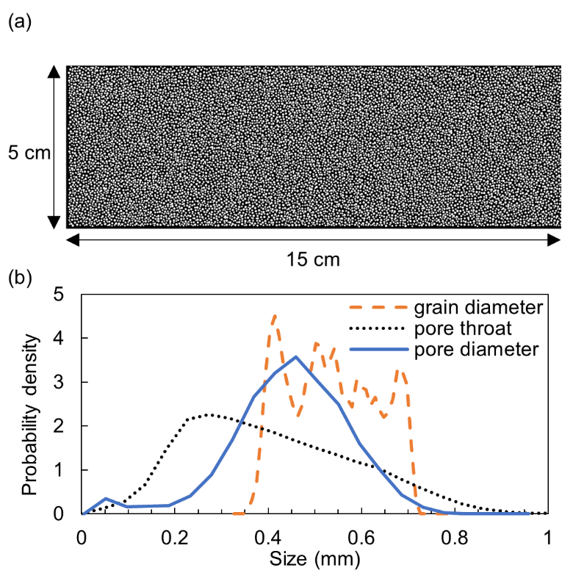
Figure S2. Characteristics of the 2D porous medium (a) Top view of 2D porous media (black: pore space, white: pillars) and (b) Cumulative distribution function of grain diameters, pore throat sizes and pore diameters in the 2D porous medium.

1.3 Calibration between the image grey level and the height of the precipitation
Calcite precipitation is expected to build up from the bottom to the top. Since calcite is partly transparent, the grey scale of the digital image is related to the height of the precipitate. To calibrate the relationship between grey levels in the image and the height of the precipitate, the spatial distribution of the precipitate height was measured with an optical profilometer at the end of the experiment. The calibration curve was obtained from four selected areas. These areas were selected based on the following two criteria: i) the precipitation is intact after the flow cell is opened to allow for meaningful height measurements with the profilometer, and ii) a wide range of precipitation heights is present in the selected area. Within each selected area, the 3D geometry of the precipitate measured with the profilometer was downscaled to obtain the same horizontal resolution as that of the digital images recorded during the experiments. Because of the height of the porous media, the measured and predicted height of the precipitates should range between 0 mm and 1 mm. The data showed a dependence of the precipitate height as a function of image grey level that has a similar shape as the Arctan function. Therefore, the following procedure was used to establish a calibration relationship. First, the precipitation height h was converted using the empirical function:
 | $$h^{'}=\text{tan}\left(\frac{h+0.05}{2}×π\right)$$ | (S1)
Here, we added an offset of 0.05 to the height h in order to avoid values near $±π/2$, where the tangent function is extremely sensitive (i.e. its derivative is extremely large). Next, the relationship between $h^{'}$ and the grey level I, which ranges from 0 to 255, was fitted using a linear function:
 | $$h^{'}=aI+b$$ | (S2)
where a and b are the fitting parameters. To obtain a function that relates grey level to height of the precipitates, the inverse formulation was used:
 | $$h=\frac{\text{arctan}\left(aI+b\right)}{π}-0.05$$ | (S3)
The use of this procedure ensures that h does not take a value over 1 nor below 0.
Figure S3 shows the results of the calibration between the image grey level and the height of the calcite precipitates. Considering that a calcite crystal is almost transparent, the grey level of the images is mostly determined by the amount of edges of the calcite grains that scattered light. The height of the precipitate is therefore only indirectly related to the grey level in the image, which likely explains the significant scattering. However, a clear correlation was obtained, allowing to fit a calibration curve using the method outlined above. This relationship was applied to all images taken by the overview camera during the experiment, which provided an approximate spatio-temporal evolution of the height of the precipitation over the entire porous medium and duration of the experiment.
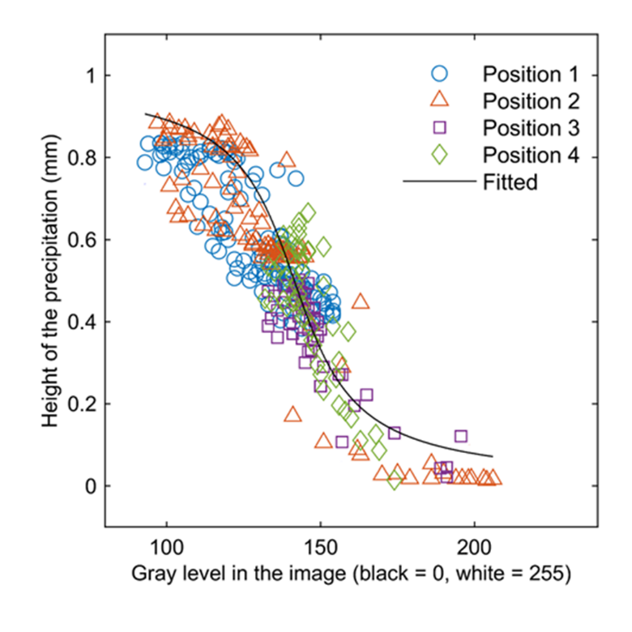
Figure S3. Relationship between image grey level and height of the precipitates measured with the profilometer. The fitted calibration curve allows calculating the heights of the precipitates from image grey levels.

1.4 Effect of heterogeneous solute concentration on SIP response
To test the possible influence of an heterogeneous solute concentration field on the SIP response, we designed an experiment where a neutral solution was injected on both side of the precipitation front. This allowed to eliminate the influence of a heterogeneous solute concentration field on the SIP response. For this, we selected an MgCO₃ solution, which had two main advantages. First, this ensured that calcite did not react with the injected MgCO₃ solution and that additional precipitation of minerals including Mg did not occur. This is possible because magnesium-bearing calcite with Mg contents higher than 10 mol% is a thermodynamically unstable phase of calcium carbonate under ambient conditions³. Formation of dolomite or magnesite thus is virtually impossible at ambient temperature⁴. At the same time, dissolution of calcite is inhibited by the presence of Mg²⁺ ⁵. Second, it allowed more charge on the calcite surface, leading to potentially large SIP signals. Indeed Mg²⁺ is expected to adsorb on the surface of calcite with high affinity⁶. Furthermore, the solubility of amorphous MgCO₃ is substantially higher than that of amorphous CaCO₃⁷. On the calcite surface, this results in a larger amount of adsorption of Mg²⁺ and the carbonate species in the mixed solution of MgCl₂ and Na₂CO₃, compared to the adsorption of Ca²⁺ and the carbonate species in the mixed solution of CaCl₂ and Na₂CO₃.
- Supplementary results for image analysis and SIP response

2.1 Composite images of the precipitate wall
Figure S4 shows images of the calcite wall at different scales, taken at different times. Images of the full measurement zone are taken with the overview camera, while zoom images of different sections of the wall were obtained with the second high-sensitivity camera. Composite images provided images of the sections of the wall with a resolution of about 0.4 μm capturing the development of individual crystals. After 5 hours, precipitation was clearly ongoing but the wall was discontinuous in space and the timing of downstream extension was different in each pore. Zoom images showed that a layer of crystals is first formed on the bottom plate, followed by the growth of the wall (which appears out of focus). Finally, the formation of crystals on the top plate was observed and some crystals grew on the pillars of the porous medium (Movie S1, taken at the same place as the results in Figure S4, right column). It was also observed that small crystals were less abundant later in the experiment because of Ostwald ripening^{8,9} (Movie S1). The size of the crystals near the top of the flow domain did not change after 20 h and there was no aggregation process, which suggests that the reaction rate was not very large at this position after 20 h (Figure S4). The transformation of the crystal (from vaterite to calcite) was unlikely in our setup after 20 h because there was no change in the shape of the crystals (vaterite is spherical and calcite is cubic)¹⁰.
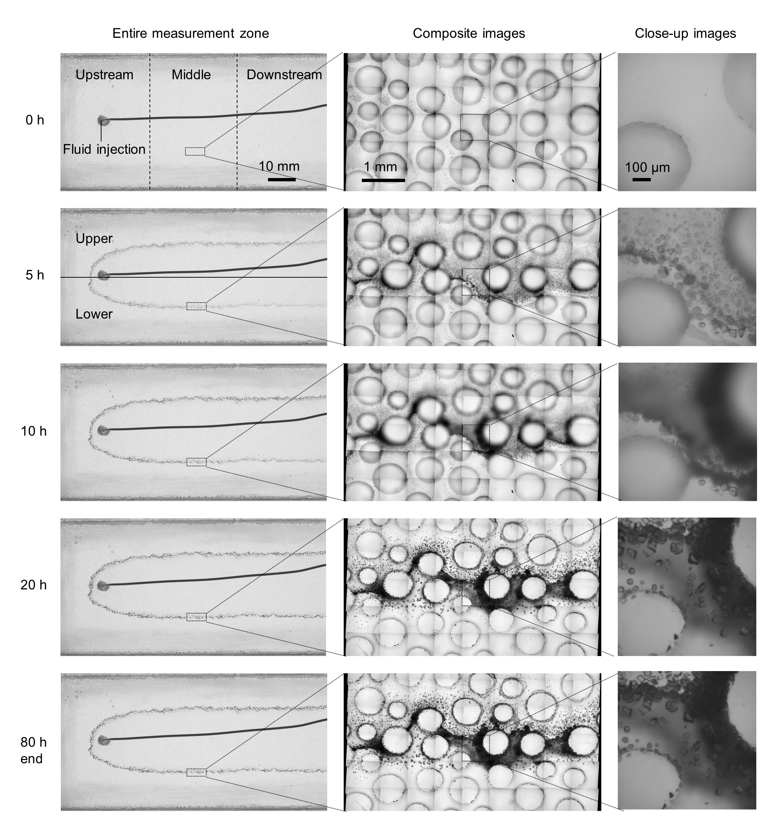
Figure S4. Digital images of the entire measurement area, taken at different times (left column), composite images of a selected area along the calcite precipitation front (center column), and calcite crystals in high-zoom images (right column). The black line in the middle of the left panels is the injection tube.

After the experiment, close-up images were made in the entire measurement region (Figure S5). The size range of the crystals at the end of the experiment was found to be similar in all three measurement zones, except for the stagnation point where crystal size was smaller.

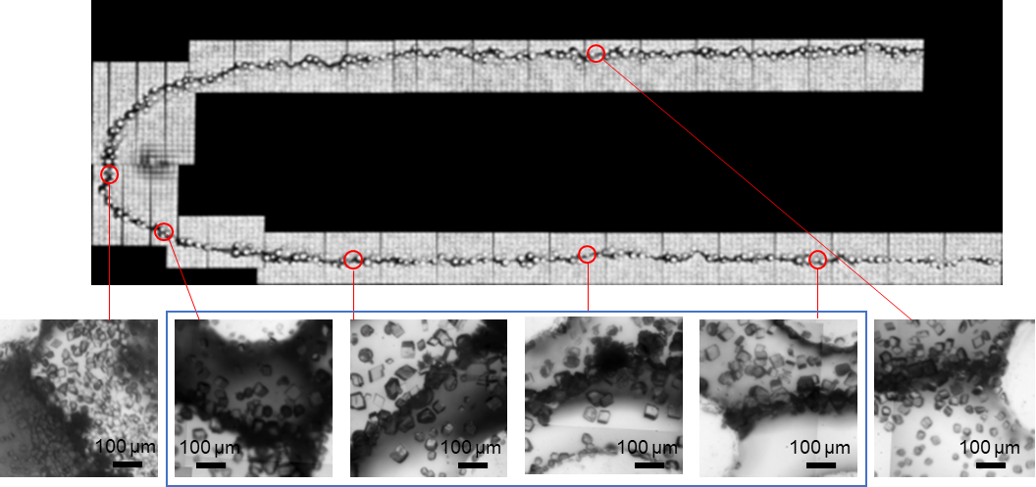
Figure S5. Close-up images showing calcite crystals in different parts of the measurement domain. The images in the blue box have a similar range of crystal sizes.

2.2 Microscopic images of the calcite precipitates
To visualize the micro-scale structure of the calcite precipitate, we examined some parts of the calcite wall under the microscope after opening the cell at the end of the experiment. The wall appeared to be continuous without visible pores at 0.16 $×$ 0.16 $\text{μ}$m² resolution (Figure S6). This is likely related to the precipitation process. The strongly oversaturated condition led to instantaneous generation of amorphous calcium carbonate when the two solutions were mixed¹¹, followed by transformation of the amorphous phase to calcite crystals. This amorphous calcium carbonate mainly settled on the bottom of the sample holder due to its higher density (as compared to the liquid). A small amount attached to the top plate and pillars of the porous medium (Movie S1). The amorphous phase of calcium carbonate is able to attach on calcite surfaces and allows calcite precipitates to grow further^{11,12}. Because of this process, continuous calcite walls were formed along the entire precipitation front.

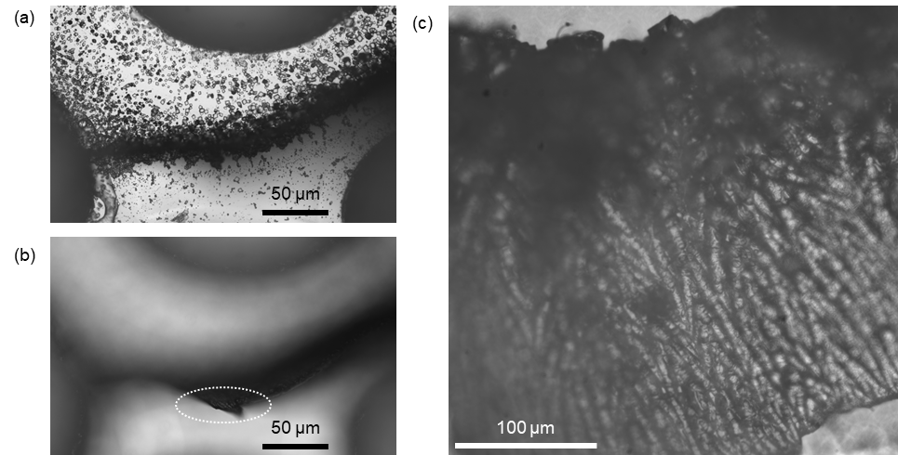
Figure S6. Microscopic images of calcite precipitates: (a) top view with the focus set on the bottom of the measurement cell, (b) top view with the focus set on the top of the calcite wall (white circle indicates the position of focus) and (c) side view of the calcite wall.

2.3 Additional information on model for calcite wall development
Given the experimental flow conditions, calcite precipitation is expected to occur in the mixing zone where the two injected solutions are in contact. This will lead to the formation of a calcite precipitate wall limiting the mixing rate between the two fluids (Figure S7). This results in a feedback mechanism between the reaction rate and the height of the calcite precipitation, which may lead to a slow but continuous growth of the volume of calcite precipitation even after 20 h. This model should be valid as long as the upward growth of the calcite precipitate wall can be approximated as a continuous process. If amorphous phase particles have a size comparable to the size of the gap space, the attachment of the amorphous phase could lead to a local filling of the remaining gap. However, this process was unlikely in our experiments because it requires precise control of flow in small scale (the size of amorphous phase is in the order of 100 nm¹¹). Note that this feedback model is applicable even though part of the calcite is locally growing from the top plate or on the pillars of the porous medium, as observed in the experiments.
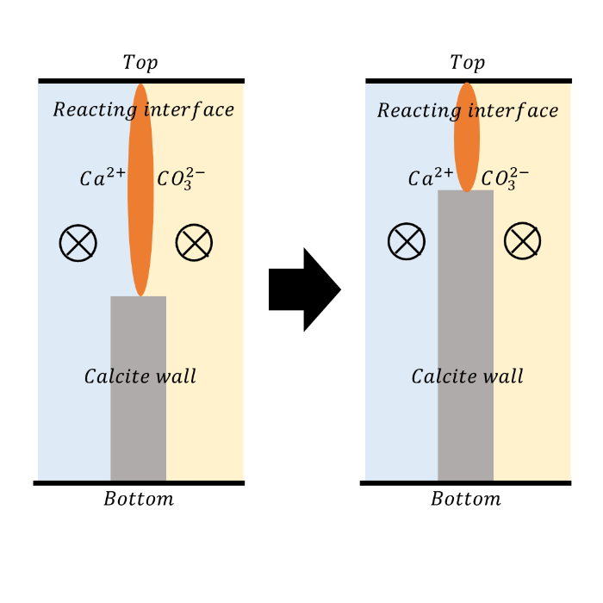
Figure S7. Conceptual model to explain why the rate of calcite precipitation is reduced during the formation of the calcite precipitation front. The colors represent the zone with CaCl₂ solution (blue), the zone with Na₂CO₃ solution (yellow), the calcite wall (grey), and the mixing zone (orange). The circles with a cross inside indicate the flow direction, which is perpendicular to the paper.

To investigate the impact of the calcite wall formation on the mixing rate, we have developed a mechanistic model in section 3.1 of the main manuscript. We consider the domain close to the calcite precipitate (Supplementary Figure S8a), where the calcite wall separates two reactive species (carbonate species and calcium ion). Because the wall is continuous, reaction occurs only in the volume above the calcite precipitate. We assume that the reactive species are transported from bulk water to the reaction zone by diffusion alone because advection occurs mostly along the wall. Because of the high oversaturation, we further assume that the reaction rate is mostly controlled by mixing in the bulk water rather than the attachment of small calcite particles on the calcite surface. The formed calcite particles in bulk water may be suspended and transported by advection. To evaluate the impact of suspended calcite particles, we estimated the size of the suspended particle as 1 $μm$ based on acquired images. The time required for the sedimentation is approximated as:
 | $$t_{sed}=\frac{H}{v_{term}}$$ | (S4)
where $H$ is the channel height (1 mm) and $v_{term}$ is the terminal velocity of the particle during sedimentation based on Stokes’ law:
 | $$v_{term}=\frac{2}{9}\frac{(ρ_{cal}-ρ_{w})}{μ}gR^{2}$$ | (S5)
where $ρ_{c}$ is the density of calcite (2.71 g cm⁻³), $ρ_{w}$ is the density of water (1.00 g cm⁻³), $μ$ is the dynamics viscosity of water (10⁻³ Pa m), g is the gravitational acceleration (9.8 $m^{2} s^{-1}$) and R is the size of the particle (1 $μm$). This leads to $t_{sed}=270$s. Considering the inlet flow velocity (4 mL h⁻¹ for each solution), the horizontal travel distance during sedimentation is ~1.8 mm, which is much smaller than the entire measurement zone. Thus, we assume instantaneous sedimentation.
We also quantify the effect of dissolution using a rough approximation. According to a previous study¹³, the dissolution rate of the calcite is about $5×{10}^{-8}$ mol m⁻² s⁻¹ in a pH range similar to our experimental setup. Using the molar volume of the calcite $(3.69×{10}^{-5}$m³ mol⁻¹)¹⁴, the amount of calcite dissolved during the 80 h of our experiment is $5.3×{10}^{-7}$ m³ m⁻². The height of the calcite wall was 1 mm and the total length of the calcite wall was estimated as $10×π×π×2=193$ (cm), which is the product of the length of the measurement zone (10 cm), the assumed tortuosity factor of the calcite wall due to the curved reaction front in the porous media ($π$), the assumed surface roughness factor of the calcite wall ($π$), and the two branches of calcite wall. By using $π$ we assumed that the shape of the calcite wall along the reaction front and the surface of the calcite wall can be approximated by an assemblage of many cylinders. These parameters lead to an estimated total dissolution amount of $1.0$ mm³. This is much smaller than the volume of the precipitate (about 35 mm³). Thus, we do not consider dissolution as significant in the model. With these simplifying assumptions, the diffusive flux of the reactive species is:
 | $$q=S\left(t\right)D∇C$$ | (S6)
where q is the diffusive flux (mol s⁻¹), S(t) is the area of reaction above the calcite precipitate that changes over time, D is the molecular diffusion coefficient assumed to be the same for both species, and C is the concentration of the reactive species. S(t) can be written as:
 | $$S(t)=\left(H-h(t)\right)L$$ | (S7)
where H is the height of the channel, h is the height of the calcite precipitate and L is the length of the calcite precipitate wall. $∇C$ can be approximated as:
 | $\left\|∇C\right\|=C_{\text{bulk}}/L_{\text{D}}$ , | (S8)
where $\left\|∇C\right\|$ is the magnitude of the concentration gradient, $C_{\text{bulk}}$ is the concentration at the bulk and $L_{\text{D}}$ is the length determining the concentration gradient. Assuming that the reaction is fast and limited by diffusion (i.e., that the Damköhler number is large), the evolution of the volume of calcite precipitate, $V= whL$, where w is the thickness of the calcite precipitate wall, can be approximated by
 | $$\frac{dV}{dt}=\left\|q\right\|\frac{M_{\text{cal}}}{ρ_{\text{cal}}}$$ | (S9)
where ${\text{M}}_{\text{cal}}$ is the molar mass of calcite (m³ mol⁻¹), and $ρ_{\text{cal}}$ is the calcite density (g m⁻³). From Eq. (S7)-(S9) we thus obtain,
 | $$V=V_{∞}\left(1-e^{-αt}\right)$$ | (S10)
where $V_{∞}$ is the calcite volume when no reaction can occur any more ($V_{∞}= wHL$), $α=1/t_{c}$ where $t_{c}$ is the characteristic time for calcite wall formation given by:
 | $$t_{c}=\frac{ρ_{\text{cal}}L_{\text{D}}\text{w}}{{M_{\text{cal}}C}_{\text{bulk}}D}$$ | (S11)
The parameters in eq. (S11) were estimated as follows: $M_{\text{cal}}/ρ_{\text{cal}}=3.69×{10}^{-5}$(m³ mol⁻¹)¹⁴, $C_{\text{bulk}}$ is the average concentration of the two solutions ($C_{\text{bulk}}$ = 27.6 mM), D is the average diffusion coefficient of ${CO}_{3}^{2-}$ and $Ca^{2+}$ ($D=1.17×{10}^{-9}$ m² s⁻¹)^{15,16}. The calcite wall width $w$ was visually estimated from the zoom images to range from 10 to 100 $\text{μm}$ in different pores. The mixing width $L_{D}$ is also variable, depending on pore scale flow heterogeneity, and generally increases downstream. We estimated its value at different locations from a conservative tracer experiment using fluorescein sodium salt. The mixing width was estimated by fitting an error function to the concentration profiles along the red lines in Figure S8b. We used the average value of one standard deviation range of the fitted error function as the $L_{D}$ value. The derived $L_{D}$ value varied over one order of magnitude in different pores, ranging between ${10}^{-3}$ and ${10}^{-4}$ m. These estimations lead to $α$ in the range ${10}^{-3}$ to ${10}^{-5} {\text{s}}^{\text{-1}}$. The proposed model (eq. S10) fitted the experimental data well with an additional offset for the initial time (Figure S8d), leading to the $α$ value of $5.2×{10}^{-5}{ \text{s}}^{\text{-1}}$. This $α$ parameter determined the observed time scale of 20 h at which the wall starts to be continuous.

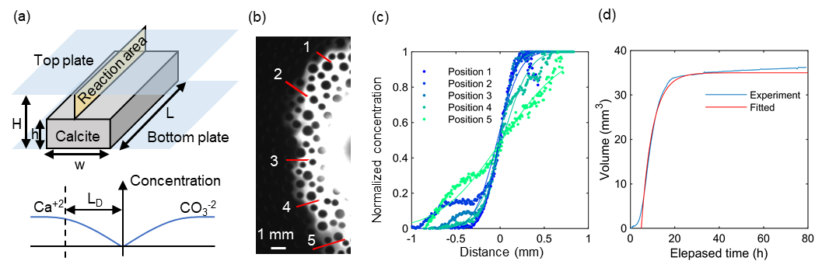
Figure S8. (a) The model domain for calcite precipitation with parameters used for the calculation. (b) Image of the conservative tracer experiment. The red lines represent the places where concentration profiles were obtained to evaluate the mixing front width. (c) Fitted functions for the concentration profiles in figure (b). The position numbers correspond to those in (b). (d) Fitted analytical solution to the experimental data.

2.4 Effect of capacitive coupling
In the frequency range above 100 Hz, the parasitic capacitance of the measurement system can have significant impact on the measurement¹⁷. To evaluate this effect, we have examined the impact of the parasitic capacitance of our measurement system during data processing^{1,2}. In Figure S9, we compare $σ''$ with and without accounting for the parasitic capacitance (uncorrected and corrected, respectively) following the procedure in the previous study². The difference between uncorrected and corrected data was clear only in high frequency range above 10 kHz (see red square in Figure S9). Also, in corrected data, some measurement showed negative $σ''$ in high frequency range due to over-correction in early time. This is probably because relatively high resistance of the 2D porous medium leaded to over-estimation of contact impedance. Based on those considerations, we used uncorrected data for further analysis.
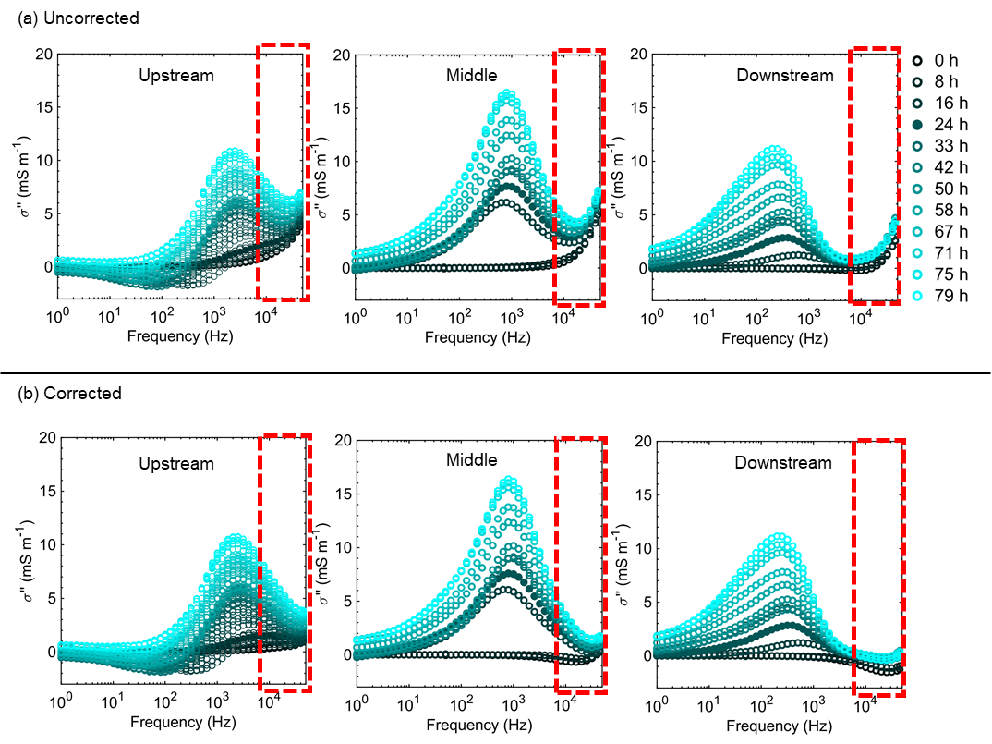
Figure S9. (a) Uncorrected $σ''$, which is the same data as in the main manuscript, and (b) corrected $σ''$. The red square indicates the frequencies which was influenced by the correction of parasitic capacitance.

2.5 Observed changes in the real part of the electrical conductivity
The real part of conductivity $σ'$ increased substantially with frequency (Figure S10) in most of the data, which indicates the occurrence of polarization processes given the analogy to a capacitance¹⁸. A small decrease in $σ'$ was observed only at earlier times at frequencies around 10 kHz and larger, which is likely due to incomplete correction of parasitic capacitances^{1,17}. The initial drop of $σ'$ at time 0 h in all the measurement zones was due to the start of the injection of Na₂CO₃ solution, which has a lower electrical conductivity than the CaCl₂ solution initially present in the porous medium. At the same time, the precipitation reaction started and further decreased the ion concentration and thus the electrical conductivity. Based on the injection rates, it took about 1.25 h to replace the background CaCl₂ solution with the Na₂CO₃ solution. Thus, changes in $σ'$ between 1.25 and 20 h can be attributed to the formation of the calcite precipitation, which may reduce $σ'$ because calcite is non-conductive in the frequency range of SIP measurements. On the other hand, $σ'$ may also increase because the reaction rate was decreasing over time (see section 3.1), which may increase the ion concentration. In the measured $σ'$, both increases and decreases were observed at different locations and times (Figure 3d,e).

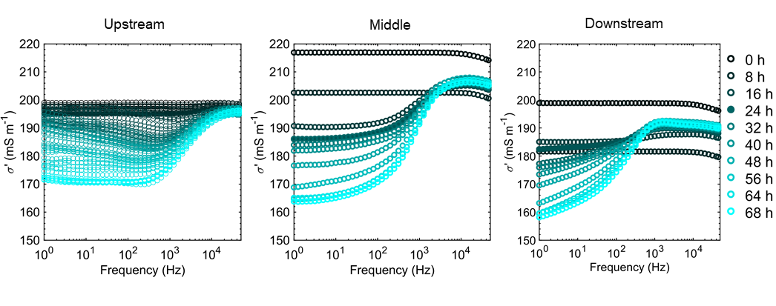
Figure S10. The real part of the conductivity at upstream, middle and downstream positions over time.

2.6 SIP response in duplicated experiment and occurrence of streaming potential
We have run a duplicate experiment with the same conditions as described in the main text and measured the SIP response without imaging. The SIP response showed the same general trend as in the main experiment (Figure S11): increase in $σ''$, higher peak frequency for upstream area, negative $σ''$ at low frequency for upstream area, large variation of $σ'$ at 1 Hz, and much smaller variation at 10 kHz. The reproducibility of the experiment is further discussed in Supplementary section 2.8 along with the interpretation of the results. In the duplicated experiment, we also measured the SIP response of the entire measurement zone (between the left electrode and right potential electrode). At the end of this experiment, flow was stopped to check for possible effects of streaming potential on the SIP measurement. It was found that the effect of flow on the SIP response was small (Figure S12). In addition, our measurement system is designed to remove the direct current component by making use of a lock-in amplifiers¹ for SIP data acquisition. These experimental results and the design of our SIP measurement system ensure that streaming potential (SP) can be excluded as a major influence on the measured SIP response.

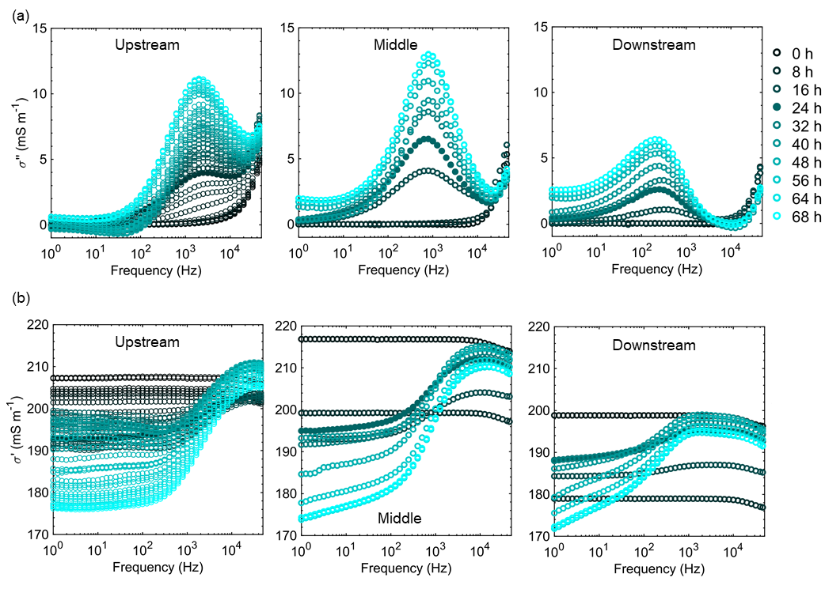
Figure S11. SIP response at upstream, middle and downstream regions over time in the duplicate experiment. (a) The imaginary part of the conductivity. (b) The real part of the conductivity.
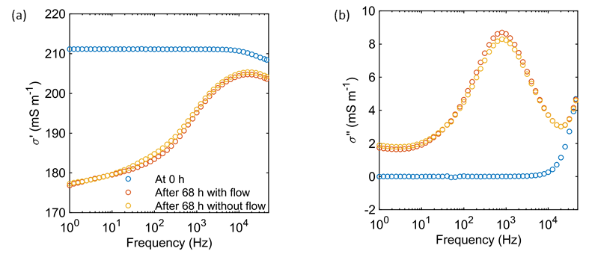
Figure S12. SIP responses in duplicated experiment at time 0 and at the end of the experiment (after 68 h) with and without flow. (a) Real part of the conductivity. (b) Imaginary part of the conductivity.
2.7 SIP response of calcite precipitation in homogeneous concentration field
The SIP response obtained during injection of CaCl₂ and Na₂CO₃ is affected by spatial and temporal variation in solute concentration because of the ongoing precipitation reactions. To test the effect of such variations, an additional experiment was performed where the measurement cell was flushed twice with MgCO₃ solution after a time period with calcite precipitation. The development of the image grey level followed a similar behavior as in the main experiment (Figure S13) with two stages of the calcite precipitation process as discussed in the main text. The development of $σ'$ and $σ''$ as a function of time showed that both $σ'$ and $σ''$ changed in a similar way as in the experiments using CaCl₂ and Na₂CO₃ solution only (Figure S14, S15). This indicates that the experimental conditions in this additional experiment were sufficiently similar to the previous experiments. In addition, only small changes in $σ'$ (less than 5%) and $σ''$ (less than 10% for peak magnitude of middle and downstream regions) were observed before and after injecting MgCO₃ solution. This suggests that the effect of the presence of MgCO₃ solution on the calcite surface properties is likely reversible and does not change the crystal properties. This is expected because calcite reacts only slowly with magnesium ions⁵. The $σ''$ increased between the first and second injection of MgCO₃ solution and the peak frequency in the upstream region was higher after injecting MgCO₃ solution (Figure S14,15). Thus, these characteristics were not governed by a heterogeneous distribution of solute concentration.
We have tried to interpret this result using the grain polarization model. If the adsorption of Mg²⁺ were responsible for this shift in peak frequencies, the grain polarization model (eq. 6) would predict a diffusion coefficient roughly 2 to 5 times smaller for Ca²⁺ than for Mg²⁺, based on the observed peak frequencies. However, the diffusion coefficient of Ca²⁺ ($7.93×{10}^{-10}$ m² s⁻¹)¹⁹ is larger than that of Mg²⁺ ($7.05×{10}^{-10}$ m² s⁻¹)¹⁹. Therefore, this seems an unlikely explanation for the observed differences in peak frequencies. The interpretation of the results is again discussed in section 3.6 in this supplementary information.
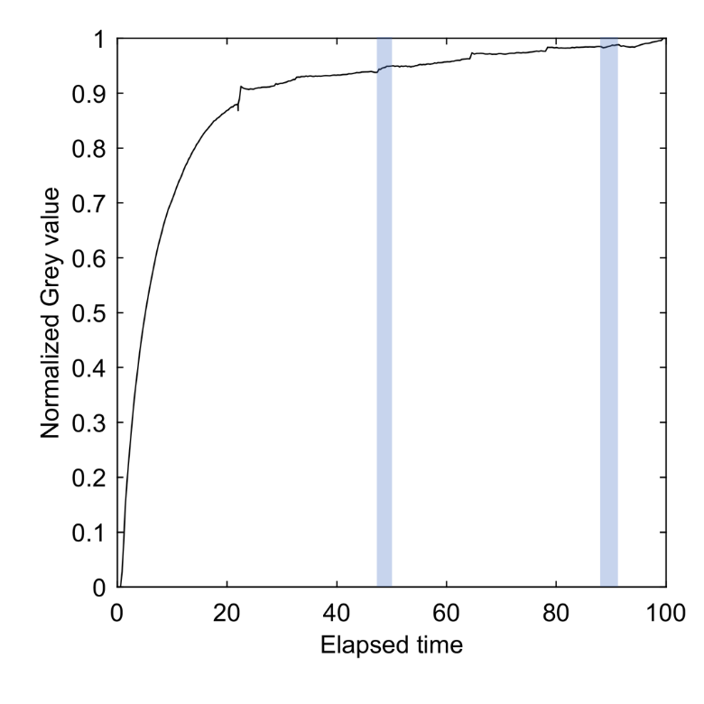
Figure S13. Change in normalized grey level in the entire measurement zone in the experiment with intermediate injections with MgCO₃ solution (blue zones).
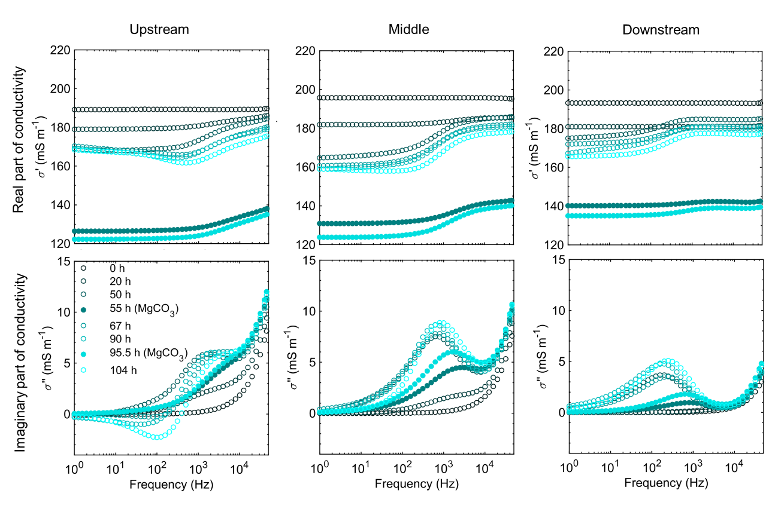
Figure S14. SIP response as a function of time for the three measurement zones in the experiment with intermediate injection of MgCO₃ solution. The measurement zone was filled with MgCO₃ solution at times 55h and 95.5h.

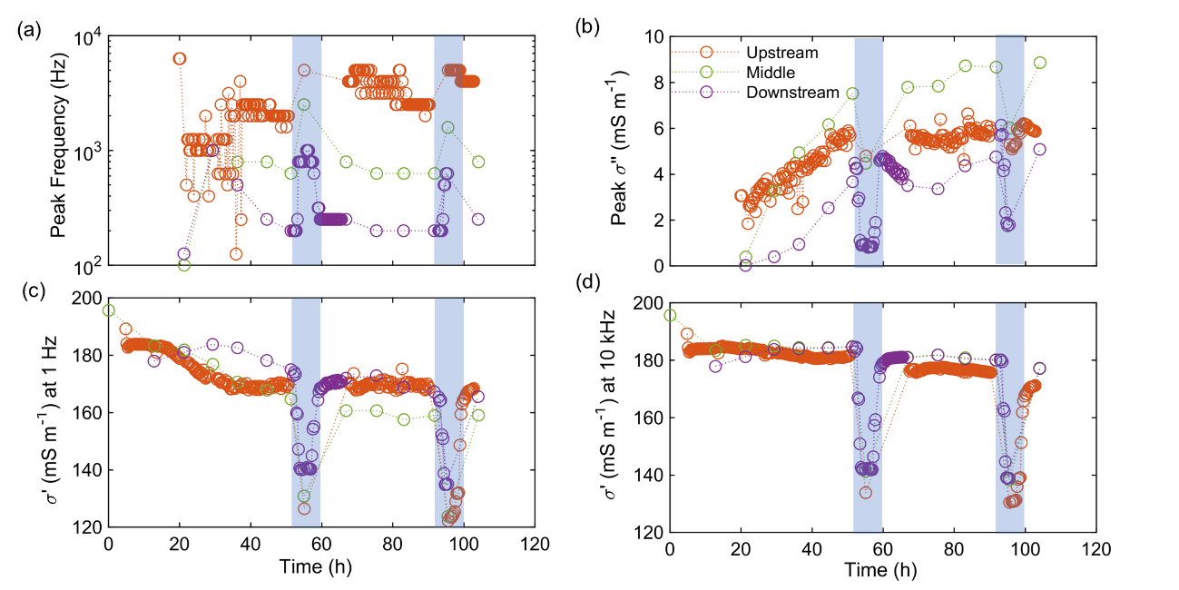
Figure S15. Key characteristics of the SIP response as a function of time for the three measurement zones: (a) peak frequency, (b) $σ''$ at peak frequency, (d) $σ^{'}$ at 1 Hz and (e) $σ^{'}$ at 10 kHz. MgCO₃ solution was in the measurement zone during the times denoted by the blue zones.

3. Microscopic and macroscopic controls on SIP response
3.1 Electrical circuit model
The impedance of the electrical circuit in Figure 4a was calculated as follows using standard circuit analysis:
 | $$Z=2R_{1}+\frac{1}{\frac{1}{R_{2}}+2πfCi}$$ | (S12)
where $Z$ is the impedance of the modelled circuit ($Ω$), $R_{1}$ is the resistance in the surrounding water ($Ω$), $R_{2}$ is the resistance of the water at the mixing zone ($Ω$), $f$ is frequency (Hz), $C$ is capacitance (F) and $i^{2}=-1$. $R_{1},R_{2},C$ were calculated as
 | $$R_{1}=\frac{ρ_{1}d_{1}}{wh_{\text{t}}}$$ | (S13)
 | $$R_{2}=\frac{ρ_{2}d_{2}}{w(h_{\text{t}}-h_{\text{c}})}$$ | (S14)
 | $$C=\frac{εh_{\text{c}}w}{d_{2}}$$ | (S15)
where $ρ_{1}$ is the resistivity of the surrounding water ($ρ_{1}=2 Ω m$), $ρ_{2}$ is the resistivity of the solution in the mixing zone calculated using the open source software PhreeqC ¹⁹ and assuming the equilibrium of the injected solutions ($ρ_{2}=2.7 Ω m$), $d_{1}$ is the length of the water channel ($d_{1}=5 mm$), $d_{2}$ is the wall thickness ($d={10}^{-3} mm$), $w$ is the width of the entire domain ($w=1 mm$), $h_{\text{t}}$ is the total height ($h_{t}=1 mm$), $h_{\text{c}}$ is the height of the calcite wall ($h_{\text{c}}=0.99, 0.999, 0.9999 mm$), and $ε$ is the permittivity of calcite ($ε=1.1×{10}^{-10} F m^{-1}$). The resulting complex conductivity is:
 | $$σ^{*}=Z^{-1}/K$$ | (S16)
where K is the geometrical factor calculated by:
 | $$K=\frac{wh_{\text{t}}}{d_{1}}$$ | (S17)

3.2 Parameterization of three scenarios for electrical field simulations
Three simulation scenarios are considered. The first scenario corresponds to the experimental period after 20 h where a clear and continuous precipitate wall was observed (Figure S16a). A second simulation scenario represents a relatively early stage of the experiment where the calcite precipitate wall is not yet completely continuous (Figure S16b). In a third and final simulation scenario, we explore how a heterogeneous spatial distribution of the complex electrical conductivity of the calcite precipitate would influence the SIP response (Figure S16c).
Using the first scenario, the model parameters m and $R_{σ}$ were varied in a wide range to determine a set of parameter values that reproduce the experimental results (Figure S17). By comparing the simulated SIP response in each measurement zone and the experimental results shown in Figure 3a, it was found that a chargeability of 0.995 and an $R_{σ}$ equal to 0.9 times the background conductivity for the calcite area resulted in an SIP response qualitatively similar to the experimental results. Note that the effect of $R_{σ}$ seems minor only for high $R_{σ}$ values ($R_{σ}=0.5, 0.9$ and $0.99$, Figure S17). The background conductivity was taken as 200 mS m⁻¹ by calculating the average conductivity of the solutions (500 mS m⁻¹) divided by the measured formation factor (2.5). The Cole-Cole model with these parameters is plotted in Figure S18. The peak frequency was about 100 kHz, which is in the range of Maxwell-Wagner polarization.
The simulated $σ'$ reproduced some characteristics of the experimental results. For example, the range of $σ'$ (150 - 210 mS m⁻¹) in all scenarios (Figure S19) was similar to the experimental results (150 - 220 mS m⁻¹) (Figure S10). Also, the local minimum existed for the upstream region in heterogeneous case (Figure S19c), which could be also observed in the experimental results (Figure S10). This local minimum suggests that negative $σ''$ existed.
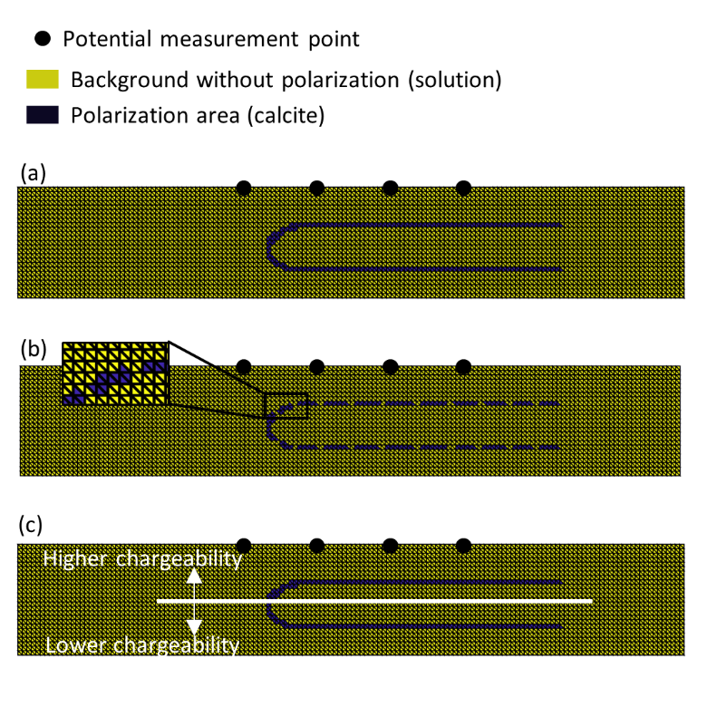
Figure S16. Simulation domains for three different scenarios: (a) continuous calcite precipitate wall, (b) discontinuous calcite precipitation front, and (c) spatially variable complex electrical conductivity of calcite. The yellow colour represents the background and the blue colour represents the distribution of calcite precipitation.
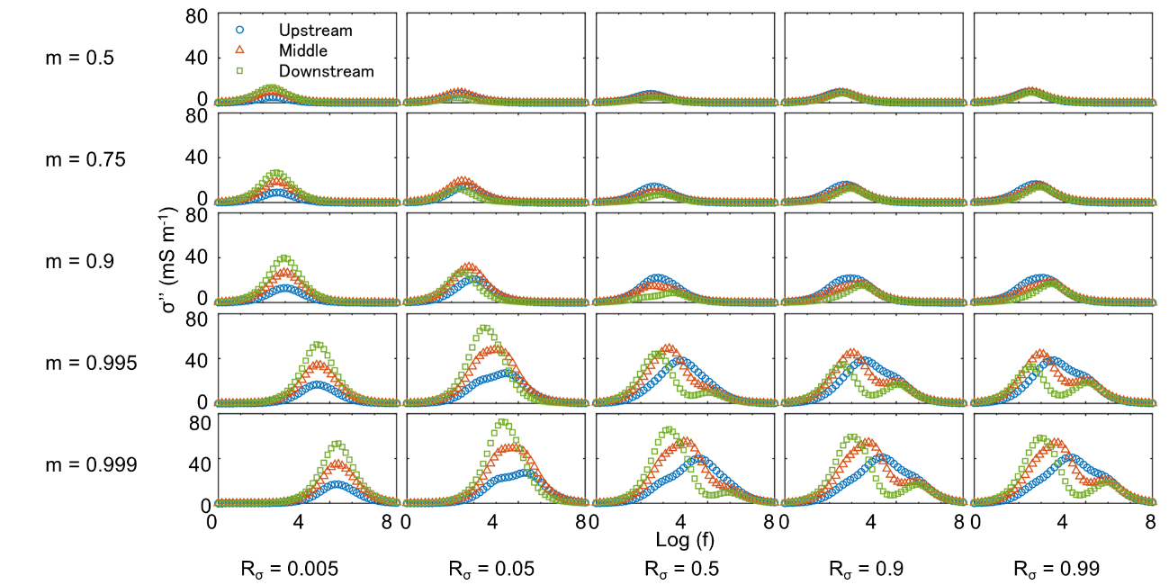
Figure S17. Simulated SIP responses in different measurement zones depending on chargeability and $R_{σ}$ value. The higher frequencies up to 100 MHz are also shown here to follow the change in peak frequency in all the simulations qualitatively.

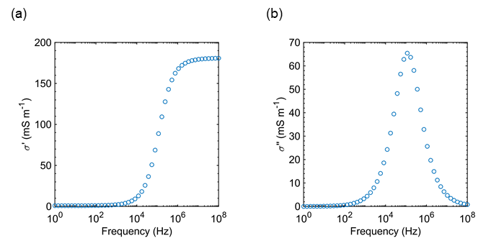
Figure S18. Cole-Cole model with m = 0.995 and $R_{σ}$ = 0.9 times the background conductivity (200 mS m⁻¹). (a) The real part of the conductivity. (b) The imaginary part of the conductivity.

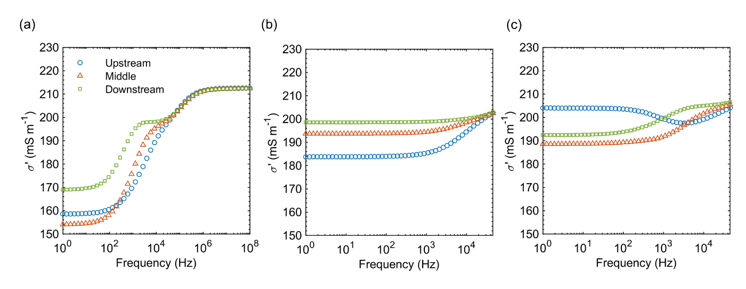
Figure S19. The simulated real part of the conductivity for corresponding cases (a) - (c) in Figure S16.

3.3 Visualization of electrical potential field
To better understand the origin of the different peak frequencies, the normalized imaginary part of the electrical potential field is shown in Figure S20 for two different sets of Cole-Cole parameters for the calcite zone. According to Figure S17, we identified $R_{σ}$ as the parameter that controls the shift of peak frequencies in different measurement zones when $R_{σ}$ is not too high (see the change in peak frequencies between $R_{σ}$ = 0.005 and $R_{σ}$ = 0.5), whereas m largely determines the magnitude of the peak $σ''$. In a first simulation with $R_{σ}$ = 0.9 and m = 0.995, the peak frequency differs between the measurement zones. In a second simulation with $R_{σ}$ = 0.005 and m = 0.995, the peak frequency is identical for all three measurement zones. The key to interpreting these two simulations is to analyze the imaginary potential across the calcite wall. In the case of $R_{σ}$=0.9 (Figure S20a), there is a strong contrast between each side of the calcite wall for low frequencies (for example at 193 Hz), but this contrast is less strong at high frequencies (for example at 51 kHz). In this case, the semi-ellipsoidal shape of the calcite precipitate acts as a resistor for low frequencies because of the low electrical conductivity. In the high frequency range, calcite does not act as a resistor because it is more conductive. Conversely, for $R_{σ}$ = 0.005 (Figure S20b), the contrast does not disappear for the higher frequencies because the calcite is assumed to have a low conductivity throughout the entire frequency range. From this comparison, we deduce that the relaxation of the imaginary potential across the calcite wall is key to understanding different peak frequencies for the different measurement zones, and that the shape of the calcite precipitation front results in different peak frequencies in different measurement zones. In the second scenario with discontinuous calcite precipitation ($R_{σ}$ = 0.9 and m = 0.995), the imaginary potential differences across the calcite wall are much smaller than in the case with a continuous calcite wall (Figure S20c). This suggests that the contrast in the imaginary potential determines the SIP response. In the third scenario with heterogeneous calcite properties, the normalized imaginary potential is highest near the middle potential electrodes (Figure S20d). This local maximum resulted in positive and negative imaginary potential as follows. The imaginary potential is measured at three places: on the left and right side of this local maximum (V_{l} and V_{r} respectively), and close to the local maximum between the two other measurement places (V_{c}). From this measurement, we obtain two potential differences (either a pair of V_{l} – V_{c} and V_{c} – V_{r}, or V_{c} – V_{l} and V_{r} – V_{c} depending on the direction of the measurement). Since V_{c} is close to the local maximum and larger than V_{l} and V_{r}, one potential difference will show a positive and the other will show a negative value given that the sign of the potential difference depends on the measurement direction. Thus, the negative $σ''$ values are introduced because of the local maximum in the imaginary potential associated with the heterogeneous distribution and properties of the calcite precipitation.
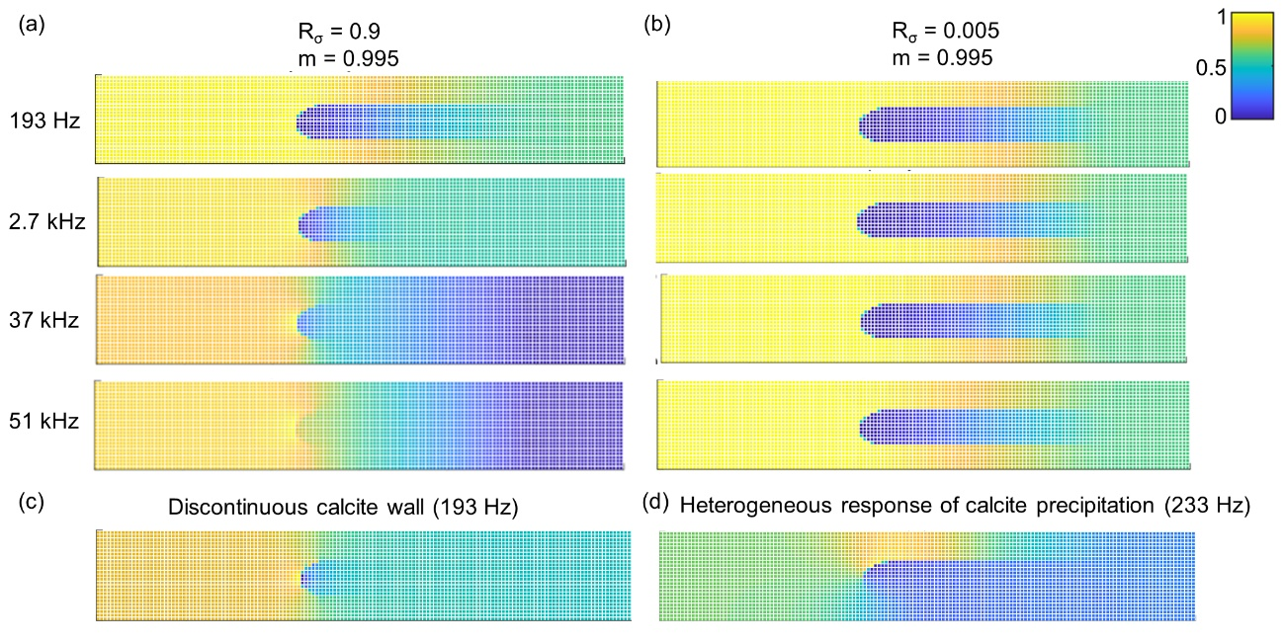
Figure S20. Normalized imaginary part of the potential field for different simulation scenarios: (a) continuous precipitation front with m = 0.995 and $R_{σ}$ = 0.9 and (b) continuous precipitation front with m = 0.995 and $R_{σ}$ = 0.005. Note that each row corresponds to different frequencies in (a) and (b): 193 Hz, 2.7 kHz, 37 kHz and 51 kHz. (c) Discontinuous precipitation front at 193 Hz (m = 0.995 and $R_{σ}$ = 0.9), and (d) heterogeneous complex electrical properties of calcite at 233 Hz (upper: m = 0.995 and $R_{σ}$ = 0.9, lower: m = 0.4 and $R_{σ}$ = 0.9).

3.4 Heterogeneous chargeability in flow direction
We explored how the change in chargeability in flow direction influence SIP response. We simulated this scenario by setting $R_{σ}$ equal to 0.9 times the background conductivity, and a chargeability m of 0.995, 0.8 and 0.6 for upstream, middle and downstream region, respectively (Figure S21). This heterogeneity did not reproduce characteristics of $σ''$ (negative $σ''$ and large variation of peak frequency) because of the absence of local maxima and contrast between each side of the calcite wall in the imaginary part of the electrical potential field, as discussed in section 3.3. Therefore, we expect that downstream variability in calcite properties is not able to explain the observed variability in SIP response.
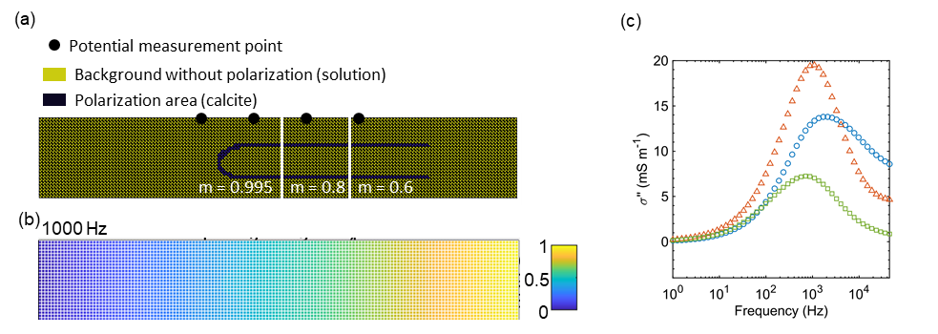
Figure S21. (a) Simulation domain (b) Normalized imaginary part of the potential at 1000 Hz (c) Simulated imaginary part of the conductivity.

3.5 Understanding reproducibility of SIP response by mechanism
We have three replicates for measurements of the SIP response up to 50 hours, including the experiments with injected MgCO₃ solution. We compare the obtained responses around 50 hours (Figure S22). The peak frequencies were very similar in all the experiments, while the magnitude of the response varied. We can understand these characteristics based on the discussion about the pore-scale and macroscopic controls on the SIP response (section 3.3 in main text). In each experiment, the macroscopic controls, such as the shape of the Rankine half-body flow, are easily reproducible. Because this process mainly controls peak frequency, almost the same peak frequencies were observed in all three experiments. On the other hand, the microscopic controls, such as the local development of the calcite precipitation front, are more difficult to reproduce precisely because slight perturbations in the flow may lead to considerable disturbances in the pore scale flow field. This difficulty resulted in discontinuity of the calcite wall in the early stages of the experiments and a nonuniform gap space between the calcite wall and top plate, which in turn resulted in variations in the magnitude of the response.

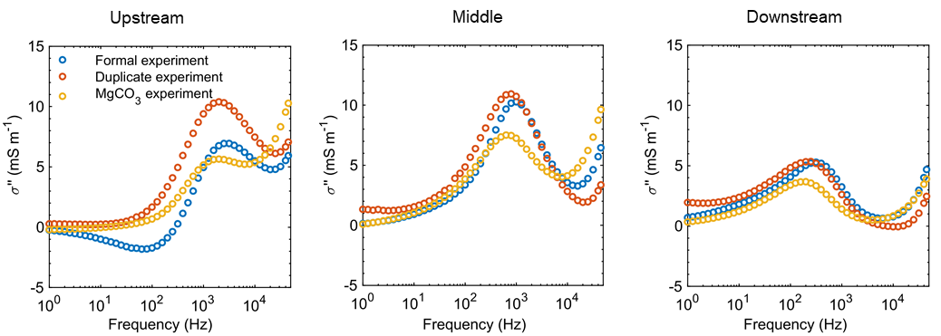
Figure S22. The $σ''$ in different experiments at time close to 50 h (50 h for formal experiment and MgCO₃ experiment, 48 h for duplicate experiment).

3.6 Interpretation of the SIP response in homogeneous solution
In section 2.7, we discussed the SIP response in homogeneous solution (namely MgCO₃ solution). In this section, we interpret the results by applying our electric circuit model (Figure 4a) and the results of electrical field simulations (Figure S17). We first simulated the pore scale SIP response using the electric circuit model, where the conductivity of the MgCO₃ solution (mixing of Na₂CO₃ and MgCO₃ solution allowing MgCO₃ precipitation) was determined by the PhreeqC¹⁹ calculation as 385 mS m⁻¹. The channel length was chosen as 0.1 mm to investigate whether high chargeability values, such as the values used for electric field simulations (Figure S17), are feasible in our electric circuit model if we focus on small area. Next, from the calculated responses (Figure S23), we try to find the corresponding cases in Figure S17. For this, we compared the chargeability $m=(σ_{∞}-σ_{0})/σ_{0}$ and $σ_{∞}(={R_{σ}σ}_{bulk})$ between the MgCO₃ solution case and the original solution case. The reason for calculating $σ_{∞}$ instead of $R_{σ}$ is the following. Figure S17 was determined under constant $σ_{bulk}$, but this is not the case when we change the conductivity of the bulk solution. This is problematic partly because the prefactor F of the Eq. (4) $(F{=R}_{σ}σ_{bulk})$, which was used to calculate the $σ^{*}$ of calcite area, depends on $σ_{bulk}$. To avoid this problem, we notice that changing $R_{σ}$ under fixed $σ_{bulk}$ is the same as changing $F$ because $R_{σ}$ appears only in F in Eq. (4). By using the relationship $F{=R}_{σ}σ_{bulk}=σ_{∞}$, the ratio of $F$ between the MgCO₃ solution and the original solution can be calculated by the ratio of $σ_{∞}$. Therefore, by focusing on the prefactor F $(=σ_{∞})$, we can avoid introducing $σ_{bulk}$, and can qualitatively use Figure S17 by replacing $R_{σ}$ by F. The results showed that $m$ was almost the same (0.995 times smaller for MgCO₃ solution) because $σ_{0}$ was almost zero for both cases. The calculated m also assured that high m value (in this case 0.99 for the original solution case) is feasible. The $σ_{∞}$ was 0.77 times smaller for MgCO₃ solution, so the F is also 0.77 times smaller. By referring to Figure S17, we can predict that the peak frequency should be higher for smaller F value, namely in MgCO₃ solution (e.g. compare $m=0.995$, $R_{σ}=0.5$ and $m=0.995$, $R_{σ}=0.99$). This can explain the experimental results (Figure S14). Please note that we assumed that the change in $σ_{bulk}$ outside the calcite area does not influence the peak frequency. For the magnitude of $σ''$, we need to be careful to interpret Figure S17 because the magnitude of $σ''$ is clearly influenced by $σ_{bulk}$ outside the calcite precipitation area (e.g., if the phase shift is the same, $σ''$ becomes larger for larger $σ_{bulk}$). According to Figure S14, $σ'$ decreased when we inject MgCO₃ solution. Therefore, unless the phase shift largely increases for MgCO₃ solution, we expect that the magnitude of $σ''$ should decrease. This again corresponds to the results in the experiments (Figure S14). Therefore, our electric circuit model and the results of electric filed simulation can be directly used to partly interpret the experimental results when we replaced the original solution by MgCO₃ solution.
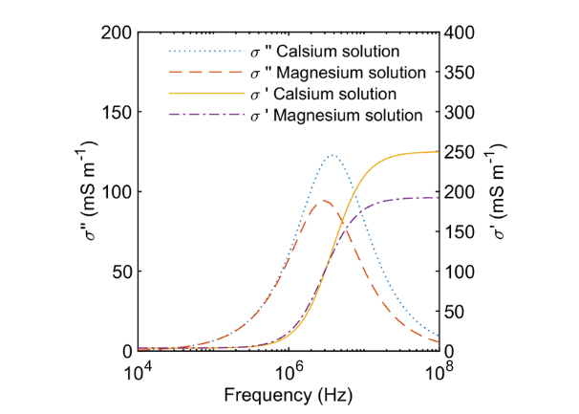
Figure S23. The calculated $σ'$ and $σ''$ in the original solution (Calcium solution) and in MgCO₃ solution using the electric circuit model, with the modified water channel length (0.1 mm).

References
(1) Zimmermann, E.; Kemna, A.; Berwix, J.; Glaas, W.; Münch, H. M.; Huisman, J. A. A High-Accuracy Impedance Spectrometer for Measuring Sediments with Low Polarizability. Meas. Sci. Technol. 2008, 19, 1–9. https://doi.org/10.1088/0957-0233/19/10/105603.
(2) Huisman, J. A.; Zimmermann, E.; Esser, O.; Haegel, F.; Treichel, A.; Vereecken, H. Evaluation of a Novel Correction Procedure to Remove Electrode Impedance Effects from Broadband SIP Measurements. J. Appl. Geophys. 2016, 135, 466–473. https://doi.org/10.1016/j.jappgeo.2015.11.008.
(3) Yang, H.; Chai, S.; Zhang, Y.; Ma, Y. A Study on the Influence of Sodium Carbonate Concentration on the Synthesis of High Mg Calcites. CrystEngComm 2016, 18 (1), 157–163. https://doi.org/10.1039/C5CE01821H.
(4) Montes-Hernandez, G.; Findling, N.; Renard, F. Dissolution-Precipitation Reactions Controlling Fast Formation of Dolomite under Hydrothermal Conditions. Appl. Geochemistry 2016, 73, 169–177. https://doi.org/10.1016/j.apgeochem.2016.08.011.
(5) Arvidson, R. S.; Mackenzie, F. T. Temperature Dependence of Mineral Precipitation Rates along the CaCO3-MgCO3 Join. Aquat. Geochemistry 2000, 6 (2), 249–256. https://doi.org/10.1023/A:1009619426406.
(6) Al Mahrouqi, D.; Vinogradov, J.; Jackson, M. D. Zeta Potential of Artificial and Natural Calcite in Aqueous Solution. Adv. Colloid Interface Sci. 2017, 240, 60–76. https://doi.org/10.1016/j.cis.2016.12.006.
(7) Purgstaller, B.; Goetschl, K. E.; Mavromatis, V.; Dietzel, M. Solubility Investigations in the Amorphous Calcium Magnesium Carbonate System. CrystEngComm 2019, 21 (1), 155–164. https://doi.org/10.1039/C8CE01596A.
(8) Lifshitz, I. M.; Slyozov, V. V. The Kinetics of Precipitation from Supersaturated Solid Solutions. J. Phys. Chem. Solids 1961, 19 (1–2), 35–50. https://doi.org/10.1016/0022-3697(61)90054-3.
(9) Bots, P.; Benning, L. G.; Rodriguez-Blanco, J. D.; Roncal-Herrero, T.; Shaw, S. Mechanistic Insights into the Crystallization of Amorphous Calcium Carbonate (ACC). Cryst. Growth Des. 2012, 12 (7), 3806–3814. https://doi.org/10.1021/cg300676b.
(10) Zeng, Y.; Cao, J.; Wang, Z.; Guo, J.; Lu, J. Formation of Amorphous Calcium Carbonate and Its Transformation Mechanism to Crystalline CaCO3 in Laminar Microfluidics. Cryst. Growth Des. 2018, 18 (3), 1710–1721. https://doi.org/10.1021/acs.cgd.7b01634.
(11) Rodriguez-Navarro, C.; Cara, A. B.; Elert, K.; Putnis, C. V. Direct Nanoscale Imaging Reveals the Growth of Calcite Crystals via Amorphous Nanoparticles. Cryst. Growth Des. 2016, 16, 1850–1860. https://doi.org/10.1021/acs.cgd.5b01180.
(12) Morse, J. W.; Arvidson, R. S.; Lüttge, A. Calcium Carbonate Rormation and Cissolution. Chem. Rev. 2007, 107 (2), 342–381. https://doi.org/10.1021/cr050358j.
(13) Pokrovsky, O. S.; Golubev, S. V.; Schott, J. Dissolution Kinetics of Calcite, Dolomite and Magnesite at 25 °C and 0 to 50 Atm PCO2. Chem. Geol. 2005, 217 (3-4 SPEC. ISS.), 239–255. https://doi.org/10.1016/j.chemgeo.2004.12.012.
(14) Ruiz-Agudo, E.; Putnis, C. V.; Jiménez-López, C.; Rodriguez-Navarro, C. An Atomic Force Microscopy Study of Calcite Dissolution in Saline Solutions: The Role of Magnesium Ions. Geochim. Cosmochim. Acta 2009, 73 (11), 3201–3217. https://doi.org/10.1016/j.gca.2009.03.016.
(15) Ribeiro, A. C. F.; Barros, M. C. F.; Teles, A. S. N.; Valente, A. J. M.; Lobo, V. M. M.; Sobral, A. J. F. N.; Esteso, M. A. Diffusion Coefficients and Electrical Conductivities for Calcium Chloride Aqueous Solutions at 298.15 K and 310.15 K. Electrochim. Acta 2008, 54 (2), 192–196. https://doi.org/10.1016/j.electacta.2008.08.011.
(16) Zeebe, R. E. On the Molecular Diffusion Coefficients of Dissolved CO2, HCO3-, and CO32- and Their Dependence on Isotopic Mass. Geochim. Cosmochim. Acta 2011, 75 (9), 2483–2498. https://doi.org/10.1016/j.gca.2011.02.010.
(17) Wang, C.; Slater, L. D. Extending Accurate Spectral Induced Polarization Measurements into the KHz Range: Modelling and Removal of Errors from Interactions between the Parasitic Capacitive Coupling and the Sample Holder. Geophys. J. Int. 2019, 218 (2), 895–912. https://doi.org/10.1093/gji/ggz199.
(18) Slater, L. D.; Lesmes, D. IP Interpretation in Environmental Investigations. Geophysics 2002, 67 (1), 77–88. https://doi.org/10.1190/1.1451353.
(19) Parkhurst, D. L.; Appelo, C. A. J. Description of Input and Examples for PHREEQC Version 3 — a Computer Program for Speciation , Batch-Reaction , One-Cimensional Transport , and Inverse Geochemical Calculations; 2013. https://doi.org/10.1016/0029-6554(94)90020-5.

