SUPPORTING INFORMATION

Microwave-assisted synthesis of lanthanide coordination polymers with 2-bromobenzoic acid as ligand from hexa-lanthanide molecular precursors.

Haiyun Yao^{a,b}, Guillaume Calvez^{a,}*, Carole Daiguebonne^{a,}*, Yan Suffrenª, Kevin Bernotª and Olivier Guillouª

ªUniv Rennes, INSA Rennes, CNRS UMR 6226 "Institut des Sciences Chimiques de Rennes", F-35708 Rennes, France.
^{b}Present address: School of Opto-electronic Engineering, Zaozhuang University, Zaozhuang 277160, China.

* To whom correspondence should be addressed.

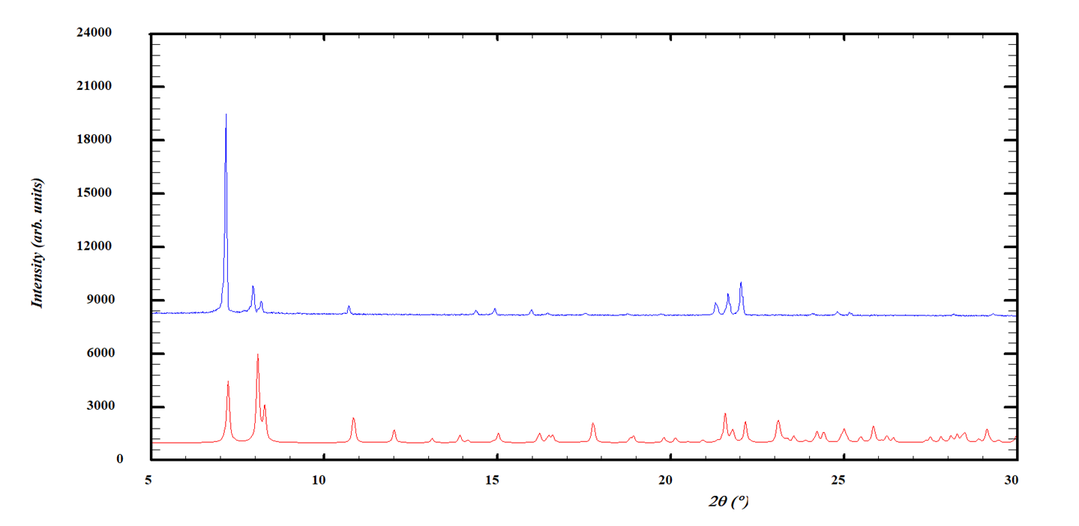Figure S1. Experimental X-ray powder diffraction pattern of [Tb(2-bb)₃]∞ (top) and calculated from the crystal structure X-ray powder diffraction diagram of [Dy(2-bb)₃]∞ (bottom).

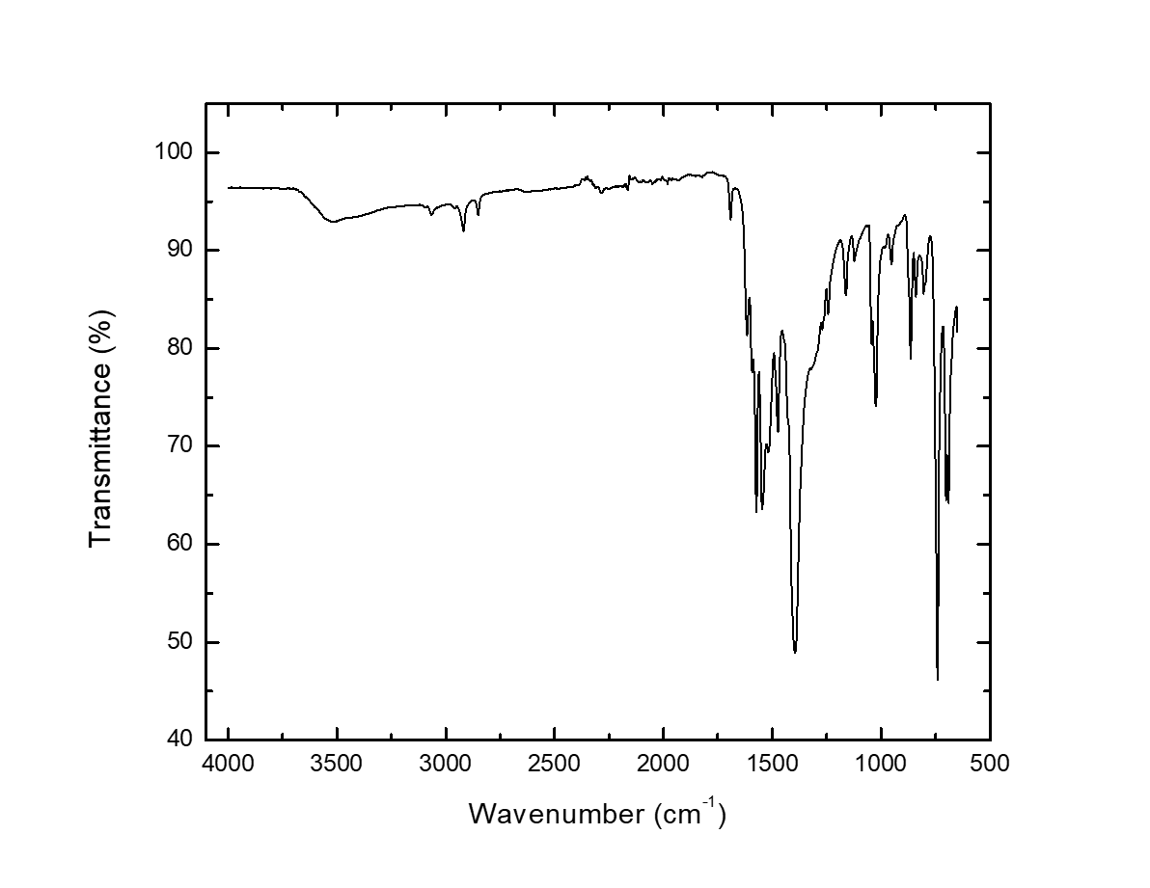
Figure S2. IR spectrum of [Tb(2-bb)₃]∞.

Table S1. Metallic relative contents in [Y_{x}Tb_{1-x}(2-bb)₃]∞ and [Eu_{x}Tb_{1-x}(2-bb)₃]∞ with 0.1 ≤ x ≤ 0.5.
 | [Y_{x}Tb_{1-x}(2-bb)₃]∞
x | Y³⁺ (%) | Tb³⁺ (%)
0.1 | 9(2) | 91(2)
0.15 | 16(2) | 84(2)
0.3 | 28(2) | 72(2)
0.5 | 56(2) | 44(2)
 | [Eu_{x}Tb_{1-x}(2-bb)₃]∞
x | Eu³⁺ (%) | Tb³⁺ (%)
0.1 | 8(2) | 92(2)
0.15 | 12(2) | 88(2)
0.3 | 28(2) | 72(2)
0.5 | 48(2) | 52(2)

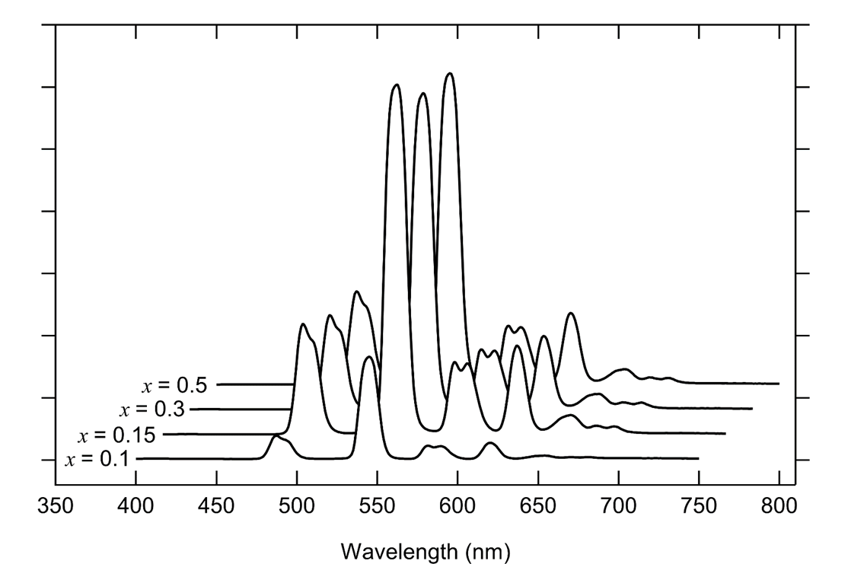
Figure S3. Room temperature solid state emission spectra of [Y_{x}Tb_{1-x}(2-bb)₃]∞ with 0.1 ≤ x ≤ 0.5 (λ_{exc} = 295 nm).

