Development of a wearable framework for the assessment of a mechanical-based indicator of falling risk in the field.

Helene Pillet¹, Bruno Watier²

¹ Arts et Métiers, Institut de Biomécanique Humaine Georges Charpak, Paris, France

² LAAS-CNRS, Université de Toulouse, CNRS, UPS, Toulouse, France
Email: helene.pillet@ensam.eu

Abstract –
This paper presents both normative thresholds of the distance of the Body Center of Mass (BCOM) to the Minimal Moment Axis (MMA) during able-bodied level walking that can be used as a proxy of whole-body angular momentum variations to characterize the instability of gait and a wearable framework to assess this indicator in the field. The results are based on experimental analysis of the gait of able-bodied subject from a motion capture system and on a preliminary comparison of wearable-based against optoelectronic-based assessment of gait instability in one asymptomatic subject and one person with transfemoral amputation.

Keywords: locomotion, gait instability, wearable sensors, falling risk

- Introduction
Quantifying the instability of gait is of crucial importance for the monitoring of falling risk. In the literature, variation of the whole-body angular momentum has been identified as a good mechanical candidate to this aim, but its interpretation can be a bit challenging in a clinical context [1]. In the same time, the ability to compute such indicator in the field is also essential for its implementation in relevant wearable monitoring tools of the actual risk of falling. Thus, there is a need for visual indicator of the mechanics of gait that can be interpreted and understood by clinicians and patients. Contrary to whole body angular momentum, the distance of the Body Center of Mass (BCOM) to the Minimal Moment Axis (MMA) referred hereafter as $d_{BCOM-MMA}$ appears as an alternative easy to represent and accessible in the field [2,3].
The 3D kinetics of the BCoM are usually acquired with either force plates or the combination of inertial models and optical motion capture system (OMCS), generally not available in clinical routine (cost, set-up time, …). Therefore, the use of magneto-inertial measurement units (MIMUs) has been proposed as a wearable alternative for the estimation of BCoM-derived parameters. Shahabpoor et al. proposed a method to select a reduced number of MIMUs for the estimation of vertical BCoM acceleration [4]. This method has been recently extended and validated considering the 3D nature of BCoM movement to obtain accurate 3D BCoM acceleration of one person with transfemoral amputation [5].

The aim of the present abstract is (i) to give the normative thresholds of $d_{BCOM-MMA}$ associated to able-bodied level walking (ii) to describe a framework that could be used to assess $d_{BCOM-MMA}$ from fully wearable sensors and to present bottlenecks that still have to be overcome for the final implementation of this framework.

- Distance of the Minimal Moment Axis to the body Center Of Mass as a proxy of whole body angular momentum variations during locomotion
- Theoretical background
1) Minimal Moment Axis

Contact mechanical actions can be represented at any point $A$, by a force $F$ and a moment $M_{A}$. $F$ and $M_{A}$ define a moment field that can be expressed at any point B as:
$M_{B}= M_{A}+F×P_{\left(A,B\right)}$ (1)
where$P_{(A,B)}$ is the position of $B$ with respect to $A$.
There exists one axis called the Minimal Moment Axis (MMA) such that, at each point of this axis, the moment is collinear to $F$ [6].
Assume that point $Q∈MMA$.
$MMA$ is computed as in [7]:
${∀B in space, ∀Q ∈MMA, P}_{\left(B,Q\right)}=\frac{F×M_{B}}{{\left\|F\right\|}^{2}}+λF, λϵR.$ (2)

2) External mechanical actions during gait

Considering the contact mechanical actions between the foot and the ground during gait and if we now assume that B is the BCoM
${∀Q ∈MMA, P}_{(BCoM,Q)}=\frac{F×M_{BCoM}}{{\left\|F\right\|}^{2}}+λF, λϵR.$ (3)
When $λ=0$, Q is the orthogonal projection of the COM onto $MMA$, and the distance $\left\|P_{(BCoM,Q)}\right\|$ is the minimal distance between $MMA$and the BCoM. The vector $P_{(BCoM,Q)}$ will be called $d_{BCoM-MMA}$ hereafter:
$d_{BCoM-MMA}=\frac{F×M_{BCoM}}{{\left\|F\right\|}^{2}}$ (4)
From equation (4), we compute the Euclidian norm of the distance from BCoM position and force platform data:
$d_{COM-MMA}=\left\|d_{COM-MMA}\right\|=\frac{\left\|F×M_{COM}\right\|}{{\left\|F\right\|}^{2}}$ (5)
Interestingly, it can be noted that this distance can also be linked to the angular momemtum at the BCoM by considering the relation : ${\dot{h}}_{BCoM}=M_{BCoM}$ where ${\dot{h}}_{BCoM}$ is the derivative of the angular momentum. Thus:
$\left\|d_{COM-MMA}\right\|=\frac{\left\|{\dot{h}}_{COM}\right\|∙\left|\sin{θ}\right|}{\left\|F\right\|}$ (6)
With $θ$ is the angle between $F$ and ${\dot{h}}_{COM}$.

- Material and Methods

1) Experimental procedure

The study, under approval of the ethics committee, included 11 able-bodied volunteers. Each volunteer was equipped with 47 retro-reflective skin markers tracked at 200 Hz using a 13 T10 Vicon system (Oxford Metrics, UK). Ground reaction forces and moments (GRF) were simultaneously measured at 2000 Hz by three force plates (AMTI, USA) and filtered with a 4th order Butterworth low-pass filter with a 15 Hz cutoff frequency. Each subject performed several trials at self-selected walking velocity.

2) Data treatment

From GRF, the MMA along which the moment of the external contact forces is minimal was obtained. 3D BCOM position was determined from a regression method. The vector between the BCOM and its projection on the MMA was computed at each instant of time (4), the norm of this vector $d_{BCOM-MMA}$ and its components in the global reference frame denoted as $d_{ML}, d_{AP}, d_{V}$ on the Medio-Lateral, Anterior-Posterior and Vertical axes respectively.

- Normative thresholds of the distance of the Minimal Moment Axis to the body Center Of Mass during able bodied gait

The results confirm that the components of the vector between the BCOM and its projection on the MMA remains low for able-bodied subjects walking on level ground (Table 1). The pattern of $d_{BCOM-MMA}$ (Figure 1) also shows that the norm increases at the end of the single support phase.
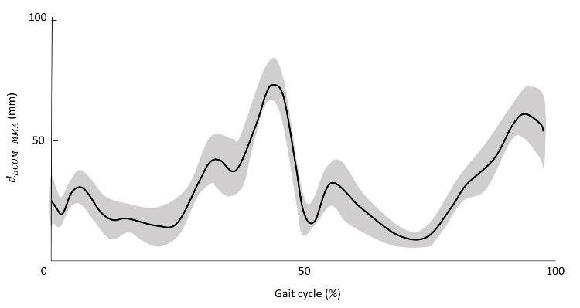
Figure 1: Evolution of $d_{BCOM-MMA}$ over a gait cycle (average and corridor +/-1 standard deviation for the 11 participants)

Table 1: Average and standard deviation for the 11 participants of the ranges of$d_{ML}, d_{AP}, d_{V}$ and $d_{BCOM-MMA}$ in mm
Range (mm) | $$d_{AP}$$ | $$d_{ML}$$ | $$d_{V}$$ | $$d_{BCOM-MMA}$$
Average | 42 | 101 | 7 | 70
Standard deviation | 14 | 14 | 2 | 9

- Wearable framework and Preliminary results
- Framework overview

The developed framework is based on the methodology described by Simonetti et al. [5] to obtain the 3D acceleration of the BCoM. Briefly three steps are necessary: i) computing the 3D acceleration of each segment’s center of mass (sCoM) from MIMUs data, ii) merging sCoM accelerations in a consistent common global frame $R_{G}$, and iii) estimating the 3D BCoM acceleration from a weighted average of selected sCoM accelerations. Adapting the approach from Shahabpoor et al. [4], the trunk, pelvis, thighs and feet were identified as the major contributors in 3D BCoM acceleration in both able-bodied and people with amputation. Therefore, 6 MIMUs, manually aligned with the longitudinal axes of the segments, are adopted. For further details, the reader can refer to Simonetti et al. [5]. From the computation of 3D BCoM acceleration, 3D BCoM velocity and position can be retrieved from an integration process assuming integration constants. The feasibility of such approach has already been demonstrated from force plates data [8]. To determine the distance of the Minimal Moment Axis to the body Center Of Mass, an estimation of the center of pressure would be useful and could be provided by wearable insoles.

- Framework implementation

- Experimental protocol

One male individual with transfemoral amputation (mass: 83 kg, stature: 1.69 m) and one female able-bodied subject (mass: 56 kg, stature: 1.69m) gave their written informed consent to participate in the study. They were instrumented with a full-body marker set [3] and 6 MIMUs (Xsens, 100 Hz) on the feet, thighs, pelvis, and trunk, each mounted on a 3D-printed plastic support with housings for 4 reflective markers. An OMCS (VICON, 200 Hz) recorded the markers’ positions while 4 photographs (front, back, both sides) were taken. Then, starting from a static standing posture, the participant walked at self-selected speed along an 8 m pathway, with 3 force plates (AMTI, 1000 Hz) in the middle. Synchronization between instruments was achieved by a trigger signal. Only trials with three successive foot contacts on the force plates (i.e. a complete stride), were considered for further analysis.

- Preliminary data processing

Data were filtered using a zero-phase 4th-order Butterworth filter (cut-off frequencies identified using a trial-and-error approach: 5 Hz markers and MIMUs, 10 Hz force plates). Reference BCoM acceleration was computed from force plates’ signals.

- Preliminary results and discussion

High consistency between reference and MIMU 3D BCoM acceleration patterns can be observed (Figure 2).
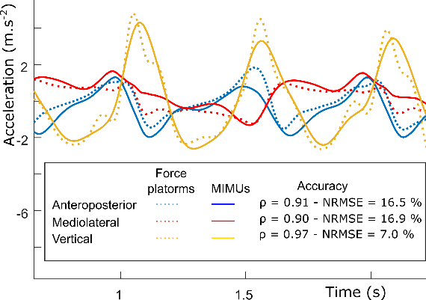
Figure 2: BCoM acceleration obtained with force plates (dotted lines) and MIMUs (straight lines).

- Conclusion and Perspectives
The present article gives two important results. First, reference values of the distance of the Body Center of Mass (BCOM) to the Minimal Moment Axis (MMA) during able-bodied gait are computed and constitute the normative thresholds that could be used to characterize pathological or instable gait. Second, the potential of a fully wearable framework has been demonstrated based on a preliminary experiment with two individuals that revealed very encouraging results for the assessment of 3D BCoM acceleration.
Next steps include the obtention of BCoM trajectory and the synchronization with pressure insoles to estimate the position of the Minimal Moment Axis. The accuracy of these parameters remains to be investigated.

Acknowledgment
This work was supported by the national research agency (ANR), through the projects: ANR-HOBIS [18CE27- 0010] and ANR-COBOT [18CE10 – 0003] and by the Fondation de l'Avenir (grant number AP-RM-20-001)
References
[1] M. Popovic, A. Hofmann, H. Herr, Angular Momentum Regulation during Human Walking: Biomechanics and Control, Robot. Autom. Proceedings. ICRA’04. IEEE Int. Conf. (2004) 2405–2411.
[2] F. Bailly, J. Carpentier, P. Soueres, B. Watier, A human-inspired mechanical criterion for multi-contact locomotion in humanoids To cite this version : A human-inspired mechanical criterion for multi-contact locomotion in humanoids, (2017). https://doi.org/10.13140/RG.2.2.16869.91367.
[3] N. Al-Abiad, H. Pillet, B. Watier, A Mechanical Descriptor of Instability in Human Locomotion : Experimental Findings in Control Subjects and People with Transfemoral Amputation, Appl. Sci. 10 (2020) 1–12. https://doi.org/10.3390/app10030840.
[4] E. Shahabpoor, A. Pavic, Estimation of vertical walking ground reaction force in real-life environments using single IMU sensor, J. Biomech. 79 (2018) 181–190. https://doi.org/10.1016/j.jbiomech.2018.08.015.
[5] E. Simonetti, E. Bergamini, J. Bascou, G. Vannozzi, H. Pillet, Development of a wearable framework for body center of mass acceleration assessment in people with transfemoral amputation, Comput. Methods Biomech. Biomed. Engin. (accepted) (2020). https://doi.org/10.1080/10255842.2020.1816294.
[6] T. Shimba, AN ESTIMATION OF CENTER OF GRAVITY fr ,, (1983).
[7] F.F. Bailly, J. Carpentier, B. Pinet, P. Souères, B. Watier, P. Soueres, B. Watier, A Mechanical Descriptor of Human Locomotion and its Application to Multi-Contact Walking in Humanoids, Proc. IEEE RAS EMBS Int. Conf. Biomed. Robot. Biomechatronics. 2018-Augus (2018) 350–356. https://doi.org/10.1109/BIOROB.2018.8488125.
[8] M.W. Whittle, Three-dimensional motion of the center of gravity of the body during walking, Hum. Mov. Sci. 16 (1997) 347–355. https://doi.org/10.1016/S0167-9457(96)00052-8.

