A Geodata Production System To Allow People To Stay At Home

Alexandre Patarot1A, Nel Samama2

1SNPA, Saint-Junien, France

2Telecom SudParis, Institut Polytechnique de Paris, Palaiseau, France

nel.samama@telecom-sudparis.eu

***Abstract - The well-being of people depends in part on the sense of freedom, and one aspect is certainly the possibility for people to remain at home. However, there is a need for “following” the movements and, if possible, the activity of the person. The problem is that very few home systems make it possible to have these data at a reasonable price, and at an acceptable reliability level. We offer a simple to use, reliable and energy self-sufficient person location system. People are the first "targets", but objects could be involved. The system is described and their performance analyzed in real conditions of use. In addition, person’s activity is also investigated and coupled to some home automation devices.***

***Keywords: geo data, self-sufficient system, person’s activity sensing, stay at home.***

1. Introduction

The two aspects covered here are the location and determination of the activity. These two areas have been actively addressed in the scientific literature and our differentiator lies mainly in the simplicity of implementation and analysis of the system. Approaches using vision [9],[10] are based on heavy image processing and do not ensure the anonymity of individuals in a satisfactory way. Other systems use ZigBee [1] or passive RFID [11] and analyze connectivity or consumption data to determine activity and position. The case of several people and objects is therefore delicate. Many studies also deal with smart floors [2],[6],[12] and mainly expose methods allowing to recognize several people and their activities by analyzing the loads observed on the ground. We propose for our part a simplified analysis of the radio signals that we make reliable by a coupled approach of mapping and Bluetooth signals. Moreover, the person or object is only equipped with a simple tag, unlike systems based on many sensors carried by the individual [8]. Some approaches, still based on radio measurements, propose to determine people's posture and position either over long periods of time [4] or using very wideband signals [7] that are nevertheless sensitive to the indoor environment.

Our approach provides simplicity of implementation and very high reliability in real time, without aiming for high accuracy in all cases. Conceptually taking into account the high variability of indoor radio measurements makes it possible to significantly increase the reliability of the geo-data produced.

1. Description of the approach
2. *Introduction*

The approach we propose is based on the coupling between object-oriented mapping and a radio location system using Bluetooth modules. This last part might seem very (too?) classic, but we still propose some major innovations. First, the modules are integrated into power-supplied elements such as sockets or lights, making them energy self-sufficient. Then, the location is of a "symbolic" type (see II.B). The combination of these characteristics results in a positioning that is characterized by its very high reliability.

Our overall approach to such a system can be broken down into a few actions, as follows:

1. Mapping of buildings and site: this point is absolutely fundamental. It is intuitive to consider that it is important to have a map of the places you are travelling in to help you find your way around. However, the construction of the mapping is in our case closely linked to the quality of the positioning because it takes into account the physical location of the building.

2. Deployment of the positioning and location system: our algorithms closely intertwine radio signal reception and mapping to produce a result whose main quality is very high reliability. Positioning is provided in terms of "zone" of presence.

3. The recovery of data transmitted by all kinds of "wearables" (smartphones, watches, necklaces, pins, specific devices, etc...). It should be noted that the confidentiality of people is preserved because we only track technical device numbers. Only the people have, locally, the correspondence between these numbers and what they do with the "wears", so that this data remains the property of the people.

4. The visualization of the person’s and objects positions on a graphical interface, managed by the person’s itself.

1. *Radio modules and cartography*

The Bluetooth Low Energy (BLE) modules are incorporated in the sockets in the rooms and in the living rooms, and in the light bulbs in the kitchen and the bathroom. Their locations are included in the cartography in order to allow the symbolic approach to be easily implemented without any further required actions.

Several architectures are possible in order to carry out the measurements and then send the information to a location server that determines the symbolic position of the module (this allows to improve the algorithms without having to intervene on site). In this case, it is the "wear" module worn by the person who emits a signal. The latter is picked up by the modules located in the sockets and which send this data back to the server (via mesh network).

The position is then available by simply accessing the server. This architecture allows any device with access to our server to know its position in order to access services: map of wear positions, time spent in a room, duration of inactivity, etc. Although unnecessary in this case, navigation to any destination is of course one of the possible services.

1. *The localization engine*

Despite some rather good results from traditional approaches, our feeling is that WiFi/Bluetooth positioning is a delicate task in terms of absolute XY (and perhaps Z) coordinates. Approaches based on the use of power levels (RSSI: Received Signal Strength Indicator) depend on the interior configuration and are not easily transposable to another building. They require investment in terms of information collection during the calibration phase, then in terms of processing when calculating the position, without taking into account the essential redundancy with respect to the system required for telecommunications applications (number of stations).

However, it is quite clear to the observer of these power levels, for example, whether he enters or leaves a room. Based on this, we believe that a symbolic positioning (room, office, corridor, etc.) could be a better approach. This method requires only simple algorithms and is robust (compared to new types of environments or limited infrastructure). The idea is schematized in Figure 1.

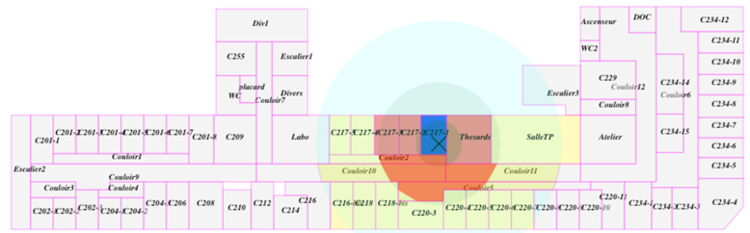

Figure 1. Philosophy of the symbolic positioning

The principle of our “symbolic” positioning is briefly described hereafter.

In order to define the various zones, there is a need for an "automatic" algorithm that could be used in all kind of environments. The main idea relies on the concept of “adjacencies”, but is also associated to the sizes of the various rooms. Once the location of a radio module is defined, we are going to determine three zones as follows:

* Zone 1 is defined as being the zone where the module lies, limited to a radius of R1 meters for rooms of a size greater than, say SurfMaxZ1. As a matter of fact, this has to be taken into account for the specific case of very large rooms, such as large living rooms where propagation is almost identical to outdoors in the vicinity of the AP. For this specific implementation, R1 is taken to be equal to 4 meters and SurfMaxZ1 is 50 m2. Thus, for example, for rooms greater than 50 m2, Zone1 is limited to a circle of 4 meters of radius. Figure 2 gives a view of Zone1 for a module located in a long corridor.



Figure 2. Zone 1 (in red) for the module in black, located in the mddle of the corridor.

* Zone 2 includes zone 1 and adds to it all the adjacent areas to zone 1. See figure 3 for details. Note that similar rules apply regarding the sizes of the various rooms. The fundamental aspect is here to understand that zone 2 includes zone 1. Without this taken into account, the algorithm will not work correctly.



Figure 3. Zone 2 for the module in black.

* Zone 3 includes zone 2 and adds to it all the adjacent areas to areas in zone 2. See figure 4 for details.



Figure 4. Zone 3 for the module in black.

This approach involves dividing the space into symbolic surfaces, designated by rooms, offices or corridors. The very specific size and shape of some parts led us to take into account their specificities, in particular with regard to their surfaces as well as to define a spatial neighborhood graph allowing us to specify the spatial organization of the parts (and in particular the neighbors). Figure 1 also shows the estimated coverage of a WiFi/Bluetooth access point positioned in 2C217-1. This coverage is the result of the abovementioned algorithm.

In our present case, the wear is transmitting and the modules are receiving the signal. Thus, one has to reverse the above description: depending on the received power from the wear, each module defines a zone where the wear should be (note that the symbolic approach allows a very high reliable positioning system, although not always an accurate one).

When considering several receiving modules, the resulting positioning is obtained by intersecting the various zones from the different modules. Such a result is illustrated in Fig. 5.

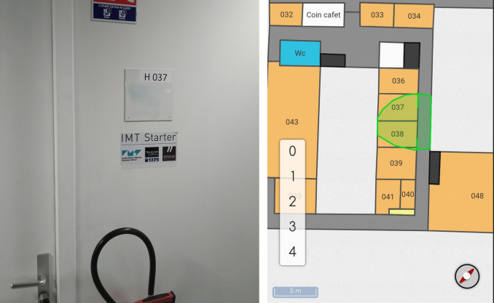

Figure 5. The coupling principle between the cartography and the localization: the green surface is the resulting localization and requires no calibration or model design. On the left hand side the picture of what the smartphone "sees" and on the right hand side the restitution of the proposed system

As already stated, there is a tight coupling between the cartography and the localization engine. Thus it is not necessary to try to design a propagation model that will be defective at the first modification of the environment, or to map the received power levels, which will also have to be regularly updated to maintain its quality. The principle of this coupling is shown in Figure 5.

1. *The possible “wears”*

The different possible portable devices cover a wide range of devices, from pins to smartphones, or to any specific devices. In medical facilities such as EPHAD or hospitals, these are mainly bracelets, necklaces or pins provided to pa-tients/residents. In the case of a need for data visualization or guidance/navigation, it is then very simple to couple these devices with a smartphone for example. Note that a smartphone can also be the "wearable", or a wristband (Fig. 6).

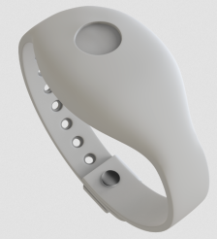

Figure 6. A possible wearable for hospitals: a wristband

Edouard did not like to have to wear a wristband and preferred to have a necklace, as the one shown in Fig. 7.

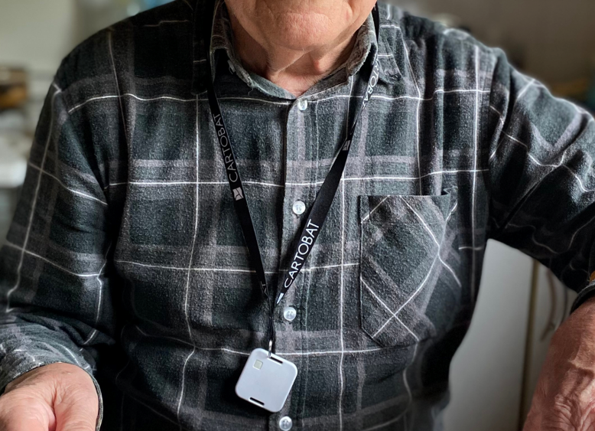

Figure 7. The necklace worn by Edouard at home

1. *The global architecture of the complete system*

The network architecture of the system is briefly shown in Figure 8.

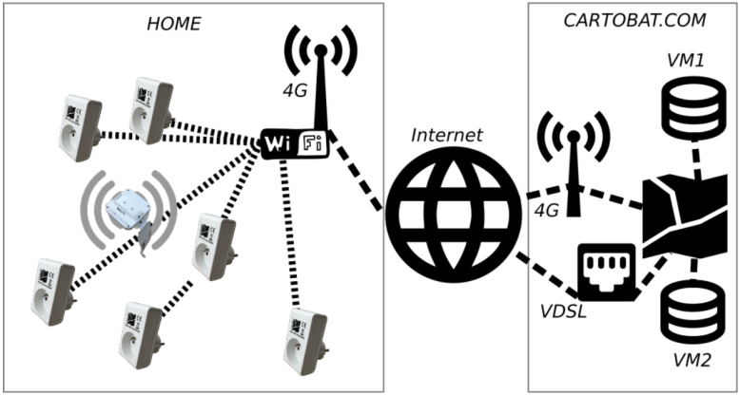

Figure 8. Network architecture of the system

At Edouard's home, the modules are deployed inserted in sockets. The latter remain usable because the modules are "staggered" (Fig. 9). The modules are sensors of BLE signals emitted by the wear worn by Edouard. The modules are also connected to the internet box of the latter.

Several connection modes to Cartobat servers are possible Several connection modes to Cartobat servers are possible (4G, VDSL, etc.) and the data is then stored on virtual servers and duplicated to reduce the risk of data loss. When the data is "sensitive", such as health data, it is also at least anonymized or even encrypted.

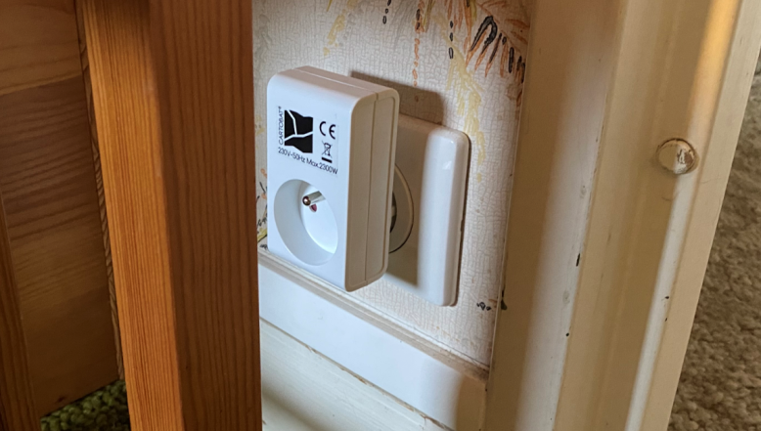

Figure 9. A typical module

1. The evaluation environment considered

The house set-up is shown in Figures 10 and 11. It is a classic house in the countryside of France with a living room, a dining room, three bedrooms, an office, a bathroom and a kitchen for a total of about 80 square meters.

The red pictograms represent the connected sockets that allow the person to be located in real time. Some wears were also deployed on everyday objects such as car and house key chains, as well as in the jacket and coat usually used by the person.

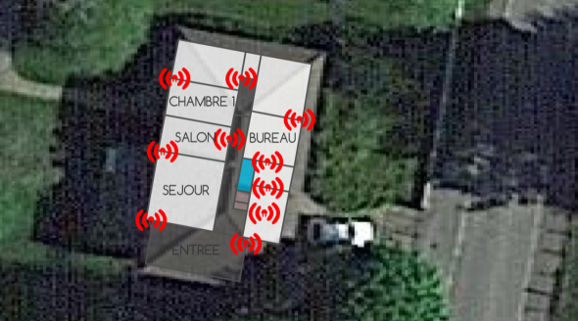

Figure 10. The localization set-up of the house

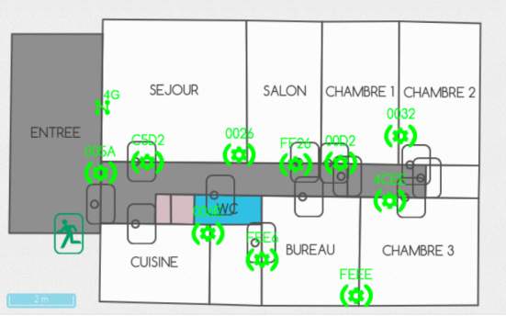

Figure 11. The localization deployed socket of the house

1. The obtained results

Our goal was to design a system to produce geo-location data. The exploitation and processing of these data is not our specialty but we propose here some tracks.

First of all, a screen allows to visualize in real time all the data of the system (Fig. 12): date and time of the last detection of the wear, state of its battery, estimated position, quality of the received signal, etc. This allows a continuous management of both the "network" aspects of the system and the follow-up of the patients (Edouard was alone in this case) This allows a continuous management of both the "network" aspects of the system and the follow-up of the patients (Edouard was alone in this case).

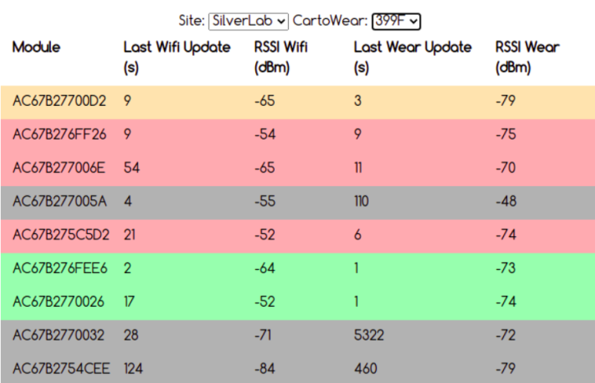

Figure 12. A screenshot of the system interface

The first one consists of visualizing, in real time, the position of the wear on the house plan (Fig. 13). Indeed, it should be noted that it is the wear that is followed and not Edouard. In principle, both are supposed to be in the same place, but this may not be the case. If there is any doubt about the fact that the wear is well worn, or if the stationarity of the wear seems abnormal, it will probably be necessary to try to contact Edouard by phone for example.

A second way is to plot daily, weekly or monthly presence rates in the different rooms of the house (Fig. 14). The long-term analysis of these data by current Artificial Intelligence techniques will then most probably allow to derive habits or on the contrary to generate alarms in case of anomalies. Figure 14 gives a typical example of a Wednesday in April 2020.

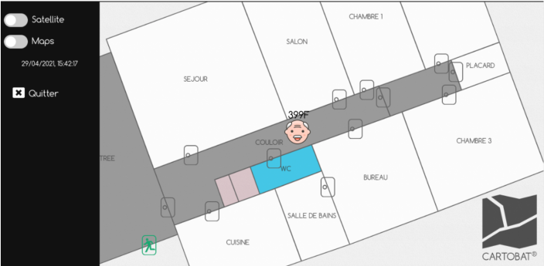

Figure 13. The localization of Edoaurd in real time

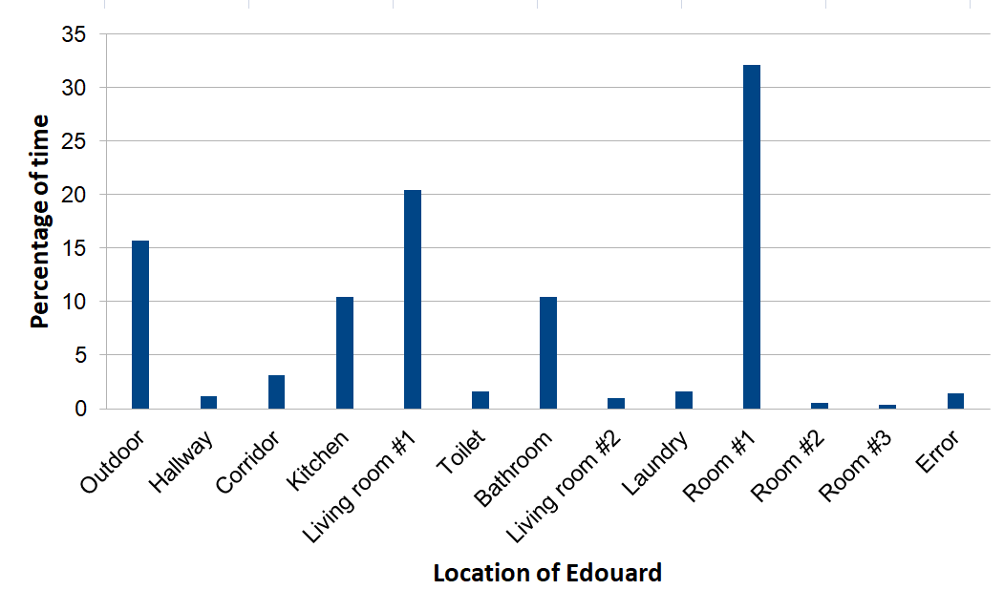

Figure 14. A typical daily activity

Of course, all these data are available for further analyses. Another very simple possibility is to define the times when the wear is not detected: Edward is then out, either in the garden, a little far from the house, or to go shopping.

A few other results are also possible, like for example:

➢ determination of periods of physical inactivity

➢ evaluation of the daily distance travelled

➢ coupling of activity data with location and duration

➢ analysis of the stationarity of car and house keys and correlation with the person's activity

A coupling could also be envisaged with some home automation installations such as the automatic shutdown of equipment when the person leaves the kitchen for example, unless specific action is taken by the person.

1. Synthesis and Conclusion

In this paper, we have presented a system for producing geo-data that allows us to know the position of people or objects in the home, but also to produce some analyses of their behavior. The results are based on an implementation in real conditions for a 75-year-old man living alone in an isolated region of central France.

Acknowledgment

We want to thank Edouard who accepted to test the system for a few months. Edouard is a 75 years old man who lives alone in a mid-size house located in the center of France. He is in good health, thus the presented results are probably not representative of an elderly person with medical handicaps, but allow us to set-up the system in a real environment and extract some statistics from its use.

References

[1] V. Bianchi, P. Ciampolini and I. De Munari, "RSSI-Based Indoor Localization and Identification for ZigBee Wireless Sensor Networks in Smart Homes," in IEEE Transactions on Instrumentation and Measurement, vol. 68, no. 2, pp. 566-575, Feb. 2019.

[2] M. Andries, O. Simonin and F. Charpillet, "Localization of Humans, Objects, and Robots Interacting on Load-Sensing Floors," in IEEE Sensors Journal, vol. 16, no. 4, pp. 1026-1037, Feb.15, 2016.

[3] A. Hadj Henni, R. Ben Bachouch, O. Bennis and N. Ramdani, "Enhanced Multiplex Binary PIR Localization Using the Transferable Belief Model," in *IEEE Sensors Journal*, vol. 19, no. 18, pp. 8146-8159, 15 Sept.15, 2019.

[4] N. Patwari, L. Brewer, Q. Tate, O. Kaltiokallio and M. Bocca, "Breathfinding: A Wireless Network That Monitors and Locates Breathing in a Home," in IEEE Journal of Selected Topics in Signal Processing, vol. 8, no. 1, pp. 30-42, Feb. 2014.

[5] A. L. Ballardini, L. Ferretti, S. Fontana, A. Furlan and D. G. Sorrenti, "An Indoor Localization System for Telehomecare Applications," in IEEE Transactions on Systems, Man, and Cybernetics: Systems, vol. 46, no. 10, pp. 1445-1455, Oct. 2016.

[6] G. Feng, Y. Yang, X. Guo and G. Wang, "A Smart Fiber Floor for Indoor Target Localization," in IEEE Pervasive Computing, vol. 14, no. 2, pp. 52-59, Apr.-June 2015.

[7] J. Sachs and R. Herrmann, "M-sequence-based ultra-wideband sensor network for vitality monitoring of elders at home," in IET Radar, Sonar & Navigation, vol. 9, no. 2, pp. 125-137, 2 2015.

[8] J. Wang, Z. Zhang, B. Li, S. Lee and R. S. Sherratt, "An enhanced fall detection system for elderly person monitoring using consumer home networks," in IEEE Transactions on Consumer Electronics, vol. 60, no. 1, pp. 23-29, February 2014.

[9] M. Yu, Y. Yu, A. Rhuma, S. M. R. Naqvi, L. Wang and J. A. Chambers, "An Online One Class Support Vector Machine-Based Person-Specific Fall Detection System for Monitoring an Elderly Individual in a Room Environment," in IEEE Journal of Biomedical and Health Informatics, vol. 17, no. 6, pp. 1002-1014, Nov. 2013.

[10] D. Anderson, R. H. Luke, J. M. Keller, M. Skubic, M. J. Rantz and M. A. Aud, "Modeling Human Activity From Voxel Person Using Fuzzy Logic," in IEEE Transactions on Fuzzy Systems, vol. 17, no. 1, pp. 39-49, Feb. 2009.

[11] L. Yao et al., "Compressive Representation for Device-Free Activity Recognition with Passive RFID Signal Strength," in IEEE Transactions on Mobile Computing, vol. 17, no. 2, pp. 293-306, 1 Feb. 2018.