Layered Vanadium Phosphates as Electrodes for Electrochemical Capacitors
Part II: The Case of VOPO₄•CTAB and K_{0.5}VOPO₄•1.5H₂O

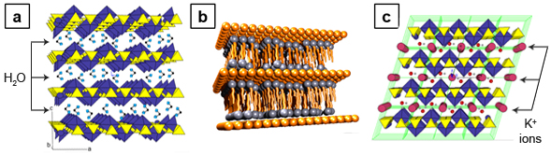
Figure SI1. Crystalline structure of a) VOPO₄•2H₂O b) VOPO₄•CTAB intercalated CTAB molecules into the crystalline structure (orange spheres represents VOPO₄ units) and c) K_{0.5}VOPO₄•1.5H₂O (large red spheres represents K⁺ ions).

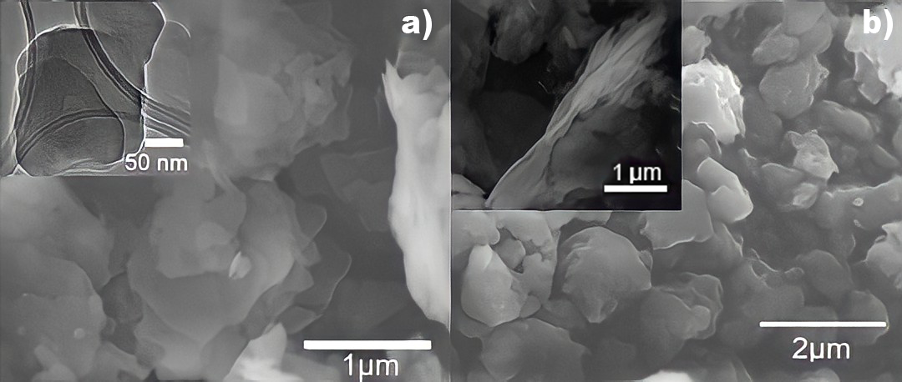
Figure SI2. a) SEM image of VOPO₄•CTAB and inset TEM image. b) SEM image of K_{0.5}VOPO₄•1.5H₂O

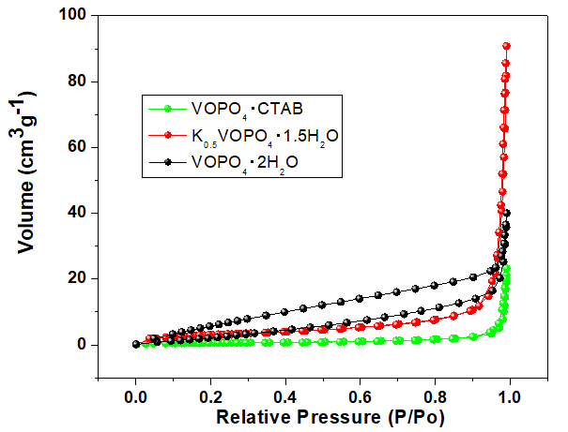
Figure SI3. Adsorption-desorption isotherms of VOPO₄•CTAB, K_{0.5}VOPO₄•1.5H₂O and VOPO₄•2H₂O.

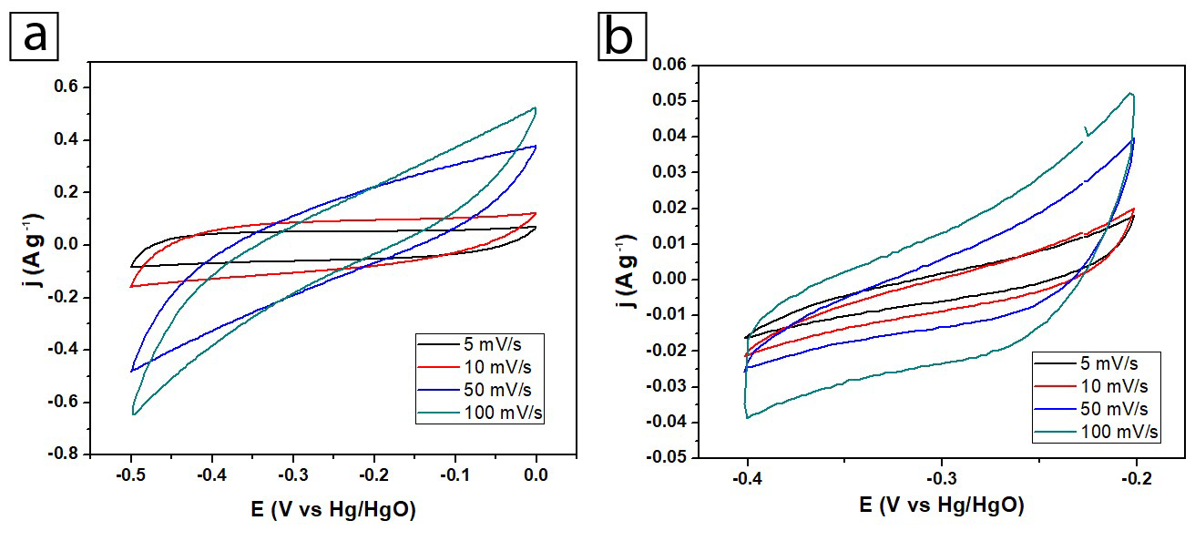
Figure SI4. CV evolution vs scan rate of VOPO₄•CTAB in a) 3M LiOH and b) 3M KOH.

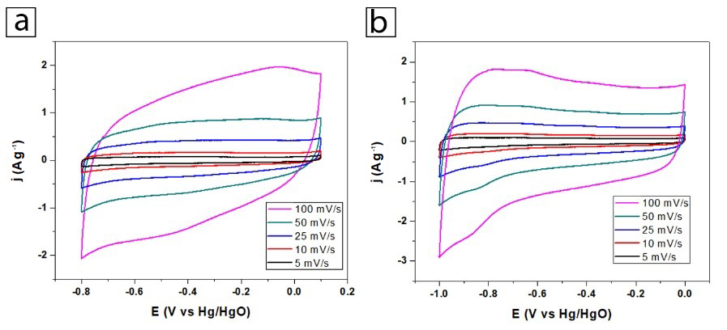
Figure SI5. CV evolution vs scan rate of K_{0.5}VOPO₄•1.5H₂O in a) 3M LiOH and b) 3M KOH.

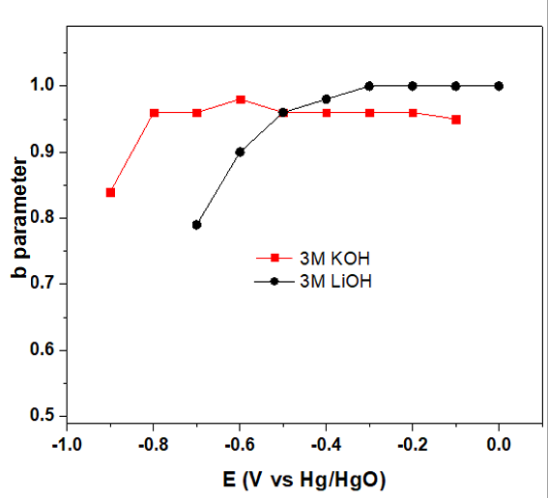

Figure SI6. The b parameter in different electrolytes for K_{0.5}VOPO₄•1.5H₂O in 3M LiOH, and 3M KOH.

The Trasatti and Dunn methods

In order to estimate the charge that arise from electric double layer (EDL), pseudocapacitive and Faradaic processes, the Trasatti method [1], and Dunn method [2] are coupled as follow.

In the Trasatti method, the total stored charge relies on the outer surface charge attributed to only the electric double layer and the inner charge is attributed to both pseudocapacitive and Faradaic process (see equation 1).
q_{T} = q_{O} + q_{i} (1)
q_{O} is obtained from the intercept of the linear plot of the voltammetric charge q(V), versus the sweep rate v^{-1/2}, when v → ∞ (see equation 2).
q(V) = q_{O} + C₁v^{-1/2} (2)
The total charge, q_{T} is obtained from the intercept of the linear plot of q(V)⁻¹ versus v^{1/2} when v → 0 (see equation 3).

$\frac{1}{q\left(V\right)}=\frac{1}{q_{T}}+C_{2}v^{12}$ (3)

This method allows to estimate the charge that arise from the electric double layer process and the total charge. Subtracting the double layer charge from the total charge leads to the inner charge that could be composed at least by one of the two processes, pseudocapacitive or Faradaic.

Dunn method allows to estimate the capacitive charge that involves the electric double layer and pseudocapacitive process and the charge that arise from diffusion-dependent processes like ion intercalation. The capacitive and pseudocapacitive current is proportional to v, the scan rate and the diffusion limited current to v^{1/2}. Thus, the current is the combination of the above process as equation 4 shows. The rearrangement in equation 5 allows to estimate the two constants, k₁ from the slope and k₂ from the intercept of the plot i(V)v^{-1/2} versus v^{1/2} at each fixed potential. The origin of the current and thus the origin of the charge can be known at each potential step.

i(V) = k₁v + k₂v^{1/2} (4)
$\frac{i\left(V\right)}{v^{1/2}}=k_{1}v^{1/2}+k_{2}$ (5)

The deconvolution of the three charge storage processes can be achieved by subtracting the charge of the electric double layer estimated with the Trasatti method from the capacitive charge obtained with Dunn method (that includes EDL and pseudocapacitive charge). This leads to calculated values of the EDL, pseudocapacitive and Faradaic charge [3].

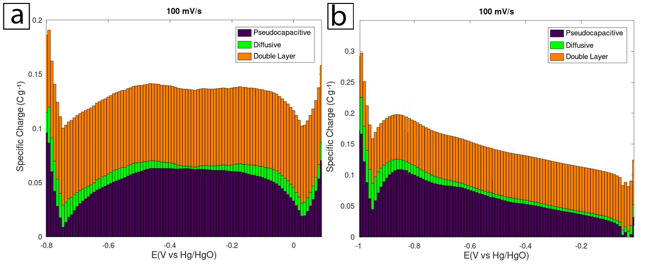
Figure SI7. Specific charge of K_{0.5}VOPO₄•1.5H₂O originated from EDL, pseudocapacitive and diffusive processes at 100 mVs⁻¹ as a function of the applied voltage in a) 3M LiOH, and b) 3M KOH.

Active Thickness

The calculation of the active thickness was achieved using the equation 6, considering one-electron process.
$Active Thickness= \frac{Q_{D}*MM}{S*F*ρ }$ (6)

Where “Q_{D}” is the diffusive charge in Cg⁻¹, “S” is the specific surface area of the active material in gcm⁻², “MM” the molecular weight in gmol⁻¹, “F” the Faraday constant and ρ the density of the active material in gcm⁻³.

References

- S. Ardizzone, G. Fregonara and S. Trasatti. “Inner and Outer active surface of RuO2 electrodes. Electrochemical Acta, 35 , 263, (1990).
- Torsten Brezesinski, John Wang, Julien Polleux, Bruce Dunn and Sara H. Tolbert. J. Am. Chem. Soc. 131, 1802-1809, (2009).
- J. Zúñiga, S. González, E. Le Calvez, R. Lucio Porto, I. Moreno, T. Brousse, L. López Pavón, J. Electrochem. Soc. 168, 070531 (2021).

