SUPPORTING INFORMATION

Supplementary Figure 1. Hierarchical structure of the data
Supplementary Figure 2: Flow chart.
Supplementary Table 1: Incidence rate ratios estimating the effect of patient characteristics (individual and customer effects) on the waiting list registration rate (per 1,000 months of dialysis): results of Model 2 with a network random effect and transplant center random effect) according to age group.
Supplementary Table 2. Clinical characteristics of patients registered before the start of dialysis and patients registered in the first year after starting dialysis.
Supplementary Table 3. Estimation of variability in the network random effect according to time of registration (before or after starting dialysis) for the whole cohort and for two age groups. The number of patients registered in the oldest group (75-84 years old) was too small for subgroup analysis.
Supplementary Figure 3. Scatter plots representing the registration rate of each network according to each age group on the vertical axis and the mean age of patients in the network on the horizontal axis.
Supplementary Figure 4. Scatter plots representing the registration rate for each network according to each diabetes group on the vertical axis and the proportion of diabetic patients in the network on the horizontal axis.

Supplementary Figure 1 : Hierarchical structure of data
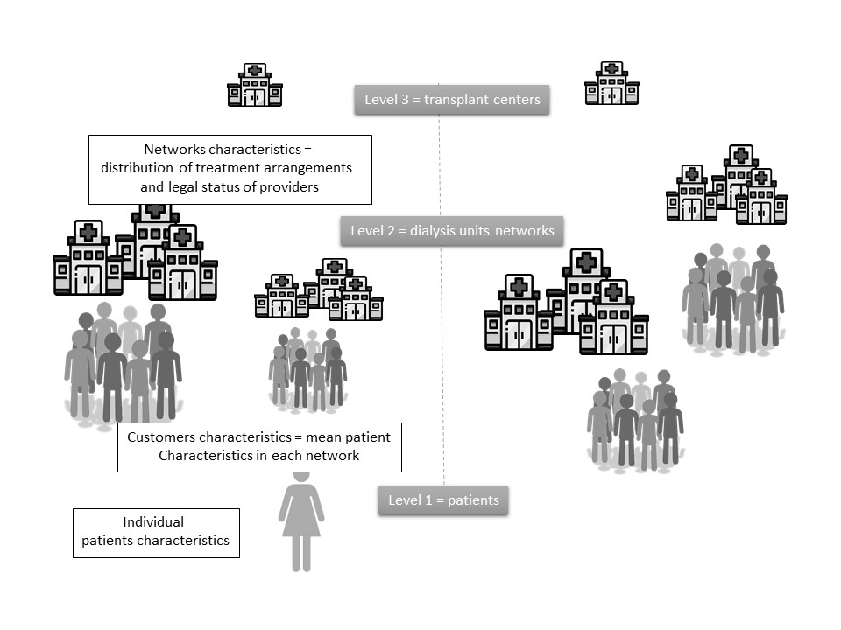

Supplementary Figure 2 : Flow Chart

21 815 incident patients starting a dialysis treatment during the period 2016 -2017 in France

Not listed at 1 year, N = 12 456

Excluded patients
Paediatric patients < 18 yrs, n = 171
Elderly patients >85 yrs, n= 3 670
Patients in overseas dialysis units, n = 1 041
Patients treated in units that were not affected to a network or early loss to follow-up n= 91

16 842 incident patients on dialysis during the period 2016 -2017

Listed on the waiting list during the 1st year, N = 2 423
Listed on the waiting list before starting dialysis, N = 1 963
Supplementary Table 1. Incidence rate ratios estimating the effect of patient characteristics (individual and customer effect) on the waiting list registration rate (per 1,000 months of dialysis): results of Model 2 with network random effect and transplant center random effect) according to age group.
 | 18-64 years |  |  | 65-74 years |  |  | 75-84 years
Number of patients | 5644 |  |  | 5336 |  |  | 5862
Mean age (SD) years | 52.0(10.8) |  |  | 70.3(2.76) |  |  | 80.2(2.89)
Number of registrations (%) | 2880 (51%) |  |  | 1206 (23%) |  |  | 300 (5%)
 | IRR | 95%CI |  | IRR | 95%CI |  | IRR | 95%CI
Patient effect
Age (+1SD) | 0.89 | 0.82 | 0.96 | 0.73 | 0.64 | 0.84 | 0.14 | 0.10 | 0.21
No Obesity | 2.32* | 1.70 | 3.16 | 3.71 | 2.32 | 5.95 | 19.67 | 3.66 | 105.83
No Heart failure | 1.54 | 1.15 | 2.05 | 1.94 | 1.33 | 2.84 | 9.92 | 4.01 | 24.57
No Peripheral vascular disease | 1.83 | 1.33 | 2.52 | 2.22 | 1.55 | 3.18 | 3.66 | 1.64 | 8.15
No Cerebrovascular disease | 1.78 | 1.24 | 2.56 | 1.33 | 0.87 | 2.02 | 2.04 | 0.77 | 5.42
No Arrhythmia | 1.51 | 1.06 | 2.16 | 1.04 | 0.73 | 1.49 | 1.31 | 0.66 | 2.60
No Cardiovascular disease | 1.52 | 1.14 | 2.02 | 1.36 | 0.98 | 1.88 | 1.08 | 0.52 | 2.23
No Diabetes | 1.50 | 1.24 | 1.82 | 1.84 | 1.39 | 2.44 | 1.42 | 0.78 | 2.59
Walk without help | 5.10 | 3.21 | 8.10 | 7.01 | 3.85 | 12.76 | 13.80 | 3.44 | 55.26
No Active malignancy | 6.33 | 4.14 | 9.69 | 5.08 | 3.20 | 8.08 | 5.21 | 1.86 | 14.63
No Pulmonary disease | 1.81 | 1.35 | 2.44 | 1.83 | 1.27 | 2.66 | 1.52 | 0.66 | 3.50
No Behavioural disorder | 5.67 | 2.83 | 11.35 | 2.92 | 1.23 | 6.94 | 1.83 | 0.24 | 14.01
Emergency initiation | 0.37 | 0.30 | 0.44 | 0.24 | 0.17 | 0.33 | 0.10 | 0.04 | 0.25
Patient's refusal to be listed | 0.04 | 0.02 | 0.09 | 0.04 | 0.02 | 0.08 | 0.22 | 0.06 | 0.76
No Denutrition | 1.19 | 1.01 | 1.40 | 1.88 | 1.42 | 2.48 | 1.66 | 0.91 | 3.01
No Liver disease | 2.06 | 1.37 | 3.10 | 1.90 | 1.02 | 3.57 | 2.35 | 0.30 | 18.44
eGFR<8 ml/min | 1.00 | 0.84 | 1.18 | 1.25 | 0.95 | 1.65 | 1.70 | 0.93 | 3.10
Customer effect
Age (+1SD) | 0.97 | 0.93 | 1.02 | 0.12 | 0.01 | 1.84 | 0.88 | 0.39 | 2.01
No Obesity | 1.35** | 1.12 | 1.62 | 1.12 | 0.95 | 1.33 | 1.14 | 0.52 | 2.48
No Heart failure | 1.09 | 0.96 | 1.23 | 1.00 | 0.85 | 1.18 | 1.28 | 0.90 | 1.82
No Peripheral vascular disease | 0.97 | 0.83 | 1.14 | 0.70 | 0.52 | 0.94 | 1.20 | 0.88 | 1.66
No Cerebrovascular disease | 1.00 | 0.82 | 1.21 | 1.21 | 1.00 | 1.46 | 0.77 | 0.41 | 1.43
No Arythmia | 1.20 | 1.00 | 1.45 | 1.07 | 0.88 | 1.29 | 1.21 | 0.83 | 1.76
No Cardiovascular disease | 0.92 | 0.80 | 1.07 | 1.22 | 0.99 | 1.49 | 1.03 | 0.67 | 1.59
No Diabetes | 1.09 | 0.96 | 1.23 | 0.74 | 0.58 | 0.93 | 1.00 | 0.64 | 1.56
Walk without help | 1.06 | 0.88 | 1.27 | 0.82 | 0.65 | 1.03 | 1.26 | 0.86 | 1.84
No Active malignancy | 1.06 | 0.84 | 1.33 | 0.93 | 0.76 | 1.13 | 1.28 | 0.72 | 2.26
No Pulmonary disease | 1.07 | 0.90 | 1.26 | 0.75 | 0.48 | 1.19 | 0.98 | 0.64 | 1.50
No Behavioural disorder | 1.84 | 1.37 | 2.46 | 1.04 | 0.89 | 1.23 | 1.03 | 0.32 | 3.33
Emergency initiation | 1.00 | 0.91 | 1.09 | 0.54 | 0.36 | 0.81 | 0.73 | 0.53 | 1.00
Patient's refusal to be listed | 0.48 | 0.35 | 0.65 | 0.99 | 0.87 | 1.14 | 1.12 | 0.55 | 2.29
No Denutrition | 1.02 | 0.95 | 1.10 | 0.75 | 0.53 | 1.07 | 1.27 | 0.96 | 1.68
No Liver disease | 1.02 | 0.82 | 1.27 | 0.99 | 0.87 | 1.13 | 0.89 | 0.26 | 3.03
eGFR<8 ml/min | 1.08 | 0.99 | 1.17 | 1.00 | 1.00 | 1.00 | 1.21 | 0.93 | 1.58
Reading key :
Cells are in gray when the effect is not significant.
* In young patients, the registration rate for a patient without obesity is twice as high compared to a patients with obesity.
** In young patients, the registration rate increases by 35% when the proportion of obese patients in the network decreases by 10%.

Supplementary Table 2. Clinical characteristics of patients registered before starting dialysis and patients registered in the first year after starting dialysis.
 | Registered after starting dialysis | Preemptive registration
N | 2423 | 1963
Age (years)
18-44 | 23.5 | 17.9
45-64 | 43.1 | 46.6
65-74 | 26.7 | 28.4
75-84 | 6.6 | 7.1
Male | 67.9 | 61.1
Diabetes | 35.8 | 23.8
Heart failure | 11.1 | 7.1
Cardiovascular disease | 14.3 | 11.1
Arryhthmia | 8.1 | 7.3
Cerebrovascular disease | 5.9 | 5.9
Peripheral vascular disease | 10.6 | 6.8
Pulmonary disease | 9.1 | 6.8
Active malignancy | 2.7 | 4.2
Liver disease | 5.0 | 2.8
Behavioural disorder | 1.1 | 1.2
Walk without help | 97.2 | 98.0
Denutrition | 44.6 | 45.7
Obesity | 5.7 | 5.4
EGFR<8 ml/min | 59.1 | 55.9
Emergency initiation | 25.9 | 8.3

Supplementary Table 3. Estimation of variability in the network random effect according to time of registration (before or after starting dialysis) for the whole cohort and for two age groups. The number of patients registered in the oldest group (75-84 years old) was too small for subgroup analysis.
 | 18-84 years | 18-64 | 65-74
 | Cohort registered before starting dialysis
Number of registrations (%) | 1963 (12%) | 1266 (22%) | 558 (10%)
Model 0 random network effect and no fixed effects | 0.83 (0.17) | 0.65 (0.16) | 0.75 (0.33)
Model 1 random network effect and fixed effects from Level 1 (patient characteristics) and Level 2 (customer characteristics) | 0.80 (016) | 0.50 (0.15) | 1.21 (0.42)
 | Cohort of patients registered after starting dialysis
Number of registrations (%) | 2423 (14%) | 1614 (29%) | 648 (12%)
Model 0 random network effect and no fixed effects | 0.33 (0.07) | 0.11 (0.05) | 0.28 (0.16)
Model 1 random network effect and fixed effects from Level 1 (patient characteristics) and Level 2 (customer characteristics) | 0.32 (0.07) | 0.05 (0.04) | 0.22 (0.15)

Supplementary Figure 3. Scatter plots representing the registration rate of each network according to each age group on the vertical axis and the mean age of patients in the network on the horizontal axis.
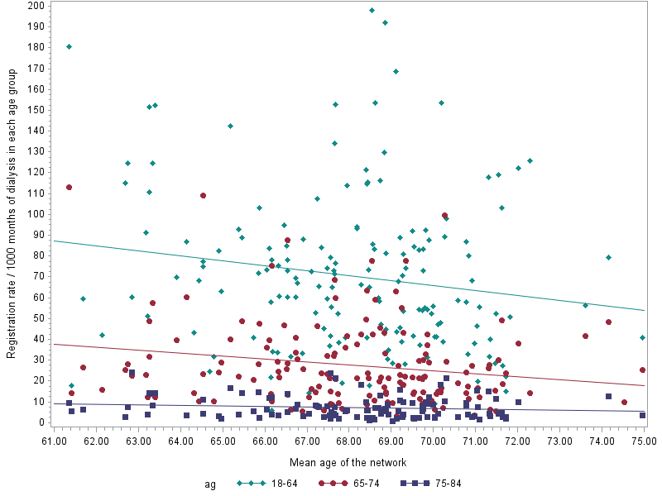
Reading key :
The level of registration rates are higher on the left of the figure = In networks with young patients, the registration rate is higher, even for older patients.
The slope for young patients (green) is steeper compared to the slope for older patients (red) = Networks with young patients tend to favour young patients for registration.

Supplementary Figure 4: Scatter plots representing, on the vertical axis, the registration rate of each network according to each diabetes group and, on the horizontal axis, the proportion of diabetic patients in the network.

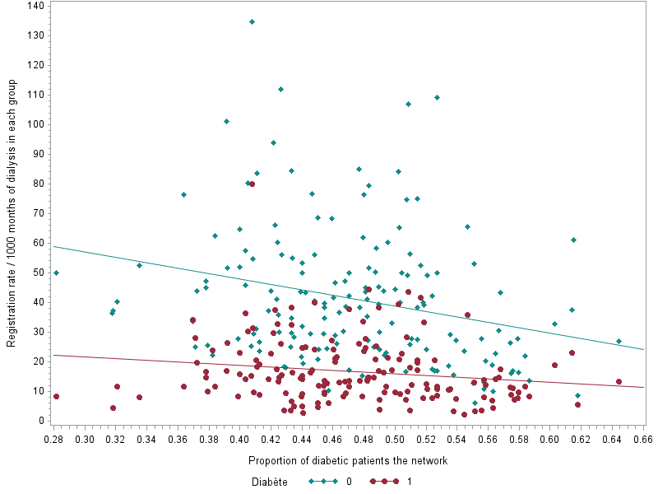
Reading key :
The level of registration rates are higher at the left of the figure = In networks with less diabetic patients, the registration rate is higher, even for diabetic patients.
The slope for non diabetic patients (green) is steeper compared to the slope for diabetic patients (red) = Networks with less diabetic patients tend to favour healthier patients for registration.

