Supplemental material
Supplemental Table1 - Acquisition and reconstruction characteristics for CE-CT imaging of patients included
Scan type was helical for all considered models.
Manufacturer /Model | CT slices | detector configuration (mm) | slice thickness (mm) | tube voltage (kV) | sFOV (mm) | e×posure time (msec) | tube current (mA) | e×posure (mAs) | spiral pitch factor | reconstruction FOV | reconstruction interval | reconstruction matri× | reconstruction kernel
GE/LightSpeed VCT | 64 | 32 × 0.625 or 64 × 0.625 | 0.625 or 1.25 or 2 | 120 | 320 | 500-1277 | 80-1095 | 2-530 | 0.53 or 1 | 183-267 | 0.625 or 1 | 512 × 512 | B30s or STANDARD or SOFT or DETAIL
GE/Brightspeed | 11 | 16 × 1.25 or 16 × 0.625 | 0.625 or 1.25 | 120 | 250 | 961-1191 | 69-376 | mai-19 | 0.93 or 0.5625 | 190-254 | 0.625 or 0.7 or 5 | 512 × 512 | DETAIL or SOFT or STANDARD
Siemens/SOMATOM Definition AS | 64 | 20 × 0.6 or 32 × 0.6 or 16 × 1.2 | 1 or 3 | 100 | 500 | 439-1000 | 44-229 | 44-286 | 0.8 or 1 | 221-500 |  | 512 × 512 | B30s or I30s or I31f or I50s or I70h
Philips/Ingenuity CT | 64 | 64 × 0.625 | 0.9 or 1.5 | 120 | 500 | 367-714 | 215-633 | 119-3970 | 0.9923 to 1.3 | 223-361 | -0.75 to 0.8 | 512 × 512 | C or B or SOFT TISSUE
Siemens/Sensation 16 | 16 | 16 × 0.75 or 16 × 0.6 | 0.75 or 1 or 1.5 or 2 | 120 | 500 | 750 | 101-161 | 101-200 |  | 170-500 |  | 512 × 512 | B30s or B31s
Siemens/SOMATOM Definition AS+ | 64 | 64 × 0.6 | 1 or 1.5 | 120 | 500 | 1000 | 116-212 | 165-265 | 0.7 | 235-289 |  | 512 × 512 | B31s or B40s or I31s
Philips/Brilliance 40 | 40 | 40 × 0.625 | 1.4 or 1.5 | 120 | 500 |  | 225-462 | 250 |  | 200 | -1 to 0.75 | 512 × 512 | B or C
Siemens/Sensation 64 | 64 | 64 × 0.6 z-FFS (32 × 0.6) | 1 or 2 | 120 | 500 | 1000 | 198 | 220 |  | 241 |  | 512 × 512 or 1024 × 1024 | B31s or B41s
Siemens/Emotion 16 | 16 | 16 × 0.6 | 0.75 or 1 or 3 | 130 | 500 | 1000 | 56-345 | 74-230 |  | 210-216 |  | 512 × 512 | B30s or B41s
Philips/Brilliance 16 | 16 | 16 × 0.75 | 1 or 1.5 | 120 | 177-230 |  | 240 | 200 |  | 177-230 | 0.5 or 0.8 | 512 × 512 | C
GE/Optima CT520 | 16 | 16 × 0.625 | 0.625 | 120 | 500 | 1099 | 346 | 18 | 0.93 | 271 | 0.625 | 512 × 512 | DETAIL
Hitachi/Scenaria CT | 64 | 64× 0.625 | 1.25 | 120 | 240 | 500 | 594 | 297 |  | 240 |  | 512 × 512 | 83
GE/Optima CT540 | 16 | 16 × 0.625 | 1.25 | 100 | 500 | 1042 | 194 | 18 | 1 | 263 | 1 or 0.5 | 512 × 512 | DETAIL
Siemens/Sensation Open |  |  | 1.5 | 120 | 500 | 1000 | 197-217 | 218-241 |  | 168-208 |  | 512 × 512 | B30s or B31s
GE/Discovery CT750 HD | 64 | 64 × 0.625 | 0.625 | 120 | 320 | 1095 | 150 | 2 | 0.52 | 270 | 0.625 | 512 × 512 | DETAIL
Toshiba/Aquilion PRIME | 40 | 40 × 1 | 1 | 120 | 320 | 500 | 100 | 50 | 0.825 | 242 |  | 512 × 512 | FC08
GE/BrightSpeed Q×/i | 4 | 16 × 0.625 | 0.625 | 120 | 250 | 961 | 102 | 4 | 0.93 | 250 | -0.625 | 512 × 512 | SOFT
GE/LightSpeed Pro 16 | 16 | 32 × 0.625 | 1.25 | 120 | 250 | 1191 | 197 | 21 | 0.93 | 219 |  | 512 × 512 | STANDARD
GE/Optima CT660 | 64 | 32 × 0.625 | 0.625 | 120 | 320 | 800 | 200 | 5 | 0.97 | 246 | 0.625 | 512 × 512 | STANDARD
Siemens/Biograph 64 | 64 | 16 × 1.2 | 3 | 120 | 500 | 1000 | 41 | 41 | 1 | 500 |  | 512 × 512 | I30s
Siemens/Biograph 20 | 20 | 16 × 1.2 | 1.5 | 140 | 500 | 500 | 53 | 33 | 0.8 | 300 |  | 512 × 512 | I30f
GE/Discovery ST | 8 | 4 × 2.5 | 2.5 | 120 | 500 | 819 | 120 | 16 | 1.5 | 700 |  | 512 × 512 | STANDARD
Philips/Ingenuity Fle× | 32 |  | 1.5 | 120 | 500 | 1332 | 277 | 369 |  | 164 | 0.75 | 512 × 512 | B
Siemens/SOMATOM Definition Edge | 64 | 64 × 0.6 | 1 | 80 | 500 | 285 | 316 | 75 | 1.2 | 354 |  | 512 × 512 | I30f
Philips/Brilliance 10 | 10 |  | 1.5 | 120 | 500 |  | 165 | 248 |  |  |  | 512 × 512 | C
GE/LightSpeed Ultra | 8 | 8 × 1.25 | 1.25 | 140 | 250 | 1546 | 381 | 41 | 0.625 |  |  | 512 × 512 | STANDARD

z-FFS : z-axis flying focal spot; FOV : Field of View

Supplemental Table 2 - list of radiomic features extracted from CE-CT
Details of the definitions and computation of the radiomic features are available in the IBSI reference document: https://ibsi.readthedocs.io/en/latest/03_Image_features.html
Category |  | order |  | Type |  | Features
Shape |  |  |  |  |  | Volume, Approximate Volume, Surface area, Surface to volume ratio, Compactness 1, Compactness 2, Spherical disproportion, Sphericity, Asphericity, Max 3D diameter, Major axis length, Minor axis length, Least axis length, FlatnessElongation
Intensity |  | first |  | Intensity histogram features |  | Mean, Max, Min, Variance, Standard Deviation, Skewness, Kurtosis, Energy, Entropy, Area under the IVH curve, SUV
Texture |  | second |  | Grey-level Cooccurrence Matrix (GLCM) |  | Joint Maximum, Joint Average, Joint Variance, Joint Entropy, Difference average, Difference Variance, Difference Entropy, Sum Average, Sum Variance, Sum Entropy, Angular Second Moment, Inverse Difference, Normalised Inverse Difference, Inverse Difference moment, Normalised Inverse Difference moment, Inverse variance, Correlation, Autocorrelation, Cluster tendency, Cluster Shade (cm.clust.shade), Cluster prominence, First measure of information correlation, Second measure of information correlation
 |  | second |  | Neighbourhood greytone difference matrix (NGTDM) |  | Complexity, Busyness, Contrast, Coarseness, Strength
 |  | third |  | Grey-level Run-Length matrix (GLRLM) |  | Short runs emphasis (rlm.sre), Long runs emphasis (rlm.lre), Grey level non uniformity (rlm.glnu), Run length non-uniformity (rlm.rlnu), Run percentage (rlm.r.perc), Low grey level run emphasis (rlm.lgre), High grey level run emphasis (rlm.hgre), Short run low grey level emphasis (rlm.srlge), Short run high grey level emphasis (rlm.srhge), Long run low grey level emphasis (rlm.lrlge), Long run high grey level emphasis (rlm.lrhge), Normalised grey level non-uniformity, Normalised run length non-uniformity (rlm.rlnu.norm), Grey level variance (rlm.gl.var), Run length variance (rlm.rl.var), Run entropy (rlm.rl.entr)
 |  | third |  | Grey-level Size Zone Matrix (GLSZM) |  | Small Zone Emphasis (szm.sze), Large Zone Emphasis (szm.lze), Low grey level zone emphasis (szm.lgze), High grey level zone emphasis (szm.hgze), Small zone low grey level emphasis (szm.szlge), Small zone high grey level emphasis (szm.szhge), Large zone low grey level emphasis (szm.lzlge), Large zone high grey level emphasis (szm.lzhge), Grey level non-uniformity (szm.glnu), Normalised grey level non-uniformity (szm.glnu.norm), Zone size non-uniformity (szm.zsnu), Normalised zone size non-uniformity (szm.zsnu.norm), Zone percentage (szm.z .perc), Grey level variance (szm.gl.var), Zone size variance (szm.zs.var), Zone size entropy (szm.zs.entr)

Supplemental Figure 1- Graph in determining the optimal number of clusters based on Silhouette scoring.
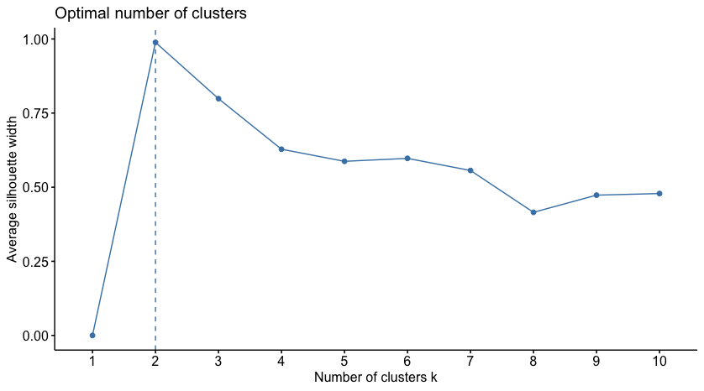

Supplemental Figure 2 – Patients selection flowchart
Screened: patients who received TPF for the treatment of head and neck cancer between 2008 and 2018 (n=594)

-Patients who received TPF outside the indication of laryngeal preservation (palliative indications or other anatomical site: sinus, cavum, oral cavity, oropharynx, lymph node metastases) (n=416)
- No CE-CT available (n=74)

Included (n=104)

Excluded from analysis (n=6)
- patients who died after C1 (n=5)
- Corrupted image file (n=1)

Analyzed (n=98)

Five patients died after the first course of TPF chemotherapy, so that their response could not be assessed. CE-CT: contrast-enhanced computed tomography; C1 : first course of chemotherapy

Supplemental Table 3: Association between clinical variables or potential confounding factors (Number of TPF chemotherapy cycles) and lack of response to chemotherapy in univariate analysis

clinical variable | Cut-off | AUC | Se | Sp | p
Age | >64 | 0.60 | 40 | 80 | 0.24
BMI | ≤23 | 0.63 | 78 | 49 | 0.1
Initial laryngeal mobility | decreased or abolished | 0.56 | 50 | 66 | 0.55
Localisation | glottic | 0.61 | 40 | 82 | 0.20
N-stage | N0 or N1 | 0.63 | 40 | 82 | 0.61
PS | >0 | 0.66 | 60 | 72 | 0.06
Gender | male | 0.58 | 100 | 16 | 0.001
T-stage | T3 without cord fixation or less | 0.59 | 60 | 57 | 0.33
Number of TPF cycles | 2 vs. 3 | 0.61 | 30 | 91 | 0.18

