

*Journal of Geophysical Research - Biogeosciences*

Supporting Information for

**The chemistry of hyperalkaline springs in serpentinizing environments: 1. the composition of free gases in New Caledonia compared to other springs worldwide.**

Christophe Monnin1*, Marianne Quéméneur2, Roy Price3, Julie Jeanpert4, Pierre Maurizot4, Cédric Boulart5, Jean-Pierre Donval6, Bernard Pelletier7

1 Géosciences Environnement Toulouse, (CNRS/UPS/IRD/CNES), 14 Avenue E Belin, 31400 Toulouse, France.

2 Aix Marseille Univ., Université de Toulon, CNRS, IRD, MIO, Marseille, France.

3 School of Marine and Atmospheric Sciences, Stony Brook, NY, USA.

4 DIMENC (Direction de l’Industrie, des Mines et de l’Energie), Nouméa, Nouvelle-Calédonie

5 AD2M UMR 7144 (CNRS, Sorbonne Université), Station Biologique de Roscoff, Place Georges Tessier, 29680 Roscoff, France

6 IFREMER, Unité Géosciences Marines/Laboratoire Cycles Géochimiques, ZI Pointe du Diable. CS 10070. 29280 Plouzané, France

7 Géoazur (UCA, IRD, CNRS, OCA), Centre IRD de Nouméa, BP A5, Nouméa, Nouvelle-Calédonie.

**Contents of this file**

Figure S1 – Photos of the springs

Figure S2 – Records of ORP, PH and T versus time for La Coulée and Pirogues springs

Figure S3 – Triangular plots of the free gas compositions at various locations. The black plain line is the line with a slope of -0.25 corresponding to the Sabatier reaction involving CO2. The short dash line has a slope of -0.33 corresponding to a Fisher-Tropsch-type reaction involving carbon monoxide (see text).

Table S1 – Temperature, pH, DO (Dissolved oxygen) and ORP (oxidation-reduction potential) measured in situ for the on-land alkaline springs of New Caledonia

Table S2 – The composition of free gases venting at the Bain des Japonais and at the Kaoris springs.

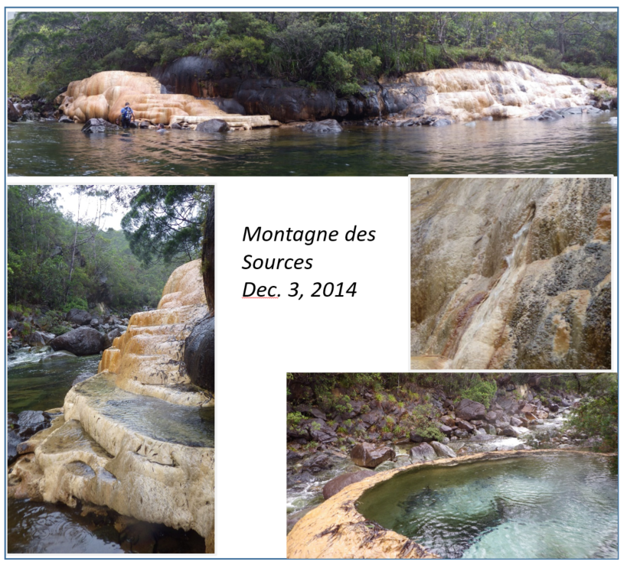

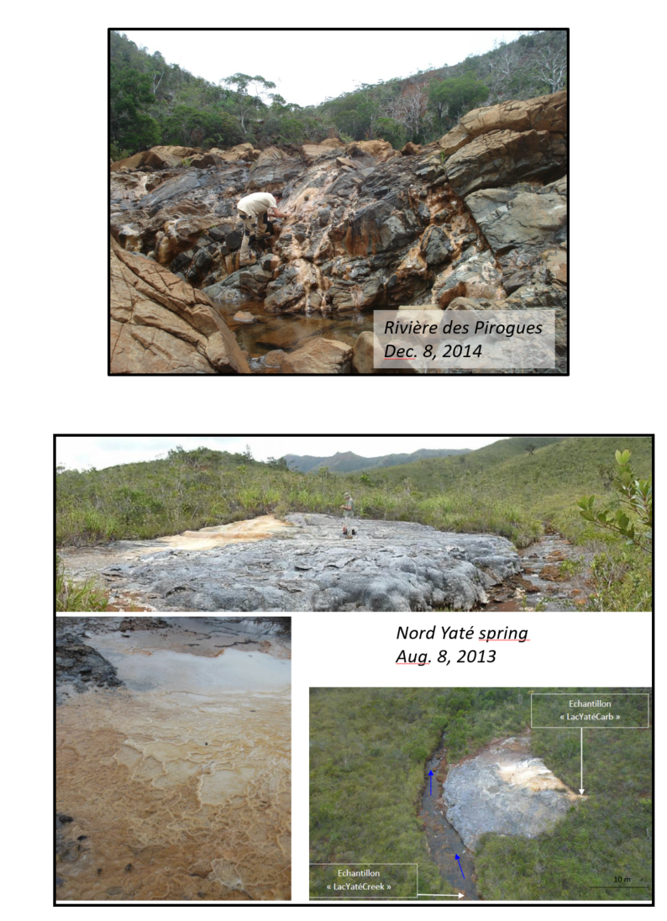

*Figure S1 – Photos of the springs*





*Figure S2 – Records of ORP, PH and T versus time for La Coulée and Pirogues springs*

The Eh value (hydrogen electrode reference) was calculated from the measured ORP value (Ag/AgCl reference) using the potential difference between the two reference electrodes given by the provider (WTW; https://www.wtw.com/en/) that had supplied the probe. These values have been fitted to the following polynomial:

$$∆Eh=221.02-0.9189 t-0.0017 t^{2}$$

where t is the temperature (°C). Eh and ORP are in millivolts. The redox potential Eh is then:

$$Eh=ORP+ ∆Eh$$

The redox correction $∆Eh$ between the two references is about +200 mv.



Figure S3 – Triangular plots of the O2-corrected free gas compositions at various locations. The black plain line is the line with a slope of -0.25 corresponding to the Sabatier reaction involving CO2. The short dash line has a slope of -0.33 corresponding to a Fisher-Tropsch-type reaction involving carbon monoxide (see text).



*Table S1 – Temperature, pH, DO (Dissolved oxygen) and ORP (oxidation-reduction potential) measured in situ for the on-land alkaline springs of New Caledonia. n.m.: not measured.*



*Table S2 – The composition of free gases venting at the Bain des Japonais and at the Kaoris springs determined in the three laboratories. Note that the N2 concentration for that analyses carried out in the NASA AMES lab (in italic underlined) are calculated by difference because nitrogen was the carrier gas in the gas chromatographer.*