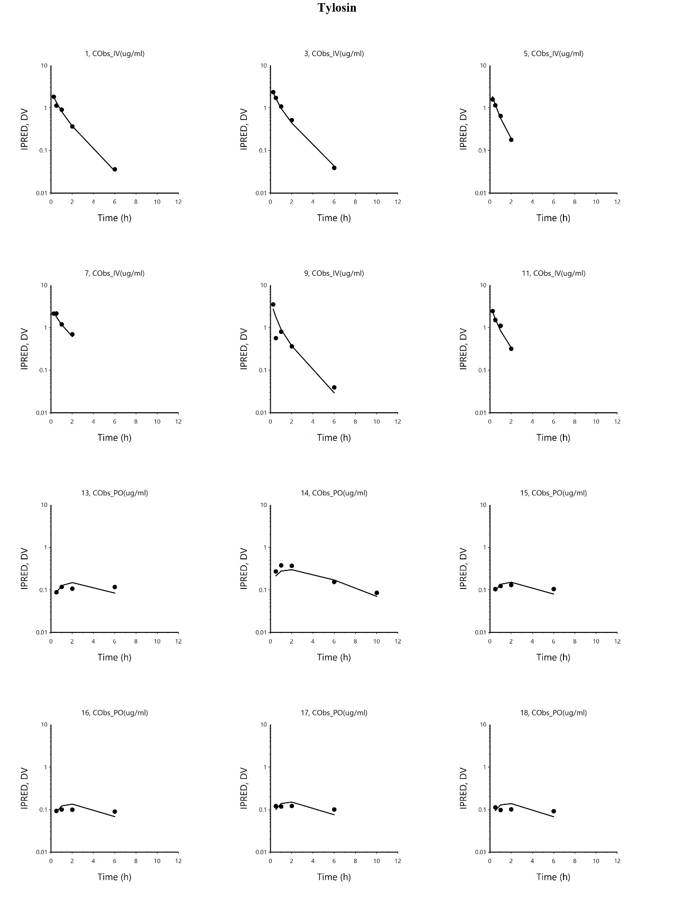
Additional file 3 PK plots obtained from NLME
Plots (latticed by individual) of dependent variable (DV) i.e. observed TYL serum concentration (black spots), and individual predicted (IPRED) concentration (black line), vs time (h) after dosing (TAD), obtained from NLME.
IPRED: Individual prediction of serum concentration, DV: dependent variable, TAD: time after dosing, IV: intravenous, PO: oral administration.

