Additional file 2 Plots for PD modeling of TYL against S. delphini
Plots of dependent variable (DV) i.e. observed bacterial population vs. model-predicted individual bacterial population (IPRED) of S. delphini.
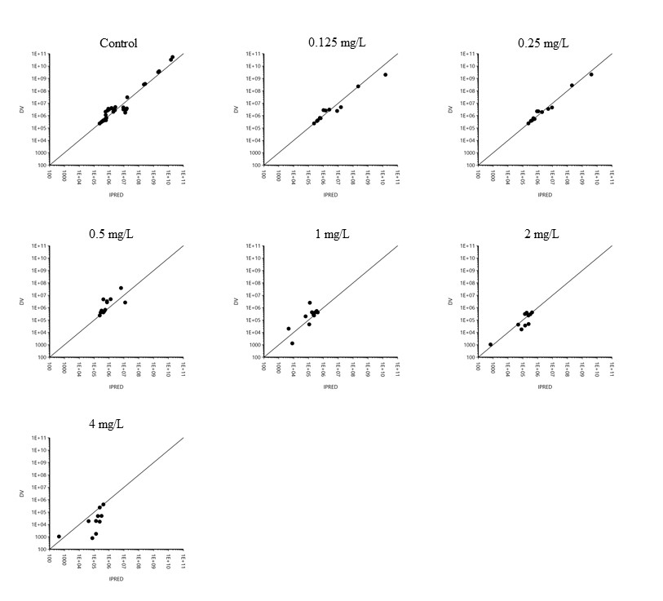
DV: dependent variable i.e. bacterial concentration (CFU/mL), IPRED: individual prediction of bacterial concentration (CFU/mL). There were two isolates for S. delphini at each TYL concentration, except for control that same two isolates were tested in triplicate.

