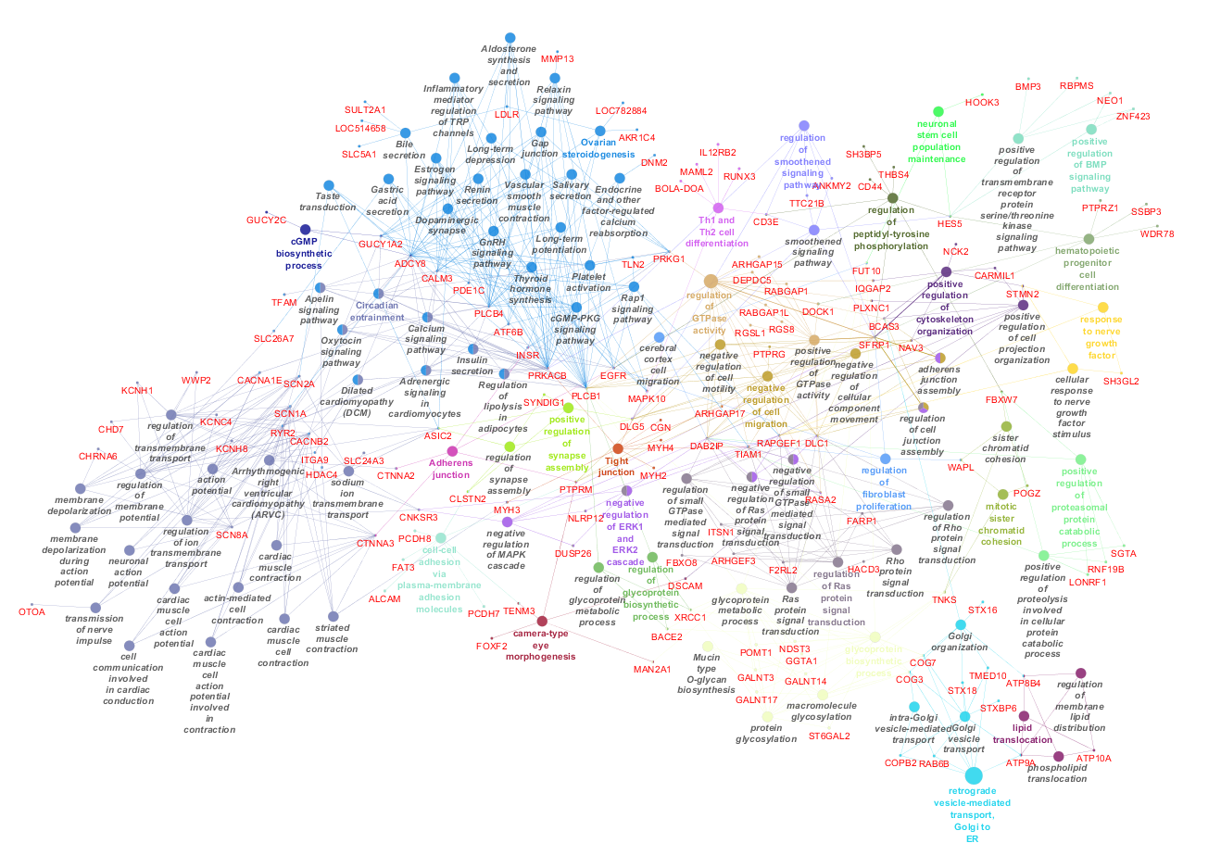
Figure S2 Network interaction between GO terms, KEGG pathways and genes from the AWM analysis with RG as key phenotype
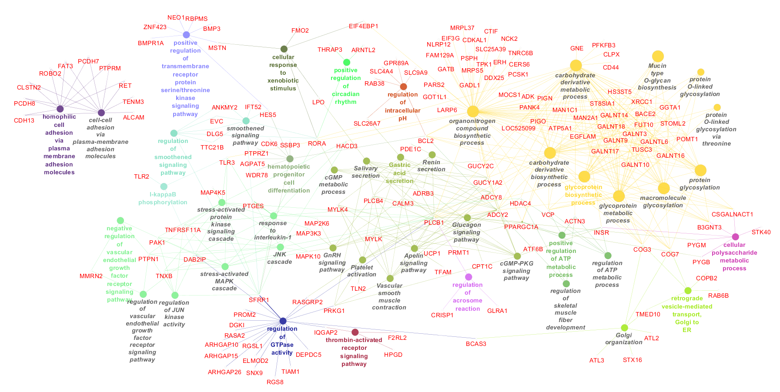
Figure S3 Network interaction between GO terms, KEGG pathways and genes from the AWM analysis with FE as key phenotype

