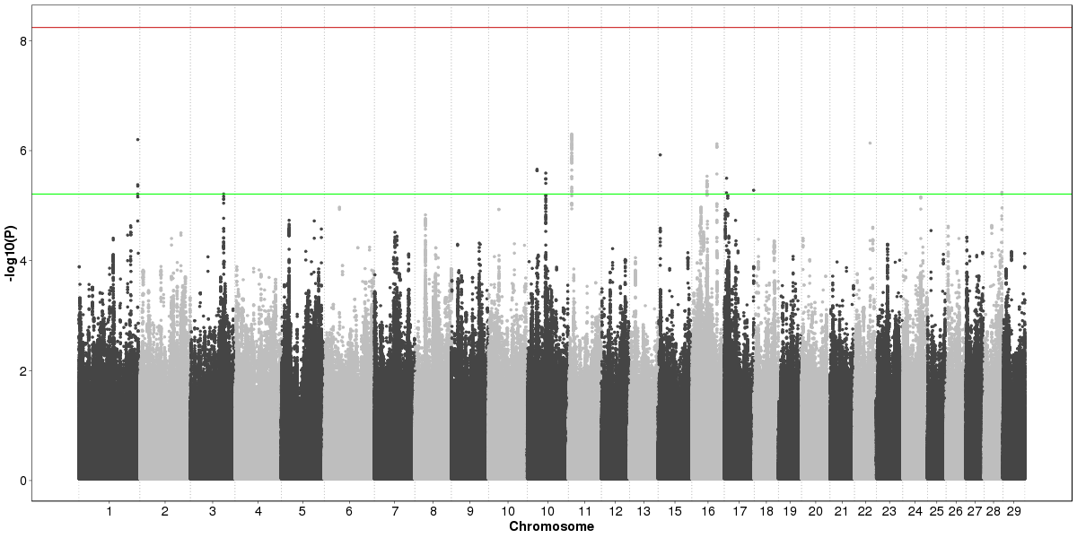
a
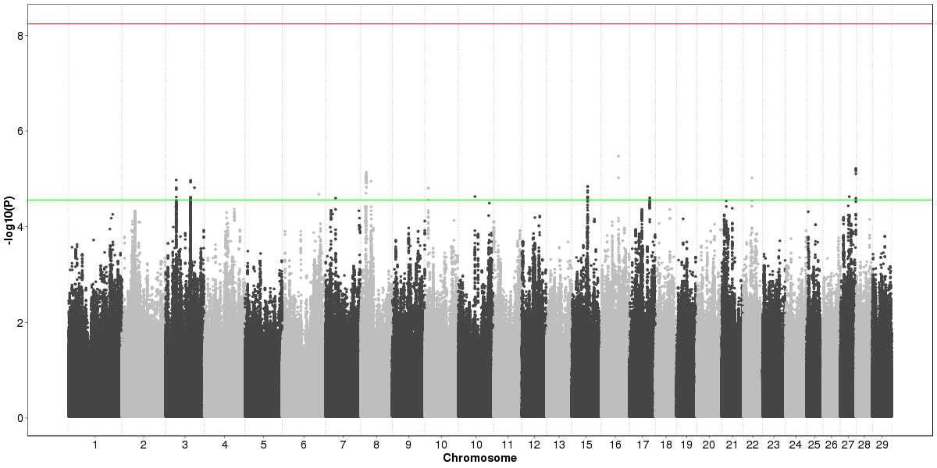
b
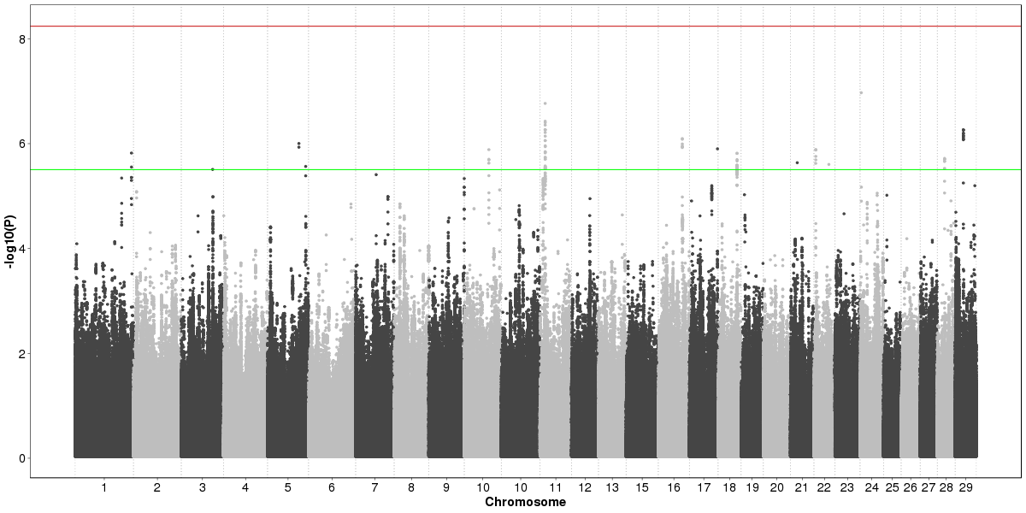
c
Figure S1 Manhattan plots of residual feed intake (a), residual gain (b) and feed efficiency ratio (c)
Red line denotes the Bonferroni correction threshold for genome-wide type I error rate of 5% and green line represents the top 100 SNP with the highest –log10(P).

