Supporting Information

Sylwia Waluś^{1,2}, Céline Barchasz², Renaud Bouchet^{1,*}, Fannie Alloin^{1,3,*}

¹Univ. Grenoble Alpes, Univ. Savoie Mont Blanc, CNRS, Grenoble INP, LEPMI, 38 000 Grenoble, France
² Univ. Grenoble Alpes, CEA, LITEN, DEHT, STB, F-38054 Grenoble
³Réseau sur le Stockage Electrochimique de l’Energie (RS2E), CNRS, FR3459, 80039 Amiens Cedex, France
*Corresponding author: +33 4 76 82 65 61 fannie.alloin@lepmi.grenoble-inp.fr; renaud.bouchet@lepmi.grenoble-inp.fr

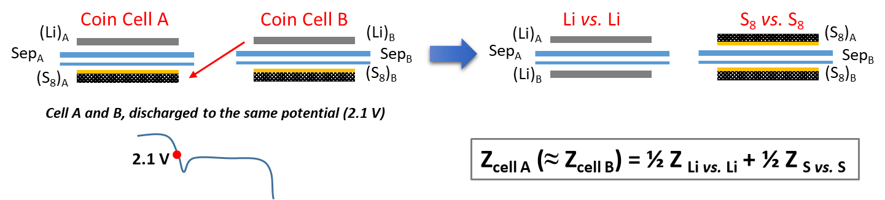
Figure S1. Illustrated approach of symmetric coin cells (Li-Li and S₈-S₈) prepared from pre-cycled to the desired SoC% half cells (Li/S). Formula used for validating the correctness of the symmetric cell approach.
Two conventional Li/S coin cells (cell A and B) were discharged to the same potential of 2.1 V vs Li (identical discharge profiles were obtained) and relaxed for 15 min before EIS was measured. After that, coin cells were opened and sulfur electrode from ‘cell A’ was exchanged with Li electrode from ‘cell B’ (as shown on schematic illustration on Figure S1). The same separators were kept. Only new coin cells components (casing, spring, spacer, etc.) were used to make symmetric cells: S₈||S₈ and Li||Li. EIS was then measured on such prepared symmetric coin cells.
EIS of the Li/S cell measured at 2.1 V vs Li (refer as ‘experimental’ value, obtained from Li/S cell) was then compared with the ‘calculated’ one, based on the equation: Z_{Li/S} = ½ Z_{S/S} + ½ Z_{Li/Li}. Some differences are expected between the ‘calculated’ and the ‘experimental’ values, notably in terms of the resistance amplitude, since the symmetric cells were built by recombination of the two positive and negative electrodes. In particular, such divergences in the resistance values are mostly expected for metallic Li and may be easily explained by its surface state. Even if cell A and cell B displayed identical discharge behavior (resulting in almost superimposed voltage profiles), the surface of the lithium and also sulfur electrode might have not evolved necessarily in identical manner. Moreover, knowing the strong reactivity of the lithium surface, some changes can already appear during symmetric coin cell preparation (even if the precautions were taken).
(b)
(a)
Figure S2: Galvanostatic cycling results (C/20) of Li/S coin cell obtained during 25 cycles. Voltage profiles evolution (a), as well as capacity retention with coulombic efficiency (b).
(b)
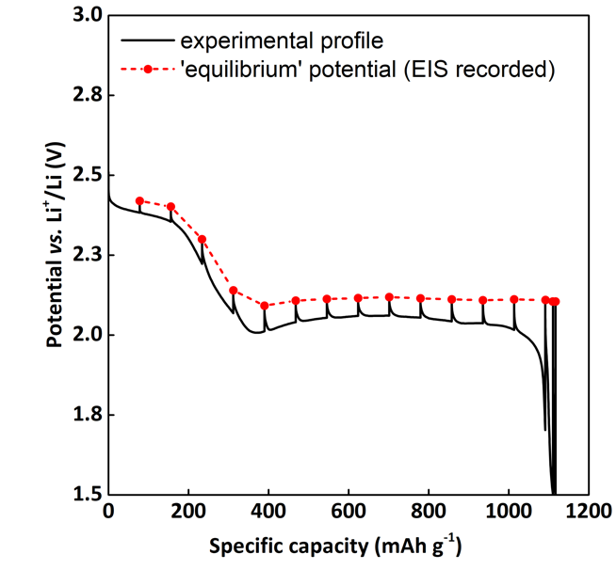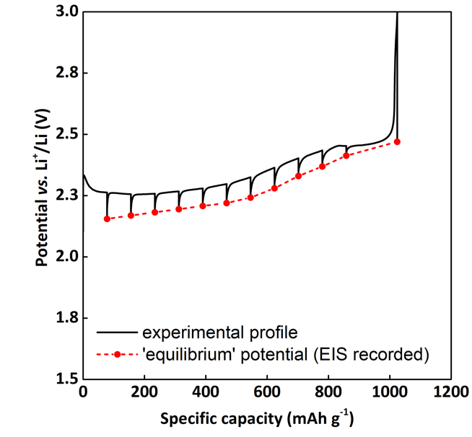
(a)
Figure S3. Voltage profile of the initial cycle with indicated points at which EIS spectra were recorded, i.e. equilibrium potential (red dots) obtained after a relaxation of 15 min: discharge (a) and charge (b) profiles.

(a) | (b)
Figure S4. Nyquist plots of conventional Li/S cell (in red) and symmetric coin cells (Li||Li in blue and S₈||S₈ in black) obtained at 2.1 V vs Li (a). ‘Experimental’ values compared with ‘calculated’ ones after normalization to 1 (b).

‘Calculated’ spectrum was obtained from the equation mentioned in Figure S1. Given that the surface of Lithium is very sensitive to any treatment and manipulation, it is suspected that it might have evolved during coin cell disassembly and then assembly into a symmetric coin cell. In that case, the resistance value of the semicircle in the MF region might have artificially increased (95 Ω instead of 60 Ω) due to the transfer for one cell to the other. Therefore, normalization was used to compare the ‘experimental’ and calculated spectra and the main focus of these results is on the shape of the Nyquist plot, including especially the characteristic frequency associated with each phenomenon, rather than the absolute value.

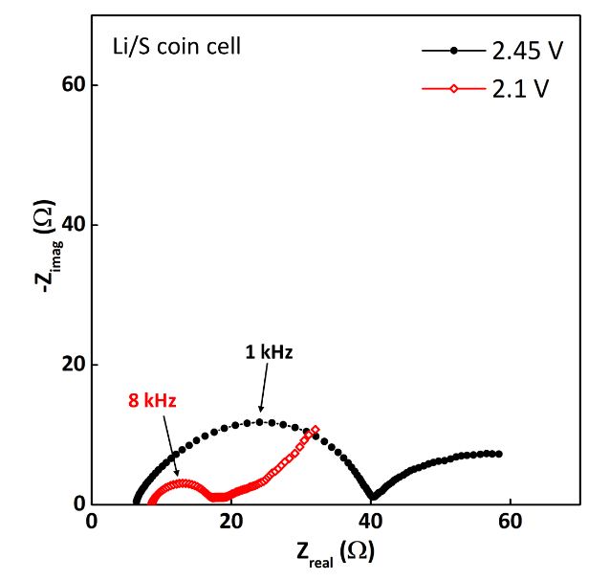  (a) | 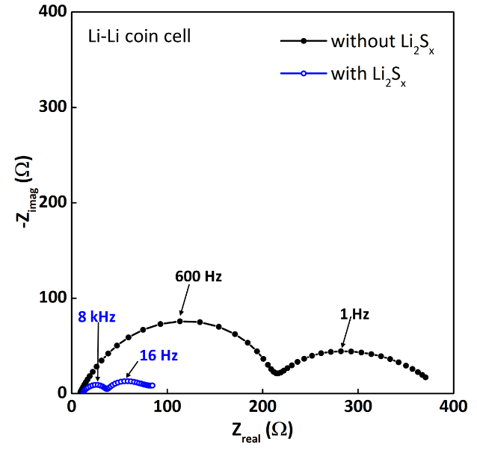
Figure S5: Comparison of Nyquist plots recorded during initial discharge of Li/S coin cell (presented in Figure 4), at the very beginning of discharge (2.45 V vs Li) and at the beginning of lower discharge plateau (2.1 V vs Li) (a). Symmetric coin cell Li-Li with/without polysulfides left for storage (b).
(b)

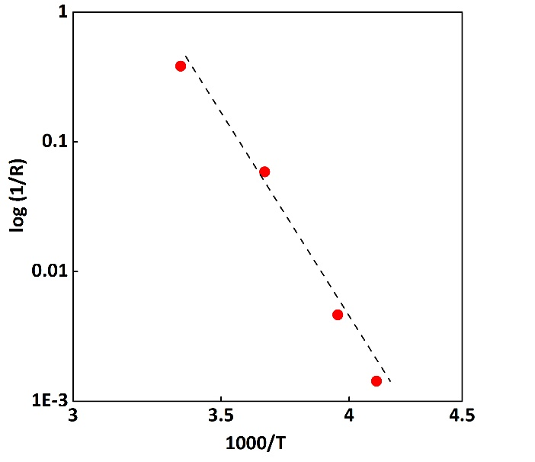
Figure S6: Arrhenius plot obtained with the R_{PS} determined at the end of charge at different temperatures.

