Australian bulls, fat percentage
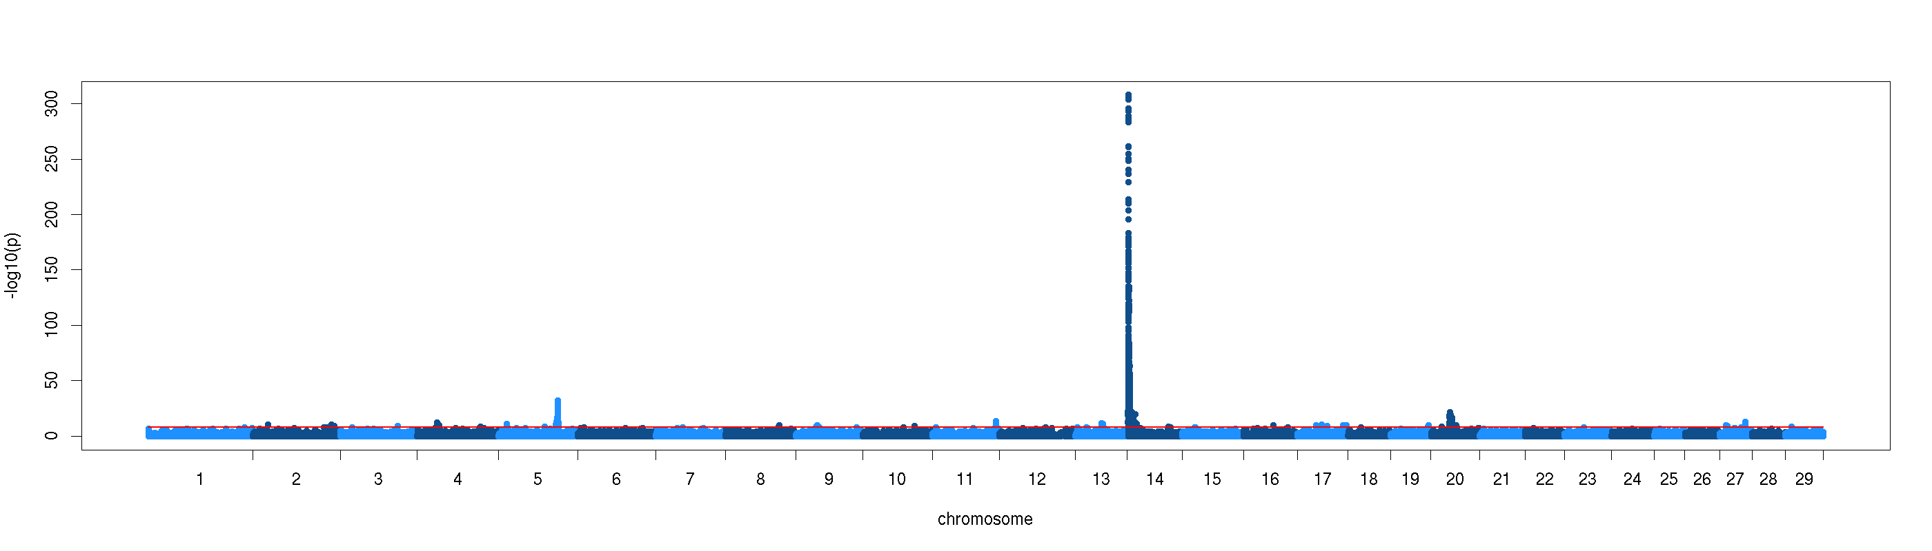

Australian cows, fat percentage
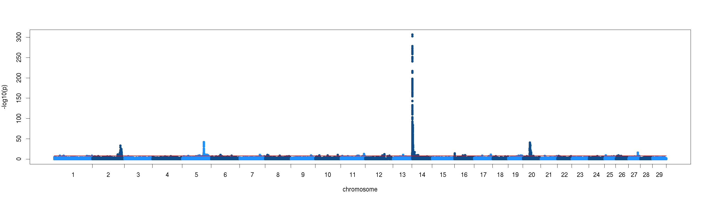
French Holstein, fat percentage
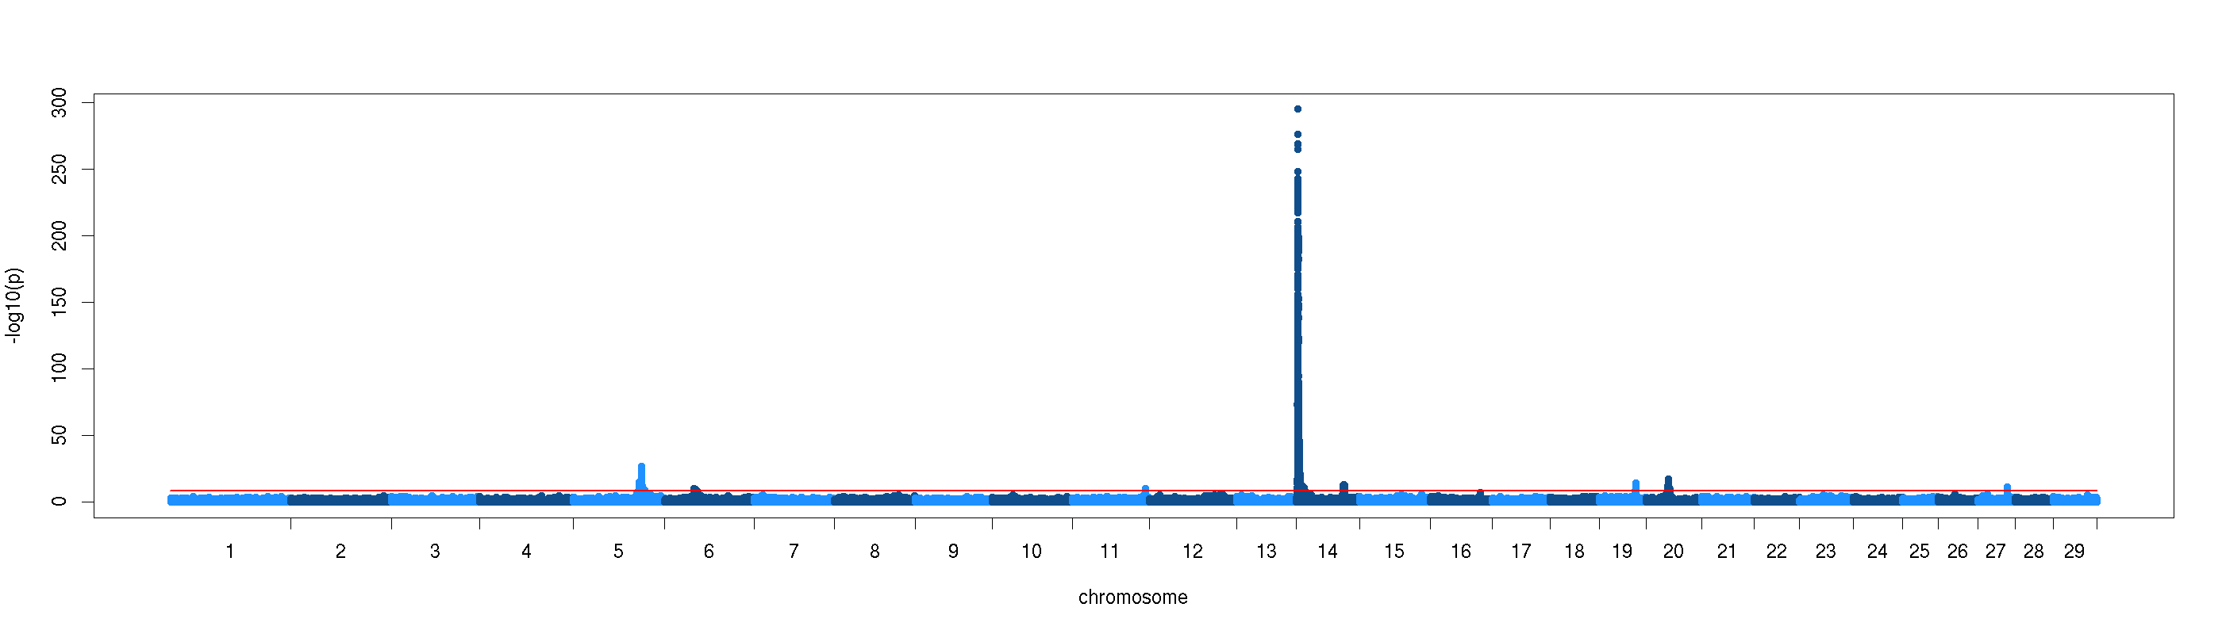
Montbéliarde, fat percentage

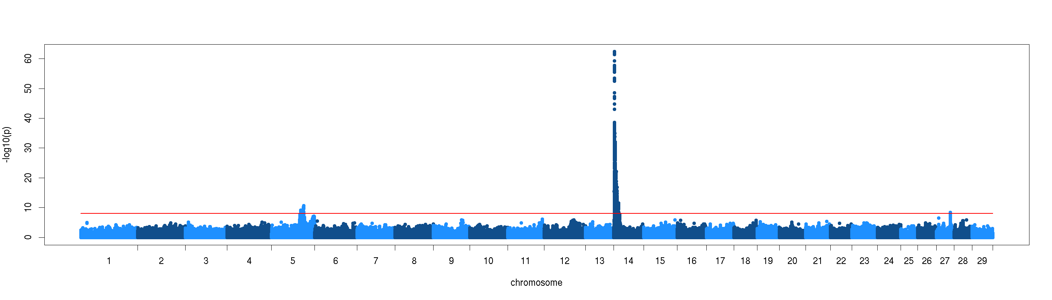
Normande, fat percentage
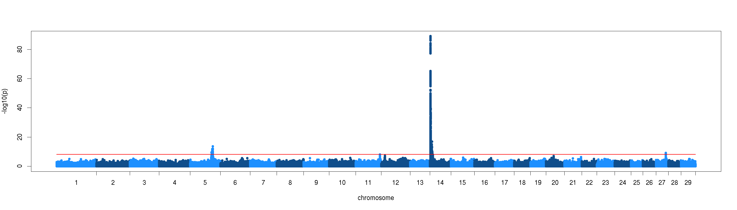

Norwegian Red, fat percentage
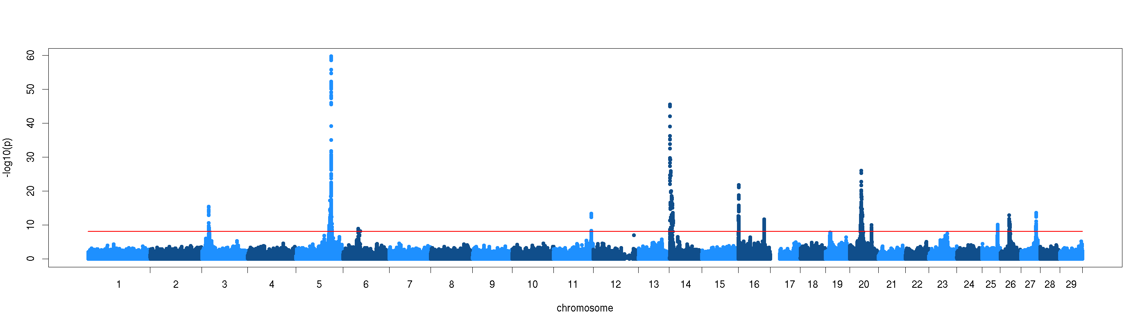
German Holstein, fat percentage
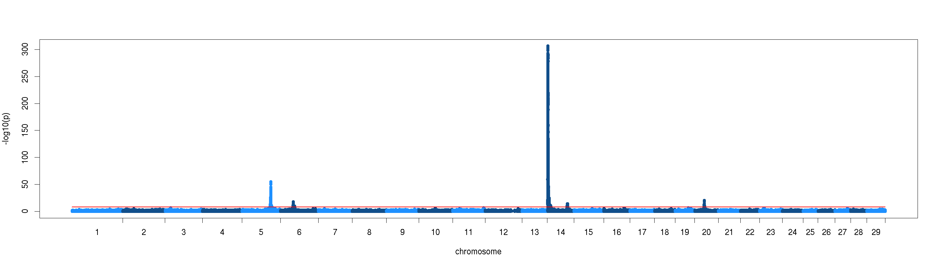

Braunvieh, fat percentage
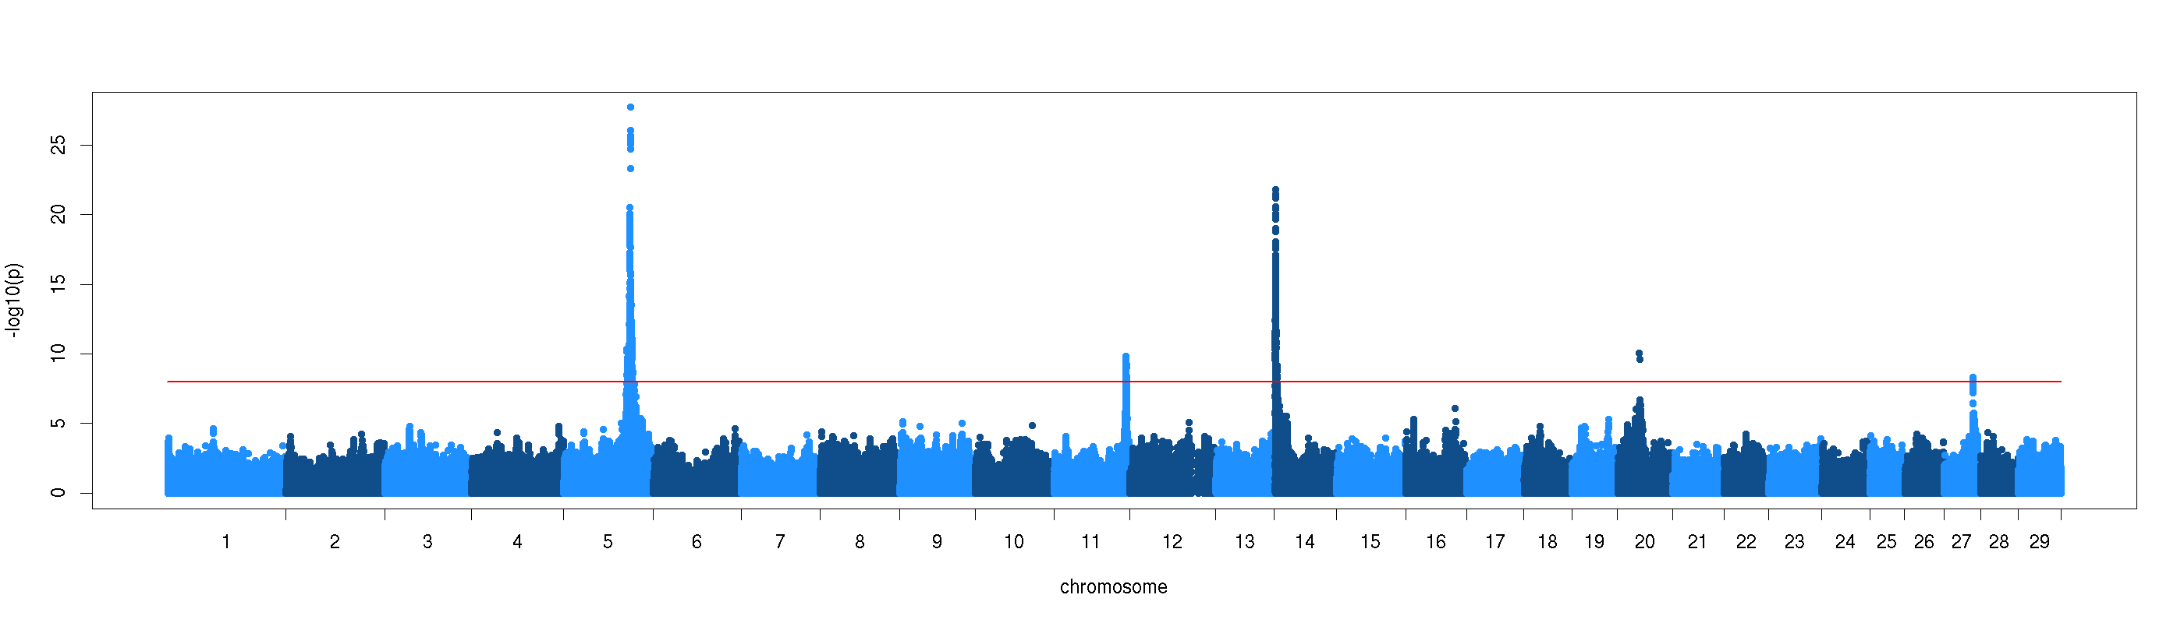
Fleckvieh, fat percentage
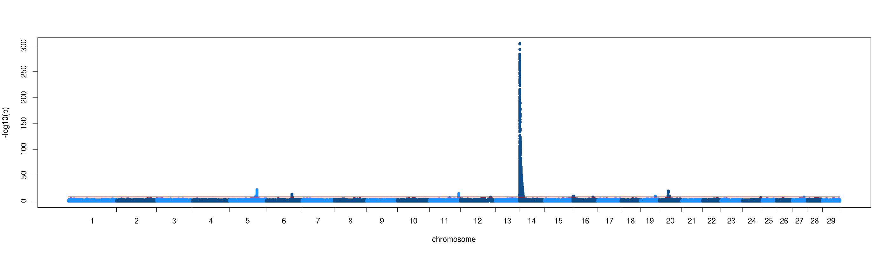

Australian bulls, protein percentage
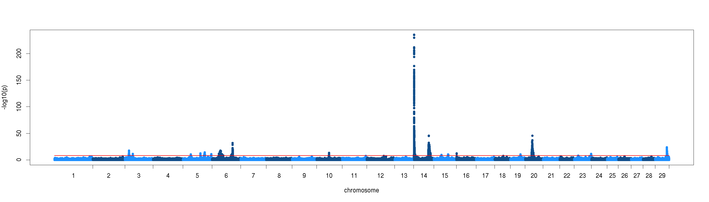
Australian cows, protein percentage
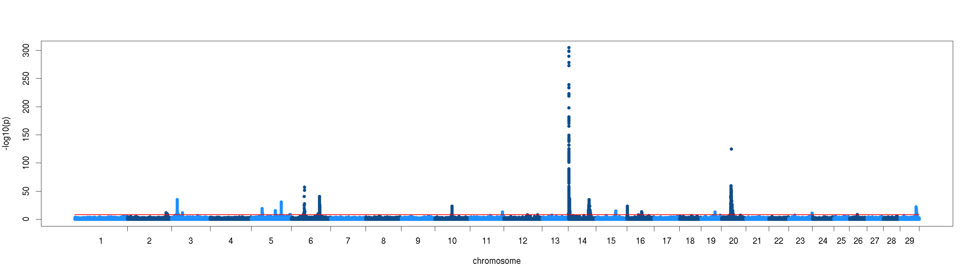

French Holstein, protein percentage
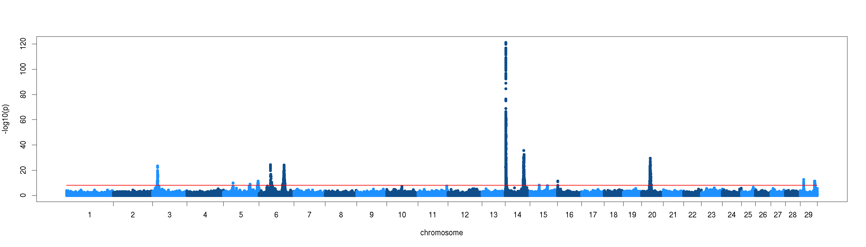
Montbéliarde, protein percentage
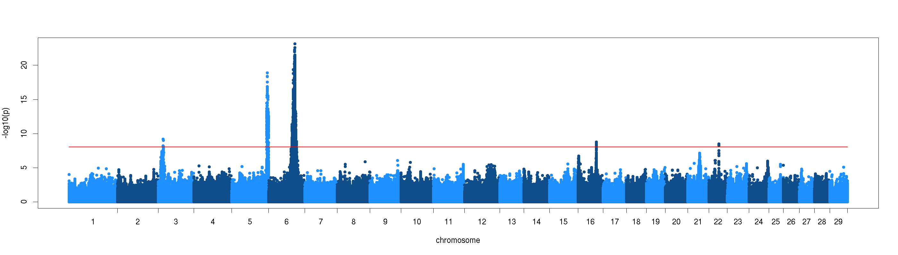

Normande, protein percentage
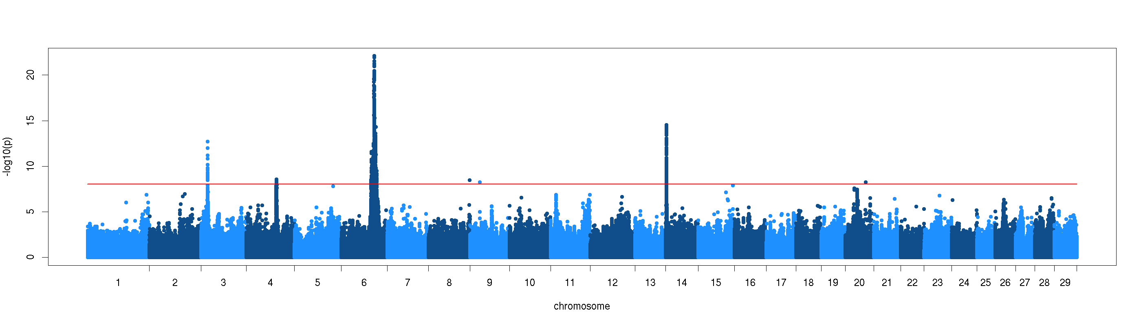
Norwegian Red, protein percentage
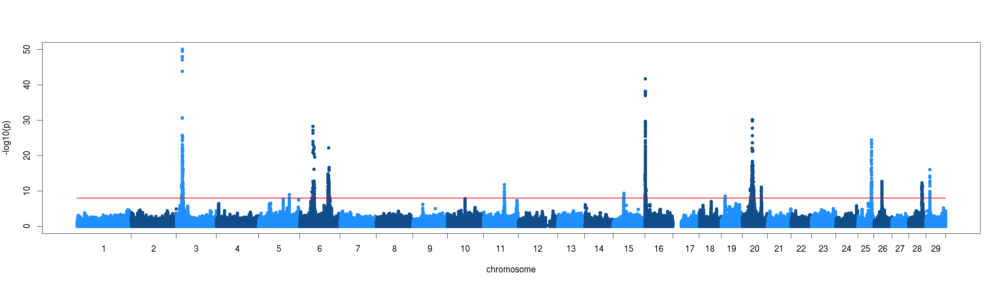
German Holstein, protein percentage

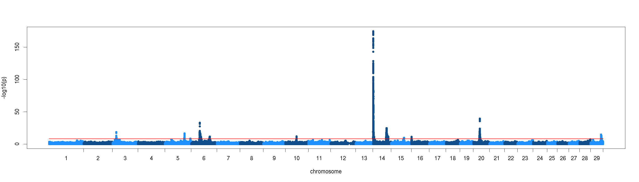
Braunvieh, protein percentage
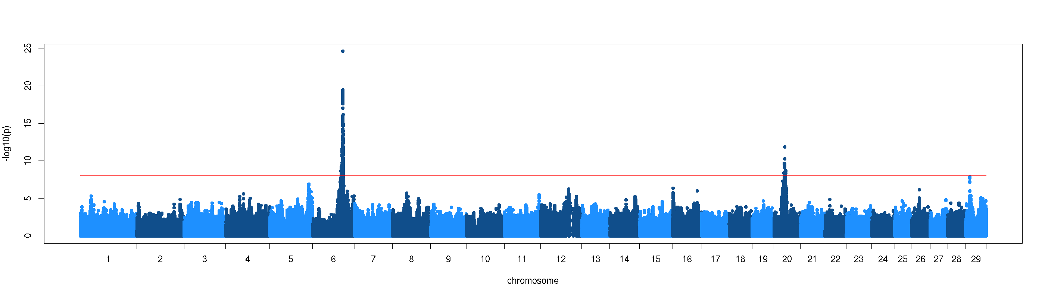
Fleckvieh, protein percentage
