**Additional File 12: Separated meta-analyses on abundance measured at community and species levels.** Summary flow chart and results of the meta-analyses performed separately on abundance measured at community level and at species level.

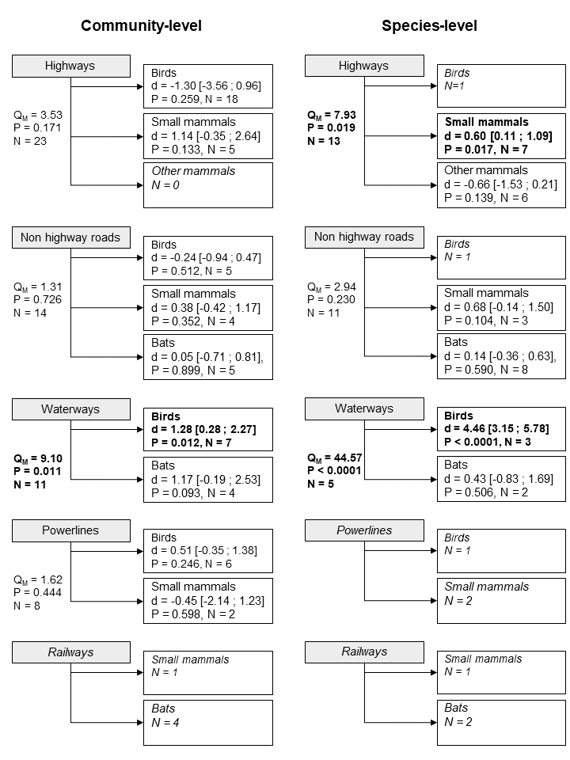

**Figure A**: Summary flow chart and results of the meta-analyses performed on abundance measured at community level (left) and at species level (right). Data was split according to the type of LTI. The statistical results presented are QM the between-class heterogeneity, P the P-value, N the number of cases, and d the estimated mean effect size with 95% confidence interval in brackets. Statistical significance (P-value < 0.05) is highlighted in bold.

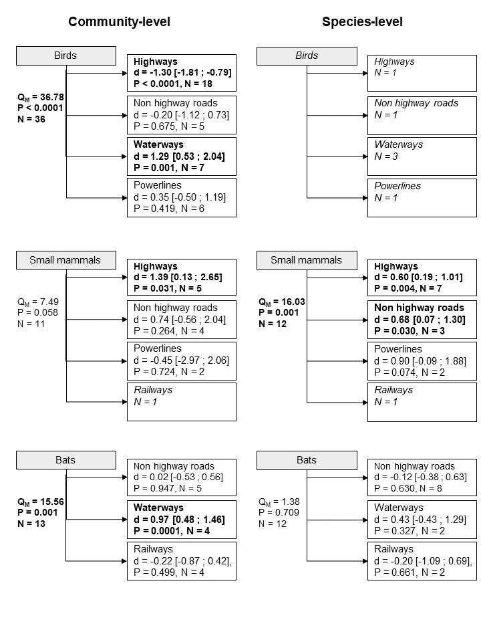

**Figure B**: Summary flow chart and results of the meta-analyses performed on abundance measured at community level (left) and at species level (right). Data was split according to biological groups. The statistical results presented are QM the between-class heterogeneity, P the P-value, N the number of cases, and d the estimated mean effect size with 95% confidence interval in brackets. Statistical significance (P-value < 0.05) is highlighted in bold.