**Additional file 10: Publication bias analysis.** Analysis of publication bias with funnel plot, Egger’s regression test and cumulative meta-analysis.

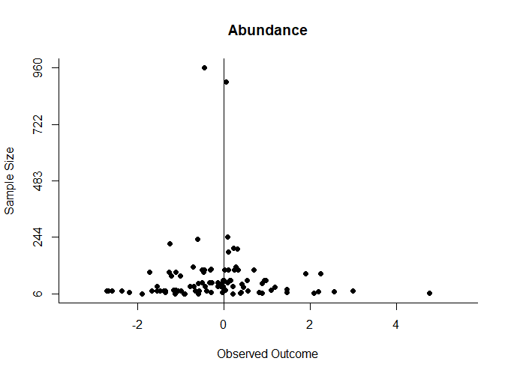

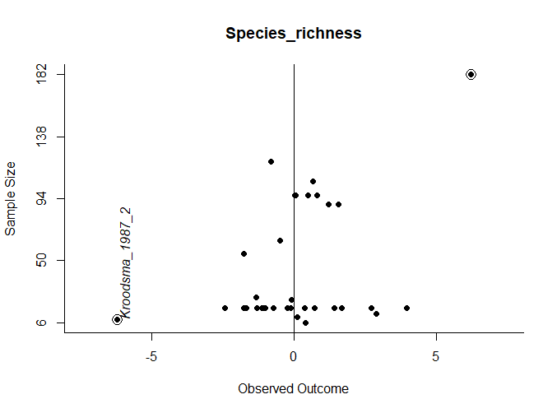

**Figure A**: Funnel plots of the studentized residuals of the model testing the effect of the type of LTI on vertebrate response (x-axis) for abundance and species richness. The residual of the highly influential case “Kroodsma_1987_2” is indicated, and the two residuals corresponding to Powerlines were circled.

**Table A:** Results of the Egger’s regression test for funnel plot asymmetry (Z value and P value) and sample size (N). The test was performed on the studentized residuals of the model testing the effect of the type of LTI on vertebrate response. The regression model used was a weighted regression with multiplicative dispersion and the predictor was the sample size. For species richness, the analysis of Cook’s distance revealed a highly influential case (“Kroodsma_1987_2”). We therefore repeated Egger’s test without this influential case (and because removing this case left only one case for Powerlines it was also removed to be able to fit the model testing the effect of the type of LTI on vertebrate response).

|  |  |  |  |
| --- | --- | --- | --- |
| **Variable** | **Z value** | **P value** | **N** |
| Abundance (residuals) | -0.2587 | 0.7964 | 99 |
| Species richness (residuals) | 5.5002 | < 0.0001 | 37 |
| Species richness (residuals, model without Powerlines) | 0.4910 | 0.6267 | 35 |

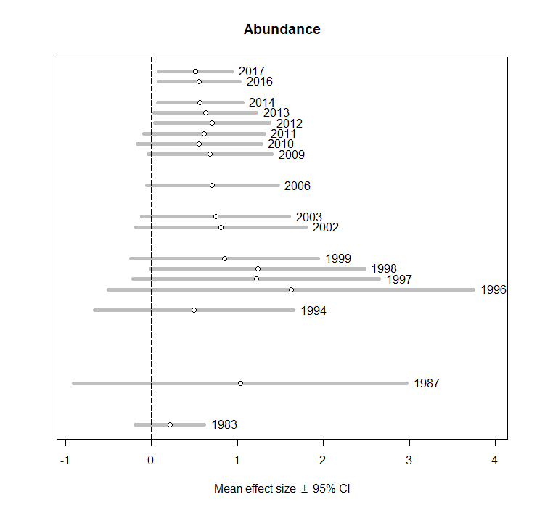 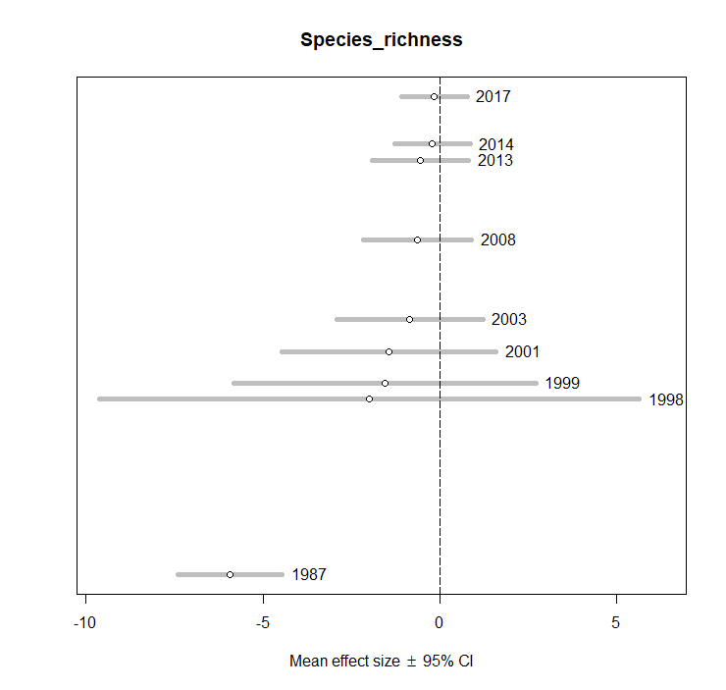

**Figure B**: Plots for abundance and species richness of the cumulative mean effect size by publication year with 95% confidence intervals. At each year studies are added to the analysis and the new grand mean effect size and 95% CI are recalculated through a null mixed model with cases nested in studies as random effects on intercept.