Supporting information

Wavelength critical role during UV-activated grafting of 1-alkene on silicon and silicon nitride Si_{x}N₄ surfaces

Marine Brunet,^{a,b} Damien Aureau,^{c} François Guillemot,^{d} Arnaud Etcheberry,^{c} François Ozanam,ª Anne Chantal Gouget-Laemmel^{a,*}

ª Physique de la Matière Condensée, Ecole Polytechnique-CNRS, Université Paris Saclay, 91128 Palaiseau, France
^{b} Saint-Gobain Recherche, 39 quai Lucien Lefranc, 93303 Aubervilliers, France
^{c} Institut Lavoisier, UMR 8180 CNRS-UVSQ-CNRS, Université Paris-Saclay, Versailles, France

S1. Experimental section

Materials. All chemicals were supplied by Sigma-Aldrich and were of the highest available grade. 1-decene (97%) was passed through a fluorisil column (eluent: pentane). All cleaning (H₂O₂, 30%; H₂SO₄, 96%) and etching (HF, 50%; NH₄F, 40%) reagents were of RSE grade and were supplied by Carlo Erba. Ultrapure water (Milli-Q, 18 MΩ cm) was used. The silicon samples were purchased from Siltronix (France) and were cut from double-side polished float-zone purified n-type (111) silicon.
Safety considerations: Piranha solution is a strong oxidant which can provoke violent explosion with organic molecules, and HF is a toxic acid which can provoke serious tissue damage if burns are not appropriately treated. HF attacks glass and therefore appropriate Teflon vials and tweezer must be used. They must be handled with extreme care in a well-ventilated fume hood, while wearing appropriate chemical safety protection (neoprene gloves and glasses).”
Si_{x}N₄ deposit. Silicon nitride Si_{x}N₄ thin films of ~35 +/-2 nm thickness were deposited on both sides of as received silicon prisms by magnetron sputtering from a silicon target containing 8% by weight of aluminium, under a pressure of 1.5 µbar in an argon/nitrogen atmosphere. For depositing Si₃N₄, the argon flow was 19 sccm and the nitrogen flow was 25 sccm; for depositing Si₅N₄, the argon flow was 19 sccm and the nitrogen flow was 15 sccm; for Si₈N₄, the argon flow was 22 sccm and the nitrogen flow was 10 sccm. The layer thickness was measured with a Dektak 8 Veeco profilometer.
Wet etching. The Si_{x}N₄ and Si(111) samples were cleaned in a 1/3 H₂O₂/H₂SO₄ piranha solution at 100°C for about 10 min and then copiously rinsed with ultrapure water. The bare silicon sample was chemically etched for 5 s in a 50% HF solution (29 M). The Si_{3.4}N₄ coated silicon (prisms) samples were etched in 0.2 % (0.12 M) HF solution for 30 s; the Si₅N₄ and Si₈N₄ coated prims were etched in 2% (1.2M) HF solution for 30 s. After etching, all surfaces were rinsed with ultrapure water and carefully dried under nitrogen.
Photochemical hydrosylilation of 1-decene
In a glass or quartz Schlenk tube, 1-decene was outgassed at 100°C for 30 minutes and then cooled to room temperature. The freshly HF-etched sample is then transferred into the Schlenk tube with continuous argon bubbling for 15 min. The Schlenk was closed hermetically and irradiated for 3-24 h in a UV reactor consisting of 8 UV lamps (6 mW cm⁻² at 312 nm and 5 mW cm⁻² at 254 nm). The functionalized surface was carefully rinsed to avoid uncontrolled physisorption: typically four times in an ultrasonic bath in THF for 5 min and in CH₂Cl₂ for 5 min. For Si₃N₄, enriched Si₅N₄, Si₈N₄ and c-(111)Si samples after irradiation at 254 nm (24 h), an additional mechanochemical rinse was performed between the ultrasonic bath rinse for AFM experiments: typically THF with cotton swab for 60 s between each ultrasonic bath rinse. The sample is then dried under nitrogen flow.
Surface Characterizations
Attenuated Total Reflection Fourier Transform Infrared (ATR-FTIR). ATR-FTIR spectra were recorded using a Bomem MB100 FTIR spectrometer or a Bruker Equinox spectrometer coupled to a home-made, nitrogen-gas purged external ATR compartment, equipped with a liquid-nitrogen-cooled MCT photovoltaic detector. The ATR prisms were home made by mechanical polishing from a silicon wafer. Their typical dimensions are 15 × 15 × 0.5 mm³ with a bevel angle of 45° and a number of reflection of N ~ 27. The spectra were collected with p and s polarization over the 950 – 4000 cm⁻¹ spectral range (4 cm⁻¹ resolution). They were displayed as absorbance per reflection by using a reference spectrum recorded prior to surface modification. The displayed spectra were normalized to the actual number of reflections N. For deriving quantitative information from IR spectra, one first needs to determine the IR cross section of the vibrational mode of interest. This is done by performing a calibration of the corresponding mode of a parented molecule in the liquid phase. Then, the surface concentration of the grafted molecules can be obtained from the integration of the vibrational peaks of the ATR-IR spectra recorded in s- and p-polarization, using an already published procedure (reference 17 from A. Faucheux et al. Langmuir 2006).
Contact angle measurements
The contact angles were measured with a Krüss DSA 100 tensiometer using 3 µL of H₂O. For each sample, the given value corresponds to an average of at least 5 drops.
Ellipsometry
The spectra were recorded over the 200-1000 nm range with a 2 nm interval at two incidence angles (50° and 75°) in an ellipsometer Woolan VASE (Variable Angle spectroscopic ellipsometry) M-2000 Xi. The apparatus was calibrated with a silicon wafer as a reference. The high accuracy mode was selected and the data were processed with Complete Ease software. The Cauchy model was used to fit the optical properties of Si₃N₄ layer whereas the Tauc-Lorentz model was used for Si₅N₄ and Si₈N₄. For the data fitting, the starting values are chosen as follow: i) the expected layer thickness as a function of deposit parameters is initially set in the model. The final value was differed no more than 5% from the initial guess, ii) the parameters of the Cauchy model for the refractive index are initially set to their values for standard Si₃N_{4.} Convergence was always obtained before reaching the maximum allowed number of cycles.
Tapping Mode-Atomic Force Microscopy (TM-AFM)
The images were obtained using a Bruker Veeco diNanoscope V-ICON in tapping mode with silicon nitride cantilever (radius of curvature given by the supplier of 10 nm) under air. The images were processed with the Nanoscope Analysis software from Bruker-Veeco.
Time of flight secondary ion mass spectrometry (TOF-SIMS)
The measurements were performed on a 200 × 200 µm² area with a Time of Flight spectrometer TOF-SIMS 5 from Ion-Tof in static mode with a Bi₃⁺ source for 100 s. The data were processed with the SurfaceLab software from Ion-Tof.

S2. FTIR-ATR spectra in p-polarization of Si₃N₄ surfaces after the photochemical irradiation of 1-decene at 312 (black) and 254 nm (grey) in the 1000-1500 cm⁻¹ (A) and 1800-2200 cm⁻¹ (B) spectral range. The reference spectra are the freshly etched surface. Note the contribution of Si-O-Si modes around 1200 cm⁻¹ due to partial surface oxidation.

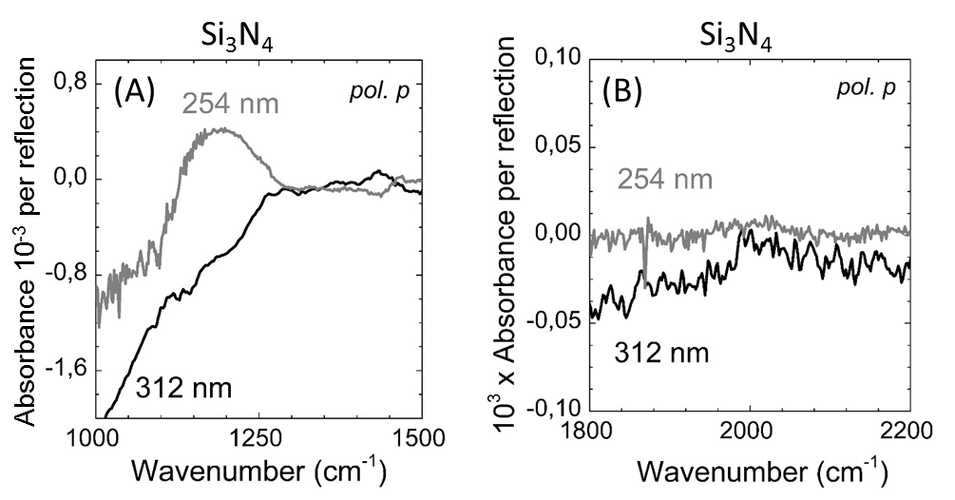

S3. FTIR-ATR spectra in p-polarization of Si₅N₄ surfaces after the photochemical irradiation of 1-decene at 312 (black) and 254 nm (grey) in the 1000-1500 cm⁻¹ (A) and 1800-2300 cm⁻¹ (B) and 2700-3050 cm⁻¹ (C) spectral range. The reference spectra are the freshly etched surface. As in Figure S2A, note the partial surface oxidation. The shape of the oxide contribution is affected by the negative contribution of Si-N-Si vibrations arising from the Si₅N₄ etching performed between the recording of the reference spectrum and the grafting of the surface.

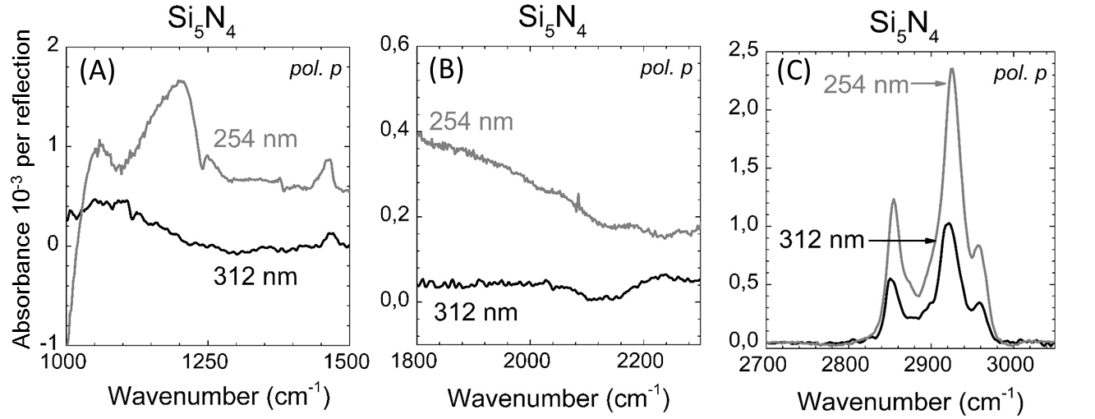

S4. AFM image (5 × 5 µm²) of etched Si₃N₄ (A) and etched Si₅N₄ (B) surfaces, quickly rinsed with MilliQ H₂O (without cotton swab). AFM image (5 × 5 µm²) of etched Si₅N₄ surface after mechanochemical rinse in ethanol (C). AFM images (5 × 5 µm²) of Si₅N₄ (D) functionalized with 1-decene at 254 nm after optimized rinse without any cotton swab.
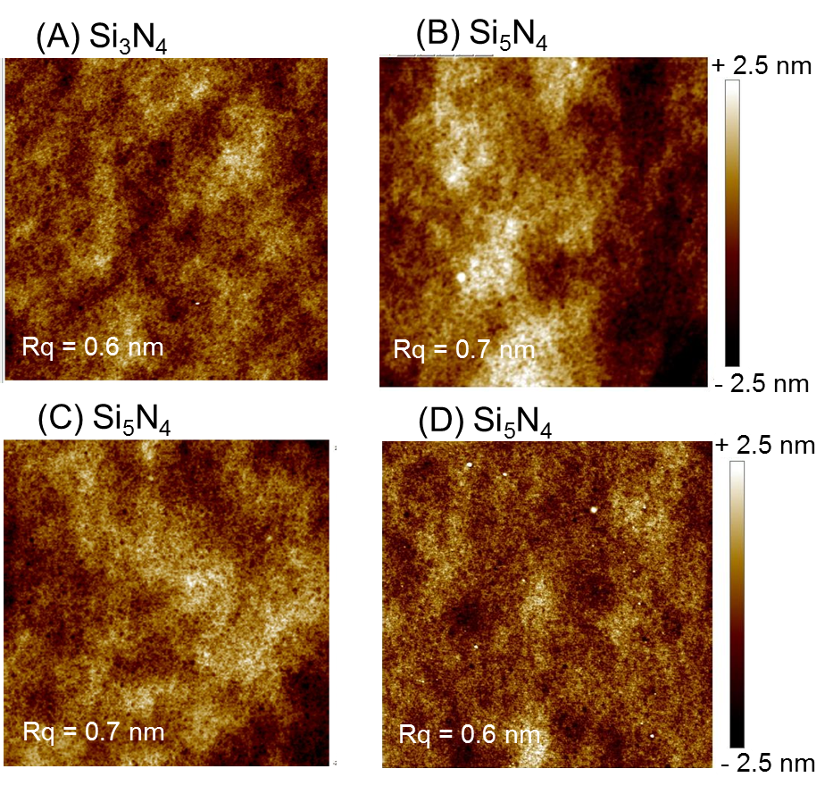

S5. AFM image (5 × 5 µm²) of etched Si₈N₄ (A) functionalized with 1-decene at 254 nm after mechanochemical rinses and AFM depth profile (B) of one of the lines shown in (A); Calculated density of decyl chains on Si₈N₄ compared with c-(111)Si, Si₃N₄ and Si₅N₄.
