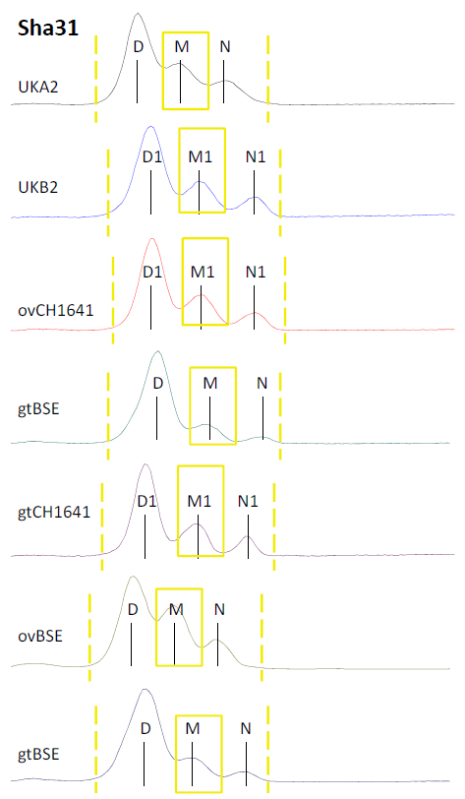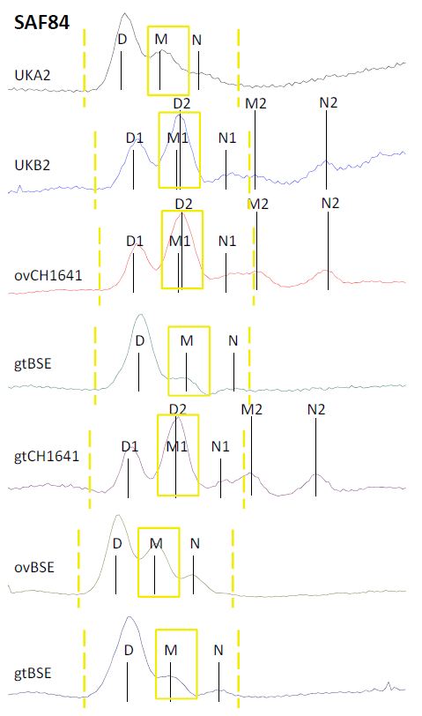
Graphic comparison of the PrP^{res} double and single triplet state in resp. CH1641 and scrapie/BSE. See for original Triplex WB picture Figure 2. Application of two PrP-core specific antibodies in WB - in this case Sha31 and SAF84 - unveils the unique PrP^{res} triplet property of CH1641 scrapie samples, and of the similarity of sample UK-B2 with CH1641 scrapie. D, M, and N point to the migration position of respectively di-glycosylated, monoglycosylated and non-glycosylated PrP bands in a PrP^{res} triplet. Where two populations are present, the D, M and N positions of PrP^{res}#1 and PrP^{res}#2 are labelled with respectively 1 and 2. The signal fraction (yellow blocks) within the triplet #1 region (yellow lines) is used to calculate the SAF84/Sha31 fractional ratio at the “24 kDa” region within the area surround with two dashed yellow lines.

