Experimental and numerical study of the hydrodynamics of an isolated bubble in non-Newtonian liquid phase in a thin gap bubble column

Sikandar ALMANI¹, Walid BLEL¹, Emilie GADOIN¹ and Caroline GENTRIC^{1*}
¹GEPEA, CNRS-UMR 6144, Saint-Nazaire Cedex, France.
caroline.gentric@univ-nantes.fr
SUMMARY:
Development of photobioreactors (PBR) for microalgae cultivation is a primary concern, keeping in mind the applicative potential of these photosynthetic microorganisms. For this purpose, optimization of culture parameters and PBRs design are the two possible solutions in order to obtain high volumetric productivities. The thin-gap intensified PBR allows to obtain these performances via an increase of culture concentration for a given illuminated surface. When compared with usual PBRs, the confinement results in a high change of the hydrodynamics and mass transfer[1]. To optimize these production systems, our study focuses on the characterization of local hydrodynamics in a 2D bubble column of 4 mm thickness (FIG. 1). Furthermore, it has been shown that the increase in cell concentration is accompanied by rheological properties modifications of the microalgae suspension. To mimic such high concentration of Chlorella vulgaris cultures which have non-Newtonian shear thinning behaviour at concentrations ranging from 30-40 g/L[2], solutions of Xanthan Gum (XG) and Carboxymethyl cellulose (CMC) are used respectively at the concentrations of 1 g/L and 2 g/L. In order to put forward the effect of the rheological behaviour, demineralized water is also used as a Newtonian fluid. In this preliminary work, the main purpose is to estimate the terminal velocity (V_{t}) of an isolated bubble in this confined column. In fact, if the terminal velocity for an isolated bubble is modified due to wall effects, there will have consequences for hydrodynamics and mass transfer of the whole bubble column: for instance, bubble residence time or gas hold up will be modified[1]. B.Figueroa Espinoza et al. [3] reported the confinement effect for a single clean bubble, pointing out that the drag coefficient widely increases for oscillating bubbles rising in a Hele-shaw cell.
The experimental part consists in studying the local hydrodynamics behaviour of isolated bubbles of different diameters for three liquid media: water, CMC and XG solutions. Capillaries tubes, having diameters (d_{c}) of 0.127, 0.264, 0.508, 0.762 or 1.016 mm are used to generate isolated bubbles at different diameter sizes with the help of a low-pressure syringe pump (NEMESYS, GERMANY). Bubble injection is performed 7 cm away from the lateral wall which can be considered sufficient to avoid wall influence on the hydrodynamics of isolated bubble. Bubble size and instantaneous bubble velocity are estimated by a shadowgraphy method using the DANTEC DYNAMICS Shadow Strobe. These measurements are performed at mid height of the column, where bubble terminal velocities have been reached. The experimental terminal velocities for different bubble diameters (d_{b}) in water, CMC and XG liquid media are reported in Table 1 and plotted in FIG. 2(a). Water measurements are also compared to the correlation established by M.Jamialahmadi et al.[4] and the data of R.Clift et al. [5] which concern isolated bubble in pure water in infinite liquid medium (FIG. 2(b)). It is found that for an isolated bubble rising in quiescent liquid, with a diameter lower than 4 mm, the terminal velocity is divided by V_{t} ratio between 1.2 and 1.6 for water. Besides this in non-Newtonian solutions, for lower bubble diameters the terminal velocity is less than water medium and as the bubble diameter increases it becomes constant this phenomena was also experienced by Shahram Amirnia et al.[6].
In parallel to experiments, a numerical study is performed to characterize the behaviour of one single bubble in the confined space between two walls in Newtonian and Non-Newtonian media. Simulations are performed with academic Ansys Fluent 17.2 solver using volume of fluid (VOF) method for interface tracking along with continuum surface Force (CSF) model to treat surface tension. Firstly, mesh independency verification has been performed by 2D and 3D simulations of a 3 mm diameter bubble in infinite medium. These results have been validated with the results of F.Bertola et al.[7](FIG.2(b)). Thereafter the same confined geometry as experimental setup has been adopted to simulate the bubble diameters determined experimentally. Numerical results are reported in FIG. 2(b) and seem to be in good agreement with the experiments results (FIG 2(b)).

KEYWORDS OF THEME: Hydrodynamics, Computational Fluid Dynamics (CFD)

KEYWORDS: Gas liquid reactor, bubble column

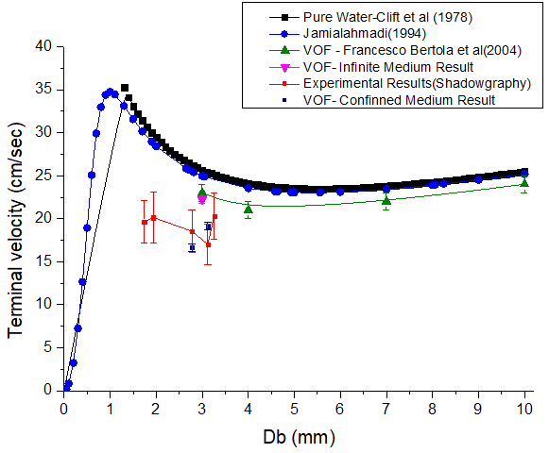
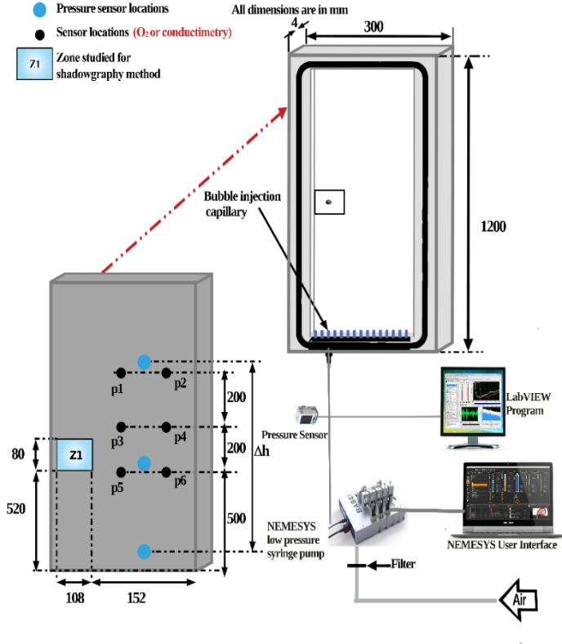
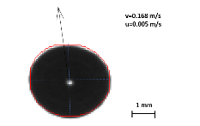
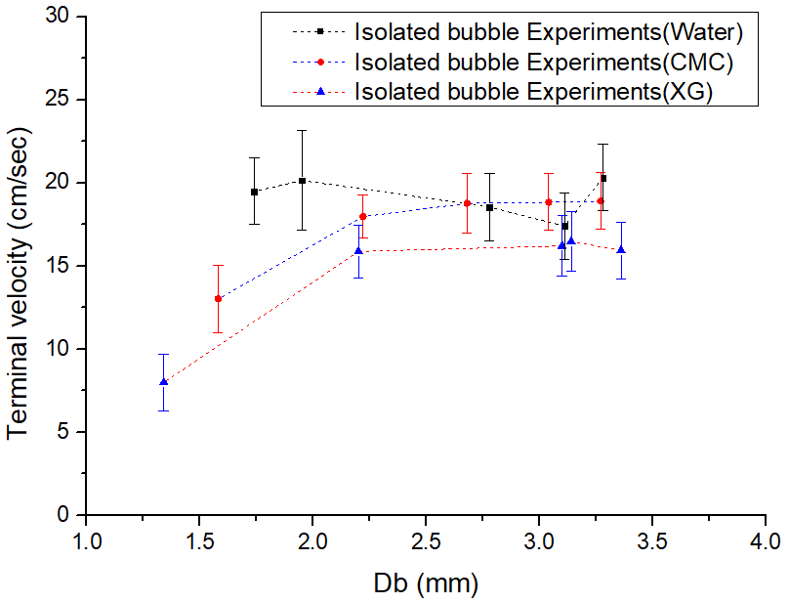
2(a)
2(b)

Fig. 1. Isolated Bubble Experimental Setup. Fig. 2(a). Experimental results of water, CMC and XG.
Fig. 2(b). Experimental and numerical comparison of terminal velocities in confined and infinite medium for air-water system
Table 1. Terminal velocities of the generated bubbles from capillaries.
Fluid | d_{c} (mm) | d_{b} (mm) | V_{t}  (m/sec) | Standard Deviation | V_{t} by Correlation [4]  (m/sec) | V_{t} Ratio  (Infinite/confined results)
Water | 0.127 | 1.74 | 0.1948 | ± 0.025 | 0.3139 | 1.61
 | 0.254 | 1.95 | 0.2014 | ± 0.003 | 0.3001 | 1.49
 | 0.508 | 2.78 | 0.1853 | ± 0.025 | 0.2619 | 1.41
 | 0.762 | 3.11 | 0.1704 | ± 0.024 | 0.2545 | 1.49
 | 1.016 | 3.28 | 0.2030 | ± 0.027 | 0.2505 | 1.23
CMC  (2 g/L) | 0.127 | 1.58 | 0.1301 | ± 0.020
 | 0.254 | 2.22 | 0.1797 | ± 0.013
 | 0.508 | 2.68 | 0.1876 | ± 0.018
 | 0.762 | 3.04 | 0.1883 | ± 0.017
 | 1.016 | 3.27 | 0.1890 | ± 0.017
XG  (1 g/L) | 0.127 | 1.34 | 0.0800 | ± 0.017
 | 0.254 | 2.20 | 0.1587 | ± 0.016
 | 0.508 | 3.10 | 0.1621 | ± 0.018
 | 0.762 | 3.14 | 0.1647 | ± 0.018
 | 1.016 | 3.36 | 0.1594 | ± 0.017
REFERENCES:
[1] C. Thobie, E. Gadoin, W. Blel, J. Pruvost, and C. Gentric, “Global characterization of hydrodynamics and gas-liquid mass transfer in a thin-gap bubble column intended for microalgae cultivation,” Chem. Eng. Process. Process Intensif., vol. 122, pp. 76–89, 2017.
[2] A. Souliès, J. Pruvost, J. Legrand, C. Castelain, and T. I. Burghelea, “Rheological properties of suspensions of the green microalga Chlorella vulgaris at various volume fractions,” Rheol. Acta, vol. 52, no. 6, pp. 589–605,2013.
[3] B. Figueroa-Espinoza, R. Zenit, and D. Legendre, “The effect of confinement on the motion of a single clean bubble,” J. Fluid Mech., vol. 616, no. 2008, pp. 419–443, 2008.
[4] M. Jamialahmadi, C. Branch, and H. Muller-Steinhagen, “Terminal Bubble Rise Velocity in Liquids,” Chem. Eng. Res. Des., vol. 72, pp. 119–122, 1994.
[5] R. Clift, J. R Grace, and M. E Weber, Bubbles, Drops, and Particles. 1978.
[6] S. Amirnia, J. R. de Bruyn, M. A. Bergougnou, and A. Margaritis, “Continuous rise velocity of air bubbles in non-Newtonian biopolymer solutions,” Chem. Eng. Sci., vol. 94, pp. 60–68, 2013.
[7] F. Bertola, G. Baldi, D. Marchisio, and M. Vanni, “Momentum transfer in a swarm of bubbles: Estimates from fluid-dynamic simulations,” Chem. Eng. Sci., vol. 59, no. 22–23, pp. 5209–5215, 2004.

