Grape solids: lipid composition and role during alcoholic fermentation under oenological conditions

Erick Casalta¹, Jean-Michel Salmon², Christian Picou¹ and Jean-Marie Sablayrolles¹

- INRA, UMR Sciences Pour l’Œnologie, 2 Place Viala, F34060 Montpellier, France
- INRA, UE Pech Rouge Domaine de Pech-Rouge, F11430 Gruissan, France

Corresponding author: E. Casalta, Phone: 00 33 4 99 61 30 83
E-mail address: erick.casalta@inra.fr

Acknowledgments
The authors thank Mrs Evelyne Aguera for her technical support on must clarification process and grape solids preparation and Mrs Martine Pradal for performing the amino acids analyses. Authors are grateful to Dr Catherine Tesnière for her helpful advices during the redaction of this manuscript.
Abstract
Grape must contains residual solid particles after clarification. The quantity of residual solid particles depends on the clarification level. In absence of oxygen, lipids included in solid particles are essential for yeast metabolism and viability. Thus, we investigated the lipid composition of grape solids to gain a better understanding of their impact during alcoholic fermentation. Experimental fermentations were carried out on synthetic must in 1.1 L fermenters with the addition of grape solids from red, rosé or white winemaking processes. β-sitosterol was the main sterol in grape must, but there was considerable variability of overall sterol content of solid particles depending on their origin. Must turbidity was not representative of sterol content. Sterol content appeared to be determinant for maximum fermentation rate and duration when lipids were the limiting yeast nutritional factor. This impact can be explained by the fact that sterol directly i) favor yeast nitrogen assimilation and consequently cell growth, ii) improve cell viability at the end of fermentation reducing risk of sluggish fermentation. Thus, taking into account the sterol content of the must should allow winemakers to improve fermentation control of fermentations in liquid phase.
Key words: grape solids, sterols, yeast, alcoholic fermentation

Introduction
During winemaking, solids of various sizes, mainly composed of cell fragments are removed by clarification. Clarification can be achieved by various processes (Battle et al. 1998): cold-settling, filtration, centrifugation, flotation, or microbiological stabilization. Clarification in red winemaking is usually performed after fermentation, whereas it generally occurs before fermentation in white winemaking. New practices in red winemaking (e.g. thermovinification, flash release, centrifuge decantation) followed by pressing of the must allow fermentations in liquid phase, at low temperature, without maceration.
Clarification is carried out for several reasons. Solid particles contain polyphenol oxidase activity which can lead to must browning (Sire et al. 2016). Solid particles also include esterase activity which reduces the accumulation of esters synthesized by yeasts (Boulton et al. 1996). Clarification reduces the concentration of herbaceous alcohols and aldehydes in wines (Mesias et al. 1983) produced from unsaturated fatty acids. It allows to obtain wine with a fresh, clean, delicate, characteristic fruity odour (Singleton et al. 1975).
However, excessive clarification negatively affects wine quality (Groat and Ough 1978, Feuillat et al. 1989, Ochando et al. 2016). It is widely considered that solid particles contain nutrients, useful for fermentation, mainly in their lipid fraction (Ribéreau-Gayon 1985). Indeed, the major lipid components of eukaryotic membranes are phospholipids, sterols, sphingolipids, glycerolipids and fatty acids. Fatty acids and sterols are not only essential for maintaining membrane integrity and function (Henschke and Rose 1991), and consequently yeast cell viability and fermentation activity, but also for adaptation to fermentation stresses, such as high sugar levels and ethanol toxicity, which can increase the cellular requirement for lipids (Aguilera et al. 2006, Chi and Arneborg 1999).
Among lipids, sterols play major roles in building and maintenance of eukaryotic membranes (Daum et al. 1998). In yeast cells, they represent 6% of the protoplasmic membrane dry weight (Longley et al. 1967). They compensate, at least partially, for oxygen (Andreasen and Stier 1953) and long chain fatty acid deficiencies (Cabanis and Flanzy 1998) under anaerobic conditions. Sterols are necessary for cell growth at the beginning of alcoholic fermentation. The required amount for maximal yeast growth is 2 to 4 mg/L (Deytieux et al. 2005). Later in the process, sterols allow the yeast to resist high ethanol concentrations and decrease the risks of sluggish or stuck fermentations. Nevertheless, Luparia et al. (2004) showed that in the absence of oxygen, yeast cells cannot achieve complete alcoholic fermentation by only assimilating grape phytosterols. Oxygen addition is thus necessary to complete such fermentations. Under aerobic conditions, yeast do not take up exogenous sterols. They synthesize their own major sterols (mainly ergosterol) (Parks, 1978). Under anaerobic conditions, since yeasts are unable to synthetize sterols, these compounds, if exogenously supplied to the cells, are called “survival factors” as they provide better yeast viability at the end of fermentation (Lafon-Lafourcade et al. 1977).
The synthesis, storage, turnover and some regulatory aspects of lipids in S. cerevisiae have been described in a review by Klug and Daum (2014).
Turbidity is the most common criterion used in winemaking to estimate the quantity of grape solids in juices. A sufficiently high level of turbidity (approximately 50 to 150 NTU) is essential for white wine production. Turbidity generally ranges from 1000 to 5000 NTU in red musts obtained after pomace extraction (Vernhet et al. 2016). Although useful and easily accessible to winemakers, this parameter does not provide any indication of the nature or composition of the suspended solids. Turbidity not only depends on the suspended solid volumetric fraction, but also on particle size. Thus, the same amount of suspended solids can result in different turbidities, depending on their nature and size distribution (Vernhet et al. 2016).
Alexandre et al. (1994) studied the overall composition of small particles fractionated by static settling from a white must. Lipids represented 8% of dry weight and contained 52.8% unsaturated fatty acids. Experimental alcoholic fermentation with addition or removal of grape solids showed that the positive effect of grape solids on yeast population, viability and fermentation kinetics was mainly due to lipid content (Casalta et al. 2013). The interaction between grape solids and assimilable nitrogen has been studied, showing that the effect of adding grape solids is highly dependent on the assimilable nitrogen content of the must. This relation points out the importance of taking into account the balance between lipid content and nitrogen content for controlling fermentation (Casalta et al. 2012). Varela et al. (2012) studied the effect of oxygen and lipid supplementation on the formation of flavour active metabolites during wine fermentation and showed that lipid addition increased the concentration of esters, higher alcohols, and volatile acids, whereas oxygen increased the concentration of higher alcohols and altered the proportion of acetate to ethyl esters and branch-chain acids to medium chain fatty acids. The combined addition of lipids and oxygen showed an additive effect on the concentration of higher alcohols, whereas oxygen suppressed the enhancing effect on the formation of esters and volatile acids. Rollero et al. (2015) developed a model to predict the combined effects of initial nitrogen, phytosterol content and fermentation temperature on the production of volatile compounds. The model showed that the final liquid concentration of all ethyl esters was strongly influenced by the three studied parameters.
Data on the lipid fraction in grape solids, particularly phytosterols, are scarce. Moreover, although the effect of turbidity on alcoholic fermentation has been studied (Casalta et al. 2013), the direct relationship between phytosterol content and alcoholic fermentation is not well understood. Our aim was to more extensively determine the lipid composition of grape solids and highlight the impact of must sterol content on alcoholic fermentation.

Materials and methods
The study was carried on seven samples of solid particles from Languedoc Roussillon (France) grape musts: two from red wine process (Red 1 and Red 2), two from rosé wine process (Rosé 1 and Rosé 2) and three from white wine process (White 1, White 2 and White 3). Grape varieties and clarification processes are indicated in Table 1.

Experimental fermentations
The aim of the experimental fermentations was to study the effect of various solid particles on the yeast population and on the fermentation kinetics.
Fermentation was carried out in synthetic medium (SM) that simulates standard grape juice (Bely et al. 1990). The composition of the SM has been described by Rollero et al. (2015). SM contained 250 g/L sugar (125 g/L glucose and 125 g/L fructose). The concentration of assimilable nitrogen was 425 mg/L, with a ratio (m/m) of 72% nitrogen from assimilable amino acids and 28% ammoniacal nitrogen (NH₄Cl).

The experiments were designed as follows (Table 2):
Preliminary experiment: SM without sterol and solid particle addition (negative control), SM with 1.5, 3.0, 4.5 and 6.0 mg of synthetic β-sitosterol (85451, Sigma, Aldrich) per litre.
First set of experiments: SM without sterol and solid particle addition (negative control), SM with 1 mg of synthetic β-sitosterol (85451, Sigma, Aldrich) per litre (positive control) and SM complemented with solid particle samples issued from different musts. Solid particles were added to must to obtain a standardized phytosterol content (1 mg/L). Mass additions were calculated according to dry matter (DM) weight.
Second set of experiments: SM without sterol and solid particle addition (negative control) and SM with the same solid particle samples added to obtain a final must turbidity of 30 NTU.
Fermentations were carried out in duplicate in 1.1 L cylindrical glass bottles (non-commercial bioreactors) fitted with fermentation locks. Must was inoculated at 10 g/ hL with the Saccharomyces cerevisiae strain Lalvin EC 1118® (Lallemand, Toulouse, France). Fermentations were performed under isothermal conditions at 24°C.
The amount of CO₂ released was calculated from the weight loss of the fermenter by automatic measurement every 20 min. The CO₂ production rate was calculated using polynomial smoothing (Sablayrolles et al. 1987).

Analytical methods
Turbidity measurement
Turbidity due to solid particles in SM was measured with a Hanna HI 88703 turbidimeter (Hanna Instruments, Carpiquet, France).
Dry matter
Grape solids dry matter was determined by weighting before and after drying at 105°C for 24 h.
Lipid composition
Total lipids from lyophilized grape solids (1 g) were extracted overnight with methanol/chloroform (2 : 1, v/v) and the solid residue was then extracted for 2 h with methanol/chloroform/water (2 : 1 : 0.8, v/v/v). The organic extracts were combined, dried over Na₂SO₄, and concentrated to dryness using a rotatory evaporator. Phytosterols and fatty acids were determined in the remaining solids according to Grison et al. (2015) adapted as follows:
Total fatty acids
Fatty acids from dry matter were transmethylated overnight/85°C in 1 mL of methanol:H₂SO₄ solution (100:2.5, v/v) containing the internal standards C17:0. After cooling, 1 mL of hexane / 2.5% NaCl (1:1, v/v) was added and the upper hexane phase containing FAMEs (Fatty acid methyl ester) was recovered and buffered with 1 mL of 0.9% NaCl 2.5%. The upper hexane phase was transferred to injection vials for GC-FID analysis. GC-FID was performed using an Agilent 7890 gas chromatograph (Agilent Technologies France, Les Ulis, France) equipped with a Carbowax column (15 m x 0.53 mm, 1.2 µm; Alltech Associates, Deerfield, IL, USA) and flame ionization detection. The temperature gradient was 160°C for 1 min, increased to 190°C at 20°C/min, increased to 210°C at 5°C/min and then remained at 210°C for 5 min. FAMES were identified by comparing their retention times with commercial fatty acid standards (Sigma-Aldrich) and quantified using ChemStation (Agilent) to calculate the peak surfaces, and then comparing them with the C17:0 response.
Sterols analysis
A saponification was performed on dry matter (0.1 g), by adding 1 mL of ethanol and 100 µL of 11 N KOH containing the internal standard b‐cholestanol and incubating it overnight at 85°C. After the addition of 1.5 mL of hexane and 1 mL of water, the sterol-containing upper phase was recovered and the solvent was evaporated under an N₂ gas stream. Sterols were trimethylsilylated by N,O‐bis(trimethylsilyl) trifluoroacetamide (BSTFA)-trimethylchlorosilane for 30 min at 115°C. After complete evaporation of BSTFA under N2 gas, sterols were dissolved in 400 µL of hexane and analyzed by GC-MS. GC-MS was performed using an Agilent 6850 gas chromatograph and coupled MS detector MSD 5975-EI (Agilent). An HP-5MS capillary column (5% phenyl-methyl-siloxane, 30-m, 250-mm, and 0.25-mm film thickness; Agilent) was used with helium carrier gas at 2 mL/min; injection was done in splitless mode; injector and mass spectrometry detector temperatures were set to 250°C; the oven temperature was held at 50°C for 1 min, then programmed with a 25°C/min ramp to 150°C (2-min hold) and a 10°C/min ramp to 320°C (6-min hold). Quantification of derivatized sterols was based upon peak areas that were derived from the total ion current.

Reducing sugars
Reducing sugar concentrations were measured on media at the end of the fermentation by HPLC (HPLC 1290 Infinity, Agilent Technologies, Santa Clara, California, USA) using a Phenomenex Rezex ROA column (Agilent Technologies, Santa Clara, California, USA) at 60°C. The column was eluted with 0.005 N H₂SO₄ at a flow rate of 0.6 mL/min. Analysis was carried out using the Agilent EZChrom software package. Fermentations were considered to be complete when the residual sugar concentration was below 2 g L⁻¹.
Nitrogen
The ammonium concentration (NH₄) was determined enzymatically (RBiopharm, Darmstadt, Germany). The free amino acid content of the must (Naa) was determined by cation exchange chromatography, with post-column ninhydrin derivatization (Biochrom 30, Biochrom, Cambridge, UK), as described by Crépin et al. (2012). These two determinations were carried out at 80% fermentation progress. Assimilated nitrogen (Assimilated N_{80%}) was calculated as follows:
Assimilated N_{80%} = Naa in must + NH₄ in must – Naa 80% – NH₄ 80%. The percentage of assimilated nitrogen was determined as:
Assimilated N_{80%}x100__
Naa in must + NH₄ in must
Cell counting
Must samples harvested during fermentation were first diluted (1000 to 2500 times) with Isoton II® (Beckman-Coulter, Margency, France). After sonication (35 s, 10W), cells were counted with a Coulter Z2 electronic counter (Coulter Multisizer3, Beckman Coulter, Fullerton, California, USA) fitted with a 100-µm aperture probe. Measurements and analysis were carried out in duplicate.

Results
Lipid composition
The concentration of phytosterols ranged from 3.61 to 11.25 mg/g DM with a mean value of 6.72 mg/g DM depending on the solid particle type (Table 3). β-Sitosterol was the principal phytosterol (75 %). Campesterol and stigmasterol represented approximately 5% of total phytosterols.
The total fatty acid concentration varied from 16 to 53 mg/g DM with a mean value of 33 mg/g of DM (Table 4). Unsaturated acids (mainly C:18) represented approximately 49% of total fatty acid content. The most abundant fatty acid was palmitic acid (26%). They represented between 79 and 85% of total lipid content and were more abundant than phytosterols in dry matter (Table 5).
Preliminary experiment: fermentation with increasing synthetic phytosterol content
Figure 1a shows that phytosterol content positively impact fermentation kinetics. This result suggests that in these conditions, phytosterol content is limiting. As a matter of fact, maximum yeast population increased from 51 x 10⁶ without phytosterol to 75 x 10⁶ cells/mL with 1.5 mg/L synthetic phytosterol and 126 x 10⁶ cells/mL with 6.0 mg/L phytosterol (Figure 1b).
First set of experiments: fermentation with musts containing 1 mg/L phytosterol
Turbidity varied from 14 to 38 NTU after the addition of solid particles to obtain a concentration of phytosterols of 1 mg /L (Figure 2). This indicates that turbidity is not representative of the lipid nutritional supply. Indeed, figure 3 shows that the relationship between turbidity and sterol content depends on must. As a matter of fact, exogenously supply of 0.5 mg/L sterols from different solids can result in turbidities ranging from 100 to 330 NTU, depending on the origin of the grape solids.
Concerning nitrogen, assimilated N at 80% fermentation ranged from 251 (59%) to 276 mg/L (65%), depending on the grape solids (Table 6). In this situation, nitrogen is not the limiting yeast nutritional factor. Considering that the addition of phytosterol dramatically affects kinetics (Figure 4), phytosterol content seems to act as the main limiting factor. When compared with the negative control, the addition of grape solids increased yeast nitrogen assimilation (from + 24 mg N/L with Red 2 to + 49 mg N/L with White 3) (Table 6). Grape solids also positively impacted maximum yeast population (Table 6) which range from 51 x 10⁶ cells/mL without grape solids (negative control) to 84 x 10⁶ cells/mL with grape solids (positive control and White 3). There was almost the same amount of residual sugar at the end of fermentation, whatever the origin of solid particles (Table 6). Thus, in these conditions, the amount of added and available phytosterols, whatever their origin -synthetic or natural-, did not allow completion of the fermentation.
The fermentation kinetics were very similar, irrespective of the type of added solids (Figure 4). The kinetics with 1 mg/L synthetic β-sitosterol added (positive control) were similar to those obtained with grape solids. The negative control showed slower kinetics, characterized by a low maximum fermentation rate (Vm). These results show that the kinetic parameters depend on phytosterol content, when this compound is the limiting nutritional factor.
Second set of experiments: fermentations with musts at 30 NTU
The fermentation kinetics varied, depending on the origin of the grape solids, when the fermentations were carried out with musts at 30 NTU. The fastest fermentation was obtained with White 2 grape solids and the lowest with Rosé 2 grape solids (Figure 5).

Discussion
The lipid composition of white sludges, with about 50% unsaturated fatty acids and 50% saturated fatty acids, is in accordance with results of Alexandre et al. (1994), who reported a composition of 53% unsaturated fatty acids and 47% saturated fatty acids. Sludges from Red 2 had the highest concentration of fatty acids. This may be linked to the thermo-vinification process, which tends to extract fatty acids from the skin. In fact, the skin was found to be 1.5-3 times richer than pulp for these compounds (Roufet et al. 1987).
Total phytosterol content of the solids varied considerably, depending on the origin of the sludges (from 3.61 to 11.25 mg/g DM for White 3 and White 2, respectively). There was also considerable variation among sludges of the same type (for example from 3.61 to 11.25 mg/g DM for white sludges). These results highlight the substantial heterogeneity of phytosterol content of grape solids. The proportion of stigmasterol and campesterol in grape solids (approximately 5% for each) were similar to that in mature berry skins, reported by Le Fur et al. (1994). The main difference was for β-sitosterol, for which the proportion was higher in berry skins (86-89%) than in grape solids (75%). Ruggiero et al. (2013) also reported that β-sitosterol is the most abundant sterol in berry flesh, skin, and seeds, with campesterol and stigmasterol found at lower levels. Thus, the use of classical clarification or thermic processes to obtain sludges have a poor impact on the repartition of phytosterols.
On white grape solids sample, the content of phytosterols and fatty acids varied between 20 and 54 mg/g. This result is coherent with Alexandre et al. (1994) who reported a total lipid content of 80 mg/g.
Our results show that for a given sterol content, turbidity reached after solids addition depends on the solid origin. So, no simple relationship between turbidity and sterol contents can be established. For example, Red 1 solid particles were distinct from the others by providing higher turbidity. This sample was the only one subjected to flash release extraction. It may thus be informative to know whether this process can explain such a difference in turbidity.
The fermentation kinetics obtained with different grape solids were not similar when the turbidity was standardized to a low level (30 NTU), with the fastest kinetics obtained with grape solids containing the highest sterol content. In contrast, when phytosterol content was standardized at 1 mg/L, the origin of the grape solids did not affect the kinetics. In this situation, phytosterol is not sufficient to fit the requirements of yeast which are evaluated at about 5 mg/L when assimilable nitrogen must content is 300 mg/L (Deytieux et al., 2005). As a matter of fact, sterol content appears to be a key factor for alcoholic fermentation, maximum fermentation rate, and fermentation duration. This can be explained by the fact that phytosterol levels directly affect yeast nitrogen assimilation and yeast population, as demonstrated by the substantial increase of the maximum yeast population in the presence of synthetic sterol or grape solids. The relationship between sterol content and yeast nitrogen assimilation was previously evidenced by Casalta et al (2012) who showed an important increase of yeast nitrogen assimilation when solids are added on natural must. In addition, in very clarified musts, the porosity of the yeast cell wall is higher (Boivin et al. 1998) and acetic acid and medium chain fatty acid production are increased (Alexandre et al. 1994), inhibiting fermentation (Edwards et al. 1990). Therefore, phytosterols are both necessary for growth and for maintaining cell viability. Larger quantities of grape solids and lipids are required when the assimilable nitrogen content is higher (Casalta et al. 2013; Tesnière et al. 2013). Thus, it is important to take into account the must assimilable nitrogen content to fit the lipid requirements of the yeast (Duc et al. 2017). In fact, these authors have shown that in case of lipid deficiency (excessive clarification), yeast cells are unable to trigger an appropriate stress response resulting in the death of numerous cells. Winemakers can better control fermentation in two ways:
- providing a sufficient initial level of grape solids and lipids to the must. The critical level of solids in grape juice is between 0.1 and 0.5% (v/v) (Groat and Ough 1978). Analysing sterol content of solids is time consuming and expansive. A simple and reliable criterion would greatly aid the estimation of solid particle sterol content as an alternative to turbidity measurements. Such a criterion would allow better control of alcoholic fermentation,
- adding oxygen at the end of the growth phase (Ochando et al. 2017). In the absence of lipids in the must, yeast oxygen requirements is estimated at approximately 5-10 mg/L (Sablayrolles and Barre 1986).

Conclusion
We provide quantitative data on the lipid fraction of wine solid particles, confirming that β-sitosterol is the principal sterol in grape must. Our results highlight the differences in grape solid sterol content and it would be informative to study the factors which may cause this variability (grape variety and/or maturity, clarification process). Sterol content directly affects fermentation kinetics when lipids are the limiting yeast nutritional factor. Such deficiency is not very common, but occurs in case of excessive clarification during white or rosé winemaking. Thus, these compounds are a key element of yeast nutrition. Sterol content in must should be taken into account for the control of alcoholic fermentation to avoid both slow and sluggish fermentation. Knowledge of the sterol content necessary to consume all the assimilable nitrogen should allow winemakers to improve the control of fermentation.

References
Aguilera F, Peinado RA, Millan C, Ortega JM and Mauricio JC. 2006. Relationship between ethanol tolerance, H+-ATPase activity and the lipid composition of the plasma membrane in different wine yeast strains. International J Food Microbiol 110:34–42.

Alexandre H, Nguyen Van Long T, Feuillat M and Charpentier C. 1994. Contribution à l’étude des bourbes : influence sur la fermentescibilité des moûts. Rev Fr Œnol 146:11-20.
Andreasen AA and Stier TJB. 1953. Anaerobic nutrition of Saccharomyces cerevisiae. I. Ergosterol requirement for growth in a defined medium. J Cell Compar Physl 41:23-36.
Battle GL, Boulet JC, Brugirard A, Dubernet M, Escudier JL, Moutounet M, Saint-Pierre B and Vernhet A. 1998. Clarification, stabilisation des vins. In Œnologie : Fondements scientifiques et technologiques Tec & Doc (eds.), pp. 920-1001. Lavoisier, Paris.
Bely M, Sablayrolles JM and Barre P. 1990. Automatic detection of assimilable nitrogen deficiencies during alcoholic fermentation in enological conditions. J Ferment Bioeng 70:246-252.
Boivin S, Feuillat M, Alexandre H and Charpentier C. 1998. Effect of must turbidity on cell wall porosity and macromolecule excretion of Saccharomyces cerevisiae cultivated on grape juice. Am J Enol Vitic 49:325-332.
Boulton RB, Singleton VL, Bisson LF and Kunkee RE. 1996. Preparation of musts and juice. In Principles and practices of winemaking, Chapmann & Hall (eds.), pp. 65-101. International Thomson Publishing, New York.
Cabanis JC and Flanzy C. 1998. Lipides. In Oenologie : Fondements Scientifiques et Technologiques. Tec & Doc (eds.), pp. 3-34. Lavoisier, Paris.
Casalta E, Cervi MF, Sablayrolles JM and Salmon JM. 2012. Effet combiné des niveaux d’azote assimilable et de bourbes : nouveau paramètre à prendre en compte pour la maîtrise de la fermentation alcoolique. Rev Fr Œnol 255:9-15.
Casalta E, Cervi MF, Salmon JM and Sablayrolles JM. 2013. White wine fermentation: interaction of assimilable nitrogen and grape solids on alcoholic fermentation under oenological conditions. Aust J Grape Wine Res 19:47-52.
Casalta E, Vernhet A, Sablayrolles JM, Tesnière C and Salmon JM. 2016. Review: characterization and role of grape solids during alcoholic fermentation under enological conditions. Am J Enol Vitic 67:133-138.
Chi Z and Arneborg N. 1999. Relationship between lipid composition, frequency of ethanol-induced respiratory deficient mutants, and ethanol tolerance in Saccharomyces cerevisiae. J Appl Microbiol 86:1047-1052.
Crépin L, Nidelet T, Sanchez I, Dequin S and Camarasa C. 2012. Sequential use of nitrogen compounds by Saccharomyces cerevisiae during wine fermentation: a model based on kinetic and regulation characteristics of nitrogen permeases. Appl Environ Microb 78:8102-8111.
Daum, G, Lees ND, Bard M. and Dickson R. 1998. Biochemistry, cell biology and molecular biology of lipids of Saccharomyces cerevisiae. Yeast 14:1471-1510.
Deytieux C, Mussard L, Biron MJ and Salmon JM. 2005. Fine measurement of ergosterol requirements for growth of Saccharomyces cerevisiae during enological fermentations. Appl Microbiol Biot 68:268-271.
Duc C, Pradal M, Sanchez I, Noble J, Tesnière C and Blondin B. 2017. A set of nutrient limitations trigger yeast cell death in a nitrogen-dependent manner during wine alcoholic fermentation. PLoS ONE 12:e0184838.
Edwards CGR, Beelman RB, Bartley CE and McConnell LA. 1990. Production of decanoic acid and other volatile compounds and the growth of yeasts and malolactic bacteria during vinification. Am J Enol Vitic 41:48-56.
Feuillat M, Freyssinet M and Charpentier C. 1989. L’élevage sur lies des vins de Bourgogne. II Evolution des macromolécules: polysaccharides et protéines. Vitis 28:161-176.
Grison MS, Brocard L, Fouillen L, Nicolas W, Wever V, Dörmann P, Nacir H, Benitez-Alfonso Y, Claverol S, Germain V, Boutté Y, Mongrand S and Bayer EM. 2015. Specific Membrane Lipid Composition is important for plasmodesmata function in Arabidopsis. Plant Cell 27:1228-50.
Groat M and Ough CS. 1978. Effects of insoluble solids added to clarified musts on fermentation rate, wine composition and wine quality. Am J Enol Vitic 29:112-119.
Henschke PA and Rose AH. 1991. Plasma membranes. In Yeast organelles AH Rose & JS Harrison (eds.). vol. 4, pp. 297-345. Academic Press Limited, London.
Klug L and Daum G. 2014. Yeast lipid metabolism at a glance. FEMS Yeast Res 14:369-388.
Lafon-Lafourcade S, Larue F, Brechot P and Ribéreau-Gayon P. 1977. Les stéroïdes « facteurs de survie » des levures au cours de la fermentation alcoolique du moût de raisin. C. R. Acad. Sci. Ser. D. 284:1939-1942.
Le Fur Y, Hory C, Bard MH and Olsson A. 1994. Evolution of phytosterols in Chardonnay grape berry skins during last stages of ripening. Vitis 33:127-131.
Longley RP, Rose AH and Knights BS. 1967. Composition of the protoplast membrane from Saccharomyces cerevisiae. Biochem J 108:401-412.
Luparia V, Soubeyrand V, Berges T, Julien A and Salmon JM. 2004. Assimilation of grape phytosterols by Saccharomyces cerevisiae and their impact on enological fermentations. Appl Microbiol Biotechnol 65:25-32.
Mesias JL, Maynar JI, Henao F and Mareca I. 1983. Alcools et aldéhydes herbacés (C6) dans les raisins et les moûts en fermentation alcoolique. Rev Fr Œnol 23:51-55.
Ochando T, Mouret JR, Humbert-Goffart A, Sablayrolles JM and Farines V. 2016. Nitrogen-lipid balance in alcoholic fermentations: the case of Champagne musts. International Symposium on Macromolecules and Secondary Metabolites of Grapevine and Wine (Macrowine), 27-30 june 2016, Changins, Nyons, Switzerland.
Ochando T, Mouret JR, Humbert-Goffart A, Sablayrolles JM and Farines V. 2017. Impact of initial lipid content and oxygen supply on alcoholic fermentation in Champagne-like musts. Food Res Int 98:87-94.
Parks L. W.1978. Metabolism of sterols in yeast. Crit. Rev. Microbiol 6:301–341.
Ribéreau-Gayon P. 1985. New development in wine microbiology. Am J Enol Vitic 36:1-10.
Rollero S, Bloem A, Camarasa C, Sanchez I, Ortiz-Julien A, Sablayrolles JM, Dequin S. and Mouret JM. 2015. Combined effects of nutrients and temperature on the production of fermentative aromas by Saccharomyces cerevisiae during wine fermentation. Appl Microbiol Biotechnol 99:2291-2304.
Rosenfeld E, Beauvoit B, Blondin B and Salmon JM. 2003. Oxygen consumption by anaerobic Saccharomyces cerevisiae under enological conditions: Effect on fermentation kinetics. Appl Environ Microb 69:113-121.
Roufet C, Bayonove L and Cordonnier RE. 1987. Lipid composition of grapevine berries, Vitis vinifera L.: Changes during maturation and localization in the berry. Vitis 26:85-97.
Ruggiero A, Vitalini N, Bernasconi S and Iriti M. 2013. Phytosterols in grapes and wine and effects of agrochemicals on their levels. Food Chem 14:3473-3479.
Sablayrolles JM and Barre P. 1986. Evaluation of oxygen requirement of alcoholic fermentation in simulated enological conditions. Sci Aliment 6:373-383.
Sablayrolles JM, Barre P and Grenier P. 1987. Design of a laboratory automatic system for studying alcoholic fermentation in anisothermal enological conditions. Biotechnol Tech 1:181-184.
Singleton VL, Sierberhagen HA, de Wet P and van Wyk C J. 1975. Composition and sensory qualities of wines prepared from white grapes by fermentation with and without grape solids. Am J Enol Vitic 26:62-69.
Sire Y, Douçot S, Pull MJ, Samson A, Moutounet M and Salmon JM. 2016. Activité polyphénol-oxydase du raisin : influence de la température et de différentes opérations. Rev Œnologues 160:38-40.
Tesnière C, Delobel P, Pradal M and Blondin B. 2013. Impact of nutrient imbalance on wine alcoholic fermentations: nitrogen excess enhances yeast cell death in lipid-limited must. PLoS ONE 8:e61645.
Varela C, Torrea D, Schmidt SA, Ancin-Azpilicueta C and Henschke PA. 2012. Effect of oxygen and lipid supplementation on the volatile composition of chemically defined medium and Chardonnay wine fermented with Saccharomyces cerevisiae. Food Chem, 135:2863-2871.
Vernhet A, Bes M, Bouissou D, Carrillo S and Brillouet JM. 2016. Characterization of suspended solids in thermo-treated red musts. J Int Sci Vigne Vin 50:9-21.

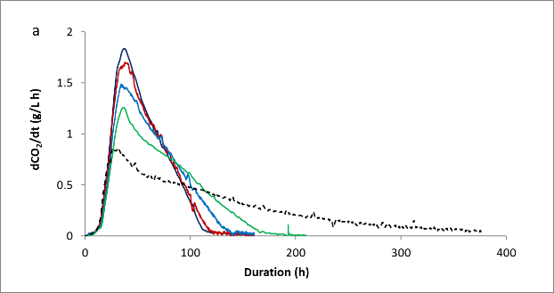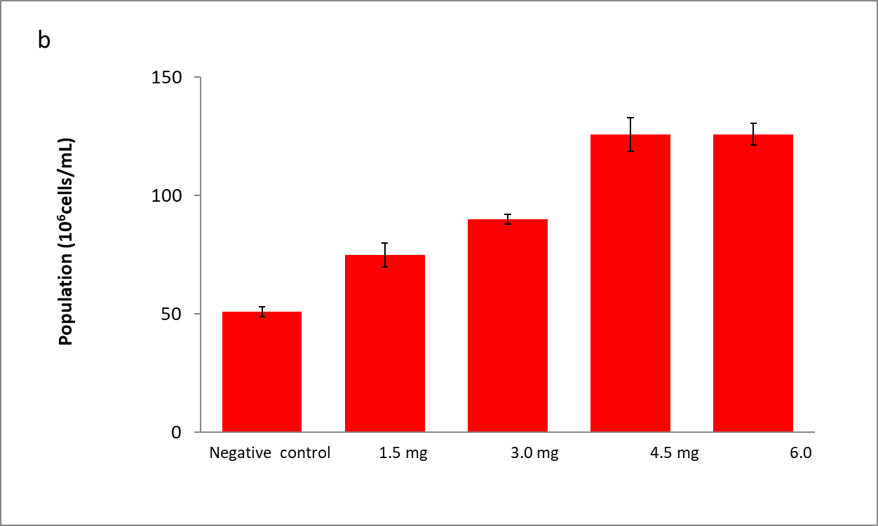
Figure 1: Effect of phytosterol addition. Effect on fermentation kinetics (a). Mean CO₂ production rate (n = 2) during alcoholic fermentation on must without added exogenous sterols nor grape solids (negative control) (- - -), on must with addition of 1.5 (—), 3.0 (—), 4.5 (—) and 6.0 (—) mg/L of synthetic β-sitosterol. Effect on maximum yeast population reached during alcoholic fermentation (n = 2) (b).
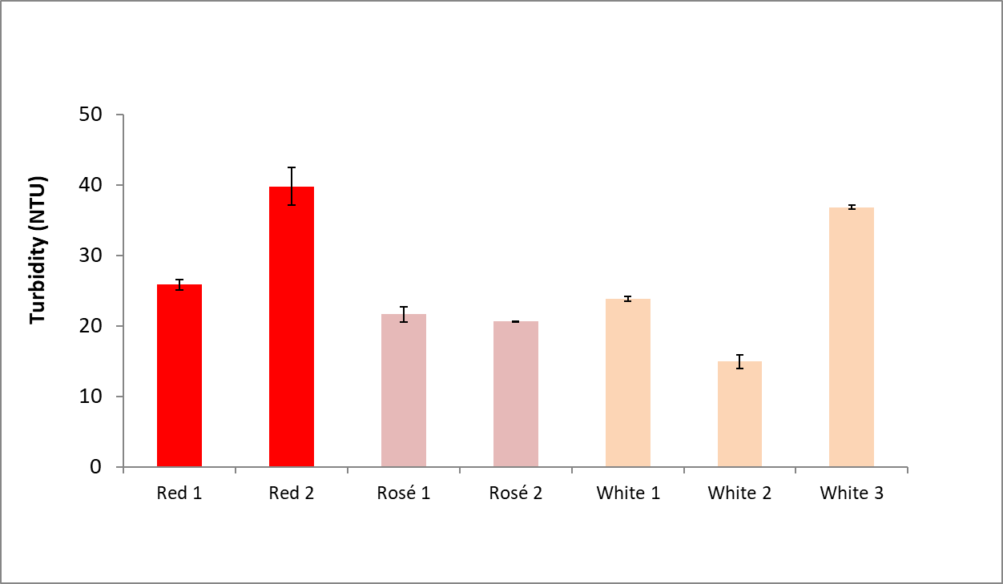
Figure 2: Turbidity measured in musts standardized at 1 mg sterol/L with addition of different grape solids (n = 2).
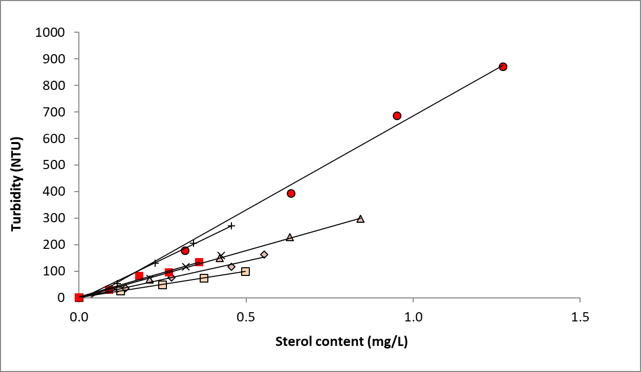
Figure 3: Relationship between sterol content and must turbidity. Synthetic must with addition of solids from Red 1 ( ) Red 2 ( ), Rosé 1 ( ), Rosé 2 ( ), White 1 Chardonnay (×), White 2 ( ) and White 3 (+).

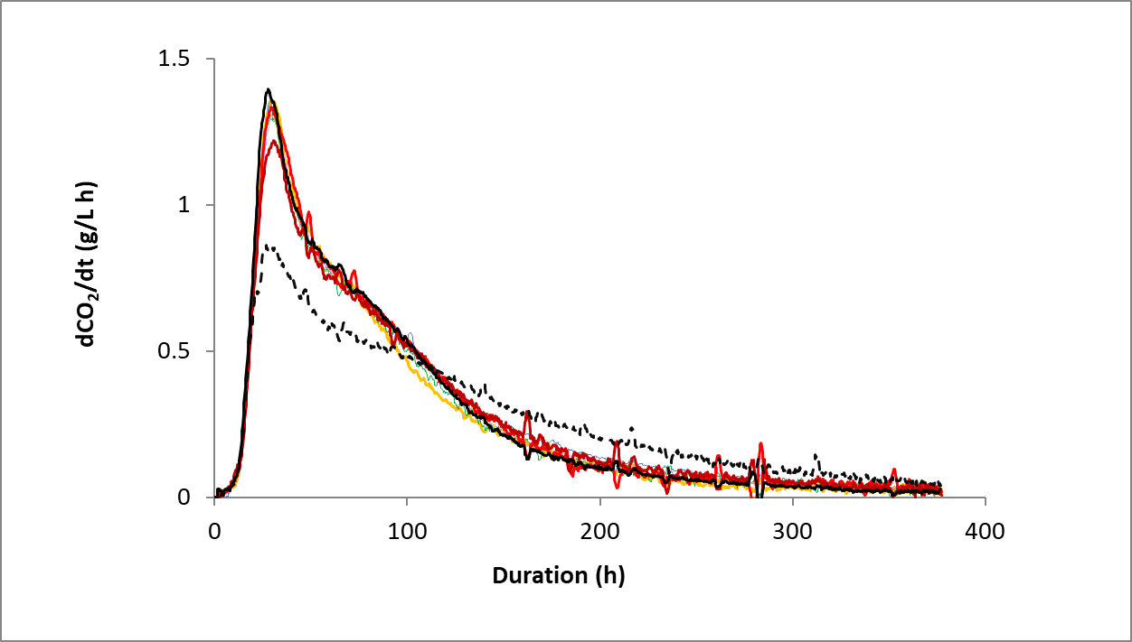
Figure 4: Mean CO₂ production rate (n = 2) during alcoholic fermentation on must without grape solids (negative control) (- - -) and on must standardized at 1 mg/L with synthetic β-sitosterol (positive control) (—), with solids from Red 1 (—), Red 2 (—), Rosé 1 (—), Rosé 2 (—), White 1 (—), White 2 (—) and White 3 (—).
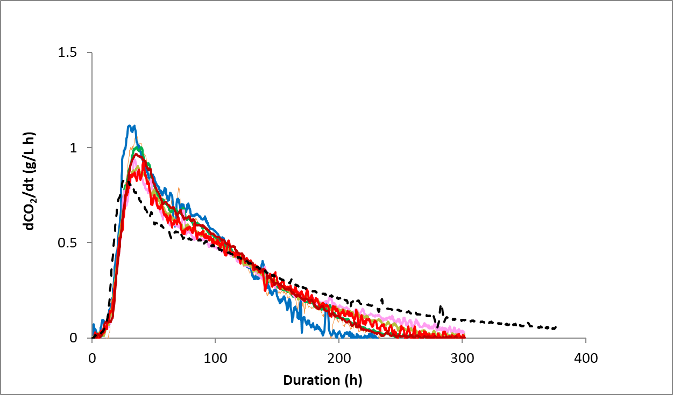
Figure 5: Mean CO₂ production rate (n = 2) during alcoholic fermentation on must without grape solids (negative control) (- - -), on must standardized at 30 NTU with addition of solids from Red 1 (—), Red 2 (—), Rosé 1 (—), Rosé 2 (—), White 1 (—), White 2 (—) and White 3 (—).

