## Supporting Information

High ionic conductivity in oxygen-deficient Ti-substituted sodium niobates and the key role of structural features

Guillaume Gougeta,†,*, Mathieu Duttinea, U-Chan Chung Seua, Sébastien Fourcadea, Fabrice Mauvya, Marc-David Braidab, Thierry Le Mercierb and Alain Demourguesa,*.

a CNRS, Université de Bordeaux, ICMCB, UMR 5026, 87 Avenue du Dr. Albert Schweitzer, 33608 F Pessac Cedex, France

b Solvay, Research and Innovation Center Paris, F-93308, Aubervilliers, France

**Figure S1**.Rietveld refinement ofNaNb0.90Ti0.10O2.95 structure in the Pbma space group, after annealing at 950 °C during 24 h.

**Table S1.** Na-Oi distances in NaNbO3 and NaNb0.90Ti0.10O2.95 structures in the P21ma space group.

**Figure S2**.Profile matching of NaNb0.80Ti0.20O2.90 structure in the P21ma space group.

**Figure S3**. Thermal polymorphism of NaNb0.95Ti0.05O2.975 and NaNb0.85Ti0.15O2.925.

**Figure S4.** Rietveld refinements of NaNb0.90Ti0.10O2.95 XRD patterns acquired at 400 and 700 °C with a Co K*α*1/K*α*2 source (λ = 1.7890 and 1.7919 Å, respectively) under helium.

**Figures S5 :** XRD pattern of NaNb0.9Ti0.1O2.95 recorded at T=100 °C with a Co K*α*1/K*α*2 source (λ = 1.7890 and 1.7919 Å, respectively) under helium.

**Figure S6** : XRD pattern of NaNb0.9Ti0.1O2.95 recorded at T=300 °C with a Co K*α*1/K*α*2 source (λ = 1.7890 and 1.7919 Å, respectively) under helium

**Figure S7**. Nyquist diagrams of NaNb1-xTixO3-0.5x (x= 0, 0.05, 0.10, 0.15) from complex impedance spectroscopy.

**Figure S8**: Typical impedance diagram obtained at 313°C (NaNb0.90Ti0.10O2.95 pellet).

**Figure S9**: a) Arrhenius plots of the conductivities of bulk and grain boundaries of NaNb0.9Ti0.9O2.95 pellet, deduced from impedance diagram (Figure S8) b) Arrheniius plots of the HF and MF relaxation frequencies for the different impedance contributions, c) associated HF and MF capacitive effects.

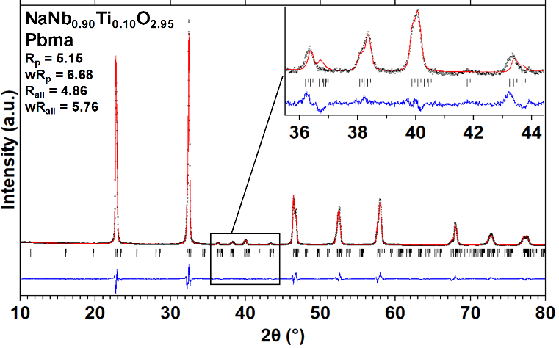

**Figure S1**.Rietveld refinement ofNaNb0.90Ti0.10O2.95 structure in the Pbma space group, after annealing at 950 °C during 24 h. Compared to a refinement in P21ma space group, correct reliability factors are also achieved (slightly higher here), however the fit highlights the absence of key features that should appear with Pbma space group in the range 35.5 ≤ 2θ ≤ 44.5 °.

**Table S1.** Na-Oi distances in NaNbO3 and NaNb0.90Ti0.10O2.95 structures in the P21ma space group.

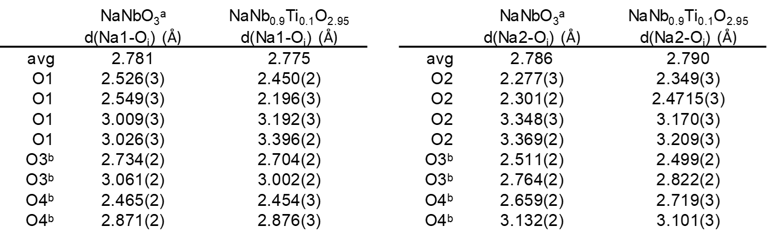

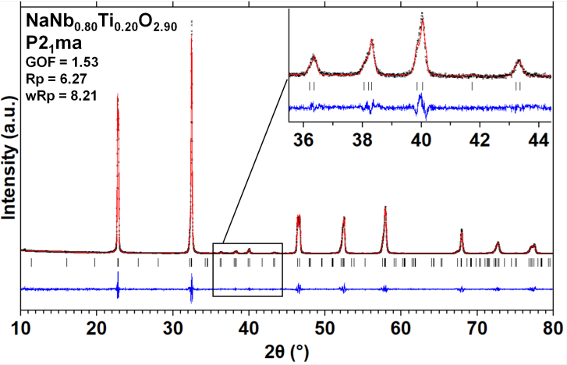

**Figure S2**.Profile matching of NaNb0.80Ti0.20O2.90 structure in the P21ma space group. XRD pattern is acquired on powder synthesized in hydrothermal conditions (24 h at 200 °C) from Nb2O5 and TiOCl2 mixed in NaOH 6 M, followed by an annealing treatment under air at 950 °C during 6 h. Data were acquired on a Phillips X’Pert PRO MPD diffractometer in the Bragg-Brentano *θ*-2*θ* geometry equipped with a monochromatic Cu K*α*1 source, using a forefront Ge (111) monochromator. Acquisition conditions: 8 ≤ 2*θ* ≤ 130 ° with 0.008 ° steps, counting time of 600 s.

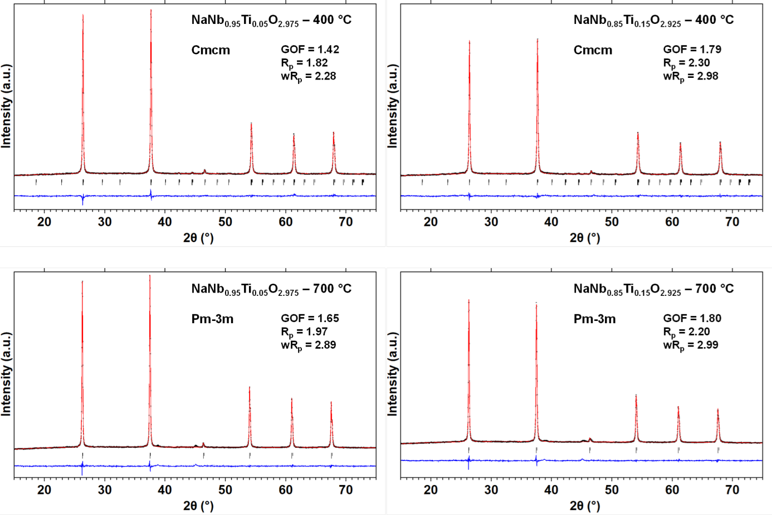

**Figure S3**. Thermal polymorphism of NaNb0.95Ti0.05O2.975 and NaNb0.85Ti0.15O2.925. XRD patterns were acquired at 400 and 700 °C with a Co K*α*1/K*α*2 source (λ = 1.7890 and 1.7919 Å, respectively) under helium. Profile matchings confirm structures in Cmcm and Pm-3m space groups. Note that at 700 °C, two minor unidentified signals are observed at 2*θ* = 38.8 and 45.3 °. They are possibly due to the decomposition of surface sodium-based species. In the case of NaNb0.90Ti0.10O2.95, the pollution is avoided thanks to improved washing of the powder synthetized in hydrothermal conditions.

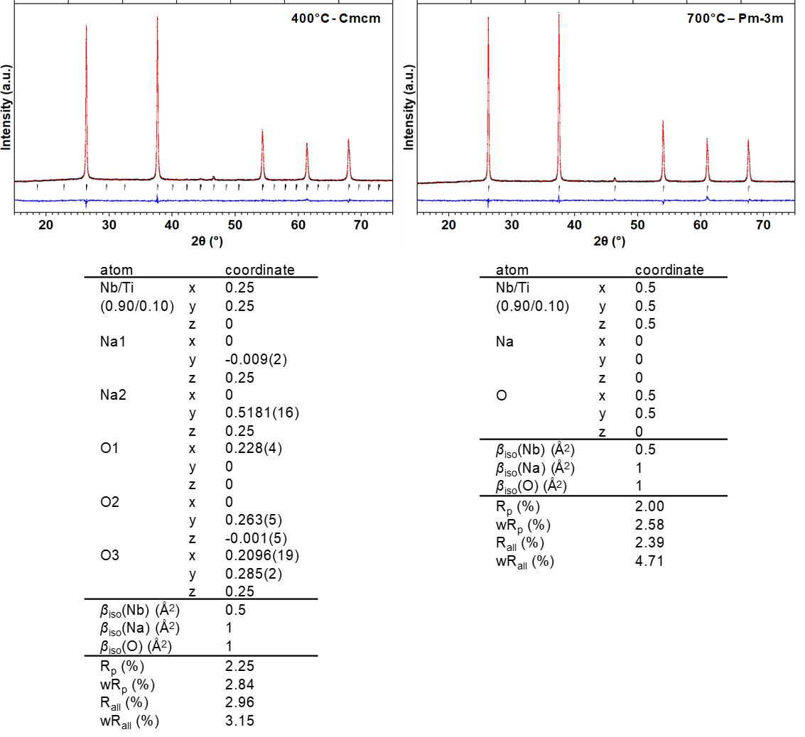

**Figure S4.** Rietveld refinements of NaNb0.90Ti0.10O2.95 XRD patterns acquired at 400 and 700 °C with a Co K*α*1/K*α*2 source (λ = 1.7890 and 1.7919 Å, respectively) under helium. Atomic positions and refinement parameters of the associated structures in the Cmcm and Pm-3m space groups, respectively.

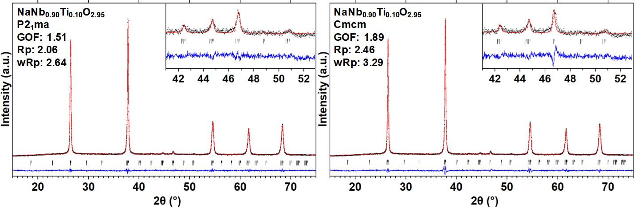

**Figures S5 :** XRD pattern of NaNb0.9Ti0.1O2.95 recorded at T=100 °C with a Co K*α*1/K*α*2 source (λ = 1.7890 and 1.7919 Å, respectively) under helium and the two structural hypothesis (full pattern profile matching) showing the P21ma space group gives the lowest reliability factors.

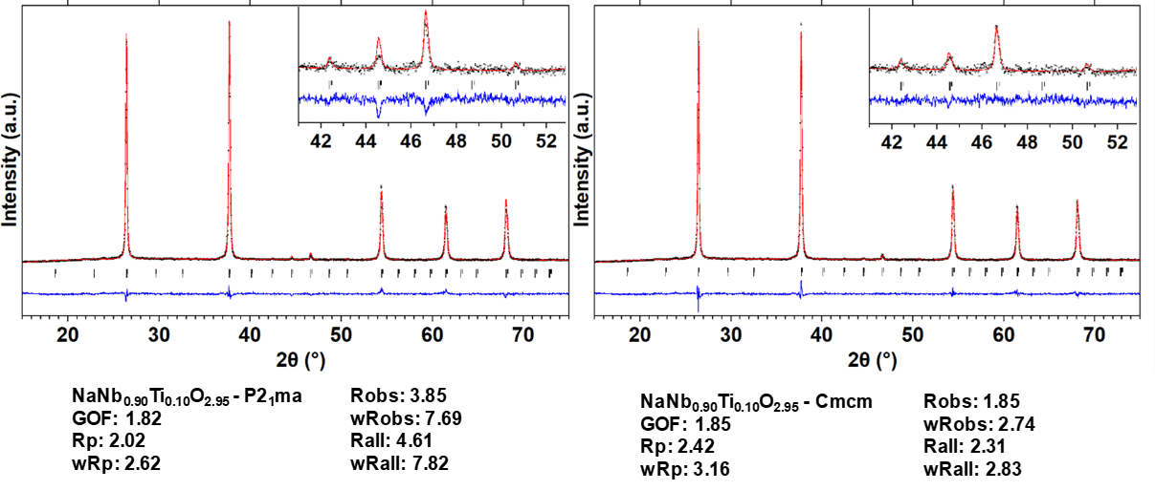

**Figure S6** : XRD pattern of NaNb0.9Ti0.1O2.95 recorded at T=300 °C with a Co K*α*1/K*α*2 source (λ = 1.7890 and 1.7919 Å, respectively) under helium and the two structural hypothesis (Rietveld analysis) showing the Cmcm space group gives the lowest reliability factors.

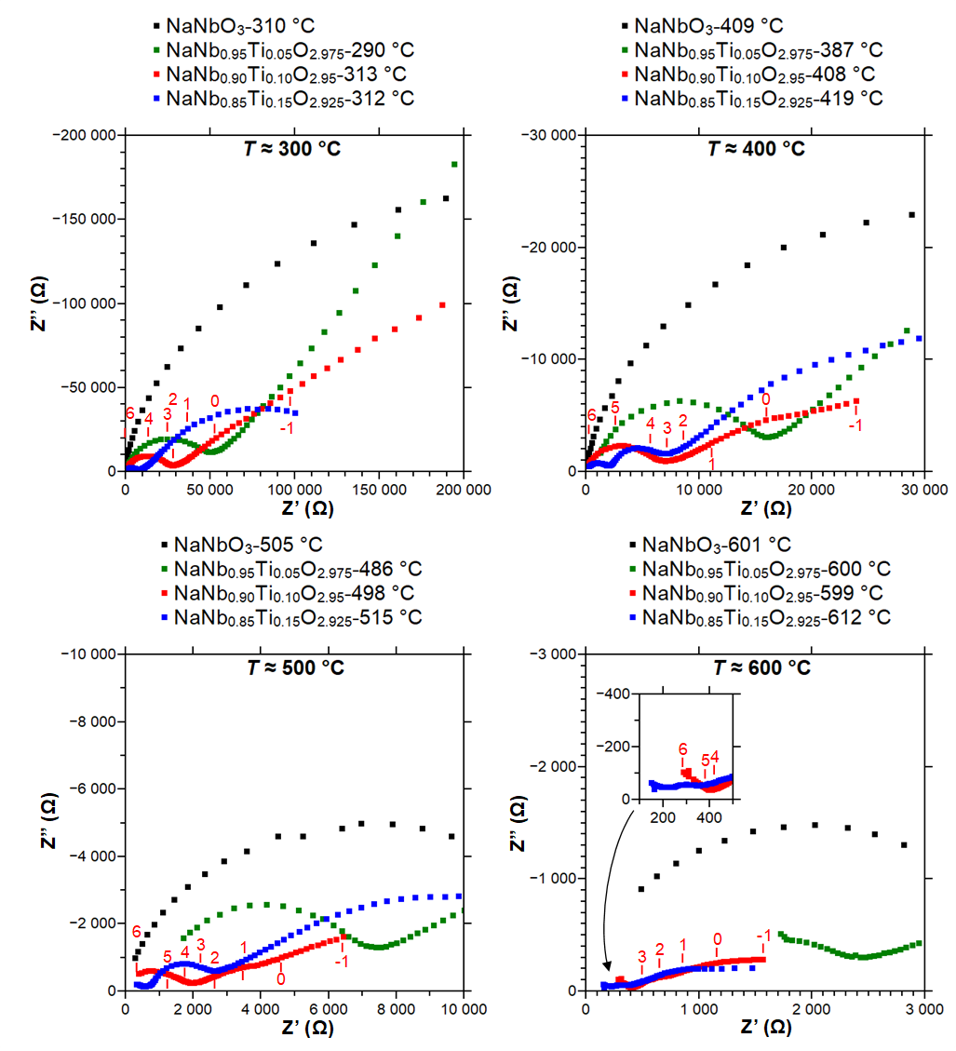

**Figure S7**. Nyquist diagrams of NaNb1-xTixO3-0.5x (x= 0, 0.05, 0.10, 0.15) from complex impedance spectroscopy. Bulk contribution (high frequency) and grain boundary contribution (middle frequency) are clearly distinguished on NaNb0.85Ti0.15O2.925 in the diagram presented over 400 °C. The numbers reported in the figure are the frequency logarithm.



**Figure S8**: Typical impedance diagram obtained at 313°C (NaNb0.90Ti0.10O2.95 pellet). Experimental data has been fitted on the basis of an equivalent circuit constituted of R-CPE elements in parallel (Resistance-Constant Phase Element) associated in series. The numbers reported in the figure are the frequency logarithm.



**a**



**b**

 **Figure S9**: a) Arrhenius plots of the conductivities of bulk and grain boundaries of NaNb0.9Ti0.9O2.95 pellet, deduced from impedance diagram (Figure S8) b) Arrhenius plots of the HF and MF relaxation frequencies for the different impedance contributions, c) associated HF and MF capacitive effects.

**c**