Photoluminescence of 2D-vertical In-rich APBs
embedded in InGaP/SiGe/Si
L. Chen,¹ O. Skibitzki,² Y. Léger,¹ C. Levallois,¹ R. Piron,¹ T. Rohel,¹ J. Stervinou,¹ A. Letoublon,¹ T. Schroeder² and C. Cornet¹*
¹:Univ Rennes, INSA Rennes, CNRS, Institut FOTON-UMR 6082, F-35000 Rennes, France
²:IHP, Im Technologiepark 25, 15236 Frankfurt (Oder), Germany

*Corresponding author: charles.cornet@insa-rennes.fr

Abstract — III-V/Si epitaxial nanostructure materials are quite promising candidates for the development of Si photonics. We deeply investigate the structural and optical properties of an InGaP/SiGe/Si platform by transmission electron microscopy, X-ray diffraction, energy-dispersive X-ray elemental mapping and photoluminescence techniques and we demonstrate the contribution of 2D-vertical In-rich antiphase boundaries (APBs) to the photoluminescence. The nonstoichiometric In-rich APB structures are found to be responsible for the localization of excitons.
Keywords—Si photonics; nanostructure; antiphase boundaries;
Heterogeneous epitaxy of III-V compounds with superior optical properties onto Si substrate very close to the III-V/Si hetero-interface becomes major concern for Si photonics¹. Antiphase boundaries (APBs) are generated during heteroepitaxy, have always been considered as detrimental defects for optical devices². Here, we provide a new insight into the APBs. In this work, we investigate structural and optical properties of 2D-vertical In-rich antiphase boundaries embedded in InGaP, integrated onto SiGe/Si platform.
The InGaP epitaxial layer was grown on a relaxed SiGe/Si pseudo-substrate by molecular-beam epitaxy (MBE). Transmission electron microscopy (TEM), X-ray diffraction (XRD) and energy-dispersive X-ray (EDX) elemental mapping techniques are used to deeply analyze the structural properties of the InGaP/SiGe/Si sample. In this sample, many vertical antiphase boundaries are found in the active InGaP layer (Fig.1) and the dispersion on antiphase boundaries directions evidences the existence of both stoichiometric and nonstoichiometric APBs. We also show that In atoms preferentially incorporate on the APBs leading to In-rich APB structures (Fig.2). Besides, the optical properties of the InGaP/SiGe/Si sample are studied with the help of temperature- and power- dependent photoluminescence (PL) (Fig.3). It is shown that the high energy peak of the PL spectrum shown in Fig.3a has a superlinear-to-linear power dependence. Finally, a scenario where the recombination of the localized excitons bounded around the neutralized In-rich APBs (especially the nonstoichiometric In-rich APBs), behaving as vertical nanostructures, is proposed^{3,4}.

This work is supported by the French National Research Agency project ANTIPODE (Grant no. 14-CE26-0014-01), ORPHEUS (Grant no. ANR-17-CE24-0019-01) and Région Bretagne.

C. Cornet et al., ISTE-Elsevier (2016).
2 Y. Wang et al., Journal of Applied Crystallography 48, 3 (2015).
3T. Schmidt et al., Physical Review B 45, 16 (1992).
4 E. Tea et al., Journal of Applied Physics 115, 6 (2014).
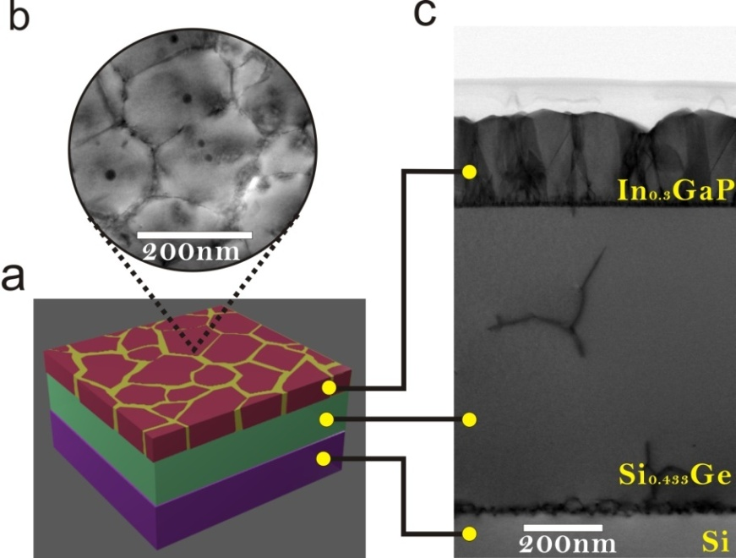
Fig. 1 Schematic(a), plan view(b) and cross-sectional view(c) TEM images of the InGaP/SiGe/Si platform. Many emerging APBs are observed in the InGaP active layer elongated along various different directions, indicating the presence of both stoichiometric and nonstoichiometric APBs.
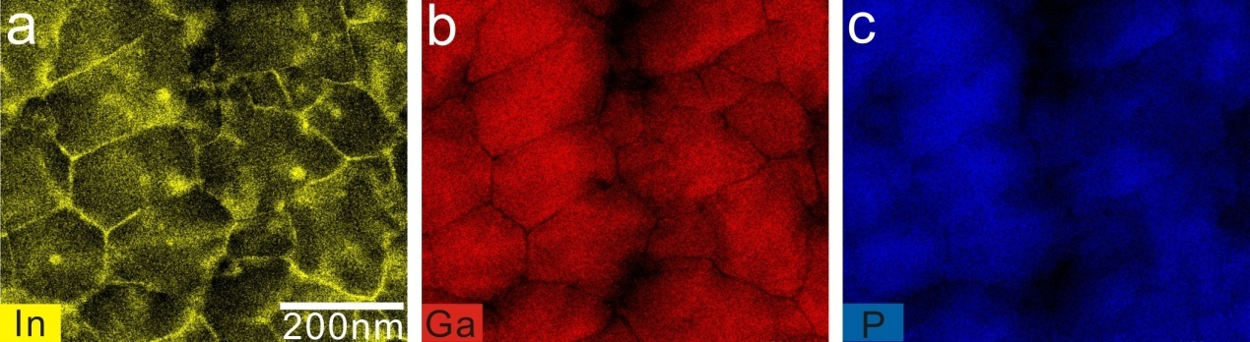
Fig. 2 EDX elemental plan view mapping images of indium(a), gallium(b), phosphorus(c) of the InGaP/SiGe/Si platform. Indium atoms preferentially incorporate on the APBs leading to charged In-rich APB structures.
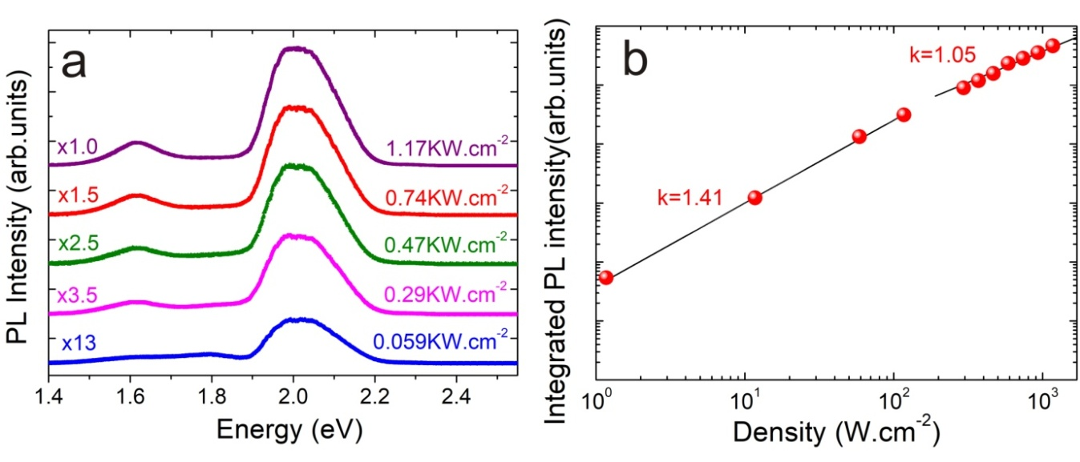
Fig. 3 a, Steady-state PL spectra with different powers at 15K. The high energy peak with the energy position around 2 eV comes from the In-rich APB nanostructures. b, Logarithm plot of the integrated PL intensity versus excitation density of the high energy peak which shows a superlinear- to- linear power dependent behavior.

