**How do multi-criteria assessments address landscape-level problems? A review of studies and practices**

Sandrine ALLAIN

Gaël PLUMECOCQ

Delphine LEENHARDT

Professional affiliation:

AGIR, Toulouse University, INRA, INPT, INP-EI PURPAN

Address:

BP 52627, F-31326 Castanet-Tolosan cedex, France

Corresponding author: Sandrine ALLAIN

Contact: sandrine.allaingranet@gmail.com

**ABSTRACT:**

Viewing the landscape as a spatialized social-ecological system allows identification of specific management challenges: integration of multiple views, multiple levels of organization, complex spatial-temporal patterns and uncertainties. Multi-criteria assessments (MCAs), which allow the comparison of alternative actions when multiple interests collide, are considered adequate to support landscape management. However, there is no consensus about how they should be applied and can integrate both multiple views and spatial dimension. We conducted an extensive quantitative and qualitative literature review targeting MCAs with a participatory and spatial approach. Our results suggest that (1) for sustainability assessments, participatory and spatial approaches endorse different rationales and hybrid methods are not so common; (2) within those methods, only scenario-selection methods (as opposed to design methods) can integrate spatially-explicit, spatially-implicit, place-specific, and overall values; and (3) current applications, which aggregate values ignoring their spatial and social distribution, do not coincide with the nature of landscape-management challenges. In addition, they give little importance to the structuration of information and to collective deliberation. We conclude that, in the absence of a good match between spatiality and participation, MCAs should, for now, be handled as insightful but distorted tools to explore and structure landscape-level management problems.

**KEYWORDS:**

landscape management, integrated assessment, spatialization, participation, social-ecological system

1. **INTRODUCTION**

Landscapes are complex social-ecological systems (SES) because many human and natural processes mutually interact (Bastian, 2001; Cumming et al., 2012; Naveh, 2000; Wu, 2006) and because they are shaped by a social history (Antrop, 2000; Pedroli et al., 2006), which promotes perceptions, values or expectations that differ spatially and among individuals. This makes it challenging to collectively define a desirable future for a given landscape. Many possible ways exist to address this issue; one of them is multi-criteria assessment (MCA). Nonetheless, there is no consensus on how to apply this method given the nature of landscape-level challenges.

A first challenge comes from the complexity of processes and multiple interactions. Because landscapes are characterized by interdependencies between human societies and their environment that originate from a coevolutionary history (Berkes et al., 2000; Costanza et al., 1998; Daily, 1997; Kallis and Norgaard, 2010), they exhibit non-linear and cascading effects that make their trajectories of change impossible to predict (Kinzig et al., 2006; Walker et al., 2004). It is generally acknowledged that command-and-control approaches (Folke et al., 2002; Holling and Meffe, 1996) and risk assessment (Linkov et al., 2014) are ill-suited in this context. Instead, scholars advocate exploring possibilities for change (Berkes et al., 2002; Olsson et al., 2006) and adopting an adaptive management approach (Linkov et al., 2006; Plummer, 2009).

Another challenge with landscape-level problems arises because the different groups concerned hold different and sometimes irreconcilable values (Gómez-Sal et al., 2003; Hunziker et al., 2008; Swedeen, 2006). This problem of multiple views, which is common to many decision-making situations, has led to recommendations to include non-experts in evaluations of the quality of decisions (Funtowicz and Ravetz, 1990) and explicitly consider incommensurabilities[1] (Martinez-Alier et al., 1998; Munda, 2004). Deliberative approaches and MCAs involving multiple stakeholders are considered particularly well-suited to operationalize these principles (Frame and Brown, 2008; Munda, 2004).

The landscape is a complex system that has another challenging characteristic: material resources and populations are distributed in space. Human and natural systems can interact “through” the spatial dimension: social and ecological processes increasingly overlap as perspective widens to a global scale (Alessa et al., 2008), and spatial mismatches can have far-reaching consequences (Cumming et al., 2012; Wilson et al., 1999). Likewise, human and natural systems can interact "within” the spatial dimension: processes such as species migration, farming dynamics or social exclusion are closely related to spatial patterns, such as habitat heterogeneity and the spatial distribution of crops or infrastructure networks (Benoît et al., 2012; Cumming, 2011). Accounting for complexity at the landscape level therefore requires considering these different spatial interactions. This is one reason why geographic information systems (GIS), given the wide possibilities they offer to investigate spatial relationships, have become key tools to analyze and resolve landscape-level management problems (Malczewski, 2006; Malczewski and Rinner, 2015).

Because social-ecological interactions have a spatial dimension, diverse and potentially conflicting representations of space, i.e. new types of incommensurabilities, coexist within a landscape. Because people relate to places in many different ways – not only through their actions, but also through their perceptions and history (Antrop, 2005) – they do not have the same definition of boundaries, meaningful zoning, significant places, features of identity, etc. The same occurs with expert descriptions: relevant extents, resolutions and locations differ when describing water dynamics or pollination. The ecological economics community does not formally address these types of incommensurabilities specific to spatial problems, though it is aware of “scale biases” when stakeholders express value judgments (Hein et al., 2006; McFadden, 1994; Zia et al., 2011). Incommensurabilities are not well integrated into spatial decision support systems either, because the latter are designed as “expert systems” that rely on a uniform understanding of space (Ramsey, 2009).

Applying MCAs to landscape management problems raises the fundamental challenge of integrating spatiality with multiple views. In an initial step to meet this challenge, we investigate current practices of MCA reported in the scientific literature that combine a spatial approach with multi-stakeholder or participatory approaches. More specifically, we address the following issues: how, and how well, MCA practices reflect landscape-specific challenges.

These issues are addressed following three nested analyses that enable us to:

1. Position spatial and participatory approaches within the broad scope of multi-criteria methods
2. Distinguish types of MCA methods that combine spatial and participatory approaches
3. Clarify how MCAs are applied to assess landscape-management scenarios
4. Generate suggestions for using MCAs at the landscape level.
5. **MATERIALS AND METHODS**

This literature review follows three steps (the overall method is described in Fig. 1). First, we performed a lexicometric analysis of a large sample of studies to characterize the position of sustainability assessments, participatory approaches and spatial approaches within the wide spectrum of multi-criteria methods (Section 2.2). Second, we qualitatively classified applications of multi-criteria approaches mixed with participatory and spatialization methods in the field of natural resource management (Section 2.3). Our aim was to provide a typology of existing methods with their general steps. Third, we focused on a specific type of methods arising from the typology, “scenario-selection support method”, and undertook a detailed qualitative analysis of the corresponding case-studies (Section 2.4).

* 1. ***Bibliographical data.***

We generated three datasets of studies of decreasing size using the Web of Science database, corresponding to the three steps of our review. For better traceability, we summarized this selection process in a PRISMA diagram[2] (Moher et al., 2009) (Fig. 1). A large dataset of abstracts (10,691) was selected to analyze recent trends (2005-2015) in sustainability assessments within multi-criteria methods. For the two subsequent steps, the time span was extended to all available years (1975-2005) to embrace a wider diversity of research; nonetheless, few records were published before 2005.

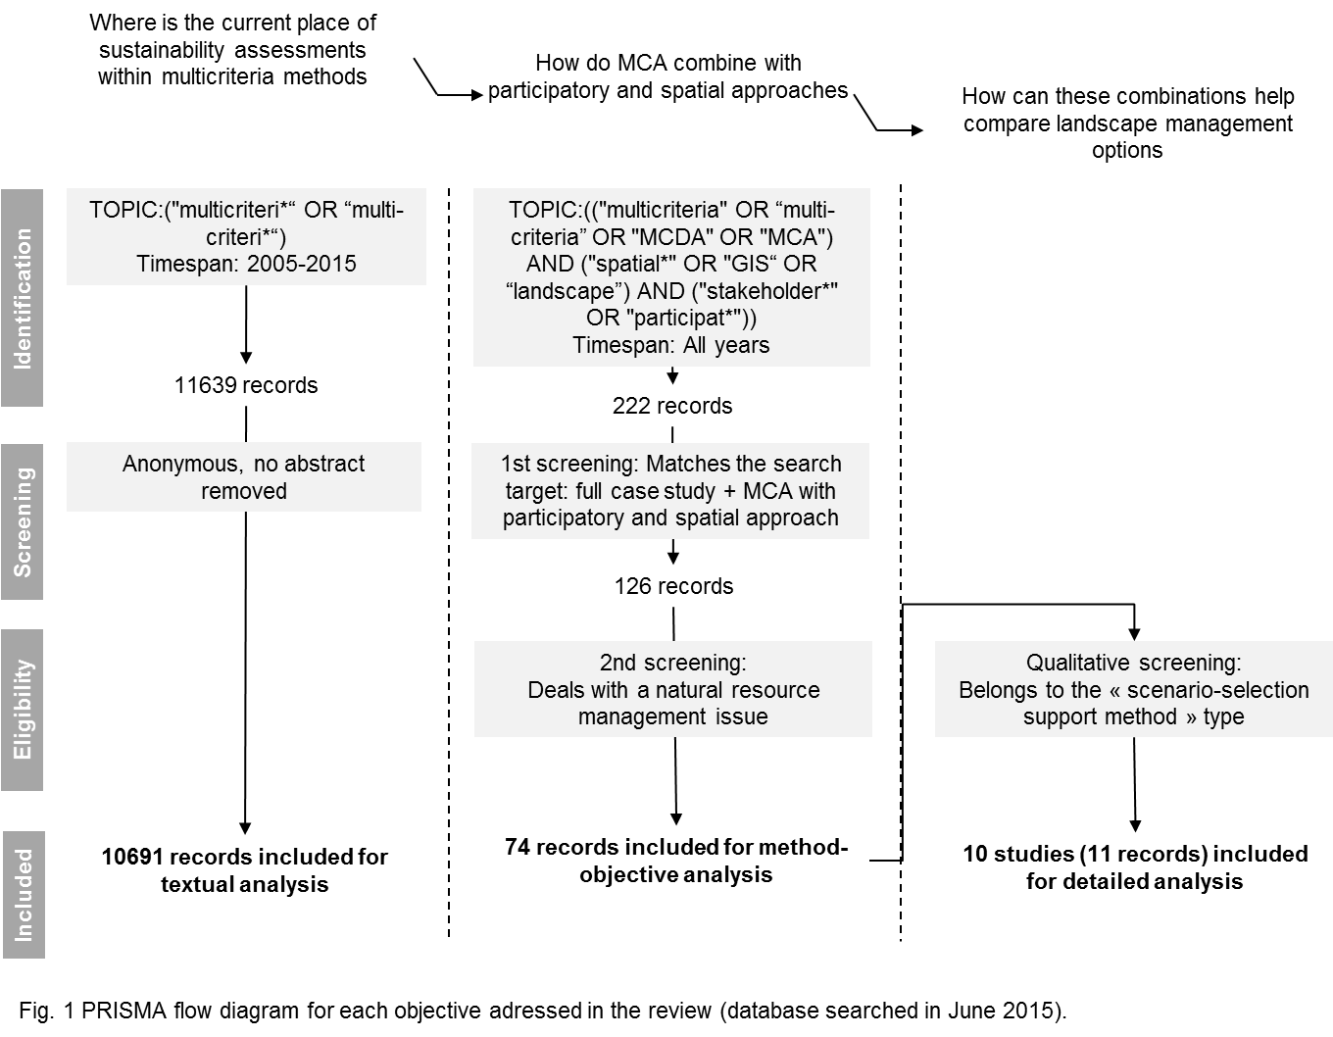The three steps reflected in the PRISMA diagram are detailed in the three following sub-sections.

* 1. ***Step 1. Quantitative analysis of multi-criteria methods.***

Lexicometric analysis compresses complex information contained in large numbers of texts. Reorganizing and classifying segments of texts and providing textual statistics promotes understanding of the meaning and context of use of utterances (Lebart et al., 1998). We used this method to identify trends in the current use of multi-criteria methods throughout the observation of lexical similarities among abstracts.

We collected information that characterizes the heterogeneity of research referring to multi-criteria methods. We compiled the 10,691 abstracts we selected into a single textual corpus and used IRaMuTeQ software (Ratinaud and Marchand, 2012) to implement Reinert’s method (1993) of textual clustering. This clustering technique proceeds from a contingency table showing the presence or absence of words (except pronouns, conjunctions, and some adjectives) in a given abstract. IRaMuTeQ clusters abstracts by performing descending hierarchical classification iteratively: abstracts are divided into two significantly different groups (p-value < 0.05) according to the presence or absence of words, and then the cluster with the most abstracts is divided into two new significantly different groups, etc. Clustering stops when the number of clusters predefined by the analyst is reached or when the largest cluster contains no significantly different vocabulary. A chi-square test is then calculated for the classification of each word to assess the significance of the association between a word and a semantic class. This enabled us to obtain a broad view of multi-criteria methods and then identify subgroups relevant for analysis.

We also assessed the classification via correspondence analysis, in which variability in the vocabulary and its distribution among clusters (assessed as a chi-square value) is statistically explained by inertia. For each inertia factor, correspondence analysis provides a statistical basis for interpreting why certain clusters are similar to or different from others.

* 1. ***Step 2. Qualitative classification of multi-criteria assessments that use participatory and spatial approaches.***

In the second step of our analysis, we emphasize the participatory and spatial approaches of MCA.

We collected research that links these three aspects (i.e., multi-criteria, spatialization, participation) through a database search and manual screening*.* “Spatialization” meant that alternatives and/or the assessment results had to be spatialized; “participation” meant that people other than the authors had to be involved at some stage of the research. We also removed all reviews, theoretical developments and studies that introduced a multi-criteria tool without applying it (even though they could provide interesting insights for interpretation). Among the 222 studies collected, 126 met those eligibility conditions, and among them 74 belonged to the field of natural resource management. The others referred to waste- or pollution-management issues, urban or infrastructure development and health.

We systematically read the abstracts of the 74 studies dealing with natural resource management, with a special focus on their objectives and methods; when necessary, we also read the studies’ methods sections. We focused more on the stages in which the inclusion of a spatial or participatory component to MCA adds to or modifies the way the method is developed. We summarized the most frequent method patterns according to their objective.

* 1. ***Step 3. Systematic qualitative analysis of case studies for scenario exploration.***

To address our third objective, we analyzed a subset of the previous studies. We only investigated articles that developed a method for exploring landscape management alternatives and possibly selecting one of them. We ended up with 10 studies, some of them covered by more than one article. When necessary, we used additional articles referring to the same research project and contacted the corresponding author to clarify certain points or to obtain additional information.

Two types of characteristics were examined for each study. First, general characteristics of MCA were analyzed: the problem structure (i.e. alternatives, criteria, stakeholders and their judgments) and the decision analysis (the weighting system and the aggregation procedure used to produce the final evaluation of alternatives) (Kiker et al., 2005; Malczewski, 1999). Second, we investigated characteristics related to the landscape viewed as a spatialized SES, focusing on participation of multiple stakeholders (i), representation of multiple levels in the assessment(ii), consideration of spatial and temporal patterns and relationships (iii), and management of uncertainties (iv).

We created an analytical table (provided in the appendix) with columns referring to the 10 studies reviewed and rows featuring the characteristics of each case-study in terms of:

* general characteristics (objective, type of issue addressed, area)
* problem structure (definition of alternatives, criteria (and indicators), stakeholders, value judgments)
* decision rules (weighting, aggregation method)
* involvement of stakeholders (participants, stages with participation, differentiation between participant input, participatory settings)
* multi-level system (levels of assessment, upscaling methods)
* spatiotemporal patterns (knowledge sources for spatial data, accounting for spatial patterns (heterogeneity, distribution of values), use of visualization tools, accounting for temporal behavior)
* integration of uncertainties (sensitivity analysis, uncertainties in outcomes, uncertainties/inconsistencies in judgments, flexibility of tools)

This way of synthesizing information allowed us to identify trends and gaps in the ways landscape-management options are assessed with a multi-criteria approach.

1. **RESULTS AND DISCUSSION**

***3.1. Results of lexicometric analysis.***

* + 1. *Main clusters of multi-criteria methods: the vocabulary of sustainability assessments*

In the abstract corpus (10,691 records), we performed a three-cluster classification, which allowed 9,450 abstracts (88%) to be classified (Fig. 2). The most significant forms of words, tool-words excluded, define three distinct “lexical worlds”.

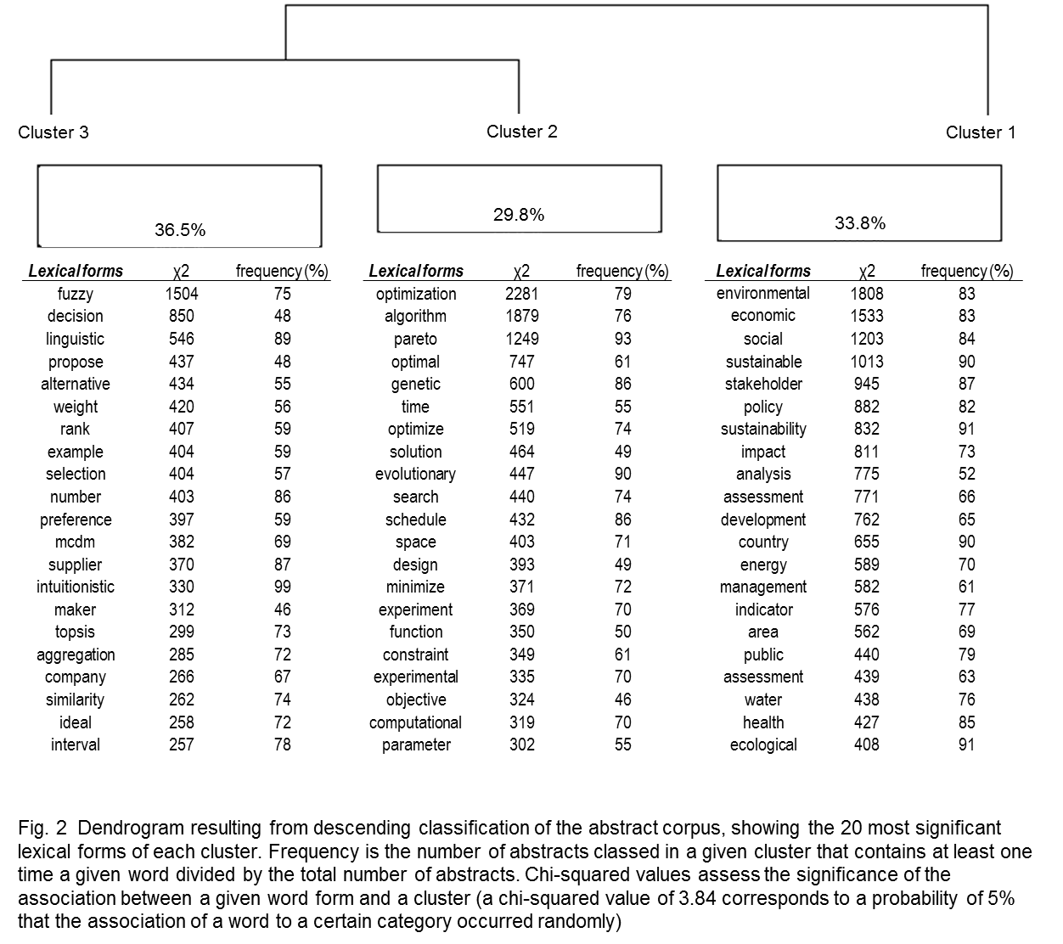We identified a first cluster of abstracts (3,189 records, 34% of the total) with the most significant forms relating to:

* integrating economic, environmental, social and institutional issues (“environmental”, “economic”, “social”, “policy”, “public”)
* considering future consequences and uncertainties (“impact”, “assessment”, “options”, “management”, “potential”)
* engaging the public (“stakeholder”, “public”)

Gasparatos et al. (2008) depicted these different aspects as shared properties of sustainability assessments and added equity considerations (intra- and inter-generational) to this list. Equity considerations, however, are not directly reflected by the most significant words in the “sustainability assessment” cluster. The first word in this semantic field, “equity”, appears in 312th position (still significant for this cluster) because it occurs rarely. We conclude that social justice issues are, in most cases, absent from sustainability assessments based on a multi-criteria method. Sustainability remains mainly understood as the fulfilment of competing goals rather than a trajectory of change that reconfigures social interactions.

A second cluster of abstracts focuses on optimization problems (“optimization”, “Pareto”, “solution”, “design”, etc.) aiming at designing Pareto-optimal[3] solutions for a limited set of objectives and constraints (Linkov et al., 2006). Decision-analysis procedures (“decision”, “rank”, “selection”, “aggregation”) are grouped together in the last cluster of abstracts (cluster 3). Considering that no optimal solution can be found, a variety of procedures exist to rank/sort alternatives (Guitouni and Martel, 1998), each of them corresponding to a specific definition of what makes the best compromise (the closest from an ideal point, the one that is not outranked by others, etc.).

* + 1. *Rationales underlying MCA methods: the specificity of spatial approaches*

We generated an additional classification to see how the sustainability assessment cluster would split up, adding two more successive phases of clustering. The abstract corpus was consequently divided into 5 classes (8,964 abstracts included in the new classification, ~84% of the corpus). We were then able to distinguish two new subgroups of abstracts: strategic business decision-making (within the “decision analysis” cluster, former cluster 3) and spatial approaches (within the “sustainability assessment” class), the latter being of special interest for our purpose. The “optimization problem” cluster, (former cluster 2) remained unaffected by this new classification. Projection on the two first axes of the correspondence analysis (Fig. 3), which summarize 69% of the total inertia, reveals that spatial assessments constitute both a marginal (approx. 1/4 of the abstracts on sustainability assessments) and specific branch of sustainability-assessment approaches.

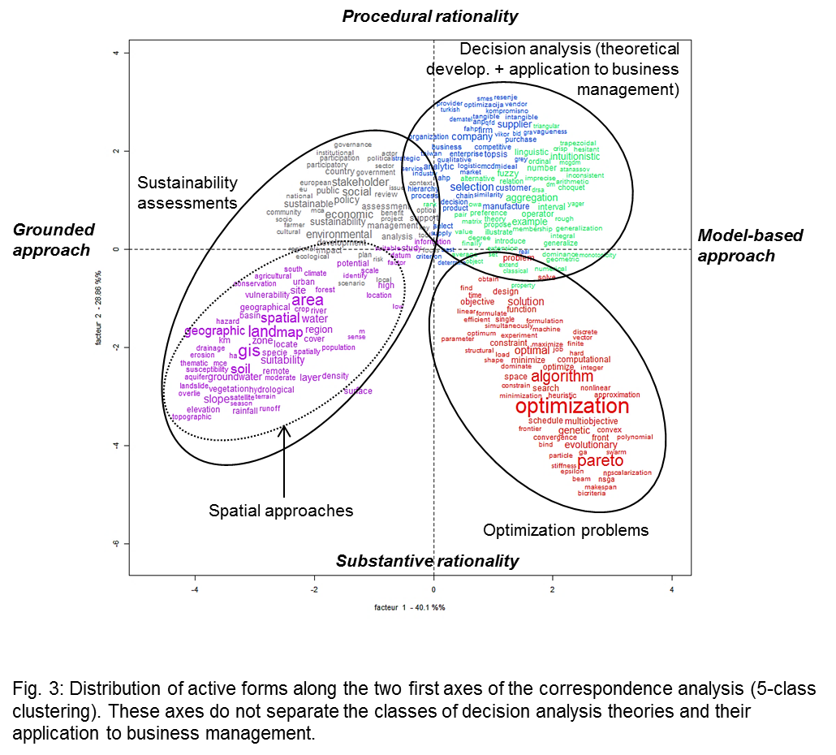

We interpret the two first factors as reflecting what is understood as a rational decision (axis 2, 29% of total variance) and what makes a scientifically-sound decision (axis 1, 40% of total variance).

The first axis differentiates multi-criteria methods that rely on grounded, contextualized information from those that mainly rely on mathematical equations to find a solution. By “grounded*”*, we mean that theory proceeds from the accumulation and analysis of place-based data. Since they seek to capture multiple indicators and multiple views, sustainability assessments imply such bottom-up view of science, providing they not only try to formulate ad-hoc solutions but also create new knowledge. The opposite pole of axis 1 represents another view of how science interacts with decision-making, in which there are “rules of nature” that can be formalized (by scientists) and then applied to any situation (e.g. to support decision-making). According to this view, generic models and algorithms are the elements that validate the results obtained. Decision analysis, which focuses on finding the best compromise when no optimum solution exists, and optimization methods, which focus on finding solutions that maximize utility under a set of constraints, are two different methods that share the assumption that mathematical formalization is the best way to reach a valid solution.

Axis 2 reflects the opposition between substantive rationality and procedural rationality behind multi-criteria methods (Simon, 1976). Under a substantive rationality hypothesis, rational behaviors allow the fulfillment of a set of goals under a set of constraints (from the external environment, its perception, or internal characteristics of the decision maker). This realm assumes a “heroic” (Béjean et al., 1999) decision-maker who, according to Simon (1990: 195): *“contemplates, in one comprehensive view, everything that lies before him. […] He has reconciled or balanced all his conflicting partial values and synthesized them into a single utility function that orders, by his preference for them, all these future states of the world*”. This idea is clearly embedded in optimization procedures. However, the substantive rationality paradigm is also dominant in spatial assessments. The use of spatial data is thought to “empower the decision-maker” (Densham, 1991) by providing both more precise and more usable information. The environment (objective and subjective) is considered fixed and the coexistence of different value schemes and conflicting preferences not allowed.

In the realm of procedural rationality, behaviors are rational because they come from an appropriate individual deliberative process in the face of incomplete information, an unknown future, or shifting beliefs and values (Simon, 1976). Studies related to decision analysis, since they model uncertainty and the interaction of multiple views towards a compromise, typically assume a procedural rationality (extended from the individual to the group) (Garmendia and Gamboa, 2012; Munda, 2004). Sustainability assessments following a participatory approach (Fig. 3, upper-left corner) also fall in this category because deliberation is the pivotal process for integrating heterogeneous information and values (Vatn, 2005). Nonetheless, these approaches often fail to accommodate the evolutionary nature of preferences and the existence of non-utilitarian values (values that cannot be reflected in competing individual interests). Rather, they assume that one’s motivation can be captured in a unique order of preferences (Béjean et al., 1999). They therefore only partially fall under procedural rationality paradigm.

We have just demonstrated how two branches of sustainability assessment distinguish themselves. Though common in their place-based anchorage, sustainability assessments following a spatial approach and those following a participatory approach endorse fundamentally different philosophies about what constitutes a good decision (the process or the availability of information) and the context under which a decision is to be taken (irreducible uncertainties and conflicting values or a well-defined decision space). Nonetheless, bridges between these two branches exist and are crucial if one wants to address multi-stakeholder landscape-level issues. We examine these bridges in the following section.

* 1. ***How MCA combines with participatory and spatial approaches. Synthesis of methods and objectives.***

In this section, we present results of our qualitative analysis that classified studies using participatory and spatial approaches (Fig. 4). We distinguish three types of objectives, hence three types of methods: scenario-design support, scenario-selection support, and spatial assessment of real situations. The categories of both scenario-design support and scenario-selection support methods are future-oriented, leading to management recommendations. Method steps can be shared between real-world and future-oriented methods even when their objectives differ (prescriptive as opposed to descriptive). We found two studies (3 records) combining scenario-design support and scenario-selection support objectives (detailed in section 3.3.2).

Regarding the two families of future-oriented methods, their differences in objectives are reflected in different method steps (Fig. 5). Scenario-design support methods deal with a location or spatial allocation problem (van Herwijnen and Janssen, 2007): Which areas should be managed or preserved first (prioritization)? How best to allocate land-uses in the landscape (zoning/ mapping proposals)? Those questions refer respectively to multi-attribute or multi-objective problems. In the first case, every location is scored according to a set of attributes (van Herwijnen and Janssen, 2007). Then, value maps are overlaid and aggregated, generally with a weighted linear combination procedure (Malczewski, 2000), to define the best area(s) or rank sites for a given purpose. This method is also used for suitability assessments. In the second case, a set of goals are defined and multi-objective optimization algorithms produce land-use plans or spatially-explicit management proposals.

Conversely, scenario-selection support methods differentiate and often rank management alternatives based on their effects (impact assessment) and sometimes their implementation (generally cost, but sometimes applicability or flexibility; e.g. Sahin and Mohamed, 2013). A scenario can be evaluated and possibly selected according to both spatially-explicit and non-spatial criteria. An aggregation procedure can be performed first on criteria (producing a landscape-level score for each criteria) or on alternatives (producing total performance maps) (see van Herwijnen,1999, cited by van Herwijnen and Janssen, 2007), for different possible pathways).

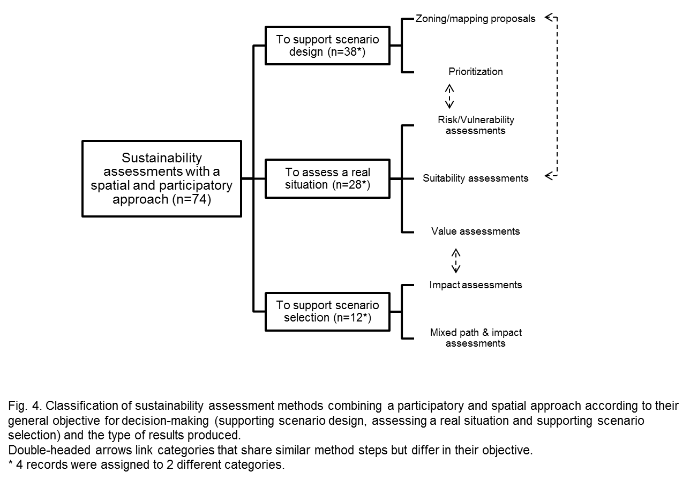

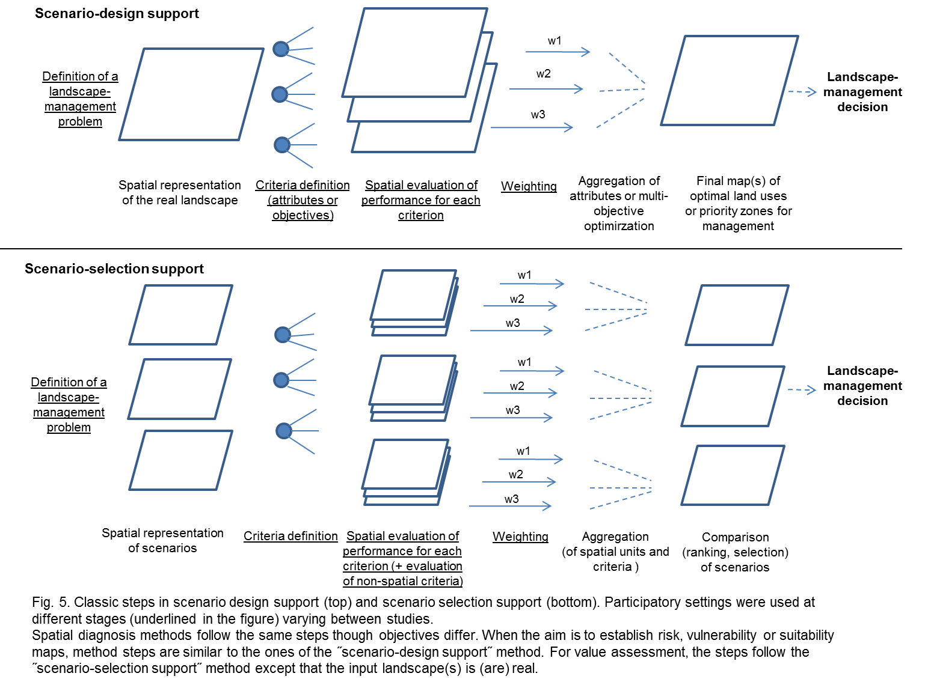

The involvement of non-academic participants, including local experts, can occur at different stages. In such cases, identified criteria and/or weighting are designed to reflect stakeholder preferences. The issues of how to select participants, how to elicit their preferences and how to combine them are the same for non-spatial evaluation (see e.g. Garmendia and Gamboa, 2012; Hajkowicz and Collins, 2006; Reichert et al., 2015). Also, some criteria can be evaluated on a participatory basis when they integrate a sensible dimension (e.g. visual aspect (Sheppard and Meitner, 2005)); risk perception (Raaijmakers et al., 2008)); place attachment (Newton et al., 2012; Nordström et al., 2011) or when the evaluation of performances relies on the statements of local experts (e.g. Arciniegas and Janssen, 2012).

Through this clarification exercise, we highlighted consistent patterns in scenario-design and scenario-selection methods. The way stakeholders are involved does not appear to differentiate methods. Stages with participation – and the extent of that participation – reflect the diversity of scientific postures in action-research, which is independent from the operational objective pursued. In contrast, the position of the MCA within the decision-making process and the nature of criteria and values do distinguish scenario-design support from scenario-selection support. In the former, alternatives are generally not defined *a priori*,and the decision-making process is in its exploratory stage; also, criteria and values are necessarily spatially-explicit. In the latter, alternatives are established *a priori*. They can be realistic plans identified by managers (when the decision process is in an advanced stage) or contrasting images of the future created to support learning. With scenario-selection support methods, alternatives can be spatially-explicit or not (e.g. a normative change) and the assessment of alternatives can accommodate both spatially-explicit and non-spatial values. Assessment is therefore more comprehensive, which suits a holistic and integrative view of the landscape. Because of these possibilities, we focus on the potential of scenario-selection methods to compare landscape-management alternatives.

* 1. ***How MCA combining participatory and spatial approaches can help compare landscape-management alternatives. Detailed analysis of current practices.***
     1. *Overview of selected studies*

In our corpus, we found 11 studies (12 records) that implement a multi-criteria scenario-selection method at the landscape level, i.e. studies that use, at some stage, the input of non-academics to compare a set of landscape-management scenarios to highlight those best-suited (Table 1). The study of Raaijmakers et al. (2008) was excluded as there was no integration between the stakeholder assessment of alternatives (not spatial) and the simulation of their impacts using a GIS-based model. The 10 remaining studies deal with land-use planning (4), ecosystem conservation (3), water management (2) and forest management (2).

Table 1. General description of selected studies (LU = land-use). Italics indicate studies with a “light” participatory approach. Additional articles used for the analysis are also mentioned.

|  |  |  |  |
| --- | --- | --- | --- |
| Selected studies | Goal | Issue addressed | Geographic area |
| Ahrens and Kantelhardt, 2009 | Assessing the impact of farming production options on landscape functions | Agricultural landscape planning | Bayerisches Donauried (Germany) |
| Arciniegas et al., 2011 Arciniegas and Janssen, 2012 | Designing LU plans of increased quality | LU planning | Bodegraven Polder (Netherlands) |
| Chakroun et al., 2015 | Assessing impacts of water-allocation alternatives on watershed sustainability | Water management | Ichkeul Basin (Tunisia) |
| Fürst et al., 2013 Fürst et al., 2010 | Assessing effects of forest LU management on ecosystem services | Regional LU planning | Saxony (Germany) |
| Janssen et al., 2005 Goosen et al., 2007 | Assessing impacts of alternative water-management regimes on ecological functions | Wetland ecological functioning | Wormer and Jisperveld fen meadow (Netherlands) |
| Linhoss et al., 2013 | Selecting a management strategy for the Snowy Plover conservation | Species conservation and coastal conservation | Florida Gulf Coast (USA) |
| Manoli et al., 2005 | Assessing possible water-management interventions | Water management | Paros Island (Greece) |
| Newton et al., 2012 (+ supporting information) | Assessing costs and benefits of alternative ecological network plans | Ecological restoration | River Frome watershed (United Kingdom) |
| Nordström et al., 2010 Nordström et al., 2011 | Designing and assessing alternative forest-management plans | Strategic forest planning | Lycksele forest (Sweden) |
| Sheppard and Meitner, 2005 Sheppard et al., 2006 | Reducing conflicts and assessing alternative forest-management plans | Sustainable forest management | Lemon Landscape Unit (Canada) |

Our sample covers the gradient of research postures that characterizes integrated assessments (Barreteau et al., 2010; van Asselt and Rijkens-Klomp, 2002). Some of the studies we analyzed hence implemented a “lighter” participatory approach, corresponding to a situation of consultation or information (Barreteau et al., 2010). In these cases, stakeholders are only present at the very beginning of the process (associated with generating alternatives) or merely exist as assumed recipients/users of assessment results. They can also be absent but different values nonetheless considered through archetypical weighting schemes (in the case of Linhoss et al., 2013).

We identified two studies that combine scenario-selection and scenario-design approaches, and hence promote iteration for adaptive management. One (Nordström et al., 2011, 2010) used a scenario-design approach to generate and select three realistic but contrasting scenarios of forest management, which were consequently assessed. The other (Arciniegas et al., 2011; Arciniegas and Janssen, 2012) followed the oppose approach: scenario assessment was used as an exploratory phase prior to generating land-use plans. Although they are rarely used jointly, scenario-design and scenario-selection methods are not mutually exclusive.

* + 1. *Results of qualitative analysis*

Table 2 summarizes the options adopted in the case studies reviewed.

Table 2. Qualitative analysis of the multi-criteria structure and incorporation of landscape-management characteristics of the 10 selected case studies. Options in bold refer to the most frequently observed practice. def.: definition; AHP: analytic hierarchy process; MAUT: multi-attribute utility theory; CP: compromise programming; MCDA: multi-criteria decision analysis; SDSS: spatial decision support system.

|  |  |  |
| --- | --- | --- |
| **MULTI-CRITERIA STRUCTURE** | **Alternative def.** | * Directly developed by researchers according to local issues (consultation of stakeholders, literature review, etc.) * Developed by selected stakeholders or experts * Exploration-Selection process (computer-aided, matrix of scenarios) |
| **Criteria def.** | * Defined by researchers (according to local issues) * Based on a scientific reference framework (more or less adapted to a specific context) * Defined by stakeholders in participatory settings (workshops, interviews) |
| **Indicator def.** | * **Defined or specified (following consultation) by experts or researchers** * Defined by reference framework |
| **Stakeholder def.** | * **Absence of a formalized method** * Snowball sampling, Stakeholder analysis followed by grouping and selection of participants |
| **Value judgment def.** | * **Importance** or perceived performance (scoring/allocation of 30 points ) * Preference (pairwise comparison) |
| **DECISION RULES** | **Weighting systems** | * **Average of scores** (for all stakeholders or at the group level) * No weights / Exploratory weights / Weighting schemes reflecting different focuses * Group average score x Group importance score * Market value (0 weight to non-marketable ecosystem services) |
| **Aggregation method** | * When value maps are produced: **weighted summation** or absence of aggregated results * When assessment is not spatially-explicit : varied methods hypothesizing strong to weak compensation (AHP, MAUT, CP, Electre-II, Stochastic MCDA ) |
| **INVOLVEMENT OF STAKEHOLDERS** | **Participating stakeholders** | **Managers**, Users of different types, Experts of different types, Representatives of interest groups, Farmers, Landowners |
| **Differentiation of stakeholder input** | * **No** * Distinct role of different stakeholder groups * Evaluation at the group level (through averaging) |
| **Stages with participation** | * **Criteria def. and/or Alternative def.** * Assessment, Feedback, Selection of participants |
| **Participatory methods** | * **Workshops,** Interviews, Surveys/Inquiry |
| **HIERARCHICAL ORGANIZATION** | **Levels of assessment** | * When assessment of criteria is spatially-explicit **: basic units/compartments + Landscape/Region** * When assessment is not spatially-explicit : entire landscape/Region |
| **Upscaling/downscaling methods** | * **Area-weighted aggregation of basic units’ normalized performance** * Temporal aggregation according to statistical metrics * Corrected spatial aggregation according to landscape metrics |
| **SPATIAL & TEMPORAL PATTERNS** | **Knowledge sources of spatial data** | * **Generic (from database)** * Local (expert opinion, field survey, online stakeholder survey) * Simulation outputs |
| **Spatial distribution** | * **No** * Qualitative analysis of value maps, Use of landscape metrics, Use of spatially-explicit metapopulation models |
| **Visualization tools** | * **Value maps** * **No** * Landscape visualization |
| **Temporal dynamics** | * **No** * Statistical metrics describing temporal behavior |
| **UNCERTAINTIES** | **Sensitivity analysis in MCA** | * **No** * Varying weights, Exploration of the whole weight space, Varying aggregation methods, |
| **Uncertainties in outcome** | * **No** * Assessment under varying futures |
| **Uncertainties in judgment** | * **No** * Consistency ratio to eliminate inconsistent stakeholders * Use of different methods to reveal preferences * Stochastic MCDA allowing undefined weights |
| **Flexibility** | * **No** * Possible modification in the SDSS, Use of interactive devices |

1. Multi-criteria structure

The case studies highlight typical limitations of MCAs in general (i.e. not specifically applied to landscape problems) about problem structuring. It is however acknowledged that the way in which problems are structured, including how to define alternatives or criteria, how to determine who is relevant and what legitimacy they have, how to elicit judgments and which decision rules to choose, is central to any MCA (Choo et al., 1999; Garmendia and Gamboa, 2012; Guitouni and Martel, 1998; Munda, 2004; Vatn, 2009).

In the 10 studies we reviewed, alternatives and criteria are either developed by researchers or by a set of stakeholders. Specific reference frameworks (for ecosystem services, ecological functions or management standards) are sometimes used. In some cases, definition of alternatives is a central part of the assessment method and results from a formalized exploration-selection-specification process (in Fürst et al., 2013; Nordström et al., 2011). Often, but not always, criteria are translated into indicators (in other cases, this hierarchical structure is absent); definition of these indicators is managed by researchers and experts, without feedback from other participants.

The process for selecting the stakeholders included in the assessment is often not formally addressed. Two studies (Nordström et al., 2010; Sheppard and Meitner, 2005), which defined their study area as conflict-ridden (both around the issue of forest management), used stakeholder analysis to identify stakeholders and group them according to their assumed interests.

1. Weighting and aggregation

In 6 of the studies analyzed, criteria weights reflect stakeholder preferences. Individual elicitation of weights is preferred over collective deliberation, so that group-level values are actually the average of individual scores. The only case of using collective decision-making to derive weights was found in an expert workshop in Arciniegas and Janssen (2012). Generally, stakeholders are asked to score criteria according to their importance. In one study (Nordström et al., 2010), stakeholders were asked to state preferences using a pairwise comparison of criteria.

More originally, Newton et al. (2012) and Linhoss et al. (2013) used archetypical weighting systems to reflect different ethical positions but not any particular stakeholder preferences. Linhoss et al. (2013) produced weighting schemes for human-focused, bird-focused and mixed values, while Newton et al. (2012) included a weighting scheme based on purely monetary valuation.

In all the other cases reviewed, authors chose to use equal weights or exploratory weights (weights are modified to determine how they influence the final ranking).

When value maps are produced as intermediate or final results of the assessment, weighted summing is the common aggregation method. Studies producing spatially-aggregated, spatially-implicit or non-spatial values to assess each criterion use different decision analysis possibilities. The majority of those procedures assume that values associated with criteria can compensate each other (compensatory procedures). Nonetheless, Ahrenz and Kantelhardt (2009) specifically address the question of compensability between criteria by comparing the outcomes of an additive model (multi-attribute utility theory) with those of an outranking model (Electre-II).

1. Interaction with stakeholders

In most of the studies we collected, stakeholders of different status and with different interests in the problem are considered and consulted during workshops. Interviews and surveys are other observed practices. Most commonly, participating stakeholders are managers (who are involved in the decision-making process) and representatives of interest groups (representing users – farmers, timber-harvesters, hunters, etc. – or a political view – environmentalists, bankers, community leaders, etc.); they are involved in the definition of criteria and/or alternatives. Though researchers generally assign them to a category of stakeholders, Ahrenz and Kantelhardt (2009) instead let each participant choose the group to which he/she belonged. A few studies introduce hierarchy among stakeholders, either by differentiating the stages when they intervene (e.g., in Arciniegas et al. (2011), “public” stakeholders explored and designed alternatives, researchers introduced criteria, and experts defined indicators and weights) or by determining importance coefficients (in Nordström et al. (2010)), a steering group was established to define relevant stakeholder groups and their relative importance).

1. Multiple levels and spatio-temporal patterns

Consideration of the multi-level nature of the landscape system is generally simplified into a two-scale problem: elementary units and landscape/region. The study of Ahrenz and Kantelhardt (2009) is an exception, as authors consider an intermediate level – the farm – to derive production responses and calculate socio-economic indicators. Nonetheless, results are produced at the landscape-level only.

In the spatially-explicit assessments we analyzed, basic units or compartments are defined according to their homogeneous functioning (Chakroun et al., 2015; Janssen et al., 2005; Manoli et al., 2005) or their use (Arciniegas and Janssen, 2012). Another option is to use a cell grid (Fürst et al., 2009; Newton et al., 2012). Those units constitute the resolution of the spatial assessment. Value maps are then generated, showing the distribution of performances in the entire landscape. Subsequent spatial aggregation consists of adding the value of all units (with their size as a coefficient when it is not uniform). Some authors acknowledge the limits of such additive aggregation. For instance, Janssen et al. (2005) insist on the need to give disaggregated results to decision-makers, while Fürst et al. (2013) “corrected” the results of spatial aggregation for two ecosystem services using landscape metrics[4]. Limits of spatial aggregation can also be overcome through an overall evaluation: Sheppard and Meitner (2005) attempted to do so by asking stakeholders to directly assess semi-realistic landscape visualizations of competing alternatives.

Temporal patterns are conspicuous by their absence, with the notable exception of Manoli et al. (2005), who first spatially aggregated each criterion considered (e.g., cost, water availability) and then considered second-level criteria describing temporal behavior.

1. Uncertainties

Finally, uncertainties are generally not considered. When they are, the most common practice is to perform a sensitivity analysis on the weighting systems, which reflect uncertainties in the preferences for each criteria (Chakroun et al., 2015; Janssen et al., 2005; Newton et al., 2012). Linhoss et al. (2013) chose to use of a stochastic multi-criteria decision analysis in order to test a case of uninformed weights (the whole weighting space is explored and a rank acceptability index is calculated, describing the percentage of times one alternative ranks as “most-preferred”). Uncertainties about future changes are addressed in two studies (Linhoss et al., 2013; Manoli et al., 2005), in which climate is considered the main driver of change. Uncertainties in judgment are addressed in the two studies that attempted to structure stakeholder participation in a conflict-ridden context (Nordström et al., 2010; Sheppard and Meitner, 2005) and in the study of Linhoss et al. (2013) that uses a stochastic procedure. Another way to handle uncertainties is to design a flexible decision-support tool that allows modifications. Some tools are also user-friendly (e.g. the touchtable of Arciniegas and Janssen (2009); the "Pimp your landscape" software of Fürst et al. (2009)). It is not clear, however, whether these tools can be modified by end-users.

* 1. ***Research gaps to fill to effectively address landscape-level management problems. Critical discussion of observed practices.***

This systematic qualitative analysis enables us to identify and discuss several research gaps in the application of MCA methods to assess landscape management alternatives.

(i) Lack of attention to problem structuring

Problems observed in MCA in general are also found in our analysis. Among them, the lack of attention to problem structuring, which is crucial for establishing a shared platform for deliberation and effectively linking assessment to decision making, is striking (Boroushaki and Malczewski, 2010; Giampietro, 2003; Hajkowicz and Collins, 2006; Ramsey, 2009). This loophole is particularly prevalent in the generation of alternatives, selection of stakeholders, and definition of indicators.

The selection of stakeholders, alternatives, criteria and indicators constitute a “compression” of the information space (Giampietro, 2003) that conditions the quality of the MCA outcome. As shown by this literature review, alternatives and criteria are often defined with relatively little involvement of local stakeholders, although the conditions of their involvement are often not fully clarified or formalized. Institutional analysis – at worst to identify the diversity of interests and “legitimate” people to participate in the evaluation and at best to gain knowledge about their power relations – is a noteworthy method to justify the choices made about participants, scenarios and criteria (De Marchi et al., 2000; Munda, 2004; Xenarios and Tziritis, 2007). Also, if alternatives are used to expand the decision-space – i.e. alternatives represent contrasting images that stimulate stakeholders’ creativity – then formalized procedures (computer-assisted or not) that enable moving out of the classic set of “sketched” alternatives can be useful (Groot and Rossing, 2011).

Defining indicators related to criteria is commonly considered the task of researchers and experts, which is consistent with a positivist view of science. However, using MCA, especially in conjunction with participatory methods, should force researchers to endorse a post-normal paradigm for evaluating sustainability (Funtowicz and Ravetz, 1994). Following Le Bellec et al. (2012), we suggest that MCA would gain in quality – under a post-normal assumption – if stakeholders were involved in the design and validation of the indicator set. Also, if we acknowledge that a set of indicators reflects a specific way of organizing information (i.e. a specific view of the problem), then it modifies the status of indicators in MCA: indicators are not only “proxies” that provide a measurement of a criterion’s performance but are also objects for collective deliberation (Frame and O’Connor, 2011).

(ii) Mismatches in the use of aggregation procedures

Another recurrent problem with current practices is that common aggregation procedures (i.e. compensatory methods) are not consistent with the way value judgments are made or with sustainability issues characterized by incommensurabilities. The first problem that was repeatedly observed lies in the meaning of weights, which relates to the type of question stakeholders are asked (Choo et al., 1999). In most studies that integrate stakeholder preferences, stakeholders are asked to allocate points between criteria and then to score or rank them. Compensability is generally not addressed as such because scientists do not ask “By how many times is this more important?” or “How many units of one criteria would compensate for losing one unit of another?”, etc. (Choo et al., 1999; Garmendia and Gamboa, 2012). Nonetheless, compensatory methods are usually used to aggregate preferences. Participants could learn about the conceptual bases that distinguish, for instance, compensatory aggregation from outranking methods through the questions they answer. Therefore, defining a “good” question to elicit preferences could improve the general challenge of making the assessment process more transparent for and controllable by those involved in decision-making (Bell et al., 2001).

A second inconsistency lies in the idea that compensatory aggregation methods suit sustainability assessments. If we consider the question of sustainability under a “non-substitutability” hypothesis (strong sustainability, *sensu* Neumayer, 2003), then values of one criteria cannot compensate values of another criteria, which excludes compensatory aggregation. Garmendia and Gamboa (2012) and Munda (2004) suggest using outranking methods to avoid this bias. Ahrenz and Kantelhardt (2009) tested one outranking method (Electre-II) and concluded that the transparency of the method is limited, so that the choice between compensatory and non-compensatory methods for landscape planning decisions should account for the context of the assessment. Likewise, the ordered weighted averaging aggregation method allows partial compensability among criteria. In a GIS environment, it has been used mainly for scenario-design support (e.g. prioritizing areas for forest conservation, Averna Valente and Vettorazzi (2008) adjusting forest-management plans, Greene et al. (2010). Nonetheless, its mathematical and computational sophistication (Aliyu and Ludin, 2015) seriously limits its use in participatory settings. This trade-off between transparency and integration of complexity should therefore be clearly addressed and discussed by scientists to justify their aggregation choices.

(iii) Lack of consideration of the potential of GIS to enhance deliberation

In sustainability assessments, MCA methods often aim to produce group or societal solutions (Boroushaki and Malczewski, 2010; Garmendia and Gamboa, 2012). In the studies selected, the “group” solutions achieved are intermediate positions between the preferences of the various stakeholders (e.g. a“compromise”, *sensu* Vodoz, 1994). Preferences are considered immutable throughout the evaluation process, which can, at best, enhance the mutual understanding of participants. Only one of our 10 studies effectively links spatial evaluation to deliberation (Arciniegas and Janssen, 2012). In this study, maps not only provide a spatialized representation of performances, but are also intermediate objects for exchanging views (for analysis and negotiation). In the other studies, social learning remains understood as a “by-product” and not as a core process fundamentally attached to the evaluation activity.

We support the rehabilitation of deliberation in spatially-explicit evaluations, understood as an opportunity to dialogue, understand the position of others and eventually produce novel solutions underlying a change of view. Such a deliberative perspective reconnects spatial assessments with the philosophy of collaborative GIS (Boroushaki and Malczewski, 2010). Conditions to foster collective deliberation encompass: establishing inclusive platforms for exchanging views (considering the dominated actors and the silent mass of future generations), tracing the history of changes in the evaluation matrix, engaging reiterations, and analyzing the reasons that led to a group solution or impeded its emergence. This methodological posture suggests that the coupling of GIS tools with MCA should turn toward the former’s potential to stimulate exploration, understanding and redefinition of the decision problem by those who are involved in the evaluation (Malczewski, 2006; Ramsey, 2009).

(iv) Forming stakeholder groups based on an *a priori* affiliation

Delineation of the stakeholder groups in the evaluation is crucial to allow for comparison of contrasting views. This task differs from the identification of knowledge-holders (to define indicators) and stakeholders (to choose diverse criteria and elicit judgments about them). The delineation of groups for comparing alternatives comes later, as a way to organize the diverse opinions previously explored and to identify possible alliances and conflicts. The common practice for forming groups that we observed (when groups are considered) is reliance on social and/or professional affiliation (e.g., farmers, environmentalists, water managers). However, it supposes that social and/or professional affiliation serves as a good proxy for value systems, i.e. value systems are considered homogenous within each social or professional group.

Leaning on other research works, we suggest alternative guidelines to form groups of participants and reflect the diversity of competing value systems. The first option is strategic: it consists in analyzing stakeholders’ interests and relationships to identify “key” participants, e.g. participants who have a legitimate influence on the problem (e.g. De Marchi et al., 2000). In a landscape context, this option also supposes to make clear what scale of interest drives one’s value judgments (Zia et al., 2011). A second option is to construct preferences archetypes as done in Ravier et al. (2015) from the statistical clustering of individual preference trees. The various preferences archetypes reflect the diversity of value systems without *a priori* assuming that these archetypes would coincide with socially instituted categorization. We believe this method is useful in conflict-prone situations, which are often encountered at the landscape level. A third option is to let participants define the group to which they belong, as done by Ahrenz and Kantelhardt (2009). This way, part of the structuring bias is transferred from researchers to the participants, which is more consistent with bottom-up approaches to multi-actor problems.

(v) Difficulty integrating multiple levels in assessments

Given the complex nature of landscapes, one must account formultiple levels in the assessment. At the landscape scale, two types of aggregation occur: vertical (among criteria, already well addressed by the MCA literature) and horizontal (across space, a core component of spatial analysis). Landscape-level MCAs mainly address the latter issue via spatially aggregative methods, such as weighted linear combination, that are fully compensatory (i.e. increased performance at one location compensates for decreased performance at another location). However, the overall performance of a landscape management alternative cannot be reduced to the sum of performances of its spatial units at a given moment. Such additive aggregation to combine attribute maps ignores the existence of spatial relationships and patterns (Malczewski, 2000).

Two directions appear for reducing this gap. The first “corrects” the aggregation result by adding other evaluation techniques. This option is illustrated by Fürst et al. (2013), who use landscape metrics to improve assessment of esthetic and biological integrity services. The second acknowledges that “gaps” between the multiple levels of assessment are irreducible; as a consequence, levels of assessment should be explicitly distinguished. Though formal methods exist to identify gaps between organizational levels (e.g. MuSIASEM, Giampietro et al., 2009), relying on management levels or stakeholders’ levels of interests can be more operational (see point iv). Using different criteria to assess different levels of the system could however undermine the consistency and intelligibility of the evaluation system. López-Ridaura et al. (2005) define disciplinary- and scale-independent criteria for sustainability assessments: productivity, stability, reliability, resilience and adaptability. This idea gave birth to the MESMIS framework (Astier et al., 2012), in which farm, community and regional sustainability are evaluated with the same set of criteria but with different indicators. Similarly, Manoli et al. (2005) use response properties (reliability, vulnerability, and resilience) to assess the temporal variability of management performances. These options offer a generic multi-level framework but are at odds with a bottom-up definition of criteria.

(vi) Uncertainties are under-considered

Finally, the question of uncertainties remains under-considered, or at best is reduced to a sensitivity analysis of the weighting systems and flexible support tools. We assert that sensitivity to scenarios of future change (as in Linhoss et al., 2013; Manoli et al., 2005), to resolution and spatial aggregation units (Malczewski, 2000), and to group delineation, among others, can enrich the deliberative process. Moreover, since judgments can change during the deliberative process, solutions to capture uncertainties may also lie in the participatory settings (Garmendia and Stagl, 2010) and the research posture (e.g. “co-design”, Barreteau et al., 2010). Specific mathematical procedures (e.g., fuzzy sets, stochastic methods) can help address the vague or fuzzy nature of human judgments and information (Ascough et al., 2008; Geneletti et al., 2003).

**CONCLUSIONS**

We critically examined the place of sustainability assessments within multi-criteria methods, trends in methods that combine a participatory and spatial approach, and current practices for assessing landscape-management alternatives through a systematic review of the literature, combining quantitative textual statistics from large datasets and qualitative analysis of specific research.

Drawing upon the results of textual statistics, we suggest that conceptual assumptions constitute the primary discriminating element of multi-criteria methods and that methodological elements should be both adapted to those conceptual bases (i.e. the nature of the problem tackled), as well as operational questions (i.e. the decision context). We offer insight into multi-criteria methods that differ from the classic multi-attribute/multi-objective typology or aggregation procedures. We consider the dichotomies of substantive/procedural rationality and grounded/positivist scientific legitimacy to explain the diversity of methods and approaches. In this respect, though both are grounded in real-life problems, spatial sustainability assessments and participatory sustainability assessments differ in what they consider a “rational” decision-process. Spatial assessments focus on accumulating as much information as possible to provide manager(s) with “all the elements” to make a substantively rational decision. In contrast, participatory approaches recognize deliberation as the principal justification of results. Consequently, cross-approaches are not so common.

When attempting to classify participatory spatial MCA methods, we noted that to assess a real situation, support design of a management alternative or accompany selection of an alternative, a wide variety of research postures towards society can be adopted. Unlike treatment of the participatory aspect, treatment of the spatial aspect depends to some extent on the MCA goal. For landscape-management issues, the method chosen should capture the diverse ways people relate to spaces and locations. Scenario-selection methods have the greatest potential to accommodate spatially-explicit, spatially-implicit, place-specific, overall visual and non-spatial values. However, putting this into practice in a consistent and feasible way remains in an embryonic stage in the literature. The choice of participants, criteria, indicators and competing alternatives can also support the integration of diverse spatial values and multiple interest levels. Several initiatives for problem structuring could be formalized to better address the spatiality of problems. As a result, current cases of landscape-level MCAs resemble “patchworks” of different methods with distinct underlying hypotheses.

The main unaddressed issue of landscape-level MCAs is strikingly the question of distribution and heterogeneity. How are benefits distributed in space, time, and between social actors? How do spatial patterns and temporal behavior influence the overall “performance” of a management alternative? These questions remain under-considered. It is implicitly assumed that increased overall value is desirable, irrespective of social or spatial justice issues. Similarly, most studies assume that the performance and acceptability of a management alternative only depends on the total extent of each land cover or land-use type, irrespective of its shape, location, or configuration. Assessments are grounded in a weak conception of sustainability and a reductionist view of the landscape. While MCAs provide formal methods to overcome problems of vertical aggregation (how to aggregate results for different criteria), horizontal aggregation (how to aggregate results from different locations) is rarely considered. In addition, although (or maybe because) more complex aggregation algorithms exist, they are not accessible or transparent to the wider public. Other important aspects of MCA for landscape-management issues remain under-investigated: how stakeholders are involved, the group values produced, the maps and other spatial representations valued, and the uncertainties addressed.

To conclude, we emphasize that MCA at the landscape-level do not succeed in addressing the joint issues of spatiality and multiple views, and thus has important scientific loopholes to close. MCA is nonetheless a promising method to structure landscape problems, to explore management options and to foster social learning. Even with these objectives, it is necessary to reveal biases and ethical positions implicitly assumed in the assessment process.

**ACKNOWLEDGEMENTS**

This review is part of a PhD research funded by the French Ministry of Higher Education and Research. We warmly thank two anonymous reviewers whose comments helped improve and clarify this manuscript.

References

Ahrenz, H., Kantelhardt, J., 2009. Accounting for farmers’ production responses to environmental restrictions within landscape planning. Land Use Policy 26, 925–934. doi:10.1016/j.landusepol.2008.11.003

Alessa, L., Kliskey, A., Brown, G., 2008. Social–ecological hotspots mapping: A spatial approach for identifying coupled social–ecological space. Landsc. Urban Plan. 85, 27–39. doi:10.1016/j.landurbplan.2007.09.007

Aliyu, M., Ludin, A.N.B.M., 2015. A Review of Spatial Multi Criteria Analysis (SMCA) Methods for Sustainable Land Use Planning (SLUP). planning 2.

Allan, C., Curtis, A., 2003. Learning to implement adaptive management. Nat. Resour. Manag. 6, 25–30.

Allen, C.R., Fontaine, J.J., Pope, K.L., Garmestani, A.S., 2011. Adaptive management for a turbulent future. J. Environ. Manage., 92, 1339–1345. doi:10.1016/j.jenvman.2010.11.019

Anderies, J.M., Janssen, M.A., Ostrom, E., 2004. A framework to analyze the robustness of social-ecological systems from an institutional perspective. Ecol. Soc. 9, 18.

Antrop, M., 2005. Why landscapes of the past are important for the future. Landsc. Urban Plan., Rural Landscapes: past processes and future strategies 70, 21–34. doi:10.1016/j.landurbplan.2003.10.002

Antrop, M., 2000. Background concepts for integrated landscape analysis. Agric. Ecosyst. Environ. 77, 17–28. doi:10.1016/S0167-8809(99)00089-4

Arciniegas, G., Janssen, R., 2012. Spatial decision support for collaborative land use planning workshops. Landsc. Urban Plan. 107, 332–342. doi:10.1016/j.landurbplan.2012.06.004

Arciniegas, G., Janssen, R., Omtzigt, N., 2011. Map-based multicriteria analysis to support interactive land use allocation. Int. J. Geogr. Inf. Sci. 25, 1931–1947. doi:10.1080/13658816.2011.556118

Arciniegas, G.A., Janssen, R., 2009. Using a touch table to support participatory land use planning. 18th World Imacs Congr. Modsim09 Int. Congr. Model. Simul. Interfacing Model. Simul. Math. Comput. Sci. 2206–2212.

Ascough, J.C., Maier, H.R., Ravalico, J.K., Strudley, M.W., 2008. Future research challenges for incorporation of uncertainty in environmental and ecological decision-making. Ecol. Model. 219, 383–399. doi:10.1016/j.ecolmodel.2008.07.015

Astier, M., Garcia-Barrios, L., Galvan-Miyoshi, Y., Gonzalez-Esquivel, C.E., Masera, O.R., 2012. Assessing the Sustainability of Small Farmer Natural Resource Management Systems. A Critical Analysis of the MESMIS Program (1995-2010). Ecol. Soc. 17, 25. doi:10.5751/ES-04910-170325

Averna Valente, R. de O., Vettorazzi, C.A., 2008. Definition of priority areas for forest conservation through the ordered weighted averaging method. For. Ecol. Manag. 256, 1408–1417. doi:10.1016/j.foreco.2008.07.006

Barreteau, O., Bots, P., Daniell, K., 2010. A Framework for Clarifying Participation in Participatory Research to Prevent its Rejection for the Wrong Reasons. Ecol. Soc. 15, 22 p.

Bastian, O., 2001. Landscape Ecology – towards a unified discipline? Landsc. Ecol. 16, 757–766. doi:10.1023/A:1014412915534

Bejean, S., Midy, F., Peyron, C., 1999. La rationalité simonienne: Interprétations et enjeux épistémologiques (LATEC - Document de travail - Economie (1991-2003) No. 1999–14).

Bell, M.L., Hobbs, B.F., Elliott, E.M., Ellis, H., Robinson, Z., 2001. An evaluation of multi-criteria methods in integrated assessment of climate policy. J. Multi-Criteria Decis. Anal. 10, 229–256. doi:10.1002/mcda.305

Benoît, M., Rizzo, D., Marraccini, E., Moonen, A.C., Galli, M., Lardon, S., Rapey, H., Thenail, C., Bonari, E., 2012. Landscape agronomy: a new field for addressing agricultural landscape dynamics. Landsc. Ecol. 27, 1385–1394. doi:10.1007/s10980-012-9802-8

Berkes, F., Colding, J., Folke, C., 2002. Navigating Social-Ecological Systems: Building Resilience for Complexity and Change. Cambridge University Press.

Berkes, F., Folke, C., Colding, J., 2000. Linking Social and Ecological Systems: Management Practices and Social Mechanisms for Building Resilience. Cambridge University Press.

Bhave, A.G., Mishra, A., Raghuwanshi, N.S., 2014. A combined bottom-up and top-down approach for assessment of climate change adaptation options. J. Hydrol. 518, 150–161. doi:10.1016/j.jhydrol.2013.08.039

Boroushaki, S., Malczewski, J., 2010. Measuring consensus for collaborative decision-making: A GIS-based approach. Comput. Environ. Urban Syst. 34, 322–332. doi:10.1016/j.compenvurbsys.2010.02.006

Chakroun, H., Chabaane, Z.L., Benabdallah, S., 2015. Concept and prototype of a spatial decision support system for integrated water management applied to Ichkeul Basin, Tunisia. Water Environ. J. 29, 169–179. doi:10.1111/wej.12095

Choo, E.U., Schoner, B., Wedley, W.C., 1999. Interpretation of criteria weights in multicriteria decision making. Comput. Ind. Eng. 37, 527–541.

Costanza, R., d’Arge, R., De Groot, R., Farber, S., Grasso, M., Hannon, B., Limburg, K., Naeem, S., O’Neill, R.V., Paruelo, J., others, 1998. The value of ecosystem services: putting the issues in perspective. Ecol. Econ. 25, 67–72.

Cumming, G.S., 2011. Spatial resilience: integrating landscape ecology, resilience, and sustainability. Landsc. Ecol. 26, 899–909. doi:10.1007/s10980-011-9623-1

Cumming, G.S., Olsson, P., Chapin, F.S., Holling, C.S., 2012. Resilience, experimentation, and scale mismatches in social-ecological landscapes. Landsc. Ecol. 28, 1139–1150. doi:10.1007/s10980-012-9725-4

Daily, G., 1997. Nature’s services: societal dependence on natural ecosystems. Island Press.

De Marchi, B., Funtowicz, S.O., Lo Cascio, S., Munda, G., 2000. Combining participative and institutional approaches with multicriteria evaluation. An empirical study for water issues in Troina, Sicily. Ecol. Econ. 34, 267–282. doi:10.1016/S0921-8009(00)00162-2

Densham, P.J., 1991. Spatial decision support systems. Geogr. Inf. Syst. Princ. Appl. 1, 403–412.

Folke, C., Carpenter, S., Elmqvist, T., Gunderson, L., Holling, C.S., Walker, B., 2002. Resilience and Sustainable Development: Building Adaptive Capacity in a World of Transformations. AMBIO J. Hum. Environ. 31, 437–440. doi:10.1579/0044-7447-31.5.437

Frame, B., Brown, J., 2008. Developing post-normal technologies for sustainability. Ecol. Econ. 65, 225–241. doi:10.1016/j.ecolecon.2007.11.010

Frame, B., O’Connor, M., 2011. Integrating valuation and deliberation: the purposes of sustainability assessment. Environ. Sci. Policy 14, 1–10. doi:10.1016/j.envsci.2010.10.009

Funtowicz, S.O., Ravetz, J.R., 1994. The worth of a songbird: ecological economics as a post-normal science. Ecol. Econ. 10, 197–207. doi:10.1016/0921-8009(94)90108-2

Funtowicz, S.O., Ravetz, J.R., 1990. Uncertainty and Quality in Science for Policy. Springer Science & Business Media.

Fürst, C., Frank, S., Witt, A., Koschke, L., Makeschin, F., 2013. Assessment of the effects of forest land use strategies on the provision of ecosystem services at regional scale. J. Environ. Manage., Integrated land-use and regional resource management – A cross-disciplinary dialogue on future perspectives for a sustainable development of regional resources 127, Supplement, S96–S116. doi:10.1016/j.jenvman.2012.09.020

Fürst, C., Nepveu, G., Pietzsch, K., Makeschin, F., 2009. Pimp your Landscape: a software application for interactive landscape management - potential and limitations. Rev. For. Francaise 61, 21–36.

Garmendia, E., Gamboa, G., 2012. Weighting social preferences in participatory multi-criteria evaluations: A case study on sustainable natural resource management. Ecol. Econ., The Economics of Degrowth 84, 110–120. doi:10.1016/j.ecolecon.2012.09.004

Garmendia, E., Stagl, S., 2010. Public participation for sustainability and social learning: Concepts and lessons from three case studies in Europe. Ecol. Econ. 69, 1712–1722. doi:10.1016/j.ecolecon.2010.03.027

Gasparatos, A., El-Haram, M., Homer, M., 2008. Critical review of reductionist approaches for assessing the progress towards sustainability. Environ. Impact Assess. Rev. 28, 286–311. doi:10.1016/j.eiar.2007.09.002

Geneletti, D., Beinat, E., Chung, C.F., Fabbri, A.G., Scholten, H.J., 2003. Accounting for uncertainty factors in biodiversity impact assessment: lessons from a case study. Environ. Impact Assess. Rev. 23, 471–487.

Giampietro, M., 2003. Multi-Scale Integrated Analysis of Agroecosystems. CRC Press.

Giampietro, M., Mayumi, K., Ramos-Martin, J., 2009. Multi-scale integrated analysis of societal and ecosystem metabolism (MuSIASEM): Theoretical concepts and basic rationale. Energy, WESC 2006 Advances in Energy Studies 6th World Energy System Conference 5th workshop on Advances, Innovation and Visions in Energy and Energy-related Environmental and Socio-Economic Issues 34, 313–322. doi:10.1016/j.energy.2008.07.020

Gibson, C.C., Ostrom, E., Ahn, T.K., 2000. The concept of scale and the human dimensions of global change: a survey. Ecol. Econ. 32, 217–239. doi:10.1016/S0921-8009(99)00092-0

Gómez-Sal, A., Belmontes, J.-A., Nicolau, J.-M., 2003. Assessing landscape values: a proposal for a multidimensional conceptual model. Ecol. Model., Landscape Theory and Landscape Modelling 168, 319–341. doi:10.1016/S0304-3800(03)00144-3

Greene, R., Luther, J.E., Devillers, R., Eddy, B., 2010. An approach to GIS-based multiple criteria decision analysis that integrates exploration and evaluation phases: Case study in a forest-dominated landscape. For. Ecol. Manag. 260, 2102–2114. doi:10.1016/j.foreco.2010.08.052

Groot, J.C.J., Rossing, W.A.H., 2011. Model-aided learning for adaptive management of natural resources: an evolutionary design perspective. Methods Ecol. Evol. 2, 643–650. doi:10.1111/j.2041-210X.2011.00114.x

Guitouni, A., Martel, J.-M., 1998. Tentative guidelines to help choosing an appropriate MCDA method. Eur. J. Oper. Res. 109, 501–521. doi:10.1016/S0377-2217(98)00073-3

Hajkowicz, S., Collins, K., 2006. A Review of Multiple Criteria Analysis for Water Resource Planning and Management. Water Resour. Manag. 21, 1553–1566. doi:10.1007/s11269-006-9112-5

Hein, L., van Koppen, K., de Groot, R.S., van Ierland, E.C., 2006. Spatial scales, stakeholders and the valuation of ecosystem services. Ecol. Econ. 57, 209–228. doi:10.1016/j.ecolecon.2005.04.005

Holling, C. s., Meffe, G.K., 1996. Command and Control and the Pathology of Natural Resource Management. Conserv. Biol. 10, 328–337. doi:10.1046/j.1523-1739.1996.10020328.x

Holling, C.S., 2001. Understanding the Complexity of Economic, Ecological, and Social Systems. Ecosystems 4, 390–405. doi:10.1007/s10021-001-0101-5

Hunziker, M., Felber, P., Gehring, K., Buchecker, M., Bauer, N., Kienast, F., 2008. Evaluation of Landscape Change by Different Social Groups. Mt. Res. Dev. 28, 140–147. doi:10.1659/mrd.0952

Janssen, R., Goosen, H., Verhoeven, M.L., Verhoeven, J.T.A., Omtzigt, A.Q.A., Maltby, E., 2005. Decision support for integrated wetland management. Environ. Model. Softw. 20, 215–229. doi:10.1016/j.envsoft.2003.12.020

Kallis, G., Norgaard, R.B., 2010. Coevolutionary ecological economics. Ecol. Econ., Special Section: Coevolutionary Ecological Economics: Theory and Applications 69, 690–699. doi:10.1016/j.ecolecon.2009.09.017

Kiker, G.A., Bridges, T.S., Varghese, A., Seager, P.T.P., Linkov, I., 2005. Application of multicriteria decision analysis in environmental decision making. Integr. Environ. Assess. Manag. 1, 95–108. doi:10.1897/IEAM_2004a-015.1

Kinzig, A.P., Ryan, P.A., Etienne, M., Allison, H.E., Elmqvist, T., Walker, B.H., 2006. Resilience and regime shifts: assessing cascading effects. Ecol. Soc. 11.

Le Bellec, F., Rajaud, A., Ozier-Lafontaine, H., Bockstaller, C., Malezieux, E., 2012. Evidence for farmers’ active involvement in co-designing citrus cropping systems using an improved participatory method. Agron. Sustain. Dev. 32, 703–714. doi:10.1007/s13593-011-0070-9

Lebart, L., Salem, A., Berry, L., 1998. Exploring Textual Data, Text, Speech and Language Technology. Springer Netherlands, Dordrecht.

Linhoss, A.C., Kiker, G.A., Aiello-Lammens, M.E., Chu-Agor, M.L., Convertino, M., Muñoz-Carpena, R., Fischer, R., Linkov, I., 2013. Decision analysis for species preservation under sea-level rise. Ecol. Model. 263, 264–272. doi:10.1016/j.ecolmodel.2013.05.014

Linkov, I., Bridges, T., Creutzig, F., Decker, J., Fox-Lent, C., Kröger, W., Lambert, J.H., Levermann, A., Montreuil, B., Nathwani, J., others, 2014. Changing the resilience paradigm. Nat. Clim. Change 4, 407–409.

Linkov, I., Satterstrom, F.K., Kiker, G.A., Bridges, T.S., Benjamin, S.L., Belluck, D.A., 2006. From optimization to adaptation: Shifting paradigms in environmental management and their application to remedial decisions. Integr. Environ. Assess. Manag. 2, 92–98. doi:10.1002/ieam.5630020116

Liu, J., Dietz, T., Carpenter, S.R., Alberti, M., Folke, C., Moran, E., Pell, A.N., Deadman, P., Kratz, T., Lubchenco, J., Ostrom, E., Ouyang, Z., Provencher, W., Redman, C.L., Schneider, S.H., Taylor, W.W., 2007. Complexity of Coupled Human and Natural Systems. Science 317, 1513–1516. doi:10.1126/science.1144004

López-Ridaura, S., Keulen, H.V., Ittersum, M.K. van, Leffelaar, P.A., 2005. Multiscale Methodological Framework to Derive Criteria and Indicators for Sustainability Evaluation of Peasant Natural Resource Management Systems. Environ. Dev. Sustain. 7, 51–69. doi:10.1007/s10668-003-6976-x

Malczewski, J., 2006. GIS‐based multicriteria decision analysis: a survey of the literature. Int. J. Geogr. Inf. Sci. 20, 703–726. doi:10.1080/13658810600661508

Malczewski, J., 2000. On the use of weighted linear combination method in GIS: common and best practice approaches. Trans. GIS 4, 5–22.

Malczewski, J., 1999. GIS and Multicriteria Decision Analysis. John Wiley & Sons.

Malczewski, J., Rinner, C., 2015. Multicriteria decision analysis in geographic information science. Springer.

Manoli, E., Katsiardi, P., Arampatzis, G., Assimacopoulos, D., 2005. Comprehensive water management scenarios for strategic planning, in: Lekkas, T.D. (Ed.), Proceedings of the 9th International Conference on Environmental Science and Technology, Vol A - Oral Presentations, Pts A and B. pp. A913–A920.

Martinez-Alier, J., Munda, G., O’Neill, J., 1998. Weak comparability of values as a foundation for ecological economics. Ecol. Econ. 26, 277–286. doi:10.1016/S0921-8009(97)00120-1

McFadden, D., 1994. Contingent valuation and social choice. Am. J. Agric. Econ. 76, 689–708.

Munda, G., 2004. Social multi-criteria evaluation: Methodological foundations and operational consequences. Eur. J. Oper. Res. 158, 662–677. doi:10.1016/S0377-2217(03)00369-2

Munda, G., Nijkamp, P., Rietveld, P., 1994. Qualitative multicriteria evaluation for environmental management. Ecol. Econ. 10, 97–112.

Naveh, Z., 2000. What is holistic landscape ecology? A conceptual introduction. Landsc. Urban Plan. 50, 7–26. doi:10.1016/S0169-2046(00)00077-3

Neumayer, E., 2003. Weak Versus Strong Sustainability: Exploring the Limits of Two Opposing Paradigms. Edward Elgar Publishing.

Newton, A.C., Hodder, K., Cantarello, E., Perrella, L., Birch, J.C., Robins, J., Douglas, S., Moody, C., Cordingley, J., 2012. Cost-benefit analysis of ecological networks assessed through spatial analysis of ecosystem services. J. Appl. Ecol. 49, 571–580. doi:10.1111/j.1365-2664.2012.02140.x

Nitschelm, L., Aubin, J., Corson, M.S., Viaud, V., Walter, C., 2016. Spatial differentiation in Life Cycle Assessment LCA applied to an agricultural territory: current practices and method development. J. Clean. Prod. 112, Part 4, 2472–2484. doi:10.1016/j.jclepro.2015.09.138

Nordstrom, E.-M., Eriksson, L.O., Ohman, K., 2011. Multiple Criteria Decision Analysis with Consideration to Place-specific Values in Participatory Forest Planning. Silva Fenn. 45, 253–265. doi:10.14214/sf.116

Nordström, E.-M., Eriksson, L.O., Öhman, K., 2010. Integrating multiple criteria decision analysis in participatory forest planning: Experience from a case study in northern Sweden. For. Policy Econ. 12, 562–574. doi:10.1016/j.forpol.2010.07.006

Olsson, P., Gunderson, L.H., Carpenter, S.R., Ryan, P., Lebel, L., Folke, C., Holling, C.S., 2006. Shooting the rapids: navigating transitions to adaptive governance of social-ecological systems. Ecol. Soc. 11, 18.

Ostrom, E., 2009. A General Framework for Analyzing Sustainability of Social-Ecological Systems. Science 325, 419–422. doi:10.1126/science.1172133

Pedroli, B., Pinto-Correia, T., Cornish, P., 2006. Landscape – What’s in it? Trends in European Landscape Science and Priority Themes for Concerted Research. Landsc. Ecol. 21, 421–430. doi:10.1007/s10980-005-5204-5

Plummer, R., 2009. The adaptive co-management process: an initial synthesis of representative models and influential variables. Ecol. Soc. 14, 24.

Raaijmakers, R., Krywkow, J., van der Veen, A., 2008. Flood risk perceptions and spatial multi-criteria analysis: an exploratory research for hazard mitigation. Nat. Hazards 46, 307–322. doi:10.1007/s11069-007-9189-z

Ramsey, K., 2009. GIS, modeling, and politics: On the tensions of collaborative decision support. J. Environ. Manage., Collaborative GIS for spatial decision support and visualization 90, 1972–1980. doi:10.1016/j.jenvman.2007.08.029

Ratinaud, P., Marchand, P., 2012. Application de la méthode ALCESTE à de «gros» corpus et stabilité des «mondes lexicaux»: analyse du «CableGate» avec IRaMuTeQ. Actes 11e Journ. Int. Anal. Stat. Données Textuelles JADT 2012.

Ravier, C., Prost, L., Jeuffroy, M.-H., Wezel, A., Paravano, L., Reau, R., 2015. Multi-criteria and multi-stakeholder assessment of cropping systems for a result-oriented water quality preservation action programme. Land Use Policy 42, 131–140. doi:10.1016/j.landusepol.2014.07.006

Reichert, P., Langhans, S.D., Lienert, J., Schuwirth, N., 2015. The conceptual foundation of environmental decision support. J. Environ. Manage. 154, 316–332. doi:10.1016/j.jenvman.2015.01.053

Reinert, M., 1993. Les “mondes lexicaux” et leur “logique‘ à travers l’analyse statistique d’un corpus de récits de cauchemars.” Lang. Société 66, 5–39. doi:10.3406/lsoc.1993.2632

Sahin, O., Mohamed, S., 2013. A spatial temporal decision framework for adaptation to sea level rise. Environ. Model. Softw. 46, 129–141. doi:10.1016/j.envsoft.2013.03.004

Sheppard, S.R.J., Meitner, M., 2005. Using multi-criteria analysis and visualisation for sustainable forest management planning with stakeholder groups. For. Ecol. Manag., Decision Support in Multi Purpose ForestryDecision Support in Multi Purpose ForestrySelected papers from the symposium on “Development and Application of Decision Support Tools in Multiple Purpose Forest Management” 207, 171–187. doi:10.1016/j.foreco.2004.10.032

Simon, H.A., 1990. Alternative visions of rationality, in: Moser, P.K. (Ed.), Rationality in Action: Contemporary Approaches. Cambridge University Press, pp. 189–204.

Simon, H.A., 1976. From substantive to procedural rationality, in: Kastelein, T.J., Kuipers, S.K., Nijenhuis, W.A., Wagenaar, G.R. (Eds.), 25 Years of Economic Theory. Springer US, pp. 65–86.

Swedeen, P., 2006. Post-normal science in practice: A Q study of the potential for sustainable forestry in Washington State, USA. Ecol. Econ. 57, 190–208. doi:10.1016/j.ecolecon.2005.04.003

van Asselt, M., Rijkens-Klomp, N., 2002. A look in the mirror: reflection on participation in Integrated Assessment from a methodological perspective. Glob. Environ. Change 12, 167–184. doi:10.1016/S0959-3780(02)00012-2

van Herwijnen, M., Janssen, R., 2007. The use of multi-criteria evaluation in spatial policy, in: Asian Conference on Remote Sensing. Kuala Lumpur.

Vatn, A., 2009. An institutional analysis of methods for environmental appraisal. Ecol. Econ. 68, 2207–2215. doi:10.1016/j.ecolecon.2009.04.005

Vatn, A., 2005. Institutions and the Environment. Edward Elgar Publishing.

Vodoz, L., 1994. La prise de décision par consensus: pourquoi, comment, à quelles conditions. Environ. Société 13, 57–66.

Walker, B., Holling, C.S., Carpenter, S.R., Kinzig, A., 2004. Resilience, adaptability and transformability in social–ecological systems. Ecol. Soc. 9, 5.

Wilson, J., Low, B., Costanza, R., Ostrom, E., 1999. Scale misperceptions and the spatial dynamics of a social–ecological system. Ecol. Econ. 31, 243–257. doi:10.1016/S0921-8009(99)00082-8

Wu, J. (Jingle), 2006. Landscape Ecology, Cross-disciplinarity, and Sustainability Science. Landsc. Ecol. 21, 1–4. doi:10.1007/s10980-006-7195-2

Xenarios, S., Tziritis, I., 2007. Improving pluralism in Multi Criteria Decision Aid approach through Focus Group technique and Content Analysis. Ecol. Econ. 62, 692–703. doi:10.1016/j.ecolecon.2006.08.017

Zia, A., Hirsch, P., Songorwa, A., Mutekanga, D.R., O’Connor, S., McShane, T., Brosius, P., Norton, B., 2011. Cross-Scale Value Trade-Offs in Managing Social-Ecological Systems: The Politics of Scale in Ruaha National Park, Tanzania. Ecol. Soc. 16. doi:10.5751/ES-04375-160407

1. Specific concepts are defined in the appendix.
2. The “PRISMA (Preferred Reporting Items for Systematic Reviews and Meta-Analyses) statement” includes a flow chart that maps out the number of records identified, selected for analysis and excluded. The general aim is to improve the reporting of systematic reviews and to help the reader identify bias in the selected materials.
3. Resource allocation is considered optimal (*sensu* Pareto) when an increase in one objective cannot be achieved without worsening another objective. The total number of situations that satisfy the Pareto criterion forms a boundary limit from which no improvement can be made given the available resources. The existence of such a boundary assumes that objectives are perfectly substitutable.
4. Landscape metrics refer to measures or indices that consider the distribution of patches (or groups of patches) within a landscape mosaic. They can characterize either a landscape’s composition (e.g., abundance of forested patches, evenness of different patch types) or spatial configuration (e.g., measures of patch density, shape, or connectivity).