SINGLE NUCLEOTIDE POLYMORPHISMS INVOLVED IN CHYLOMICRON METABOLISM PLAY A SIGNIFICANT ROLE IN THE INTERINDIVIDUAL VARIABILITY OF LUTEIN BIOAVAILABILITY.

ª Patrick Borel¹, ª Charles Desmarchelier, ª Marion Nowicki, and ª Romain Bott

ª Bioavailability of micronutrients team, Laboratory of Nutrition, Obesity and Risk of Thrombosis, INRA, UMR INRA1260, INSERM, UMR_S 1062, Aix-Marseille University, Marseille, France (¹e-mail: Patrick.Borel@univ-amu.fr).

Context – Newly absorbed lutein (LUT) is transported to the liver via triacylglycerol (TG)-rich lipoproteins called chylomicrons (CM). We have recently identified a combination of single nucleotide polymorphisms (SNPs), which were located in or near genes involved in TG metabolism, and that explains a significant part of the interindividual variability in the postprandial CM TG response to dietary fat (1).
Objective – To assess whether these genes are also involved in LUT bioavailability.
Participants and Methods - Thirty-nine healthy male volunteers, who participated in the study on the CM TG response (1), consumed a test meal that contained 15 mg LUT as a supplement. Plasma CM LUT concentrations were measured at regular intervals after meal consumption. The association of SNPs, in or near candidate genes (42 genes representing 1785 SNPs), with the CM LUT response (0 to 8 h AUC of the postprandial CM LUT concentrations) was assessed by partial least squares (PLS) regression.
Results - Data obtained allowed us to generate a validated significant (P=1.9 x 10⁻⁴) PLS model that explained most of the variance in the CM LUT response. The model included 29 SNPs in 15 genes (2), 8 of them being associated with the postprandial CM TG response (1).

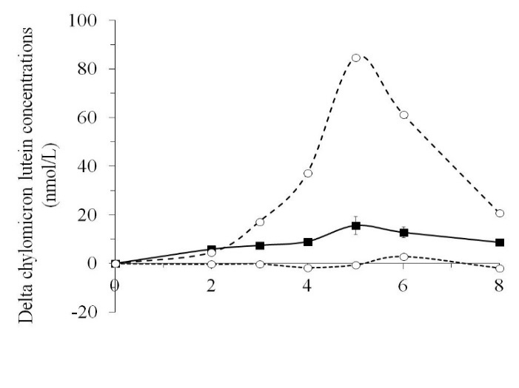
Time after meal intake (h)
Figure: Delta CM LUT concentrations measured after consumption of the meal containing the LUT supplement. Bold curve: mean ± SEM values of the 39 subjects. Lower dotted curve: LUT concentration measured in the lowest responder. Higher dotted curve: LUT concentration measured in the highest responder.
Table. Genes associated with the postprandial chylomicron lutein response
Gene | Associated with CM metabolism
ELOVL2 | N (no)
ABCG2 | N
ISX | N
MTTP | N
LPL | Y (yes)
APOA1 | N
MC4R | Y
PKD1L2 | N
INSIG2 | Y
IRS1 | Y
APOB | Y
ABCA1 | Y
RPE65 | N
LIPC | Y
COBLL1 | Y

Conclusions – SNPs in genes involved in CM metabolism play a significant role in the interindividual variability in LUT bioavailability.

Acknowledgements
This work was supported by the European Community’s Sixth Framework Programme. The funding was attributed to the Lycocard project (n°016213) which was an Integrated Project within the framework of the “Food Quality and Safety” programme.

[1] Desmarchelier C, Martin JC, Planells R, et al. J Clin Endocr Metab;Jan 13:jc20133962. [Epub ahead of print]:DOI: http://dx.doi.org/10.1210/jc.2013-3962. (2014)
[2] Borel P, Desmarchelier C, Nowicki M, Bott R, Morange S, Lesavre N. Am J Clin Nutr;in reviewing.

