**Supplemental Material:**

**Experimental and Kinetic Modeling Study of the Pyrolysis and Oxidation of 1,5-Hexadiene: The Reactivity of Allylic Radicals and Their Role in the Formation of Aromatics**

Florence H. Vermeirea , Ruben De Bruyckera, Olivier Herbinetb, Hans-Heinrich Carstensena, Frédérique Battin-Leclercb, Guy B. Marina, Kevin M. Van Geema,\*

a Laboratory for Chemical Technology, Ghent University, Technologiepark 914, 9052 Gent, Belgium

b Laboratoire Réactions et Génie des Procédés, CNRS, Universite de Lorraine, Nancy, France

Fuel

**Reaction families and rate rules considered in Genesys for this work**

Table S 1 k [bimolecular - m³ mol-1 s-1; unimolecular - s-1] = A Tn exp(-Ea/RT) where R = 8.314 10-3 kJ K-1 mol -1

|  |  |  |  |  |  |  |
| --- | --- | --- | --- | --- | --- | --- |
| **Reaction family** |  | **Comment** | **Kinetic parameters** | | | **Ref** |
|  |  |  | ***A*** | ***n*** | ***Ea*** |  |
| **Hydrogen abstraction** |  |  |  |  |  |  |
| *Intermolecular* |  |  |  |  |  |  |
| by C• from C-H |  |  | Group additivity | | | [[1](#_ENREF_1), [2](#_ENREF_2)] |
| H abstr from C(=O)-**H** by CH3 | 2.5e-6 | 3.6 | 18.1 | [[3](#_ENREF_3)] |
| by H• from C-H |  |  | Group additivity | | | [[4](#_ENREF_4)] |
| H abstr from C(=O)-**H** | 7.15e-1 | 2.4 | 6.6 | [[3](#_ENREF_3)] |
| by •OH from C-H |  | R1, R2, R3 alkyl chains or H atoms | Rate rules for alkanes | | | [[5](#_ENREF_5), [6](#_ENREF_6)] |
| R1, R2 H atoms  R3 C=C | 7.80e-1 | 2.3 | -5.7 | [[7](#_ENREF_7)] |
| R1 H atom  R2 alkyl chain  R3 C=C | 7.50e-2 | 2.4 | -3.9 | [[7](#_ENREF_7)] |
| R1 H atom  R2 OH  R3 alkyl chain | 1.15e-2 | 2.6 | -8.7 | [[7](#_ENREF_7)] |
| R1 H atom  R2 OH  R3 C=C | 2.55e-2 | 2.6 | -13.3 | [[7](#_ENREF_7)] |
| H abstr from C(=O)-**H** | 6.13e-2 | 2.7 | -19.2 | [[3](#_ENREF_3)] |
| by HO2• from C-H |  | R1, R2, R3 alkyl chains or H atoms | Rate rules for alkanes | | | [[8](#_ENREF_8)] |
| R1, R2 or R3 OH | 1.23e-11 | 5.26 | 31.3 | [[9](#_ENREF_9)] |
| R1, R2 or R3 C=C | 7.68e-2 | 4.4 | 56.7 | [[10](#_ENREF_10)] |
| H abstr from C(=O)-**H** | 1.18e-10 | 4.9 | 15.4 | [[3](#_ENREF_3)] |
| by O2 from C-H |  |  | 1.00e7 | 0.0 | ΔHr | [[11](#_ENREF_11), [12](#_ENREF_12)] |
| *Intramolecular* |  |  |  |  |  |  |
| by C• from C-H |  |  | Group additivity + rate rule  A = function of # hindered rotors in TS  Ea = ring strain in TS + activation energy analogous bimolecular reaction | | | [[1](#_ENREF_1), [2](#_ENREF_2), [13](#_ENREF_13), [14](#_ENREF_14)] |
| by R-O-O• from C-H |  | Formation of an alkyl radical | Rate rules for alkanes | | | [[15](#_ENREF_15)] |
| Formation of an allylic radical | 2.24e6 | 1.29 | 59.6 | [[16](#_ENREF_16)] |
| by R-O-O• from O-H |  | Analogy with 2-peroxy-2-methyl-propan-1-ol | 2.91e12 | -0.23 | 93.3 | [[17](#_ENREF_17)] |
| by cyclopentadienyl from C-H through 3-membered transition state |  | Analogy with methyl-cyclopentadienyl | 2.20e-3 | 4.91 | 169.0 | [[18](#_ENREF_18)] |
| **β-scission / radical addition** | |  |  |  |  |  |
| *Intermolecular* | |  |  |  |  |  |
| •C-C-C ⇄ C=C + •C |  |  | Group additivity | | | [[19](#_ENREF_19)] |
| •C-C-H ⇄ C=C + •H |  |  | Group additivity | | | [[20](#_ENREF_20)] |
| •C-C-OH ⇄ C=C+ •OH |  | Analogy with  2-hydroxy-ethyl to ethene plus OH | 3.00e13 | 0.0 | 112.1 | a |
| •C-O-H ⇄ C=O+ •H |  | Analogy with acetaldehyde plus H to 1-hydroxy-ethyl | 1.10e8 | 0.0 | 44.7 | a |
| •C-C-O-O-H ⇄ C=C+ HO2• |  |  | Rate rules for alkanes | | | [[15](#_ENREF_15)] |
| •O-C-C ⇄ C=O+ •C |  | R1 alkyl  Analogy with 2-oxy-propane | 6.00e13 | 0.22 | 59.0 | a |
| R1 C=C  Analogy with allyloxy | 2.70e14 | 0.00 | 100.0 | [[21](#_ENREF_21)] |
| •O-C-H ⇄ C=O+ •H |  | R1 or R2 C=C.  Analogy with allyloxy | 1.17e10 | 1.00 | 77.6 | [[21](#_ENREF_21)] |
| *Intramolecular* |  |  |  |  |  |  |
| exo-addition |  |  | Group additivity + rate rule  A = function of # hindered rotors in TS  Ea = ring strain in TS + activation energy analogous bimolecular reaction | | | [[13](#_ENREF_13), [19](#_ENREF_19)] |
| endo-addition |  |  | Group additivity + rate rule  A = function of # hindered rotors in TS  Ea = ring strain in TS + activation energy analogous bimolecular reaction | | | [[13](#_ENREF_13), [19](#_ENREF_19)] |
| endo-addition forming bicyclic species |  | Analogy with methyl-cyclopentadienyl | 3.20e11 | 0.17 | 18.4 | [[18](#_ENREF_18)] |
| ring-enlargement |  | Analogy with hexadienyl | 8.50e11 | 0.41 | 69.9 | [[18](#_ENREF_18)] |
| **α-scission** |  |  |  |  |  |  |
| C-C(=O)• ⇄ C• + CO |  | Analogy with acetyl radical | 3.30e12 | 0.62 | 72.4 | a |
| **Concerted reactions** |  |  |  |  |  |  |
| •O-O-C-C-H ⇄ HO2• + C=C |  |  | Rate rules for alkanes | | | [[15](#_ENREF_15)] |
| Formation of cyclic ethers from hydoperoxyl-alkyl radicals |  |  | Rate rules for alkanes | | | [[15](#_ENREF_15)] |
| •O-O-C-OH ⇄ HO2• + C=O |  | Analogy with alpha-hydroxy-ethylperoxy | 2.60e8 | 1.13 | 44.5 | [[22](#_ENREF_22)] |
| Sigmatropic hydrogen shift of 5-alkyl-1,3-cyclopentadiene to  1-alkyl-1,3-cyclopentadiene |  | Analogy with methyl-cyclopentadiene | 7.03e8 | 1.20 | 103.8 | [[23](#_ENREF_23)] |
| Sigmatropic hydrogen shift of 1-alkyl-1,3-cyclopentadiene to  2-alkyl-1,3-cyclopentadiene |  | Analogy with methyl-cyclopentadiene | 1.65e7 | 2.10 | 105.0 | [[23](#_ENREF_23)] |
| **Oxygen addition on carbon-centered radicals** | |  |  |  |  |  |
| C• + O2 ⇄ C-O-O• |  | R1, R2, R3 alkyl chains or H atoms | Rate rules for alkanes | | | [[15](#_ENREF_15)] |
| R1 C=C | 5.78e1 | 1.59 | 4.5 | [[24](#_ENREF_24)] |
| R1 OH | 4.05e7 | -0.31 | -1.4 | [[9](#_ENREF_9)] |
| **Recombination / scission** | |  |  |  |  |  |
| C-O-O-H ⇄ CO• + •OH |  | Analogy with allylhydroperoxide | 3.35e10 | 0.60 | -8.8 | [[21](#_ENREF_21)] |
| C• + HO2• ⇄ C-O-O-H |  | Analogy with allylhydroperoxide | 1.59e20 | -1.50 | 179.3 | [[21](#_ENREF_21)] |
| Recombination of cyclopentadienyl with carbon-centered radicals |  | Analogy with cyclopentadienyl plus methyl | 8.34e9 | -0.70 | -2.1 | [[23](#_ENREF_23)] |
|  | a CBS-QB3 calculations |  |  |  |  |  |

**Sensitivity analysis with respect to the allyl radical**

Supplementary to 1,5-hexadiene, benzene and 1,3-cyclopentadiene, a sensitivity analysis with respect to the allyl radical mole fraction has been performed. The results at fuel-rich oxidation conditions (ϕ=2.0) at 850K, 950K and 1050K are presented in Figure S 1. Similar to the 1,5-hexadiene mole fraction sensitivity analysis, the allyl radical mole fraction is sensitive to reactions occurring during the initial decomposition of 1,5-hexadiene at low temperatures and to reactions part of the secondary chemistry at higher temperatures. A positive sensitivity coefficient for the addition of a hydrogen atom or a hydroxyl radical to 1,5-hexadiene with the formation of a secondary radical is caused by the subsequent formation of an allyl radical through C-C β-scission. The competing hydrogen addition to 1,5-hexadiene with the formation of a primary radical has a negative sensitivity coefficient as no allyl radical is formed in further reactions. In oxidation conditions, the primary consumption pathways of the allyl radicals involve reaction with hydroperoxy radicals. Pathways in which hydroperoxy radicals are consumed hence have a positive sensitivity coefficient with respect to the allyl radical mole fraction.

C:\Users\fhvermei\Desktop\Hexadiene\Oxidation\other plots\sens_C3H5-A_FV20170130.tif

Figure S 1 Sensitivity coefficients for allyl radical mole fraction in 1,5-hexadiene oxidation (ϕ=2.0). Operating conditions correspond to P=0.107 MPa, FV=4.06 10-5 m3 s-1, x1,5-hexadiene,0=0.008, T = 800K (black), 900K (blue), and 1000K (red).

**Comparison to the propene pyrolysis model by Wang et al.**

The model performance of the kinetic model developed for the pyrolysis of propene by Wang et al. [[25](#_ENREF_25)] (CSM model) has been compared to the model performance of the kinetic model developed in this work for the pyrolysis of 1,5-hexadiene. The results are shown in Figure S 2. Although the model is developed for the pyrolysis of propene, it can well describe the pyrolysis products of 1,5-hexadiene. In general, the main product yields of the small products are well described by both models. The performance of the kinetic model in this work is better for hydrogen gas, propene, propadiene and 1-butene mole fractions. However, the CSM model seems to perform better to predict the ethane, ethyne and 2-butene mole fractions.The ethyne mole fraction in this work can be improved by re-evaluation of the reaction from a vinyl radical to ethyne and a hydrogen atom. Towards the performance for the mole fractions of the cyclic products and aromatics formed from 1,5-hexadiene, our kinetic model clearly demonstrates improved performance. The mole fraction trends as a function of temperature are better reproduced by this kinetic model compared to the CSM model. The mole fractions of cyclic C6 species, like cyclohexene and 1,3-cyclohexadiene, are clearly under predicted by the CSM model, while a quantitative agreement is obtained with our model. The CSM model predicts the trend of the benzene mole fraction quite good, but a better agreement is obtained with the model developed in this work. Furthermore, the mole fractions of all heavier aromatics, like toluene, ethyl-benzene, styrene and naphthalene, are under predicted by the CSM model.

To conclude, although the CSM model was developed for the pyrolysis of propene, it leads to good predictions of the mole fractions of the small products of 1,5-hexadiene pyrolysis. However, the model performance of the kinetic model developed in this work, more accurately predicts the mole fractions of heavier, cyclic and aromatic products.”

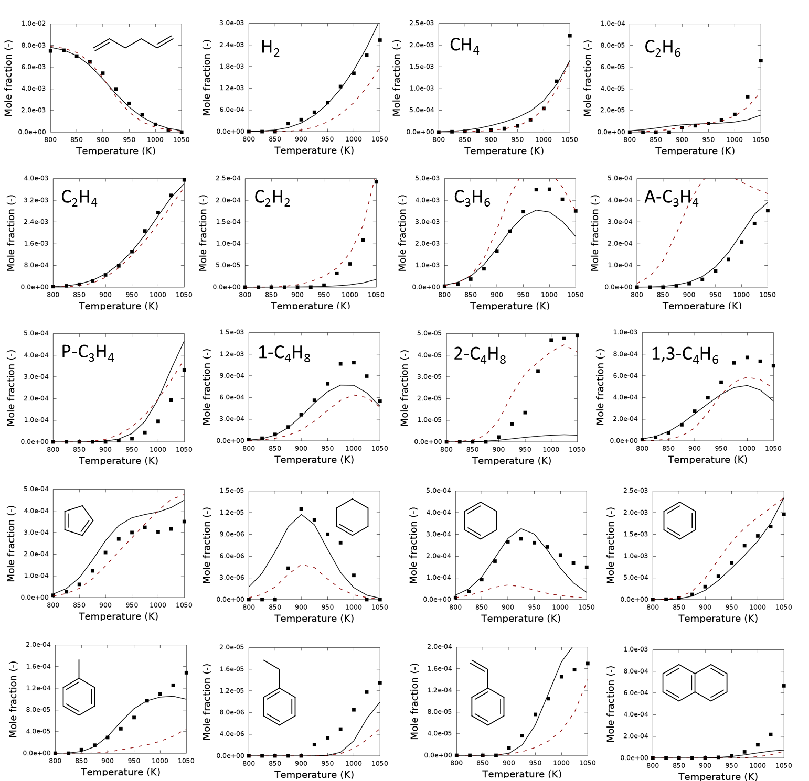

Figure S 2. Comparison of the simulated mole fractions of the main species during 1,5-hexadiene pyrolysis with experimental data (dots). Kinetic models used for simulations are the new kinetic model (black full lines) and the CSM model by Wang et al. (red dashed lines)

**References**

[1] M.K. Sabbe, A. Vandeputte, M.-F. Reyniers, M. Waroquier, G.B. Marin, Modeling the influence of resonance stabilization on the kinetics of hydrogen abstractions, PCCP, 12 (2010) 1278-1298.

[2] P.D. Paraskevas, M.K. Sabbe, M.-F. Reyniers, N.G. Papayannakos, G.B. Marin, Kinetic Modeling of α-Hydrogen Abstractions from Unsaturated and Saturated Oxygenate Compounds by Carbon-Centered Radicals, ChemPhysChem, 15 (2014) 1849-1866.

[3] J. Mendes, C.-W. Zhou, H.J. Curran, Theoretical Chemical Kinetic Study of the H-Atom Abstraction Reactions from Aldehydes and Acids by Ḣ Atoms and ȮH, HȮ2, and ĊH3 Radicals, J. Phys. Chem. A, 118 (2014) 12089-12104.

[4] P.D. Paraskevas, M.K. Sabbe, M.-F. Reyniers, N.G. Papayannakos, G.B. Marin, Kinetic Modeling of α-Hydrogen Abstractions from Unsaturated and Saturated Oxygenate Compounds by Hydrogen Atoms, J. Phys. Chem. A, 118 (2014) 9296-9309.

[5] R. Sivaramakrishnan, J.V. Michael, Rate Constants for OH with Selected Large Alkanes: Shock-Tube Measurements and an Improved Group Scheme, J. Phys. Chem. A, 113 (2009) 5047-5060.

[6] J. Badra, A. Elwardany, A. Farooq, Shock tube measurements of the rate constants for seven large alkanes + OH, P. Combust. Inst., 35 (2015) 189-196.

[7] P.D. Paraskevas, M.K. Sabbe, M.-F. Reyniers, N.G. Papayannakos, G.B. Marin, Group Additive Kinetics for Hydrogen Transfer Between Oxygenates, J. Phys. Chem. A, (2015).

[8] J. Aguilera-Iparraguirre, H.J. Curran, W. Klopper, J.M. Simmie, Accurate Benchmark Calculation of the Reaction Barrier Height for Hydrogen Abstraction by the Hydroperoxyl Radical from Methane. Implications for CnH2n+2 where n = 2 → 4, J. Phys. Chem. A, 112 (2008) 7047-7054.

[9] G. Mittal, S.M. Burke, V.A. Davies, B. Parajuli, W.K. Metcalfe, H.J. Curran, Autoignition of ethanol in a rapid compression machine, Combust. Flame, 161 (2014) 1164-1171.

[10] J. Zádor, S.J. Klippenstein, J.A. Miller, Pressure-Dependent OH Yields in Alkene + HO2 Reactions: A Theoretical Study, J. Phys. Chem. A, 115 (2011) 10218-10225.

[11] H.J. Curran, P. Gaffuri, W.J. Pitz, C.K. Westbrook, A comprehensive modeling study of n-heptane oxidation, Combust. Flame, 114 (1998) 149-177.

[12] H.J. Curran, P. Gaffuri, W.J. Pitz, C.K. Westbrook, A comprehensive modeling study of iso-octane oxidation, Combust. Flame, 129 (2002) 253-280.

[13] K. Wang, S.M. Villano, A.M. Dean, Reactivity–Structure-Based Rate Estimation Rules for Alkyl Radical H Atom Shift and Alkenyl Radical Cycloaddition Reactions, J. Phys. Chem. A, 119 (2015) 7205-7221.

[14] K. Wang, S.M. Villano, A.M. Dean, The Impact of Resonance Stabilization on the Intramolecular Hydrogen-Atom Shift Reactions of Hydrocarbon Radicals, Chemphyschem, 16 (2015) 2635-2645.

[15] J. Bugler, K.P. Somers, E.J. Silke, H.J. Curran, Revisiting the Kinetics and Thermodynamics of the Low-Temperature Oxidation Pathways of Alkanes: A Case Study of the Three Pentane Isomers, J. Phys. Chem. A, 119 (2015) 7510-7527.

[16] F. Zhang, T.S. Dibble, Effects of Olefin Group and Its Position on the Kinetics for Intramolecular H-Shift and HO2 Elimination of Alkenyl Peroxy Radicals, J. Phys. Chem. A, 115 (2011) 655-663.

[17] H. Sun, J.W. Bozzelli, C.K. Law, Thermochemical and Kinetic Analysis on the Reactions of O2 with Products from OH Addition to Isobutene, 2-Hydroxy-1,1-dimethylethyl, and 2-Hydroxy-2-methylpropyl Radicals:  HO2 Formation from Oxidation of Neopentane, Part II, J. Phys. Chem. A, 111 (2007) 4974-4986.

[18] S. Sharma, M.R. Harper, W.H. Green, Modeling of 1,3-hexadiene, 2,4-hexadiene and 1,4-hexadiene-doped methane flames: Flame modeling, benzene and styrene formation, Combust. Flame, 157 (2010) 1331-1345.

[19] M.K. Sabbe, M.F. Reyniers, V. Van Speybroeck, M. Waroquier, G.B. Marin, Carbon-centered radical addition and beta-scission reactions: Modeling of activation energies and pre-exponential factors, ChemPhysChem, 9 (2008) 124-140.

[20] M.K. Sabbe, M.-F. Reyniers, M. Waroquier, G.B. Marin, Hydrogen Radical Additions to Unsaturated Hydrocarbons and the Reverse beta-Scission Reactions: Modeling of Activation Energies and Pre-Exponential Factors, ChemPhysChem, 11 (2010) 195-210.

[21] C.F. Goldsmith, S.J. Klippenstein, W.H. Green, Theoretical rate coefficients for allyl + HO2 and allyloxy decomposition, P. Combust. Inst., 33 (2011) 273-282.

[22] G. da Silva, J.W. Bozzelli, L. Liang, J.T. Farrell, Ethanol Oxidation: Kinetics of the α-Hydroxyethyl Radical + O2 Reaction, J. Phys. Chem. A, 113 (2009) 8923-8933.

[23] S. Sharma, W.H. Green, Computed Rate Coefficients and Product Yields for c-C(5)H(5) + CH(3) -> Products, J. Phys. Chem. A, 113 (2009) 8871-8882.

[24] J. Lee, J.W. Bozzelli, Thermochemical and kinetic analysis of the allyl radical with O2 reaction system, P. Combust. Inst., 30 (2005) 1015-1022.

[25] K. Wang, S.M. Villano, A.M. Dean, Fundamentally-based kinetic model for propene pyrolysis, Combust. Flame, 162 (2015) 4456-4470.