SUPPORTING INFORMATION

Lanthanide coordination polymers with 1,2-phenylenediacetate.

Insa Badiane^{a,b}, Stéphane Freslonª, Yan Suffrenª, Carole Daiguebonneª, Guillaume Calvezª, Kevin Bernotª, Magatte Camara^{b} and Olivier Guillouª.

ª INSA Rennes, UMR 6226 “Institut des Sciences Chimiques de Rennes”, F-35708 Rennes
^{b} Université Assane Seck de Ziguinchor, LCPM – Groupe "Matériaux Inorganiques: Chimie Douce et Cristallographie", BP. 523 Ziguinchor – Sénégal
,

Table S1. Crystal and final structure refinement data already reported.
Molecular formula | Nd₂C₃₀O₁₆H₃₃ |  | La₂C₃₀O₁₆H₃₃ |  |  | Tb₂C₃₀O₁₆ H₃₆ | Ho₂C₃₀O₁₆H₃₆ | Er₂C₃₀O_{16.5}H₃₃ |  | Pr₂C₃₀O_{16.5}H₃₃ |  | Dy₂C₃₀O₁₆H₃₂
System | Monoclinic |  | Monoclinic |  |  | Monoclinic | Monoclinic | Monoclinic |  | Monoclinic |  | Monoclinic
a (Å) | 26.2906 (18) |  | 26.271 (14) |  |  | 26.2699 (4) | 26.317 (4) | 26.317 (3) |  | 26.223 (7) |  | 26.2718 (9)
b (Å) | 16.1172 (11) |  | 16.149 (8) |  |  | 16.0274 (2) | 16.004 (3) | 16.1589 (19) |  | 16.097 (4) |  | 16.0042 (6)
c (Å) | 7.8327 (5) |  | 7.966 (4) |  |  | 7.6724 (1) | 7.6263 (12) | 7.8459 (9) |  | 7.852 (2) |  | 7.6441 (3)
β (°) | 93.173 (5) |  | 92.850 (9) |  |  | 93.345 (1) | 93.471 (2) | 93.124 (2) |  | 93.031 (4) |  | 93.389 (2)
V (Å³) | 3313.9 (4) |  | 3375 (3) |  |  | 3224.87 (8) | 3206.1 (9) | 3331.6 (7) |  | 3309.8 (15) |  | 3208.41 (20)
Z | 4 |  | 4 |  |  | 4 | 4 | 4 |  | 4 |  | 4
Formula weight (g mol⁻¹) | 937.04 |  | 926.38 |  |  | 958.36 | 978.42 | 992.08 |  | 939.38 |  | 973.56
Space group (No.) | C2/c (n°15) |  | C2/c (n°15) |  |  | C2/c (n°15) | C2/c (n°15) | C2/c (n°15) |  | C2/c (n°15) |  | C2/c (n°15)
D_{calc} (g cm⁻³) | 1.878 |  | 1.823 |  |  | 1.97 | 2.027 | 1.978 |  | 1.885 |  | 2.01538
µ (mm⁻¹) | 3.173 |  | 2.570 |  |  | 4.426 | 4.976 | 5.08 |  | 2.99 |  | 4.70
R (%) | 1.75 |  | 5.05 |  |  | 2.94 | 3.30 | 1.4 |  | 1.9 |  | 2.2
R_{W} (%) | 10.357 |  | 13.315 |  |  | 8.04 | 12.4 | 11.3 |  | 10 |  | 5.5
GoF | 1.053 |  | 1.055 |  |  | 1.003 | 1.069 | 1.09 |  | 1.081 |  | 1.06
N° CCDC | 953279 |  | 952811 |  |  | 635048 | 635081 | 963497 |  | 963495 |  | 669663
Reference |  | 44 |  | 44 | 47 |  | 47 | 46 | 46 |  | 45

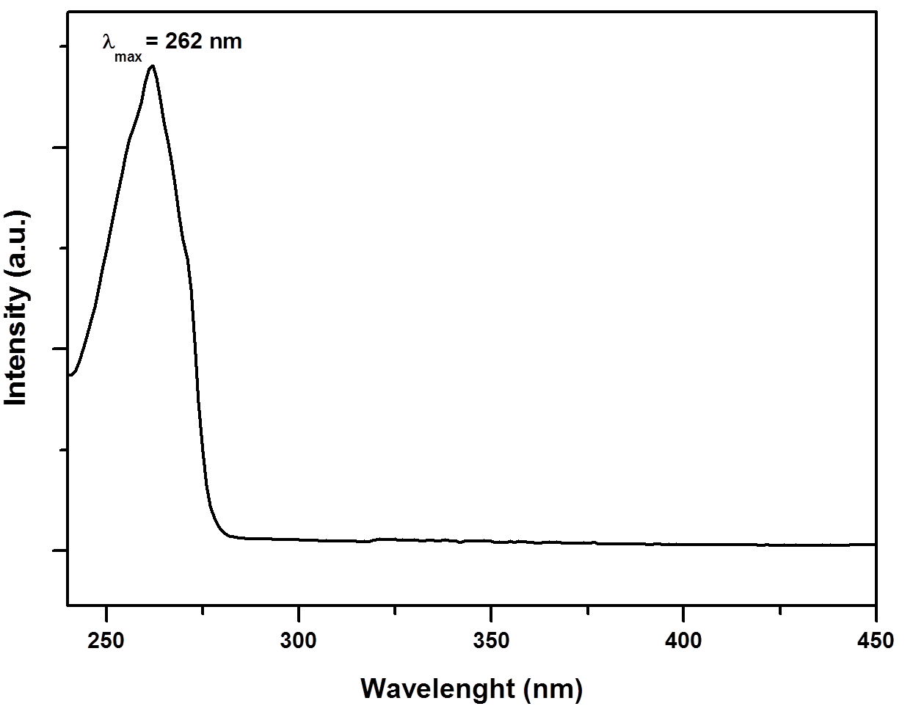
Figure S1. UV-vis absorption spectrum of an aqueous solution of Na₂o-pda (c = 4.3 10⁻⁵ mol.L⁻¹).

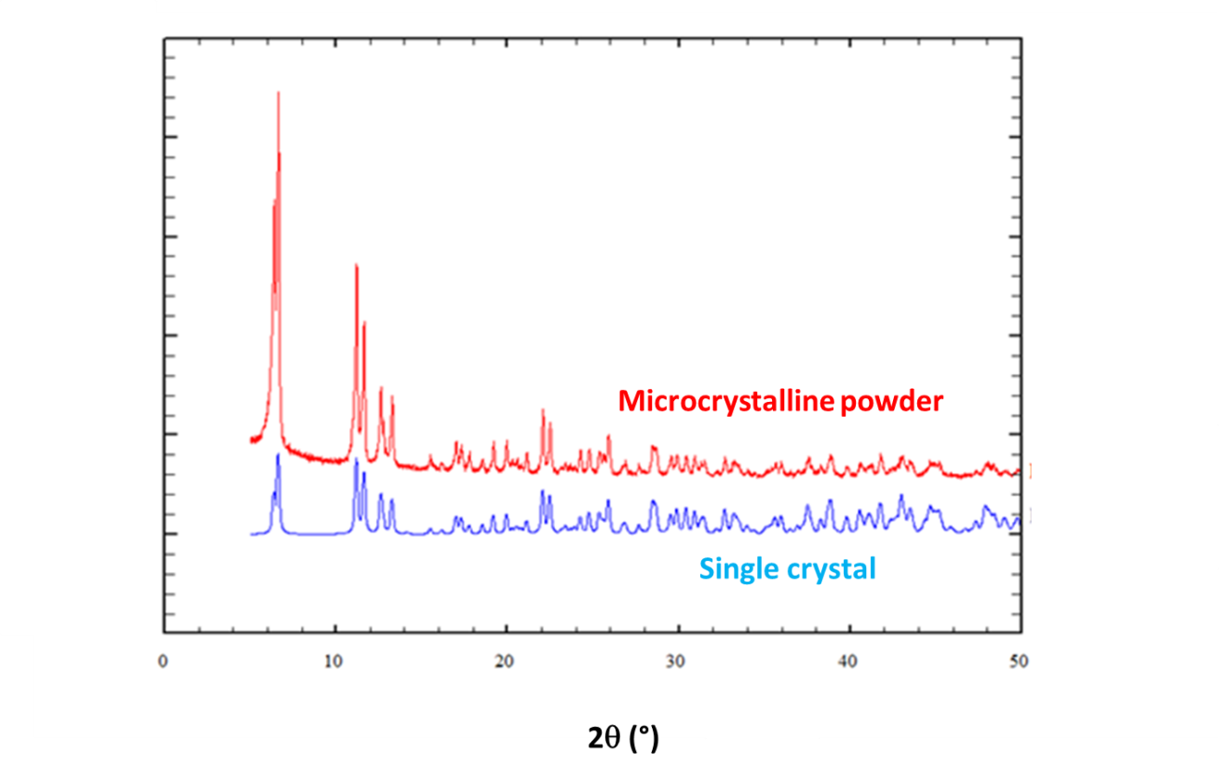
Figure S2. Experimental and simulated (on the basis of crystal structure) powder diffraction patterns of [La₂(o-pda)₃(H₂O)₄,4H₂O]∞ (1.).
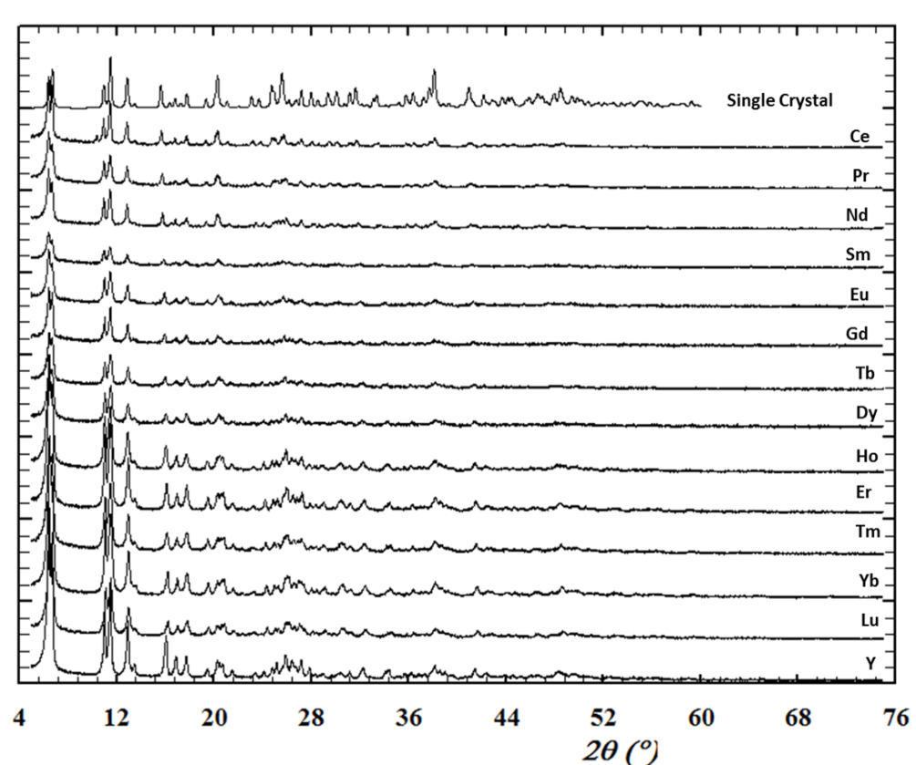
Figure S3. Experimental and simulated (on the basis of the crystal structure from reference [47]) powder X-ray diffraction patterns of microcrystalline compounds [Ln₂(o-pda)₃(H₂O)₂,2H₂O]∞ for Ln = Ce-Nd, Sm-Lu and Y (2).

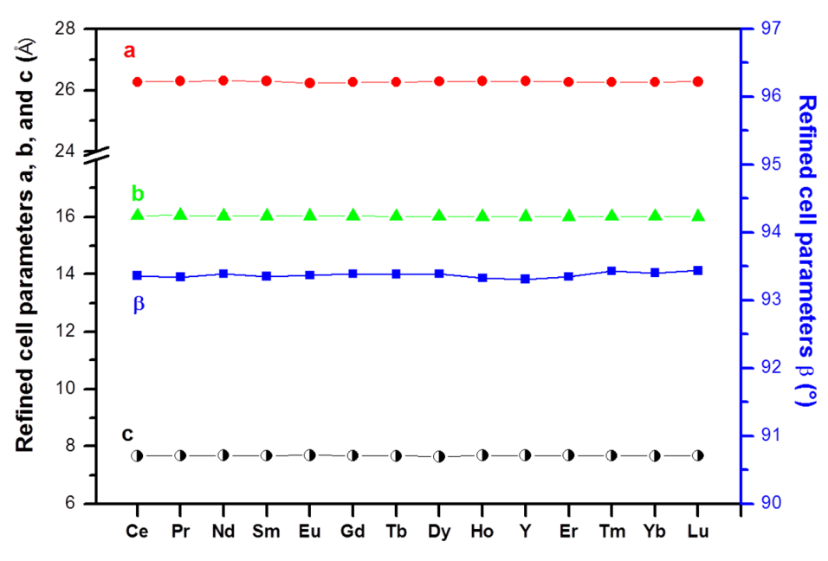
Figure S4. Refined cell parameters for microcrystalline compounds [Ln₂(o-pda)₃(H₂O)₂,2H₂O]∞ for Ln = Ce-Nd, Sm-Lu and Y (2).

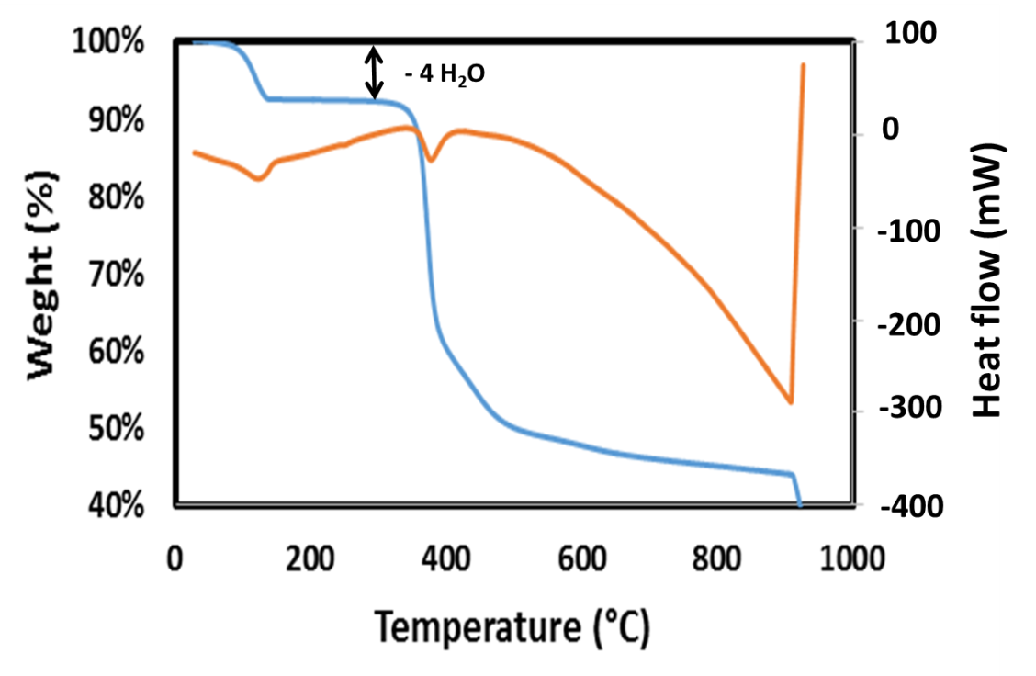
Figure S5. Thermal analyzes of microcrystalline [Gd₂(o-pda)₃(H₂O)₂,2H₂O]∞.

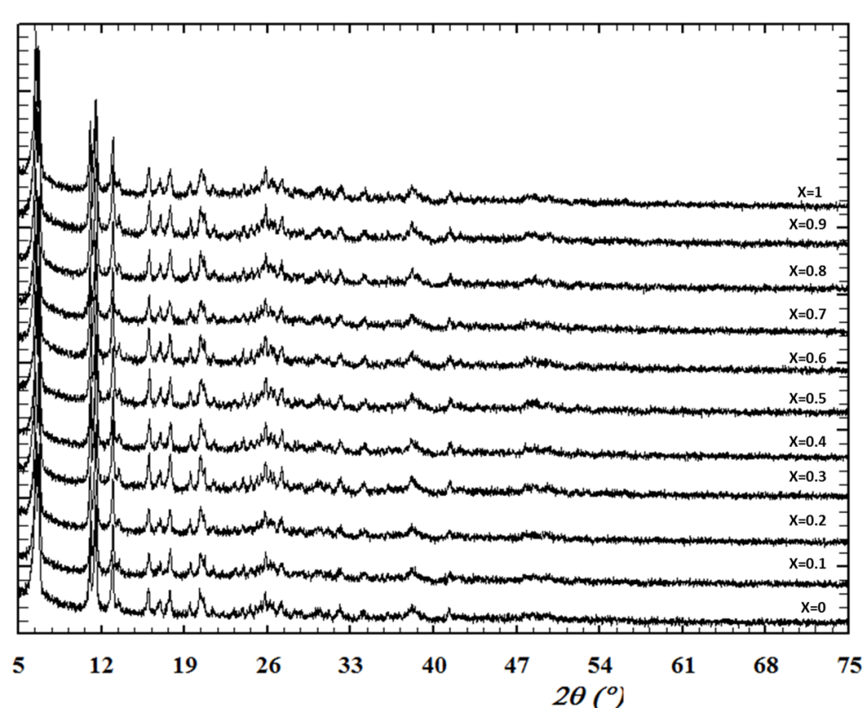
Figure S6. Powder X-ray diffraction diagrams for microcrystalline [Tb_{2-2x}Gd_{2x}(o-pda)₃(H₂O)₂,2H₂O]∞ with 0 ≤ x ≤ 0.9.
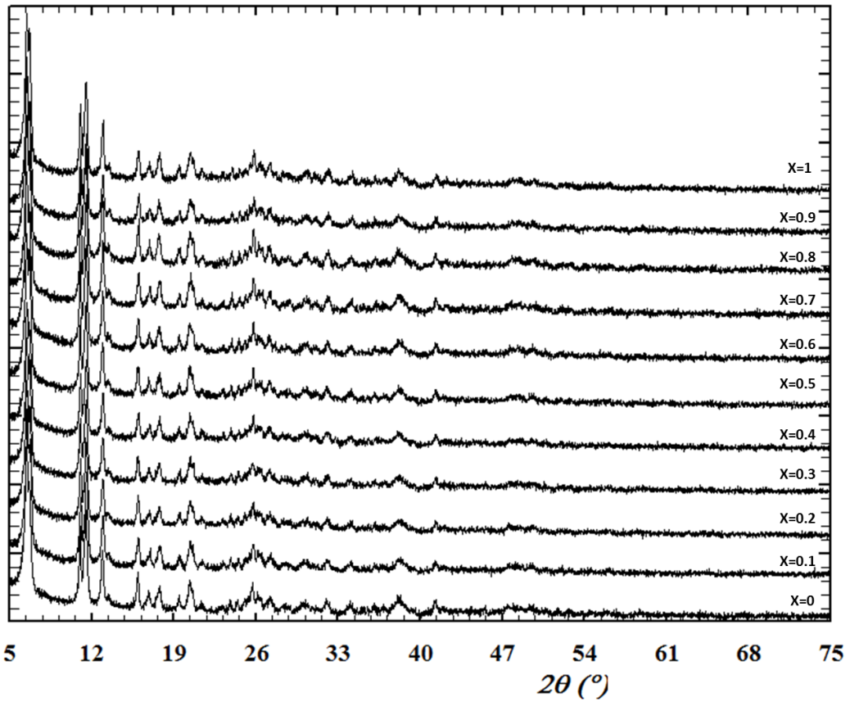
Figure S7. Powder X-ray diffraction diagrams for microcrystalline [Tb_{2-2x}Eu_{2x}(o-pda)₃(H₂O)₂,2H₂O]∞ with 0 ≤ x ≤ 0.9.

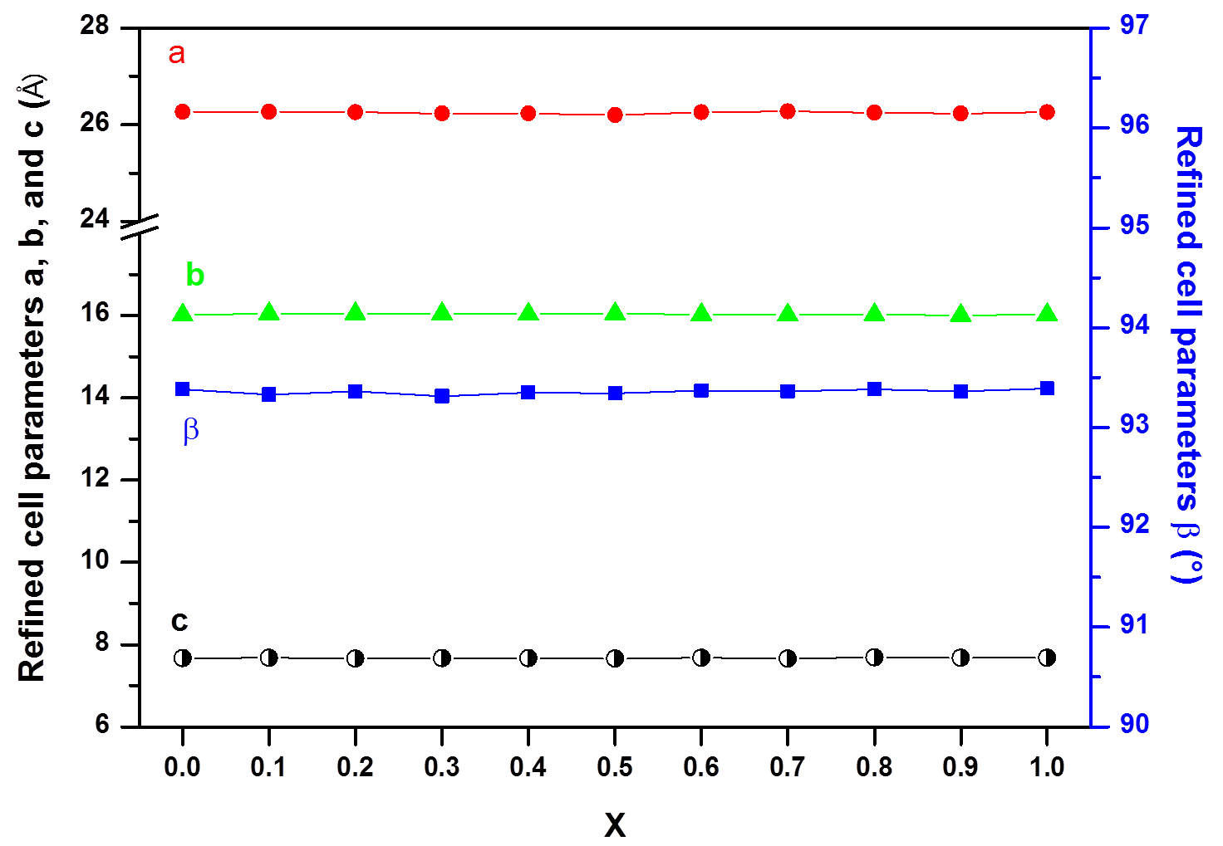
Figure S8. Refined cell parameters for microcrystalline [Tb_{2-2x}Gd_{2x}(o-pda)₃(H₂O)₂,2H₂O]∞ with 0 ≤ x ≤ 0.9.

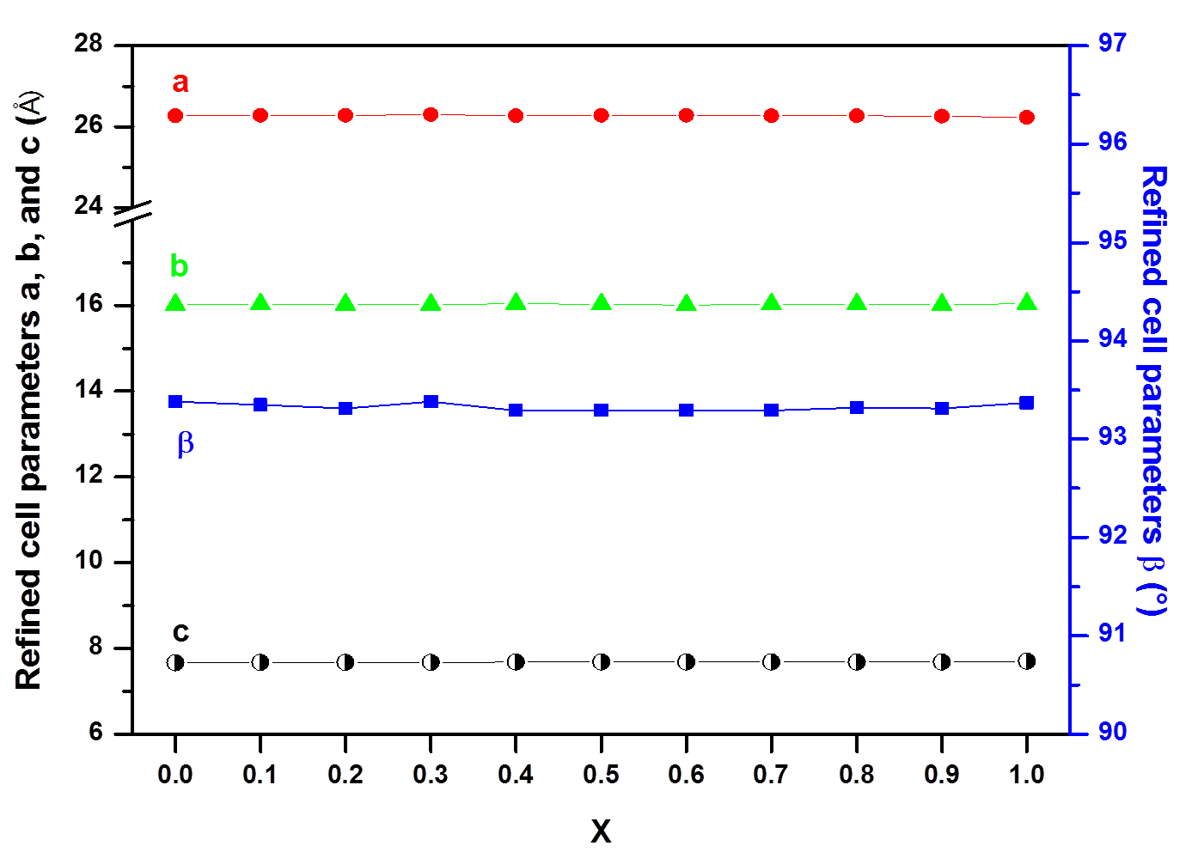
Figure S9. Refined cell parameters for microcrystalline [Tb_{2-2x}Eu_{2x}(o-pda)₃(H₂O)₂,2H₂O]∞ with 0 ≤ x ≤ 0.9.

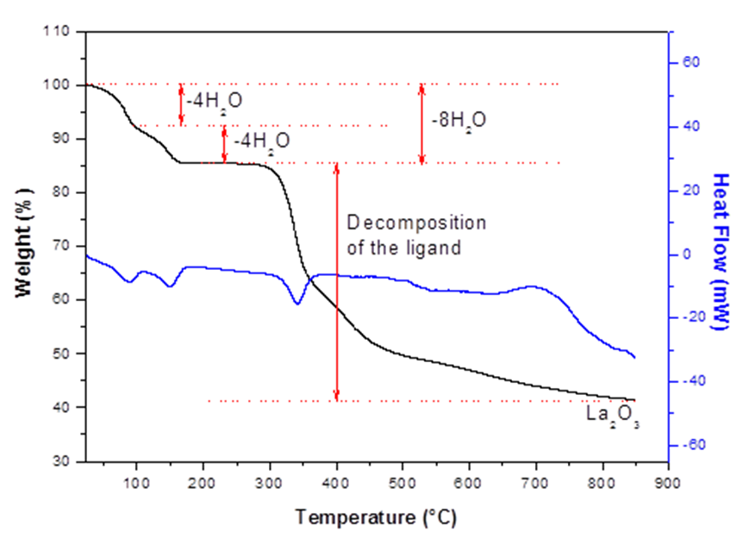
Figure S10. Thermal analyzes of microcrystalline [La₂(o-pda)₃(H₂O)₄,4H₂O]∞ (1).

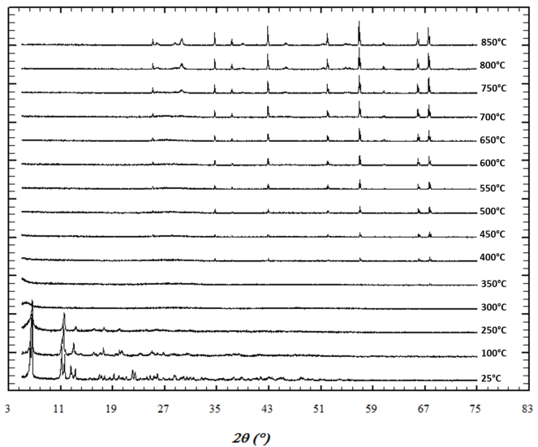 | 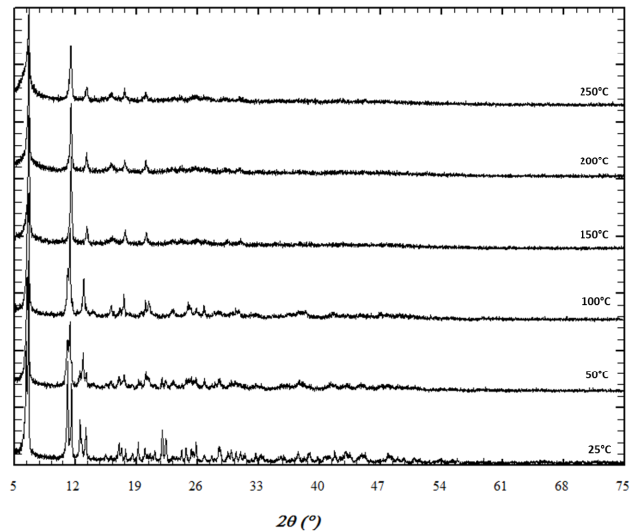
Figure S11. Temperature-dependent X-ray powder diffraction of microcrystalline [La₂(o-pda)₃(H₂O)₄,4H₂O]∞ (1).

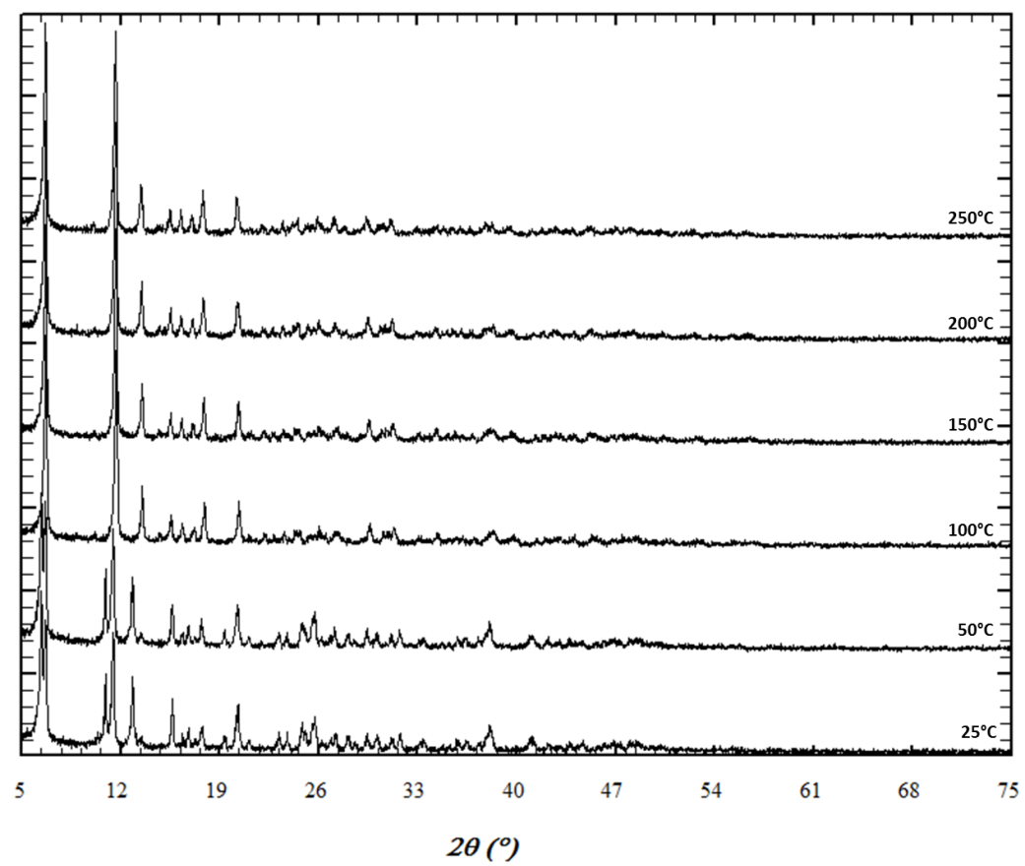
Figure S12. Temperature-dependent powder X-ray diffraction diagrams of microcrystalline [Gd₂(o-pda)₃(H₂O)₂,2H₂O]∞ between room temperature and 250°C under nitrogen atmosphere.

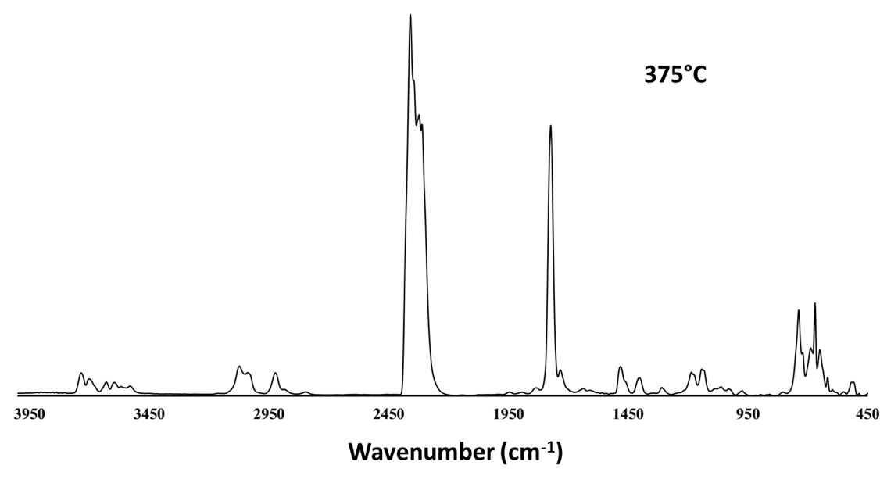
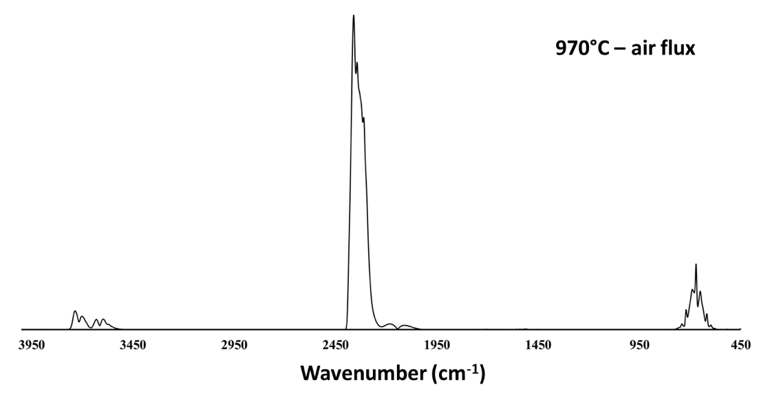
Figure S13. IR spectrum of microcrystalline [Gd₂(o-pda)₃(H₂O)₂,2H₂O]∞ recorded at 375°C (N₂ flux) and 970°C (air flux).

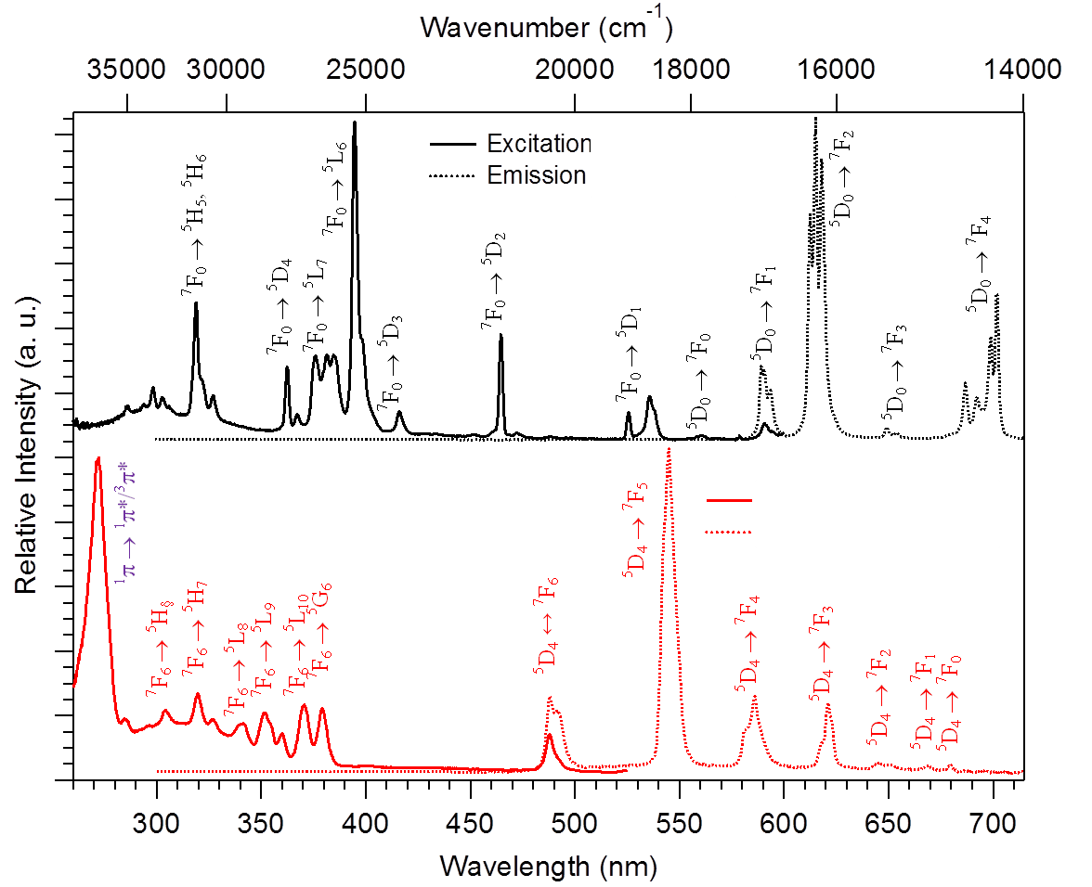
Figure S14. Top: Excitation (λ_{em} = 615 nm) and emission (λ_{exc} = 395 nm) spectra for microcrystalline [Eu₂(o-pda)₃(H₂O)₂,2H₂O]∞. Bottom: Excitation (λ_{em} = 545 nm) and emission (λ_{exc} = 379 nm) spectra for microcrystalline [Tb₂(o-pda)₃(H₂O)₂,2H₂O]∞.

Table S2. Chemical analyzes for compounds that constitute families (1) and (2).
Chemical formula | MW (g.mol⁻¹) | %C  calc. (found) | %H  calc. (found) | %O  calc. (found) | %Ln  calc. (found)
[La₂(o-pda)₃(H₂O)₄,4H₂O]∞ | 998.45 | 36.1 (36.0) | 4.0 (4.1) | 32.1 (32.2) | 27.8 (27.7)
[Ce₂(o-pda)₃(H₂O)₂,2H₂O]∞ | 928.81 | 38.8 (39.0) | 3.5 (3.5) | 27.6 (27.6) | 30.1 (29.9)
[Pr₂(o-pda)₃(H₂O)₂,2H₂O]∞ | 930.39 | 38.7 (38.7) | 3.5 (3.4) | 27.5 (27.4) | 30.3 (30.5)
[Nd₂(o-pda)₃(H₂O)₂,2H₂O]∞ | 937.05 | 38.5 (38.7) | 3.4 (3.5) | 27.3 (27.0) | 30.8 (30.8)
[Sm₂(o-pda)₃(H₂O)₂,2H₂O]∞ | 949.29 | 38.0 (38.2) | 3.4 (3.3) | 27.0 (27.0) | 31.6 (31.5)
[Eu₂(o-pda)₃(H₂O)₂,2H₂O]∞ | 952.50 | 37.8 (37.8) | 3.4 (3.4) | 26.9 (27.0) | 31.9 (31.8)
[Gd₂(o-pda)₃(H₂O)₂,2H₂O]∞ | 963.07 | 37.4 (37.4) | 3.3 (3.5) | 26.6 (26.4) | 32.7 (32.7)
[Tb₂(o-pda)₃(H₂O)₂,2H₂O]∞ | 966.43 | 37.3 (37.5) | 3.3 (3.1) | 26.5 (26.4) | 32.9 (33.0)
[Dy₂(o-pda)₃(H₂O)₂,2H₂O]∞ | 973.57 | 37.0 (36.9) | 3.3 (3.3) | 26.3 (26.2) | 33.4 (33.6)
[Ho₂(o-pda)₃(H₂O)₂,2H₂O]∞ | 978.44 | 36.8 (36.9) | 3.3 (3.4) | 26.2 (26.3) | 33.7 (33.4)
[Er₂(o-pda)₃(H₂O)₂,2H₂O]∞ | 983.09 | 36.7 (36.5) | 3.3 (3.3) | 26.0 (26.2) | 34.0 (34.0)
[Tm₂(o-pda)₃(H₂O)₂,2H₂O]∞ | 986.44 | 36.5 (36.5) | 3.3 (3.4) | 25.9 (25.8) | 34.3 (34.3)
[Yb₂(o-pda)₃(H₂O)₂,2H₂O]∞ | 994.65 | 36.2 (36.0) | 3.3 (3.1) | 25.7 (25.9) | 34.8 (35.0)
[Lu₂(o-pda)₃(H₂O)₂,2H₂O]∞ | 998.51 | 36.1 (36.2) | 3.2 (3.2) | 25.6 (25.6) | 35.1 (35.0)
[Y₂(o-pda)₃(H₂O)₂,2H₂O]∞ | 826.39 | 43.6 (43.5) | 3.9 (4.0) | 31.0 (31.0) | 21.5 (21.5)

Table S3. Relative lanthanide ratios for [Tb_{2-2x}Gd_{2x}(o-pda)₃(H₂O)₂,2H₂O]∞ with 0.1 ≤ x ≤ 0.9
 | % (expected) |  |  |  | % (measured)
 | Gd |  | Tb |  | Gd |  | Tb
x=0.9 |  | 90 |  | 10 |  | 86.4 ± 4 |  | 13.6 ± 4
x=0.8 |  | 80 |  | 20 |  | 83.7 ± 2 |  | 16.3 ± 2
x=0.7 |  | 70 |  | 30 |  | 72 ± 6 |  | 28 ± 6
x=0.6 |  | 60 |  | 40 |  | 64.7 ± 2 |  | 35.3 ± 2
x=0.5 |  | 50 |  | 50 |  | 52.3 ± 0.7 |  | 47.7 ± 0.7
x=0.4 |  | 40 |  | 60 |  | 43.4 ± 3 |  | 56.6 ± 3
x=0.3 |  | 30 |  | 70 |  | 30.8 ± 2 |  | 69.2 ± 2
x=0.2 |  | 20 |  | 80 |  | 20.4 ± 0.8 |  | 79.6 ± 0.8
x=0.1 |  | 10 |  | 90 |  | 10 ± 2 |  | 90 ± 2

Table S4. Relative lanthanide ratios for [Tb_{2-2x}Eu_{2x}(o-pda)₃(H₂O)₂,2H₂O]∞ with 0.1 ≤ x ≤ 0.9
 | % (expected) |  | % (measured)
 | Eu | Tb | Eu | Tb
x=0.9 | 90 | 10 | 91.4 ± 2 | 8.6 ± 2
x=0.8 | 80 | 20 | 81 ± 2 | 19 ± 2
x=0.7 | 70 | 30 | 74 ± 4 | 26 ± 4
x=0.6 | 60 | 40 | 62.3 ± 4 | 37.7 ± 4
x=0.5 | 50 | 50 | 48 ± 2 | 52 ± 2
x=0.4 | 40 | 60 | 43.3 ± 2 | 56.7 ± 2
x=0.3 | 30 | 70 | 31 ± 2 | 69 ± 2
x=0.2 | 20 | 80 | 17 ± 3 | 83 ± 3
x=0.1 | 10 | 90 | 12 ± 2 | 88 ± 2

