The cyclooctadiene ligand in [IrCl(COD)]₂ is hydrogenated under transfer hydrogenation conditions: a study in the presence of PPh₃ and a strong base in isopropanol

S. M. Wahidur Rahaman,^{a,b} Jean-Claude Daran,^{a,b} Eric Manoury^{a,b} and Rinaldo Poli,*^{a,b,c}

ªCNRS, LCC (Laboratoire de Chimie de Coordination), Université de Toulouse, UPS, INPT, 205 route de Narbonne, BP 44099, F-31077 Toulouse Cedex 4, France CNRS. Fax: +33-561553003; Tel: +33-561333174; E-mail:rinaldo.poli@lcc-toulouse.fr.

^{b} Université de Toulouse, UPS, INPT, F-31077 Toulouse Cedex 4, France

^{c} Institut Universitaire de France, 1, rue Descartes, 75231 Paris Cedex 05, France.

SUPPORTING INFORMATION

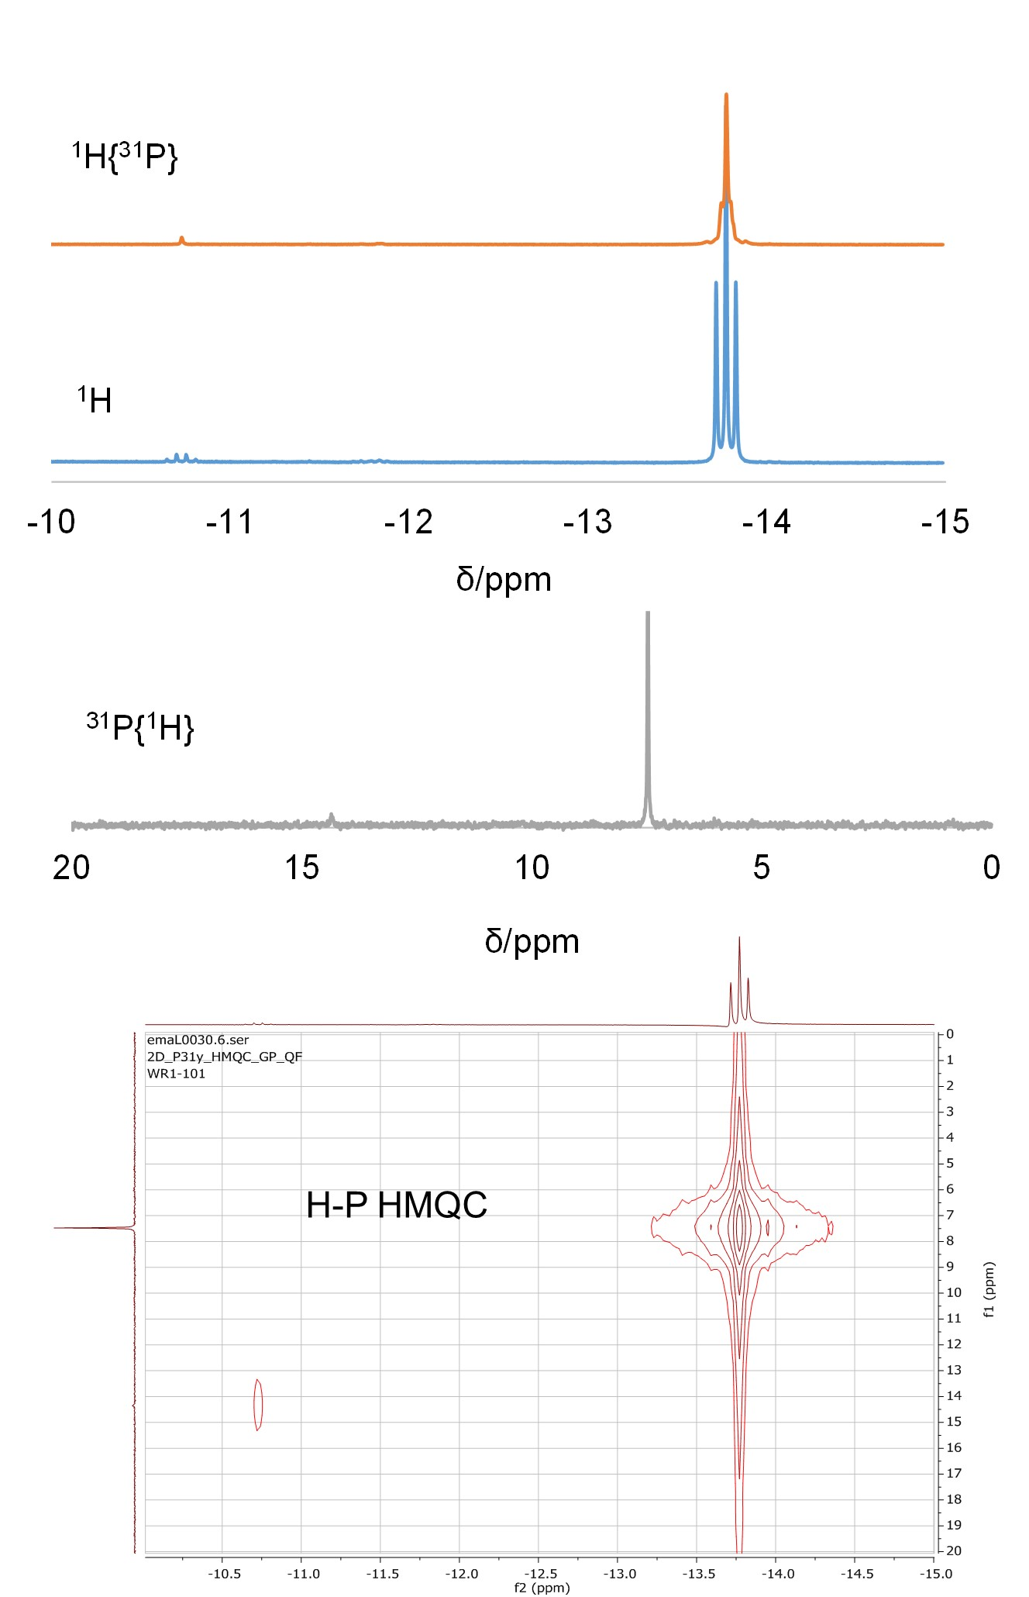
Figure 1S. NMR characterization of the [IrCl(COD)]₂/PPh₃(4 equiv)/KOtBu reaction in isopropanol at room temperature. The solution was evaporated to dryness and redissolved in CDCl₃.
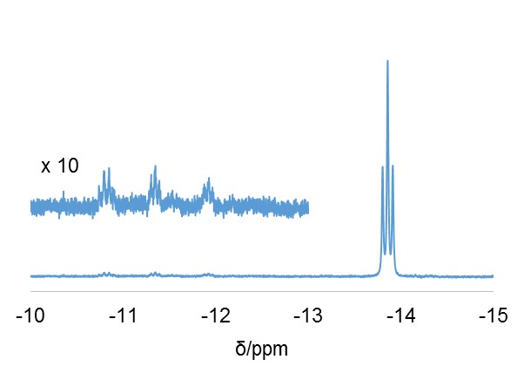
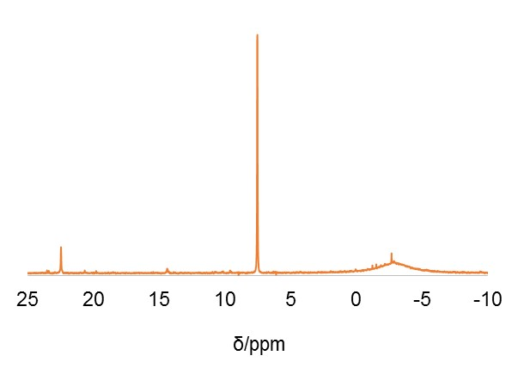
Figure 2S. ¹H (above) and ³¹P{¹H} (below) NMR spectra of the solution obtained from [IrCl(COD)]₂, PPh₃ (10 equiv.) and KOtBu (10 equiv.) in iPrOH. The solution was evaporated to dryness and redissolved in CDCl₃.
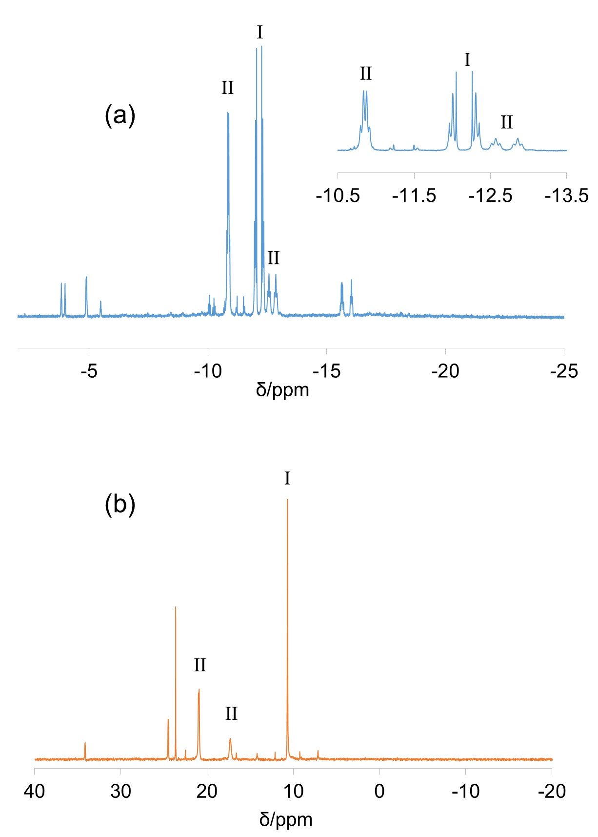
Figure 3S. ¹H NMR in the hydride region (above) and ³¹P{¹H} (below) spectra of the product mixture from the reaction between [IrCl(COD)]₂, PPh₃ (4 equiv) and excess NaOMe in boiling iPrOH for 3 h. The spectra were taken on the dried residue redissolved in THF-d₈.

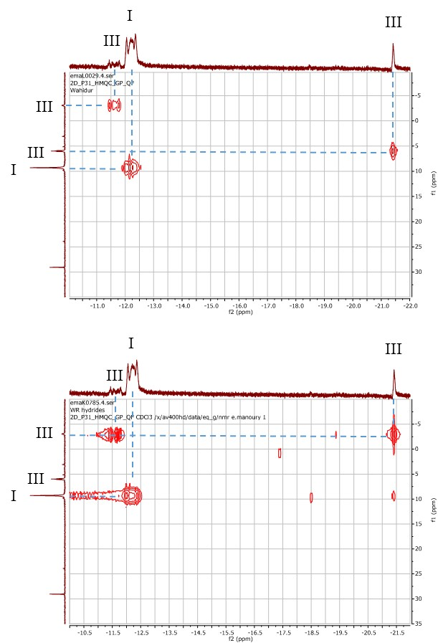
Figure 4S. ¹H-³¹P HMQC spectra (expansion of the ¹H hydride region) for the isolated product of the [IrCl(COD)]₂/4PPh₃/KOtBu reaction in boiling isopropanol (solvent = CDCl₃). The delay was optimized for a J coupling of 5 Hz (above) or 10 Hz (below).

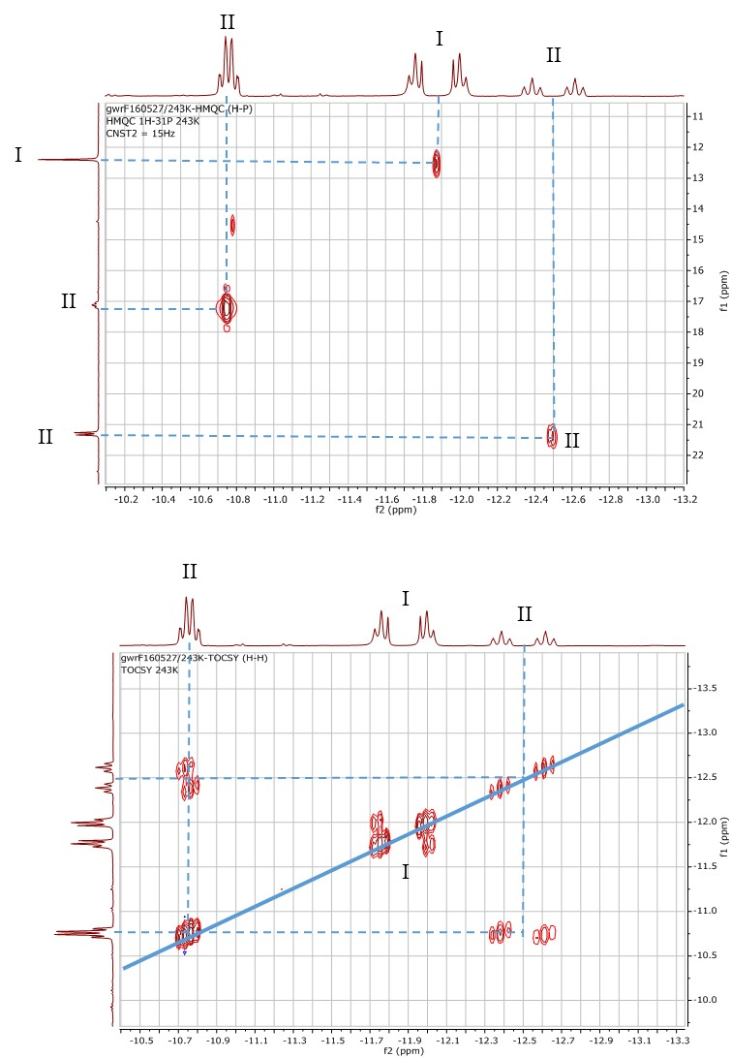
Figure 5S. ¹H-³¹P HMQC (above) and ¹H COSY (below) spectra (expansion of the ¹H hydride region) for the product mixture from the reaction between [IrCl(COD)]₂, PPh₃ (4 equiv) and excess NaOMe in boiling iPrOH for 3 h. The spectra were taken on the dried residue redissolved in THF-d₈.
I
II
II
Figure 6S. Detail of the hydride region showing compounds I and II in THF-d₈ solution at different temperatures. The sample is the same one giving the spectra shown in Figures 3S and 5S.

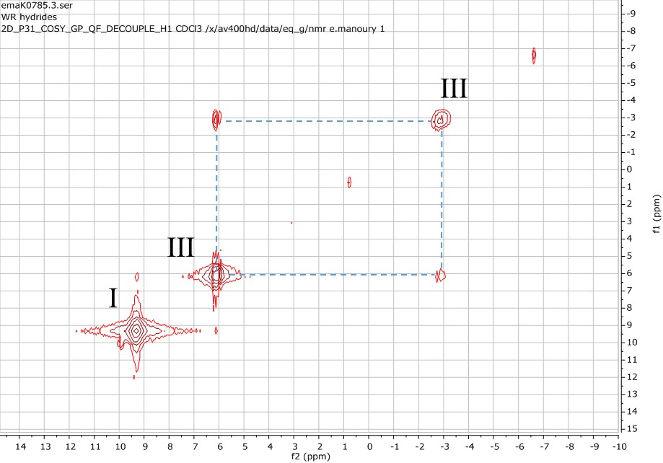
Figure 7S. ³¹P COSY NMR properties of the minor product III. The sample is the same one giving the spectra shown in Figure 4 of the main article.

