The cyclooctadiene ligand in [IrCl(COD)]₂ is hydrogenated under transfer hydrogenation conditions: a study in the presence of PPh₃ and a strong base in isopropanol

S. M. Wahidur Rahaman,^{a,b} Jean-Claude Daran,^{a,b} Eric Manoury^{a,b} and Rinaldo Poli,*^{a,b,c}

ªCNRS, LCC (Laboratoire de Chimie de Coordination), Université de Toulouse, UPS, INPT, 205 route de Narbonne, BP 44099, F-31077 Toulouse Cedex 4, France CNRS. Fax: +33-561553003; Tel: +33-561333174; E-mail:rinaldo.poli@lcc-toulouse.fr.

^{b} Université de Toulouse, UPS, INPT, F-31077 Toulouse Cedex 4, France

^{c} Institut Universitaire de France, 1, rue Descartes, 75231 Paris Cedex 05, France.

Abstract

The interaction of [IrCl(COD)]₂ with PPh₃ in isopropanol has been investigated for various P/Ir ratios, in the absence or presence of a strong base (KOtBu), at room temperature and at reflux. At room temperature, PPh₃ adds to the metal center to yield [IrCl(COD)(PPh₃)] and additional PPh₃ only undergoes rapid degenerative ligand exchange. Subsequent addition of KOtBu affords [IrH(COD)(PPh₃)₂] as the main compound, even for high P/Ir ratios, although very minor amounts of products having a “HIr(PPh₃)₃” core are also generated. Warming to the solvent reflux temperature results in a rapid (< 1 h) and quantitative COD removal from the system as hydrogenated products (54.4% of cyclooctene plus 32.2% of cyclooctane according to a quantitative GC analysis) and in the eventual generation of [IrH₃(PPh₃)₃]. The latter is observed as a mixture of the fac and mer isomers in solvent-dependent proportions. Other minor products, one of which is suggested to be mer-cis-[IrH₂(OiPr)(PPh₃)₃] by the NMR characterization, are also generated. These results show that, contrary to certain previously published assumptions, systems of this kind are unlikely to function via a COD-containing active species in transfer hydrogenation catalyses conducted in hot isopropanol in the presence of a strong base.

Keywords: Iridium, pre-catalyst activation, transfer hydrogenation, cyclooctadiene, triphenylphosphine, hydride ligands.

- Introduction

Transfer hydrogenation is a catalyzed process that allows unsaturated compounds such as aldehydes, ketones and imines to be reduced by a hydrogen donor DH₂, which is transformed to a by-product D, typically isopropanol giving acetone or formic acid giving CO₂ . Hence, it performs the same transformations as hydrogenation but, relative to the latter, presents the main advantage of removing the hazards associated to the use of the gaseous and flammable H₂. However, because of the smaller thermodynamic driving force relative to hydrogenation, harsher conditions - namely higher temperatures - are generally required. Catalysts used to accelerate this reaction span from Lewis acids, which operate through the Meerwein-Ponndorf-Verley mechanism, to unsaturated transition metal hydrides that are able to promote a coordination/insertion mechanism, to transition metal complexes with π-loaded ligands such as amido functions able to operate via an outer-sphere (the so-called Noyori-Morris) mechanism . Many transition metal complexes are able to promote both hydrogenation and transfer hydrogenation and a strong base is generally required in both cases to achieve high activity.
Rhodium and iridium complexes obtained from [MX(COD)]₂ (M = Rh, Ir; X = Cl, OMe) in the presence of various ligands have received considerable attention as pre-catalysts for transfer hydrogenation . The nature of the active species and the mechanism have been discussed in several experimental and computational contributions . It seems that a different mechanism may be adopted depending on the nature of the metal and of the supporting ligand. For instance, working with a computational model of the [RhCl(COD)]₂/chiral diamine precatalysts used in the Lemaire group, Delbecq et al. find that only the outer sphere mechanism is able to account for the observed enantioselectivity of the reaction . Oro et al., on the other hand, conclude that systems generated from [Ir(µ-OMe)(diene)]/PR₃ function through a coordination/insertion mechanism .
One crucial question is whether the diene ligand in the precatalyst remains coordinated to the metal in the catalytically active species or whether it is displaced, either as such or in a hydrogenated form. It seems clear that COD is removed under hydrogenation conditions (i.e. under H₂), but whether this occurs under transfer hydrogenation conditions (particularly in warm isopropanol) does not bring consensus. It has been shown that certain systems differing only by the nature of the diene have different activity. For instance, Lemaire et al. have shown that the activity trend at room temperature of the [RhCl(diene)]₂/diamine/KOtBu/iPrOH system as the diene is changed goes as COD > norbonadiene > hexadiene > (ethylene)₂ . Similarly, the iridium system [IrCl(diene)]₂/aminosulfide/HCOOH/NEt₃ has shown activities in the order COD >> (COE)₂ at 60°C. These observation have led the authors to propose that the diene or alkene remains metal bonded in the active species . On the basis of these reports, the above-mentioned computational investigations on Rh- and Ir-catalyzed transfer hydrogenation cycles were carried out on COD-containing systems, or models thereof .
However, evidence for COD release from iridium complexes under transfer hydrogenation conditions has been gathered since quite some time ago. Kvintovics et al. have shown that, in the presence of 2 equivalents of the chelating diphosphinite (2R,4R)-2,4-bis(diphenylphosphinoxy)pentane (BDPOP) and 10 equivalents of NaOMe, complex [IrCl(COD)]₂ loses COD within 60 min in isopropanol at room temperature to yield cyclooctene as the only detected product (no free COD and no cyclooctane) . Spogliarich et al. have reported that the activation of [Ir(COD)P₂]⁺ (P₂ = chiral diphosphine: chiraphos, prophos or diop) refluxing iPrOH yields COD-free compounds with brigding hydrides , analogous to the [Ir₂(µ-H)₃H₂L₄]⁺ complexes previously reported by Crabtree et al. , even without adding a strong base to the system. In a much more recent contribution, Jiménez et al. have shown that, in isopropanol at 80°C and in the presence of KOH, the transfer hydrogenation catalytic activity of [Ir(COD){κC-Me(o-pyCH₂)Im}₂]⁺ is identical to that of separately synthesized [IrH₂{κC,κN-Me(o-pyCH₂)Im}₂]⁺ where COD is not present, while a GC/MS analysis during catalysis with the COD derivative shows the presence of cyclooctene . Finally, Oro et al. have recently show that addition of sodium isopropoxide to [(COD)Ir{κ³PCP-1,3-(Ph₂PCH₂CH₂)-2-CH₂Im}]⁺PF₆⁻ affords free COD upon heaying to 80°C . It should also be underlined that certain Rh and Ir complexes are known to be active catalysts for the transfer hydrogenation from alcohols to olefins .
In this contribution, we report our investigations of the reaction between [IrCl(COD)]₂ and PPh₃ under a variety of conditions, including those typical of catalytic transfer hydrogenation. Indeed, in work by the Oro’s group, complex [IrH(COD)(PPh₃)₂], which is accessible directly from [IrCl(COD)]₂ and PPh₃ in the presence of base, was proven an efficient precatalyst for the transfer hydrogenation of cyclohexanone (62% conversion in 24 h in isopropanol at 60°C with a 1% catalys loading) . However, a detailed investigation of the high-temperature activation has not been previously reported for this system to the best of our knowledge. We will show here that the COD ligand is hydrogenated and removed from the metal upon warming. Our investigation has retraced a few already well established transformations, but has also brought to the surface a few unexpected and surprising results.

- Experimental

General
All reactions were carried out under an argon atmosphere using standard Schlenk techniques. Isopropanol was carefully dried by distillation on calcium hydride and kept over 4Å molecular sieves under argon before use. All commercially available chemicals ([IrCl(COD)]₂, 99%, Strem Chemicals; PPh₃, 99%, Aldrich; NaOMe, 99%, Aldrich) were used as received. ¹H and ¹³C{¹H} NMR spectra were recorded with Bruker Avance 400, Bruker Avance III 400 and Bruker Avance 500 FT-NMR spectrometers. The resonances were calibrated relative to the residual solvent peaks and are reported with positive values downfield from TMS. For all characterized compounds, the peak assignments in the ¹H and ¹³C NMR spectra were based on COSY, HSQC and HMBC 2D experiments. Gas chromatographic analyses were carried out with a Supelco SPB-20 column (40°C for 10 minutes then heating 3°C/min up to new isotherm at 120°C): cycloctene (11.6 min); cyclooctane (13.1 min); cyclooctadiene (13.6 min).

Reaction of [Ir(µ-Cl)(COD)]₂ and PPh₃ in isopropanol in the presence of KOtBu at room temperature: generation of [Ir(COD)H(PPh₃)₂]
PPh₃ (78 mg, 0.297 mmol) was added to an isopropanol solution (10 mL) of [Ir(µ-Cl)(COD)]₂ (50 mg, 0.074 mmol) and the solution was stirred at room temperature for 3 hours. Potassium tert-butoxide (83 mg, 0.74 mmol) was then added to the mixture and stirred at room temperature for 5 minutes. The white precipitate was removed by Schlenk filtration and the filtrate was concentrated under reduced pressure. Yield: 96 mg (78%). ¹H NMR (400 MHz, CDCl₃): δ 7.79-7.10 (m, 30H, Ph), 3.81 (br, 2H, COD), 3.47 (br, 2H, COD), 1.83 (br, 4H, COD), 1.54 (br, 4H, COD), -13.77 (t, 1H, Ir-H, J_{PH} = 22 Hz). ³¹P {¹H} NMR (400 MHz, CDCl₃): δ 7.5. ¹³C NMR (400 MHz, CDCl₃): δ 139.7 (Ph-ipso, m with virtual coupling), 133.4 (Ph-ortho, virtual t, J_{PC} = 5.8 Hz), 128.1 (Ph-para, s), 127.3 (Ph-meta, virtual t, J_{PC} = 4.4 Hz), 79.3 (CH COD, s), 47.7 (CH COD, m with virtual coupling), 34.7 (CH₂ COD, s), 31.4 (CH₂ COD, s).

Reaction of [Ir(µ-Cl)(COD)]₂ and PPh₃ in isopropanol in the presence of KOtBu at the reflux temperature: generation of fac-[IrH₃(PPh₃)₃]
PPh₃ (72 mg, 0.274 mmol) was added to an isopropanol solution (10 mL) of [Ir(µ-Cl)(COD)]₂ (30 mg, 0.045 mmol) and the solution was stirred at room temperature for 3 hours. Potassium tert-butoxide (50 mg, 0.446 mmol) was added to the mixture and refluxed for 3 hours, with NMR monitoring (see Results and Discussion). The yellow solution became colorless with generation of a white solid. The precipitate was filtered off and the filtrate was concentrated to dryness under reduced pressure. Yield: 70 mg (80%, based on iridium). ¹H NMR (400 MHz, CDCl₃): δ 7.64-6.82 (m, 45H, Ph), -12.25 (AA'A''XX'X'', 3H). ³¹P {¹H} NMR (CDCl₃, 400 MHz): δ 9.3 (s). Colorless crystals suitable for X-ray diffraction were obtained as a CDCl₃ solvate from the NMR solution upon standing.
In a separate experiment, the same procedure was repeated using [Ir(µ-Cl)(COD)]₂ (80 mg, 0.119 mmol), PPh₃ (124 mg, 0.473 mmol), KOtBu (132 mg, 1.18 mmol) and mesilylene (10 mg) as an internal standard in 7 mL of iPrOH. After 3 h of heating at 85°C, gas-chromatographic analysis of the solution revealed the generation of cyclooctene (54.4 %) and cyclooctane (32.2 %), while a peak at the elution time expected for cyclooctadiene was not observed.

X-ray structural analysis.
A single crystal of fac-[IrH₃(PPh₃)₃]∙CDCl₃ was mounted under inert perfluoropolyether at the tip of glass fiber and cooled in the cryostream of a Bruker APEXII diffractometer fitted with a Mo microfocus source. The structure was solved by direct methods (SHELXt) and refined by least-squares procedures on F² using SHELXL-97 . All H atoms attached to carbon were introduced in calculation in idealised positions and treated as riding models. The Ir atom as well as the C atom of the chloroform solvate are located on a 3-fold axis and then only a third of the whole molecule defines the asymmetric unit. The search for the H hydride in the region where it could be expected gave one peak which could be attributed to the hydride. This H was freely refined isotropically and gave satisfactory results. The drawing of the molecules was realised with the help of ORTEP32 . Crystal data and refinement parameters are shown in Table 1.

Table 1. Crystal data and structure refinement for fac-[IrH₃(PPh₃)₃]
Identification code | [IrH₃(PPh₃)₃]
Empirical formula | C₅₄ H₄₈ Ir P₃, CH Cl₃
Formula weight | 1101.40
Temperature, K | 173(2)
Wavelength, Å | 0.71073
Crystal system | Trigonal
Space group | R 3 c
a, Å | 12.7235(8)
c, Å | 51.890(3)
α, ° | 90.0
β, ° | 90.0
γ, ° | 120.0
Volume, Å3 | 7274.9(10)
Z | 6
Density (calc), Mg/m³ | 1.507
Abs. coefficient, mm⁻¹ | 3.054
F(000) | 3306
Crystal size, mm³ | 0.270 x 0.240 x 0.100
Theta range, ° | 2.43 to 36.30
Reflections collected | 158090
Indpt reflections (R_{int}) | 7821 (0.0391)
Completeness, % | 99.9
Absorption correction | Multi-scan
Max. / min. transmission | 0.748 / 0.618
Refinement method | F2
Data /restraints/parameters | 7821 / 1 / 190
Goodness-of-fit on F² | 1.18
R1, wR2 [I>2σ(I)] | 0.0200, 0.0399
R1, wR2 (all data) | 0.0292, 0.0434
Flack’s parameter | 0.000(2)
Residual density, e.Å⁻³ | 0.912 / -0.435

3. Results and discussion

The interaction between [IrCl(COD)]₂ and PPh₃, at various P/Ir ratios, in isopropanol solution was investigated sequentially under three different conditions. First, the phosphine ligand was added to the complex at room temperature in the absence of a base. Then, a strong base was added at room temperature. Finally, the resulting solution was warmed up to the reflux temperature.
The addition of phosphines to [IrCl(COD)]₂ is a well known process, leading to different products depending on stoichiometry, solvent and ligand denticity (monodentate L, bidentate L₂): neutral 4-coordinate [IrCl(COD)L], neutral 5-coordinate [IrCl(COD)L₂], ionic [Ir(COD)L₂]⁺Cl⁻ or [Ir(COD)L₂]⁺[IrCl₂(COD)]⁻. Addition of 1 equiv of PPh₃ per Ir atom yields a solution of [IrCl(COD)(PPh₃)], as previously described . We have only been able to find ¹H NMR characterization for this compound in the literature . We observe the phosphine resonance in the ³¹P {¹H} NMR spectrum at δ 21.7. When the amount of PPh₃ was raised to 2 equiv per Ir, only one broad resonance was observed at an average position between those of [IrCl(COD)(PPh₃)] and free PPh₃, indicating rapid self-exchange between free and coordinated ligand (equation 1, Figure 1). This shows that the formation of a 5-coordinate bis-triphenylphosphine adduct is not favorable.

[IrCl(COD)(PPh₃)] + PPh₃ PPh₃ + [IrCl(COD)(PPh₃)] (1)

Figure 1. ³¹P{¹H} NMR spectra of the [IrCl(COD)]₂ + PPh₃ reaction in isopropanol (aliquot evaporated to dryness and residue redissolved in CDCl₃). (a) P/Ir ratio = 1. (b) P/Ir ratio = 2. The starred resonance (δ 29.3) is due to a small amount of Ph₃PO impurity.

Subsequent addition of a strong base (NaOMe or KOtBu) to the solution having a P/Ir ratio of 2 led to the generation of the known [IrH(COD)(PPh₃)₂] . This compound was also previously obtained from [Ir(OMe)(COD)]₂ and PPh₃, or from [Ir(COD)(PPh₃)₂]⁺ and KOH/MeOH, or from [IrCl(COD)]₂/PPh₃/KOH/MeOH , all of these procedures generating the hydride by β-H elimination from the methoxide ligand in the putative [Ir(OMe)(COD)(PPh₃)₂] intermediate. In the present case, even though tBuO⁻ has no available β-H, it can abstract a proton from the isopropanol solvent and lead to an isopropoxide intermediate than can β-H eliminate an acetone molecule. Replacement of chloride with hydride in the coordination sphere allows coordination of a second PPh₃ ligand (equation 2).

[IrCl(COD)(PPh₃)] + PPh₃ + Me₂CHO⁻ [IrH(COD)(PPh₃)₂] + Me₂C=O + Cl⁻ (2)

The NMR (¹H, ³¹P) properties of the product of equation 2 (¹H triplet at δ -13.77 with J_{HP} = 21.9 Hz, collapsing to a singlet upon broadband P decoupling; ³¹P{¹H} singlet at δ 7.5, see Figure 1S) match those previously reported for [IrH(COD)(PPh₃)₂] . The ¹³C NMR spectrum appears to be reported here for the first time. All phenyl groups are equivalent on the NMR timescale. The CH and CH₂ groups of the COD ligand give two resonances each, consistent with mirror symmetry. Their assignment was confirmed by a DEPT135 ¹³C NMR experiment (see Figure 2). The structure of this compound has not been elucidated, but it can reasonably be assumed identical to those of the structurally characterized analogues with the bidentate diphosphines L₂ = N(sec-Bu)(CH₂CH₂PPh₂)₂ and HC(o-anisyl)(o-C₆H₄PiPr₂)₂ , namely trigonal bipyramidal with the H ligand and one of the two COD double bonds placed in the axial position, thus rendering the two P atoms equivalent and the two COD double bonds inequivalent, in agreement with the NMR evidence. A particular feature of this spectrum is that the resonances of the phenyl ipso, ortho and meta atoms, as well as that of the COD equatorial C atoms, which show coupling to the P nuclei, are virtual triplets rather than doublets, consistent with a strong homonuclear P-P coupling (see excerpts in Figure 2).

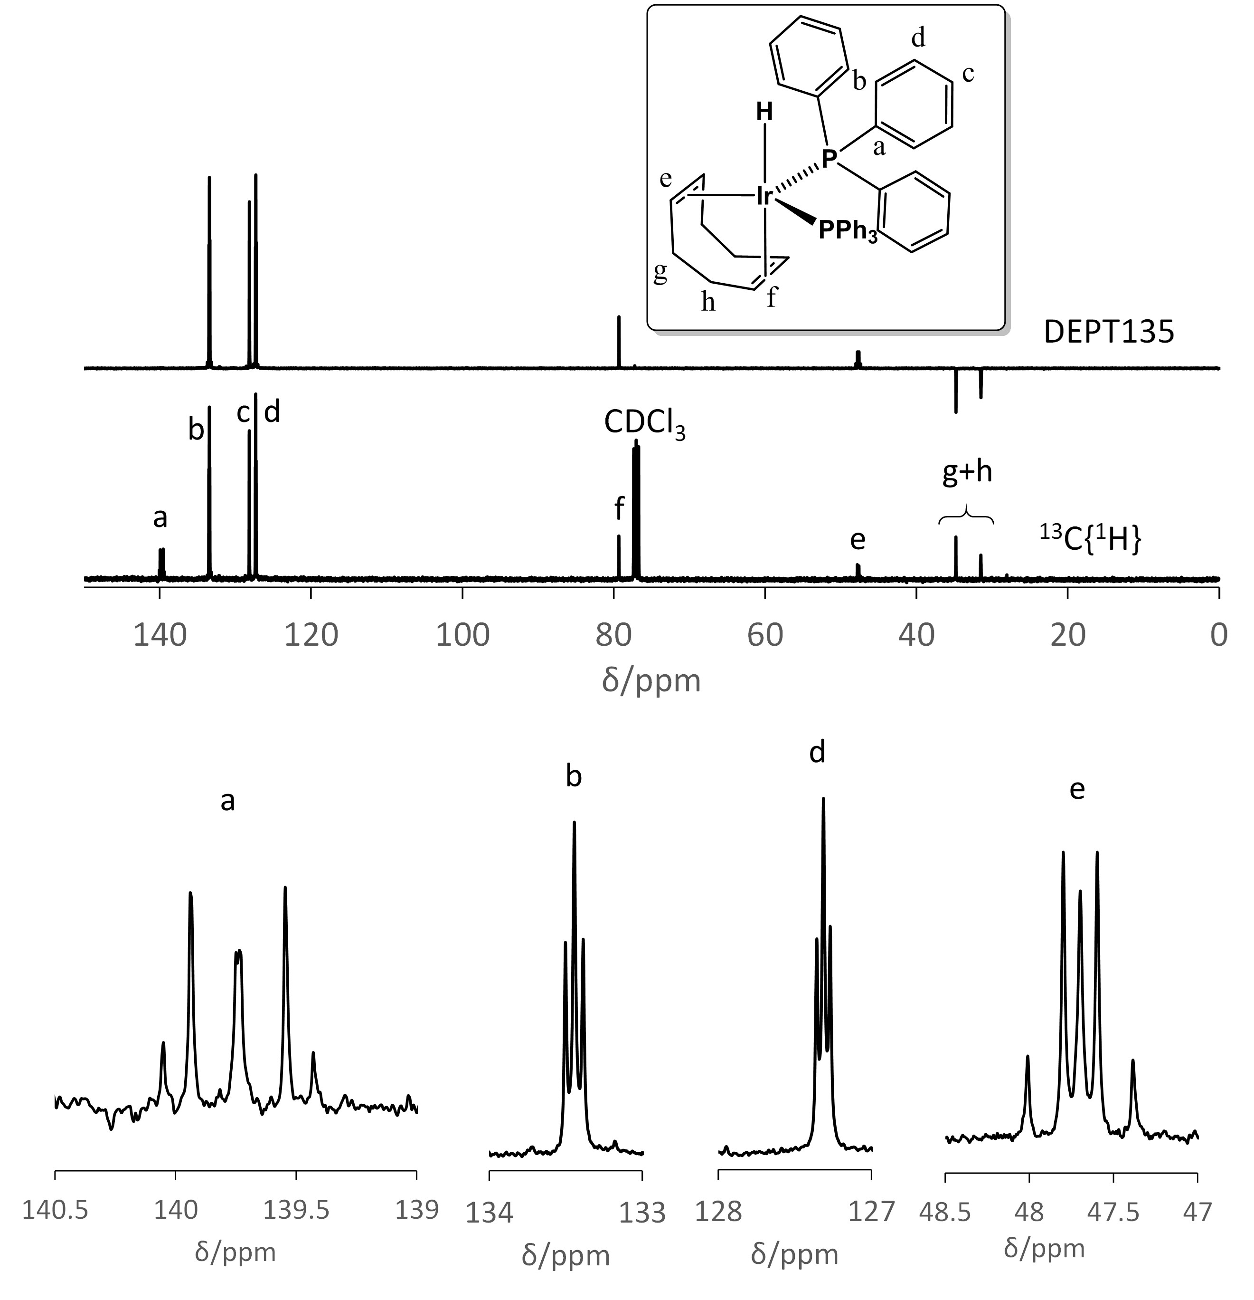
Figure 2. ¹³C{¹H} and DEPT135 NMR spectra of [IrH(COD)(PPh₃)₂], with expanded excerpts for the C atoms exhibiting virtual coupling to the two P atoms.

The reaction yielding [IrH(COD)(PPh₃)₂] (equation 2) also yields a minor by-product characterized by a ¹H quartet resonance at δ -10.73 (J_{HP} = 21.8 Hz) and a ³¹P resonance at δ 14.3 (see Figure 1S). Mutual coupling of these two resonances was confirmed by a H-P HMQC NMR experiment. This pattern is consistent with the presence of only one type of hydride and three equivalent PPh₃ ligands. The simplest possibility is [IrH(PPh₃)₃], analogous to the Rh complex known as Wilkinson’s catalyst, which has apparently never been described. This product could result from the replacement of COD by a third PPh₃ equivalent. Having a 16-electron configuration, this compound would be expected to adopt a square planar geometry with inequivalent cis and trans phosphine ligand, but an average spectrum could result from hydride positional scrambling in the fast kinetic regime. On the other hand, an isomeric ortho-metallated complex, [IrH₂(PPh₃)₂(κ²:C,P-2-C₆H₄PPh₂)], has been reported and could also be consistent with the observed spectrum under the hypothesis of fluxional behavior, but the ¹H NMR properties reported for that compound (quartet at δ -7.7 with J_{PH} = 15 Hz) are different than those observed here.
When the experiment was repeated with a P/Ir ratio of 10, the major Ir product was still [IrH(COD)(PPh₃)₂] and the above described by-product remained visible at low intensity (see Figure 2S), but an additional by-product (also very minor) also appeared. This is characterized by a ¹H hydride resonance at δ -11.64, characteristic of coupling with one trans P atom (large doublet coupling of ca. 280 Hz) and two cis P atoms (smaller triplet coupling of ca. 20 Hz). This pattern is also indicative of a [IrH(PPh₃)₃] stoichiometry, though this time not fluxional, compatible with an octahedral Ir^{III} product having two additional X-type ligands. Efforts at further elucidating the nature of this product were not made. The ³¹P{¹H} NMR spectrum confirmed the presence of [IrH(COD)(PPh₃)₂] as the major product and of the minor δ 14.3 by-product (Figure 2S), while the excess free PPh₃ gave a broad resonance centered at ca. δ -3, showing dynamic exchange with one of the minor by-products. The ¹H spectrum of this mixture recorded in THF-d₈ solution showed the same products in the same relative proportion.
Warming the solution obtained as in equation 2 to the reflux temperature intially leads to the rapid disappearance of the [IrH(COD)(PPh₃)₂] complex. It is still the main compound after 10 min but it is completely consumed after 1 h. Several products are initially generated, as shown by ¹H (hydride region) and ³¹P{¹H} NMR spectroscopy (Figure 3), but continued reflux led to the decrease of the unknown intermediates and the accumulation of three products I, II and III, of which I is dominant (relative ratio = ca. 81:4:15 according to the hydride resonances integration) when the spectrum is recorded in CDCl₃. However, the spectrum of the same product mixture recorded in THF-d₈ shows compounds I and II in approximately equimolar amounts (ca. 47:53), while III was absent and other minor inidentified products are present (Figure 3S). Products I and II have been identified respectively as fac- and mer-[IrH₃(PPh₃)₃]. Curiously, whereas both complexes have been known since the early 60’s and reported several times, including in more recent contributions , their NMR spectral properties have not been thoroughly described. The fac isomer is characterized by a complex 6-line pattern centered at δ -12.2 in the ¹H NMR spectrum for the AA’A”XX’X” system. This feature has been well described and simulated in a previous contribution . However, we find that the ³¹P resonance is located at δ 9.3 (see Figure 3) and not at the previously reported value of 30.05 , as confirmed by the ¹H-³¹P HMQC (Figure 4S in CDCl₃ and Figure 5S in THF-d₈).
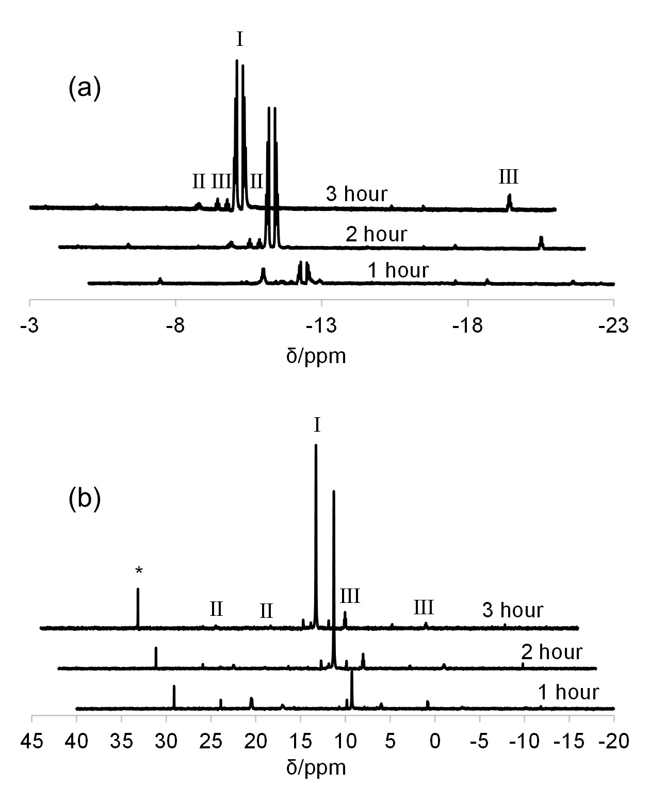
Figure 3. Monitoring by ¹H NMR in the hydride region (a) and ³¹P{¹H} (b) of the reaction between [IrCl(COD)]₂, PPh₃ (4 equiv) and excess NaOMe in boiling iPrOH. The spectra were taken from dried aliquots redissolved in CDCl₃. The starred resonance is assigned to the Ph₃PO impurity.

For the mer isomer, the ³¹P properties have apparently never been reported and only a variable temperature ¹H NMR spectrum in CDCl₃ has been previously described . The better resolved ¹H NMR spectrum in THF-d₈ solution, in which the relative proportion of this isomer is significant, reveals the expected pattern of an A₂BX₂Y spin system (A,B = H; X,Y = P) for the hydride resonances: δ_{A} -10.86 (2H, broad quartet, J_{HP} = 16 Hz, due to degeneracy of the couplings to the 2P_{X} and 1P_{Y} nuclei) and δ_{B} -12.30 (1H, broad dt, J_{HPY} = 116 Hz; J_{HPX} = 21 Hz), which sharpen at 243 K to reveal additional HH coupling (see Figure 6S). The ¹H{³¹P} spectrum at 243 K collapses these two hydride resonances into a doublet and a triplet (J_{HH} = 3.5 Hz) and the ¹H COSY (Figure 5S) further confirms their mutual coupling. These properties agree with and complete those previously reported in CDCl₃ . The corresponding ³¹P{¹H} resonances are found at δ_{X} -21.3 (2P, doublet) and δ_{Y} 17.1 (1P, triplet) with J_{PP} = 15 Hz (mutual coupling confirmed by ³¹P COSY) and the coupling to the above-described hydride ¹H resonances was confirmed by HMQC (Figure 5S).
Product III shows an ABXY₂ spin system. The spectral properties, shown in detail in Figure 4, are very similar but not identical to those described for mer-[IrClH₂(PPh₃)₃] . Notably, although the chemical shifts of the hydride resonances in the ¹H spectrum and of the phosphines in the ³¹P spectrum and the HH and HP coupling constants are very close to those reported for this compound, the PP coupling (14.4 Hz) is about half that reported for the chloro derivative (26 Hz). It seems likely, therefore, that the complex corresponds to mer-[IrXH₂(PPh₃)₃], where X is an alkoxide ligand originating from the base or from the solvent. Its formation can be formally seen as an alcohol oxidative addition to [IrH(PPh₃)₃]. It is notable that the characteristic resonances of the previously described anionic hydrides complexes [IrH₂(PPh₃)₃]⁻ and [IrH₄(PPh₃)₄]⁻ are absent. The correlation between the ¹H and ³¹P resonances is confirmed by the HMQC experiment in CDCl₃ (Figure 4S).

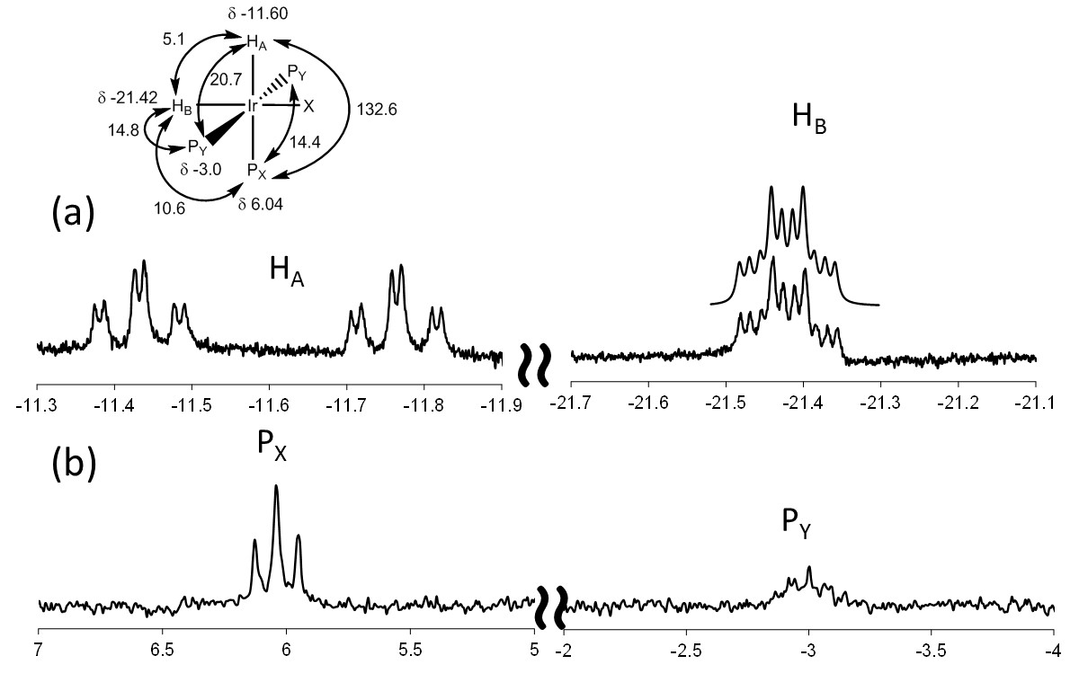
Figure 4. ¹H (a) and ³¹P{¹H} (b) NMR properties of the minor product III resulting from the reaction between [IrCl(COD)]₂, PPh₄ (4 equiv) and excess NaOMe in boiling iPrOH. The upper trace for the H_{B} resonance is the simulated spectrum using the parameters indicated in the molecular diagram (in Hz units).

The generation of COD-free products upon heating [IrH(COD)(PPh₃)₂] in the presence of base raises the question of the fate of COD. The NMR evidence that [IrH(PPh₃)₃] is generated at room temperature, even though in minor amounts (vide supra), suggests the ability of PPh₃ to displace COD. The observed isomeric [IrH₃(PPh₃)₃] products may result from subsequent transformations of this intermediate, for instance by oxidative addition if iPrOH to yield mer-[Ir(OiPr)H₂(PPh₃)₃] which is one of the proposed products, followed by β-H elimination with the generation of acetone, while the expelled COD may remain unaltered. Alternatively, thermal activation of the [IrH(COD)(PPh₃)₂] complex may lead to hydride ligand migration to the COD ligand, followed by further alcohol activation and transfer hydrogenation of COD, which would eventually be eliminated as hydrogenated products. A quantitative gas-chromatographic analysis of the isopropanol solution revealed the generation of cyclooctene (54.4%) and cyclooctane (32.2%), while cyclooctadiene was not detected. Thus, it appears that transfer hydrogenation of the COD ligand is required to accomplish the trasformation.
Another surprising feature of the above reaction is the generation of tris-PPh₃ complexes from a mixture where the PPh₃/Ir ratio is only 2. Nevertheless, the ¹H and ³¹P spectra (figures 3 and 3S) do not show any other major phosphorus-containing product nor additional hydride resonances accounting for 1/3 of the missing Ir sample. This indicates that the formation of the [IrH₃(PPh₃)₃] isomers must be accompanied by the generation of one (or more) iridium by-product that contains neither PPh₃ nor hydride, for instance [Ir(µ-OiPr)(COD)]₂. Repeating the same reaction with 3 equivalents of PPh₃ per Ir atom led to formation of the same observed products but, interestingly, the transformation was much slower: complex [IrH(COD)(PPh₃)₂] was still present in large amounts (ca. 40%) after 3 hours of reflux, whereas it was totally consumed in less than 1 h when using a P/Ir ratio of 2. This indicates a determining role of PPh₃ dissociation for triggering the reaction. We therefore propose that the reaction mechanistically involves the initial steps shown in Scheme 1.

Scheme 1. Proposed mechanism for the first steps of the transformation of [IrH(COD)(PPh₃)₂] to fac- and mer-[IrH₃(PPh₃)₃] in hot isopropanol. The stereochemical assignment to the intermediates is hypothetical.

The COD hydrogenation and elimination from the metal cordination sphere in basic isopropanol, in the absence of H₂, is in line with the previous work already mentioned in the introduction on related systems with diphospine, diphosphinite and pyridine-functionalized N-heterocyclic carbene ligands . However, whereas those previous contributions only indicated the formation of cyclooctene, we also find that a considerable amount of cyclooctane is generated in this case. A possible reason for the more extensive COD hydrogenation before expulsion in the present case is that the supporting PPh₃ ligand, through its lower binding ability and/or lack of chelate effect, dissociates more easily from the metal center allowing more isopropanol to oxidatively add and to transfer hydrogen atoms to the organic ligand before this can be expelled. However, more mechanistic work is needed before firmly rationalizing this observation. At any rate, the results described here clearly demonstrate that the previously reported transfer hydrogenation processes catalyzed by [IrCl(COD)]₂/phosphine ligand/strong base in isopropanol at high temperature likely generate active species that are devoid of the COD ligand. In the presence of PPh₃ , whether the active catalyst is one or both of the isomeric [IrH₃(PPh₃)₃] complexes or whether these are themselves precursors of the real catalyst is not yet quite clear. These componds, in our hands, appear quite stable under the conditions used for transfer hydrogenation (prolonged reflux in isopropanol in the presence of strong base). However, it cannot be excluded that they generate irreversibly minor amounts of a very active catalyst or that the catalysis is promoted, when less than 3 equivalents of PPh₃ per Ir atom are used, by the other H- and PPh₃-free compounds that are generated by the thermal activation. It has been reported that compound [IrH₃(PPh₃)₃] (undefined isomer), catalyzes the transfer hydrogenation of aldehydes by formic acid .
It is also worthy to compare the presently described behavior with that of complex [IrCl(COD)(PS)], where (PS) is the bidentate ferrocenyl phosphine-thioether CpFe[1,2-C₅H₃(PPh₂)(CH₂StBu)] ligand, which was suggested on the basis of DFT calculations to generate the tetrahydrido complex [IrH₄(PS)]⁻, isoelectronic with the above-mentioned [IrH₄(PPh₃)₄]⁻, in basic isopropanol during the catalyzed hydrogenation of acetophenone . However, in the present case the activation and COD removal occurs without the use of H₂. The generation of the neutral [IrH₃(PPh₃)₃] isomers, instead of [IrH₄(PPh₃)₄]⁻, may be related to the greater basicity of two PPh₃ ligands relative to the (PS) ligand.
Crystallization of the product mixture of the [IrCl(COD)]₂/PPh₃/KOtBu reaction in refluxing isopropanol from CDCl₃ afforded single crystals of the major fac-[IrH₃(PPh₃)₃] product. A diffraction study has confirmed the molecular geometry (see Figure 5). The molecule sits on a crystallographic threefold axis. Only the mer isomer was previously structurally characterized . Other structurally characterized [IrH₃L₃] molecules with phosphorus donor L ligands have been described with both the mer (for instance with L₃ = PhP(CH₂CH₂CH₂PCy₂)₂ or (PMe₂Ph)(PiPr₃)₂ ) and the fac geometry (with L = PMePh₂ or L₃ = N(CH₂CH₂PPh₂)₃ ). With respect to the closest structure of the fac-[IrH₃(PMePh₂)₃] complex, the Ir-H distance (1.39(5) Å) is much shorter (cf. 1.627(4) Å) while the Ir-P distance (2.3296(5) Å) is slightly longer (cf. 2.314(2) Å), but the X-ray measurement is known to underestimate the metal-H distances, while the structure of fac-[IrH₃(PMePh₂)₃] was more precisely determined by neutron diffraction . In the structure of the isomeric mer-[IrH₃(PPh₃)₃], also determined by X-ray diffraction, the Ir-H distances were rather unprecisely determined as 1.58(25), 1.62(28) and 1.59(26) Å, while the Ir-P distances are 2.347(3) Å for the unique P atom trans to H and 2.287(3) and 2.285(3) Å for the two P atoms trans to each other. The tendency for the Ir-P bonds to be lengthened by the trans influence of the H ligand is clear and the results for the two mer and fac isomers are consistent in this respect.

Figure 5. ORTEP view of fac-[IrH₃(PPh₃)₃]. Relevant structural parameters: Ir-P, 2.3296(5); Ir-H, 1.39(5) Å; P-Ir-P^{i}, 103.021(16); H-Ir-P, 89.7(19); H-Ir-P^{i}, 84(2); H-Ir-P^{ii}, 164(2)°. Symmetry codes: (i) 1-y, x-y, z; (ii) -x+y, 1-x, z.

4. Conclusions
The main contribution of the present work is the unambiguous demonstration that the [IrCl(COD)]₂/PPh₃/KOtBu precatalyst for transfer hydrogenation in isopropanol loses the COD ligand in a hydrogenated form (mixture of cycloctene and cyclooctane) when thermally activated. Thus, previous assumptions that this catalytic system, as well as related ones with other monodentate phosphine (and probably also bidentate diphosphines), operate by COD-containing active species must be discarded. This investigation arrives at the same conclusion as that of Jiménez et al. based on a systems with a pyridine-functionalized N-heterocyclic carbene as ligand . It is of interest to verify whether this phenomenon is specific to those ligands or general for Ir-based precatalysts used as transfer hydrogenation precatalysts. It is also pertinent to ask the same question about the related Rh stystems, at least those requiring high temperatures to achieve significant activity.
Along the present study, we have also completed the NMR spectroscopic characterization of compound [IrH(COD)(PPh₃)₂] with the ¹³C{¹H} spectrum, we have presented for the first time a full ¹H and ³¹P{¹H} NMR characterization of compound mer-[IrH₃(PPh₃)₃] and the X-ray structure of compound fac-[IrH₃(PPh₃)₃], we have corrected a literature misassignment of the ³¹P NMR resonance for the latter compound, and we have evidenced a few additional by-products formed by thermal activation of the above mentioned precatalyst system. The slowdown of the thermal activation in the presence of additional PPh₃ shows that PPh₃ dissociation from [IrH(COD)(PPh₃)₂] is a prerequisite for the transformations leading to hydrogenation and elimination of the COD ligand.

Acknowledgments
We are grateful to the European Commission, Contract No. 654198 (Marie Curie action IIF) for a post-doctoral Fellowship to SMWR, and CNRS (Centre National de la Recherche Scientifique) and IUF (Institut Universitaire de France) for additional funding. We gratefully acknowledge Dr. Yannick Coppel for help and advice on the NMR experiments.

Supplementary data
Additional NMR spectra as cited in the text (8 pages). The supplementary crystallographic data for fac-[IrH₃(PPh₃)₃] have been deposited to the Cambridge Crystallographic Data Centre as CCDC 1501228 and can obtained free of charge from via www.ccdc.cam.ac.uk/data_request/cif.

References
[1] G. Brieger, T.J. Nestrick, Chem. Rev., 74 (1974) 567-580.
[2] G. Zassinovich, G. Mestroni, S. Gladiali, Chemical Reviews (Washington, DC, United States), 92 (1992) 1051-1069.
[3] M.J. Palmer, M. Wills, Tetrahedron: Asymmetry, 10 (1999) 2045-2061.
[4] S. Gladiali, E. Alberico, Chem. Soc. Rev., 35 (2006) 226-236.
[5] C. Wang, X.F. Wu, J.L. Xiao, Chem. Asian J., 3 (2008) 1750-1770.
[6] B. Stefane, F. Pozgan, Catalysis Reviews-Science and Engineering, 56 (2014) 82-174.
[7] D. Wang, D. Astruc, Chem. Rev., 115 (2015) 6621-6686.
[8] J.S.M. Samec, J.E. Backvall, P.G. Andersson, P. Brandt, Chem. Soc. Rev., 35 (2006) 237-248.
[9] A. Comas-Vives, G. Ujaque, A. Lledos, Adv. Inorg. Chem., 62 (2010) 231-260.
[10] G. Zassinovich, C. Del Bianco, G. Mestroni, J. Organomet. Chem., 222 (1981) 323-329.
[11] F. Vinzi, G. Zassinovich, G. Mestroni, J. Mol. Catal., 18 (1983) 359-366.
[12] E. Farnetti, F. Vinzi, G. Mestroni, J. Mol. Catal., 24 (1984) 147-163.
[13] P. Kvintovics, J. Bakos, B. Heil, J. Mol. Catal., 32 (1985) 111-114.
[14] G. Zassinovich, G. Mestroni, J. Mol. Catal., 42 (1987) 81-90.
[15] P. Gamez, F. Fache, M. Lemaire, Tetrahedron-Asymmetry, 6 (1995) 705-718.
[16] M. Bikrani, L. Fidalgo, M.A. Garralda, Polyhedron, 15 (1996) 83-89.
[17] R. ter Halle, A. Bréhéret, E. Schulz, C. Pinel, M. Lemaire, Tetrahedron: Asymmetry, 8 (1997) 2101-2108.
[18] D.G.I. Petra, P.C.J. Kamer, A.L. Spek, H.E. Schoemaker, P.W.N.M. Van Leeuwen, J. Org. Chem., 65 (2000) 3010-3017.
[19] A. Hage, D.G.I. Petra, J.A. Field, D. Schipper, J. Wijnberg, P.C.J. Kamer, J.N.H. Reek, P.W.N.M. van Leeuwen, R. Wever, H.E. Schoemaker, Tetrahedron-Asymmetry, 12 (2001) 1025-1034.
[20] M. Albrecht, R.H. Crabtree, J. Mata, E. Peris, Chem. Commun., (2002) 32-33.
[21] M. Poyatos, E. Mas-Marzá, J.A. Mata, M. Sanau, E. Peris, Eur. J. Inorg. Chem., (2003) 1215-1221.
[22] A. Trifonova, K.E. Kallstrom, P.G. Andersson, Tetrahedron, 60 (2004) 3393-3403.
[23] N. Debono, M. Besson, C. Pinel, L. Djakovitch, Tetrahedron Lett., 45 (2004) 2235-2238.
[24] A.N. Ajjou, J.L. Pinet, J. Mol. Catal. A, 214 (2004) 203-206.
[25] R. Hodgson, R.E. Douthwaite, J. Organomet. Chem., 690 (2005) 5822-5831.
[26] A.D. Phillips, S. Bolaño, S.S. Bosquain, J.-C. Daran, R. Malacea, M. Peruzzini, R. Poli, L. Gonsalvi, Organometallics, 25 (2006) 2189-2200.
[27] W. He, B.L. Zhang, R. Jiang, P. Liu, X.L. Sun, S.Y. Zhang, Tetrahedron Lett., 47 (2006) 5367-5370.
[28] C.Y. Wang, C.F. Fu, Y.H. Liu, S.M. Peng, S.T. Liu, Inorg. Chem., 46 (2007) 5779-5786.
[29] L. Dahlenburg, H. Treffert, C. Farr, F.W. Heinemann, A. Zahl, Eur. J. Inorg. Chem., (2007) 1738-1751.
[30] R.J. Lundgren, M. Stradiotto, Chem. Eur. J., 14 (2008) 10388-10395.
[31] N. Tsoureas, G.R. Owen, A. Hamilton, A.G. Orpen, Dalton Trans., (2008) 6039-6044.
[32] P. Paredes, J. Diez, M.P. Gamasa, Organometallics, 27 (2008) 2597-2607.
[33] C. Bianchini, L. Gonsalvi, M. Peruzzini, Iridium-catalyzed C=O hydrogenation, in: L.A. Oro, C. Claver (Eds.) Iridium Complexes in Organic Synthesis, Wiley-VCH, Weinheim, 2009, pp. 55-106.
[34] G. Dyson, J.-C. Frison, A.C. Whitwood, R.E. Douthwaite, Dalton Trans., (2009) 7141-7151.
[35] A. Sinha, S.M.W. Rahaman, M. Sarkar, B. Saha, P. Daw, J.K. Bera, Inorg. Chem., 48 (2009) 11114-11122.
[36] C. Diez, U. Nagel, Appl. Organomet. Chem., 24 (2010) 509-516.
[37] A. Binobaid, M. Iglesias, D. Beetstra, A. Dervisi, I. Fallis, K.J. Cavell, Eur. J. Inorg. Chem., (2010) 5426-5431.
[38] N.B. Jokic, M. Zhang-Presse, S.L.M. Goh, C.S. Straubinger, B. Bechlars, W.A. Herrmann, F.E. Kuhn, J. Organomet. Chem., 696 (2011) 3900-3905.
[39] S. Yasar, K.J. Cavell, B.D. Ward, B. Kariuki, Appl. Organomet. Chem., 25 (2011) 374-382.
[40] M.V. Jimenez, J. Fernandez-Tornos, J.J. Perez-Torrente, F.J. Modrego, S. Winterle, C. Cunchillos, F.J. Lahoz, L.A. Oro, Organometallics, 30 (2011) 5493-5508.
[41] V. Gierz, A. Urbanaite, A. Seyboldt, D. Kunz, Organometallics, 31 (2012) 7532-7538.
[42] S. Gonell, M. Poyatos, J.A. Mata, E. Peris, Organometallics, 31 (2012) 5606-5614.
[43] S. Gulcemal, Appl. Organomet. Chem., 26 (2012) 246-251.
[44] A. Azua, J.A. Mata, E. Peris, F. Lamaty, J. Martinez, E. Colacino, Organometallics, 31 (2012) 3911-3919.
[45] S. Gülcemal, A.G. Gökçe, B. Çetinkaya, Dalton Trans., 42 (2013) 7305-7311.
[46] J.A. Fuentes, I. Carpenter, N. Kann, M.L. Clarke, Chem. Commun., 49 (2013) 10245-10247.
[47] D. Gülcemal, A.G. Gökçe, S. Gülcemal, B. Çetinkaya, Rsc Advances, 4 (2014) 26222-26230.
[48] G. Modugno, A. Monney, M. Bonchio, M. Albrecht, M. Carraro, Eur. J. Inorg. Chem., 2014 (2014) 2356-2360.
[49] P.A. Akınci, S. Gülcemal, O.N. Kazheva, G.G. Alexandrov, O.A. Dyachenko, E. Çetinkaya, B. Çetinkaya, J. Organomet. Chem., 765 (2014) 23-30.
[50] S.N. Sluijter, C.J. Elsevier, Organometallics, 33 (2014) 6389-6397.
[51] K. Riener, M.J. Bitzer, A. Pothig, A. Raba, M. Cokoja, W.A. Herrmann, F.E. Kuhn, Inorg. Chem., 53 (2014) 12767-12777.
[52] S.K. Furfari, M.R. Gyton, D. Twycross, M.L. Cole, Chem. Commun., 51 (2015) 74-76.
[53] S.J. Chen, G.P. Lu, C. Cai, New J. Chem., 39 (2015) 5360-5365.
[54] M. Blanco, P. Alvarez, C. Blanco, M.V. Jimenez, J. Fernandez-Tornos, J.J. Perez-Torrente, L.A. Oro, R. Menendez, Carbon, 83 (2015) 21-31.
[55] M. Bernard, V. Guiral, F. Delbecq, F. Fache, P. Sautet, M. Lemaire, J. Am. Chem. Soc., 120 (1998) 1441-1446.
[56] V. Guiral, F. Delbecq, P. Sautet, Organometallics, 19 (2000) 1589-1598.
[57] V. Guiral, F. Delbecq, P. Sautet, Organometallics, 20 (2001) 2207-2214.
[58] F. Delbecq, V. Guiral, P. Sautet, Eur. J. Org. Chem., (2003) 2092-2097.
[59] J.W. Handgraaf, J.N.H. Reek, E.J. Meijer, Organometallics, 22 (2003) 3150-3157.
[60] S.A. Popoola, E.A. Jaseer, A.A. Al-Saadi, V. Polo, M.A. Casado, L.A. Oro, Inorg. Chim. Acta, 436 (2015) 146-151.
[61] M. Victoria Jimenez, J. Fernandez-Tornos, J.J. Perez-Torrente, F.J. Modrego, P. Garcia-Orduna, L.A. Oro, Organometallics, 34 (2015) 926-940.
[62] N. Garcia, E.A. Jaseer, J. Munarriz, P.J. Sanz Miguel, V. Polo, M. Iglesias, L.A. Oro, Eur. J. Inorg. Chem., (2015) 4388-4395.
[63] R. Spogliarich, J. Kaspar, M. Graziani, F. Morandini, J. Organomet. Chem., 306 (1986) 407-412.
[64] R.H. Crabtree, H. Felkin, G.E. Morris, J. Organomet. Chem., 141 (1977) 205-215.
[65] A. Iturmendi, N. Garcia, E.A. Jaseer, J. Munarriz, P.J.S. Miguel, V. Polo, M. Iglesias, L.A. Oro, Dalton Trans., 45 (2016) 12835-12845.
[66] H. Imai, T. Nishiguchi, K. Fukuzumi, J. Org. Chem., 12 (1974) 1622-1627.
[67] T. Nishiguchi, K. Tachi, K. Fukuzumi, J. Org. Chem., 40 (1975) 237-240.
[68] A.S. Goldman, J. Halpern, J. Organomet. Chem., 382 (1990) 237-253.
[69] K. Tani, A. Iseki, T. Yamagata, Chem. Commun., (1999) 1821-1822.
[70] D. Morales-Morales, R. Redón, Z. Wang, D.W. Lee, C. Yung, K. Magnuson, C.M. Jensen, Canadian Journal of Chemistry, 79 (2001) 823-829.
[71] M.J. Fernandez, M.A. Esteruelas, M. Covarrubias, L.A. Oro, J. Organomet. Chem., 316 (1986) 343-349.
[72] G.M. Sheldrick, Acta Crystallographica Section C-Structural Chemistry, 71 (2015) 3-8.
[73] G.M. Sheldrick, Acta Cryst. A, 64 (2008) 112-122.
[74] M.N. Burnett, C.K. Johnson, ORTEPIII, Report ORNL-6895. , Oak Ridge National Laboratory, Oak Ridge, Tennessee, U.S. , 1996.
[75] L.J. Farrugia, J. Appl. Cryst., 30 (1997) 565.
[76] G. Winkhaus, H. Singer, Chemische Berichte-Recueil, 99 (1966) 3610-3618.
[77] K. Vrieze, H.C. Volger, J. Organomet. Chem., 11 (1968) P17-P18.
[78] K. Vrieze, H.C. Volger, A.P. Praat, J. Organometal. Chem., 14 (1968) 185-200.
[79] H. Yamazaki, M. Takesada, N. Hagihara, Bull. Chem. Soc. Jap., 42 (1969) 275.
[80] J.R. Shapley, J.A. Osborn, J. Am. Chem. Soc., 92 (1970) 6976-6978.
[81] M. Lavecchia, M. Rossi, A. Sacco, Inorg. Chim. Acta, 4 (1970) 29-32.
[82] M. Marigo, D. Millos, N. Marsich, E. Farnetti, J. Mol. Catal. A, 206 (2003) 319-329.
[83] C. Bianchini, L. Glendenning, M. Peruzzini, G. Purches, F. Zanobini, E. Farnetti, M. Graziani, G. Nardin, Organometallics, 16 (1997) 4403-4414.
[84] D.C. Babbini, V.M. Iluc, Organometallics, 34 (2015) 3141-3151.
[85] F. Morandini, B. Longato, S. Bresadola, J. Organomet. Chem., 132 (1977) 291-299.
[86] L. Malatesta, M. Angoletta, A. Araneo, F. Canziani, Angew. Chem., 73 (1961) 273.
[87] R.G. Hayter, J. Am. Chem. Soc., 83 (1961) 1259.
[88] I.M. Angoletta, Gazz. Chim. Ital., 92 (1962) 811-817.
[89] J. Chatt, R.S. Coffey, B.L. Shaw, J. Chem. Soc., (1965) 7391-7405.
[90] J.J. Levison, S.D. Robinson, J. Chem. Soc. A, (1970) 2947-2954.
[91] N. Ahmad, S.D. Robinson, M.F. Uttley, J. Chem. Soc., Dalton Trans., (1972) 843-847.
[92] C. Ammann, F. Isaia, P.S. Pregosin, Magnetic Resonance in Chemistry, 26 (1988) 236-238.
[93] S. Park, A.J. Lough, R.H. Morris, Inorg. Chem, 35 (1996) 3001-3006.
[94] G. Guilera, G.S. McGrady, J.W. Steed, A.L. Jones, Organometallics, 25 (2006) 122-127.
[95] B.A. Messerle, C.J. Sleigh, M.G. Partridge, S.B. Duckett, J. Chem. Soc., Dalton Trans., (1999) 1429-1435.
[96] S.E. Landau, K.E. Groh, A.J. Lough, R.H. Morris, Inorg. Chem., 41 (2002) 2995-3007.
[97] R.S. Coffey, Chem. Commun., (1967) 923a.
[98] J.M. Hayes, E. Deydier, G. Ujaque, A. Lledós, R. Malacea, E. Manoury, S. Vincendeau, R. Poli, ACS Catal., 5 (2015) 4368–4376.
[99] G.R. Clark, B.W. Skelton, T.N. Waters, Inorg. Chim. Acta, 12 (1975) 235-245.
[100] D.J. Kountz, C. Yang, D.W. Meek, Acta Cryst. A, 40 (1984) C293-C293.
[101] E.J. Ditzel, G.B. Robertson, Austr. J. Chem., 48 (1995) 1183-1191.
[102] R. Bau, C.J. Schwerdtfeger, L. Garlaschelli, T.F. Koetzle, J. Chem. Soc., Dalton Trans., (1993) 3359-3362.
[103] A. Rossin, E.I. Gutsul, N.V. Belkova, L.M. Epstein, L. Gonsalvi, A. Lledos, K.A. Lyssenko, M. Peruzzini, E.S. Shubina, F. Zanobini, Inorg. Chem., 49 (2010) 4343-4354.

