**Adhesion and Non-Linear Rheology of Adhesives with Supramolecular Crosslinking Points**

*X. Calliesa* , C. Fonteneaub, S. Pensecb, L. Bouteillerb, G. Ducoureta, C. Cretona*,*

*aLaboratoire SIMM, CNRS, UPMC, ESPCI, 10 rue Vauquelin, Paris, 75005, France*

*bSorbonne Universités, UPMC Univ Paris 06, CNRS, IPCM, Chimie des Polymères, F-75005 Paris, France*

[*xavier.callies@etu.upmc.fr*](mailto:xavier.callies@etu.upmc.fr)*,* [*costantino.creton@espci.fr*](mailto:xavier.callies@espci.fr)

**Supporting Information**

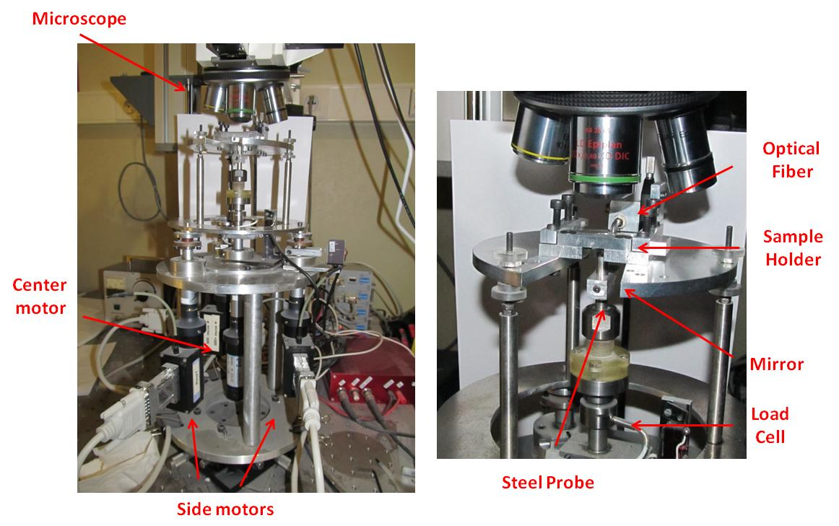

**Figure S1**: pictures of the overall set-up (left) and the contact zone (right). The steel flat-ended probe (diameter Ф=5.95 ± 0,02mm) is driven by a central stepping motor while three side motors drive an upper plate. The glass slide on which is deposited the thin adhesive layer, is fixed facing down on this upper plate. The load cell (40N $±$ 0,1N) required for the measurement of the normal force FT is positioned in series with the probe.

To check the reproducibility of adhesion tests, several coated glass slides were prepared for each material and several tests were carried out for each film. As illustrated in the following figure, the shape of the stress-strain curve and the stress peak are reproducible for different tests performed on distinct films.



**Figure S2**: Probe-tack *σ0=f(ε0)* curves obtained from PnBA3U8 and PnBA3U12-coated glass slides (thickness ~ 100µm). The different curves for the same material result from adhesion tests on different coated glass slides, at ambient temperature and with a debonding velocity of 100µm/s.

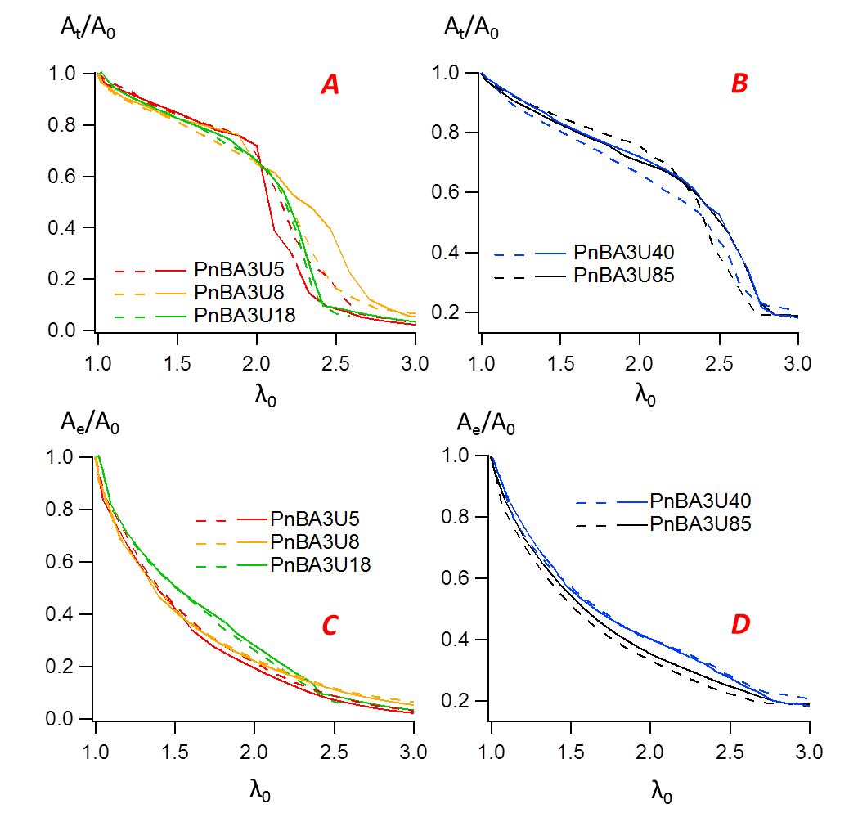

**Figure S3**: Variation of the ratio *At /A0* (***A-B***) and *Ae/A0* (***C-D***) with the nominal strain for low (***A-C***) and high (***B-D***) molecular weight PnBA3U. Two experimental curves are shown for each material to show the reproducibility of the results.

|  |  |  |  |  |
| --- | --- | --- | --- | --- |
|  | PnBA3U5 | | PnBA3U85 | |
| Modes | τ (s) | g (Pa) | τ (s) | g (Pa) |
| 1 | 0,001 | 100000 | 0,001 | 60000 |
| 2 | 0,0025 | 100000 | 0,0025 | 40000 |
| 3 | 0,01 | 100000 | 0,01 | 40000 |
| 4 | 0,025 | 25000 | 0,025 | 15000 |
| 5 | 0,1 | 20000 | 0,1 | 45000 |
| 6 | 0,25 | 20000 | 0,25 | 10000 |
| 7 | 1 | 20000 | 1 | 3000 |
| 8 | 2,5 | 15000 | 2,5 | 2000 |
| 9 | 10 | 15000 | 10 | 1200 |
| 10 | 25 | 15000 | 25 | 100 |
| 11 | 100 | 10000 | 100 | 100 |
| 12 | 2500 | 150000 | 250 | 100 |

**Figure S4**: Maxwell parameters for PnBA3U5 and PnBA3U85